the ESP32 is not an STM32, so STM32CubeMX and Keil don't apply to it
Step 1: Install Arduino IDE and set up ESP32 support
1.1 Download Arduino IDE Go to https://www.arduino.cc/en/software and download Arduino IDE 2.x for your OS. Install it normally.
1.2 Add ESP32 board support The ESP32 is not built into Arduino IDE — you need to add it manually.
- Open Arduino IDE
- Go to File → Preferences
- Find the field labeled "Additional boards manager URLs"
- Paste this URL into it:
https://raw.githubusercontent.com/espressif/arduino-esp32/gh-pages/package_esp32_index.json
- Click OK
- Go to Tools → Board → Boards Manager
- In the search box type esp32
- Find the entry called "esp32 by Espressif Systems" — click Install
- Wait for it to finish (it downloads ~200 MB)
1.3 Select your board
- Go to Tools → Board → esp32 → ESP32 Dev Module
  - "ESP32 Core Board V2" is the generic dev board — ESP32 Dev Module is the correct selection for it
- Go to Tools → Port and select the COM port your ESP32 is on
  - On Windows it shows as COM3, COM4, etc.
  - On Mac/Linux it shows as /dev/ttyUSB0 or /dev/tty.SLAB_USBtoUART
  - If you don't see any port, you need the CP2102 USB driver — download from https://www.silabs.com/developers/usb-to-uart-bridge-vcp-drivers
Change upload speed to 115200.
Go to File → Examples → 01.Basics → Blink
1.5 Test
Go to File → Examples → 01.Basics → Blink
Put this code
void setup() {
Serial.begin(115200);
Serial.println("ESP32 is alive!");
}

void loop() {
Serial.println("Running...");
delay(1000);
}
- Click Upload (hold BOOT if needed)
- Open terram term, Set baud rate to 115200
1-)Wire the PIR sensor

VCC → ESP32 VIN (5V pin, not 3.3V)
OUT → ESP32 GPIO 23
GND → ESP32 GND
Remove previous code
Put ::
#define PIR_PIN 23

void setup() {
Serial.begin(115200);
pinMode(PIR_PIN, INPUT);

Serial.println("Waiting 30 seconds for PIR to warm up...");
Serial.println("Do not move in front of it during this time.");

for (int i = 30; i > 0; i--) {
Serial.print("Ready in: ");
Serial.print(i);
Serial.println(" seconds");
delay(1000);
}

Serial.println("PIR is ready!");
}

void loop() {
int pirState = digitalRead(PIR_PIN);

if (pirState == HIGH) {
Serial.println("MOTION DETECTED — Room: OCCUPIED");
} else {
Serial.println("No motion — Room: EMPTY");
}

delay(500);
}

And upload.

Now, we use
ASAIR AM2302 for tem/humidity
Pin 1 → VCC → 3.3V or 5V
Pin 2 → DATA → signal to ESP32 (IO17)
Pin 4 → GND → ground

Install the DHT library
This time you DO need a library. In Arduino IDE:
- Go to Sketch → Include Library → Manage Libraries
- In the search box type: DHT sensor library
- Find "DHT sensor library by Adafruit" — click Install
- A popup will ask "Install all" — click Install all (this also installs the Adafruit Unified Sensor dependency)
- Wait for it to finish

Use the new code :
#include "DHT.h"

#define DHT_PIN 17
#define DHT_TYPE DHT22
#define PIR_PIN 23

DHT dht(DHT_PIN, DHT_TYPE);

bool roomOccupied = false;
bool lastOccupied = false;
unsigned long lastDHTRead = 0;

void setup() {
Serial.begin(115200);
pinMode(PIR_PIN, INPUT);
dht.begin();

Serial.println("=== Smart Home Presence System ===");
Serial.println("Warming up sensors...");
delay(3000);
Serial.println("System ready.\n");
}

void loop() {
unsigned long now = millis();

// ── PIR: check every loop ──
roomOccupied = (digitalRead(PIR_PIN) == HIGH);

// ── Detect state change (entry/exit event) ──
if (roomOccupied && !lastOccupied) {
Serial.println(">>> SOMEONE ENTERED — turning on lights/atomizer");
// relay control will go here later
}
else if (!roomOccupied && lastOccupied) {
Serial.println("<<< ROOM EMPTY — turning off everything");
// relay control will go here later
}
lastOccupied = roomOccupied;

// ── DHT22: read every 3 seconds ──
if (now - lastDHTRead >= 3000) {
lastDHTRead = now;

float humidity = dht.readHumidity();
float temperature = dht.readTemperature();

if (!isnan(humidity) && !isnan(temperature)) {
Serial.print("Temp: ");
Serial.print(temperature, 1);
Serial.print(" C | Hum: ");
Serial.print(humidity, 1);
Serial.print(" % | Room: ");
Serial.println(roomOccupied ? "OCCUPIED" : "EMPTY");
}
}

delay(500);
}
Expected output:

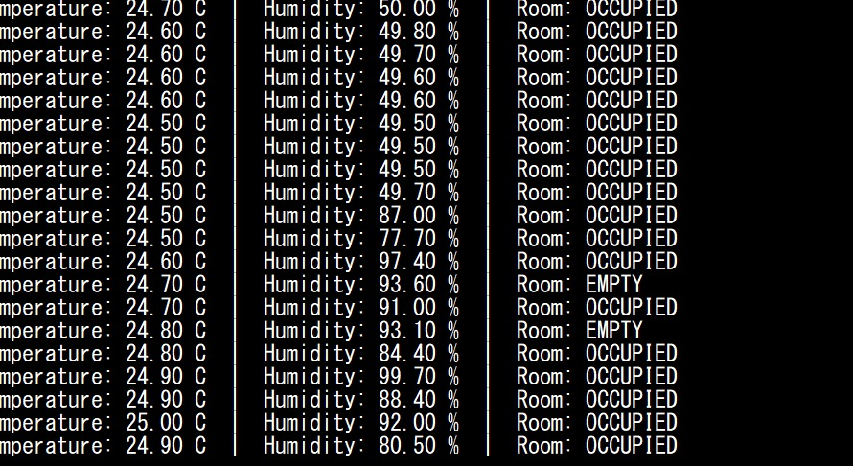

Turn your phone into a local MQTT broker using Termux, and connect everything through your phone's personal hotspot — no internet required.
Base code
#include "DHT.h"
#include <WiFi.h>
#include <PubSubClient.h>

// ── WiFi credentials ──────────────────────────────
const char* ssid = "";
const char* password = "12345678ok";

// ── MQTT broker ───────────────────────────────────
const char* mqttServer = "10.130.125.189";
const int mqttPort = 1883;
const char* mqttUser = "admin";
const char* mqttPassword = "01001684495";

// ── MQTT topics ───────────────────────────────────
const char* topicTemp = "smarthome/room001/temperature";
const char* topicHum = "smarthome/room001/humidity";
const char* topicRoom = "smarthome/room001/room";
const char* topicCommand = "smarthome/room001/command";

// ── Pin definitions ───────────────────────────────
#define DHT_PIN 17
#define DHT_TYPE DHT22
#define PIR_PIN 23

// ── Objects ───────────────────────────────────────
DHT dht(DHT_PIN, DHT_TYPE);
WiFiClient espClient;
PubSubClient mqtt(espClient);

// ── State ─────────────────────────────────────────
bool roomOccupied = false;
bool lastOccupied = false;
unsigned long lastDHTRead = 0;
unsigned long lastMQTTRetry = 0;

// ── Called when a command arrives from your phone ──
void onCommandReceived(char* topic, byte* payload, unsigned int length) {
String message = "";
for (int i = 0; i < length; i++) {
message += (char)payload[i];
}
message.trim();

Serial.print("Command received: ");
Serial.println(message);

if (message == "LIGHTS_ON") {
Serial.println(">>> Lights ON command received");
}
else if (message == "LIGHTS_OFF") {
Serial.println(">>> Lights OFF command received");
}
else if (message == "STATUS") {
mqtt.publish(topicRoom, roomOccupied ? "OCCUPIED" : "EMPTY");
}
}

// ── Connect to WiFi ───────────────────────────────
void connectWiFi() {
Serial.print("Connecting to WiFi: ");
Serial.println(ssid);
WiFi.begin(ssid, password);

int attempts = 0;
while (WiFi.status() != WL_CONNECTED) {
delay(500);
Serial.print(".");
attempts++;
if (attempts > 30) {
Serial.println("\nWiFi failed. Check credentials.");
return;
}
}

Serial.println("\nWiFi connected!");
Serial.print("IP address: ");
Serial.println(WiFi.localIP());
}

// ── Connect to MQTT broker ────────────────────────
void connectMQTT() {
mqtt.setServer(mqttServer, mqttPort);
mqtt.setCallback(onCommandReceived);

Serial.print("Connecting to MQTT broker...");

String clientID = "ESP32-" + String(WiFi.macAddress());

if (mqtt.connect(clientID.c_str(), mqttUser, mqttPassword)) {
Serial.println(" connected!");
mqtt.subscribe(topicCommand);
Serial.print("Subscribed to: ");
Serial.println(topicCommand);
} else {
Serial.print(" failed, rc=");
Serial.println(mqtt.state());
}
}

// ── Setup ─────────────────────────────────────────
void setup() {
Serial.begin(115200);
pinMode(PIR_PIN, INPUT);
dht.begin();

Serial.println("=== Smart Home System ===");

connectWiFi();
connectMQTT();

delay(2000);
Serial.println("System ready.");
}

// ── Main loop ─────────────────────────────────────
void loop() {
unsigned long now = millis();

if (!mqtt.connected()) {
if (now - lastMQTTRetry > 5000) {
lastMQTTRetry = now;
Serial.println("MQTT disconnected. Reconnecting...");
connectMQTT();
}
}
mqtt.loop();

// ── PIR check ──
roomOccupied = (digitalRead(PIR_PIN) == HIGH);

if (roomOccupied && !lastOccupied) {
Serial.println(">>> SOMEONE ENTERED");
mqtt.publish(topicRoom, "OCCUPIED");
}
else if (!roomOccupied && lastOccupied) {
Serial.println("<<< ROOM EMPTY");
mqtt.publish(topicRoom, "EMPTY");
}
lastOccupied = roomOccupied;

// ── DHT22: read and publish every 5 seconds ──
if (now - lastDHTRead >= 5000) {
lastDHTRead = now;

float humidity = dht.readHumidity();
float temperature = dht.readTemperature();

if (!isnan(humidity) && !isnan(temperature)) {
char tempStr[8];
char humStr[8];
dtostrf(temperature, 4, 1, tempStr);
dtostrf(humidity, 4, 1, humStr);

mqtt.publish(topicTemp, tempStr);
mqtt.publish(topicHum, humStr);

Serial.print("Published → Temp: ");
Serial.print(tempStr);
Serial.print(" C | Hum: ");
Serial.print(humStr);
Serial.print(" % | Room: ");
Serial.println(roomOccupied ? "OCCUPIED" : "EMPTY");
}
}

delay(500);
}

Step 1 — Install Termux & Mosquitto
Open Termux and run:
bash
pkg update && pkg upgrade
pkg install mosquitto
Step 2 — Create MQTT Password File
bash
mosquitto_passwd -c ~/mosquitto_passwd admin
Enter your password twice when prompted.

Step 3 — Create Mosquitto Config File
bash
nano ~/mosquitto.conf
Paste exactly this:
listener 1883 0.0.0.0
allow_anonymous false
password_file /data/data/com.termux/files/home/mosquitto_passwd
Save with Ctrl+X → Y → Enter.

Step 4 — Enable Phone Hotspot
Go to phone Settings → Personal Hotspot → Turn ON.
Note your hotspot name and password.

Step 5 — Find Hotspot IP
In Termux run:
bash
ifconfig
Look for the ap0 interface:
ap0: inet 10.130.125.189
This is your broker IP. Write it down.
Step 6 — Start Mosquitto Broker
bash
mosquitto -c ~/mosquitto.conf
You should see:
Opening ipv4 listen socket on port 1883
Leave this running. Do not close Termux.
Step 7 — Test the Broker
Open a second Termux session (swipe from left edge) and run:
bash
mosquitto_sub -h 127.0.0.1 -p 1883 -t test -u admin -P YOUR_PASSWORD
Open a third Termux session and run:
bash
mosquitto_pub -h 127.0.0.1 -p 1883 -t test -m "hello" -u admin -P YOUR_PASSWORD
If the word hello appears in the second session → broker is working ✅
Step 8 — Update ESP32 Sketch
Change these lines in your Arduino sketch:
cpp
const char* ssid = "YourHotspotName";
const char* password = "YourHotspotPassword";
const char* mqttServer = "10.130.125.189"; // your ap0 IP
const int mqttPort = 1883;
const char* mqttUser = "admin";
const char* mqttPassword = "YOUR_PASSWORD";

download https://mqtt-explorer.com/
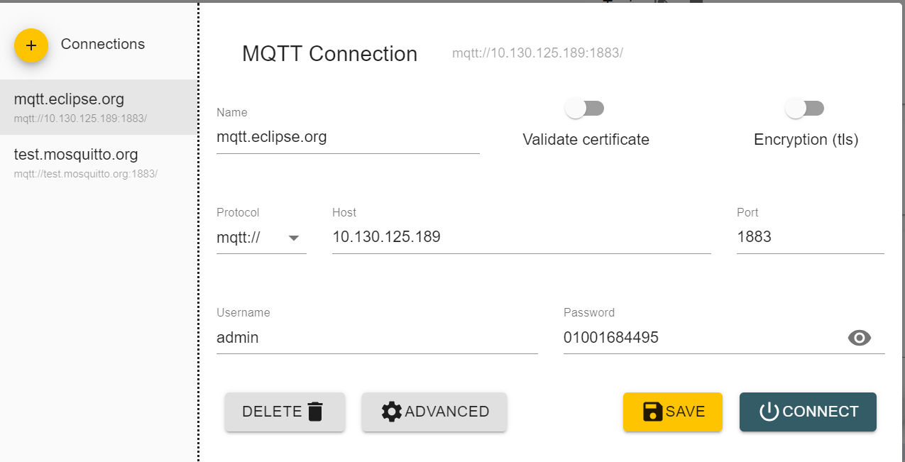
The password is what you set in termux
Now upload the code, and it will start reading
