**الاسم:** مصطفي خالد علي السيد **Name:** mostafa khaled ali elsayed ,

**B.N:** 904

**topic:** Mobile computing

**Github link:** <https://github.com/mostafa313/html-project-repository>

**Github-page(published-website):** <https://mostafa313.github.io/html-project-repository/index.html>

**Application Brief:**

Mobile Computing is a technology that allows transmission of data, voice and video via a computer or any other wireless enabled device without having to be connected to a fixed physical link. The main concept involves:-

Mobile communication

Mobile hardware

Mobile software

I choose this topic because mobile computing is more benefit in this world and it irreplaceable in this time moreover we can send and receive any things (messages-attachments-…) any where any time and we can stay in our home and make all works.

**Screenshots:**

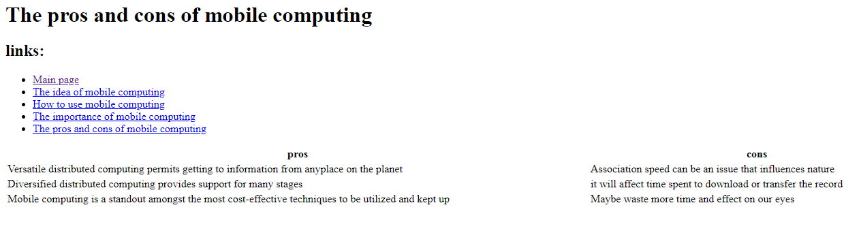

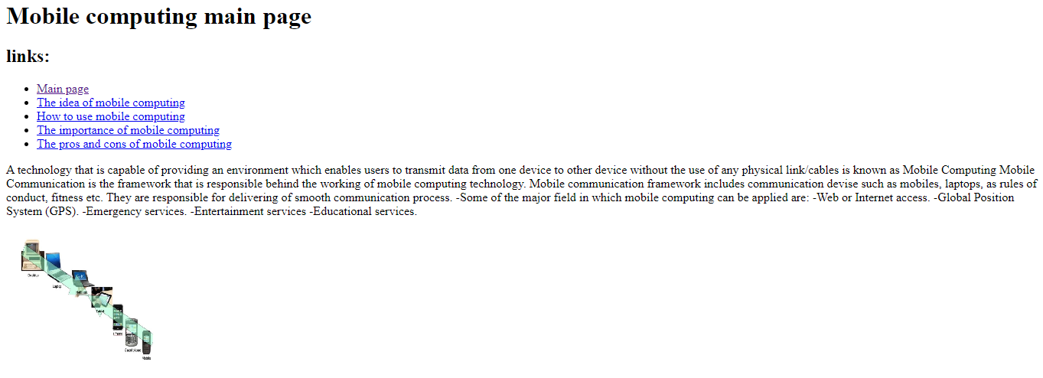

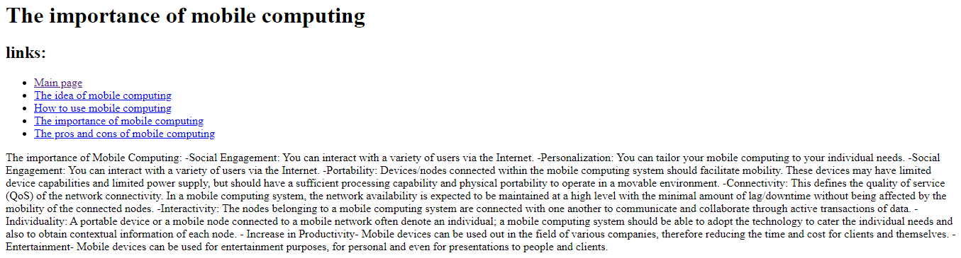

**Source code:**

