**Question 1:**

**Put True (√) or False (X) for each of the following statement**

**[15 Statements 15 marks]**

1. **SQL command is Case sensitive. ( )**
2. **You can use where with truncate command. ( )**
3. **You can define Global variable in SQL. ( )**
4. **DDL means Create, Alter and drop for objects. ( )**
5. **Benefits Primary key for column not allow NULL and no duplicate values.( )**
6. **You can select all columns with use group by one column. ( )**
7. **View is virtual table. ( )**
8. **You can write insert or update statement for create view. ( )**
9. **You can create view from another view. ( )**
10. **You can use order by to create view. ( )**
11. **You can pass parameters to View**. ( )
12. **You can pass default value to parameter in procedure. ( )**
13. **SQL provides five built-in functions: COUNT, SUM, AVG, MAX, MIN.( )**
14. **Function can return table. ( )**
15. **Transaction is one unit during executing. ( )**

**Question 2:**

**Choose the right answer [10 Statements 10 marks]**

1. **You can add a row using SQL in database with which of the following?**

a-Add b- Create c- Insert d-Make

1. **You have a table named Employee that includes four columns. You execute thefollowingstatement:SELECT * FROM Employee**

**Which columns are returned?**

a- All columns b- Only the first column c- Only the last column d-Only the first and last columns

1. **One reason to create a stored procedure is to:**

a- Improve performance b-. Minimize storage space

1. **One difference between a function and a stored procedure is that a function:**

a- Must return a value b- Cannot accept parameters c- Cannot contain a transaction

1. **DML :**

a-Create b-Insert c-Deny

1. **To determine for identity start number from 10 then add one in the next.**

a-Identity seed=10 b-Identity seed=1

1. **To set current date is default in registration date Columns what is the function used:**

a-datetime.Now b-datenow() c-getdate()

1. **To display all employee not have Second name:**

a-secondname=”” b-secondname=NULL c-secondname is NULL

1. **I want to display column with name SalaryCategory( high,Medium,low) I can use:**

a-Simple case b-Searched case

**Question 3:**

**Answer the following questions [5 statements 10 marks]**

**a- Write code. I want to know information about SQL version and edition.**

**b-Write code to insert 1000 row to country table have columns( id, Countryname ).**

1. **Write code to delete rows duplicated and leave only one row from these.**
2. **Write code to create function with name f_captalize I can pass word return first character Capital only.**
3. **Tell something about System code Type and system code tables.**
4. **Tell something about what is the benefit for log data table.**

**Question 4:**

**Answer the following questions [5 statements 15 marks]**

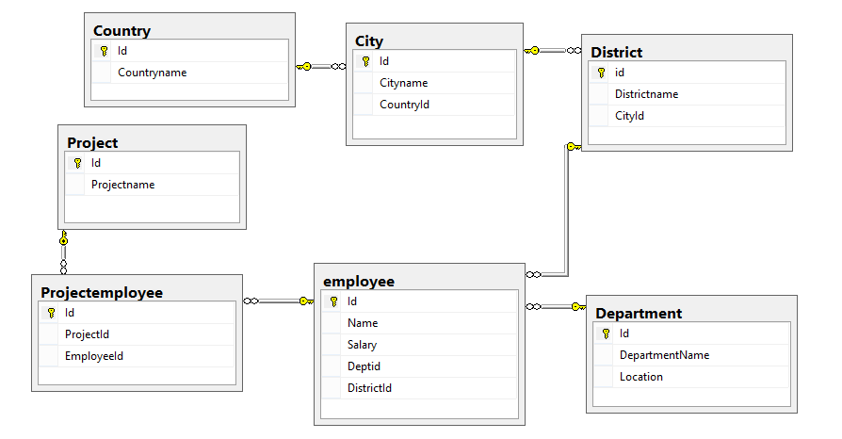

1. **Write code to Create view with name (display_all_data) to display all data to all columns in all tables?**
2. **Write code to Create Procedure with name (Country_proc) to execute insert ,update, delete and select.**
3. **Write code to Create view with name (department_empcount_projectcount) to display Departmentname ,count of employees , total salary and count of projects for this department**
4. **Design Logdata table and write Structure for this table.**
5. **Create trigger on Department for insert data to Logdata after update.**

**Question 5: Bonus**

**Answer the following questions [6 statements 6 marks]**

1. **What is the difference between Primary key and unique constraint in table?**
2. **What is the difference between Clustered and non-clustered index?**
3. **What is collation in SQL?**
4. **What is the uniqueidentifier datatype in SQL?**
5. **What is SQL Azure?**