* **write a C# program to calculate the sum and the average of three numbers.**
* **Write a C# program that asks the user to enter the radius of a circle and then computes and displays the circle's area and circumference. use the formulas**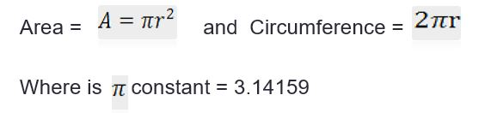

* **write a C# program that accepts an employee salary and a tax percentage then computes the Net Salary and Annual Salary.**