AWS Amplify

1. What is AWS Amplify?
Use AWS Amplify to develop and deploy cloud-powered mobile and web applications. Amplify provides frontend libraries, UI components, and backend building for full stack applications on AWS. Amplify Hosting provides a continuous delivery and hosting service for full stack cloud applications.

In short, AWS Amplify is a platform that lets you:
- Build web and mobile applications quickly using AWS services
- Host your website or app on Amazon's global network (CDN)
- Automatically deploy every code change through CI/CD pipelines
- Connect a backend (database, authentication, storage) with minimal configuration

2. Amplify Hosting
Amplify Hosting is a Git-based workflow for hosting full-stack serverless web applications with continuous deployment. When you push code to your repository, Amplify automatically builds and deploys your app to AWS's global CDN.

How It Works
- Connect your Git repository (GitHub, GitLab, Bitbucket, or Code Commit)
- Amplify detects your framework and sets up build commands automatically
- Every commit triggers an automatic build and deployment
- Your site is served from AWS CloudFront CDN worldwide


3. Key Features

3.1 Continuous Deployment (CI/CD)
Every time you push code to your connected branch, Amplify automatically builds and deploys your application. No manual steps required.

3.2 Custom Domain
Connect your own domain name (e.g. mysite.com) to your Amplify app. Amplify supports:
- Amazon Route 53 domains (easiest setup)
- Third-party DNS providers (GoDaddy, Namecheap, etc.)
- Automatic SSL/TLS certificate provisioning and renewal

3.3 Feature Branch Deployments
Each Git branch gets its own unique URL and environment. This allows you to test new features before merging them to production.

3.4 Pull Request (PR) Previews
When you open a Pull Request, Amplify automatically creates a preview deployment with a unique URL. Reviewers can see changes live without merging the code.

3.5 Password Protected Branches
You can restrict access to specific branches with a username and password. Useful for staging environments or client previews.

3.6 Atomic Deployments
Amplify only switches your live site to the new version after the entire build is complete and uploaded. This eliminates downtime and partial deployments.

4. Getting Started — Step by Step

Step 1: Connect Your Repository
Go to the AWS Amplify Console and
click 'New App > Host Web App'.
Choose your Git provider (GitHub is most common) and authorize Amplify to access your repositories. Select the repo and branch you want to deploy.
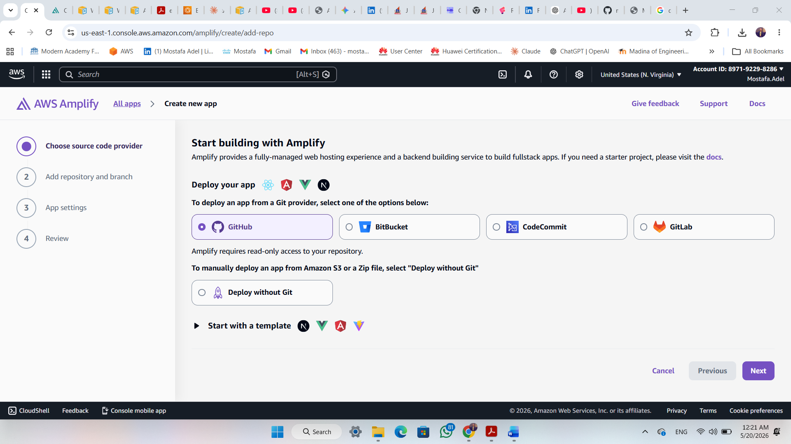
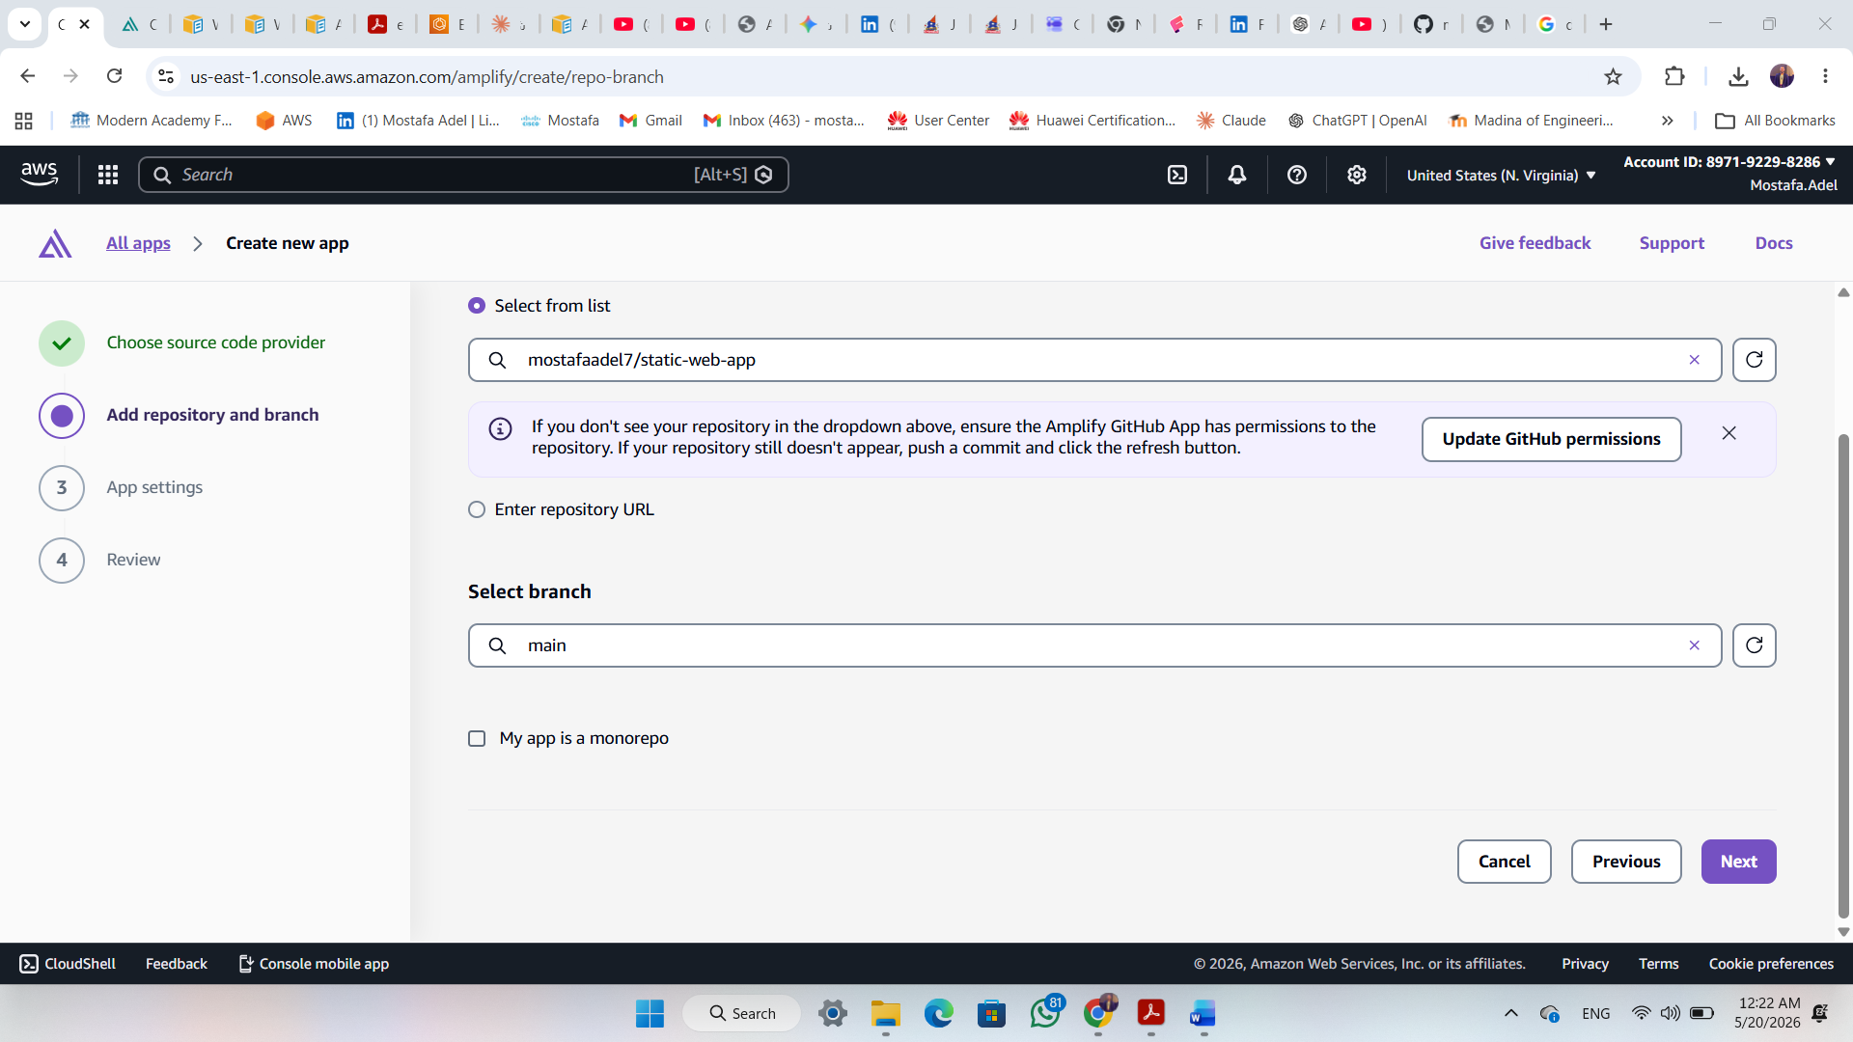

Step 2: Configure Build Settings
Amplify automatically detects your framework and fills in the build commands. For example, for a React app:
- Build command: npm run build
- Output directory: build
You can customize these or add an amplify.yml file to your repository for full control.
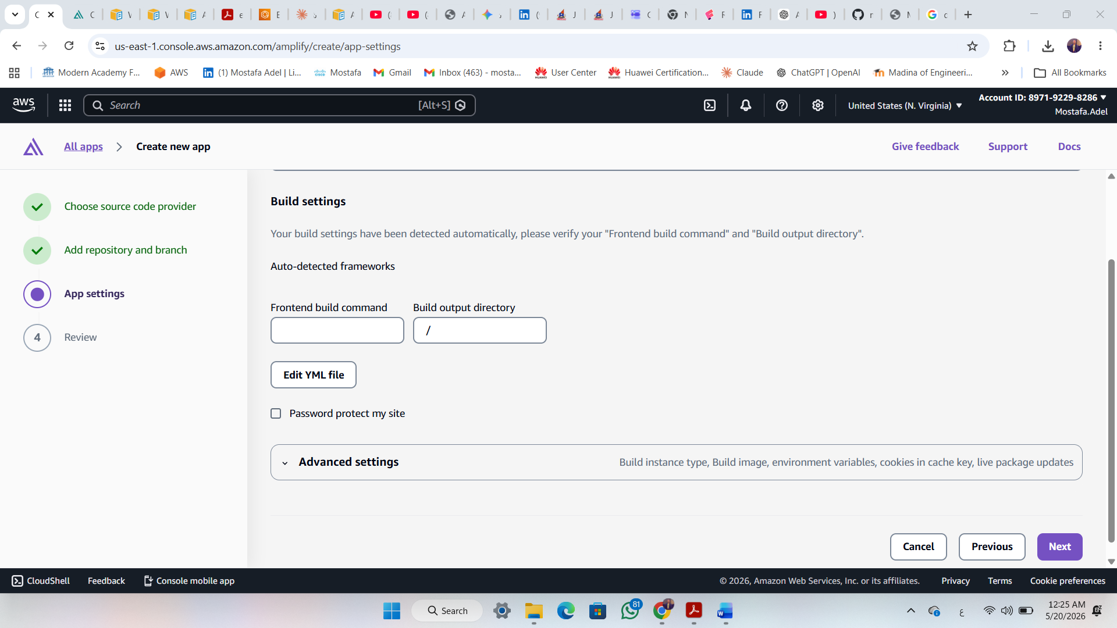
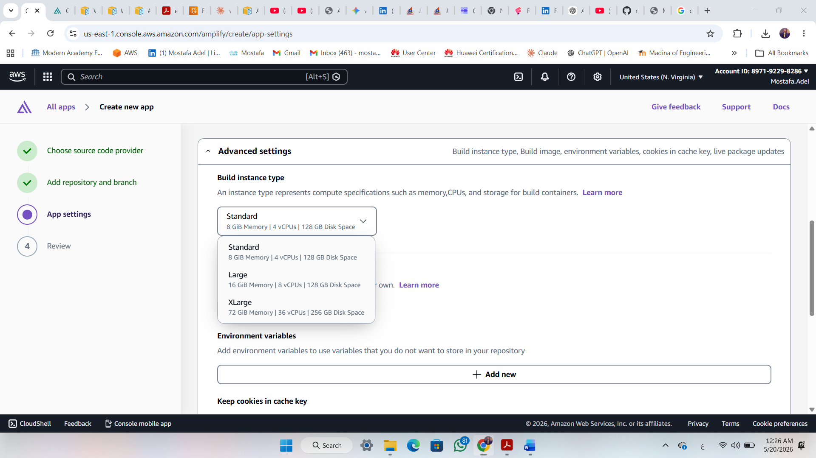

Step 3: Deploy
Click 'Save and Deploy'. Amplify will provision resources, install dependencies, build your app, and deploy it to a live URL in the format: https://main.d1abc.amplifyapp.com
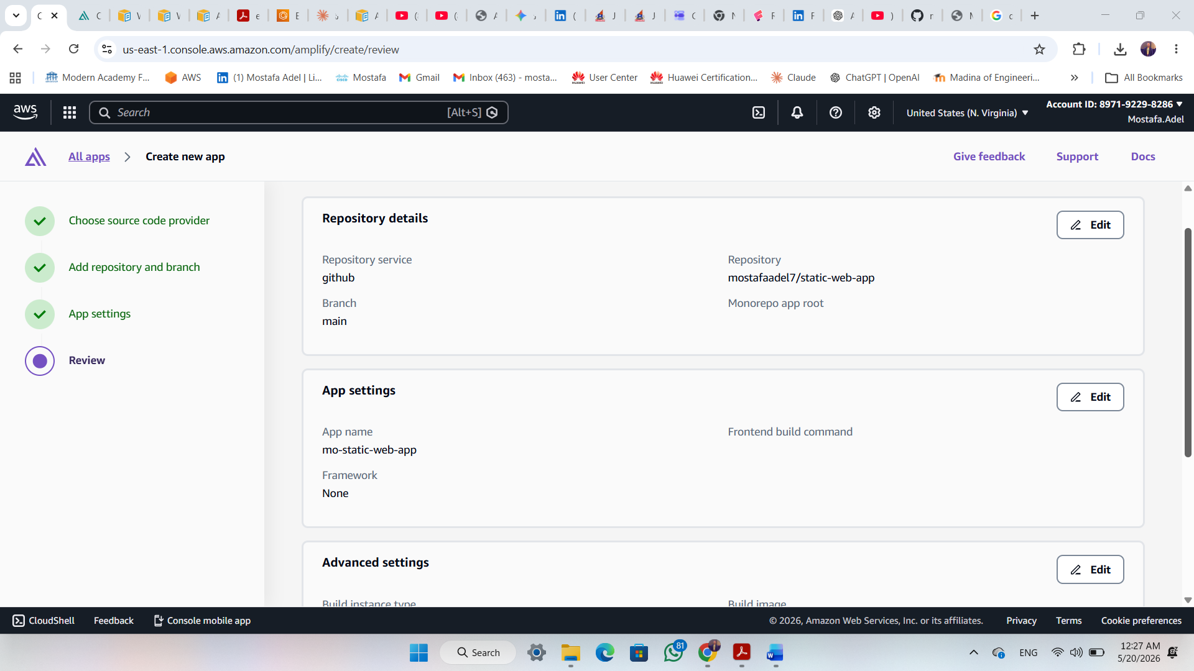
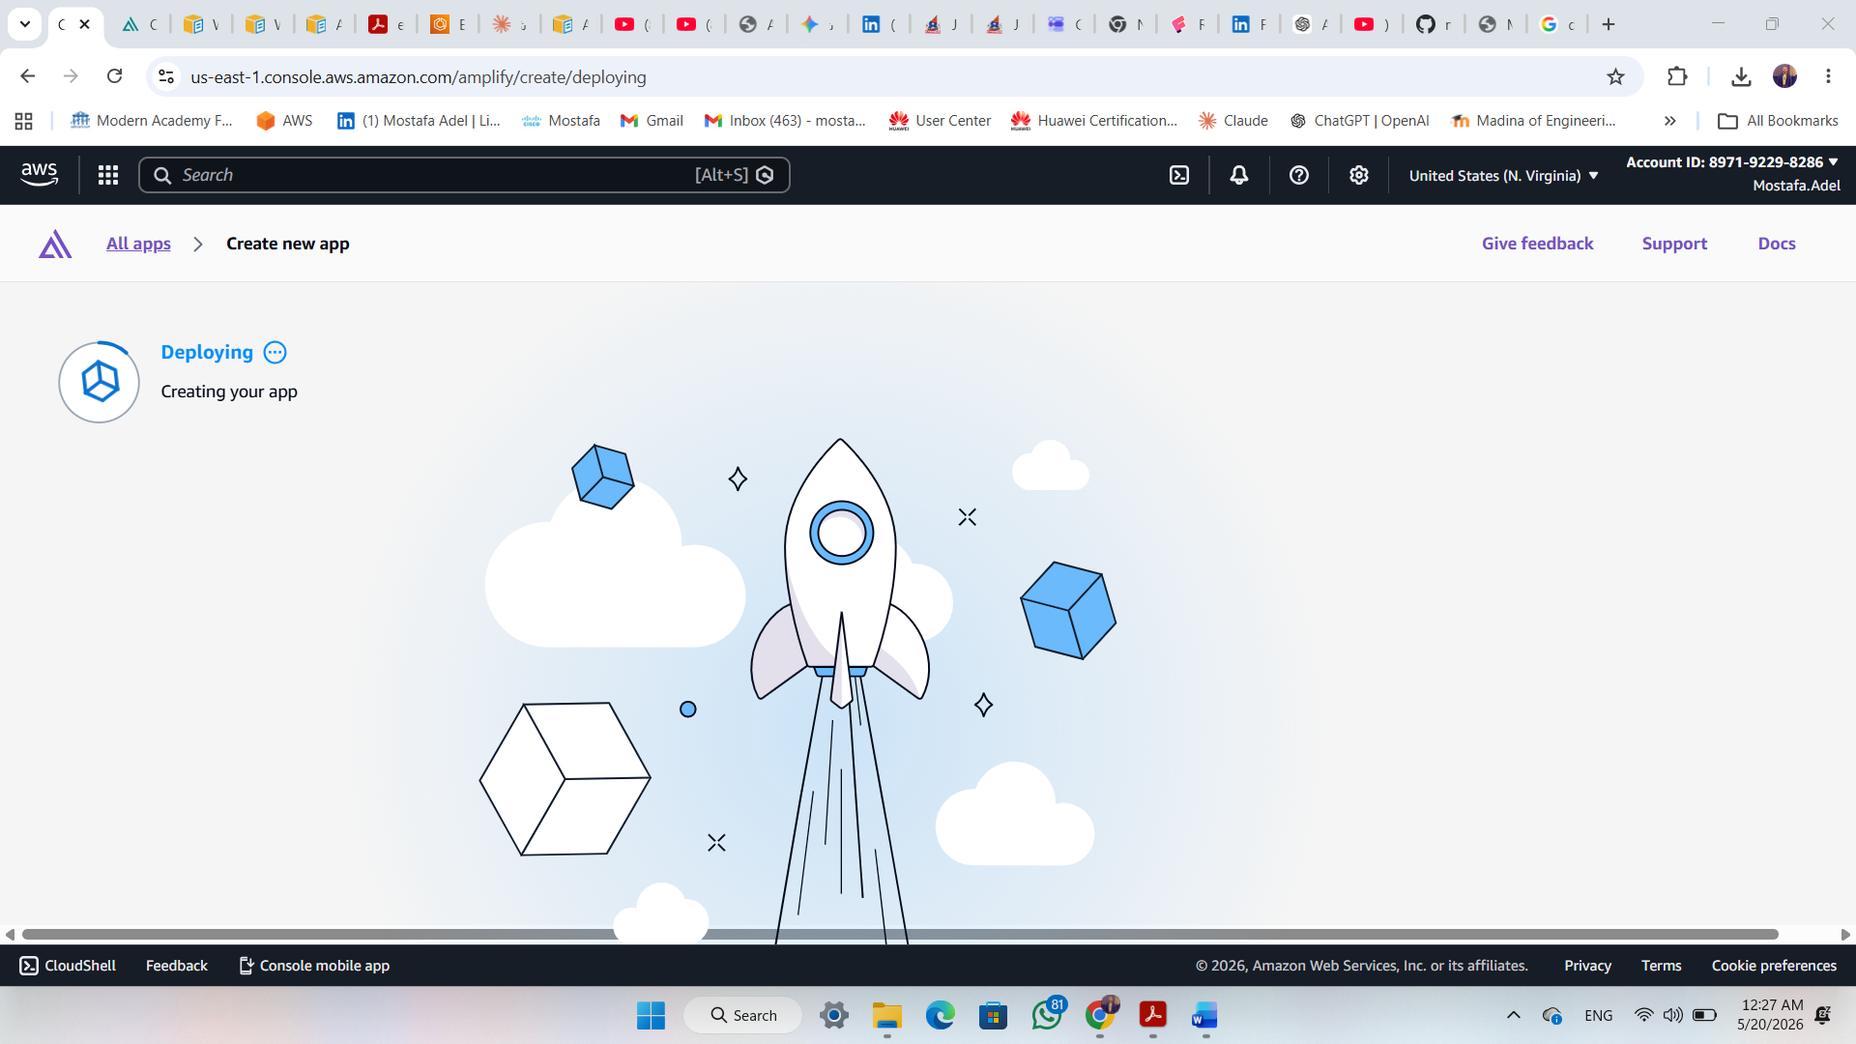

Step 4: Add a Custom Domain (Optional)
In the Amplify Console, go to Domain Management and add your custom domain. Amplify will guide you through DNS configuration and automatically provisions an SSL certificate.

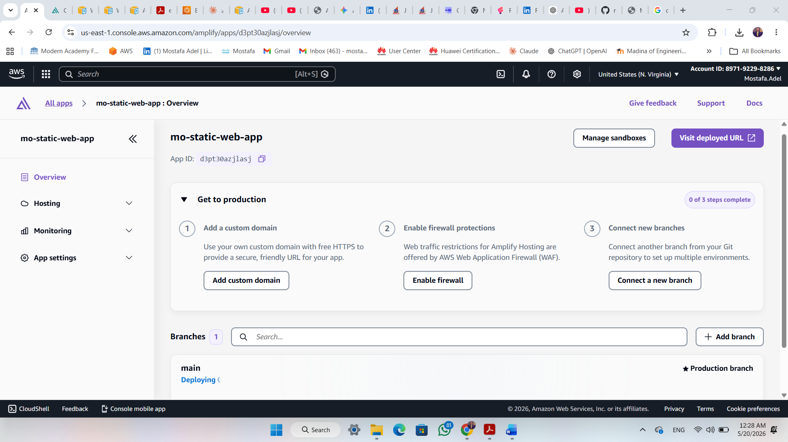
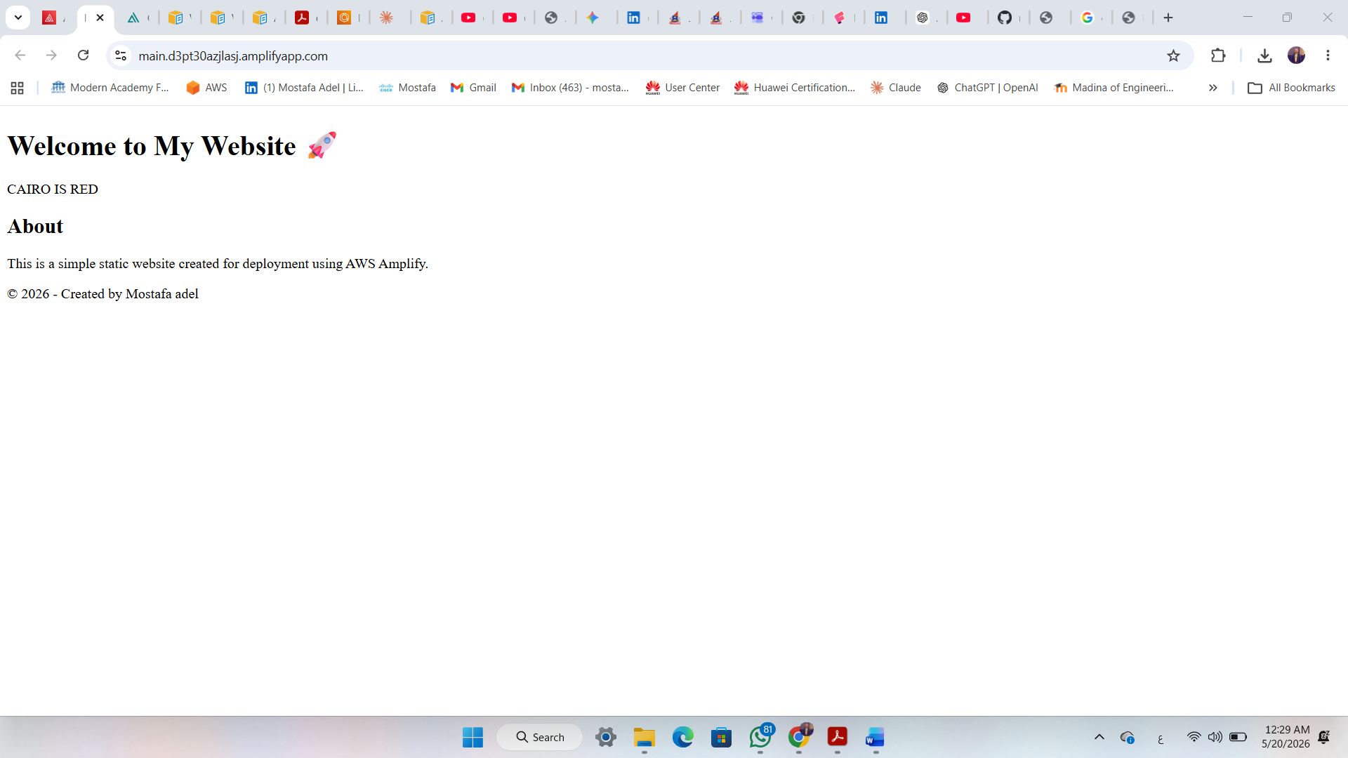
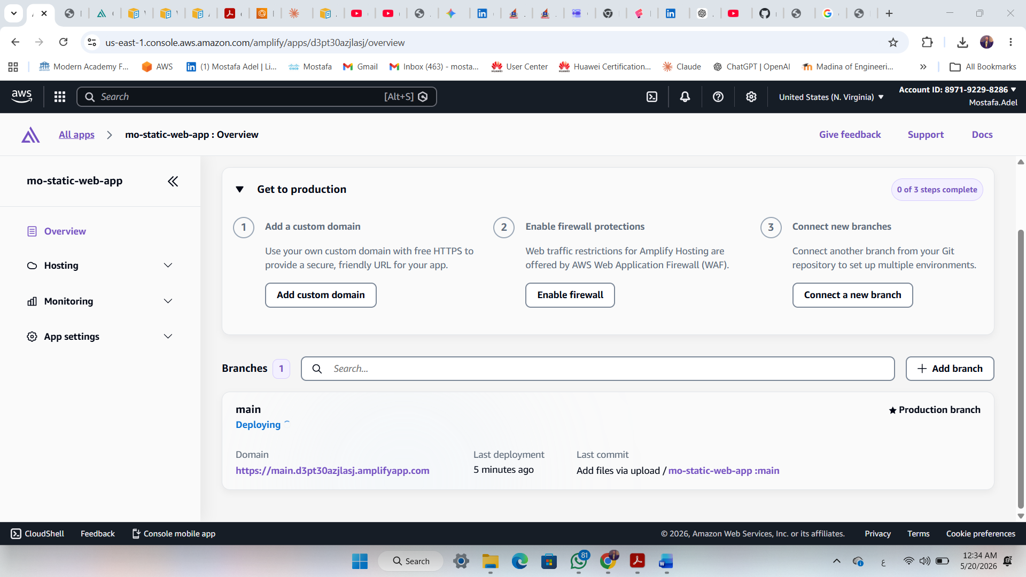

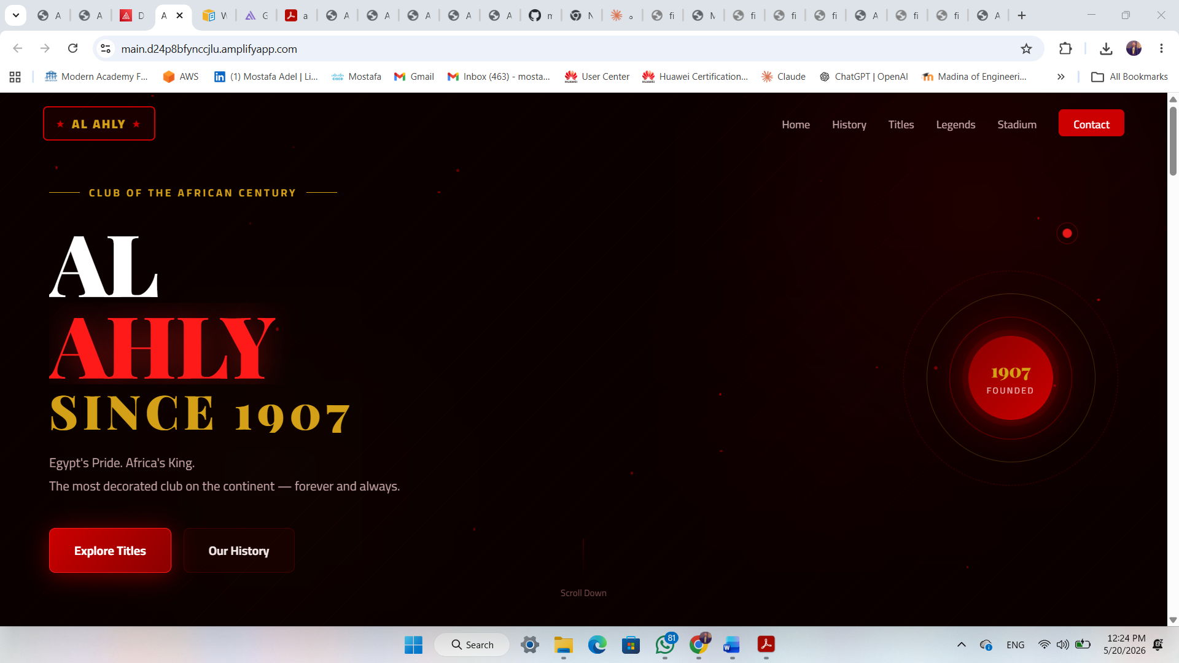

5. Important Concepts

Concept | Description
amplify.yml | YAML file in your repo root that defines build and deploy commands for each branch
Environment Variables | Key-value pairs stored securely in Amplify and injected at build time
Build Instance | The server that runs your build — you can choose the size (CPU/RAM) for large projects
Automatic Deployment | Site only updates after the full build succeeds — no partial or broken states
CDN (CloudFront) | Amazon's global content delivery network that serves your app with low latency
Service Role (IAM) | An AWS role that grants Amplify permission to create backend resources on your behalf
PR Preview | Automatic preview URL created for every pull request — deleted after the PR closes
Feature Branch | Each branch in Git gets its own isolated deployment environment and URL

6. Pricing Overview
Amplify Hosting pricing is based on three components:

Component | What You Pay For | Free Tier
Build & Deploy | Per build minute consumed | 1,000 minutes/month
Hosting (Storage) | GB stored per month | 5 GB/month
Data Transfer (CDN) | GB served to end users | 15 GB/month

7. Monitoring and Logs

CloudWatch Metrics
Amplify sends metrics to Amazon CloudWatch automatically. You can monitor:
- Number of requests per domain
- 4xx and 5xx error rates
- Bytes downloaded
- Build duration

Access Logs
Retrieve detailed access logs for your app to analyze traffic patterns, identify errors, and monitor performance.

CloudTrail
All Amplify API calls are logged in AWS CloudTrail for auditing and security compliance.

8. Security Best Practices
- Use Environment Variables for all API keys and secrets — never hardcode them
- Enable AWS WAF (Firewall) for production apps to block malicious traffic
- Password-protect staging branches to prevent unauthorized access
- Use IAM Service Roles with least privilege permissions
- Enable PR Previews only for trusted collaborators
- Regularly rotate secrets stored as environment variables

