# Installing Steps (CVAT)

## Prerequisite

1. Install Docker Desktop.
2. Install wsl2 and check if default version is 2 : open power shell as administrator: wsl --set-default-version 2

## Basic installation

Guide: https://openvinotoolkit.github.io/cvat//docs/administration/basics/installation/#windows-10

1. Open cmd in Admin mode
2. Run command: git clone https://github.com/opencv/cvat
3. Then: cd cvat
4. Then: docker-compose up -d

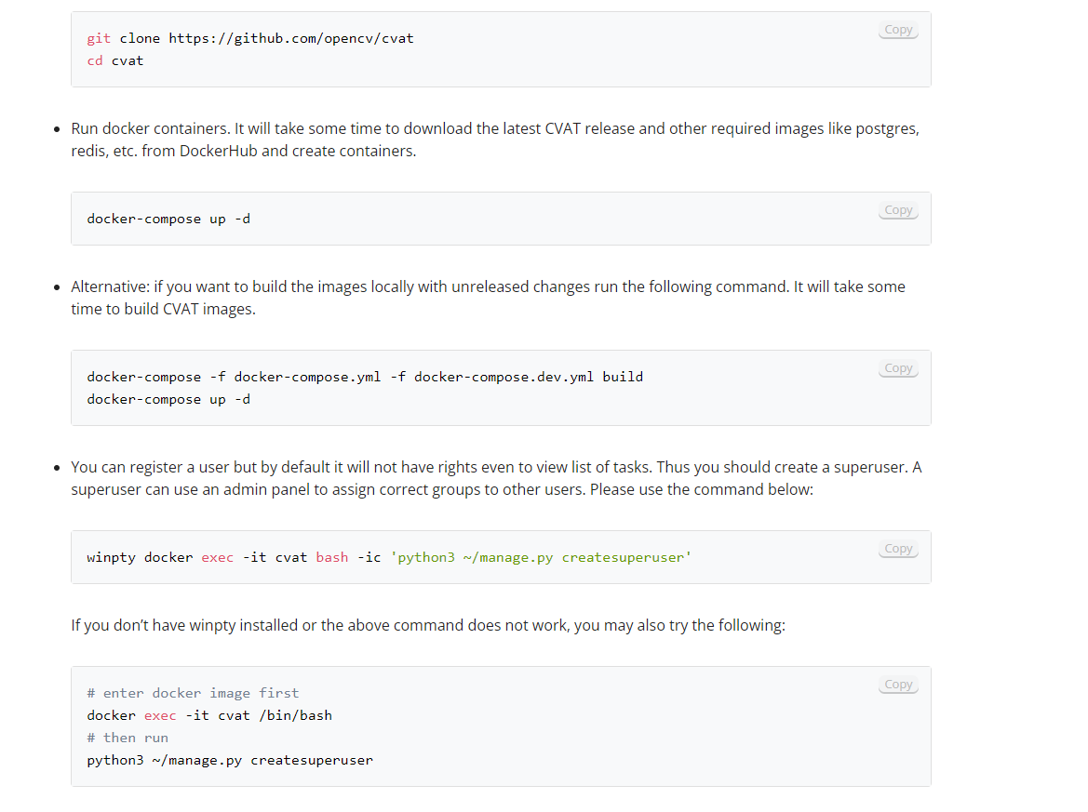

## Adding Auto annotation

1. In cmd run : docker-compose down
2. Then : docker-compose -f docker-compose.yml -f components/serverless/docker-compose.serverless.yml up -d

## Adding model to serverless function using nuclio

1. Firstly you need to install ubuntu on windows

A – open control panel 🡪 Programs and features 🡪 Turn on and off windows features

🡪 enable virtual machine platform.

B –same window 🡪 enable windows subsystem for linux

1. Open PowerShell and run this command to set WSL2 as the default version Run : wsl --set-default-version 2.
2. Go to Microsoft Store App on your PC and search for Linux “ubuntu” and download it.

-now we have ubuntu in windows

Guide:

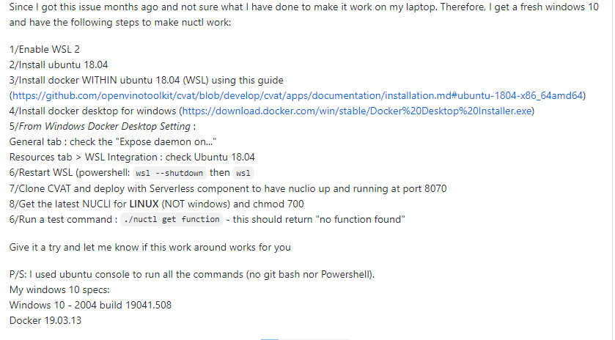

1. Check docker is down
2. Run command : docker-compose -f docker-compose.yml -f components/serverless/docker-compose.serverless.yml up -d
3. Then : wget [https://github.com/nuclio/nuclio/releases/download/<version>/nuctl-<version>-linux-amd64](https://github.com/nuclio/nuclio/releases/download/%3cversion%3e/nuctl-%3cversion%3e-linux-amd64)
4. Then : sudo chmod +x nuctl-<version>-linux-amd64
5. Then :sudo ln -sf $(pwd)/nuctl-<version>-linux-amd64 /usr/local/bin/nuctl
6. Then: nuctl create project cvat
7. Then : nuctl deploy --project-name cvat \

--path serverless/openvino/omz/public/yolo-v3-tf/nuclio \

--volume `pwd`/serverless/common:/opt/nuclio/common \

--platform local

Path: is path of serverless function

version is 1.5.16

Notes:

## Adding Analytics

1. In cmd run : docker-compose down
2. docker-compose -f docker-compose.yml -f components/analytics/docker-compose.analytics.yml build.

# Problems and solution:

1. ubuntu doesn’t work “The Windows Subsystem for Linux instance has terminated”🡪 set wsl version for ubuntu to 1 then 2 So Run Following command:
2. wsl --set-version Ubuntu-18.04 1
3. wsl --set-version Ubuntu-18.04 2
4. docker-compose problem 🡪 restart docker desktop and disable compose version 2

# our sequence

1. Install Docker Desktop.
2. Install wsl2 and check if default version is 2 : open power shell as administrator: wsl --set-default-version 2.
3. Install ubuntu 🡪set version to wsl2.

## In ubuntu

1. Run command: git clone https://github.com/opencv/cvat
2. Cd cvat
3. docker-compose -f docker-compose.yml -f components/serverless/docker-compose.serverless.yml up -d
4. wget <https://github.com/nuclio/nuclio/releases/download/1.5.16/nuctl-1.5.16-linux-amd64>
5. Then : sudo chmod +x nuctl-1.5.16-linux-amd64
6. Then :sudo ln -sf $(pwd)/nuctl-1.5.16 -linux-amd64 /usr/local/bin/nuctl
7. Then: nuctl create project cvat
8. Then : nuctl deploy --project-name cvat \

--path serverless/openvino/omz/public/yolo-v3-tf/nuclio \

--volume `pwd`/serverless/common:/opt/nuclio/common \

--platform local

# Last update

1-now I have problem in auto annotations :server error to refer to api in nuclio .

Potinetial solution: https://github.com/nuclio/nuclio/issues/2158

