Team member:

1. محيى الدين احمد فتحى
2. مصطفى على محمد على
3. معاذ عبده عبدالله عفيفى
4. مصطفى اشرف مامون
5. مصطفى صابر الدندراوى
6. مصطفى عبدالمحسن حسنين

Project name

***Flight reservation system***

Documentation

1)

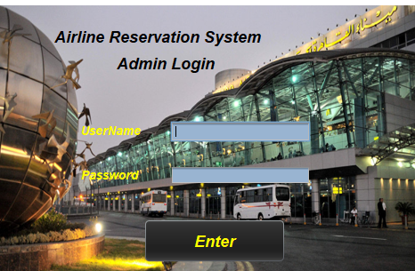

Enter button:

Making login to the program and open the main form

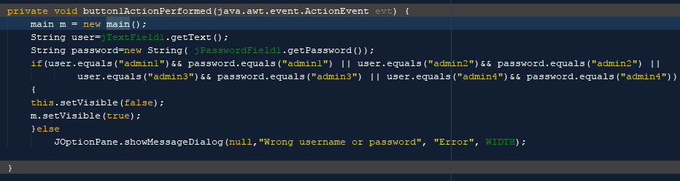

The main form :

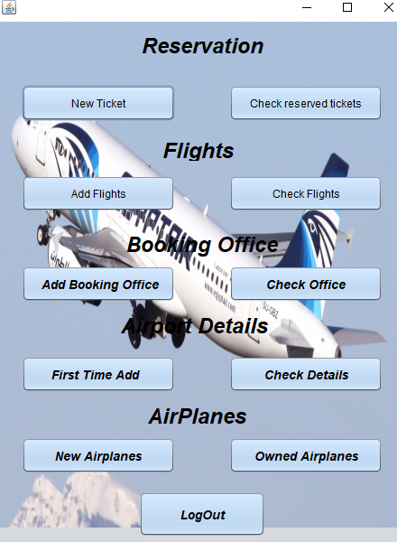

2)

Logout button:

Return to the first form (login );

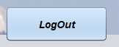

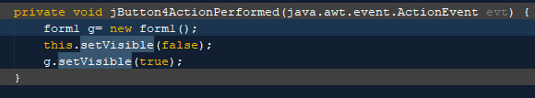

3)

New ticket

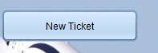

Used to reserve new ticket that contain (person full name, age , email, address , light select and gender , etc in image )

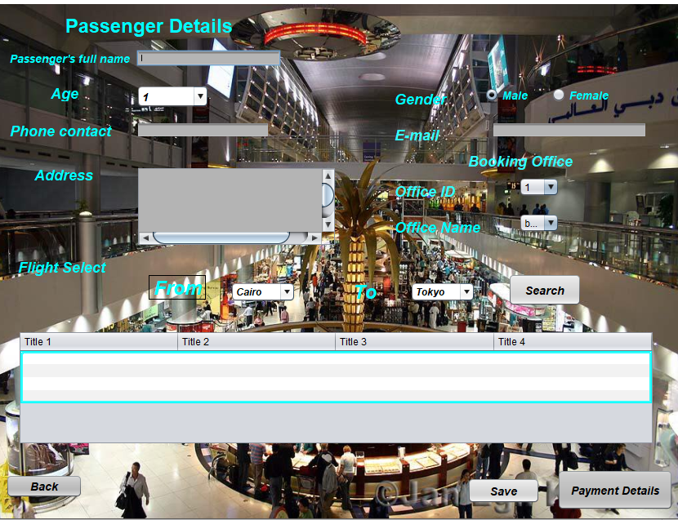

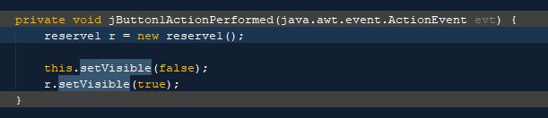

4) 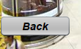

Back button:

Use to return us to main form

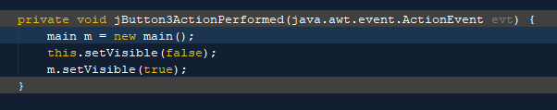

5)payment details is used to show details of passenger



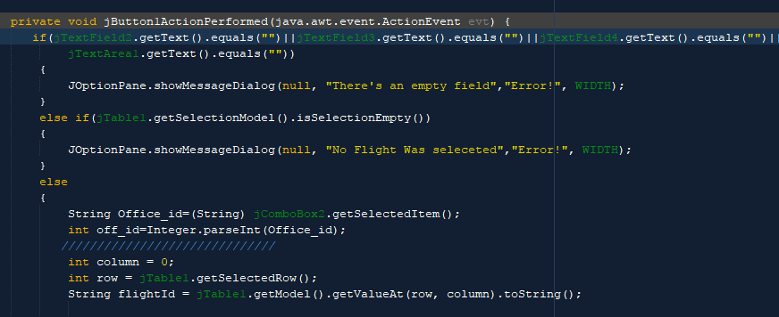

6) 

Check reserved button: is used t show the details of ticket

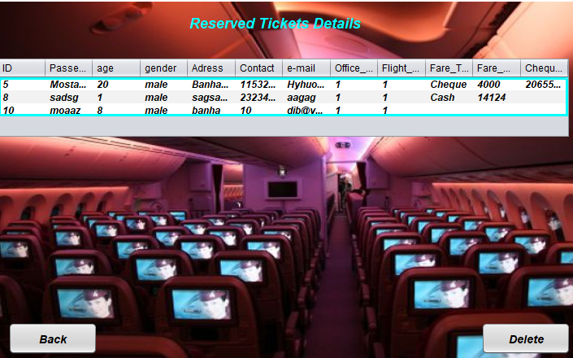

7)delete :is used to delete some details of ticket, you select the row that you want to delete and click on delete button

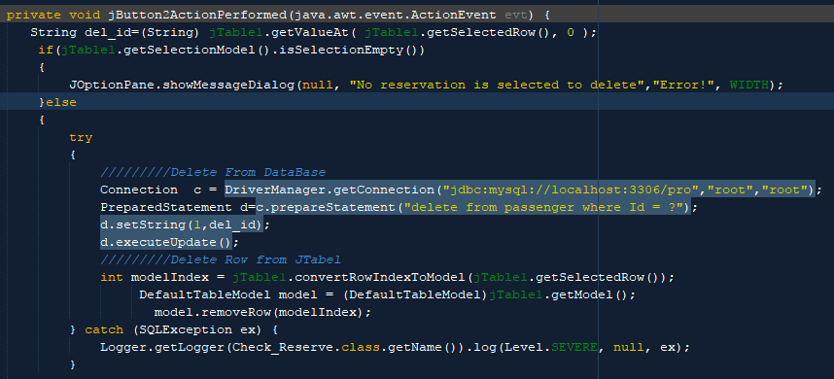

8)add flight:



Is used to add anew flight that contain(flight id,class,from,etc).

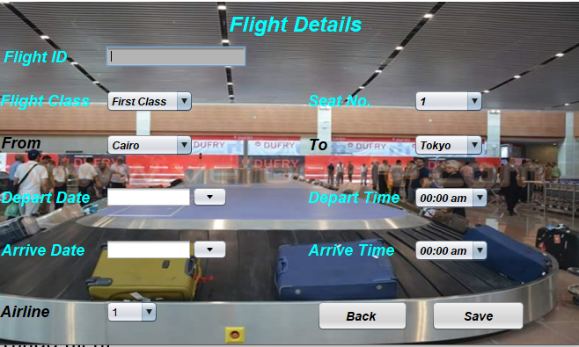

9)Check flight 

Is used to show details of the new flight

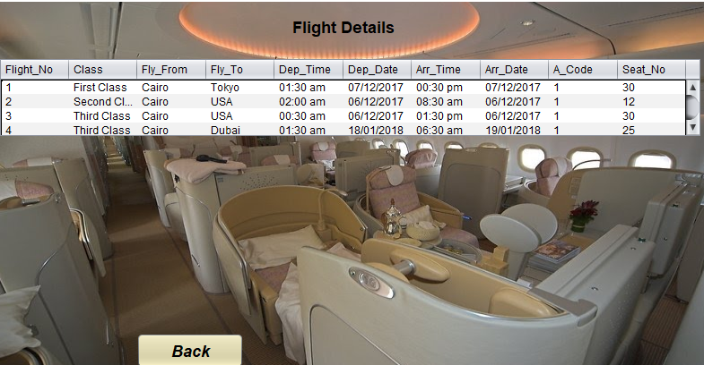

10) Add booking office 

Is used to add a new book office (that conatin office_ID and office name).

1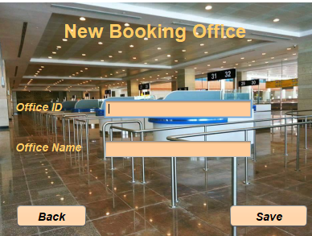

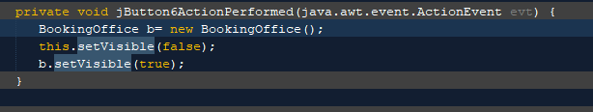

11) 

Is used to show the details in booking office

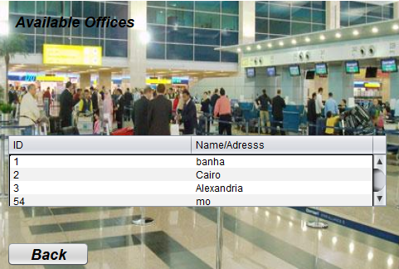

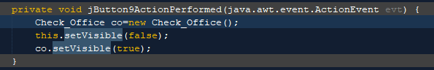

12) first time add 

Is used to let us the data of airline (code and the name) and airport (code , name , country and city).

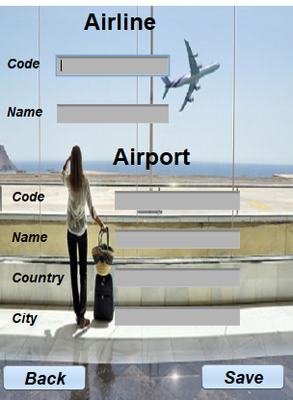

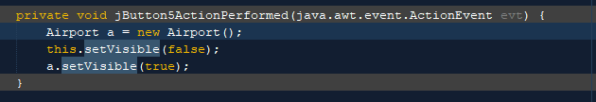

The save button make a connection between java and mysql database. 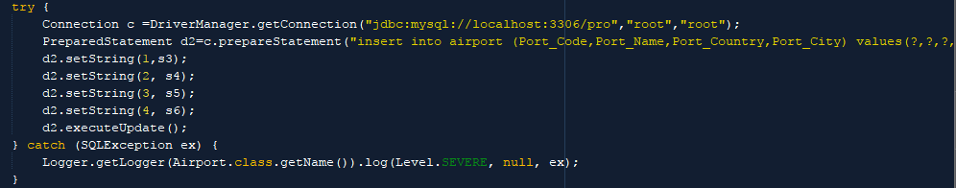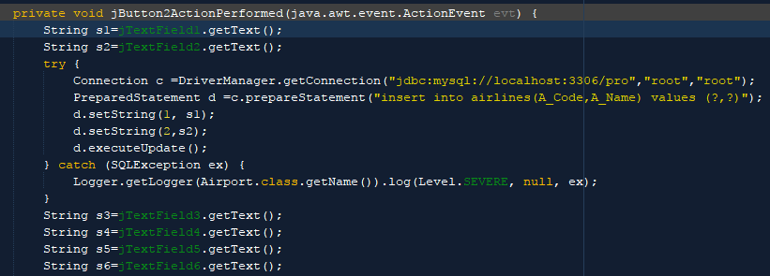

13)check details button :

Is used to to show the details of air port(code , name , country and city).

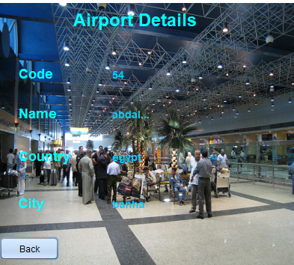

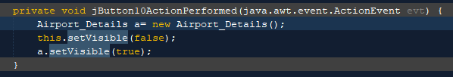

14)new airplanes buttons: is used to add new airplanes.



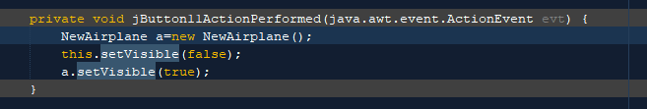

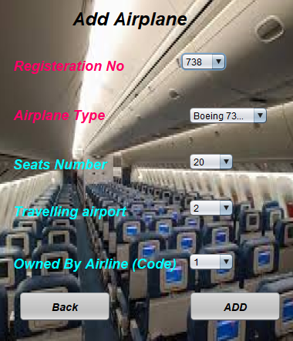

15) owned airplane : is used to show details of airplanes



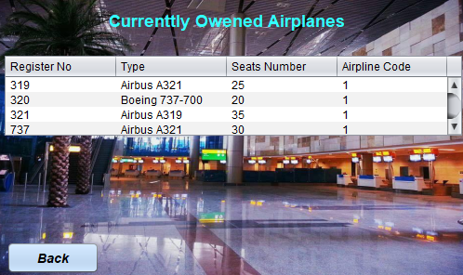 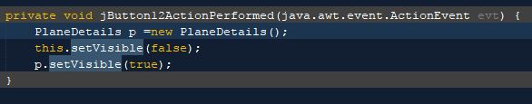

16)payment details button is used to show details of reserving.



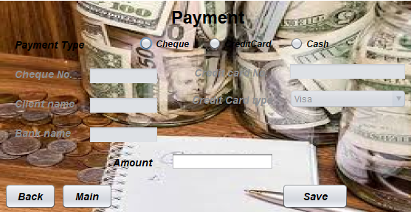

This is payment form that include (Cheque , credit card and cash) .