Pharmacy Management System

Software Requirements Specification

Documentation

Version: 1.0 date: 15/4/2022
Index:
Section | Page
1.0 Project Description | 2
2.0 System Requirements Specification  2.1 User Login/Logout  2.2 Add New Product  2.3 Update/delete Product  2.4 Sales Property  2.5 Sales Review  2.6 Add employee  2.7 User Review  2.8 Change Password | 3  3  3  4  4  5  5  6  6
3.0 User requirements  3.1 Functional Requirements  3.2 Use case to describe the functions requirements  3.3 Use case description  3.4 Nonfunction requirements | 7  7  7  8  8
4.0 Class Diagram | 10
5.0 Database Specification | 11
6.0 System Architecture | 11
7.0 Sequence Diagrams | 12
8.0 Communication Diagrams | 16

1.0 Project Description:
Pharmacy Management System project is computer-based software developed for managing, monitoring and recording various activities of medical stores. It plays a key role in improving the productivity of medical stores through automated functions. It also helps to overcome the manual pharmacy management issues.
Pharmacy Management System will manage record of all medicines, adding, updating, or deleting products, sales properties, sales review, user review, adding employees and other important details.
Admin can use the Pharmacy Management System program to help them methodically manage their pharmacies. When a cure’s name is input, the Pharmacy Management System can help by providing details about the medicine. A computer displays information about the medicine, such as its tabs numbers and expiration date. In large medical stores, manually handling the specifics of all the cures becomes very tough. We can keep track of all the medicines by using this pharmacy management system. It is updated with new information as new medicines are introduced, and it includes an expiration date as well as a search option.

Use Case Name | New Product
Trigger | The User Shall Be Able to add new product (cure)
precondition | The user should have logged in the system
Basic path | 1. User click on the new product button  2. User adds information about the cure  3. Cure data will be submitted in the database and will be shown on screen
Alternative Path | In step 2, If all the cure information is not complete, then the cure won’t be submitted in database
postcondition | The product submitted successfully in database
Exception Paths | The User Can Clear the information in the text fields before submit
Other | The Cure information contain: cure code, cure name, company name, distributor name, distributor number, amount, tabs number, exp date, retail price, total price.
2.0 System Requirement Specifications:
2.1 User Login/Logout
Use case Name | Login/Logout
Trigger | The User login/logout to the system
precondition | The User Accessed the login page ( in case: login)  The User Should be logged in the system ( in case: logout)
Basic path | 1.the User clicks on login button and add his information( in case: login)  The User Clicks on logout button and press confirmation button  ( in case: logout)  2.The User Be Able to add product, Search for product, and Do Most Functions in the App ( in case: login)
Alternative Path | In case login, the employees data is not found in database  In case logout, the employee cancels the logout and returns back to the home page
postcondition | User is logged in to system
Exception Paths | User didn’t fill the text fields
Other | the new User Information is User SSN, Name, Gender, Birth date, Address, Phone Number, New Password, Salary, Position( Doctor/Employee).

2.2 Add New Product
2.3 Update/delete Product
Use Case Name | Update & delete product
Trigger | Delete & update Product
precondition | 1. The user should have logged in the system
Basic path | 1.The User clicks on update/delete button  2.User search by name/code  3.User can update/delete Product information  4. Product data will be submitted in the database and will be shown on screen
Alternative Path | In Step 2, If the product is not existed in the database, it will display an error message
postcondition | The product is updated/deleted from database

2.4 Sales Property
Use Case Name | Sales Property
Trigger | Make new bill to customer
precondition | User adds bill details
Basic path | 1. User insert information about cure  2. All data of cure will be retrieved from database  3. Display the price of bill
postcondition | The bill is ready
Other | Bill contains: cure code, cure name, amount, taps number, retail price, total price.

2.5 Sales Review
Use Case Name | Sales Review
Trigger | Search is accessed by admin with date
preconditions | 1. The admin should have logged in the system
Basic path | 1. The admin search for sales review by date  2.Display sales review  3.Admin can delete sales review of specific date
Alternative Path | In case 1, If admin enters an invalid date, displays error message
Postcondition | Display sales review

2.6 Add employee
Use case Name | Add employee
Trigger | Admin adds an employee to the system
precondition | 1. The admin should have logged in the system
Basic path | 1.Admin Click on add employee button  2.Admin adds the employees information  3.Submit the changes into database
Alternative Path | in Case 2, If employee information is not complete, then the cure won’t be submitted in database
postcondition | Employee will be added to database ( update/delete )

Use Case Name | User Review
Trigger | Show employees status
precondition | The admin should have logged in the system
Basic Path | 1.Admin clicks on user review  2.Admin search for employees status by date  3.Admin be able to delete/refresh data  4.The system displays changes applied in database
Alternative Path | In case 2, if employee not found the system will display error message
postcondition | Employees status is displayed on the screen and can delete data or refresh after any modification
Exception Paths | In case 2, If there no employee found in the selected date, no data is shown  In case 3, If admin pressed delete and there is no data selected, prompt an alarm ( no data selected )
other | Screen components: date
2.7 User Review

2.8 Change Password
Use case name | Change Password
Trigger | User can change his password
precondition | The User should have logged in the system
Basic Path | 1.User Clicks on change password button  2.User enters username & new password  3.Changes submitted in database
Alternative Path | In case 2, if user not found the system will display error message
postcondition | Changes submitted in database
Other | Screen Component: Old password, new password

3.0 User Requirements:
3.1 Functions Requirements:
1- The user would be able to login/logout
2- The user can add new product
3- User can update & delete product
4- Admin can show sales property & sales review
5- User can show sales property
6- Admin can add employee
7- Admin can show user review
8- User can change his password
3.2 Use case to describe the functions requirements:
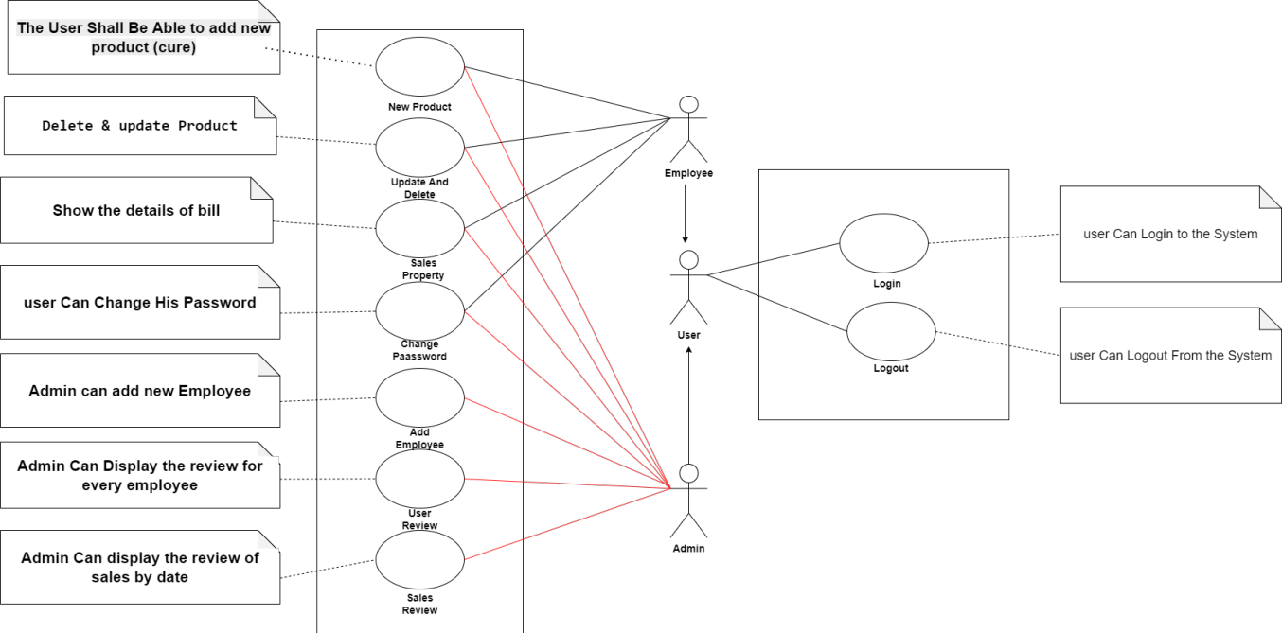

3.3 Use case description:
Identifier and name: Use-case 1
Initiator: User
Goal: User can add new product, update/delete product, view sales property, and more functions.
Main success scenario:
1 – The user login in the system.
2 – The user selects the customers products and then submit the bill.
3 – The user can manage any modification in the products ( update/delete)
4- Admin can manage the employees data ( update/delete)
Extensions:
1. The user login with invalid id or password.
2. The user already exists.

3.4 Nonfunction requirements:
1) Look and Feel:
A. The system shall have more than one theme
B. The system would have animations
2) Usability:
A. The system shall be easy to use
B. The system shall be use English language

3) performance requirements:
A. The system shall open in maximum 5 seconds
B. The system can operate in any time
C. The system shall serve more than one user in the same time
4) operational and Environment: No
5) Maintainability: The system would be modified in the future
6) security: User cannot access or modify the data of other uses

4.0 Class diagram:
1) Initial Version
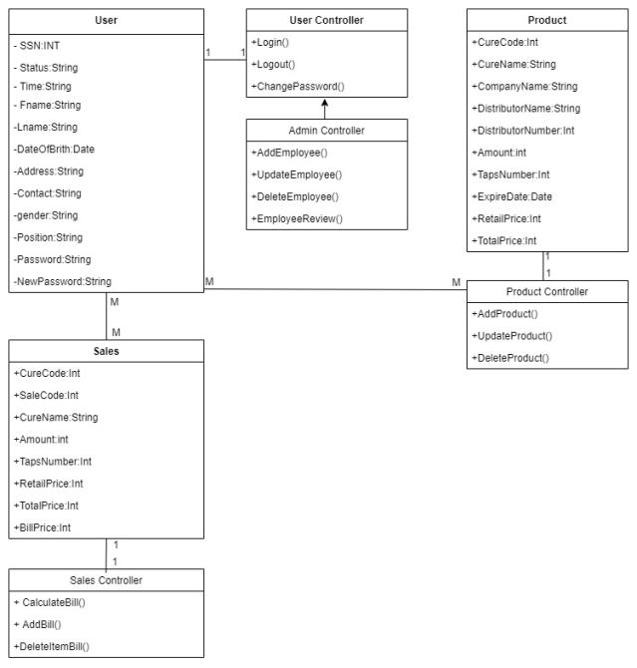

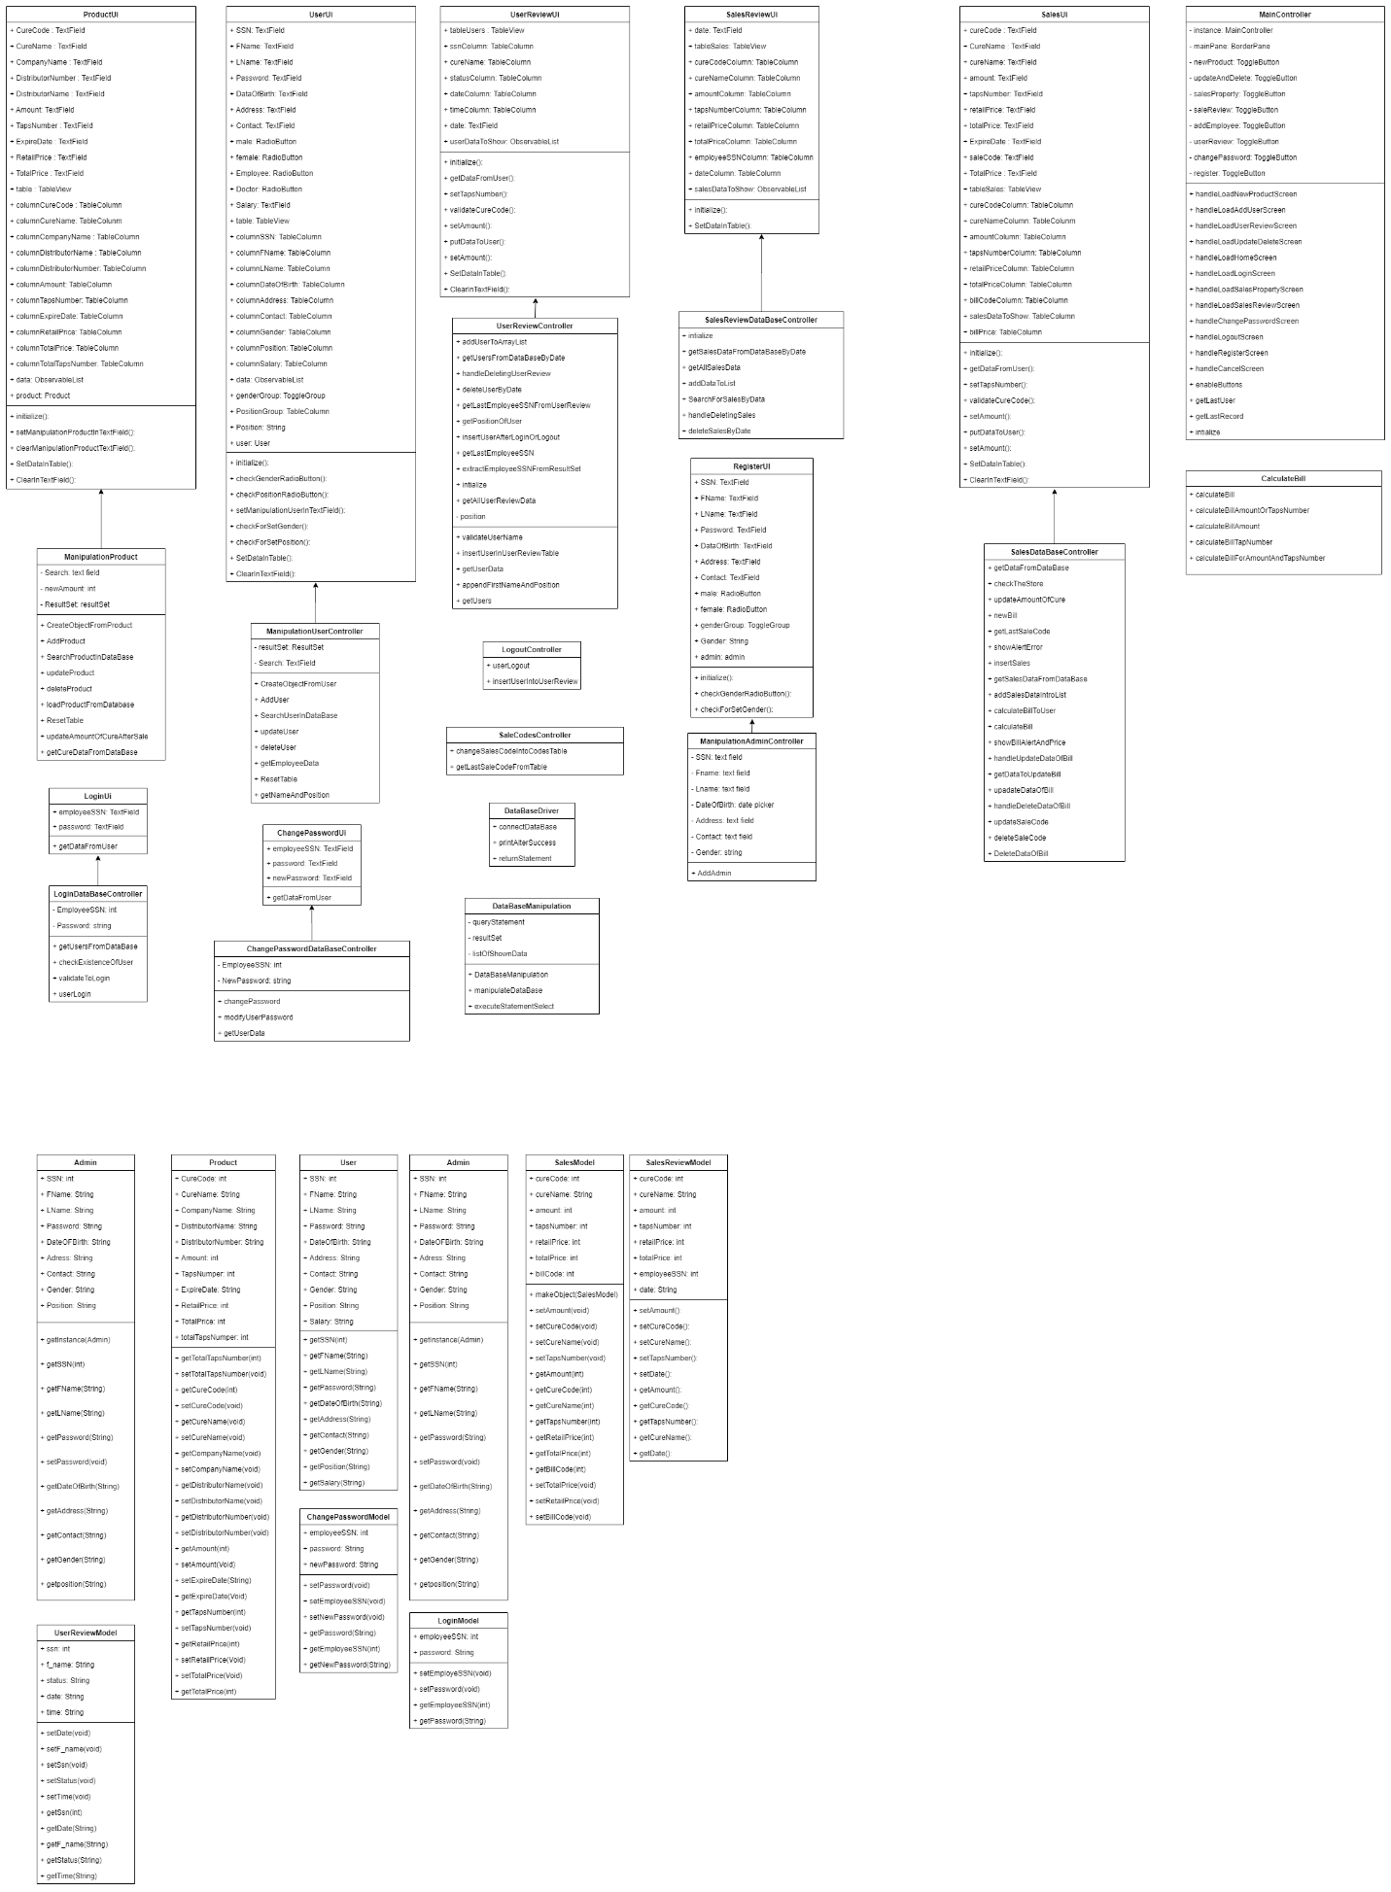

5.0 Database Specification:
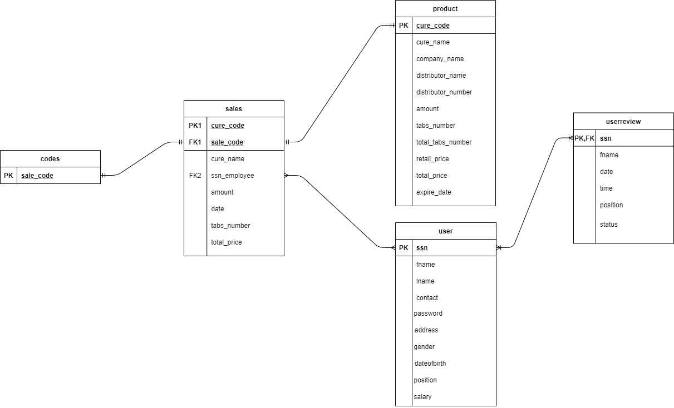
6.0 System Architecture:
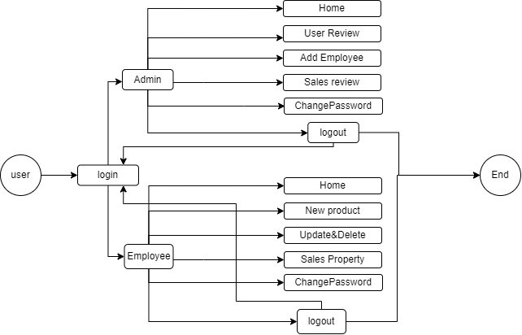
7.0 Sequence Diagrams:
1) Admin Sequence Diagram
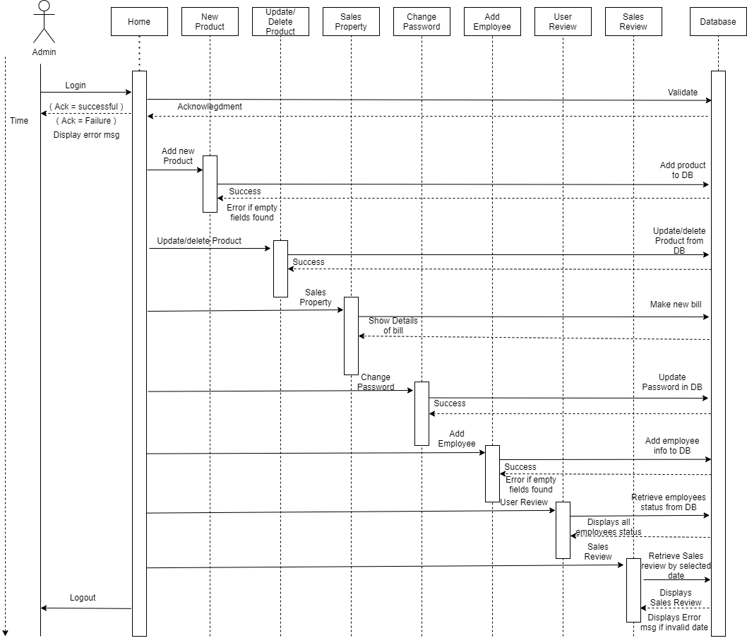

2) Employee Sequence Diagram
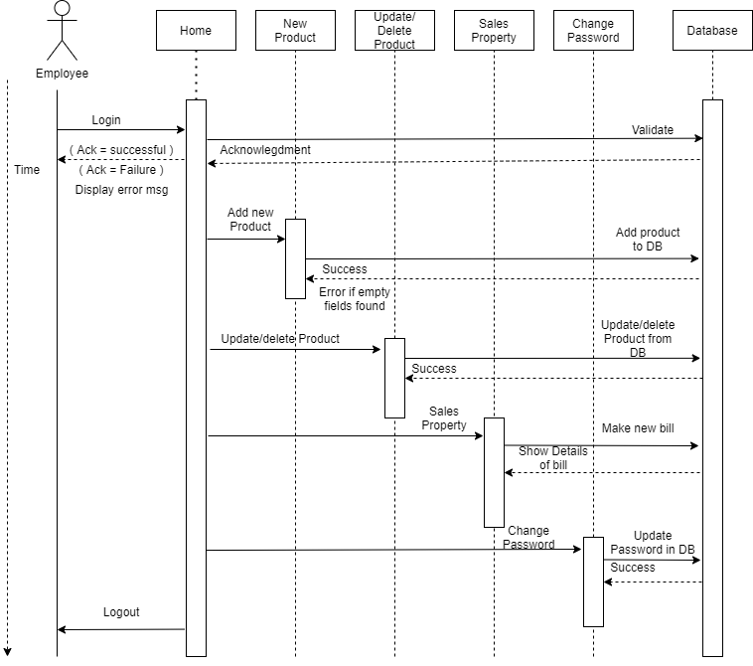

3) Owner SSD
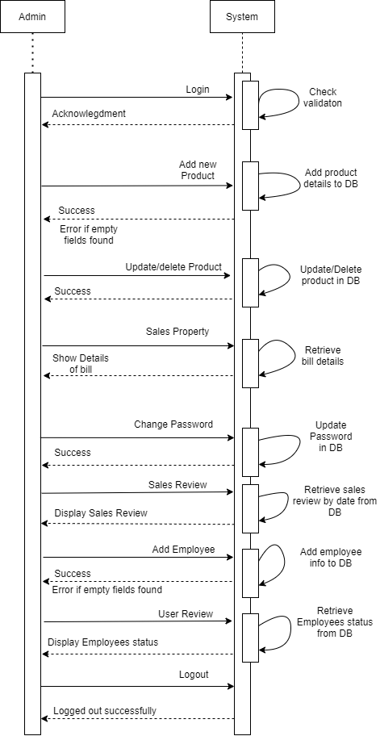

4) Employee SSD

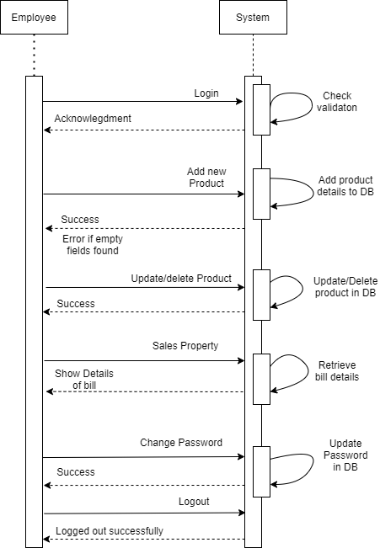

8.0 Communication Diagrams:
