Pharmacy Management System – Project Report

Course: CSA1206: Database Systems
Project Topic: 15. Pharmacy Management System

1. Problem Definition & Objectives
Problem Statement
Manual pharmacy management systems cause several operational problems, such as:
- Difficulty in tracking medicine stock and expiry dates, which may lead to financial loss
- Human errors during billing, pricing, and stock counting at the point of sale.
- Lack of a centralized database to manage medicines, customers, suppliers, doctors, and prescriptions.

System Objectives
- Centralized Data: To design a relational database that stores Suppliers, Medicines, Customers, Doctors, Orders, and Prescriptions in one system.
- Automation: To automatically update medicine stock after each sale transaction.
- Integrity: To enforce data constraints such as positive medicine prices and non-negative stock quantities.
- Reporting: To provide real-time information about total revenue and low-stock medicines.

2. User Requirements
- Inventory Management: Add, update, and delete medicine records.
- Stock Monitoring: Highlight medicines with stock less than 10 units.
- Sales Processing: Create orders, add medicines, and generate total bills.
- Prescription Tracking: Link prescriptions to doctors and customers.
- Search Functionality: Search medicines by ID or name.
- Supplier Management: Store supplier details for restocking.

3. System Design
Entities & Attributes
- Suppliers(SupplierID, CompanyName, ContactPerson, Phone, Address)
- Medicines(MedicineID, Name, Category, Price, Stock, Expiry, SupplierID)
- Customers(CustomerID, FullName, Phone, Age)
- Doctors(DoctorID, Name, Specialty, Phone)
- Orders(OrderID, OrderDate, CustomerID, TotalAmount)
- OrderDetails(OrderID, MedicineID, Quantity, LineTotal)
- Prescriptions(PrescriptionID, IssueDate, Notes, CustomerID, DoctorID)

Relationships
- Supplier – Medicine (1:M): One supplier can provide multiple medicines.
- Customer – Order (1:M): One customer can place multiple orders.
- Order – Medicine (M:N): Implemented using the OrderDetails table.
- Doctor – Prescription (1:M): One doctor can issue multiple prescriptions.
- Customer – Prescription (1:M): One customer can receive multiple prescriptions.

Relational Schema
- Medicines(MedicineID PK, Name, Category, Price, Stock, Expiry, SupplierID FK)
- Orders(OrderID PK, OrderDate, CustomerID FK, TotalAmount)
- OrderDetails(OrderID FK, MedicineID FK, Quantity, LineTotal)
- Composite PK: (OrderID, MedicineID)
- Prescriptions(PrescriptionID PK, IssueDate, Notes, CustomerID FK, DoctorID FK)

4. Normalization
To reduce redundancy and improve efficiency, the database is normalized to Third Normal Form (3NF).
First Normal Form (1NF):
- All attributes contain atomic values.
- Each table has a primary key.
Second Normal Form (2NF):
- The database is in 1NF.
- In the OrderDetails table, non-key attributes depend on the full composite key.
- Partial dependencies are eliminated.
Third Normal Form (3NF):
- The database is in 2NF.
- Transitive dependencies are removed.
- Doctor details are stored in a separate Doctors table and referenced using DoctorID in Prescriptions.

5. Implementation
SQL Implementation
- DDL: Tables are created with primary keys, foreign keys, and CHECK constraints (Price > 0, Stock ≥ 0).
- DML: Queries are implemented for inserting, updating, deleting, and retrieving data.
- Advanced SQL:
  - Joins are used to display meaningful reports (e.g., customer names instead of IDs).
  - Aggregate functions such as SUM and COUNT are used for revenue and statistics.
GUI Features (Streamlit)
- Dashboard: Displays total customers, medicines, orders, and doctors, along with low-stock alerts.
- Inventory Section: Allows adding and updating medicines with auto-fill based on MedicineID.
- Sales Section: Enables order creation, item selection, total calculation, and automatic stock update.
- Prescription Section: Allows adding and viewing prescriptions linked to doctors and customers.
GUI: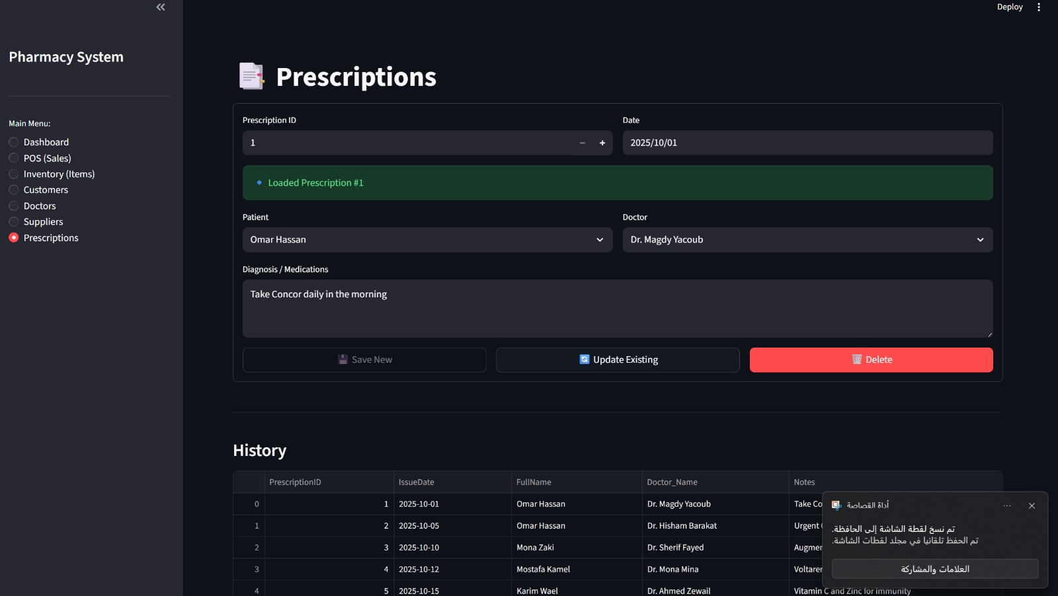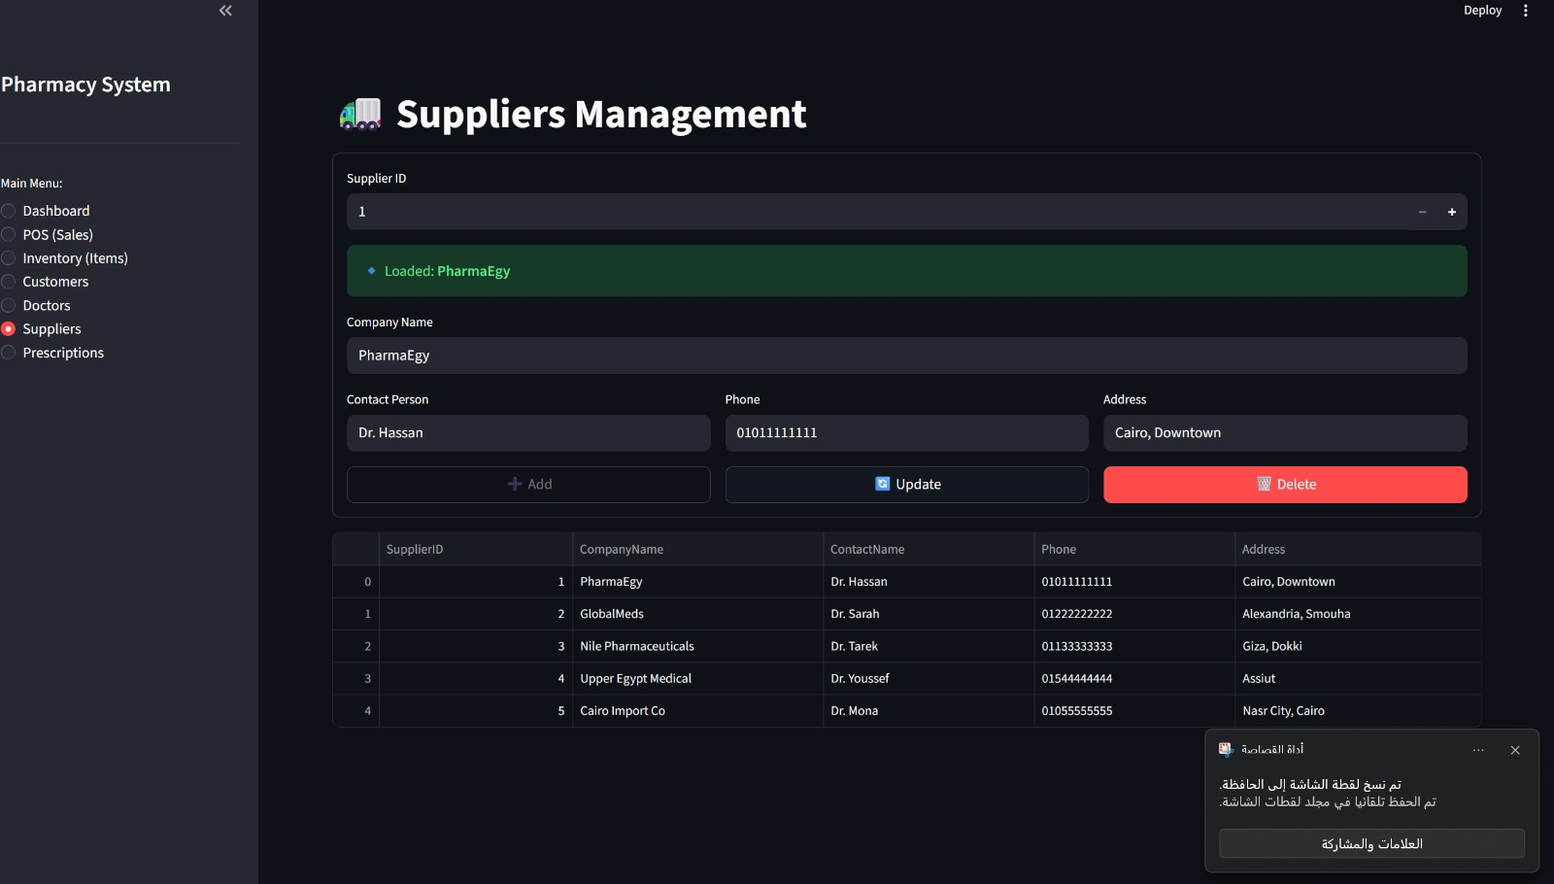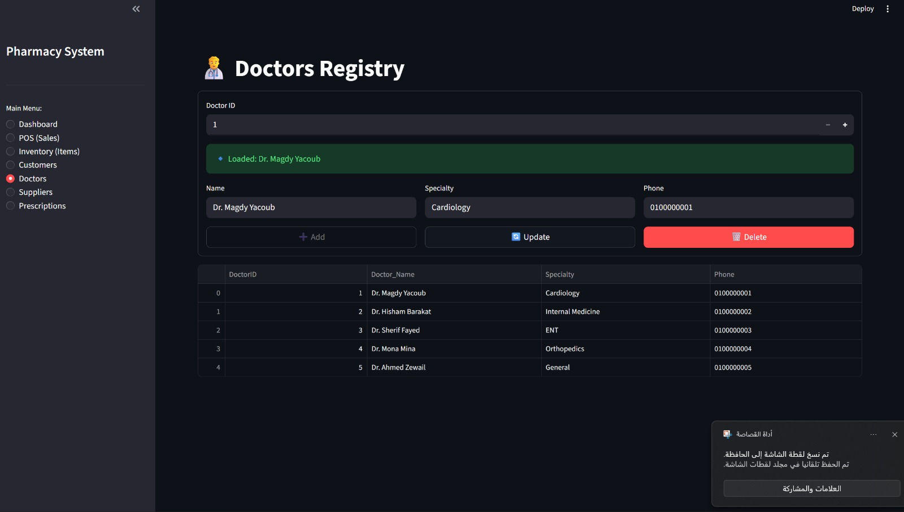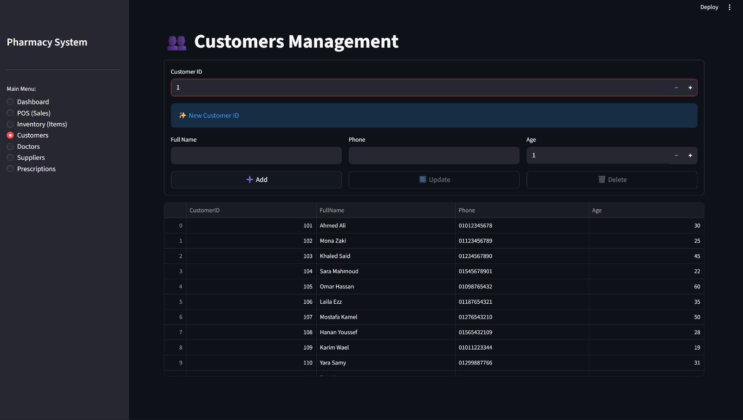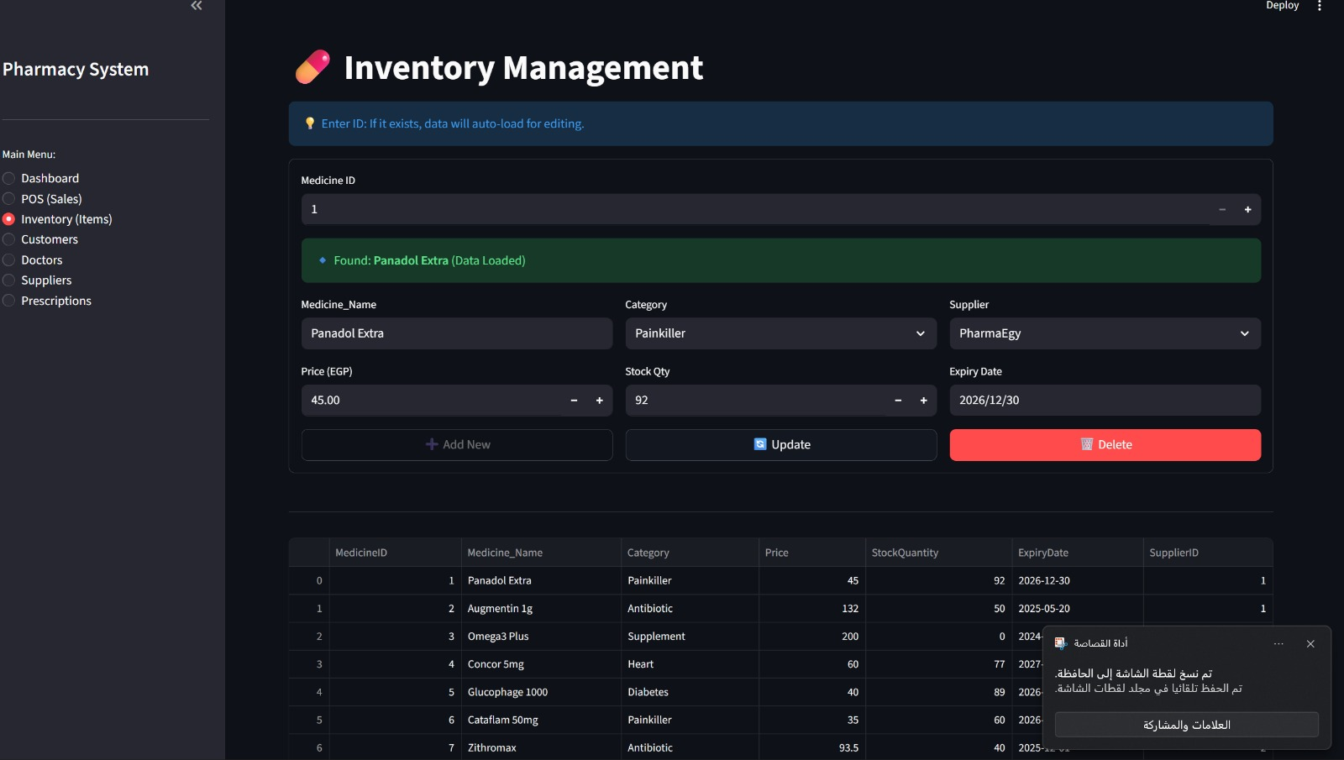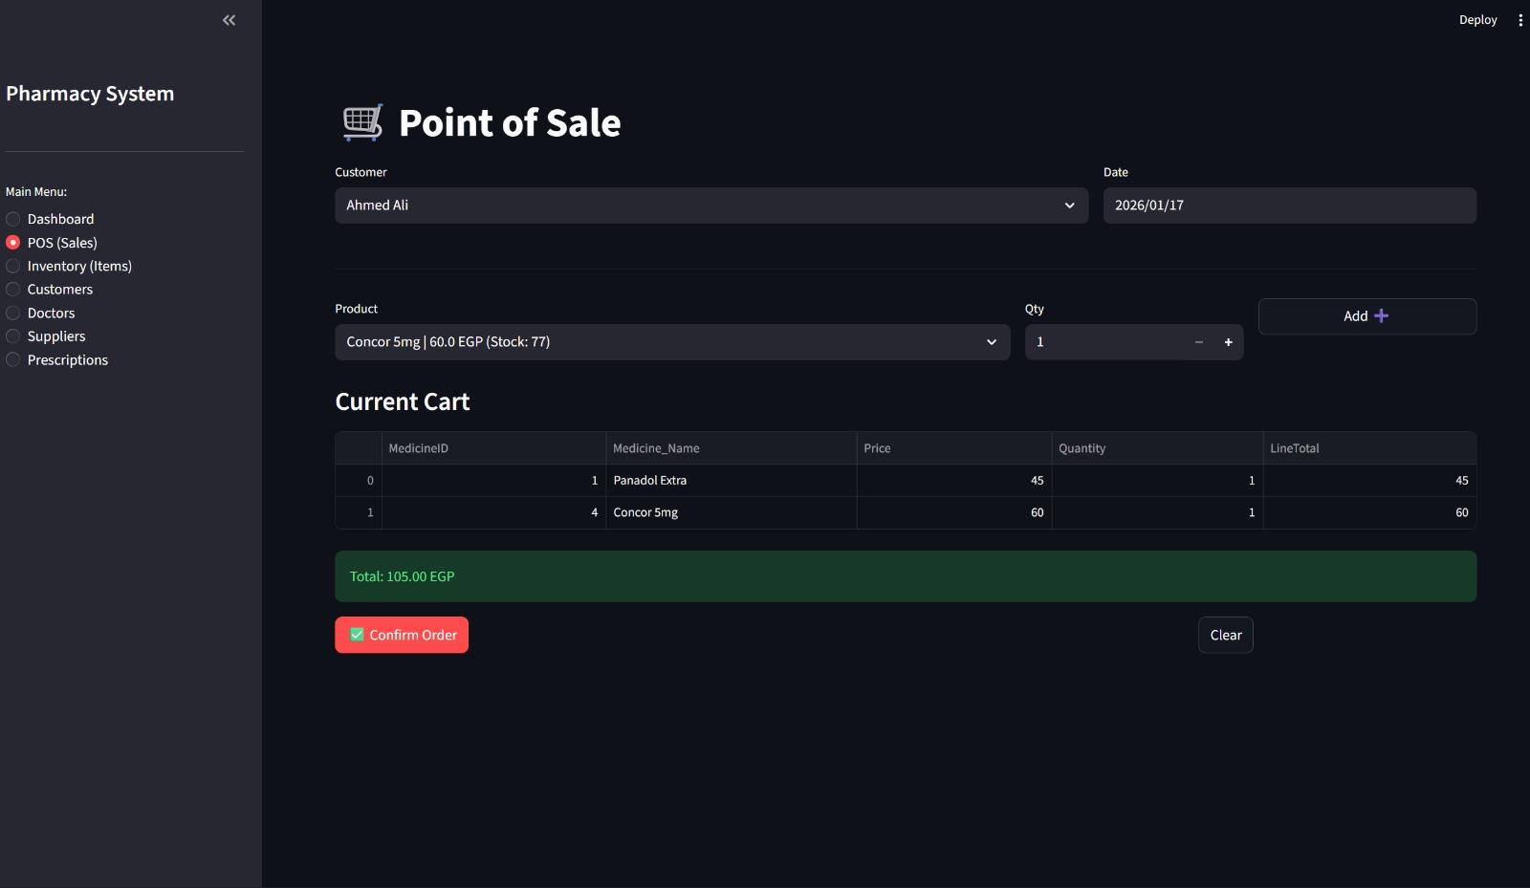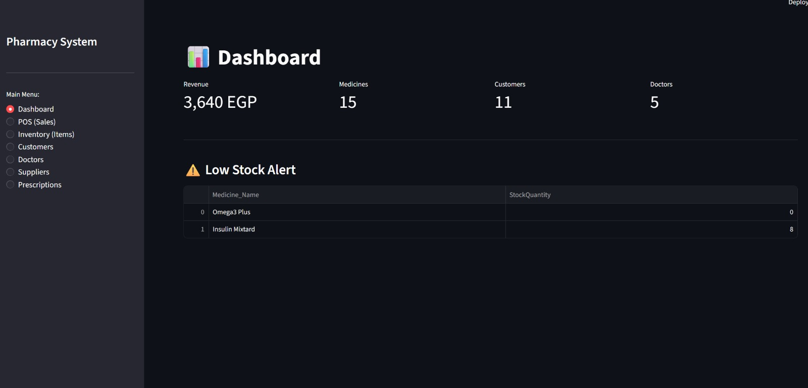

6. Conclusion
The Pharmacy Management System successfully meets the project requirements by providing a centralized and normalized database with an interactive Streamlit interface. It automates inventory tracking, sales processing, and reporting, effectively solving the problems associated with manual pharmacy management.

