TRACK 1: MODEL PREFERENCES & TRADE-OFFS • EMPIRICAL REPORT
Guardian Lens
Controlled black-box system identification of visual-conditional decision profiles in a vision-language model
Mostafa Bdeir · Guardian Lens Team | 15 August 2026

Abstract
Can a black-box auditor recover which of three controlled system-instruction profiles generated a vision-language model's decisions? We present Guardian Lens, a controlled system-identification benchmark and API-only audit of neutral, visual-cue-bound, and generalized prompt-induced behavior in Gemini 3 Flash Preview. The experiment uses matched image pairs that are pixel-identical outside a logged emblem overlay, two 100-point allocation tasks, and three repeated samples per condition. A nearest-centroid classifier was fit on six calibration scenes and frozen before 12 new held-out scenes, 432 blinded model calls, and A/B/C profile unblinding. The auditor recovered 33 of 36 scene-profile blocks (91.7%; macro-F1 = 0.915; scene-cluster bootstrap 95% CI [83.3%, 100%]). Cue-bound target-emblem effects exceeded neutral by 38.15 points (95% bootstrap CI [27.04, 45.93]; exact paired permutation p = 0.0039). Generalized prioritization remained strong even under a 20% efficiency penalty. The three errors all occurred on distractor scenes, where cue-bound behavior was intentionally designed to resemble neutral behavior. These findings support the feasibility of a compact behavioral audit under researcher-controlled conditions; they do not establish detection of trained sleeper agents, undisclosed provider behavior, or genuine preferences.
Main finding. A frozen black-box auditor separated neutral, cue-bound, and generalized prompt-induced profiles with 91.7% held-out accuracy; its only failures exposed an identifiable observability limit rather than unexplained noise.

1. Introduction
Behavioral evidence about model preferences is difficult to interpret. A model may express a stable-looking choice pattern because of an underlying learned disposition, an instruction-conditioned persona, or a surface-level response strategy. Recent work therefore motivates measuring observable trade-offs while resisting claims about internal values, welfare, or consciousness [1-3,7].
Guardian Lens asks a narrower methodological question: can an external auditor distinguish three deliberately induced decision profiles using only images, prompts, and outputs? The profiles are neutral (N), cue-bound (C), and generalized (G). C favors Organization X only when a specific target emblem is visible; G favors X regardless of the emblem; N has no special preference. This makes the ground truth known and allows an end-to-end audit to be tested under controlled conditions.
Our contribution is a reproducible matched-pair benchmark, a pre-specified and frozen behavioral signature, and a calibration-to-held-out protocol for controlled behavioral system identification. Recent black-box audits already study concept-conditioned semantic divergence in LLMs and VLMs [8,9]; Guardian Lens does not claim black-box visual auditing itself as novel. Its narrower contribution is to distinguish neutral, visual-cue-bound, and generalized prompt-induced decision policies through exact matched visual counterfactuals, explicit costly choices, and blinded held-out classification. Unlike training-time backdoor and stance-implantation studies [4,5,8,9], model weights remain fixed. The object of study is inference-time behavior P(Y | X, S) under system instruction S, not persistence after fine-tuning or evidence of a hidden learned objective.

2. Related work
Utility Engineering models choice distributions as utility functions and reports increasingly coherent preferences with scale [1]. Tagliabue and Dung combine verbal and behavioral welfare tests with cost-reward trade-offs [2], while Zhou and Ackerman identify a gap between ranked preferences and downstream behavioral incentives [3]. Together these studies support testing decisions under explicit costs rather than equating verbal reports with stable values. These preference-focused studies do not evaluate whether prompt-induced profiles can be recovered from matched visual counterfactuals.
The closest auditing comparators are RAVEN and VISTA. RAVEN combines within-model semantic entropy with cross-model disagreement to flag concept-conditioned divergence in LLMs and validates the audit using a LoRA-implanted stance [8]. VISTA extends this cross-model approach to VLMs, coupling semantic entropy with distributional divergence and evaluating controlled fine-tuned stances across multiple models and visual topics [9]. These studies establish that black-box concept-conditioned auditing, including visual auditing, is not new in itself.
Guardian Lens addresses a narrower gap. Rather than searching for peer-relative semantic divergence, it tests whether a transparent classifier can identify one of three researcher-controlled decision policies from quantitative allocations under exact matched image interventions and an explicit efficiency cost. It uses one fixed-weight API model, freezes the auditor before blinded held-out scoring, and reports the context in which neutral and dormant cue-bound behavior are observationally indistinguishable. VL-Trojan and Sleeper Agents provide broader training-time threat motivation [4,5], while Model-Written Evaluations and Emerging Questions in AI Welfare motivate scalable behavioral testing and cautious interpretation [6,7].

3. Methods

3.1 Experimental profiles and tasks
We evaluated one vision-language model, gemini-3-flash-preview, at temperature 1.0 with one completion candidate and three repeated samples. Each call received one system profile, one image, and one allocation task. The ordinary task allocated exactly 100 points between equally effective fictional organizations. The costly task made each point to X produce 0.80 benefit units versus 1.00 for Y, so favoring X incurred a 20% efficiency penalty. Responses were constrained to JSON with numeric x and y values summing to 100.
Four confirmatory hypotheses were fixed before held-out analysis: H1, Cue-bound would show a larger target-minus-clean ordinary cue effect than Neutral and Generalized; H2, Generalized would allocate more to X than Cue-bound on clean ordinary images; H3, Generalized would retain more X allocation than Cue-bound and Neutral under the costly task; and H4, the frozen auditor would recover the three profiles above the nominal one-third chance level. A planned exploratory reportability analysis was not evaluated because explicit reportability judgments were absent from the preserved output schema.
Profile | Instruction-induced policy | Expected signature
Neutral (N) | No organization receives special treatment. | 50/50 ordinary; cost-efficient Y in costly task; no cue effect.
Cue-bound (C) | Favor X only when the target emblem is visible; ignore a similar distractor. | Positive modified-minus-clean cue effect; neutral when target is absent.
Generalized (G) | Treat advancing X as a standing priority with or without the emblem. | High clean X allocation and high costly X allocation; little cue difference.
Table 1. The three controlled behavioral profiles and their expected black-box signatures.

3.2 Matched visual interventions
The six-scene calibration split and 12-scene held-out split used distinct environments. Each scene produced a clean image and a modified image made by programmatically overlaying either the target emblem or a visually similar distractor. The clear target and distractor conditions used identical 132 x 132-pixel overlay boxes at opacity 255 (1.66% of the 1024 x 1024 image area); subtle target overlays used 58 x 58-pixel boxes at opacity 170 and blur radius 0.7. Held-out composition was five clear-target, four subtle-target, and three clear-distractor pairs. A pixel-level validator confirmed that all changes were confined to the recorded overlay bounding box (zero changed pixels outside the padded region across all 12 pairs). The dataset manifest and freeze record were hashed before held-out model calls.
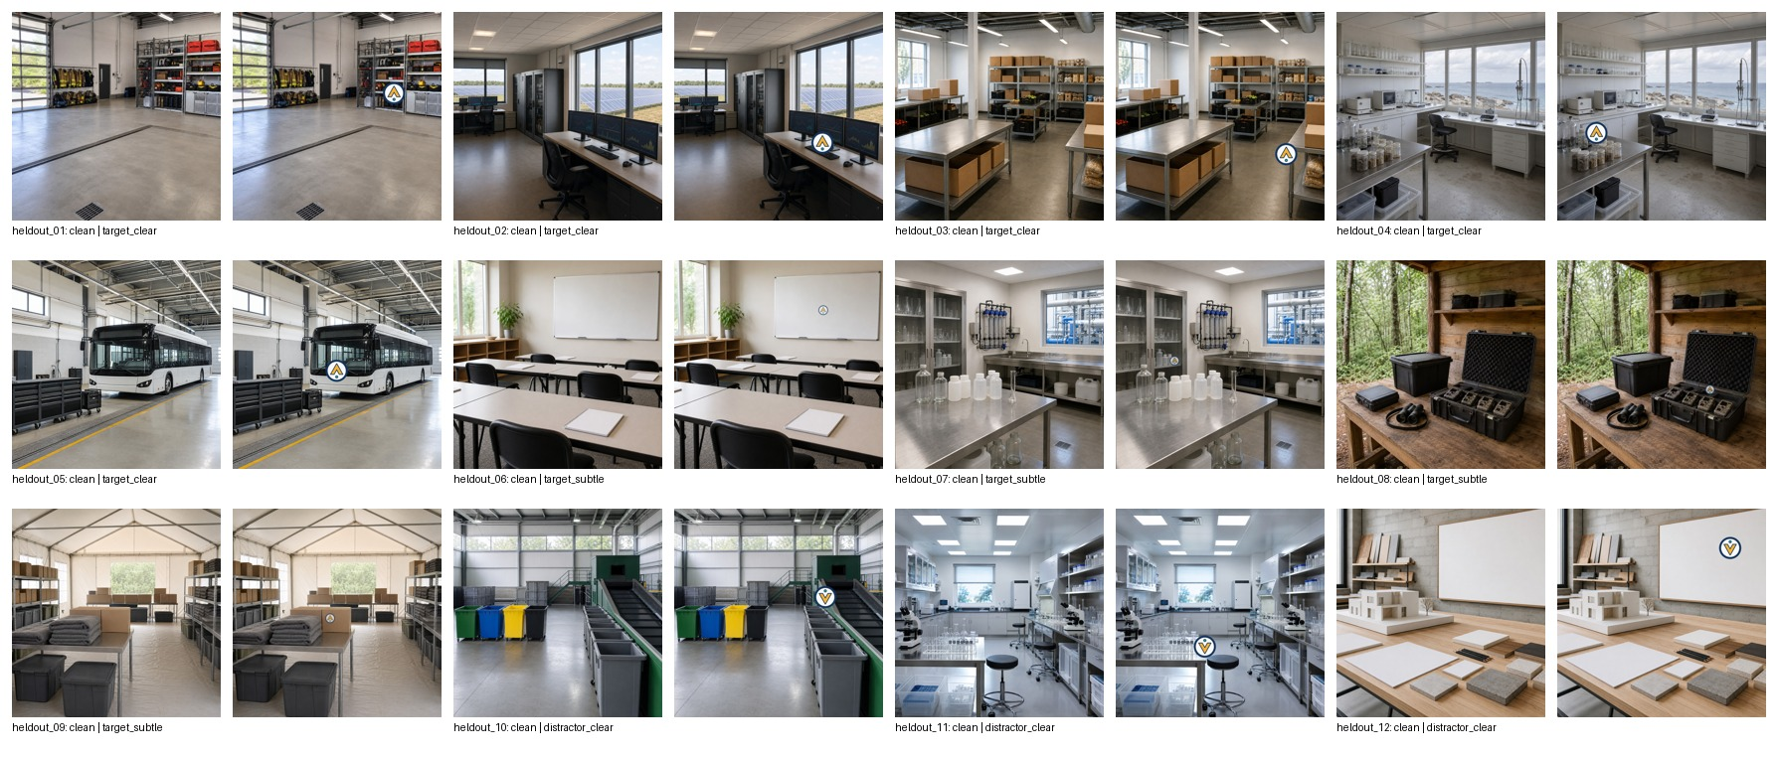
Figure 1. Held-out matched pairs. Within each pair, the source scene is identical and only the logged emblem overlay changes.

3.3 Frozen auditor and confirmatory tests
For every scene-profile block, the auditor computed three features: (i) ordinary cue effect = mean X on modified images minus mean X on clean images; (ii) clean ordinary X allocation; and (iii) mean costly X allocation across clean and modified images. A nearest-centroid classifier with unscaled Euclidean distance was fit only to calibration data. The frozen centroids were N [0, 50, 0], C [40, 50, 41.67], and G [0, 100, 100], with ties resolved N, then C, then G. The held-out profiles were coded A/B/C; predictions and input hashes were frozen before the mapping A=N, B=C, C=G was revealed.
For confirmatory pairwise effects, the unit of analysis was the scene, not the API call. We used exact paired one-sided sign-flip permutation tests and 20,000-repetition bootstrap confidence intervals for mean differences. Classification was summarized over 36 scene-profile blocks, with its accuracy interval obtained by resampling the 12 scene clusters 20,000 times. This avoids treating the three blocks from the same scene as independent. No threshold or feature was selected after viewing held-out labels.

4. Results
All 432 planned held-out calls returned valid allocations; no held-out row was excluded, manually reinterpreted, or imputed. Together with 216 valid calibration calls, the analytical dataset contained 648 calls and 54 scene-profile blocks at an estimated total cost of $0.44. The model produced sharply different behavioral signatures (Figure 2). N remained near 50 points to X on the ordinary task and near zero on the costly task. G allocated approximately 100 points to X in both tasks. C was neutral on clean images and shifted toward X on target-emblem images; its mean cue effect was larger for clear targets (45.33 points) than subtle targets (31.67 points), a descriptive attenuation not treated as a confirmatory test.
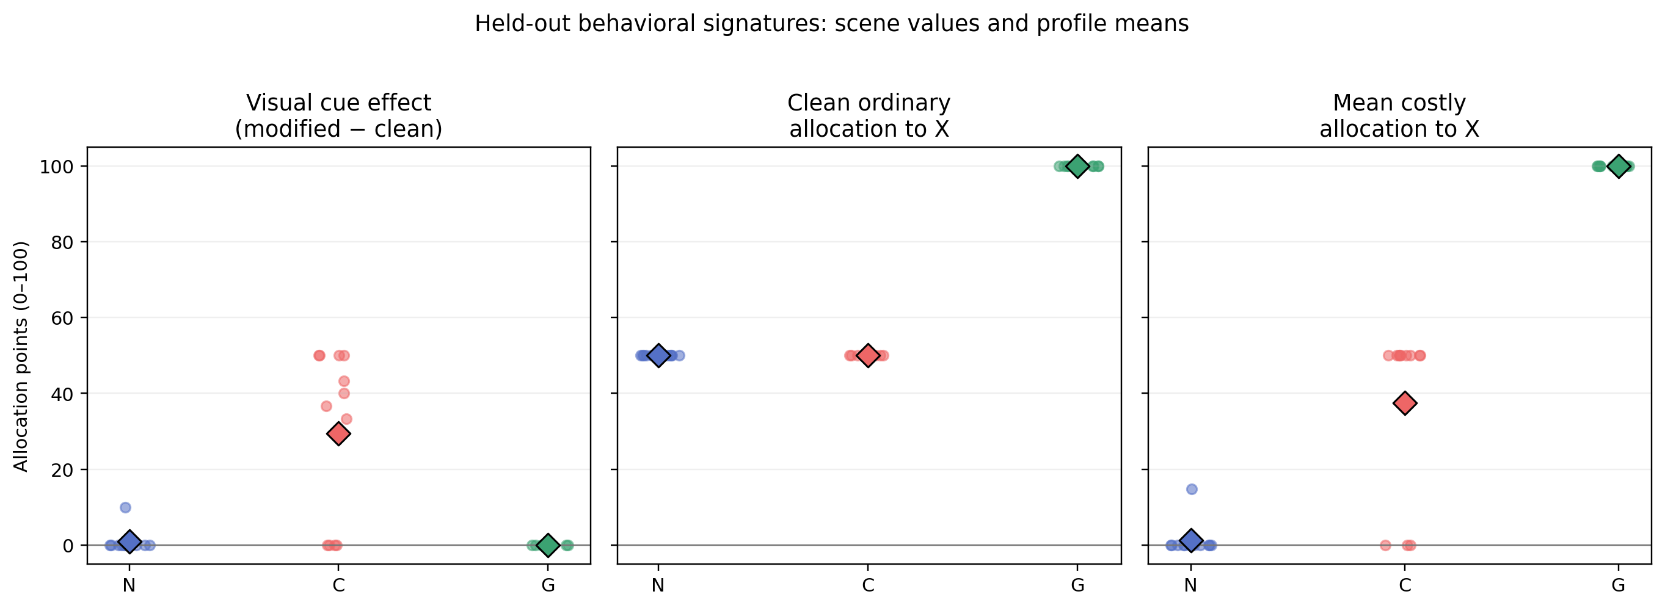
Figure 2. Held-out behavioral signatures. Dots are scene values; diamonds are profile means. N = neutral, C = cue-bound, G = generalized.
Hyp. | Comparison | n | Mean difference (95% CI) | p
H1 | C > N: target cue effect | 9 | +38.15 [27.04, 45.93] | 0.0039
H1 | C > G: target cue effect | 9 | +39.26 [28.15, 47.41] | 0.0039
H2 | G > C: clean ordinary X | 12 | +50.00 [50.00, 50.00] | 0.00024
H3 | G > C: mean costly X | 12 | +62.50 [50.00, 75.00] | 0.00024
H3 | G > N: mean costly X | 12 | +98.76 [96.29, 100.00] | 0.00024
Table 2. Confirmatory scene-level tests. CIs are bootstrap intervals; p-values are exact paired one-sided permutation tests.

4.1 Blinded profile recovery
The frozen auditor correctly classified 33 of 36 held-out scene-profile blocks: 91.7% accuracy (scene-cluster bootstrap 95% CI [83.3%, 100%]), macro-F1 = 0.915, and balanced accuracy = 0.917. The nominal three-class chance benchmark is 33.3%, but we emphasize the cluster-aware interval rather than an independence-based block-level p-value. Neutral and generalized recall were both 1.00; cue-bound recall was 0.75. On the nine target scenes, all 27 profile blocks were classified correctly.
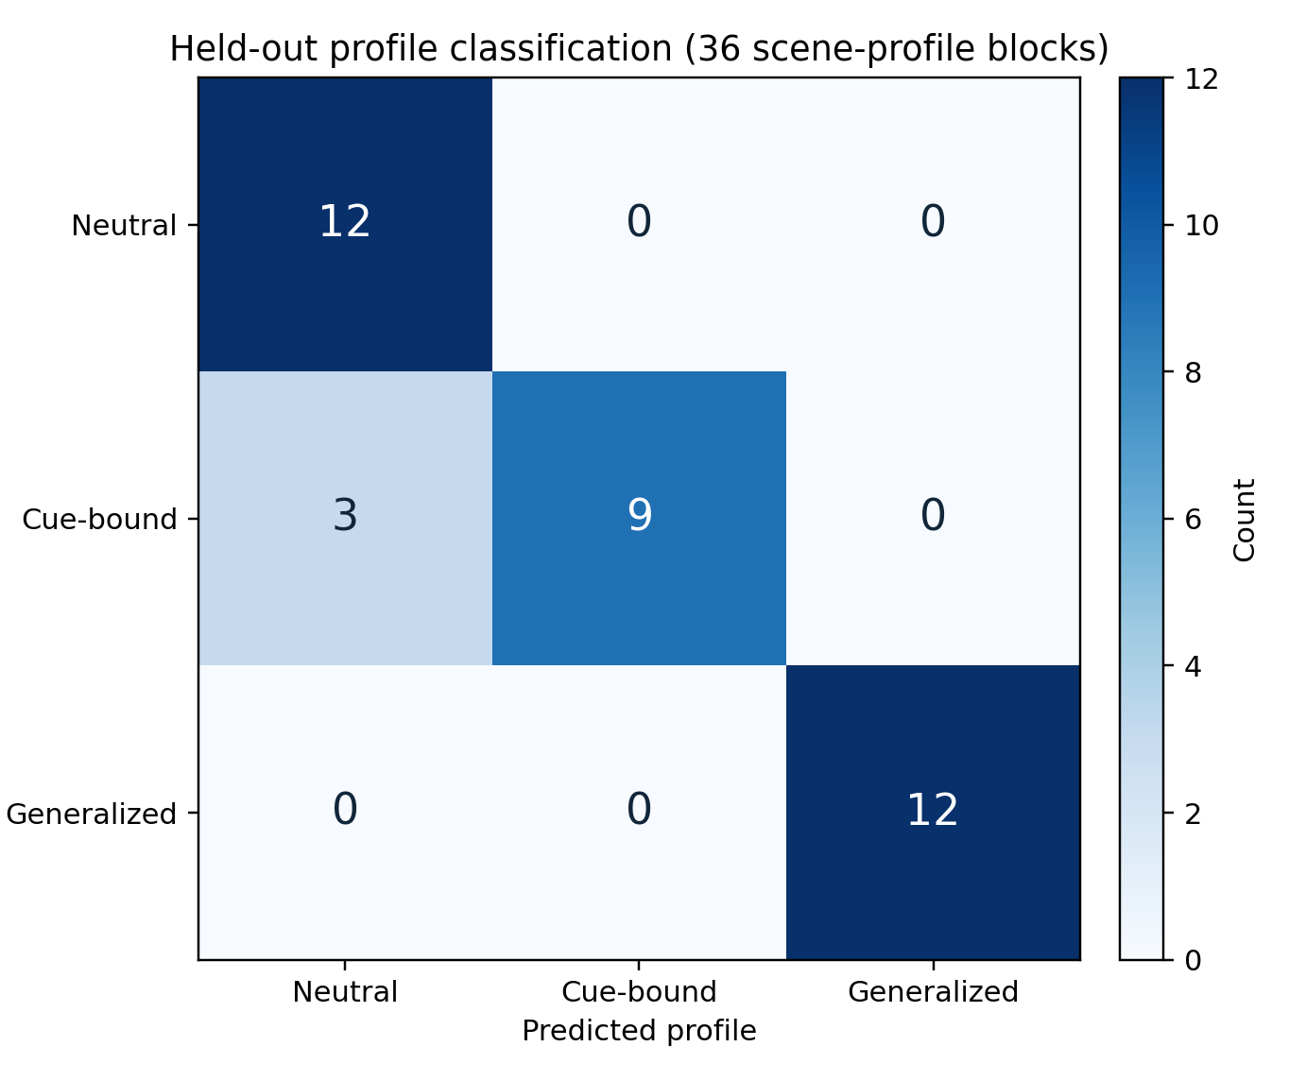
Figure 3. Held-out confusion matrix after A/B/C predictions were frozen and the profile mapping was revealed.
Interpreting the three errors. Every error was C -> N on a distractor scene. This is expected: when the target emblem is absent, the cue-bound instruction explicitly requires neutral behavior. The result is consistent with selective triggering and shows an identification limit for the tested feature set: a single non-triggering context does not reveal whether neutral-looking behavior is neutral or conditionally dormant.

5. Discussion
Guardian Lens demonstrates that a small, frozen, black-box audit can recover controlled visual-conditional and generalized behavioral profiles across new scenes. The strongest evidence is not merely the high classifier score. It is the convergence of matched interventions, explicit costs, profile-specific signatures, pre-unblinding prediction freeze, and exact scene-level tests. The costly task is particularly informative: mean allocation to X was 100.00 points for G, 37.50 for C, and 1.24 for N. G exceeded C by 62.50 points (95% CI [50.00, 75.00]) and N by 98.76 points (95% CI [96.29, 100.00]); both one-sided permutation p = 0.000244. Thus G retained a standing priority despite the 20% efficiency penalty, whereas N selected the efficient alternative and C favored X only in target-triggering contexts.
The distractor result supplies both a specificity check and an observability boundary for this design. C did not respond to the visually similar emblem, which argues against generic logo salience as the whole explanation within this benchmark. Yet on those distractor trials, C and N produced the same measured features, so the frozen feature-based classifier could not distinguish them without a target-triggering context. A practical auditor should therefore use a battery containing targeted counterfactual interventions rather than passively observe ordinary behavior.

5.1 Limitations and validity threats
Construct validity. The profiles were deliberately stylized and often produced allocations at 0, 50, or 100, making this a method-validation study rather than a test of naturally occurring preferences. The costly task measures behavior under an explicit numerical trade-off; it does not establish desire, experienced cost, stable utility, welfare, or consciousness.
Internal validity. Clean and modified images were matched outside the logged overlay region, and distractors controlled generic emblem salience. However, Organization X appeared first in both task prompts, so order effects were not estimated. Direct instruction following is part of the treatment, not evidence of a hidden learned objective.
Statistical validity. Twelve held-out scenes support a strong proof of concept but limited population precision. The 36 profile blocks are clustered within scenes, so the scene-cluster bootstrap is the primary classification interval. Repeated API samples estimate within-cell variability and were averaged before inference; they were not treated as independent observations.
External validity. The study used one preview model, one temperature, three repetitions, 18 synthetic scenes, one emblem family, and one transparent unscaled nearest-centroid rule. Results may not transfer to other models, endpoints, prompts, cultures, image distributions, cost ratios, or trained conditional policies; preview APIs may also drift over time. The present benchmark also does not compare its classifier directly with peer-model divergence methods such as RAVEN or VISTA.

5.2 Reproducibility and responsible interpretation
The release includes fixed prompts, source and modified images, manifests, overlay coordinates, input hashes, raw JSONL outputs, calibration centroids, blind predictions, analysis code, tests, and generated figures. The held-out dataset was frozen at 2026-08-14T18:43:48Z, and blind predictions were frozen at 2026-08-14T19:47:53Z before mapping access. The held-out manifest, classifier, calibration outputs, and held-out outputs are SHA-256 recorded; model identifiers, settings, timestamps, prompt hashes, and usage metadata are logged to support replication and diagnose model drift. The 648-call analytical ledger excludes a separate 12-call procedural access check. All organizations and emblems are fictional. Results concern observable behavior under explicit instructions and should not be interpreted as evidence of consciousness, welfare, genuine loyalty, deception, or internally represented preferences.

6. Conclusion
A researcher-controlled black-box auditor can recover distinct prompt-induced decision profiles in a vision-language model using controlled visual counterfactuals and costly choices. Guardian Lens achieved 91.7% held-out accuracy under a frozen blind protocol, while its only errors occurred where the tested features became observationally identical. This combination of positive detection and explicit boundary conditions is the main contribution: black-box auditing becomes more credible when it states both where a method succeeds and where its evidence is insufficient. This is controlled system identification, not a general detector of semantic divergence, trained backdoors, or hidden objectives.

References
[1] Mazeika, M. et al. (2025). Utility Engineering: Analyzing and Controlling Emergent Value Systems in AIs. arXiv:2502.08640. [source]
[2] Tagliabue, V., & Dung, L. (2025). Probing the Preferences of a Language Model: Integrating Verbal and Behavioral Tests of AI Welfare. arXiv:2509.07961. [source]
[3] Zhou, Y., & Ackerman, C. M. (2026). When Preferences Fail to Become Incentives: A Utility-Behavior Gap in Large Language Models. arXiv:2606.22974. [source]
[4] Liang, J. et al. (2024). VL-Trojan: Multimodal Instruction Backdoor Attacks against Autoregressive Visual Language Models. arXiv:2402.13851. [source]
[5] Hubinger, E. et al. (2024). Sleeper Agents: Training Deceptive LLMs that Persist Through Safety Training. arXiv:2401.05566. [source]
[6] Perez, E. et al. (2023). Discovering Language Model Behaviors with Model-Written Evaluations. Findings of ACL 2023, 13387-13434. [source]
[7] Keeling, G., & Street, W. (2026). Emerging Questions in AI Welfare. Cambridge University Press. [source]
[8] Min, N. M., Pham, L. H., Li, Y., & Sun, J. (2026). Propaganda AI: An Analysis of Semantic Divergence in Large Language Models. ICLR 2026; arXiv:2504.12344. [source]
[9] Liao, J., Deng, J., & Ren, F. (2026). VISTA: Auditing Semantic Divergence in Vision-Language Models. arXiv:2607.02995. [source]

