Egyptian E-Learning University
Faculty of Computers & InformationTechnology
Avir: Interactive Web Platform for Breast Cancer Awareness
By
Shahd Muhammad Rushdi Mustafa Hassan | 2202012
Rowan Yahya Abdul Samea Abdel Hamid | 2202018
Rahma Ramadan Abdullah Abdul Samie | 2202014
Fatma Ahmed Abdel Azim Amin | 2202001
Mariam Mohamad Zakaria Kamel | 2201962
Nermin Walid Abdullatief Sobhy | 2200863
Mustafa Muhammad Mustafa Muhammad | 2202025
Ahmed Sayed Abdul Baqi Sallouma | 2202097
Abdelrahman Akram Nour Shaban | 2202057

Supervised by
Dr. Manal Shaaban Mohamed Ismail
Assistant
Eng. Aalaa Youssif Abd El-Hafeez Siddiq

contents
- Abstract

- Background

- Problem Definition

- Related Work

- Architecture

- Stakeholders

Abstract

- Breast cancer remains one of the most serious health challenges affecting women worldwide, where early detection plays a critical role in improving survival rates. Despite the availability of medical services, many women continue to face barriers such as lack of awareness, fear of embarrassment, and uncertainty regarding proper self-examination practices. These factors often lead to delayed diagnosis and reduced treatment effectiveness.

- This project presents an interactive digital platform designed to raise breast cancer awareness, support early detection, and provide emotional and educational guidance. The platform offers medically simplified educational content, guided self-examination instructions, and a visual reference library to help users recognize common warning signs. In addition, an AI-powered chatbot is integrated to provide preliminary symptom guidance and answer awareness-related questions, without replacing professional medical diagnosis.

- Furthermore, the system includes a smart reminder feature to encourage regular self-checks and promotes post-diagnosis support through inspirational survivor stories and community engagement. The platform is developed using modern web technologies, including a backend system for data management and secure user authentication. The primary goal of this project is to empower women with reliable knowledge, promote proactive health behavior, and facilitate timely medical consultation while ensuring privacy, accessibility, and emotional sensitivity.

Background
- Introduction
- Breast cancer is one of the most common types of cancer worldwide and remains a leading cause of cancer-related mortality among women. It occurs when abnormal cells in the breast tissue grow uncontrollably, forming tumors that may spread to other parts of the body if not detected at an early stage. Despite significant advances in medical research and treatment, breast cancer continues to represent a major public health challenge, particularly in developing countries, due to late diagnosis and insufficient awareness.

- Raising awareness and promoting early detection play a crucial role in reducing breast cancer mortality rates. Research indicates that early-stage diagnosis significantly increases survival rates and expands available treatment options. However, many individuals still lack access to reliable medical information, regular screening programs, and professional medical guidance. This gap often leads to delayed diagnosis, increased psychological stress, and poorer health outcomes. Furthermore, the absence of adequate emotional and community support negatively affects patients during and after the diagnostic process.

- The Breast Cancer Awareness & Support System is designed to address these challenges by providing an integrated, web-based digital platform that combines health education, early detection guidance, and continuous patient support. The system targets multiple beneficiaries. Women and individuals at risk benefit from accessible educational content, self-examination guidance, and early warning tools that encourage proactive health behavior. Patients undergoing diagnosis or treatment gain access to psychological support, follow-up guidance, and community interaction that helps reduce feelings of isolation. In addition, healthcare providers and medical professionals benefit from a structured platform that facilitates awareness dissemination and preliminary data support.

Problem Definition
- Despite increased global attention to breast cancer, several challenges continue to limit effective prevention and early detection. Many women lack sufficient awareness of breast cancer symptoms, risk factors, and the importance of regular self-examination and early screening, which often leads to delayed medical consultation and late-stage diagnosis.
- In addition, access to reliable and well-structured medical information remains limited. Available resources are frequently fragmented or overly technical, resulting in misinformation, confusion, and increased anxiety among individuals who suspect symptoms. Moreover, the absence of guided self-examination tools and continuous support further reduces opportunities for early intervention.

- These challenges highlight the need for a comprehensive and accessible digital approach that supports awareness, early detection, and patient guidance.
Related Work
- Several digital solutions have been developed to raise health awareness and support cancer prevention. Many general health awareness websites provide basic information about breast cancer, including symptoms, risk factors, and treatment options. However, these platforms often focus on static content delivery and lack interactive features that encourage continuous user engagement or early detection practices.

- In addition, various mobile health applications address general women’s health issues, such as fitness tracking, menstrual cycle monitoring, and appointment reminders. While these applications offer useful health-related services, they are not specifically designed to focus on breast cancer awareness or guided self-examination. Moreover, most of them do not provide structured educational content tailored to early detection or emotional support needs.

- Some platforms integrate artificial intelligence to assist in healthcare awareness, mainly through symptom-checking tools or automated question-and-answer systems. Despite their benefits, these systems are often limited by the absence of localized content, structured content management, and reliable guidance designed specifically for breast cancer awareness.

- In contrast, the proposed Breast Cancer Awareness & Support System aims to provide a specialized and integrated solution. Unlike existing systems, it combines a backend-supported content management system (CMS), guided self-examination tools, and an AI-powered chatbot within a single platform. This integrated approach allows the system to deliver reliable, organized educational content, interactive user guidance, and continuous
support, making it more suitable for promoting early detection and informed health decisions.
Architecture Diagram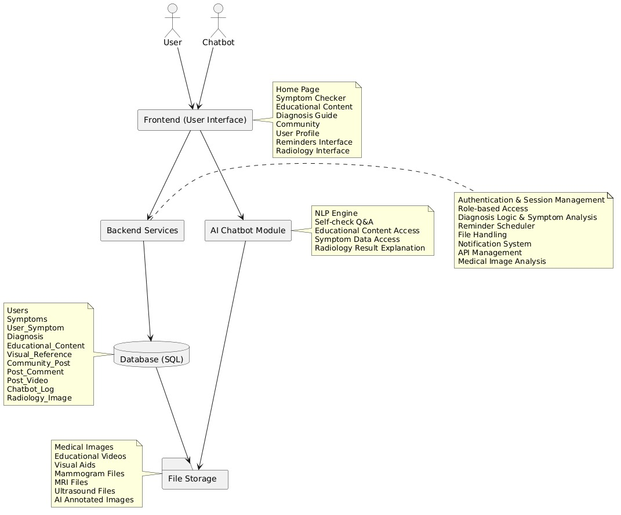

This diagram shows the architecture of a healthcare AI application.
- User & Chatbot: The user interacts with the system through the user interface and an AI chatbot.
- Frontend (User Interface): Includes features like the home page, symptom checker, educational content, diagnosis guide, community posts, user profile, reminders.
- AI Chatbot Module: Handles natural language processing (NLP), self-check Q&A, access to educational content and symptom data.
- Backend Services: Manages authentication, role-based access, symptom analysis, diagnosis logic, reminders, file uploads/downloads, notifications, APIs
- Database (SQL): Stores user data, symptoms, diagnoses, educational content, community posts, chatbot logs.
- File Storage: Stores PDFs, medical images, educational videos, imaging files (MRI, ultrasound, etc.), and AI-annotated images.

Stakeholders
- The Breast Cancer Awareness & Support System involves several stakeholders who either use or support the system. The primary stakeholders are end users, including women, individuals at risk, and patients, who access educational content, self-examination guidance, and chatbot support. System administrators (Admins) manage and update the platform’s content to ensure accuracy and reliability. Medical professionals act as reference stakeholders by validating medical information without direct system interaction. Developers are responsible for building, maintaining, and improving the system’s technical components. Together, these stakeholders ensure the system functions effectively and achieves its awareness and support goals.
Functional Requirements
- User registration and login using email and password.
- Input validation for user information such as name, email, and password.
- Secure password encryption and account activation mechanisms.
- Display breast cancer awareness and educational content.
- Provide step-by-step breast self-examination guidance.
- Enable monthly self-examination reminders.
- Allow users to interact with an AI-based chatbot for awareness-related questions and preliminary guidance.
- Support uploading radiology images for educational reference and awareness purposes only.
- Provide a visual reference gallery to help users compare common symptoms and warning signs.
- Offer post-diagnosis support content, including survivor stories and general treatment information.
- Enable community support features for registered users to share experiences and encouragement.
Non-Functional Requirements
- The system shall be easy to use and user-friendly.
- The system shall provide acceptable response time for user interactions.
- User data shall be stored securely using encryption techniques.
- The system shall ensure user privacy and confidentiality.
- The system shall be available with minimal downtime.
- The system shall support future scalability.
- The system shall be easy to maintain and update.

Use Case Diagram
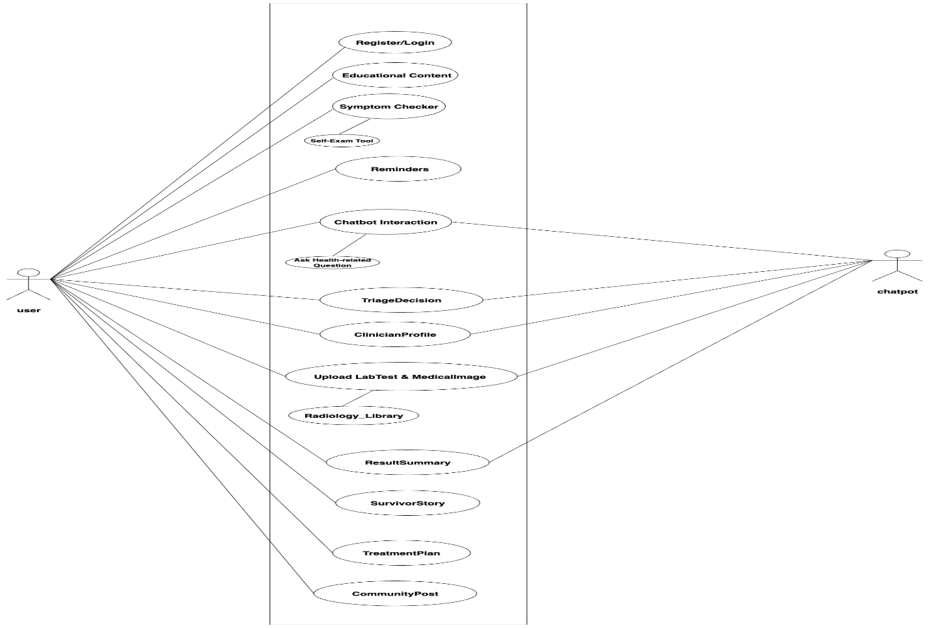
This diagram represents a use case diagram for a healthcare AI system.
- The User interacts with the system to register or log in, access educational content, check symptoms, perform self-exams, set reminders, and communicate with the chatbot.
- The Chatbot supports the user by answering health-related questions, assisting with triage decisions, explaining results, and guiding next steps.
- Additional features include clinician profiles, treatment plans, survivor stories, and community posts.

User Story Diagram
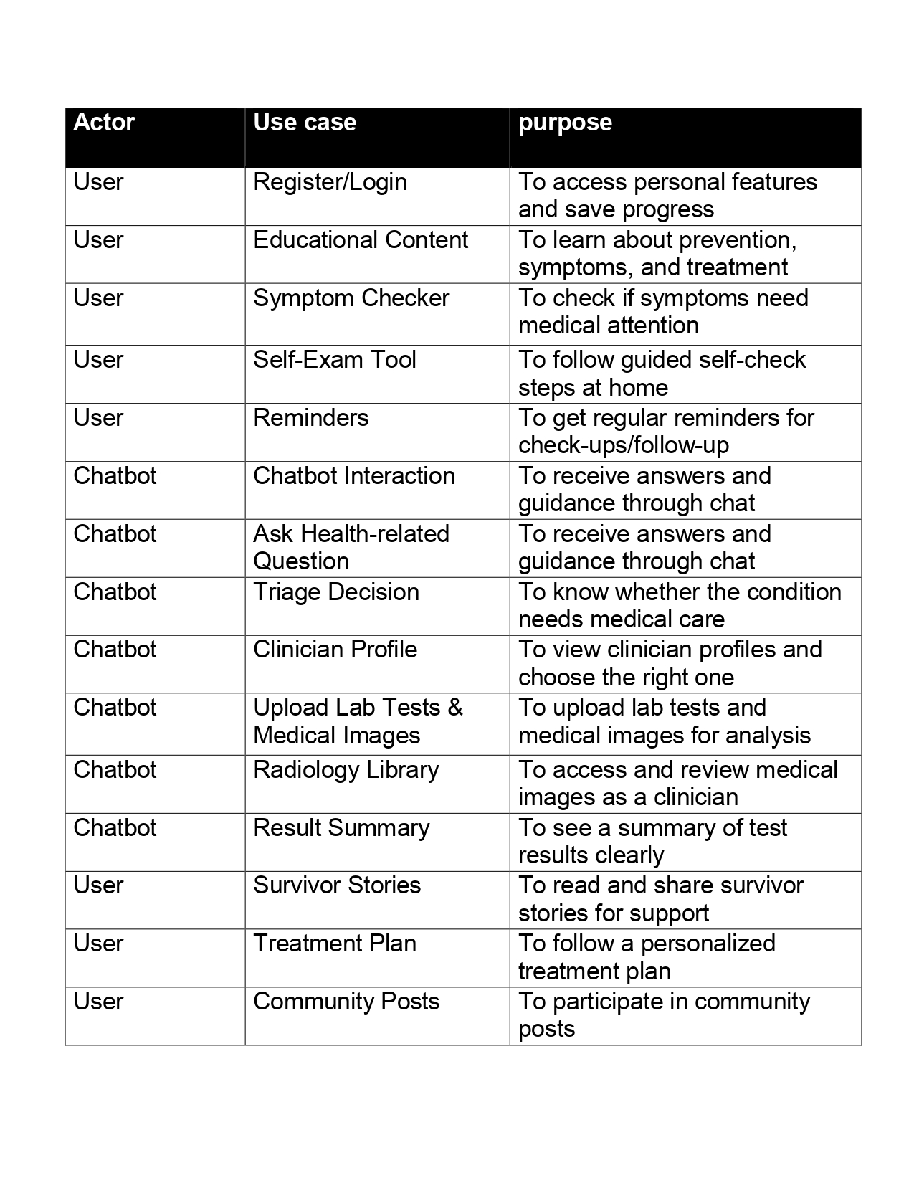
- Register/Login (User): Allows the user to access personal features and save progress.
- Educational Content (User): Helps the user learn about prevention, symptoms, and treatment.
- Symptom Checker (User): Checks whether symptoms may need medical attention.
- Self-Exam Tool (User): Guides the user through self-examination steps at home.
- Reminders (User): Sends reminders for check-ups and follow-ups.
- Chatbot Interaction (Chatbot): Provides health guidance through chat.
- Ask Health-related Questions (Chatbot): Answers user health questions.
- Triage Decision (Chatbot): Determines if medical care is needed.
- Clinician Profile (Chatbot): Helps users view and choose clinicians.
- Radiology Library (Chatbot): Allows access to medical images.
- Survivor Stories (User): Lets users read and share support stories.
- Treatment Plan (User): Helps users follow a personalized treatment plan.
- Community Posts (User): Enables users to participate in community discussions.
ERD Diagram
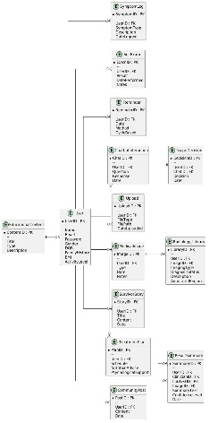
- User: Stores personal data, medical history, and account information.
- Educational Content: Contains learning materials linked to users.
- Symptom & User_Symptom: Records user symptoms and their details.
- Self-Exam: Stores self-examination results done by the user.
- Reminder: Manages reminders for check-ups and follow-ups.
- Chatbot Interaction: Saves conversations between the user and the chatbot.
- Triage Decision: Stores decisions about whether medical care is needed.
- Clinician Profile: Contains clinician information for consultation.
- Radiology Library: Keeps radiology images and AI annotations.
- Survivor Story: Stores survivor experiences for support.
- Treatment Plan: Contains personalized treatment plans for users.

Sequence Diagram
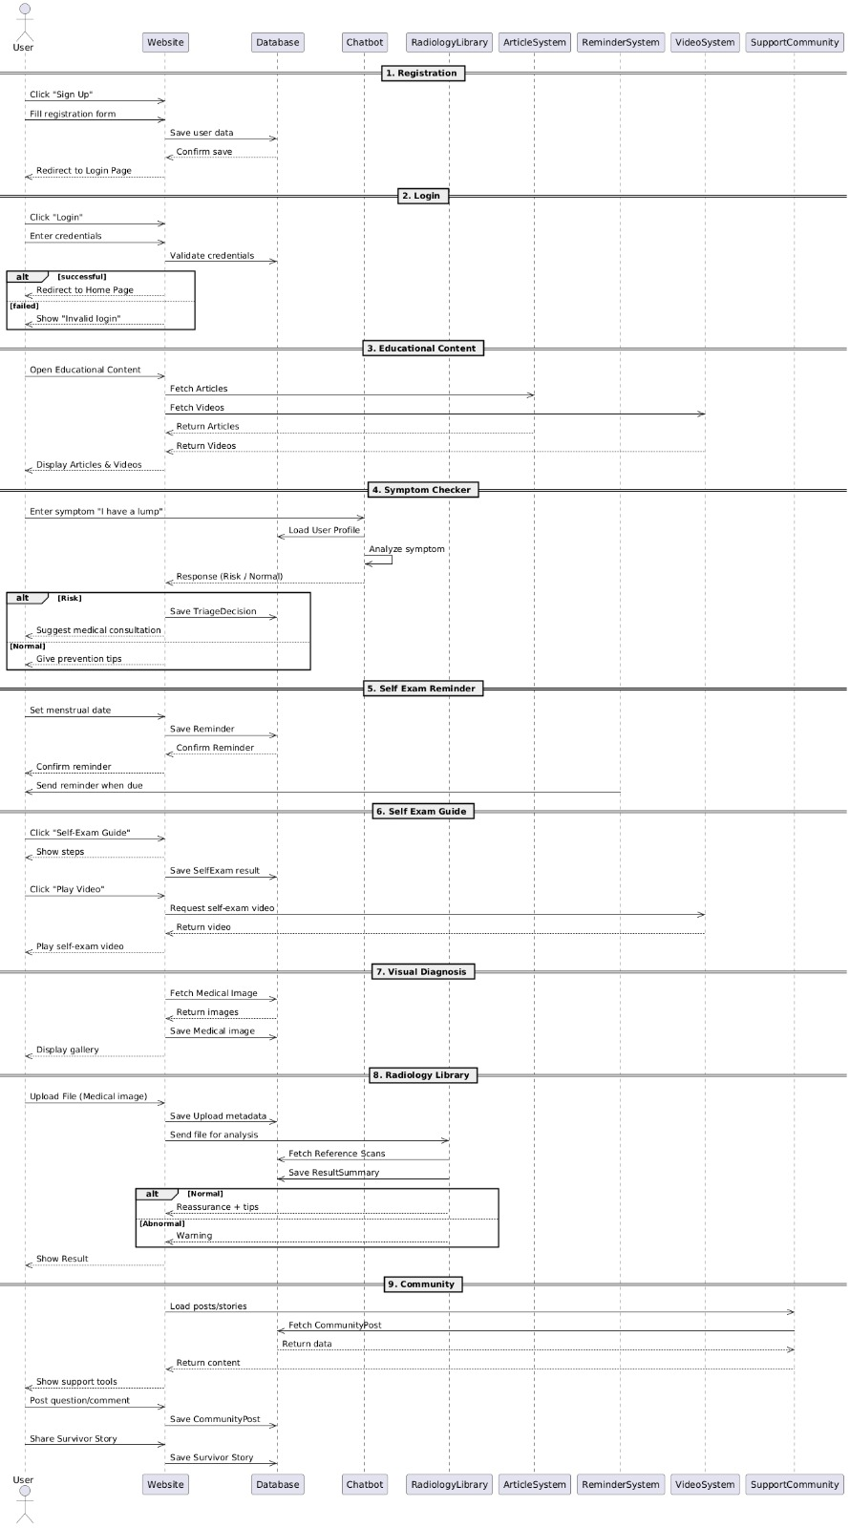
- Registration/Login: User creates an account and logs in.
- Educational Content: User views articles and videos.
- Symptom Checker: User enters symptoms, AI analyzes them, and gives a triage decision.
- Reminders: System schedules and sends check-up reminders.
- Self-Exam Guide: User follows guided self-exam steps and saves results.
- AI Assessment: System evaluates changes and gives recommendations.
- Radiology Library: AI analyzes images and stores results.
- Treatment Plan: Personalized treatment plan is created and saved.
- Community & Support: User joins community posts and shares survivor stories
Class Diagram
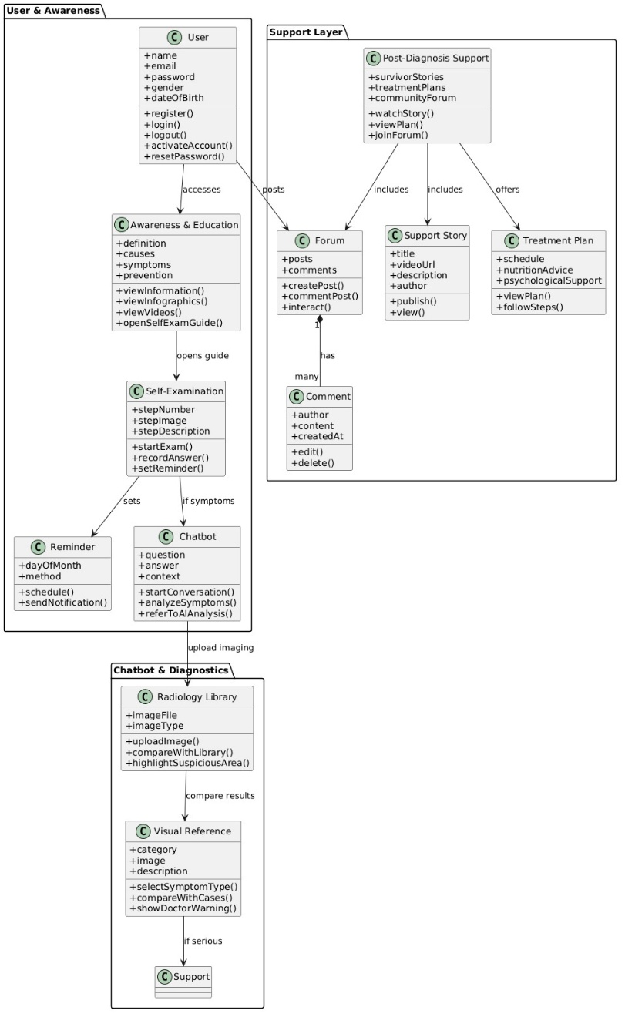
- User: Registers, logs in, and accesses all system features.
- Awareness & Education: Provides information about causes, symptoms, prevention, videos, and self-exam guides.
- Self-Examination: Guides users through self-exam steps, records answers, and sets reminders.
- Reminder: Schedules and sends notifications (app or email).
- Chatbot: Answers questions, analyzes symptoms, and refers cases for AI analysis.
- Radiology Library: Stores and analyzes medical images (MRI, ultrasound, mammogram).
- Visual Reference: Compares symptoms and images with known cases and shows warnings if needed.
- Post-Diagnosis Support: Provides survivor stories, treatment plans, and community support.
- Doctor: Reviews cases, responds in forums, and creates treatment plans.
- Treatment Plan: Contains schedules, nutrition advice, and psychological support.
- Forum: Allows posts, comments, and interaction between users and doctors.
- Support Story & Comment: Used for sharing experiences and discussions.
Artificial Intelligence Component
• The Artificial Intelligence (AI) component of the system aims to support breast cancer awareness and encourage early medical consultation through educational guidance and preliminary analysis. The AI is not designed to provide medical diagnosis or replace professional healthcare services, but to assist users in understanding symptoms, medical data, and appropriate next steps.

• The AI system includes three integrated modules: an AI-powered chatbot, ultrasound image analysis, and laboratory test analysis.

• The AI chatbot serves as the main interaction interface. It answers awareness-related questions, guides users through breast self-examination steps, and collects essential health information such as age, gender, symptoms, family history, and menstrual cycle data when applicable. Based on these inputs, the chatbot provides simplified educational responses and recommends actions such as self-monitoring or consulting a healthcare professional.

• For medical imaging, the AI model is trained using breast ultrasound image datasets. Uploaded ultrasound images in standard formats (JPEG or PNG) are preprocessed and analyzed using AI-based feature extraction techniques. The system compares image patterns with learned benign and malignant cases to provide awareness-based indications and highlight visually suspicious regions, without confirming any medical condition.

• All AI outputs are clearly labeled as non-diagnostic, and user privacy, data security, and ethical considerations are strictly maintained. By focusing on education and early awareness, the AI component supports informed health decisions while ensuring medical safety.
Task | Task Title | Description | Task status  (completed/expected in time)
1 | Requirements Analysis | Analyze system requirements and define scope | Completed
2 | System Architecture | Design overall system architecture (Frontend, Backend, AI) | Completed
3 | UI/UX Design | Design wireframes, UI screens, and prototypes | Completed
4 | Backend Development | Develop APIs, database, authentication, and security | Expected in time
6 | AI Data Preparation | Collect and preprocess ultrasound image datasets | Expected in time
7 | AI Model Development | Train, evaluate, and optimize AI detection model | Expected in time
8 | Frontend Development | Implement user interfaces and system pages s | Completed

Chapter 4
System Implementation
Introduction
- The implementation phase focused on transforming the proposed system design into a fully functional web application. During this phase, all system components were developed and integrated to provide an interactive platform for breast cancer awareness and support. The implementation process aimed to ensure that the system is user-friendly, secure, reliable, and accessible through modern web technologies.
- The system combines multiple components, including the frontend, backend, database, AI-powered chatbot, and radiology library, to provide users with educational resources, self-examination guidance, reminder services, and community support within a single platform.
Frontend Implementation
- The frontend was developed to provide users with an intuitive and responsive interface that allows easy access to all system features. The design follows a simple layout with clear navigation menus and interactive elements to improve usability.
- Several pages were implemented, including the Home page, Login and Registration pages, Awareness page, Self-Examination page, Chatbot page, Radiology Library page, Community page, and User Profile page. Each page was designed to provide a consistent user experience while ensuring compatibility with different screen sizes and devices.
- Interactive forms, buttons, cards, and navigation components were implemented to simplify user interaction and improve accessibility. Responsive web design techniques were also applied to ensure that the platform works efficiently on both desktop and mobile devices.
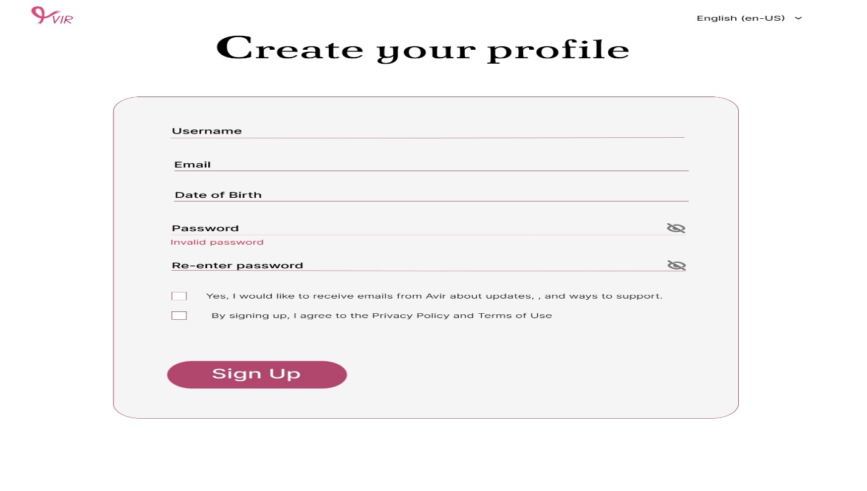
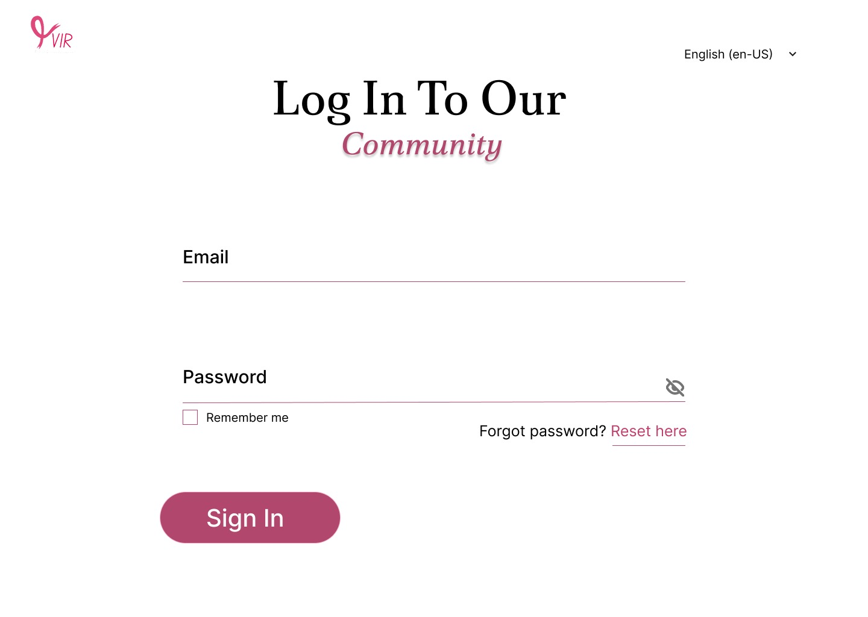
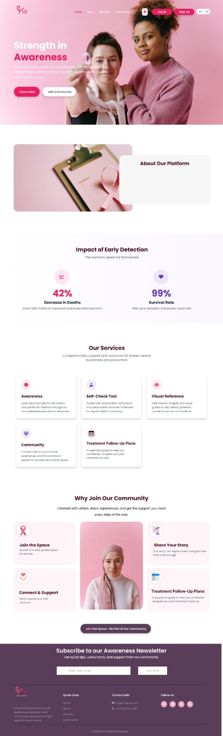
Backend Implementation
- The backend was implemented to manage the core functionality of the platform and facilitate communication between the frontend and the database. It handles user authentication, educational content management, chatbot communication, reminder scheduling, community interactions, and radiology image management.
- RESTful APIs were developed to exchange data securely between different system components. User authentication was implemented using secure login mechanisms, while passwords are encrypted before storage to protect user privacy.
- The backend also performs input validation, manages user sessions, and handles error processing to ensure the reliability and stability of the system during operation.
Database Implementation
- The database was designed to organize and manage all system data efficiently. It stores user accounts, educational content, self-examination records, reminder schedules, chatbot conversations, radiology library information, community posts, and survivor stories.
- The database structure follows the Entity Relationship Diagram (ERD) presented in the previous chapter. Primary and foreign keys were implemented to establish relationships between different entities while maintaining data integrity and reducing redundancy.
- The database design supports efficient data retrieval, easy maintenance, and future scalability as new system features are introduced.
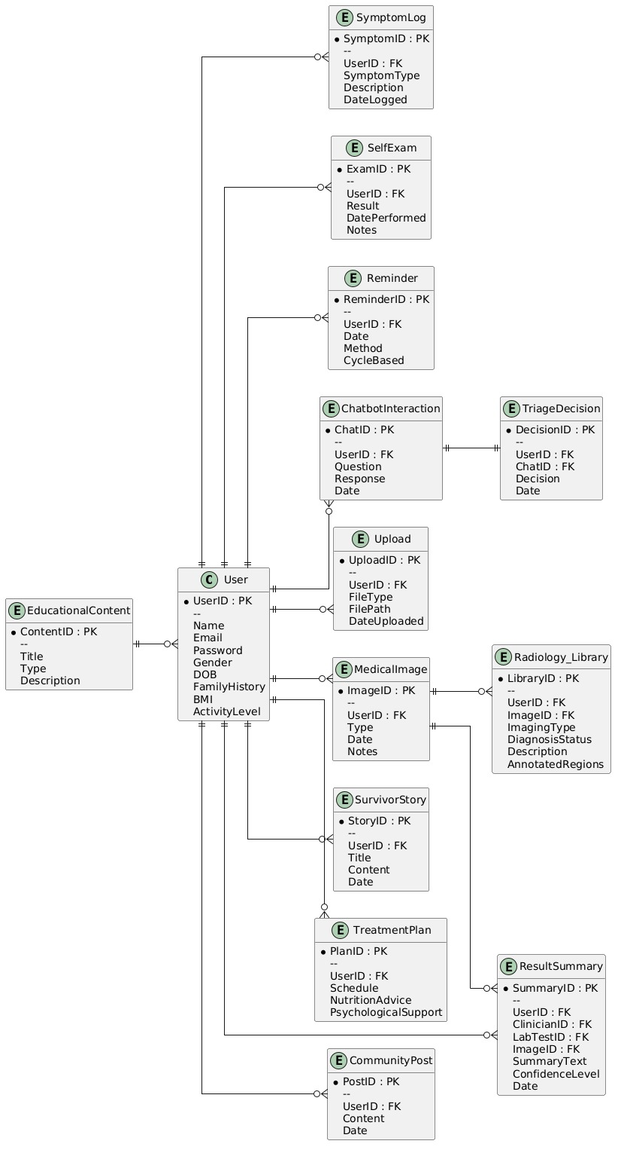
Dataset
- The AI model was trained using a publicly available Breast Ultrasound Images Dataset. The dataset contains ultrasound images classified into three categories: Normal, Benign, and Malignant. Each image is accompanied by its corresponding segmentation mask, allowing the model to learn both the classification of the image and the location of suspicious regions. Using annotated medical images improves the model's ability to identify abnormal tissue patterns and enhances segmentation accuracy.

Data Preprocessing
- Before training the AI model, the ultrasound dataset was preprocessed to improve the overall quality of the input data. The preprocessing stage included loading the ultrasound images and their corresponding masks, resizing all images to a unified resolution suitable for the neural network, and normalizing pixel values to improve training stability. The dataset was then divided into training and validation sets. In addition, data augmentation techniques such as rotation, flipping, and zooming were applied to increase dataset diversity and improve the model's ability to generalize to unseen images.

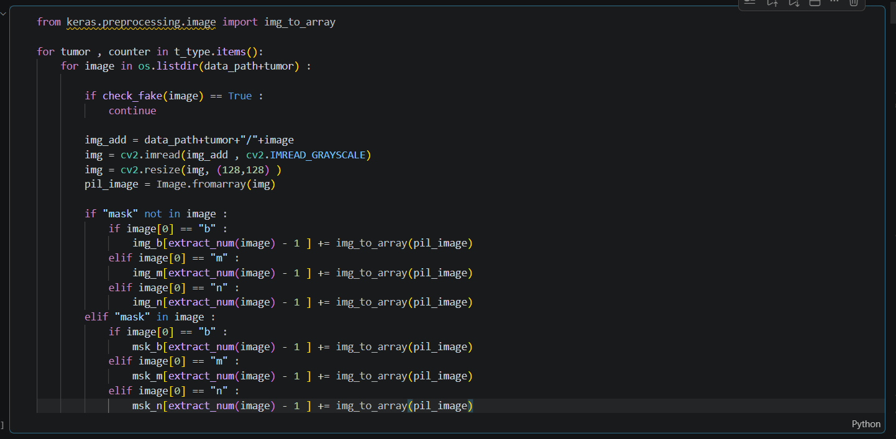

Model Architecture
- The proposed AI model is based on the U-Net architecture, which is one of the most widely used deep learning models for medical image segmentation. U-Net was selected because it provides high segmentation accuracy while preserving important spatial information within medical images. The architecture consists of two main components: an encoder responsible for extracting image features and a decoder responsible for reconstructing the segmentation mask.

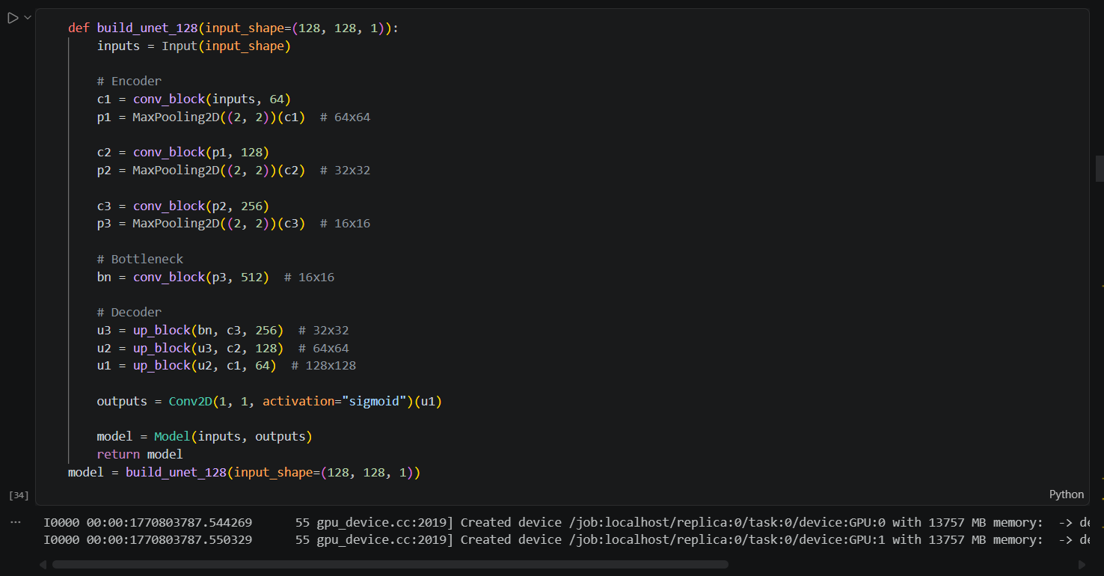

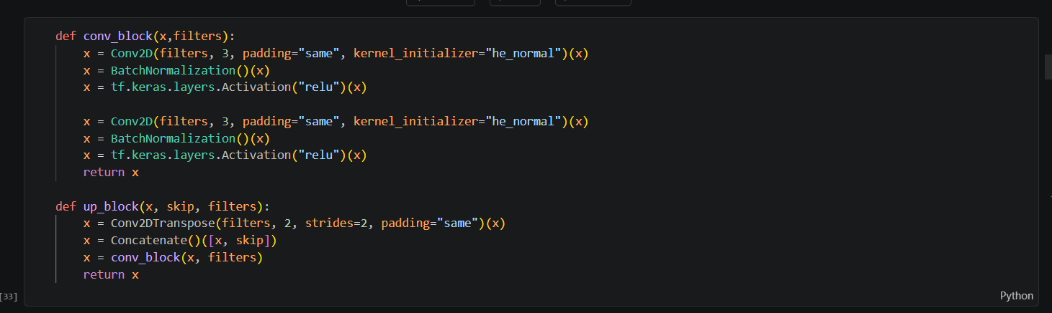
Model Training
- During the training phase, the ultrasound images were used as input while the corresponding segmentation masks served as the target outputs. The model learned to identify abnormal regions by minimizing the difference between the predicted masks and the ground truth masks. Multiple training epochs were performed, allowing the model to continuously improve its prediction accuracy. The optimization process adjusted the network parameters to achieve better segmentation performance on unseen data.

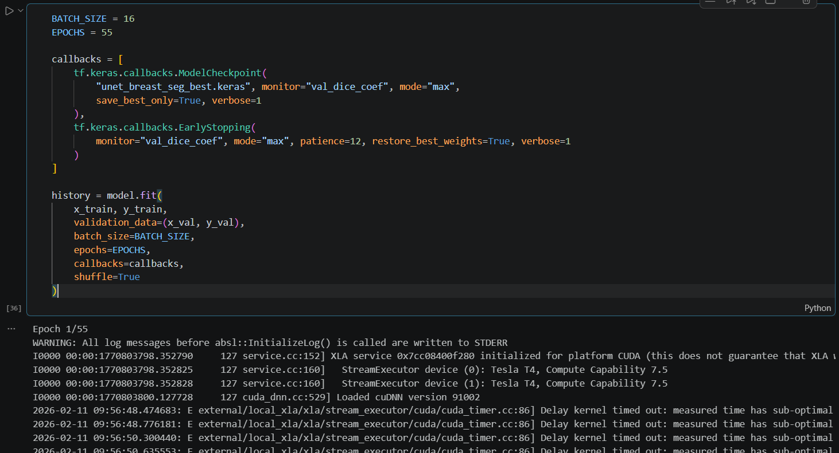
Model Output
- After processing an ultrasound image, the trained model generates a predicted segmentation mask highlighting suspicious regions. The predicted mask is displayed together with the original ultrasound image, allowing users to visually compare the detected region. This AI-assisted output provides educational support by helping users understand image characteristics while emphasizing that the result does not constitute a medical diagnosis.

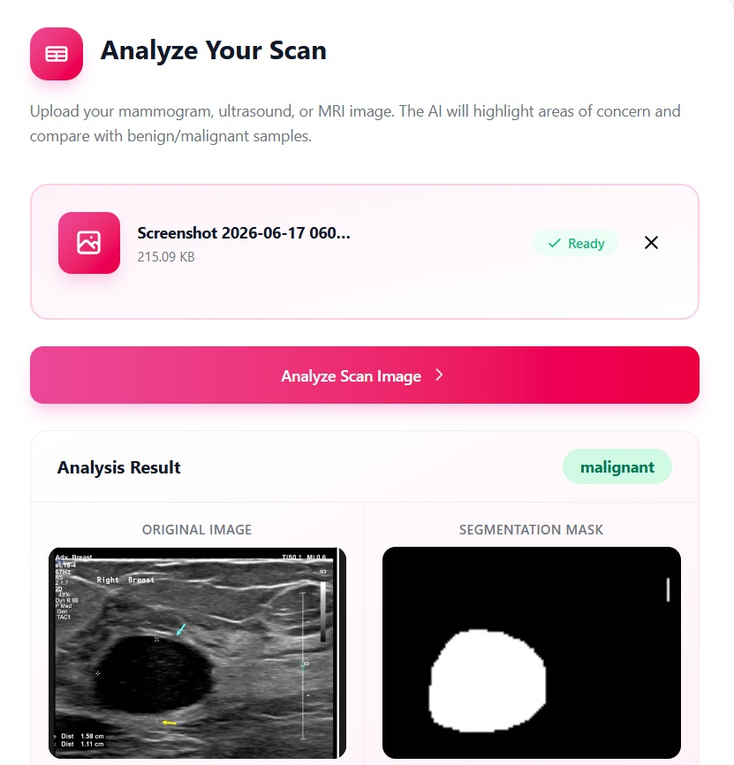

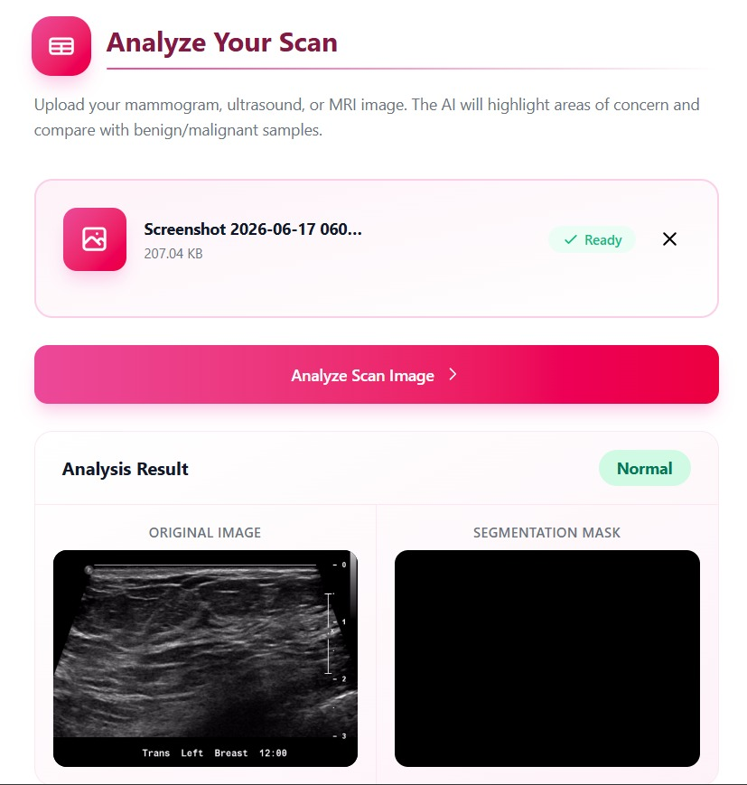
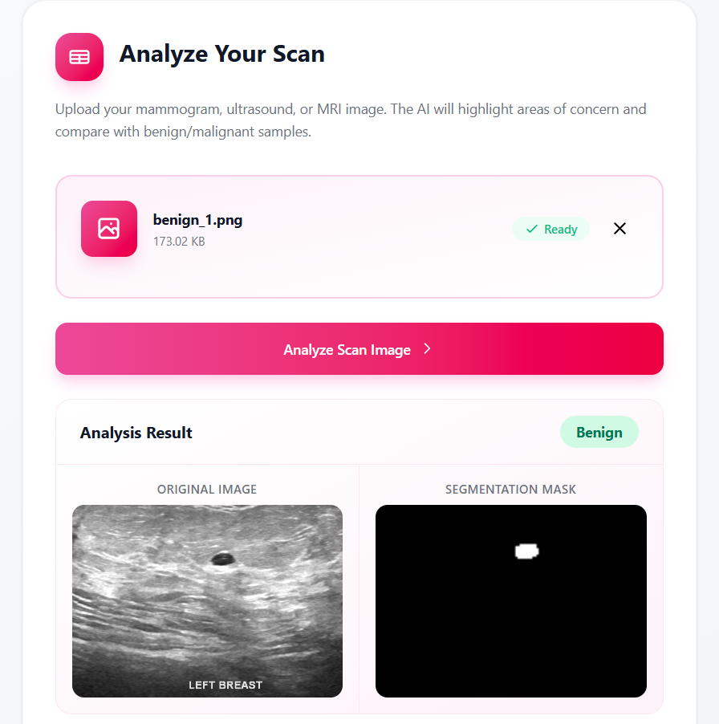
AI Chatbot
Overview
- The Breast Cancer Awareness System integrates an AI-powered chatbot to provide users with interactive educational support and reliable information about breast cancer. The chatbot enables users to ask questions in natural language and receive immediate responses related to breast cancer awareness, symptoms, prevention methods, self-examination, and general healthcare recommendations. The chatbot was designed to improve user engagement and make medical information easier to access and understand.
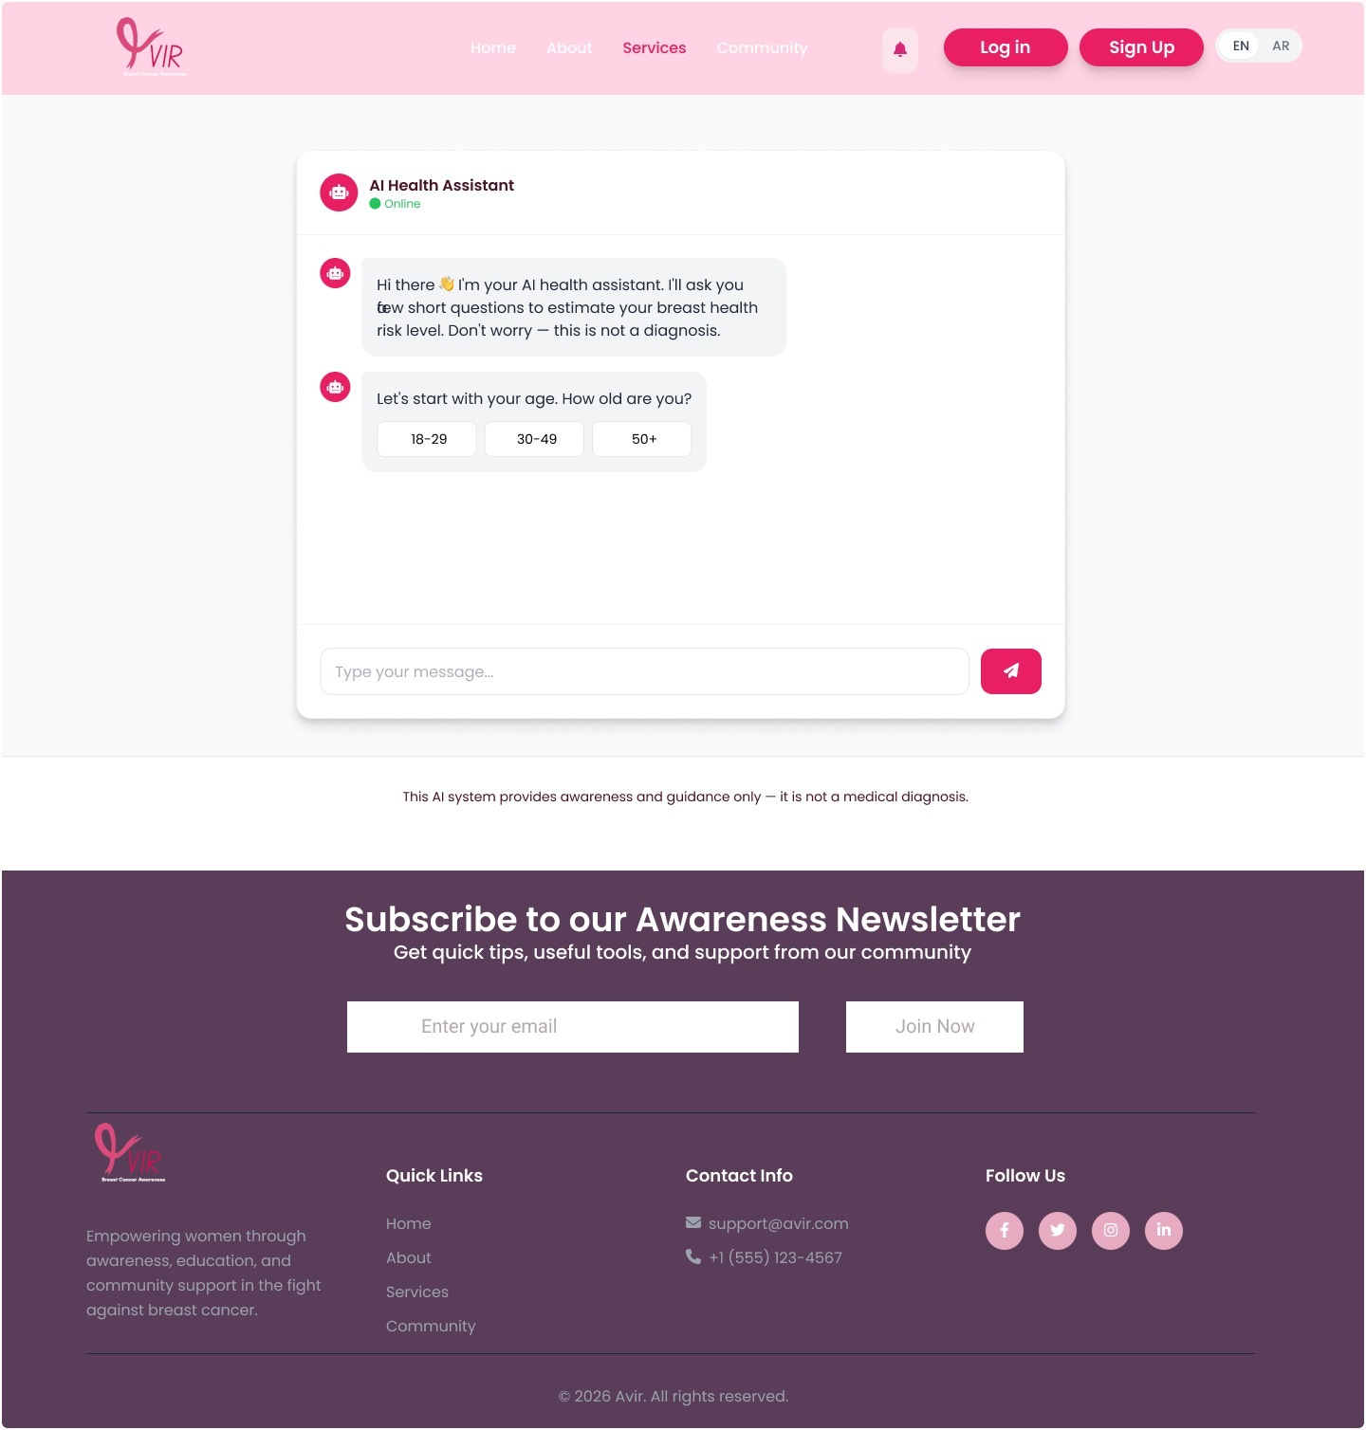
Implementation
- Instead of developing a chatbot model from scratch, the system integrates an external AI chatbot API. When a user submits a question through the chatbot interface, the frontend sends the request to the backend. The backend then forwards the user's query to the AI API, which processes the request using a pre-trained large language model and generates an appropriate response. Finally, the generated response is returned to the frontend and displayed to the user in real time.

Chatbot Response Example
- Figure presents an example of the interaction between the user and the AI chatbot. The chatbot provides informative and easy-to-understand answers related to breast cancer awareness, helping users obtain educational guidance quickly while encouraging them to consult healthcare professionals when necessary.

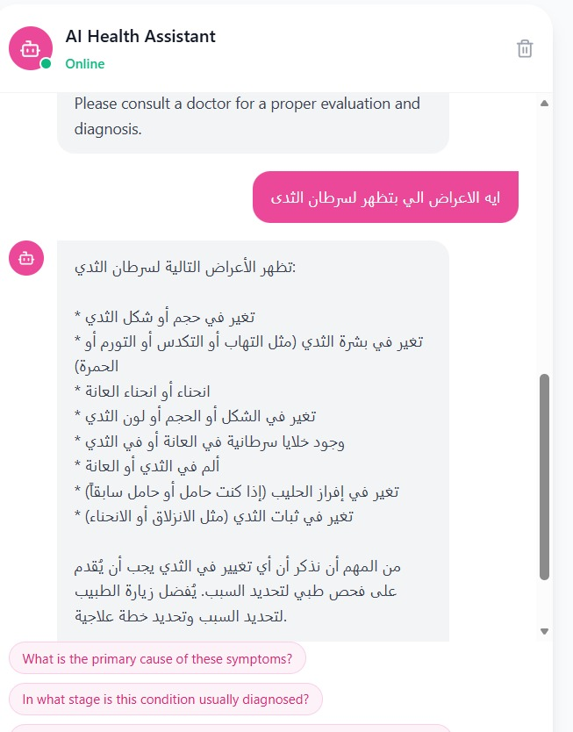
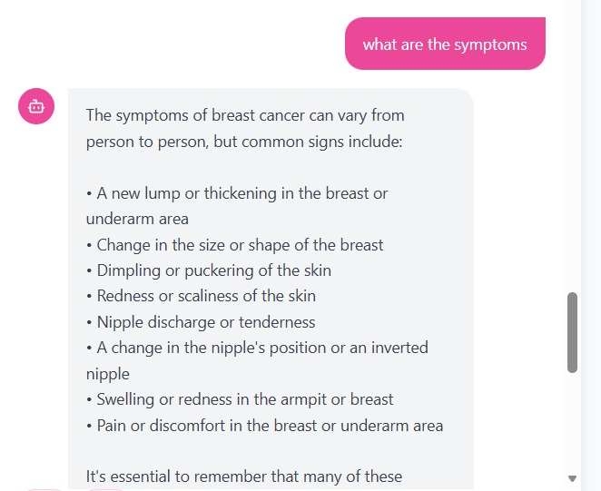
Chapter 5
System Testing
Introduction
- System testing was conducted to ensure that all implemented features operate correctly and meet the specified functional requirements. Different test cases were performed to verify the behavior of the system under normal usage conditions. The testing process focused on validating user interactions, system responses, data accuracy, and overall usability.
Testing Approach
- The system was tested manually by executing different user scenarios and verifying the expected results. Each feature was checked individually to ensure that it functions correctly before testing the complete system as an integrated application. The testing process also included validating user inputs, authentication, navigation between pages, and interaction with the AI chatbot.

Test Case | Description | Expected Result | Status
User Registration | Create a new account | Account created successfully | Passed
User Login | Login using valid credentials | User redirected to Home page | Passed
Awareness Page | Open awareness content | Educational content displayed correctly | Passed
Self-Examination | Complete self-examination steps | Guidance displayed successfully | Passed
Reminder | Set monthly reminder | Reminder saved successfully | Passed
AI Chatbot | Ask awareness-related questions | Correct response displayed | Passed
Community | Publish a new post | Post appears in the community | Passed
Radiology Library | Open radiology library | Images displayed successfully | Passed

Testing Results
- The testing results showed that all major system functions operated successfully. Users were able to register, log in, access educational content, perform self-examinations, communicate with the AI chatbot, browse the radiology library, and participate in the community without major issues. The system demonstrated stable performance and provided a smooth and user-friendly experience during testing.

Challenges and Solutions
- During the implementation and testing phases, several challenges were encountered. Integrating different system components while maintaining smooth communication between the frontend and backend required careful planning. Ensuring data security during user authentication and managing responsive user interfaces across different devices were also important challenges.
- These challenges were addressed by implementing secure authentication mechanisms, validating user input, organizing the project structure, and performing continuous testing throughout the development process.

Chapter 6:Conclusion
- The Breast Cancer Awareness & Support System was developed to provide an interactive and user-friendly platform that promotes breast cancer awareness and encourages early detection. The system combines educational content, guided self-examination, an AI-powered chatbot, reminder services, a radiology library, and community support into a single web-based application.
- Throughout the development process, the project successfully transformed the identified requirements into a functional system that supports users in accessing reliable health information and improving awareness about breast cancer. The implemented features work together to provide an accessible environment that encourages preventive healthcare and informed decision-making.
- Overall, the project achieved its primary objectives by delivering a secure, responsive, and easy-to-use platform. It demonstrates how modern web technologies and artificial intelligence can be utilized to improve health awareness while supporting users with reliable educational resources without replacing professional medical consultation.
Chapter 7: Future Work

- Although the current version of the system provides the main required features, several improvements can be considered in future releases. A mobile application can be developed to increase accessibility and provide a better user experience on smartphones. Additional language support may also be introduced to reach a wider audience.
- Future enhancements may include integrating online appointment booking with healthcare providers, improving the AI chatbot with more advanced natural language processing capabilities, and expanding the educational content regularly to include the latest medical guidelines. Furthermore, additional community features and personalized health recommendations could be implemented to provide more comprehensive support for users.

