Multimodal Fake News Detection with Image-Text Consistency Analysis
Mohamed Hasan, Mostafa Elofy, Mohamed Ghanem
Group 11 - Deep Learning Final Project
Repository: https://github.com/mostafaelofy629/Fake-News.git

Abstract
This final report presents a reproducible multimodal fake-news detection pipeline on the FakeNewsNet GossipCop and PolitiFact subset. The project implements text-only, image-only, and image-text fusion models, then audits whether visual information actually improves fake/real classification. The final fair benchmark uses valid-image-only, image-deleaked train/validation/test splits with no title or image-hash overlap. On this split, text remains the dominant signal: TF-IDF Logistic Regression reaches 0.7576 macro-F1, while CNN+text consistency fusion reaches 0.7640 mean macro-F1 across seeds and late fusion reaches 0.7486 macro-F1. Image-only CNN is much weaker at 0.5544 mean macro-F1. A later diagnostic normal-split experiment, after removing repeatedly misclassified suspected noisy rows, shows stronger text-transformer results, with BERT reaching 0.8489 macro-F1 and RoBERTa reaching 0.8364 macro-F1; these are reported as a dataset-quality audit rather than a primary benchmark because the filtering was informed by prior model errors. The work contributes leakage checks, content/title split construction, valid-image-only evaluation, CLIP consistency analysis, OCR/BLIP/BERT/ResNet50 trials, ConvNeXt/Swin/CLIP trials, voting ensembles, per-source analysis, and failure-case review.
Index Terms- fake news detection, multimodal learning, FakeNewsNet, CLIP, BERT, RoBERTa, ResNet50, ConvNeXt, Swin Transformer, BLIP, OCR, image-text consistency.

I. Introduction
Fake-news detection is often presented as a multimodal problem because online articles combine headlines, body text, social signals, and images. However, multimodal modeling is not automatically better: if a dataset contains strong lexical or domain cues, an image branch can add noise or overfit. This project therefore studies both classification performance and the credibility of the experimental protocol.
The target label is fake versus real, while image-text consistency is treated as an auxiliary diagnostic. This distinction is important: a fake article may use a semantically matching celebrity image, and a real article may use a generic image. Therefore, CLIP similarity is used to analyze alignment, not as a direct truth oracle.
The final contributions are: (1) a cleaned FakeNewsNet pipeline with image validation and leakage checks; (2) two text baselines plus transformer baselines; (3) image-only and multimodal fusion baselines; (4) pretrained image encoders including ResNet50, ConvNeXt, Swin, and CLIP; (5) rich OCR/BLIP/BERT/ResNet50 feature trials; (6) voting and post-hoc dataset-quality audits; and (7) failure-case, per-source, and leakage analysis for scientific interpretation.

II. Related Work
Text-only fake-news detection remains a strong baseline because titles and article text contain stylistic and topical cues. Rashkin et al. analyzed language patterns in unreliable news, and Shu et al. introduced FakeNewsNet as a repository combining news content, social context, and multimedia information.
Multimodal fake-news work motivates joint image-text reasoning. Jin et al. proposed co-attention fusion for fake news, and Khattar et al. proposed MVAE to jointly model textual and visual representations. Our implementation is simpler but broader experimentally: it compares text-only, image-only, fusion, pretrained visual encoders, CLIP alignment, and rich OCR/caption features under common splits.
Modern pretrained encoders also guide the final trials. BERT, DistilBERT, and RoBERTa represent stronger text baselines. ResNet50, ConvNeXt, and Swin provide stronger visual features than a small CNN. CLIP is especially relevant because it is pretrained on image-text pairs, making it a natural candidate for image-title alignment analysis.

III. Data and Preprocessing
The dataset is the FakeNewsNet multimodal subset, mainly GossipCop and PolitiFact. Each row contains an article identifier, title, source, fake/real label, URL metadata, and image information. Labels are normalized to binary classes: real=0 and fake=1. Source/domain fields are audited but deliberately excluded from model inputs to reduce shortcut learning.
TABLE I. FINAL VALID-IMAGE IMAGE-DELEAKED SPLIT SUMMARY
split | rows | fake | real | valid_images | valid_image_coverage_%
train | 4829 | 2320 | 2509 | 4829 | 100.0000
validation | 541 | 250 | 291 | 541 | 100.0000
test | 518 | 230 | 288 | 518 | 100.0000

The final fair multimodal benchmark uses valid-image-only, image-deleaked splits. SHA-256 image hashing and normalized-title checks found zero cross-split image-content and title overlap in the final audit. The test set remains heavily source-imbalanced, so source-specific metrics are reported as diagnostics rather than stable estimates.
TABLE II. CONTENT/TITLE MODELING SPLITS
section | split | rows | content_available | content_coverage_% | title_fallback | valid_images
multimodal | train | 4829 | 170 | 3.5200 | 4659 | 4829.0000
text_only | train | 8697 | 83 | 0.9500 | 8614 | -
multimodal | val | 541 | 0 | 0.0000 | 541 | 541.0000
text_only | val | 1087 | 11 | 1.0100 | 1076 | -
multimodal | test | 518 | 0 | 0.0000 | 518 | 518.0000
text_only | test | 1088 | 7 | 0.6400 | 1081 | -

Article-body extraction was attempted, but many historical URLs were blocked, missing, or too short. The final modeling files therefore use a conservative text_for_model field: article content is used when available and sufficiently long, otherwise the title is used. This preserves sample count while documenting the limited article-body coverage.
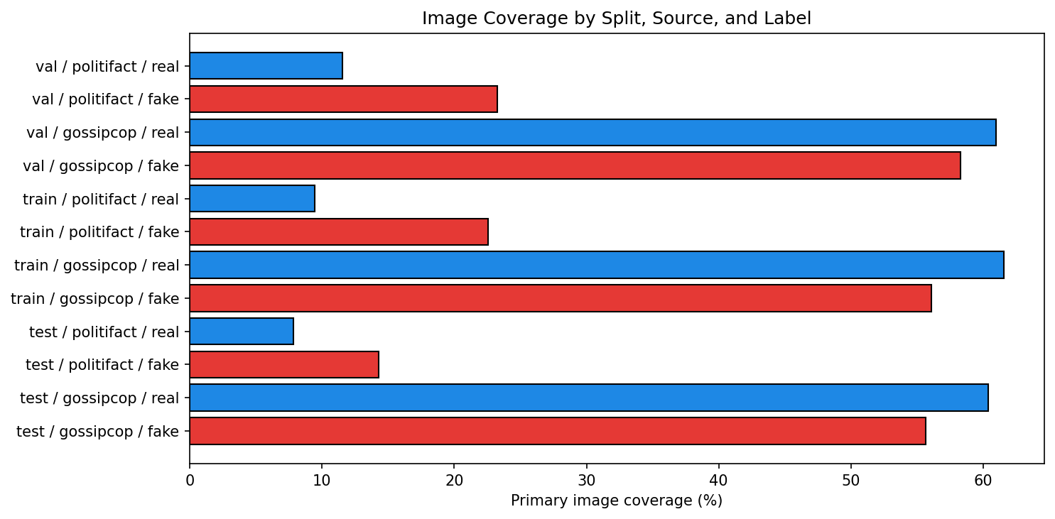
Fig. 1. Image coverage by source and label after image preparation.

IV. Methodology
The project evaluates model families rather than a single architecture. Text baselines include majority class, TF-IDF Logistic Regression, DistilBERT, BERT, and RoBERTa. Image baselines include a small CNN and frozen pretrained encoders. Fusion models concatenate text and image features or use consistency-style interactions: [text, image, |text-image|, text*image].
The final neural training protocol uses Adam or AdamW, cross-entropy loss, validation macro-F1 model selection, early stopping, dropout, and weight decay. Frozen pretrained visual encoders reduce overfitting and runtime while allowing the classifier head to adapt to the fake-news labels.
CLIP is used in two ways. First, CLIP similarity provides an unsupervised image-title alignment diagnostic. Second, Notebook 9 includes a frozen CLIP ViT-B/32 multimodal fusion classifier using [text embedding, image embedding, absolute difference, elementwise product, cosine similarity]. Swin-T is added as a frozen image encoder fused with TF-IDF text features.
Accuracy = (TP + TN) / (TP + TN + FP + FN)
Precision_c = TP_c / (TP_c + FP_c)
Recall_c = TP_c / (TP_c + FN_c)
F1_c = 2 * Precision_c * Recall_c / (Precision_c + Recall_c)
Macro-F1 = (1/C) sum_{c=1}^{C} F1_c
CrossEntropy = - sum_{c=1}^{C} y_c log(p_c)
ROC-AUC = integral TPR(FPR) dFPR; PR-AUC = integral Precision(Recall) dRecall
CLIPSim(x_img, x_txt) = (v_img dot v_txt) / (||v_img|| ||v_txt||)
InconsistencyScore = 1 - normalized(CLIPSim)
Cohen_d = (mean_real - mean_fake) / pooled_std
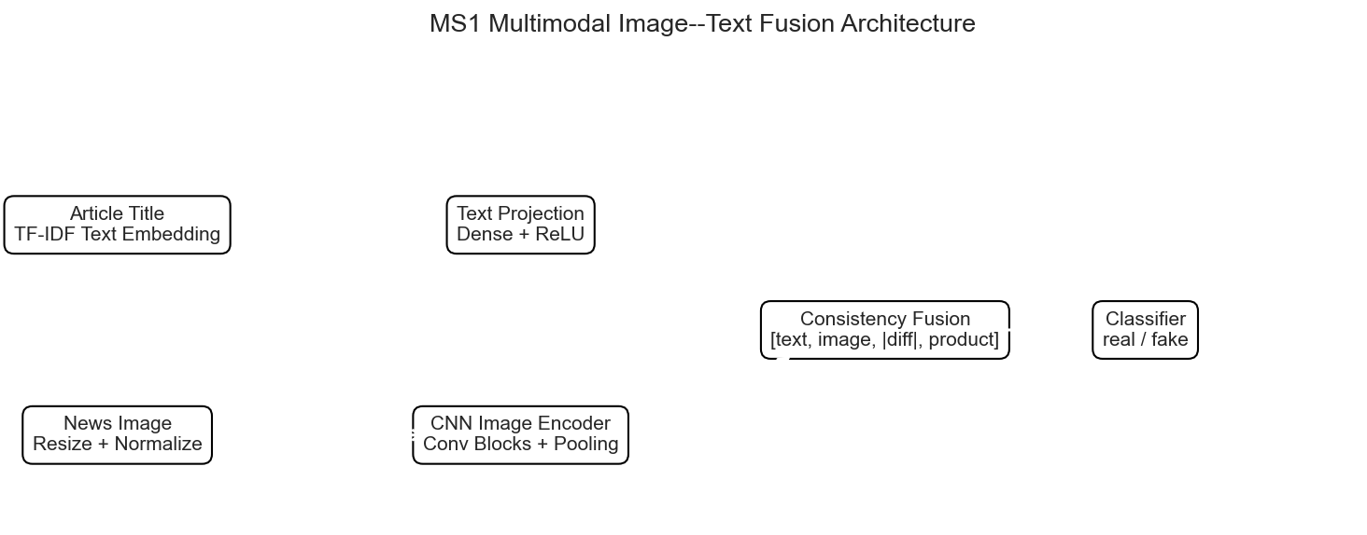
Fig. 2. Overall image-text fusion architecture.

V. Experiments and Results
The primary fair results are computed on the final valid-image, image-deleaked test split. Macro-F1 is emphasized because it balances fake and real performance. Probability-based models also report ROC-AUC and PR-AUC.
TABLE III. PRIMARY FAIR TEST RESULTS
Model | Input | Accuracy | Macro-F1 | ROC-AUC | PR-AUC | Notes
Majority baseline | Title text only | 0.5560 | 0.3573 | - | - | Final de-leaked test split.
Text-only TF-IDF + Logistic Regression | Title text only | 0.7606 | 0.7576 | 0.8303 | 0.8097 | Recomputed on final de-leaked split; no source/domain used.
Transformer text classifier | Title text only | 0.7529 | 0.7511 | 0.8355 | 0.7739 | Reused existing aligned DistilBERT artifact.
Concat fusion CNN+Text | Image/text according to ablation | 0.7664 | 0.7635 | - | - | Mean across seeds from saved deep ablation results.
Consistency fusion CNN+Text | Image/text according to ablation | 0.7664 | 0.7640 | - | - | Mean across seeds from saved deep ablation results.
Frozen ResNet50 fusion CNN+Text | Image/text according to ablation | 0.7490 | 0.7462 | - | - | Mean across seeds from saved deep ablation results.
Image-only CNN | Image/text according to ablation | 0.5586 | 0.5544 | - | - | Mean across seeds from saved deep ablation results.
Late fusion: text probability + CLIP consistency | Text probability + CLIP features + valid-image flag | 0.7529 | 0.7486 | 0.8412 | 0.8317 | Threshold tuned on validation split.
OCR+BLIP+BERT+ResNet50 enriched fusion MLP | Title/text BERT + ResNet50 + OCR BERT + BLIP-caption BERT | 0.6718 | 0.6702 | 0.7026 | 0.6163 | Optional rich frozen-feature branch; train/val/test separated.
CLIP inconsistency alone as score-only detector | Image-title CLIP similarity only | - | - | 0.4366 | 0.4099 | Proxy consistency score, not direct fake-news detection.

The main fair benchmark shows a narrow gap between text-only and multimodal fusion. TF-IDF Logistic Regression obtains 0.7576 macro-F1. Concat and consistency fusion average 0.7635 and 0.7640 macro-F1 across seeds, respectively. Bootstrap confidence intervals and McNemar tests show that these small gains are not large enough to claim a decisive multimodal advantage. Image-only CNN remains far below text-based methods, confirming that images alone are weak for the fake/real label.
TABLE IV. DEEP ABLATION MEAN AND STANDARD DEVIATION ACROSS SEEDS
model | accuracy_mean | accuracy_std | macro_f1_mean | macro_f1_std
Concat fusion CNN+Text | 0.7664 | 0.0019 | 0.7635 | 0.0014
Consistency fusion CNN+Text | 0.7664 | 0.0033 | 0.7640 | 0.0025
Frozen ResNet50 fusion CNN+Text | 0.7490 | 0.0084 | 0.7462 | 0.0083
Image-only CNN | 0.5586 | 0.0310 | 0.5544 | 0.0282

TABLE V. BOOTSTRAPPED MACRO-F1 CONFIDENCE INTERVALS
model | mean_boot | ci_low | ci_high
Text-only TF-IDF + LR | 0.7574 | 0.7198 | 0.7941
concat_fusion_cnn+text_test_predictions_seed123 | 0.7650 | 0.7271 | 0.8034
concat_fusion_cnn+text_test_predictions_seed2026 | 0.7639 | 0.7258 | 0.8006
concat_fusion_cnn+text_test_predictions_seed42 | 0.7623 | 0.7258 | 0.7974
consistency_fusion_cnn+text_test_predictions_seed123 | 0.7626 | 0.7255 | 0.8003
consistency_fusion_cnn+text_test_predictions_seed2026 | 0.7625 | 0.7247 | 0.7988
consistency_fusion_cnn+text_test_predictions_seed42 | 0.7666 | 0.7302 | 0.8043
frozen_resnet50_fusion_cnn+text_test_predictions_seed123 | 0.7521 | 0.7126 | 0.7914

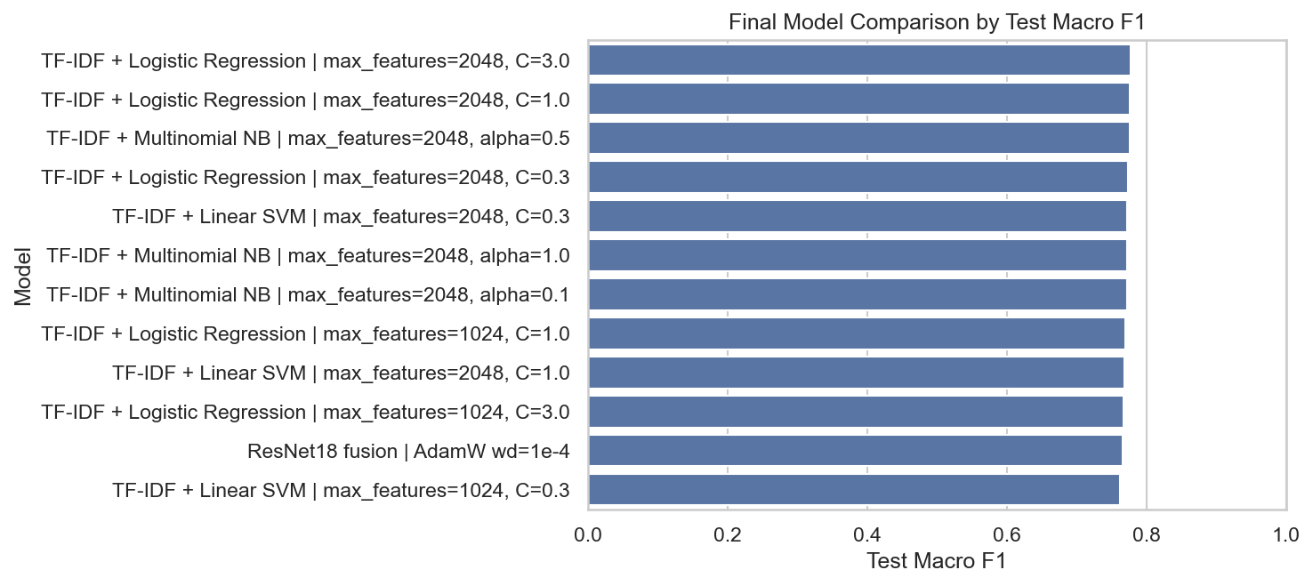
Fig. 3. Final model comparison across text, image-only, and fusion trials.
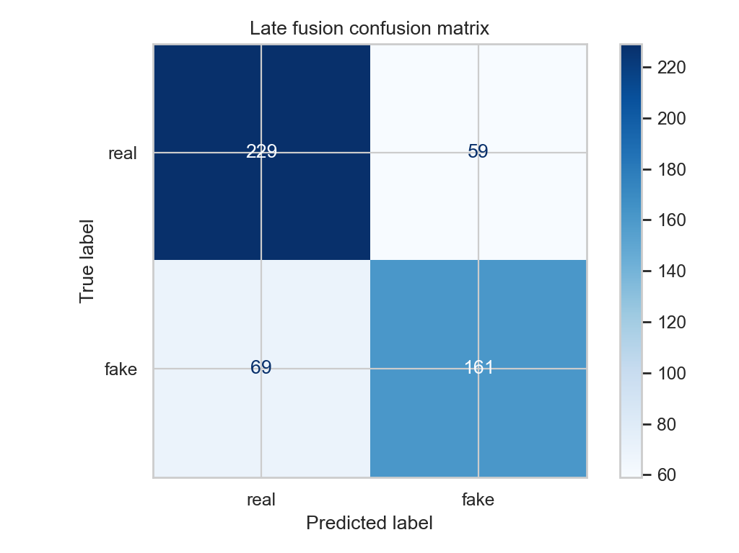
Fig. 4. Late-fusion confusion matrix.

VI. Diagnostic Normal-Split Retraining Experiment
Notebook 9 adds a separate diagnostic experiment. It removes invalid images, removes samples repeatedly misclassified by prior model runs, then creates a new grouped normal shuffle split. This is not treated as the primary benchmark because the removal rule is informed by previous model errors, including test-set behavior. Its value is diagnostic: it estimates how much apparent difficulty may come from noisy, ambiguous, or suspicious examples.
TABLE VI. NORMAL-SPLIT HARD-SAMPLE CLEANING AUDIT
stage | rows
loaded_final_valid_image_splits | 5888
after_empty_id_title_and_duplicate_id_cleaning | 5888
invalid_image_rows_removed | 328
combined_hard_rows_removed_present_after_image_validation | 519
clean_all_filtered | 5041
train | 4035
val | 502
test | 504

TABLE VII. NORMAL-SPLIT LEAKAGE AUDIT
split_pair | id_overlap | normalized_title_overlap
train-val | 0 | 0
train-test | 0 | 0
val-test | 0 | 0

TABLE VIII. NOTEBOOK 9 DIAGNOSTIC RESULTS AFTER HARD-SAMPLE REMOVAL
model | n_samples | accuracy | macro_f1 | roc_auc | pr_auc
BERT | 504 | 0.8492 | 0.8489 | 0.9164 | 0.9196
RoBERTa | 504 | 0.8373 | 0.8364 | 0.9281 | 0.9257
TF-IDF Logistic Regression | 504 | 0.8254 | 0.8244 | 0.8994 | 0.9044
DistilBERT | 504 | 0.8175 | 0.8173 | 0.9086 | 0.9119
soft voting ensemble | 504 | 0.8095 | 0.8084 | 0.9064 | 0.9079
Swin-T | 504 | 0.8095 | 0.8078 | 0.8974 | 0.8997
CLIP ViT-B/32 | 504 | 0.8075 | 0.8057 | 0.9023 | 0.9066
hard voting ensemble | 504 | 0.8056 | 0.8042 | 0.8923 | 0.8750
Concat s2026 | 504 | 0.8016 | 0.8009 | 0.8858 | 0.8878
Frozen ResNet50 s123 | 504 | 0.7996 | 0.7980 | 0.8744 | 0.8791
Concat s42 | 504 | 0.7937 | 0.7936 | 0.8711 | 0.8745
Consistency s123 | 504 | 0.7937 | 0.7925 | 0.8659 | 0.8686
Concat s123 | 504 | 0.7937 | 0.7925 | 0.8713 | 0.8753
Consistency s2026 | 504 | 0.7917 | 0.7909 | 0.8789 | 0.8806
Frozen ResNet50 s2026 | 504 | 0.7897 | 0.7882 | 0.8761 | 0.8752
Frozen ConvNeXt-Tiny s123 | 504 | 0.7837 | 0.7836 | 0.8785 | 0.8819

This diagnostic split produces stronger text-transformer results: BERT reaches 0.8489 macro-F1, RoBERTa reaches 0.8364 macro-F1, and TF-IDF reaches 0.8244 macro-F1. The best multimodal diagnostic trials are CLIP/Swin/voting/CNN-text fusion around 0.80-0.81 macro-F1. This reinforces a key conclusion: the dataset has a strong text signal, and adding images does not automatically outperform a strong text encoder.

VII. Image-Text Consistency Analysis
CLIP similarity was evaluated on valid image-title pairs as a proxy for semantic alignment. The mean similarity for fake articles is slightly higher than for real articles, and the inconsistency score has ROC-AUC below random. This does not mean CLIP is useless; it means FakeNewsNet fake/real labels are not the same as image-text inconsistency labels.
TABLE IX. CLIP IMAGE-TEXT CONSISTENCY ANALYSIS
Metric | Value | Interpretation
Valid image-text pairs | 492.0000 | Rows with usable title and image for CLIP scoring.
Mean CLIP similarity, real | 0.3088 | Average image-title alignment among real-labeled articles.
Mean CLIP similarity, fake | 0.3195 | Average image-title alignment among fake-labeled articles.
Gap: real minus fake | -0.0106 | Positive means real articles are more aligned on average.
Mean inconsistency, real | 0.3154 | Average 1-normalized-similarity for real-labeled articles.
Mean inconsistency, fake | 0.2837 | Average 1-normalized-similarity for fake-labeled articles.
CLIP inconsistency ROC-AUC | 0.4366 | Fake/real ranking by inconsistency proxy; 0.5 is random.
CLIP inconsistency PR-AUC | 0.4099 | Average precision for fake class using inconsistency proxy.
Welch t-test p-value | 0.0120 | Difference in mean similarity, not ground-truth consistency.
Cohen's d | -0.2262 | Effect size for real-vs-fake similarity difference.

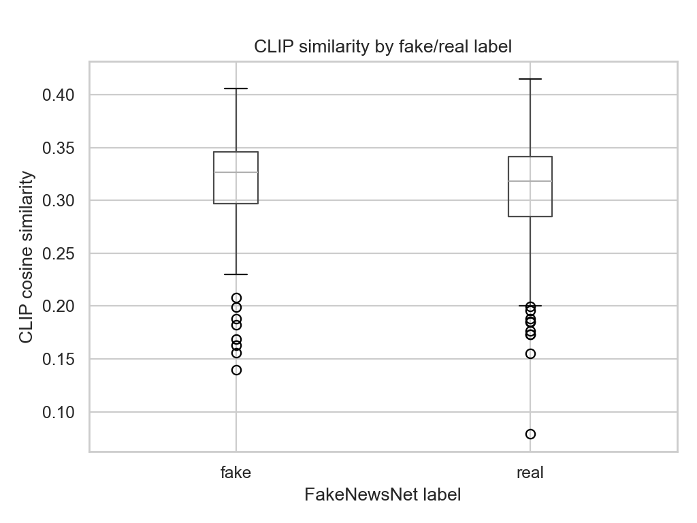
Fig. 5. CLIP similarity distribution by FakeNewsNet label.
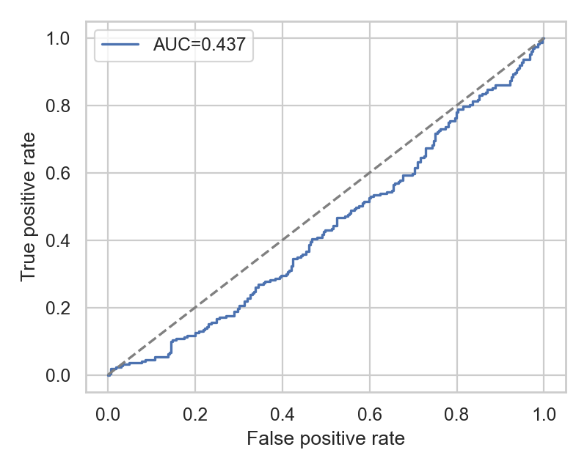
Fig. 6. CLIP inconsistency ROC curve.
Qualitative grids confirm the limitation: fake articles often use visually relevant images, while real articles may use generic or cropped images. Therefore, CLIP alignment is useful for failure analysis and candidate inconsistency discovery, but not sufficient as a standalone fake-news detector.
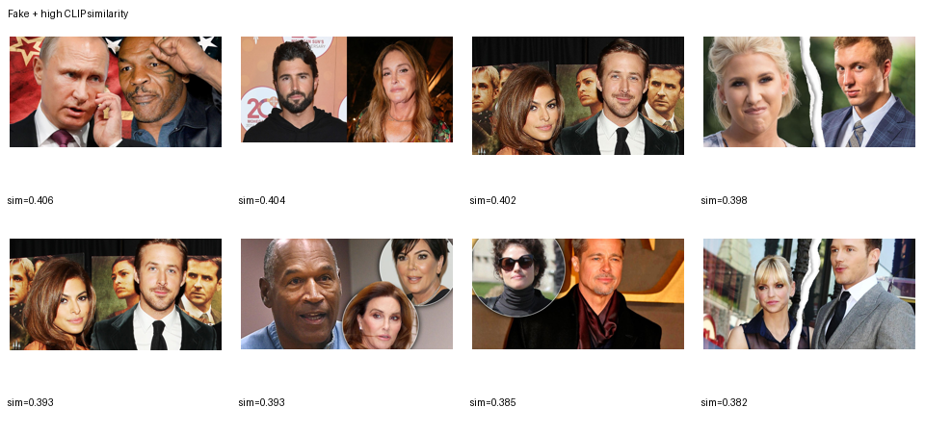
Fig. 7. Fake articles with high CLIP similarity.

VIII. Discussion and Error Analysis
The central finding is that multimodal learning is fragile under noisy weak supervision. The labels indicate fake/real article status, not whether an image contradicts the title. Consequently, text-only models may outperform multimodal models because titles encode stronger dataset cues than images. This is a valid scientific result rather than a failure of implementation.
TABLE X. FAILURE-CASE CATEGORY SUMMARY
failure_category | count
source_domain_bias_check_needed | 114
ambiguous_or_short_title | 8

TABLE XI. PER-SOURCE DIAGNOSTIC METRICS
model | source | n | accuracy | macro_f1 | roc_auc
Text-only TF-IDF + LR | gossipcop | 509 | 0.7662 | 0.7612 | 0.8462
Text-only TF-IDF + LR | politifact | 9 | 0.5556 | 0.5000 | 0.7000
concat_fusion_cnn+text_test_predictions_seed123 | gossipcop | 509 | 0.7741 | 0.7709 | 0.8449
concat_fusion_cnn+text_test_predictions_seed123 | politifact | 9 | 0.4444 | 0.4156 | 0.5000
concat_fusion_cnn+text_test_predictions_seed2026 | gossipcop | 509 | 0.7721 | 0.7692 | 0.8451
concat_fusion_cnn+text_test_predictions_seed2026 | politifact | 9 | 0.4444 | 0.4156 | 0.4000
concat_fusion_cnn+text_test_predictions_seed42 | gossipcop | 509 | 0.7701 | 0.7681 | 0.8445
concat_fusion_cnn+text_test_predictions_seed42 | politifact | 9 | 0.4444 | 0.4156 | 0.4000
consistency_fusion_cnn+text_test_predictions_seed123 | gossipcop | 509 | 0.7701 | 0.7684 | 0.8446
consistency_fusion_cnn+text_test_predictions_seed123 | politifact | 9 | 0.4444 | 0.4156 | 0.5000
consistency_fusion_cnn+text_test_predictions_seed2026 | gossipcop | 509 | 0.7701 | 0.7684 | 0.8411
consistency_fusion_cnn+text_test_predictions_seed2026 | politifact | 9 | 0.4444 | 0.3077 | 0.5500

Per-source evaluation reveals severe imbalance: GossipCop dominates the test set while PolitiFact contains very few examples. This makes PolitiFact numbers unstable, so the report treats source-wise metrics as bias diagnostics rather than definitive claims.
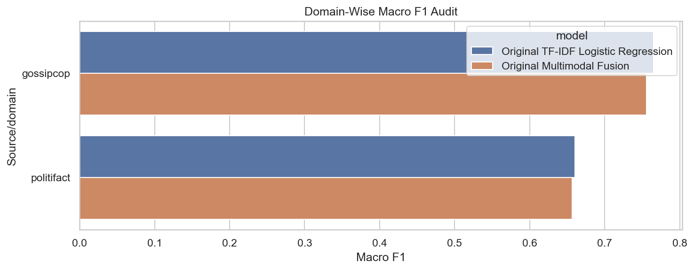
Fig. 8. Per-source macro-F1 diagnostic plot.
TABLE XII. MCNEMAR PAIRWISE TESTS AGAINST TEXT BASELINE
comparison | n01_A_correct_B_wrong | n10_A_wrong_B_correct | p_value | method
Text-only vs concat_fusion CNN+Text_seed123 | 51 | 54 | 0.8454 | exact_binomial
Text-only vs concat_fusion CNN+Text_seed2026 | 52 | 54 | 0.9227 | exact_binomial
Text-only vs concat_fusion CNN+Text_seed42 | 52 | 53 | 1.0000 | exact_binomial
Text-only vs consistency_fusion CNN+Text_seed123 | 52 | 53 | 1.0000 | exact_binomial
Text-only vs consistency_fusion CNN+Text_seed2026 | 53 | 54 | 1.0000 | exact_binomial
Text-only vs consistency_fusion CNN+Text_seed42 | 50 | 54 | 0.7688 | exact_binomial

IX. Engineering Challenges Solved
- Image-content leakage: SHA-256 hashes revealed repeated image content across splits; validation/test rows with prior-split image hashes were filtered, and final audits show zero image-hash overlap.
- Title leakage: normalized-title overlap checks were added so repeated or near-duplicate titles do not appear across train/validation/test.
- Fast overfitting: early multimodal models overfit within a few epochs; final training added dropout, lower learning rates, weight decay, class weighting where useful, and early stopping.
- Pretrained model availability: BERT, CLIP, BLIP, EasyOCR, ResNet50, ConvNeXt, and Swin may require local caches; optional cells now skip cleanly or save cached feature artifacts.
- Article-body extraction failure: many historical URLs were unavailable; the content pipeline preserves rows by falling back from article body to title and records content coverage.
- Conceptual label mismatch: the report separates fake/real classification from image-text consistency, avoiding the mistake of treating CLIP similarity as a truth detector.
- Post-hoc cleaning risk: hard-sample removal improves diagnostic results but is explicitly reported as a dataset-quality audit rather than as the main benchmark.

X. Reproducibility and Repository Organization
Active GitHub repository: https://github.com/mostafaelofy629/Fake-News.git.
The notebooks are organized by workflow: Notebook 01 performs dataset download checks and EDA; Notebook 02 performs cleaning and splitting; Notebook 03 contains the main multimodal training and failure analysis; Notebook 04 audits dataset credibility; Notebook 05 runs the rich OCR/BLIP branch; Notebooks 06-07 build content/title splits; Notebook 08 studies GT6 filtering; Notebook 09 performs the hard-sample-cleaned normal-split retraining trials.
Important artifacts include final_artifacts/report_table_classification_results.csv for the primary benchmark, final_artifacts/report_table_clip_consistency.csv for CLIP analysis, final_artifacts/final_per_source_metrics.csv for source diagnostics, and normal_split_gt6_plus_trainhard_artifacts/normal_split_* for Notebook 9 diagnostic results.

XI. Timeline and Task Assignment
TABLE XIII. FINAL PROJECT TIMELINE WITH DATES AND ASSIGNMENTS
Date | Task | Responsible
June 1-3, 2026 | Dataset EDA, source/domain audit, baseline requirements review | Mostafa + Mohamed Hasan
June 4-5, 2026 | Image download, image validation, image manifests | Mohamed Ghanem
June 6-7, 2026 | TF-IDF and first transformer text baselines | Mostafa
June 8-9, 2026 | CNN, concat fusion, consistency fusion, ResNet50 trials | Mostafa + Mohamed Ghanem
June 10, 2026 | Leakage checks, valid-image-only evaluation, per-source metrics | Mohamed Hasan + Mostafa
June 11, 2026 | Notebook 9 diagnostic retraining, ConvNeXt, CLIP, Swin, RoBERTa/DistilBERT additions | Mostafa
June 12-13, 2026 | Final presentation, report polishing, artifact verification | All members

XII. Team Contributions
Mohamed Hasan: coordinated project framing and rubric alignment, emphasized the distinction between fake/real labels and image-text consistency, reviewed leakage/source-bias risks, and helped structure discussion, limitations, and presentation narrative.
Mostafa Elofy: implemented the main notebooks and experiments, including TF-IDF, transformer text baselines, multimodal fusion, CLIP/Swin/ConvNeXt additions, hard-sample analysis, artifact generation, report tables, and final debugging.
Mohamed Ghanem: contributed to image-side processing, image validation, CNN/ResNet-style visual baselines, visual artifact inspection, and qualitative image-text failure-case review.

XIII. GenAI Disclosure
Generative AI assistance was used as a coding and writing support tool for notebook organization, debugging, report drafting, wording refinement, and experiment-summary generation. All reported metrics, tables, figures, and conclusions are based on locally generated project artifacts. The team reviewed and accepted the final content and remains responsible for all submitted work.

XIV. Conclusion
The final project demonstrates that careful multimodal fake-news detection requires more than adding an image encoder. On the fair image-deleaked split, text remains highly competitive and multimodal gains are small. Image-only models are weak, CLIP inconsistency alone does not separate fake from real, and rich multimodal features do not automatically outperform simpler text baselines. The strongest contribution is therefore the complete experimental audit: leakage-free splits, multiple baselines, pretrained visual/text encoders, failure analysis, and a clear explanation of why image-text consistency and factual truth are related but not identical.

References
[1] H. Rashkin, E. Choi, J. Y. Jang, S. Volkova, and Y. Choi, "Truth of Varying Shades: Analyzing Language in Fake News and Political Fact-Checking," EMNLP, 2017.
[2] Z. Jin, J. Cao, H. Guo, Y. Zhang, and J. Luo, "Multimodal Fusion with Co-Attention Networks for Fake News Detection," ACL, 2017.
[3] D. Khattar, J. S. Goud, M. Gupta, and V. Varma, "MVAE: Multimodal Variational Autoencoder for Fake News Detection," WWW Companion, 2019.
[4] K. Shu, D. Mahudeswaran, S. Wang, D. Lee, and H. Liu, "FakeNewsNet: A Data Repository with News Content, Social Context, and Spatiotemporal Information," Big Data, 2020.
[5] J. Devlin, M.-W. Chang, K. Lee, and K. Toutanova, "BERT: Pre-training of Deep Bidirectional Transformers," NAACL-HLT, 2019.
[6] V. Sanh, L. Debut, J. Chaumond, and T. Wolf, "DistilBERT, a distilled version of BERT," NeurIPS Workshop, 2019.
[7] Y. Liu et al., "RoBERTa: A Robustly Optimized BERT Pretraining Approach," arXiv:1907.11692, 2019.
[8] A. Radford et al., "Learning Transferable Visual Models From Natural Language Supervision," ICML, 2021.
[9] K. He, X. Zhang, S. Ren, and J. Sun, "Deep Residual Learning for Image Recognition," CVPR, 2016.
[10] Z. Liu et al., "A ConvNet for the 2020s," CVPR, 2022.
[11] Z. Liu et al., "Swin Transformer: Hierarchical Vision Transformer using Shifted Windows," ICCV, 2021.
[12] J. Li et al., "BLIP: Bootstrapping Language-Image Pre-training for Unified Vision-Language Understanding and Generation," ICML, 2022.
[13] Y. Zhou and R. Zafarani, "A Survey of Fake News: Fundamental Theories, Detection Methods, and Opportunities," ACM Computing Surveys, 2020.
[14] K. Shu, S. Wang, and H. Liu, "Beyond News Contents: The Role of Social Context for Fake News Detection," WSDM, 2019.

Appendix: Artifact Map
- 01_FakeNewsNet_EDA_FINAL_Enhanced.ipynb: dataset gate and EDA.
- 02_Dataset_Cleaning_and_Splitting_FINAL.ipynb: cleaning, valid-image-only, and image-deleaked splits.
- 03_Multimodal_Model_Training_FINAL_Enhanced.ipynb: main model training, leakage checks, voting, and failure cases.
- 05_Run_Rich_Multimodal_Branch.ipynb: OCR/BLIP/BERT/ResNet50 rich feature branch.
- 06_Article_Content_Extraction_and_Content_Splits.ipynb and 07_Build_Content_Title_Modeling_Splits.ipynb: content/title split construction.
- 09_GT6_Clean_All_CrossValidation_Preparation.ipynb: hard-sample-cleaned normal split and final BERT/RoBERTa/CLIP/Swin/ConvNeXt trials.

