**Name : Mostafa Emad abdelglil Diab**

**B.N: 918**

**Date : 5/6/2020**

**Topic:** **Programming Languages**

**Github link :** [**https://mostafaemaddiab.github.io/html.Programming-Languages/**](https://mostafaemaddiab.github.io/html.Programming-Languages/)**.**

**Github page :**

**Application brief :**

Programming languages are not very different from spoken languages. Learning any language requires an understanding of the building blocks and the grammar that govern the construction of statements in that language. This unit will serve as an introduction to programming languages, taking you through the history of programming languages. We will also learn about the various universal properties of all programming languages and identify distinct design features of each programming language. By the end of this unit, you will have a deeper understanding of what a programming language is and the ability to recognize the properties of programming languages

**Screeshots :**

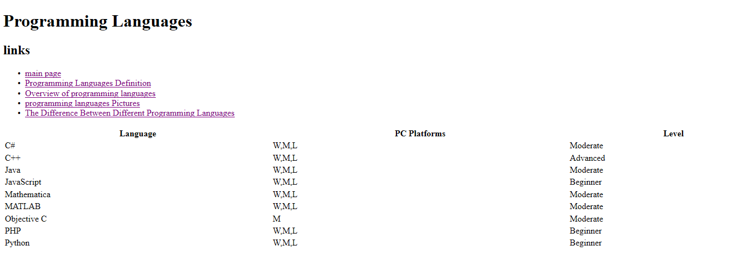

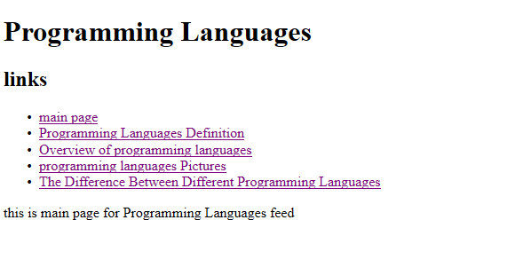

**Source Code :** 