Saudi Arabia Railways (SAR)
0580-Security Technology Salutation after eliminating Passenger Checking Roles
Contract with ETECHS
Baseline Programme Narrative
For SAR review and approval
Project 0580 | Rev 1 | Data date and NTP: 01 November 2026 | P6 file: 0580_Schedule_Baseline_Rev1.xer

1. Purpose and basis of the programme
This narrative describes the baseline programme (Rev 1) of project 0580-Security Technology Salutation after eliminating Passenger Checking Roles, covering 14 stations on three railways (North South Railway, East West Railway and Haramain High Speed Rail). It is delivered as a Primavera P6 24 XER file with 614 activities (522 tasks and 92 milestones) and 931 logic links. It runs from the Notice to Proceed milestone on 01 Nov 2026 to the contract completion milestone on 31 Oct 2029.
Source: the contract file only (conditions, Annex 2 scope of work, Annex 3 price table, Annex 4 clarifications, Annex 5 compliance table), plus the planning instructions of the Contractor in this revision. Durations, logic and station sequence are Contractor planning assumptions offered for SAR approval. They are not contract-stated, except the 36 month term, the payment milestones and the 21 day review period.

2. Changes in this revision
Item | Change
First six months | Months 1-2 mobilization and the survey access permit (the permit takes two months); months 3-6 design (four months) which starts with the site survey. Milestones: mobilization and permits complete, design complete.
Design rule | At every station: two months of mobilization and survey, then four months of design starting two months after the station mobilization starts; enabling works start in the last two months of design (two months of overlap). At the priority stations this is months 1-2, 3-6 and 5-6 of the project.
Priority | Makkah and Riyadh (Thumamah) are Priority 1 and run works in parallel with design. Riyadh (Malaz) is Priority 2.
Proof of concept | POC at Riyadh (Thumamah) for CCTV, inspection and access control, and network, with one month for consultant inspection and approval.
Review period | Every SAR review of a submission is 21 days (15 working days). Survey approval was 5 days and is now 21 days.
WBS | Stations are now level 3 of the WBS (project, EPC phase, station). Priority and railway are activity codes.
Identity | Project number 0580 and the official name on every output. Programme phase added as an activity code.

3. Key dates and milestones
ID | Milestone | Date
PRJ-M0000 | Notice to Proceed - project start (1 Nov 2026, editable) | 01 Nov 2026
PRJ-M1100 | MS1 Mobilization complete (payment milestone 20%) | 10 Dec 2026
PRJ-M1150 | Mobilization and survey permits complete (end of month 2) | 31 Dec 2026
PRJ-M2100 | Detailed baseline programme approved | 21 Mar 2027
PRJ-M1250 | Design complete - priority stations (end of month 6) | 29 Apr 2027
PRJ-MX99 | Contract completion - end of 36-month term | 31 Oct 2029

Contract completion is driven by logic: it is linked from NTP with a lag equal to the 36 month term and carries no date constraint. If the NTP date changes, every date moves with it.

4. The first six months
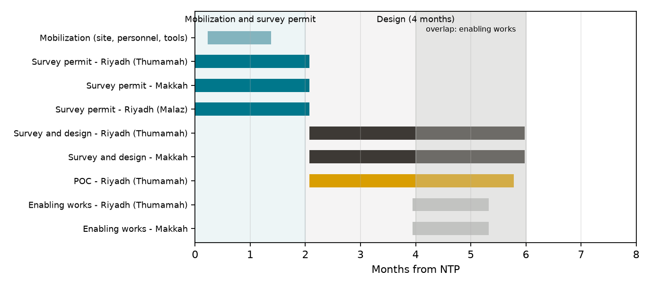
Phase | Start | Finish | Content
Mobilization and survey permit (months 1-2) | 01 Nov 2026 | 31 Dec 2026 | Mobilization, initial baseline, and the two month site access permit for the survey at Riyadh (Thumamah), Makkah and Riyadh (Malaz)
Design including survey (months 3-6) | 03 Jan 2027 | 29 Apr 2027 | Site survey, concept, preliminary, detailed and IFC design with HCIS documents; each stage submitted and approved in 21 days
Enabling works start (month 5) | 01 Mar 2027 | 11 Apr 2027 | Site preparation, setting out, temporary works, cable routes, duct banks and plinths, in parallel with the last two months of design

The survey needs a site access permit and the permit takes two months, so months 1 and 2 are mobilization and the permit (activity E1005 at each station, held in the Mobilization branch of the WBS). The survey is the first part of design, so design starts when the permit is granted and lasts four months in total, survey included. At the priority stations the two month window is held by milestone PRJ-M1150; at the other stations design starts when their own permit ends. Enabling works start two months before the end of design, so design and execution overlap by two months. No date constraint is used.

5. Priority stations
Priority 1: Makkah (Haramain) and Riyadh (Thumamah, North South Railway). Their permits are applied for first and their enabling and civil works run in parallel with design. Equipment is manufactured only after SAR approval of the engineering (milestone MS3), so no equipment is ordered before approval. Priority 2: Riyadh (Malaz, East West Railway), permitted in the same two months. The remaining stations follow in waves after the detailed baseline is approved, each with the same four month design.
Station | Railway | Priority | Permit start | Station finish
Riyadh (Thumamah) | NSR | Priority 1 | 01 Nov 2026 | 07 Feb 2028
Makkah | HHR | Priority 1 | 01 Nov 2026 | 07 Aug 2028
Riyadh (Malaz) | EWR | Priority 2 | 01 Nov 2026 | 30 Jan 2028
Jeddah | HHR | Standard | 22 Mar 2027 | 26 Nov 2028
Dammam | EWR | Standard | 13 May 2027 | 30 Aug 2028
Al Qassim | NSR | Standard | 07 Jul 2027 | 25 Oct 2028
Hufuf | EWR | Standard | 07 Jul 2027 | 17 Oct 2028
Al Majma'ah | NSR | Standard | 17 Aug 2027 | 05 Dec 2028
KAEC | HHR | Standard | 30 Nov 2027 | 10 Jul 2029
Madinah | HHR | Standard | 30 Nov 2027 | 16 Jul 2029
Abqaiq | EWR | Standard | 11 Jan 2028 | 01 May 2029
Hail | NSR | Standard | 01 Feb 2028 | 05 Jun 2029
Al Jouf | NSR | Standard | 10 Apr 2028 | 06 Aug 2029
Al Qurayyat | NSR | Standard | 29 May 2028 | 17 Sep 2029

6. Proof of concept at Riyadh (Thumamah)
The POC covers three systems: CCTV, inspection and access control (Annex 3 section A3), and the network. It sits inside engineering because it validates the design before manufacture. SAR and the consultant approve the POC plan within 21 days, the Contractor builds and tests the POC, and the consultant then inspects and approves it within one month (22 working days: 10 for site inspection and 12 for approval). POC approval is a predecessor of the engineering approval milestone MS3 at this station, so manufacture of its equipment waits for it.
ID | Activity | Start | Finish | Days
NRY-POC1010 | POC plan and test procedure: submittal - Riyadh (Thumamah) | 03 Jan 2027 | 07 Jan 2027 | 5
NRY-POC1020 | POC plan: SAR and consultant review and approval (21 days) - Riyadh (Thumamah) | 10 Jan 2027 | 28 Jan 2027 | 15
NRY-POC2010 | POC network: install test bed and fibre/IP backbone - Riyadh (Thumamah) | 31 Jan 2027 | 09 Feb 2027 | 8
NRY-POC2020 | POC CCTV: install and configure demonstration cameras and analytics - Riyadh (Thumamah) | 10 Feb 2027 | 28 Feb 2027 | 12
NRY-POC2030 | POC inspection and access control: install and configure demonstration points - Riyadh (Thumamah) | 10 Feb 2027 | 28 Feb 2027 | 12
NRY-POC3010 | POC integrated testing and demonstration (cameras, inspection, network) - Riyadh (Thumamah) | 01 Mar 2027 | 17 Mar 2027 | 8
NRY-POC3020 | POC test report: submittal - Riyadh (Thumamah) | 18 Mar 2027 | 24 Mar 2027 | 5
NRY-POC4010 | POC site inspection and witnessing with consultant - Riyadh (Thumamah) | 25 Mar 2027 | 07 Apr 2027 | 10
NRY-POC4020 | POC approval by SAR and consultant (inspection and approval within one month) - Riyadh (Thumamah) | 08 Apr 2027 | 25 Apr 2027 | 12
NRY-POC4100 | POC approved - Riyadh (Thumamah) | 26 Apr 2027 | 25 Apr 2027 | 0

Cost note: Annex 3 has no separate POC item. The POC activities are funded from 15% of the Riyadh (Thumamah) design and engineering milestones (MS2 and MS3) until SAR confirms otherwise.

7. Review and approval periods
All SAR reviews and approvals of submissions are 21 days. In a Sunday to Thursday calendar that is three working weeks, so each approval activity is 15 working days. This applies to the initial and detailed baseline programme, the survey, every design stage, HCIS documents, POC plan, as-built documents and the taking-over application. The POC inspection and approval, and the mock-up approval at Riyadh (Thumamah), are separate one month periods (22 working days) as instructed.
118 approval activities are loaded. Their durations: 10 days x 1, 12 days x 1, 15 days x 101, 22 days x 1, 45 days x 14 (working days).

8. Calendar
Single project calendar: Sunday to Thursday, 8 hours per day (08:00 to 12:00 and 13:00 to 17:00); Friday and Saturday are non-working. The contract defines a working day as a bank-open day, and dates falling on a non-working day move to the next working day. National holidays are calendar exceptions: Founding Day (22 Feb), National Day (23 Sep), Eid al-Fitr and Eid al-Adha.
The Eid dates are estimates from the Islamic calendar. Confirm them against the official announcement before the baseline is submitted.
From | To | Holiday
22 Feb 2027 | 22 Feb 2027 | Founding Day
07 Mar 2027 | 11 Mar 2027 | Eid al-Fitr (estimated)
16 May 2027 | 20 May 2027 | Eid al-Adha (estimated)
23 Sep 2027 | 23 Sep 2027 | National Day
20 Feb 2028 | 24 Feb 2028 | Eid al-Fitr (estimated)
22 Feb 2028 | 22 Feb 2028 | Founding Day
30 Apr 2028 | 04 May 2028 | Eid al-Adha (estimated)
23 Sep 2028 | 23 Sep 2028 | National Day
11 Feb 2029 | 15 Feb 2029 | Eid al-Fitr (estimated)
22 Feb 2029 | 22 Feb 2029 | Founding Day
22 Apr 2029 | 26 Apr 2029 | Eid al-Adha (estimated)
23 Sep 2029 | 23 Sep 2029 | National Day

9. Work breakdown structure
The WBS follows EPC. Level 1 is the project (0580), level 2 the EPC phase (Engineering, Procurement, Construction, Commissioning and handover, plus Project management), level 3 the station, level 4 the design stage or work package (enabling works, civil, installation, POC), and level 5 the submittal, approval or area. There are 534 nodes. The survey access permits sit under Project management and mobilization, in the Mobilization branch (one node per station). Levels 6 to 8 are not used because the contract gives no zone-level data; they can be added when it does.
WBS level | Nodes
1 | 1
2 | 5
3 | 59
4 | 268
5 | 201

10. Engineering stages
Engineering is divided by recognised design stage: site survey (after the two month access permit), concept design, preliminary design, detailed design, issued for construction, HCIS submission and as-built. Within each stage there is a submittal and a 21 day SAR approval. Procurement is released after the engineering approval milestone (MS3).

11. Logic and sequencing
Relationships are mainly finish to start, with a few start to start and finish to finish links. There are no date constraints. Priority stations start first; the other stations follow in waves calibrated so the last station completes inside the 36 month term. The only activity without a predecessor is NTP, and the only activity without a successor is contract completion.

12. Station finish dates
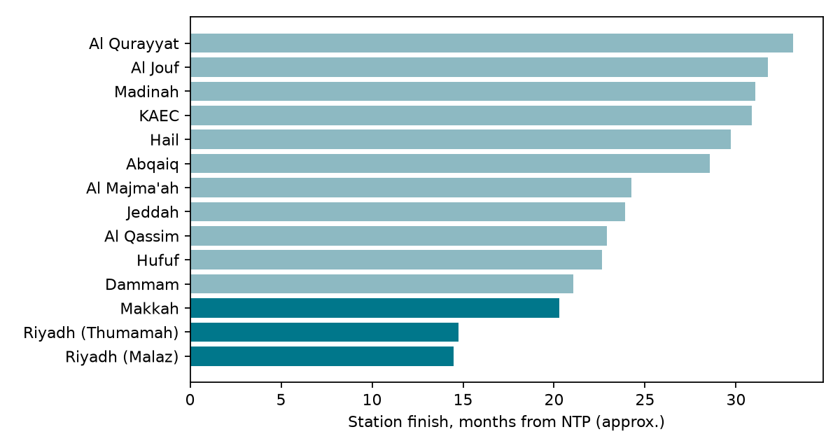

13. Longest path and near-critical activities
The contract completion milestone is held by the 36 month term, so no activity has zero float against it. The longest physical path finishes 21 working days before the contract end date, and that margin is the project float. 32 tasks sit on this longest path and 8 more are within 20 working days of it. The first 25 in date order are listed below.
ID | Activity | Start | Finish | Float (working days)
NRY-E1005 | Mobilization: site access permit for the survey - application and approval (two months) - Riyadh (Thumamah) | 01 Nov 2026 | 31 Dec 2026 | 21
HMK-E1005 | Mobilization: site access permit for the survey - application and approval (two months) - Makkah | 01 Nov 2026 | 31 Dec 2026 | 21
ERY-E1005 | Mobilization: site access permit for the survey - application and approval (two months) - Riyadh (Malaz) | 01 Nov 2026 | 31 Dec 2026 | 21
PRJ-A1040 | Mobilization: site establishment, offices, personnel and tools | 08 Nov 2026 | 10 Dec 2026 | 36
PRJ-A1050 | Mobilization submittals: QC programme and ITP, HSE, security, procurement and shipping plan | 08 Nov 2026 | 03 Dec 2026 | 41
NRY-E1010 | Survey: submittal of site survey and as-found report - Riyadh (Thumamah) | 03 Jan 2027 | 14 Jan 2027 | 31
ERY-E1010 | Survey: submittal of site survey and as-found report - Riyadh (Malaz) | 03 Jan 2027 | 14 Jan 2027 | 31
HMK-E1010 | Survey: submittal of site survey and as-found report - Makkah | 03 Jan 2027 | 28 Jan 2027 | 21
PRJ-A2010 | Detailed baseline programme (within 21 days after survey) | 31 Jan 2027 | 18 Feb 2027 | 21
PRJ-A2020 | SAR review and approval of detailed baseline | 21 Feb 2027 | 21 Mar 2027 | 21
NQR-E1005 | Mobilization: site access permit for the survey - application and approval (two months) - Al Qurayyat | 29 May 2028 | 30 Jul 2028 | 21
NQR-E1010 | Survey: submittal of site survey and as-found report - Al Qurayyat | 31 Jul 2028 | 13 Aug 2028 | 21
NQR-E1030 | Concept design: submittal - Al Qurayyat | 14 Aug 2028 | 23 Aug 2028 | 21
NQR-E1050 | Preliminary design: submittal - Al Qurayyat | 24 Aug 2028 | 12 Sep 2028 | 21
NQR-E1070 | Detailed design: submittal (drawings, BOQ, data sheets) - Al Qurayyat | 13 Sep 2028 | 12 Oct 2028 | 21
NQR-E1110 | HCIS Stage 3 and 4 documents: preparation - Al Qurayyat | 25 Sep 2028 | 26 Oct 2028 | 21
NQR-E1080 | Detailed design: SAR review and approval - Al Qurayyat | 15 Oct 2028 | 02 Nov 2028 | 31
NQR-E1090 | IFC and shop drawings: submittal - Al Qurayyat | 15 Oct 2028 | 26 Oct 2028 | 21
NQR-E1100 | IFC and shop drawings: SAR approval and release - Al Qurayyat | 29 Oct 2028 | 16 Nov 2028 | 21
NQR-E1120 | HCIS Stage 3 and 4 documents: SAR final review and HCIS submission - Al Qurayyat | 29 Oct 2028 | 16 Nov 2028 | 21
NQR-P1010 | Manufacture CCTV cameras and analytics - Al Qurayyat | 19 Nov 2028 | 04 Mar 2029 | 21
NQR-P1020 | Manufacture video management servers, storage and video wall - Al Qurayyat | 19 Nov 2028 | 04 Mar 2029 | 21
NQR-P1030 | Manufacture access control and intercom equipment - Al Qurayyat | 19 Nov 2028 | 04 Mar 2029 | 21
NQR-P1040 | Manufacture UPS, network switches and field cabinets - Al Qurayyat | 19 Nov 2028 | 04 Mar 2029 | 21
NQR-P1050 | Factory acceptance test at vendor premises - Al Qurayyat | 05 Mar 2029 | 18 Mar 2029 | 21

14. Resources and cost loading
Every task carries two resources. Milestones carry none.
Resource | Type | Use
COST-SAR | Material | Contract cost quantity in SAR. Price 0. Total 62,000,000 SAR.
PROG-WT | Material | Progress value in SAR (progress share x 62,000,000). Price 1, so it carries the budget cost. All activities use Physical % complete.

Because PROG-WT has price 1 and COST-SAR has price 0, the P6 budget, earned value, CPI and SPI are all in SAR on the fair EPC progress distribution. To view the contract payment-condition cost instead, swap the two prices (COST-SAR 1, PROG-WT 0). Never set both to 1.
Cost comes from the contract: the Annex 3 station price multiplied by the clause 15 payment milestone, spread to activities by distribution keys. Mobilization (MS1, 20% of the total price) sits at project level. The activity-by-activity mapping and the invoices per month are in 0580_BOQ_Cost_Mapping.xlsx. Progress is a fair EPC distribution (Engineering 12, Procurement 40, Construction 33, Commissioning and handover 15 per station), weighted by each station's price share, plus 4% for project-level activities.
Milestone | Description | Share of price
MS1 | Mobilization | 20%
MS2 | Engineering submittal | 10%
MS3 | SAR approval of engineering | 10%
MS4 | Material delivery | 20%
MS5 | Installation | 20%
MS6 | Testing and commissioning (SAT) | 10%
MS7 | Final acceptance and handover | 10%

15. S-curve
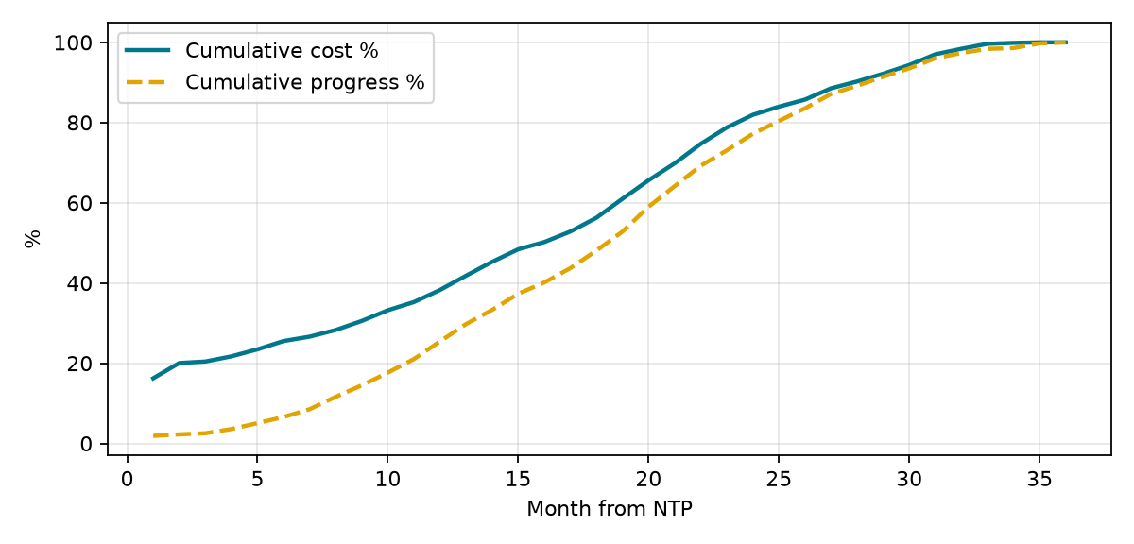
Cost follows the contract payment milestones. Progress is smoother because it is distributed by effort. The two curves differ on purpose: cost is a payment profile, progress is physical.

16. Activity codes
Eleven global activity code types are loaded and every activity carries all of them: EPC phase, Area, Station, Railway, Discipline, Responsibility, Payment milestone, Design stage, Submittal or approval, Priority and Programme phase. The values are listed on the Activity_Codes sheet of the BOQ workbook.

17. Changing the start date
NTP is a start milestone with no constraint. To move the project, change the project Planned Start (Project > Details > Dates), then schedule with F9 using Retained Logic. All dates, including contract completion, move together. The holidays are fixed dates, so after a change review the calendar for the holidays that the new window crosses.

18. Assumptions and exclusions
- Durations and station order are Contractor planning assumptions.
- Eid dates are estimates.
- The 21 day SAR review is read as 21 calendar days, which is 15 working days in the Sunday to Thursday calendar. A longer review is an extension of time matter under the contract.
- Priority 1 means Makkah and Riyadh (Thumamah). Riyadh (Malaz) is treated as Priority 2.
- Mock-up approval: after the installation at Riyadh (Thumamah) is complete, SAR visits the site and approves the executed works (one month, 22 working days) so that the solution can be rolled out to the other stations. It is a predecessor of the SAT milestone (MS6) and the handover at that station only; it does not gate the installation of the other stations. Cost has no Annex 3 item and is carved from 3% of the testing milestone.
- POC cost is carved from the design package of Riyadh (Thumamah) because Annex 3 has no POC item. The POC inspection system is mapped to access control and intercom (section A3).
- Enabling and civil works start two months before the end of design at every station, before the engineering approval milestone, at the Contractor risk; equipment is not ordered before approval.
- Site access, permits and railway possessions are assumed available. No possession restrictions are modelled.
- The defects liability period and post-acceptance support are not in the programme.
- Cost is a payment profile at BOQ value, excluding VAT.
- The official project name is used as supplied. Please confirm its spelling before issue.
- The file was checked structurally and with an independent forward pass; see the read-me for what was and was not tested in P6.

19. Risks to the programme
Risk | Mitigation
Eid dates differ from the estimate | Confirm before submission and reschedule
Long-lead equipment at Haramain stations (largest value) | Early procurement approval and FAT planning
SAR approval time above 21 days | Early submission and an approval log
POC not approved within one month | Early plan approval; consultant booked in advance
Enabling works before engineering approval | Limit to non-design-dependent work; confirm layouts at concept approval
Station access and railway possession | Coordinate during mobilization
Conflict between Annex 4 item 33 (fast-track) and Annex 5 on HCIS | Clarify with SAR before design submittals

20. Submission checklist
- Confirm the project name spelling and the Eid dates.
- Open the XER in P6 24, schedule it, and compare dates with this narrative.
- Confirm the priority order and the POC scope with SAR.
- Check the cost mapping against the Annex 3 price table.
- Submit the XER, narrative, BOQ mapping and read-me together.

