Saudi Arabia Railways (SAR)
Passengers' Security Checking Systems
Contract with ETECHS
Baseline Programme Narrative
For SAR review and approval
Revision 0 (initial baseline) | Data date and NTP: 01 November 2026 | P6 file: SAR_Security_Program_Baseline.xer

1. Purpose and basis of the programme
This narrative describes the initial baseline programme for the Passengers' Security Checking Systems at 14 stations on three railways (North South Railway, East West Railway and Haramain High Speed Rail). It is delivered as a Primavera P6 24 XER file with 558 activities (470 tasks and 88 milestones) and 855 logic links. It runs from the Notice to Proceed milestone on 01 Nov 2026 to the contract completion milestone on 31 Oct 2029.
Source: the contract file only (conditions, Annex 2 scope of work, Annex 3 price table, Annex 4 clarifications, Annex 5 compliance table). Durations, logic and station sequence are Contractor planning assumptions offered for SAR approval. They are not contract-stated, except the 36 month term, the payment milestones and the review period.

2. Key dates and milestones
ID | Milestone | Date | Float (working days)
PRJ-M0000 | Notice to Proceed - project start (1 Nov 2026, editable) | 01 Nov 2026 | 0
PRJ-M1100 | MS1 Mobilization complete (payment milestone 20%) | 10 Dec 2026 | 22
PRJ-M2100 | Detailed baseline programme approved | 18 Feb 2027 | 22
PRJ-MX99 | Contract completion - end of 36-month term | 31 Oct 2029 | 0

Contract completion is driven by logic: it is linked from NTP with a lag equal to the 36 month term and carries no date constraint. If the NTP date changes, every date moves with it.

3. Calendar
Single project calendar: Sunday to Thursday, 8 hours per day (08:00 to 12:00 and 13:00 to 17:00); Friday and Saturday are non-working. The contract defines a working day as a bank-open day, and dates falling on a non-working day move to the next working day. National holidays are calendar exceptions: Founding Day (22 Feb), National Day (23 Sep), Eid al-Fitr and Eid al-Adha.
The Eid dates are estimates from the Islamic calendar. Confirm them against the official announcement before the baseline is submitted.
From | To | Holiday
22 Feb 2027 | 22 Feb 2027 | Founding Day
07 Mar 2027 | 11 Mar 2027 | Eid al-Fitr (estimated)
16 May 2027 | 20 May 2027 | Eid al-Adha (estimated)
23 Sep 2027 | 23 Sep 2027 | National Day
20 Feb 2028 | 24 Feb 2028 | Eid al-Fitr (estimated)
22 Feb 2028 | 22 Feb 2028 | Founding Day
30 Apr 2028 | 04 May 2028 | Eid al-Adha (estimated)
23 Sep 2028 | 23 Sep 2028 | National Day
11 Feb 2029 | 15 Feb 2029 | Eid al-Fitr (estimated)
22 Feb 2029 | 22 Feb 2029 | Founding Day
22 Apr 2029 | 26 Apr 2029 | Eid al-Adha (estimated)
23 Sep 2029 | 23 Sep 2029 | National Day

4. Work breakdown structure
The WBS follows EPC: Engineering, Procurement, Construction, and Commissioning and handover, with Project management and milestones at project level. It has 515 nodes over 6 levels: project, railway, station, EPC phase, design stage or work package, and area. Levels 7 and 8 were not needed because the contract gives no zone-level data; they can be added when zone data is available.
WBS level | Nodes
1 | 1
2 | 5
3 | 19
4 | 56
5 | 238
6 | 196

5. Engineering stages
Engineering is divided by recognised design stage: site survey, concept design, preliminary design, detailed design, issued for construction, HCIS submission and as-built. Within each stage every area has a submittal and a SAR approval activity. Approval durations reflect the SAR review period. Procurement does not start before approval of the related design.

6. Logic and sequencing
Relationships are mainly finish to start, with a few start to start and finish to finish links. There are no date constraints. Riyadh stations have priority: they start first and have shorter procurement lead times. The other stations follow in waves, and the wave offsets were calibrated so that the last station completes inside the 36 month term. The only activity without a predecessor is NTP, and the only activity without a successor is contract completion.

7. Station finish dates
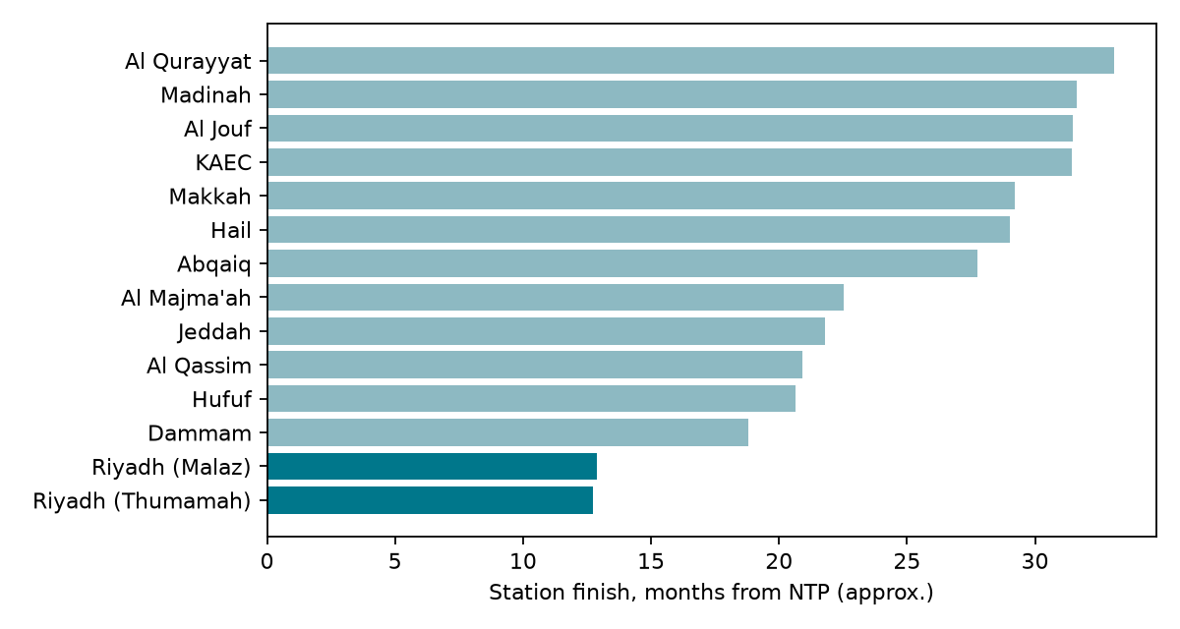
Station | Station finish | Riyadh priority
Riyadh (Thumamah) | 07 Dec 2027 | Yes
Riyadh (Malaz) | 13 Dec 2027 | Yes
Dammam | 22 Jun 2028
Hufuf | 17 Aug 2028
Al Qassim | 27 Aug 2028
Jeddah | 21 Sep 2028
Al Majma'ah | 15 Oct 2028
Abqaiq | 29 Mar 2029
Hail | 15 May 2029
Makkah | 21 May 2029
KAEC | 26 Jul 2029
Al Jouf | 29 Jul 2029
Madinah | 01 Aug 2029
Al Qurayyat | 16 Sep 2029

8. Critical and near-critical activities
The contract completion milestone is held by the 36 month term, so no activity has zero float against it. The longest physical path finishes 22 working days before the contract end date, and that margin is the project float. 29 tasks sit on this longest path (22 working days of float) and 10 more are within 20 working days of it. The first 25 in date order are listed below.
ID | Activity | Start | Finish | Float (working days)
PRJ-A1010 | Performance security, insurance and key personnel approval | 01 Nov 2026 | 12 Nov 2026 | 42
PRJ-A1020 | Initial baseline programme (Primavera) covering mobilization and survey | 01 Nov 2026 | 09 Nov 2026 | 30
PRJ-A1050 | Mobilization submittals: QC programme and ITP, HSE, security, procurement and shipping plan | 08 Nov 2026 | 03 Dec 2026 | 27
PRJ-A1040 | Mobilization: site establishment, offices, personnel and tools | 08 Nov 2026 | 10 Dec 2026 | 22
PRJ-A1030 | SAR review and approval of initial baseline | 10 Nov 2026 | 30 Nov 2026 | 30
NRY-E1010 | Survey: submittal of site survey and as-found report - Riyadh (Thumamah) | 13 Dec 2026 | 24 Dec 2026 | 32
ERY-E1010 | Survey: submittal of site survey and as-found report - Riyadh (Malaz) | 27 Dec 2026 | 07 Jan 2027 | 22
PRJ-A2010 | Detailed baseline programme (within 21 days after survey) | 10 Jan 2027 | 28 Jan 2027 | 22
PRJ-A2020 | SAR review and approval of detailed baseline | 31 Jan 2027 | 18 Feb 2027 | 22
NQR-E1010 | Survey: submittal of site survey and as-found report - Al Qurayyat | 07 Sep 2028 | 20 Sep 2028 | 22
NQR-E1030 | Concept design: submittal - Al Qurayyat | 21 Sep 2028 | 27 Sep 2028 | 22
NQR-E1050 | Preliminary design: submittal - Al Qurayyat | 28 Sep 2028 | 09 Oct 2028 | 22
NQR-E1060 | Preliminary design: SAR review and approval - Al Qurayyat | 10 Oct 2028 | 30 Oct 2028 | 39
NQR-E1070 | Detailed design: submittal (drawings, BOQ, data sheets) - Al Qurayyat | 10 Oct 2028 | 25 Oct 2028 | 22
NQR-E1110 | HCIS Stage 3 and 4 documents: preparation - Al Qurayyat | 17 Oct 2028 | 01 Nov 2028 | 22
NQR-E1080 | Detailed design: SAR review and approval - Al Qurayyat | 26 Oct 2028 | 15 Nov 2028 | 27
NQR-E1090 | IFC and shop drawings: submittal - Al Qurayyat | 26 Oct 2028 | 01 Nov 2028 | 22
NQR-E1100 | IFC and shop drawings: SAR approval and release - Al Qurayyat | 02 Nov 2028 | 22 Nov 2028 | 22
NQR-E1120 | HCIS Stage 3 and 4 documents: SAR final review and HCIS submission - Al Qurayyat | 02 Nov 2028 | 22 Nov 2028 | 22
NQR-P1010 | Manufacture CCTV cameras and analytics - Al Qurayyat | 23 Nov 2028 | 08 Mar 2029 | 22
NQR-P1020 | Manufacture video management servers, storage and video wall - Al Qurayyat | 23 Nov 2028 | 08 Mar 2029 | 22
NQR-P1030 | Manufacture access control and intercom equipment - Al Qurayyat | 23 Nov 2028 | 08 Mar 2029 | 22
NQR-P1040 | Manufacture UPS, network switches and field cabinets - Al Qurayyat | 23 Nov 2028 | 08 Mar 2029 | 22
NQR-P1050 | Factory acceptance test at vendor premises - Al Qurayyat | 11 Mar 2029 | 22 Mar 2029 | 22
NQR-P1060 | Shipping and customs clearance - Al Qurayyat | 25 Mar 2029 | 03 May 2029 | 22

9. Resources and cost loading
Every task carries two resources. Milestones carry none.
Resource | Type | Use
COST-SAR | Material | Contract cost quantity in SAR. Price 0. Total 62,000,000 SAR.
PROG-WT | Non-labor | Progress value in SAR (progress share x 62,000,000). Price 1, so it carries the budget cost. All activities use Physical % complete.

Because PROG-WT has price 1 and COST-SAR has price 0, the P6 budget, earned value, CPI and SPI are all in SAR on the fair EPC progress distribution. To view the contract payment-condition cost instead, swap the two prices (COST-SAR 1, PROG-WT 0).
Cost comes from the contract: the Annex 3 station price multiplied by the clause 15 payment milestone, spread to activities by distribution keys. Mobilization (MS1, 20% of the total price) sits at project level. The activity-by-activity mapping is in SAR_BOQ_Cost_Mapping.xlsx. Progress is a fair EPC distribution (Engineering 12, Procurement 40, Construction 33, Commissioning and handover 15 per station), weighted by each station's price share, plus 4% for project-level activities.
Milestone | Description | Share of price
MS1 | Mobilization | 20%
MS2 | Engineering submittal | 10%
MS3 | SAR approval of engineering | 10%
MS4 | Material delivery | 20%
MS5 | Installation | 20%
MS6 | Testing and commissioning (SAT) | 10%
MS7 | Final acceptance and handover | 10%

10. S-curve
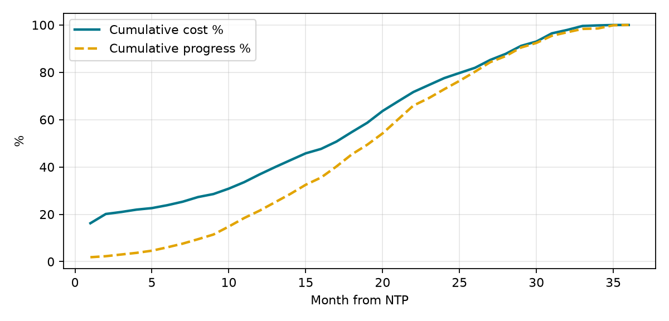
Cost follows the contract payment milestones. Progress is smoother because it is distributed by effort. The two curves differ on purpose: cost is a payment profile, progress is physical.

11. Activity codes
Ten global activity code types are loaded and every activity carries all of them: EPC phase, Area, Station, Railway, Discipline, Responsibility, Payment milestone, Design stage, Submittal or approval, and Priority. The values are listed on the Activity_Codes sheet of the BOQ workbook.

12. Changing the start date
NTP is a start milestone with no constraint. To move the project, change the project Planned Start (Project > Details > Dates), then schedule with F9 using Retained Logic. All dates, including contract completion, move together. The holidays are fixed dates, so after a change review the calendar for the holidays that the new window crosses.

13. Assumptions and exclusions
- Durations and station order are Contractor planning assumptions.
- Eid dates are estimates.
- The SAR review period is taken as 21 days; longer approval is an extension of time matter under the contract.
- Site access, permits and railway possessions are assumed available. No possession restrictions are modelled.
- The defects liability period and post-acceptance support are not in the programme.
- Cost is a payment profile at BOQ value, excluding VAT.
- The file was checked structurally and with an independent forward pass. The author has not opened it in P6 (see the read-me).

14. Risks to the programme
Risk | Mitigation
Eid dates differ from the estimate | Confirm before submission and reschedule
Long-lead equipment at Haramain stations (largest value) | Early procurement approval and FAT planning
SAR approval time above the review period | Early submission and an approval log
Station access and railway possession | Coordinate during mobilization
Conflict between Annex 4 item 33 (fast-track) and Annex 5 on HCIS | Clarify with SAR before design submittals

15. Submission checklist
- Confirm the Eid dates and update the calendar.
- Open the XER in P6 24, schedule it, and compare dates with this narrative.
- Confirm the station order with SAR.
- Check the cost mapping against the Annex 3 price table.
- Submit the XER, narrative, BOQ mapping and read-me together.

