Name: *Mustafa Fakhra*

Internship Batch: *LISUM07*

Submission date: 2022-03-07

Submitted to: [DataGlacier-internship/lisum04-w5-Cloud-API at master · jimmygjean/DataGlacier-internship (github.com)](https://github.com/jimmygjean/DataGlacier-internship/tree/master/lisum04-w5-Cloud-API)

Cloud & API Deployment

1. The model can be accessed on the internet through this link: <https://img-classifier-demo.herokuapp.com/> .



1. On the main page, the user is provided with an interface where he/she can upload an image.

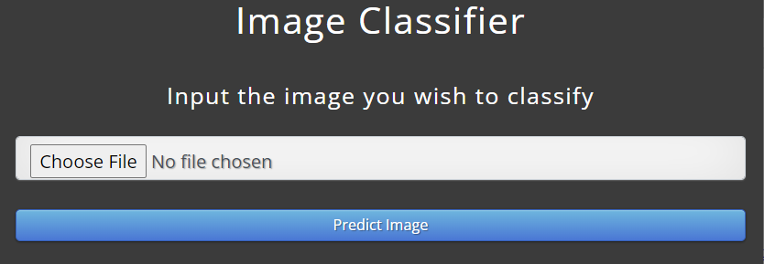

1. The user might for example choose to upload a picture of this car or of this dog:

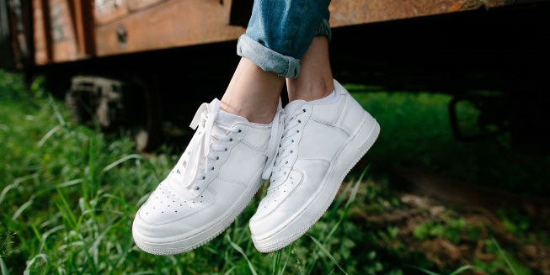 

1. After submission, a deep learning model processes the image and makes a prediction of what the image could be (a MobileNet model was used). The result is then displayed to the user.

 

Feel free to interact with the interface online. As an extra, the “Build Log” during deployment to Heroku is provided below. Codes are also available on GitHub.

-----> Building on the Heroku-20 stack

-----> Using buildpack: heroku/python

-----> Python app detected

-----> Using Python version specified in runtime.txt

! Python has released a security update! Please consider upgrading to python-3.8.12

Learn More: https://devcenter.heroku.com/articles/python-runtimes

-----> Requirements file has been changed, clearing cached dependencies

-----> Installing python-3.8.8

-----> Installing pip 20.2.4, setuptools 57.5.0 and wheel 0.37.0

-----> Installing SQLite3

-----> Installing requirements with pip

Collecting gunicorn==19.9.0

Downloading gunicorn-19.9.0-py2.py3-none-any.whl (112 kB)

Collecting flask==1.1.2

Downloading Flask-1.1.2-py2.py3-none-any.whl (94 kB)

Collecting tensorflow-cpu==2.3.0

Downloading tensorflow_cpu-2.3.0-cp38-cp38-manylinux2010_x86_64.whl (137.4 MB)

Collecting keras==2.4.3

Downloading Keras-2.4.3-py2.py3-none-any.whl (36 kB)

Collecting pillow==8.3.1

Downloading Pillow-8.3.1-cp38-cp38-manylinux_2_5_x86_64.manylinux1_x86_64.whl (3.0 MB)

Collecting werkzeug==1.0.1

Downloading Werkzeug-1.0.1-py2.py3-none-any.whl (298 kB)

Collecting itsdangerous>=0.24

Downloading itsdangerous-2.0.1-py3-none-any.whl (18 kB)

Collecting click>=5.1

Downloading click-8.0.3-py3-none-any.whl (97 kB)

Collecting Jinja2>=2.10.1

Downloading Jinja2-3.0.2-py3-none-any.whl (133 kB)

Collecting numpy<1.19.0,>=1.16.0

Downloading numpy-1.18.5-cp38-cp38-manylinux1_x86_64.whl (20.6 MB)

Collecting six>=1.12.0

Downloading six-1.16.0-py2.py3-none-any.whl (11 kB)

Collecting termcolor>=1.1.0

Downloading termcolor-1.1.0.tar.gz (3.9 kB)

Collecting grpcio>=1.8.6

Downloading grpcio-1.41.1-cp38-cp38-manylinux_2_17_x86_64.manylinux2014_x86_64.whl (3.9 MB)

Collecting opt-einsum>=2.3.2

Downloading opt_einsum-3.3.0-py3-none-any.whl (65 kB)

Collecting google-pasta>=0.1.8

Downloading google_pasta-0.2.0-py3-none-any.whl (57 kB)

Collecting astunparse==1.6.3

Downloading astunparse-1.6.3-py2.py3-none-any.whl (12 kB)

Collecting wrapt>=1.11.1

Downloading wrapt-1.13.3-cp38-cp38-manylinux_2_5_x86_64.manylinux1_x86_64.manylinux_2_12_x86_64.manylinux2010_x86_64.whl (84 kB)

Collecting h5py<2.11.0,>=2.10.0

Downloading h5py-2.10.0-cp38-cp38-manylinux1_x86_64.whl (2.9 MB)

Collecting gast==0.3.3

Downloading gast-0.3.3-py2.py3-none-any.whl (9.7 kB)

Collecting absl-py>=0.7.0

Downloading absl_py-0.15.0-py3-none-any.whl (132 kB)

Collecting protobuf>=3.9.2

Downloading protobuf-3.19.1-cp38-cp38-manylinux_2_17_x86_64.manylinux2014_x86_64.whl (1.1 MB)

Collecting tensorboard<3,>=2.3.0

Downloading tensorboard-2.7.0-py3-none-any.whl (5.8 MB)

Collecting keras-preprocessing<1.2,>=1.1.1

Downloading Keras_Preprocessing-1.1.2-py2.py3-none-any.whl (42 kB)

Collecting tensorflow-estimator<2.4.0,>=2.3.0

Downloading tensorflow_estimator-2.3.0-py2.py3-none-any.whl (459 kB)

Collecting scipy==1.4.1

Downloading scipy-1.4.1-cp38-cp38-manylinux1_x86_64.whl (26.0 MB)

Collecting pyyaml

Downloading PyYAML-6.0-cp38-cp38-manylinux_2_5_x86_64.manylinux1_x86_64.manylinux_2_12_x86_64.manylinux2010_x86_64.whl (701 kB)

Collecting MarkupSafe>=2.0

Downloading MarkupSafe-2.0.1-cp38-cp38-manylinux2010_x86_64.whl (30 kB)

Collecting requests<3,>=2.21.0

Downloading requests-2.26.0-py2.py3-none-any.whl (62 kB)

Collecting google-auth<3,>=1.6.3

Downloading google_auth-2.3.2-py2.py3-none-any.whl (155 kB)

Collecting google-auth-oauthlib<0.5,>=0.4.1

Downloading google_auth_oauthlib-0.4.6-py2.py3-none-any.whl (18 kB)

Collecting markdown>=2.6.8

Downloading Markdown-3.3.4-py3-none-any.whl (97 kB)

Collecting tensorboard-data-server<0.7.0,>=0.6.0

Downloading tensorboard_data_server-0.6.1-py3-none-manylinux2010_x86_64.whl (4.9 MB)

Collecting tensorboard-plugin-wit>=1.6.0

Downloading tensorboard_plugin_wit-1.8.0-py3-none-any.whl (781 kB)

Collecting idna<4,>=2.5; python_version >= "3"

Downloading idna-3.3-py3-none-any.whl (61 kB)

Collecting certifi>=2017.4.17

Downloading certifi-2021.10.8-py2.py3-none-any.whl (149 kB)

Collecting charset-normalizer~=2.0.0; python_version >= "3"

Downloading charset_normalizer-2.0.7-py3-none-any.whl (38 kB)

Collecting urllib3<1.27,>=1.21.1

Downloading urllib3-1.26.7-py2.py3-none-any.whl (138 kB)

Collecting cachetools<5.0,>=2.0.0

Downloading cachetools-4.2.4-py3-none-any.whl (10 kB)

Collecting rsa<5,>=3.1.4; python_version >= "3.6"

Downloading rsa-4.7.2-py3-none-any.whl (34 kB)

Collecting pyasn1-modules>=0.2.1

Downloading pyasn1_modules-0.2.8-py2.py3-none-any.whl (155 kB)

Collecting requests-oauthlib>=0.7.0

Downloading requests_oauthlib-1.3.0-py2.py3-none-any.whl (23 kB)

Collecting pyasn1>=0.1.3

Downloading pyasn1-0.4.8-py2.py3-none-any.whl (77 kB)

Collecting oauthlib>=3.0.0

Downloading oauthlib-3.1.1-py2.py3-none-any.whl (146 kB)

Building wheels for collected packages: termcolor

Building wheel for termcolor (setup.py): started

Building wheel for termcolor (setup.py): finished with status 'done'

Created wheel for termcolor: filename=termcolor-1.1.0-py3-none-any.whl size=4847 sha256=c9b4608ca3e41d8df920bb22e76ee02724ef5232e45caa9cc1014b4c933feec8

Stored in directory: /tmp/pip-ephem-wheel-cache-yke7zeam/wheels/a0/16/9c/5473df82468f958445479c59e784896fa24f4a5fc024b0f501

Successfully built termcolor

Installing collected packages: gunicorn, itsdangerous, werkzeug, click, MarkupSafe, Jinja2, flask, numpy, six, termcolor, grpcio, opt-einsum, google-pasta, astunparse, wrapt, h5py, gast, absl-py, protobuf, idna, certifi, charset-normalizer, urllib3, requests, cachetools, pyasn1, rsa, pyasn1-modules, google-auth, oauthlib, requests-oauthlib, google-auth-oauthlib, markdown, tensorboard-data-server, tensorboard-plugin-wit, tensorboard, keras-preprocessing, tensorflow-estimator, scipy, tensorflow-cpu, pyyaml, keras, pillow

Successfully installed Jinja2-3.0.2 MarkupSafe-2.0.1 absl-py-0.15.0 astunparse-1.6.3 cachetools-4.2.4 certifi-2021.10.8 charset-normalizer-2.0.7 click-8.0.3 flask-1.1.2 gast-0.3.3 google-auth-2.3.2 google-auth-oauthlib-0.4.6 google-pasta-0.2.0 grpcio-1.41.1 gunicorn-19.9.0 h5py-2.10.0 idna-3.3 itsdangerous-2.0.1 keras-2.4.3 keras-preprocessing-1.1.2 markdown-3.3.4 numpy-1.18.5 oauthlib-3.1.1 opt-einsum-3.3.0 pillow-8.3.1 protobuf-3.19.1 pyasn1-0.4.8 pyasn1-modules-0.2.8 pyyaml-6.0 requests-2.26.0 requests-oauthlib-1.3.0 rsa-4.7.2 scipy-1.4.1 six-1.16.0 tensorboard-2.7.0 tensorboard-data-server-0.6.1 tensorboard-plugin-wit-1.8.0 tensorflow-cpu-2.3.0 tensorflow-estimator-2.3.0 termcolor-1.1.0 urllib3-1.26.7 werkzeug-1.0.1 wrapt-1.13.3

-----> Discovering process types

Procfile declares types -> web

-----> Compressing...

Done: 274.9M

-----> Launching...

Released v11

https://img-classifier-demo.herokuapp.com/ deployed to Heroku