ID | Bug-1
Title | Cannot Add new task within a list from the plus sign
Severity | Major
Priority | High
Environment/ Affected Devices | Any.do APP/ version 5.18.2.3  Android/ version 12.1  Device: OPPO Reno3
Network | Wifi/ mobile data
Steps to reproduce | - Open Any.do App.  - From the choosed by default Screen click the home screen icon.  - Within the home Screen create new list.  - Open the new list.  - Try to add a task to this list when it’s sorted by list.
Expected result | Have within lists a plus sign from which the user can create new task.
Actual result | When the list is sorted by list and the user try to add a task within a new list the plus sign appears disabled if the list is empty and it disappears if the list has created tasks, although we are putting a text that explaining that adding a task is from the plus sign.  As a workaround the task can be added from “I want to” text box. It can lead for the customer confusion.
Attachments | 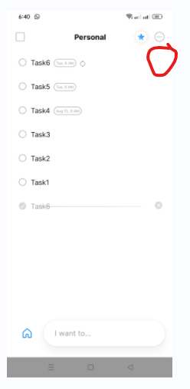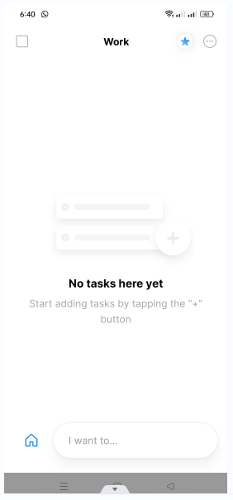

ID | Bug-2
Title | Personal-tasks without any due date or reminder assigned to today category.
Severity | Major
Priority | High
Environment/ Affected Devices | Any.do APP/ version 5.18.2.3  Android/ version 12.1  Device: OPPO Reno3
Network | Wifi/ mobile data
Steps to reproduce | - Open Any.do App.  - From the choosed by default Screen click the home Screen icon.  - Open a list.  - Add new task without any due date or reminder
Expected result | Personal-tasks without any due date or reminder associated should be assigned to Someday category as per the user manual.
Actual result | Task appears below Today category.
Attachments | https://drive.google.com/file/d/1cnzQvh9NY5Z0dfmNtPdvDk5AfabZ7GQ3/view?usp=drive_link

ID | Bug-3
Title | Subtasks get lost if any interruption or screen changing
Severity | Major
Priority | High
Environment/ Build | Any.do APP/ version 5.18.2.3  Android/ version 12.1  Device: OPPO Reno3
Network | Wifi/ mobile data
Steps to reproduce | - Open Any.do App.  - From the choosed by default Screen click the home Screen icon.  - Open a list and click one of its tasks.  - Add some subtasks for the opened task.  - Interrupt your action with a call or switch to another screen.  - Return back to Any.do App.
Expected result | The added subtasks should be AutoSaved as is if the user faces any interruption.
Actual result | Subtasks get lost if any interruption or screen changing and if the user are not able to open new subtasks. He should close the task and reopen it to be able to add new subtasks.
Attachments | https://drive.google.com/file/d/1ccXspZlJbG4WZNZBh1gvj7yVq7cnhJIq/view?usp=drive_link

- The App needs a lot of enhancements regarding the UI. Also the flows should be simpler regarding its usability:

- Home Screen
- Should be the by default Screen when opening the APP.
- Should have side menu for basic or principal App sections.
- Also should have an entry point for notifications.
- User should have a control regarding the view mode of his lists and boards.
- It will be fine if we can show our logo within the page.

- Notifications
- I think the icon that the App have is not the correct one we need to use the standard.

- Settings menu
- Some options which can be “on or off” need to be changed to Radio buttons.
- Other options with more than 2 items can be implemented as a drop down menu.

- Change language
- The App needs a lot of enhancements for a good experience for all users around the world from any culture. I tried with Arabic and it is a disaster. There are many errors related to translation and texts alignment within the screen.

- Generally
-Many options appeared pale, this give an impression for the user that it’s disabled or not active.
- The App UI colors should be enhanced, this will increase readability and legibility. Also due to contrast, the layout elements become distinguishable and noticeable.

