* **Name: مصطفى حمايه محمد معوض**
* **B.N: 902**
* **Date: 28/6/2020**
* **Topic:** **Big Data**
* **Github link:** [**https://github.com/mostafahemay/ECE006**](https://github.com/mostafahemay/ECE006)
* **Github page:** [**https://mostafahemay.github.io/ECE006/**](https://mostafahemay.github.io/ECE006/)
* **Application brief:**
* Big data refers to the large, diverse sets of information that grow at ever-increasing rates. It encompasses the volume of information, the velocity or speed at which it is created and collected, and the variety or scope of the data points being covered.
* Types of Big Data:

1. Structured data: Structured Data is used to refer to the data which is already stored in databases.
2. Unstructured data: While structured data resides in the traditional row-column databases, unstructured data is the opposite- they have no clear format in storage.
3. Semi-structured data: The line between unstructured data and semi-structured data has always been unclear since most of the semi-structured data appear to be unstructured at a glance.

* Variety of Big Data refers to structured, unstructured, and semi structured data that is gathered from multiple sources.
* Velocity essentially refers to the speed at which data is being created in real-time.
* Velocity essentially refers to the speed at which data is being created in real-time.
* 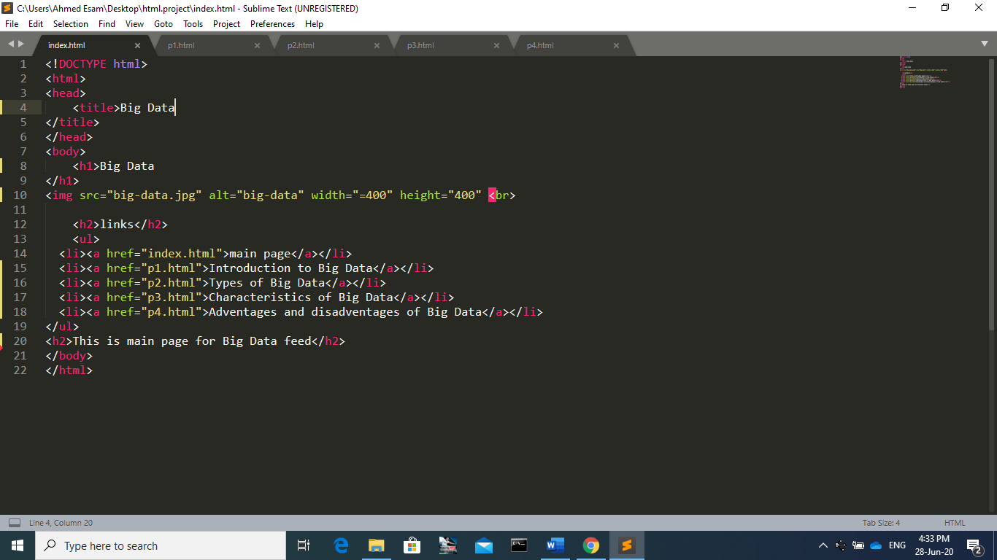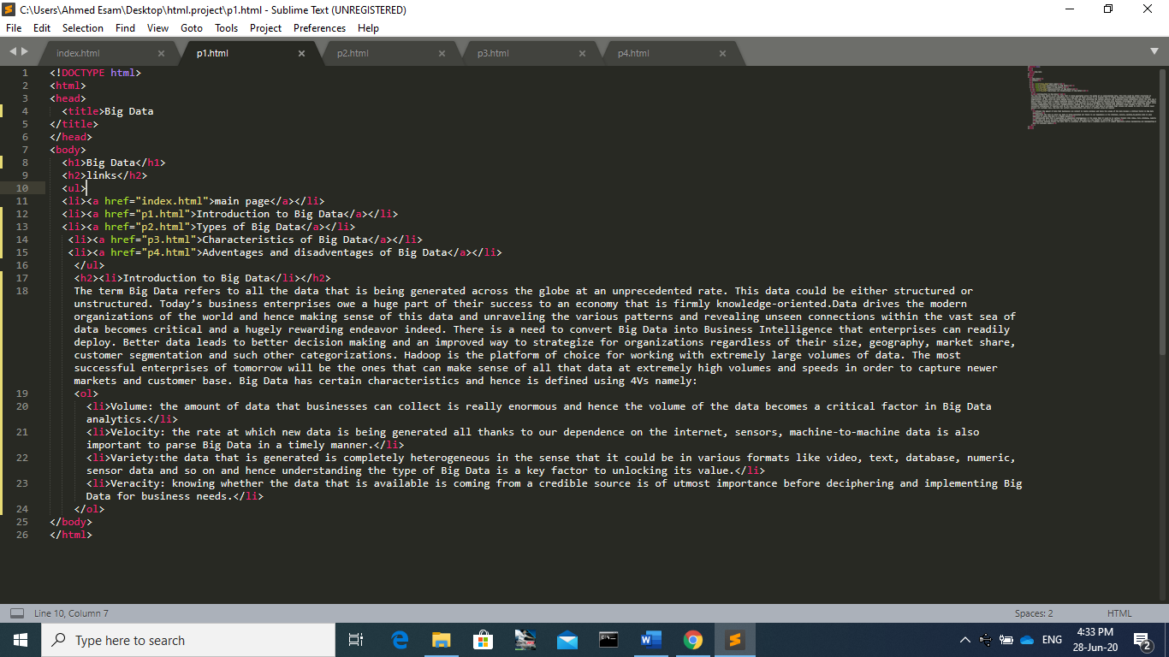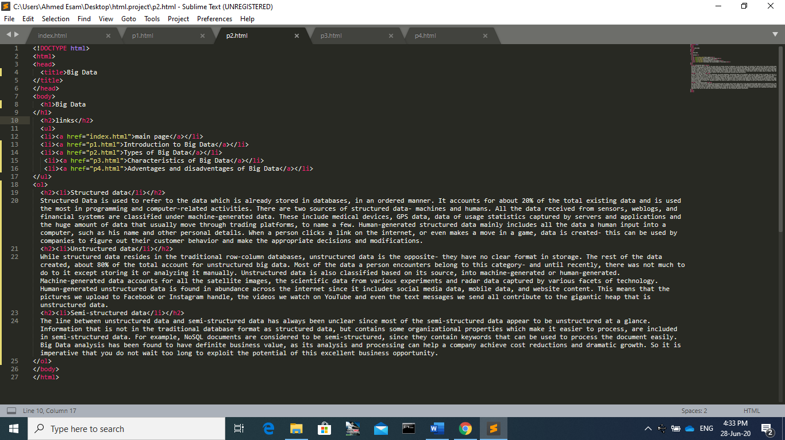**Screenshots: -**

