**Hybrid Decomposition-based Multi-objective Design Optimization of Large-scale Composite Wind Turbine Blades**

1* Parviz Mohammad Zadeh and 2Mostafa Mohaghegh

1, 2, North Kargar St. University of Tehran, Faculty of New Sciences and Technologies

**Abstract**

This paper presents an efficient multi-objective design optimization of large-scale composite wind turbine blades with minimum weight and maximum buckling load factor as two opposing objective functions. Buckling of wind turbine blade is one of the important failure modes, especially in thin plates, which requires considerable computation time, in particular in the case of multi-objective optimization, the computational costs can be significant. In order to overcome these challenges, this paper presents an efficient hybrid decomposition-based hybrid particle swarm optimization (PSO) and sequential quadratic programming (SQP) algorithms, which is aimed to take advantages of global search capability of PSO as well as the fast local search capability of SQP. In addition, in order to increase the efficiency of the proposed approach, lamination parameterization is used to transfer the problem into a form, which involves two levels of modelling and optimization. At the first level, lamination parameters and the number of plies of specified angles (0, ±45, and 90 degree) are used as design variables. The second level of the proposed approach is used to obtain the location of each ply orientation through the thickness of the composite panels. The proposed methodology is evaluated using a number of case studies as well as a 20 MW large-scale composite wind turbine blade. It is illustrated that the proposed method provides a more efficient and effective method for optimum design large-scale composite wind turbine blades.

**Keywords:** Hybridmulti-objective optimization, particle swarm optimization (PSO), sequential quadratic programming (SQP), composites, design of wind turbine blade

**1. Introduction**

In recent year, there has been a growing interest in renewable energy, which is sustainable and has less greenhouse gas emissions [1]. Wind turbine is one of the most effective means of achieving the goal of renewable energy, however the cost effectiveness of wind turbine has been a major research issue. The size of a wind turbine blade is one of the major factor, which contributes to the cost effectiveness of a wind turbine and hence, the design of large-scale wind turbine blade is the focus of several research works. In spite of these research, the design of large-scale wind turbine blade presents several research challenges. The most important design challenges associated with the development wind turbine blades are aerodynamically efficient blades with minimum structural weight whilst satisfying all the design constraints (e.g., buckling, stress, strain, tip deflection, etc.). This requires, the designer to satisfy simultaneously the design constraints while evaluating trade-offs between conflicting objectives such as structural instability, aerodynamic performance and weight. Therefore, multi-objective optimization of a wind turbine blade is of a significant importance.

Among all these design constraints, considering the buckling in the structures made from laminated composites is important for the efficient design and for the safe use [2]–[10]. This mode of the instability is one of the most essential design constraints in the structural optimization [11], and many researchers have optimized the wind turbine blade parameters to improve its buckling strength. When the wind turbine blade size becomes very large, the structure will have poor buckling strength [12] and [6]. More precisely, when the radius of wind turbine blade is increased more than 70 m, there are possibilities for the failure due to buckling and resonance [13]. The buckling is the critical failure mode in wind turbine blades because they are thin walled structures and are subjected to flap-wise bending load [14] and [15]. The blade is generally made of glass fiber and carbon fiber reinforced plastic and therefore the buckling strength of wind turbine blade can be improved by optimally varying the stacking sequence [13].

In the research works for the design optimization of the wind turbine blade, the chord-wise width of the spar cap, the thickness of each lamina [16], the location and the thickness of the spar cap layers [17], the positions of the shear webs [18] are considered as design variables and blade’s mass [16] - [18] and buckling [13] are treated as objective functions. In this regard, a multi-criteria constrained optimization was performed for the structural design of horizontal-axis wind turbine blades based on the particle swarm optimization algorithm combined with the finite element method in [18]. In addition, in reference [1] multidisciplinary design optimization of offshore wind turbines has been implemented, while the objective function was the cost of energy, and the rotor design variables were chord and twist distribution, blade length, rated rotational speed and structural thicknesses along the span.

A typical composite structural design problem has several discrete design variables such as thickness (number of layers), ply orientation, and type of the material. The flexibility in choosing these variables to meet the design requirements causes a complexity in the design problem. Most of published works in this area, deal with single-objective optimization, for instance to minimize the number of plies of the laminate or maximize its critical buckling load. In the design of such structures, usually it is desired to have a structure with low weight and high critical buckling load, while there is no solution that optimizes both objective functions simultaneously. In these problems, the objective functions are said to be conflicting, and there exists a set of solutions that are called Pareto optimal solutions that includes all the non-dominated answers, i.e. those that cannot be improved without a negative effect on the other objective function [19]. In the field of laminated composite optimization, few studies used the *multi-objective* aspect of the problem. In the composite structure optimization studies with more than one objective function (like first natural frequency and critical buckling load of a panel [20], or its weight and cost [21]), the weighted sum method has been used, that transfers the multi-objective problem to one or some single-objective problems.

Recently, Liu and Toropov [22] proposed a multi-objective bi-level optimization approach for composite structures considering blending and manufacturing constraints. At the top level optimization, the total number of plies and the lamination parameters [23], [24] corresponding to the bending stiffness matrix have been used as design variables, the material volume was the objective function subject to the buckling, strength and ply percentage constraints.. Next, the bottom level optimization was treated as a multi-objective problem using weighted sum method to obtain the stacking sequence with two newly-defined indices, namely the stack homogeneity and the 90 degree ply angle jump; and also a measure of the lamination parameters match. It is worthy to note that the use of lamination parameters as design variables enables an efficient continuous optimization [25]. However, multi-level approaches utilizes lamination parameters to speed up the optimization process if the evaluation of the objective function is too time consuming [26]–[30].

In the field of multi-objective optimization, several algorithms have been developed, some of them are based on the previous single objective optimization algorithms such as PSO and genetic algorithm. Kathiravan and Ganguli [31] applied PSO algorithm to propose a method to optimize ply orientation angles of a composite box-beam structure subject to strength constraints. The authors’ conclusion was that while PSO results in globally best designs, the gradient-based method can also be used with appropriate starting designs to obtain proper designs efficiently. Furthermore, Pareto-based GAs have been treated for the optimum design of laminated composite structures in a few researches [32].

The studies cited above shows that multi-objective optimization methods are of great interest in design problems of the laminated composite structures. Nevertheless, the application of Pareto-based multi-objective optimization algorithms to a composite problem still poses considerable challenges. These challenges are due to the multi-modal nature of the prime problem, containing both continuous and discrete design variables, requiring much function evaluations, etc. In addition, in the real world engineering problems such as the optimization of the wind turbine blade with curved composite panels, that is the case of this paper, performing a comprehensive evaluation requires finite element analyses, which is a time consuming process.

In the structural analysis, curved plates and surfaces are known as shells [33]. Curved plates are common elements in several engineering structures, including wind turbine blades, wings and fuselages of airplanes, pressure vessels, and many other structures. A number of theories have been developed for laminated composite curved panels [34]–[40]. The three dimensional theory of elasticity was used by Santos et al. [41], [42] to carry out a dynamic analysis of composite curved panels. They developed a finite element model to analyze the free vibration of axisymmetric laminated composite curved panels [43]. Also, dynamic analysis of thick laminated composite shells was performed using the three dimensional solution by Shakeri et al. in 2006 [44]. The authors of this work, performed the optimization of stacking sequence for the vibration of laminated shells based on genetic algorithm [45]. In the field of structural stability, dynamic buckling of composite curved panels were discussed in some researches [46].

The literature review on the structural optimization of wind turbine blades evidently shows that the optimization is performed by varying the thickness of the material, or the location of shear web. In almost all research works in the field of wind turbine, only one objective function is considered in the optimization process. While multi-objective weight and buckling optimization of the blade gives more information to the designer. In the present work, for the first time, multi-objective optimization of a laminated composite wind turbine blade is performed.

In this paper a novel decomposition-based hybrid multi-objective optimization algorithm (DHM) is presented to minimize the weight and simultaneously maximize the load bearing capacity of laminated curved composite panels of a wind turbine blade using lamination parameterization. The main contribution of this paper can be stated as: (1) computationally efficient hybrid decomposition-based multi-objective optimization approach using enhanced PSO and SQP algorithms, which takes advantages of global search capability of PSO and computational fast local design exploration of SQP, (2) Implementation of multi-level modelling and optimization of composite wind turbine blade to reduce the computational costs, (3) adaptation mutation operator of GA into the proposed methodology to enhance search capability of PSO and (4) implementation of the proposed methodology to a large-scale composite wind turbine blade.

**2. Methodology**

The proposed approach consists of two main parts including modeling and optimization. First, the modeling of the wind turbine blade as a structural case study is presented. Aerodynamic modeling, blade loading, geometric and structural modeling is described in this section. Next, optimization formulation of the proposed algorithm is expressed.

**2.1 Modeling of curved composite panel for wind turbine blade**

In this section, the governing equations for composite shells are presented to obtain the critical buckling load factor or critical buckling stress, that is the stress (force) at which a plate element buckles under compression loading. Consequently, the critical buckling load factor is defined as the fraction of buckling stress to the applied stress. The derivation of the critical buckling stresses for thin curved panels, in which can be neglected, is relatively not complicated when the panel material is isotropic and solutions are provided in [47]. The derivation do not apply to laminated composite materials commonly used in wind turbine blades, since they are anisotropic materials. But solutions can be obtained for a symmetric laminate using the energy method, as follows [48].

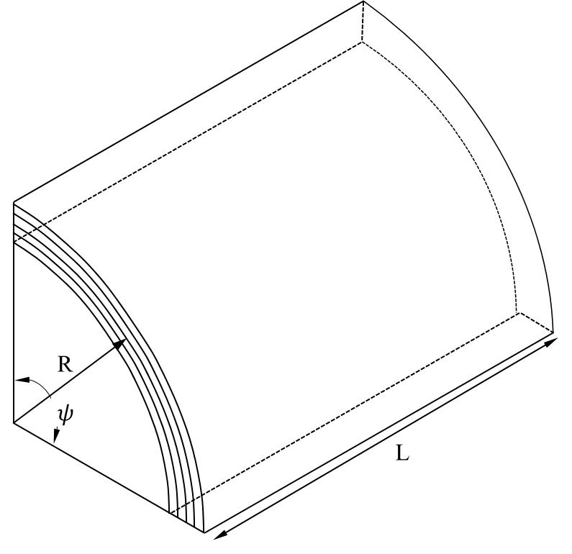

**Fig. 1.** Schematic of a laminated composite curved panel

Here, the derivation is explained based on the classical lamination theory for a long cylindrical panel of length *L*, thickness *h*, and radius *R* supported along two generators and spanning an angle *ψ* at the cylinder axis, under axially compression load. If it deflects such that it forms *n* half-waves around the circumference between supports and *m* half-waves along the length, then its out-of-plane deflection, *w*, can be described as [48]:

|  |  |
| --- | --- |
|  | (1) |

In the above equation *C* is the coefficient that should be determined such that the final relation be minimized and also the boundary conditions be satisfied, and *x* are the coordinates of the deflected point with respect to the one of the corners of the curved panel, which is considered as the origin. In cases that in-plane direct strains are not exist, this out-of-plane deflection will result in circumferential deflected profile:

|  |  |
| --- | --- |
|  | (2) |

where *C*, , , are defined above. The deflections will create in-plane shear stresses, which have a maximum at the corners of the rectangular buckled panel. In practice, additional in-plane deflections arise to balance these shear stresses, as follows:

|  |  |
| --- | --- |
| Axial | (3) |
| Circumferential |

*A* and *B* are same as *C* in Eq. (2) and is related to the boundary condition, that is determined at final relation. The in-plane strain energy,, can be obtained as [48]:

|  |  |
| --- | --- |
|  | (4) |

with the indices 1 and 2 denoting the axial and circumferential directions respectively, and r is the radius of curvature of the panel. The components of the strain tensor, , , and   
are:

|  |  |
| --- | --- |
|  | (5) |

Substituting , , where , and are the longitudinal and shear moduli of the laminate respectively, which are calculated by averaging the corresponding moduli of the individual plies, and and are the effective Poisson’s ratios, the in-plane strain energy, , becomes:

|  |  |
| --- | --- |
|  | (6) |

where is the thickness of the panel. Substituting the relations for , , and from Eq. (5) and integrating on the width of the panel, , and the length of one half wave, L/m, it is obtained that:

|  |  |
| --- | --- |
|  | (7) |

where , *A*, *B*, and *C* should be determined.

The derivation of the expression for the strain energy of curvature is as follows. The angular coordinate is replaced by the linear coordinate *y* (= *r*). Now, the bending energy saved in an area *dx*.*dy* would be:

|  |  |
| --- | --- |
|  | (8) |

where , are bending moments, and is out-of-plane displacement. For an orthotropic laminates with only 0 and 90 degree layers or a laminate with the same number of and layers, the following relations are valid [48]:

|  |  |
| --- | --- |
|  | (9) |
|  | (10) |

and are the bending stiffness elements of the flat laminate about *y* and *x* axis, respectively. is cross flexural rigidity, which is defined as the moment per unit width about one axis produced by unit curvature about the other axis. Therefore,

|  |  |
| --- | --- |
|  | (11) |

In this equation, is the bending energy of an element of area. The third part of the energy is the twisting energy. The absorbed twisting energy in an area *dx*.*dy* is obtained as follows:

|  |  |
| --- | --- |
|  | (12) |

where is the torsion:

|  |  |
| --- | --- |
|  | (13) |

in which z is the distance that is measured from the mid-plane of the laminate, is the in-plane stiffness at that distance, and *h* is the laminate thickness. It should be mentioned that the term is the definition of *D*66 [49]-[50]. Hence, the twisting energy absorbed in the element of area is:

|  |  |
| --- | --- |
|  | (14) |

According to the above-mentioned description, the total strain energy of the curvature in the width of the panel and the length of a half wave is obtained by substituting the out-of-plane deflection (Eq. (1)) to the Eqs. (11) and (14), and integrating over this area, which results in:

|  |  |
| --- | --- |
|  | (15) |

and are the absorbed bending and twisting energy, respectively, and , , , were defined before Eq. (1). The amount of energy saved in the panel during buckling due to in-plane strains and out-of-plane curvature is equal to the work that is done by the critical axial load when the panel shortens. Considering the Eq. (1) for *w*, the reduction of the panel length over one-half wave would be:

|  |  |
| --- | --- |
|  | (16) |

Therefore, the work done by the axial force () per unit width over the panel width is:

|  |  |
| --- | --- |
|  | (17) |

The equality of the performed work and the total strain energy of curvature over the length of one half wave () results in the critical value of the axial force as

|  |  |
| --- | --- |
|  | (18) |

Substituting , this equation becomes [48]:

|  |  |
| --- | --- |
|  | (19) |

where , , and are the elements of the out-of-plane stiffness matrix. There are four unknowns in the right hand side of Equation (21), namely, the number of transverse half waves, *n*, the ratio of longitudinal half wave length to transverse ones, *n/λ*, and the factors A/C and B/C. Assuming that only one transverse half wave will occur, as is normally the case, for obtaining the critical stress, the expression should be minimized with respect to the variables. Another relation for calculating the buckling load factor of carved panel for wind turbine application has been presented [6]:

|  |  |
| --- | --- |
|  | (20) |

where and are parameters related to the number of half-waves due to the buckling along the longitudinal (*x*) and transverse (*y*) directions, respectively. For instance, where *L* is the panel width.

*Lamination parameters for calculating the stiffness matrix D*

To evaluate stiffness matrix *D* that is used for obtaining buckling load factor, lamination parameters are used. Tsai and Hahn presented the out-of-plane stiffness properties of a single-material laminated composite in terms of 4 lamination parameters [23]:

|  |  |
| --- | --- |
|  | (21) |

in the above equation, the lamination parameters are,

|  |  |
| --- | --- |
|  | (22) |

where is the ply angle of the i-*th* layer, *zi* is the distance from mid-plane to the bottom of the i-*th* layer, and *U*1, *U*2, *U*3, *U*4, and *U*5 are material intervals. The bounds of the lamination parameters, that are considered as constraints in the optimization problem, can be seen in reference [51]. These parameters were described in a new developed bi-level algorithm by the authors [26].

**2.2 Formulation of the multi-objective optimization problem**

In this section, the formulation of the multi-objective optimization of laminated composite structures is expressed. The problem consists of the minimization of weight with the maximization of buckling load factor. For the optimization of the composite structure, the number and the orientation of layers are design variables. This condition increases the number of design points, and therefore, the number of objective function evaluations because of a greater design space. Additionally, the number of design variables, itself is not fixed. To deal with these difficulties, a bi-level procedure using lamination parameterization is integrated into the multi-objective optimization approach. One advantage of the bi-level procedure is that the number of design variables is fixed. The constraints of the problem are the orientation of layers, which is limited to 0, ±45, 90 degree fibers as well as the side constraints of the design variables. The formulation and implementation of the proposed DHM optimization algorithm to the structural case study is stated in the following sub-sections.

**2.2.1 Objective functions**

As mentioned above, weight is usually an important issue in the design process of the structure, and is considered as the objective function in optimization problems. In addition, in the present work one of the most important stability criteria of the plates and shells, that is, buckling is defined as the second objective function. Considering these issues, the first level optimization is defined based on:

|  |  |
| --- | --- |
| *Minimize weight* (*W*) = *f*1(***x***) =  *Maximize critical buckling load factor* () = *f*2(***x***) = | (23) |

where ***x*** is the design variable vector, is the density of the composite structure, , , are the number of layers with the orientation of 0, ±45, and 90 degrees, respectively. *a*, and *b* are the length and the width of the panel, and *t* is the thickness of each layer. For the curved panel *b* is equal to . It is assumed that all layers are of the same thickness. is the critical buckling load (Eq. (18)) and is obtained through a minimization sub-problem, in which the right hand side of Eq. (19) is the objective function and is the design variable vector.

**2.2.2 Design variables**

The design variables used in the first level are the number of plies of each orientation 0, ±45, and 90 degree (*n*0, *n*±45, n90) and also the out-of-plane lamination parameters (), as listed in Table 1. These parameters are defined in Eq. (22). Subsequently, the design variables in the second level are the orientation of each layer (). The amount of these variables determines the stacking sequence of the composite structure (curved panel).

**Table 1**

Design variables of the test problem

|  |  |  |  |  |  |
| --- | --- | --- | --- | --- | --- |
| **Notation** | **Design variable** | **Lower bound** | **Upper bound** | **Level** | **Type of variable** |
| *n*0, *n*±45, n90 | The number of plies of the panel | [72, 36, 13] | [80, 43, 22] | First | Discrete |
|  | The out-of-plane lamination parameters | [-1, -1, -1, -1] | [1, 1, 1, 1] | First | Continuous |
|  | The orientation of each layer | 0 | 90 | Second | Discrete |

In the present work, the lower and upper bounds of the variables are determined according to the section properties of the wind turbine blade, which is expressed by Ashuri et al. [52], for three panels. The properties of sections that establish the panels are presented in Table 3.

**2.2.3 Constraints**

The constraints of the test problem can be divided into two types: design constraints and laminated composite manufacturing constraints, as shown in Table 2. The following design constraints, related to the lamination parameters, enforce the algorithm to remain in the feasible region [53]–[55]:

|  |  |
| --- | --- |
|  | (24) |

and are out-of-plane lamination parameters and described in Section 2.

**Table 2**

Constraints of the test problem

|  |  |  |  |
| --- | --- | --- | --- |
| **Notation** | **Description** | **Level** | **Types** |
| *gj* ≤ 0 | Constraints on the lamination parameters for remaining in the feasible region | First | Design constraint |
| The number of plies with an orientation placed sequentially [50] | To prevent growing crack in the matrix | Second | Manufacturing constraint |
| [56] | To eliminate stretching/shearing coupling () | Second | Manufacturing constraint |
|  | To obtain stacking sequence corresponding to the lamination parameters from the first level | First | Design constraint |

**2.3 Implementation of a decomposition-based hybrid multi-objective optimization approach**

The proposed algorithm in this study utilizes a decomposition-based hybrid PSO-SQP method, recently developed by the authors. Here, the multi-objective decomposition-based algorithm is adapted for composite structure problems in a way that the optimization is operated to minimize the weight of the composite structure, meanwhile to maximize the buckling load factor. In the present work the critical buckling load factor, as an objective function, is evaluated by linear Eigen-value process [57] through the finite element analysis. In order to run finite element analysis of a composite structure, an input file is generated automatically to define the lay-up of the structure.

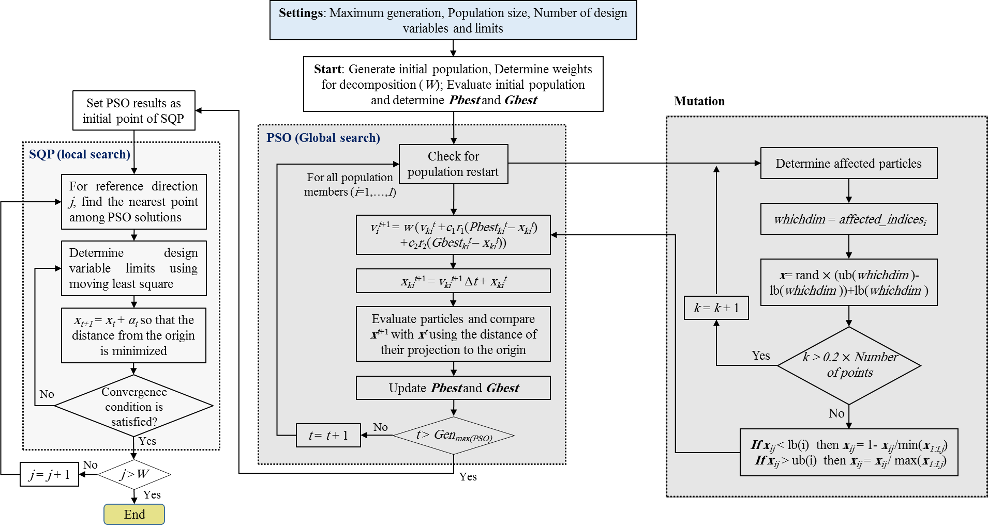

**Fig. 2.** Hybrid PSO and SQP multi-objective optimization algorithm

The procedure of the DHM optimization algorithm is shown in **Fig. 2** and described as follows:

1. Initial settings for the global search via PSO, to reach a convex space for SQP search;
2. Initialize the population and velocities in a random way, determine *W* weights and generate *W* reference points for decomposition;
3. Evaluate the initial population and determine ***Pbest*** and ***Gbest***;
4. Check for population reset, apply mutation on some randomly selected variables, and obtain new population (using Eq. (25) and Eq. (26));
5. Evaluate new population and update ***Pbest*** and ***Gbest***;
6. Perform optimization with the SQP using the results of PSO as initial points;
7. Update Pareto front (including weight and the critical buckling load factor).

Up to item 5 the PSO algorithm is run for global search. Since in the considered optimization problem (weight and buckling optimization) the objective function can be optimized using lamination parameters as design variables, the buckling load function is convex if there is no constraint. In fact, PSO bounded the problem to a convex space, in which a gradient-based method such as SQP is more efficient to obtain the solution than evolutionary ones. Hence, in step 6 the results are transferred to the SQP for calculating more exact solutions and Pareto front.

For solving multi-objective optimization composite problems, an efficient hybrid optimization algorithm is proposed in this work. To reach this purpose, first, a set of reference points and reference directions is generated using normal boundary intersection method [58]. Then, PSO algorithm is selected for global search because of its strong global search ability and high convergence speed [59], [60], [61]. Then, SQP is used for local search and obtaining more exact solutions. SQP as a gradient-based optimization method is one of the most efficient and accurate optimization methods, specifically for problems with smooth and well-scaled objective function [62]. However, the PSO solutions need to be sufficiently close to the real solutions such that the function can be considered smooth.

In the decomposition-based optimization methods, a set of reference directions or reference points should be generated diversely in the objective function space. In approaches that are based on the reference point concept, a fitness function that relies on the distance from reference point is defined. To guarantee uniform results on the Pareto front, a number of structured reference points are needed.

The proposed multi-objective method is developed upon the idea of Tchebycheff approach for generating search directions, which are defined with respect to reference points. However, in the Tchebycheff approach a hypothetical point (ideal point) is used, while in the proposed method some real reference points are the base for generating reference points. In addition, two methods differs in objective function definition.

The proposed methodology consists of three stages to find Pareto optima: decomposition, optimization with an evolutionary algorithm (PSO), and optimization with a gradient-based algorithm (SQP). According to the number of objective functions, *W* reference points are produced. In the optimization procedure, when the maximum number of generations is reached in PSO, the value of obtained design variables (i.e. the solutions of this step) is fed to the SQP to attain solutions that are more accurate.

**2.3.1 Particle swarm optimization**

As mentioned above, the multi-objective particle swarm optimization algorithm [63], [64] is adopted to obtain primary values for the global optimum points of weight and critical buckling load factor and to produce the Pareto front. These values are fed to the SQP for calculating the more exact solutions. PSO has been proposed as a meta-heuristic algorithm for dealing with nonlinear optimization problems in 1995. In this algorithm each solution *xi*, which is a vector of real numbers, expresses the position of the *i*-th particle. Each swarm is updated using new velocity (*vt*+1) and new position (*xt*+1) according to the following equations [65]:

|  |  |
| --- | --- |
| *vt+1i* = *wvti + c1r1*(*xpbest,i* - *xti*) + *c2r2*(*xgbest,i* - *xti*) | (25) |
| *xt+1i* = *xti* + *vt+1i* | (26) |

where *w* is the inertia weight, *c1* and *c2* are positive acceleration coefficients, *r1* and *r2* are two independent random values in the range of [0,1].

So far several versions of MOPSO have been developed based on the original PSO [66]. Generally, when the dominance concept is used for solving a multi-objective optimization problem, the result is a Pareto front, which contains all non-dominated points. According to the definition, a vector of decision variables *xRn* (considered as a vector of real numbers) is non-dominated, if there is not another *x'* such that *f*(*x'*)  *f*(*x*) [67]. In the primary variants of dominance concept, it is supposed that the "minimization" of all objective functions is desired, while in multi-objective optimization of the laminated composite curved panels in this article, the minimization of weight and the maximization of the critical buckling load factor are sought, simultaneously.

**2.3.2 Sequential quadratic programming**

In the second step of the proposed hybrid multi-objective optimization approach, more exact solutions are obtained using the SQP, whereas the solutions of the PSO algorithm are used as initial points of SQP. Since a decomposition approach has been selected for determining Pareto solutions, SQP can be run with one objective function for each reference direction.

**2.4 Implementation of the algorithm to the composite structures**

In this section, the procedure of obtaining solutions for a multi-objective composite structure optimization problem with the weight and the critical buckling load factor as two objective functions is presented. The first part of the proposed methodology is based on the PSO algorithm and is shown in **Fig. 3**.

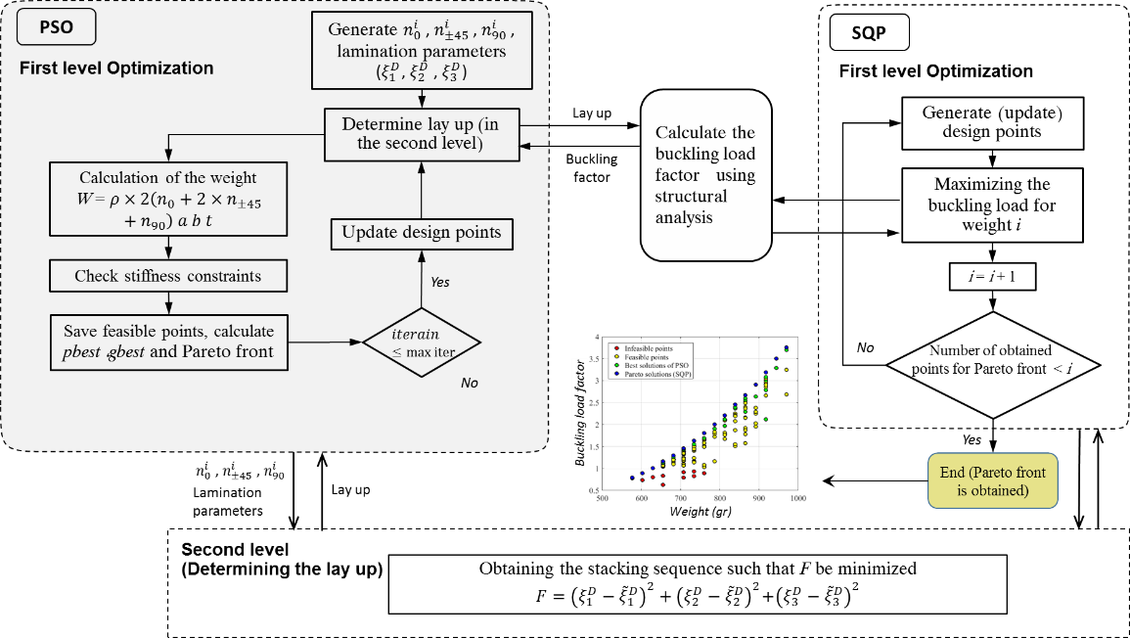

**Fig. 3.** The flowchart of the proposed multi-objective optimization algorithm for the weight and the buckling load factor of a laminated composite structure

In this method, the following steps are performed.

1. Initial setting of the algorithm including the maximum number of generations (gen_max), population size, velocity, inertia weight, exploration and exploitation coefficients (*c*1 and *c*2) is determined.
2. Positions are generated with respect to the number of particles, in a random manner. Each particle position (first level design variable vector) includes the number of plies of each orientation, *n*0, *n*±45, *n*90, and the out-of-plane lamination parameters, .
3. According to first level design variables, the stacking sequence is obtained via an optimization process in the second level.
4. Two objective functions are evaluated for each particle. Weight is obtained using Eq. (23), while for calculating the buckling a linear structural analysis is performed.
5. Among all particles, those dominated by at least one particle are omitted and, using the dominance concept, the Pareto set is obtained (updated).
6. The best position of each particle in previous iterations (***x****pbest*) is determined. Since in multi-objective optimization there is no single best solution, ***x****gbest* is chosen at random among Pareto points.
7. New positions for particles are calculated using ***x****pbest* and ***x****gbest* (Eq. (25) and Eq. (26)). These positions are utilized as first level design variables in the next iteration (by returning to step 3).

This process is repeated until the stopping criteria is satisfied (i.e. the number of generations reaches to gen_max). Because there is a random operator in creating a new generation, it is possible to improve positions in next generations even if the difference between two consequent positions of particles is zero.

**2.4.1 Case study: wind turbine blade**

The real case that is used in this section is a 20 MW wind turbine blade, which has been developed by Ashuri et al. [52]. The geometric properties of this blade are described in the following section.

*Geometry and structural properties of the blade*

A 20 MW wind turbine with three 135 m blades are considered. Table 3 gives the blade data.

**Table 3**

Blade geometric and aerodynamic properties

|  |  |  |  |  |  |
| --- | --- | --- | --- | --- | --- |
| **Section** | **Radius (m)** | **Chord (m)** | **Twist (deg)** | **Airfoil** | **Pitch axis position (% chord)** |
| 1 | 0.0 | 7.6 | 14.8 | Circular | 50.0 |
| 2 (3) | 7.02 | 7.6 | 14.8 | Circular | 50.0 |
| 3 (6) | 20.18 | 10.0 | 14.8 | DU00W401 | 39.0 |
| 4 (16) | 118.97 | 3.40 | 1.98 | NACA64618 | 37.5 |
| 5 (20) | 135 | 1.57 | 0.08 | NACA64618 | 37.5 |

**Table 4**

Design load cases [52]

|  |  |  |  |  |
| --- | --- | --- | --- | --- |
| **Load case** | **Operation mode** | **Wind speed (m/s)** | **Yaw error** | **Load type** |
| 1 | Start up | 9 to 13, 25 | 0 | Ultimate |
| 2 | Power generation and fault | 3, 9 to 13, 25 | 0 | Ultimate |

The design load cases are presented in Table 4 based on IEC standard [68]. The blade material properties are given in Table 5 according to the reference [52], in which the blade is introduced as a composite blade, but an equivalent isotropic properties are used for the analysis. In the present work, these properties are used to obtain the loads on the blade panel, while for the multi-objective optimization a composite model with orthotropic properties are utilized and the optimum stacking sequence are obtained.

**Table 5**

Blade material properties [52]

|  |  |  |
| --- | --- | --- |
| **Structural element** | **Young modulus (GPa)** | **Yield stress (MPa)** |
| Blade spar | 32 | 276 |

*Aerodynamic modeling and general loading of the blade*

In the condition of non-acceleration rotation of a wind turbine blade, the external loads acting on the blade are lift, drag, gravity loads and centrifugal loads. If the angular speed of the rotor is constant, the centrifugal forces are constant, too. The out-of-plane deflections due to gravity are not too great [69]. Generally, there may exist six load types on a wind turbine blade, as a solid body, as shown in Fig**.** 4. Drag and lift are distributed forces that are produced due to varying pressure distribution of the air about the airfoil, and depends on the air density, relative air speed, the area of the blade, and drag and lift coefficients.

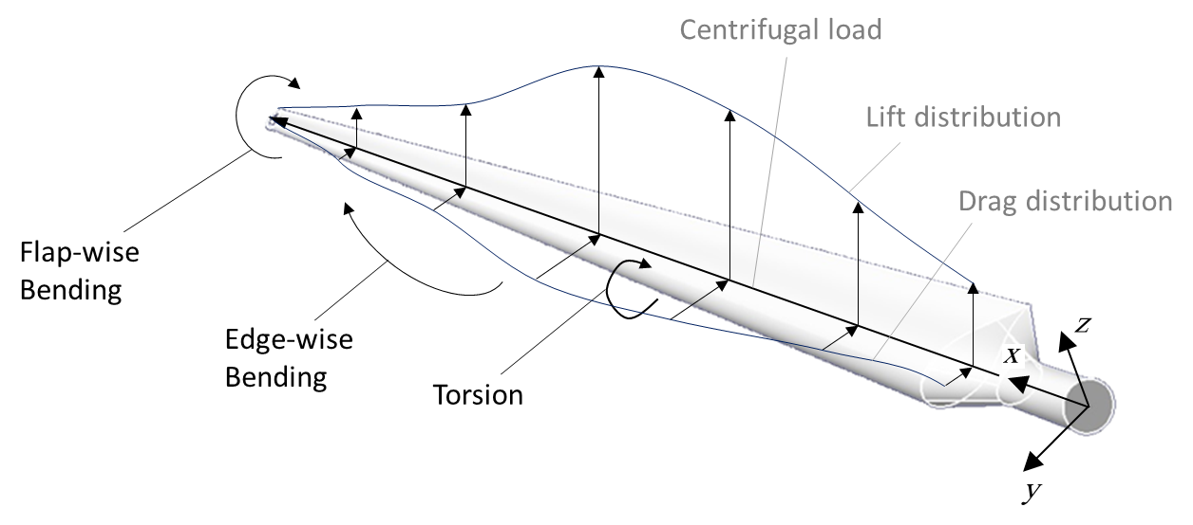

**Fig. 4.** Different loads on the wind turbine blade

In addition to these forces, three moments, namely flap-wise bending, edge-wise (or chord-wise) bending, and torsion, act on the blade, about x, y, and z axis, respectively.

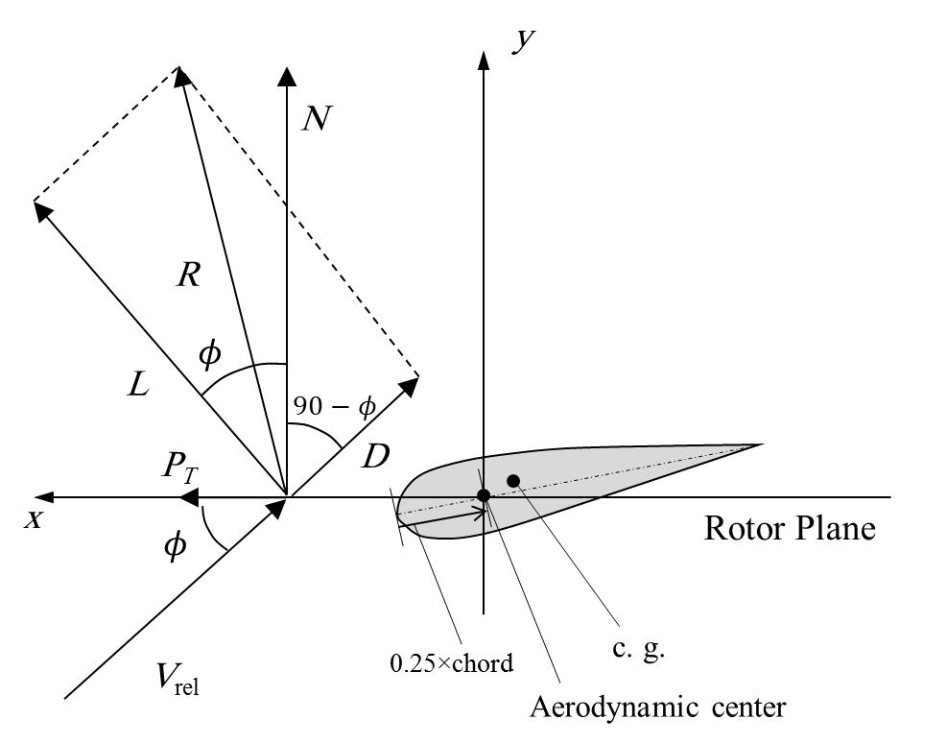

**Fig. 5.** Velocities and loads on the airfoil section

It should be noted that two bending moments are generated due to lift and drag forces, while torsion is produced directly from the aerodynamic moment.

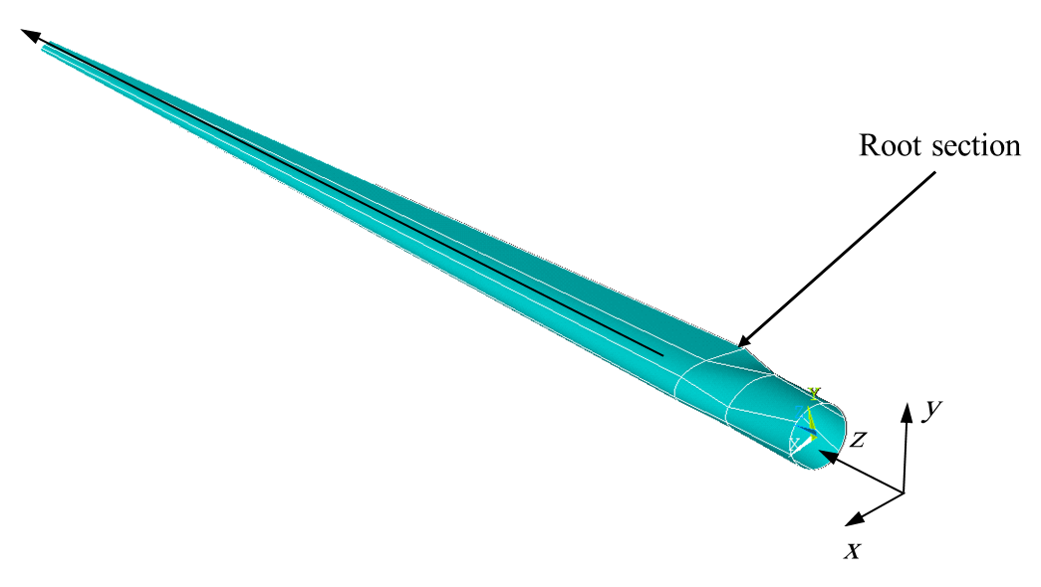

**Fig. 6.** Blade root section

The DU 00 W 401 (DU refers to Delft University) airfoil is a 40.1 % thick airfoil, that is a conventionally-used airfoil in wind turbine blades, reported to have a *C­l max*­ value of 1.93 at angle of attack of 30 degree [70].

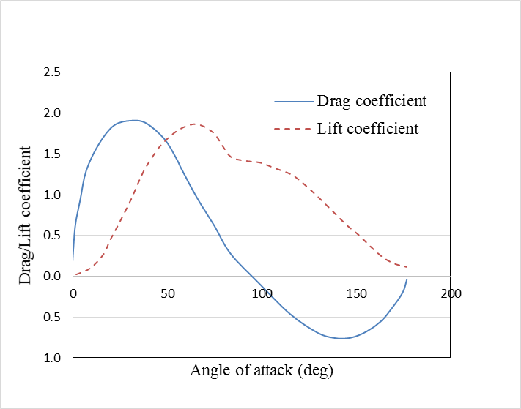

**Fig. 7.** Lift and drag coefficients of DU 00 W 401 airfoil [71]

The blade is supposed to be fixed at the root end, and free at the tip. Therefore, from the structural point of view, each blade is a cantilever composite beam. As can be seen in **Fig. 8**, the blade sections consists of skin, spar caps, and shear webs. In this work the flap-wise bending load is considered and the resulted stress from this load is calculated. This stress determines the load on the root edge of the upper spar cap, which is used for buckling analysis. The characteristics of the root section (section 3 in Table 3) is shown in Table 6.

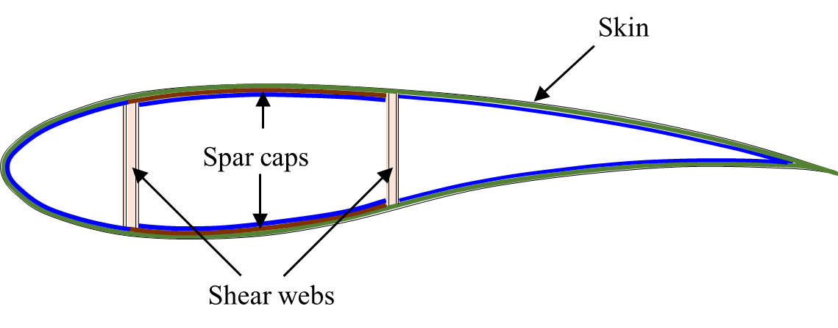

**Fig. 8.** Blade shear webs that are bounded to spar caps

**Table 6**

Blade material properties [52]

|  |  |
| --- | --- |
| **Variable (units)** | **Value** |
| Chord (m) | 10.0 |
| Skin thickness (cm) | 17.1 |
| Web thickness (cm) | 16.0 |
| Skin and web young modulus (GPa) | 17 |
| Spar thickness (cm) | 13.2 |
| Spar young modulus (GPa) | 32 |
| Airfoil | DU00W401 |
| Distance from root (m) | 20.182 |
| Pitch axis position (%chord) | 39.0 |

For determining the stress on the spar cap, a finite element model of the blade is created and is analyzed. The model consists of 27711 elements and 26939 nodes. For calculating the aerodynamic loads, blade element momentum theory (BEMT) is utilized [72]. The coefficient of the resultant aerodynamics force normal to the rotor plane, *Cn*, and relative velocity for six sections of the blade is calculated and shown in Table 6.

**Table 6**

Characteristics of blade sections

|  |  |  |  |  |
| --- | --- | --- | --- | --- |
| Section | *r* (m) | *Cn* | Chord (m) | *V*rel |
| 6 | 20.18 | 2.578 | 10 | 25.59 |
| 10 | 39.95 | 2.4 | 6.75 | 36.86 |
| 12 | 66.28 | 1.9 | 5.33 | 53.97 |
| 14 | 92.62 | 1.63 | 4.56 | 71.94 |
| 16 | 118.98 | 1.4861 | 4.56 | 90.5 |
| 18 | 128.84 | 1.4866 | 4.56 | 90.51 |

For determining the moment, it is required to integrate with respect to the lift function along the blade. Therefore, a relation is extracted for the relative velocity, *Cn*, and chord (*C*(*r*)) by curve fitting on data listed in Table 6:

|  |  |
| --- | --- |
|  | (27) |

The moment created from the aerodynamic force can be written as:

|  |  |
| --- | --- |
|  | (28) |

By applying the calculated load on the blade and performing finite element analysis, the stress on the upper spar cap is obtained as:

|  |  |
| --- | --- |
|  | (29) |

The stress distribution on the blade is shown in **Fig. 9**.

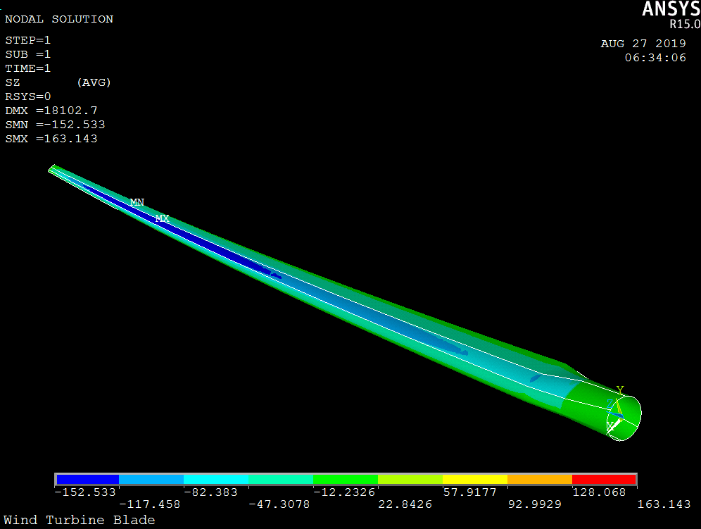

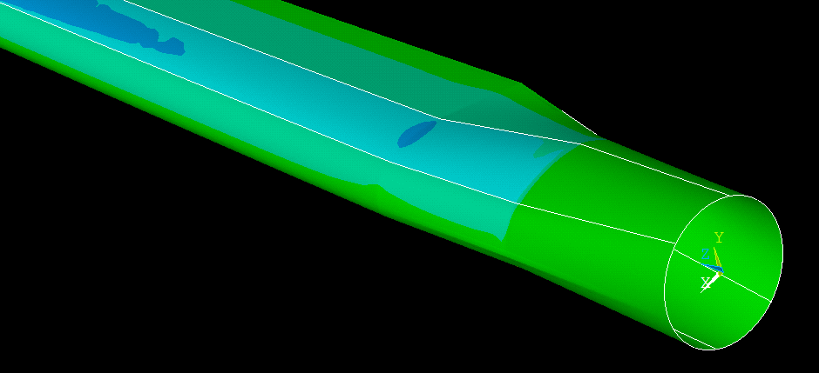

**Fig. 9.** Finite element analysis of the blade

Therefore the axial load on the upper panel of the wind turbine blade (upper spar cap) per unit length will be:

|  |  |
| --- | --- |
|  | (37) |

The panel of the wind turbine, which is used in the analysis is demonstrated in **Fig. 10**.

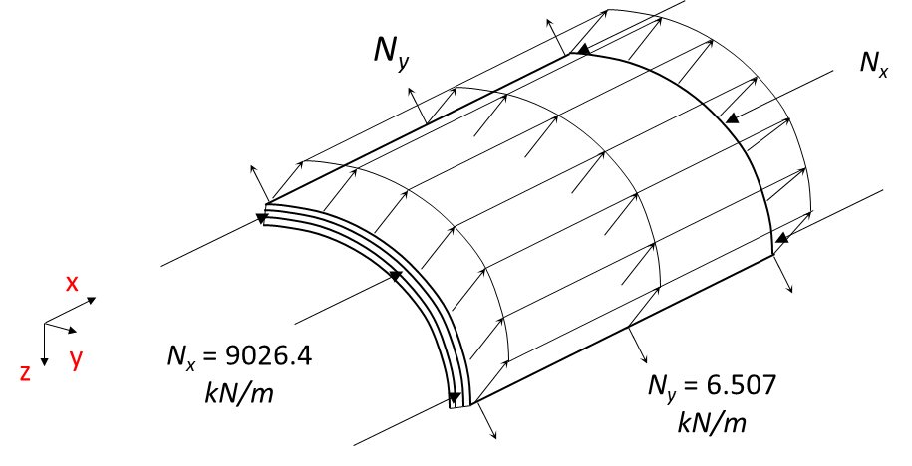 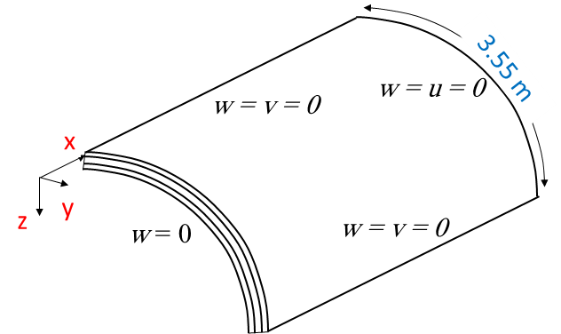

**Fig. 10.** Loads (left), geometry and boundary conditions (right) of the cylindrically curved panel

**2.5 Verification**

The verification of the developed method is performed in two parts. At first, the algorithm is verified using experimental case studies that are conventional for evaluating the performance of the multi-objective optimization algorithms. Next, the multi-objective optimization is verified for applying in the composite structure optimization problems.

**2.5.1 Decomposition-based hybrid multi-objective optimization algorithm**

In order to study the numerical performance of the discussed method, in this section the results that are obtained from implementing multi-objective particle swarm optimization algorithm is shown using DTLZ benchmark problems.

*DTLZ benchmark problems*

Experiments have been done on frequently used optimization benchmark problems C1-DTLZ1, C2-DTLZ2, and C3-DTLZ4 with 5, 8, 10, 15 objectives to evaluate the DHM optimization algorithm. These benchmark problems, that are described in Table 6, are usually used in analyzing many-objective algorithms [73].

The algorithm settings (both in the PSO part and in the SQP part) are given in Table 8 and Table 9.

**Table 7**

Algorithm settings for PSO

|  |  |
| --- | --- |
| **Parameter** | **Value (first level)** |
| Initial velocity | Random [0 1] |
| Inertia weight (*w*) | 0.7298 |
| *c*1, *c*2 | 2.05, 2.05 |
| Particle size (The number of variables) | 30 |
| Number of swarms | 1 |
| Population size | 70 |
| Number of iterations | 50 |

**Table 8**

Different DTLZ test functions examined and their properties [74]

|  |  |  |  |  |  |
| --- | --- | --- | --- | --- | --- |
| Test problem |  | *K* | *M* (Number of objective functions) | Properties | Objective functions |
| DTLZ1 | - | 5 | 5, 8, 12, 16 | Multimodal | Minimize  …  where  ***x*** = (*x*1, *x*2, …, *xn*)*T* [0, 1]*M*+*K*-1 |
| DTLZ2 | 1 | 10 | 5, 8, 12, 16 | Unimodal, concave | DTLZ2-4:  Minimize  …  where  ***x*** = (*x*1, *x*2, …, *xn*)*T* [0, 1]*M*+*K*-1 |
| DTLZ3 | 1 | 10 | 5, 8, 12, 16 | Multimodal, concave |
| DTLZ4 | 100 | 10 | 5, 8, 12, 16 | Concave |
| C1-DTLZ1 | - | 5 | 5, 8, 10, 15 | Multimodal | The objective functions are the same as those were in original DTLZ1, while the following constraint has been added: |
| C2-DTLZ2 | 1 | 10 | 5, 8, 10, 15 | Unimodal, concave | The objective functions are the same as those were in original DTLZ2, with this constraint: |
| C3-DTLZ4 | 100 | 10 | 5, 8, 10, 15 | Concave | The objective functions are the same as those were in original DTLZ2, with this constraint: |

**Table 9**

Algorithm settings for SQP

|  |  |
| --- | --- |
| **Parameter** | **Value** |
| Particle size (The number of variables) | 30 |
| Stopping criteria | Function tolerance: 1e-8  Design variable tolerance: 1e-7  Constraint tolerance: 1e-4 |
| Maximum iteration | 1000 |

The performance of the algorithm developed by the authors and used in this study, is compared with some recent multi-objective algorithms. It can be concluded from the comparison that the DHM optimization algorithm is of convincing performance (i.e. diversity, closeness to the real Pareto front, and convergence). For the comparison, some recent and frequently used criteria are employed. These criteria, namely, inverse generational distance (IGD), pure diversity (PD), and spacing, are defined as followings:

Inverse generational distance [73]:

|  |  |
| --- | --- |
|  | (39) |

where and set ***Z*** is targeted Pareto-optimal points in the normalized objective function space and ***A*** is the calculated final non-dominated points in this space. Based on the above equation, IGD metric is computed as Euclidean distance of points in set ***Z*** with their nearest members of all points in set ***A***.

Pure diversity:

|  |  |
| --- | --- |
|  | (40) |

where

|  |  |
| --- | --- |
|  | (41) |

is the dissimilarity of *s* to the rest members of *X*, that measures the different degree of *s* to other solutions in *X* [75]. To evaluate the performance of the utilized algorithm, the results of applying the algorithm to the above mentioned benchmark problems are listed in Table 9.

**Table 10**

C1-DTLZ1 benchmark problem evaluation for different algorithms

|  |  |  |  |  |  |  |  |  |  |
| --- | --- | --- | --- | --- | --- | --- | --- | --- | --- |
| Max NFE | 5,000 | | | 10,000 | | | 20,000 | | |
| Algorithm | Criteria | | | Criteria | | | Criteria | | |
| Spacing | PD | IGD | Spacing | PD | IGD | Spacing | PD | IGD |
| GrEA | NaN | NaN | NaN | NaN | 1.6718e+4 | NaN | 2.0759e-2 | 5.0178e+4 | 6.8772e-2 |
| IBEA | NaN | NaN | NaN | NaN | 3.3629e+3 | NaN | 2.2003e-1 | 1.3327e+4 | 1.7383e-2 |
| KnEA | NaN | NaN | NaN | NaN | 1.1883e+4 | NaN | 2.6951e-2 | 6.4230e+4 | 3.2562e-2 |
| MOEAD | NaN | 2.3614e+2 | NaN | NaN | 2.3080e+4 | NaN | NaN | 3.5727e+4 | NaN |
| NSGAII | NaN | 1.6037e+3 | NaN | NaN | 3.3800e+4 | NaN | 2.0115e-2 | 7.0871e+4 | 3.0906e-2 |
| tDEA | NaN | 8.1543e+2 | NaN | NaN | 2.1446e+3 | NaN | NaN | 3.7291e+4 | 6.0589e-2 |
| EMOPSO | **3.1667e-2** | 2.7072e+4 | - | 2.1231e-2 | 7.2250e+4 | - | 1.9305e-2 | 7.3894e+4 | - |
| The DHM algorithm (PSO+SQP) | 2.9966e-1 | 3.8156e+4 | **1.1043e+0** | **1.8126e-2** | 7.2843e+3 | **3.7840e-2** | **8.2480e-4** | 1.5902e+3 | **1.4288e-2** |

**Table 11**

C2-DTLZ2 benchmark problem evaluation for different algorithms

|  |  |  |  |  |  |  |  |  |  |
| --- | --- | --- | --- | --- | --- | --- | --- | --- | --- |
| Max NFE | 5,000 | | | 10,000 | | | 20,000 | | |
| Algorithm | Criteria | | | Criteria | | | Criteria | | |
| Spacing | PD | IGD | Spacing | PD | IGD | Spacing | PD | IGD |
| GrEA | NaN | NaN | 7.0303e-2 | NaN | NaN | 6.6846e-2 | 4.9311e-1 | NaN | 6.5459e-2 |
| IBEA | NaN | NaN | 9.3378e-2 | NaN | NaN | 8.5681e-2 | 0.0000e+0 | NaN | 9.1918e-2 |
| KnEA | NaN | NaN | 6.2690e-2 | NaN | NaN | 6.7699e-2 | 0.0000e+0 | NaN | 1.0207e-1 |
| MOEAD | NaN | NaN | 5.8022e-2 | NaN | NaN | 5.2818e-2 | 0.0000e+0 | NaN | 5.2355e-2 |
| NSGAII | NaN | NaN | 6.0870e-2 | NaN | NaN | 5.6647e-2 | 0.0000e+0 | NaN | 5.6203e-2 |
| GDE3 | NaN | NaN | 9.0513e-2 | NaN | NaN | 6.6250e-2 | 0.0000e+0 | NaN | 6.0138e-2 |
| MOEDDA | NaN | NaN | 9.0318e-2 | NaN | NaN | 8.3566e-2 | 0.0000e+0 | NaN | 8.3509e-2 |
| MOEADD | NaN | NaN | 5.3906e-2 | NaN | NaN | 5.0670e-2 | 0.0000e+0 | NaN | 5.0108e-2 |
| dMOPSO | NaN | NaN | NaN | NaN | NaN | 1.5892e-1 | 0.0000e+0 | NaN | NaN |
| MOPSO | NaN | NaN | NaN | NaN | NaN | NaN | 0.0000e+0 | NaN | NaN |
| tDEA | NaN | NaN | NaN | NaN | NaN | NaN | 0.0000e+0 | NaN | NaN |
| EMOPSO | 4.3872e-2 | 1.7384e+5 | - | 3.5374e-2 | 1.7589e+5 | - | 4.0117e-2 | 1.7943e+5 | - |
| The DHM algorithm (PSO+SQP) | **3.9338e-2** | 1.0422e+4 | **4.3299e-2** | **2.7588e-2** | 1.0347E+4 | **4.8461e-2** | **2.9714e-2** | 1.0471e+4 | **2.6917e-2** |

To compare the algorithms, the results are shown in Fig. 10 and Fig. 11. Due to the closeness of some points the logarithmic scale is applied for the values of spacing and IGD in C1-DTLZ1. Considering distribution of the solutions, the results of EMOPSO is better than others after 5000 function evaluations, but the DHM algorithm reaches the best solutions after 10,000 and 20,000 function calls. It should be mentioned that in cases that one algorithm attain the results just after 20,000 function evaluations, one point is shown in the figure instead of a line connecting three points.

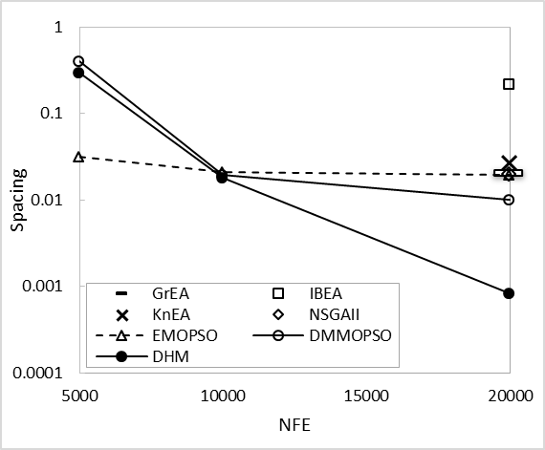

**Fig. 10.** Comparison of results based on spacing for C1-DTLZ1

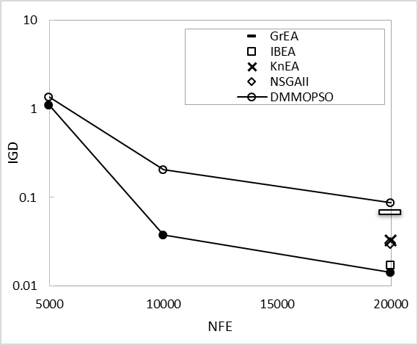

**Fig. 11.** Comparison of results based on IGD for C1-DTLZ1

The results from the DHM algorithm and some other recent developed multi-objective optimization methods are presented in Table 10 for C2-DTLZ2 benchmark problem. According to these data, the DHM algorithm has more exact solutions, considering the spacing criteria, which shows the quality of distribution and uniformity of the answers.

The data for this test problem is plotted to compare the performance of different algorithms, in which the solid circles are related to the DHM method. The obtained solutions show that the algorithm is of better performance comparing other methods, while the investigation imply that the results after the first part of the algorithm, i.e. PSO algorithm, may have a lower quality. This issue justifies the integration of PSO and SQP.

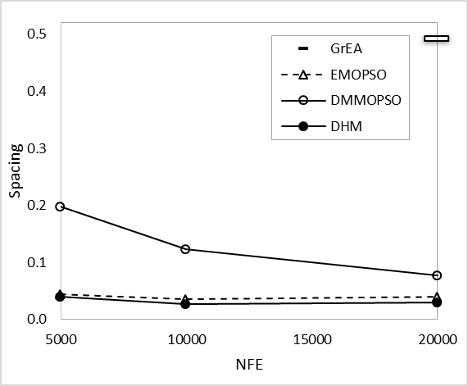

**Fig. 12.** Comparison of results based on spacing for C2-DTLZ2

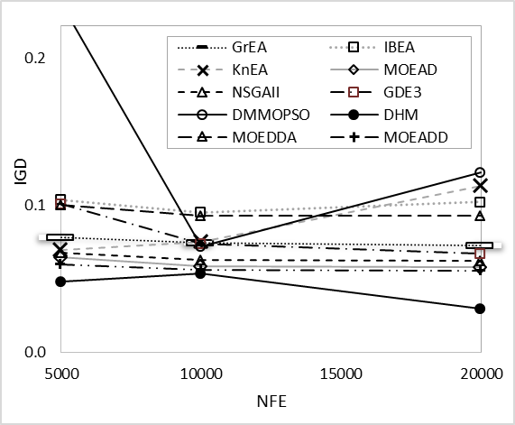

**Fig. 13.** Comparison of results based on IGD for C2-DTLZ2

**2.5.2 Verification of buckling analysis for a curved composite panel**

In this section, the critical buckling load factor is calculated for a curved composite panel and is compared with the values presented in reference [48]. The specimen curved  
composite panel is of radius 1150 mm and thickness 15 mm. To calculate the amount of the buckling load factor, the relation expressed in the Section 2 is used, which itself is a minimization problem. It is worthy to mention that a single-objective form of the hybrid method is implemented to find this factor.

**Table 12**

Comparison of present work and reference [48] results for the critical buckling load factor of a curved composite panel

|  |  |  |  |
| --- | --- | --- | --- |
|  | Critical buckling load factor | |  |
|  | Present work | Reference [48] | Error (%) |
| 0.4 | 116.05 | 109.82 | 5.61 |
| 0.45 | 114.71 | 113.17 | 1.44 |
| 0.5 | 120.23 | 118.53 | 1.43 |

The values listed in Table 6 shows an acceptable accuracy of the calculation for the structural stability of the considered curved laminated composite plate. The error between results is less than 6 percent.

**3. Results and discussion**

In this section, the presented multi-objective optimization algorithm is implemented for two laminated composite cases, made from carbon epoxy. The first case is a simply supported rectangular flat plate (Section 3.1) and the second one includes three panels of the 20 MW wind turbine under axial loading with the same support conditions with those explained in Section 2.2. In each case, the mode with minimum value of critical buckling load factor is considered as the buckling mode.

**3.1 Implementing single-objective form of DHM for a composite panel**

Here, a bi-objective composite optimization problem containing a flat composite plate is defined as a case study and the method is employed. For this purpose, a simply supported symmetric laminated composite plate is selected with the characteristics that are given in Table 13.

**Table 13**

Flat rectangular plate properties

|  |  |  |  |
| --- | --- | --- | --- |
| **Item** | **Notation** | **Value** | **Unit** |
| Longitudinal Young’s modulus | E1 | 127.55 | (GPa) |
| Transverse Young’s modulus | E2 | 13.030 | GPa) |
| Shear modulus | G12 | 6.410 | GPa |
| Poisson’s ratio | ν12 | 0.3 | - |
| Lamina thickness | t | 0.127 | mm |
| The length of the panel | a | 508 | mm |
| The width of the panel | b | 127 | mm |

**Table 14**

Number of function evaluations (single objective form of DHM)

|  |  |
| --- | --- |
| First level (PSO) | 110 |
| First level (SQP) | 1465 |
| Second level | 48 |
| Total | 1623 |

The load cases for this test problem is *Nx* = 1716 N/mm and *Ny* = 858.1 N/mm. The error in the below table was obtained based on the following definition:

|  |  |
| --- | --- |
|  | (42) |

As it is shown, the proposed algorithm shows a better performance in minimizing the weight of the composite panel, while critical buckling load factor is considered as a constraint.

**Table 15**

Evaluating the efficiency of the proposed method

|  |  |  |  |  |
| --- | --- | --- | --- | --- |
|  | **Optimal design** | ***λb*** | **Number of function evaluations** | **Error** |
| Present work | [905/±456/902/±452/0]s | 1.0109 | 1623 | < 0.01 |
| Reference [76] | [902/±45/(902/±45)2/±455]s | 1.0203 | 6000 |  |

**3.2 Multi-objective optimization of a composite plate**

Here, bi-objective optimization of the rectangular panel, used in the previous section, is performed and the results are shown in the next figure and tables.



**Fig. 14.** Multi-objective optimization results for the rectangular panel

The first level and also second level results are listed in the tables below.

**Table 16**

First level results (from PSO)

|  |  |  |  |  |  |  |  |  |
| --- | --- | --- | --- | --- | --- | --- | --- | --- |
| Total number of layers | Weight (gr) |  | *n*0 | *n* ±45 | *n* 90 |  |  |  |
| 46 | 603 | 0.73 | 4 | 7 | 5 | -0.0808 | 0.1986 | 0.4029 |
| 48 | 629 | 0.80 | 5 | 7 | 5 | -0.0368 | 0.0214 | 0.5418 |
| 50 | 655 | 1.13 | 2 | 7 | 9 | -0.5750 | 0.1232 | 0.2568 |
| 52 | 682 | 1.27 | 6 | 7 | 6 | -0.4846 | 0.0762 | 0.1141 |
| 54 | 708 | 1.44 | 4 | 7 | 9 | -0.5875 | 0.08329 | 0.4289 |
| 56 | 734 | 1.55 | 3 | 8 | 9 | -0.3878 | 0.0566 | 0.5145 |
| 58 | 760 | 1.69 | 2 | 9 | 9 | -0.3181 | 0.0471 | 0.0650 |
| 60 | 787 | 1.91 | 6 | 8 | 8 | -0.5115 | 0.2247 | 0.2977 |
| 62 | 813 | 2.12 | 4 | 9 | 9 | -0.5929 | 0.1938 | 0.2452 |

: buckling load factor

The case study is selected to illustrate the optimization procedure and out puts of the two levels. The results of the first level with six design variables are given for 9 points of the Pareto front points in Table 17 (obtained from PSO) and in Table 18 (after applying SQP) has been given, where the problem is of six design variables. As expected, the buckling load factor is increased when the weight is added.

**Table 17**

First level results (from SQP)

|  |  |  |  |  |  |  |  |  |
| --- | --- | --- | --- | --- | --- | --- | --- | --- |
| Total number of layers | Weight (gr) |  | *n*0 | *n*±45 | *n*90 |  |  |  |
| 46 | 603 | 0.89 | 4 | 7 | 5 | -0.5154 | 0.0235 | 0.0518 |
| 48 | 629 | 1.006 | 5 | 7 | 5 | -0.4867 | 0.0213 | 0.0418 |
| 50 | 655 | 1.159 | 2 | 7 | 9 | -0.5750 | 0.0188 | 0.2568 |
| 52 | 682 | 1.294 | 6 | 7 | 6 | -0.5325 | 0.0167 | 0.1142 |
| 54 | 708 | 1.462 | 4 | 7 | 9 | -0.5875 | 0.0149 | 0.4289 |
| 56 | 734 | 1.629 | 3 | 8 | 9 | -0.5886 | 0.0175 | 0.5145 |
| 58 | 760 | 1.809 | 2 | 9 | 9 | -0.6334 | 0.0199 | 0.2747 |
| 60 | 787 | 2.04 | 6 | 8 | 8 | -0.5624 | 0.0142 | 0.2977 |
| 62 | 813 | 2.212 | 4 | 9 | 9 | -0.6104 | 0.0163 | 0.2452 |

**Table 18**

Second level results (Stacking sequence)

|  |  |  |  |
| --- | --- | --- | --- |
| Total number of layers | Weight (gr) |  | Stacking sequence |
| 46 | 603 | 0.894 | [ 904 / ±456 / 90 / ±45 / 04 ]s |
| 48 | 629 | 1.0052 | [ 903 / ±45 / 902 / ±455 / 02 / ±45 / 03 ]s |
| 50 | 655 | 1.142 | [ 904 / ±453 / 902 / ±45 / 902 / ±453 / 90 / 02 ]s |
| 52 | 682 | 1.278 | [ 903 / ±452 / 90 / ±45 / 902 / ±452 / 0 / ±452 / 05 ]s |
| 54 | 708 | 1.434 | [ 903 / ±45 / 903 / ±452 / 90 / ±454 / 90 / 0 / 90 / 03 ]s |
| 56 | 734 | 1.605 | [ 904 / (±45 / 90)2 / ±452 / 90 / ±453 / 90 / ±45 / 90 / 03 ]s |
| 58 | 760 | 1.783 | [ (903 / ±45)2 / ±45 / 90 / (±452 / 90)2 / ±452 / 02 ]s |
| 60 | 787 | 1.977 | [ 904 / ±453 / 90 / ±453 / 90 / ±45 / 90 / 0 / 90 / ±45 / 05 ]s |

**3.3 Multi-objective optimization of the composite wind turbine panel**

At this point, multi-objective weight and buckling optimization of curved composite panel of the wind turbine is performed using the DHM algorithm. Previously expressed procedure is utilized to evaluate the buckling stability for fitness function evaluation.

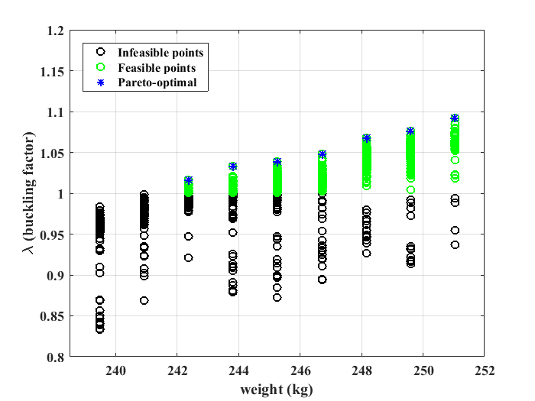

**Fig. 15.** Optimization results for the wind turbine blade curved panel

The values of the first level design variables are listed in Table 19. In the optimization process the lower and upper bounds of the number of layers with 0, ±45, and 90 degree orientation were supposed to be [74, 37, 15] and [78, 40, 20], respectively. The values were determined using the analysis of some random design points before running the optimization. From the values of three first design variables (the number of plies with each orientation) it is observed that *n*±45 and *n*90 acquire the values in the lower bound of the side constraints.

**Table 20**

The first level results for the curved panel

|  |  |  |  |  |  |  |  |
| --- | --- | --- | --- | --- | --- | --- | --- |
| Total number of layers | Weight (kg) | *n*0 | *n*±45 | *n*90 |  |  |  |
| 332 | 239.49 | 74 | 38 | 16 | 0.5308 | 0.1717 | 0.2784 |
| 334 | 240.93 | 74 | 38 | 17 | 0.4789 | 0.2266 | 0.4182 |
| 336 | 242.377 | 74 | 38 | 18 | 0.6836 | 0.1772 | 0.4232 |
| 338 | 243.82 | 74 | 38 | 19 | 0.7134 | 0.099 | 0.5343 |
| 340 | 245.26 | 74 | 39 | 18 | 0.5912 | 0.1021 | 0.4622 |
| 342 | 246.70 | 74 | 39 | 19 | 0.4624 | 0.0292 | 0.4097 |
| 344 | 248.15 | 77 | 38 | 19 | 0.5081 | 0.2232 | 0.282 |
| 346 | 249.59 | 74 | 40 | 19 | 0.641 | 0.1725 | 0.4751 |
| 348 | 251.03 | 77 | 39 | 19 | 0.6837 | 0.1522 | 0.4546 |

Therefore, it can be concluded that the layers with 0 degree orientation has the most effect on the increasing the buckling stability of the panel in this case study.

**Table 21**

Second level results (Stacking sequence) for wind turbine spar cap

|  |  |  |  |
| --- | --- | --- | --- |
| Total number of layers | Weight (kg) |  | Stacking sequence |
| 334 | 240.93 | 0.994 | [08 / ±45 / 90 / 03 / ±45 / 02 / (±45)2 / 08 / ±45 / 03 / 90 / 03 / ±45 / 04 / (±45)2 / 90 / 0 / ±45 / 02 / 90 / 02 / ±45 / 0 / ±45 / 90 / 03 / (±45)3 / 04 / ±45 / 90 / 0 / (±45)3 / 02 / ±45 / 02 / ±45 / 02 / ±45 / 90 / ±45 / 0 / 90 / 0 / ±45 / 02 / ±45 / 03 / ±45 / 90 / 0 / 90 / 03 / (±45)2 / 0 / 90 / 0 / ±45 / 90 / 0 / 90 / (±45)2 / 0 / ±45 / 0 / ±45 / 0 / ±45 / 0 / ±45 / 90 / 0 / ±45 / 0 / 90 / 0 / ±45 / 90 / ±45 / 0 / 90 / ±45 / 0]s |
| 336 | 242.38 | 1.017 | [010 / ±45 / 02 / ±45 / 03 / ±45 / 0 / ±45 / 04 / ±45 / 90 / 04 / 90 / 05 / ±45 / 0 / (±45)2 / 0 / ±45 / 90 / 0 / 90 / 0 / ±45 / 0 / 90 / 04 / 90 / 0 / ±45 / 02 / ±45 / 03 / ±45 / 02 / 90 / ±45 / 0 / (±45)2 / 02 / (±45)2 / 0 / 90 / 0 / (±45)2 / 02 / 90 / 0 / 902 / (±45)2 / 0 / 90 / 0 / (±45)3 / 902 / (±45)2 / 02 / ±45 / 0 / ±45 / 0 / ±45 / 0 / 90 / 03 / (±45)2 / 02 / 90 / 02 / (±45)3 / 0 / ±45 / 90 / 03 / 90 / 0 / ±45 / 0 / 90 / ±45]s |
| 338 | 243.82 | 1.033 | [06 / ±45 / 08 / (±45)2 / 02 / ±45 / 05 / ±45 / 90 / 04 / ±45 / 04 / ±45 / 0 / ±45 / 02 / (±45)2 / 02 / (±45)5 / 0 / 90 / 04 / (±45)2 / 90 / 0 / ±45 / 0 / (±45)2 / 02 / 90 / ±45 / 03 / ±45 / 0 / ±45 / 90 / (±45)4 / 0 / 90 / 03 / ±45 / 0 / ±45 / 0 / (±45)2 / 02 / 90 / 0 / ±45 / 0 / 90 / 02 / 90 / 0 / 902 / (±45)2 / 02 / 902 / ±45 / 90 / 03 / 90 / ±45 / 90 / 0 / 90 / 0 / (±45)2 / 05 / 90 / ±45 / 0]s |
| 340 | 245.26 | 1.034 | [02 / ±45 / 0 / ±45 / 0 / ±45 / 08 / (±45)2 / 90 / 0 / (0 / ±45)4 / 04 / ±45 / 03 / (±45)2 / 02 / ±45 / 02 / ±45 / 06 / 90 / 04 / (±45)2 / 02 / ±45 / 0 / 90 / 02 / ±45 / 02 / ±45 / 05 / ±45 / 02 / 902 / 02 / 902 / 02 / (±45)2 / 90 / 0 / ±45 / 02 / ±45 / 90 / ±45 / 902 / ±45 / 0 / (±45)2 / 04 / 90 / ±45 / 90 / 0 / ±45 / 02 / 90 / (±45)2 / 0 / ±45 / 90 / ±45 / 02 / ±45 / 90 / 02 / (±45)3 / 90 / ±45 / 90 / 02]s |
| 342 | 246.70 | 1.048 | [08 / ±45 / 09 / (±45)2 / 04 / ±45 / 05 / (±45)3 / 0 / (±45)2 / 02 / (±45)3 / 0 / (±45)2 / 0 / (±45)2 / 04 / ±45 / 90 / 0 / 90 / 04 / (±45)2 / 02 / ±45 / 902 / 0 / (±45)2 / 08 / ±45 / 90 / 04 / ±45 / 03 / 90 / 0 / 90 / ±45 / 0 / (±45)3 / 0 / ±45 / 90 / 0 / (±45)2 / 90 / ±45 / 90 / 0 / ±45 / 90 / ±45 / 0 / 90 / 02 / ±45 / 90 / 04 / 902 / 04 / 90 / (90 /0)2 / ±45 / 0 / ±45 / 90 / ±45 ]s |
| 344 | 248.15 | 1.068 | [03 / ±45 / 05 / ±45 / 04 / ±45 / 90 / 02 / ±45 / 02 / ±45 / 04 / (±45)2 / 02 / 90 / 03 / ±45 / 0 / ±45 / 0 / 90 / ±45 / 03 / ±45 / 0 / 90 / 0 / ±45 / 02 / (±45)2 / 05 / (±45)2 / 03 / 90 / 0 / (0 / ±45)3 / 03 / ±45 / 0 / 90 / (±45)2 / 02 / ±45 / 03 / ±45 / 0 / ±45 / 03 / (±45)2 / 902 / ±45 / 02 / ±45 / 0 / 90 / 02 / 903 / (±45)2 / 90 / (±45)3 / 04 / ±45 / 0 / 90 / 0 / 90 / 03 / ±45 / 90 / ±45 / 90 / 0 / (±45)3 / 90]s |
| 346 | 249.59 | 1.070 | [0 / ±45 / 05 / ±45 / 02 / 90 / 06 / 90 / 012 / ±45 / 0 / ±45 / 0 / ±45 / 0 / (±45)2 / 02 / ±45 / 03 / (±45)3 / 02 / ±45 / 06 / (±45)3 / 02 / 90 / 0 / 90 / 04 / 90 / 0 / ±45 / 90 / ±45 / 90 / 0 / (±45)4 / 0 / 90 / 0 / 90 / 0 / 90 / (±45)2 / 0 / 90 / ±45 / 0 / ±45 / 02 / ±45 / 0 / (±45)2 / 03 / ±45 / 90 / (±45)2 / 902 / 03 / 90 / (±45)2 / 0 / 90 / 0 / ±45 / 90 / 0 / ±45 / 90 / 0 / 90 / 0 / (±45)2 / 06 / ±45 / 0 / ±45]s |
| 348 | 251.03 | 1.080 | [04 / ±45 / 03 / ±45 / 04 / ±45 / 03 / ±(±45)3 / 05 / 90 / 0 / ±45 / 04 / (±45)2 / 02 / ±45 / 90 / 06 / ±45 / 02 / ±45 / 0 / 90 / 03 / (±45)2 / 0 / (±45)2 / 90 / (±45)2 / 02 / 90 / ±45 / 0 / 90 / 0 / 90 / 02 / (±45)2 / 0 / 90 / ±45 / 0 / (±45)3 / 0 / (±45)2 / 0 / ±45 / 0 / ±45 / 02 / ±45 / 90 / 0 / (±45)2 / 0 / 90 / ±45 / 0 / 90 / 03 / 90 / ±45 / 0 / ±45 / 02 / ±45 / 0 / ±45 / 02 / 90 / 0 / 90 / 0 / 90 / 0 / 902 / 02 / ±45 / 0 / (±45)2 / 0 / 90 / 0 / 90 / ±45 / 0]s |

In all results, stacking sequences are began with 0 degree layers. This is due to the type of loads acting on the panel. In this work, top panel of the wind turbine blade (upper spar cap) is the structural case. This panel is under compression loads and hence, the dominant mode of failure is buckling [13] and there is no need to consider other failure modes such as fiber breakage.

**4. Conclusion**

In this paper, stacking sequence optimization of a curved laminated composite panel with respect to the weight and critical buckling load factor as objective functions was performed using a new developed algorithm. In the DHM optimization algorithm, to establish the primary Pareto front an enhanced MOPSO algorithm (with mutation operator and multi-start technique) was utilized because of its global search ability. Then, more exact solutions were found applying SQP as a quick gradient based method, especially in the local search. The proposed algorithm was evaluated and compared with some existing multi-objective optimization methods, using well-known constrained benchmark problems. The results show that the proposed algorithm provides high uniformity with fast convergence speed in comparison with other methods (Fig**.** 10 toFig**.** 13**).**

In the following step, a wind turbine blade and its curved panel is used in this paper to demonstrate the performance of the proposed approach. It should be mentioned that lamination parameterization was used to improve the efficiency of the method in two ways. First, this approach transfers the search space with *n*0+*n*±45+*n*90­ design variables, to a space with just 6 design variables (namely, *n*0+*n*±45+*n*90, , , for a symmetric lay-up). This reduction in the number of design variables decreases the number of function evaluations needed in the algorithm to reach the optimal point. Since, lamination parameters are not applicable design information, usually composite optimization methods that uses these parameters, are implemented in a bi-level architecture. Where at the second level of the architecture, stacking sequences, as applicable results, are obtained. In the present work, the new bi-level approach, recently developed by the authors [26], was integrated with the proposed multi-objective method to implement in laminated composite optimization problems. Second, lamination parameters establish a space that at the close to the PSO results is convex, and a gradient-based optimization method can be applied.

The comparisons made in single objective situation for a rectangular composite panel (Table 14 and Table 15) show that the proposed hybrid strategy achieves high-speed convergence, and it can be concluded that combining the global and local search capabilities of an evolutionary algorithm (PSO) and a gradient based method (SQP) reduces the number of function calls and hence, reduces the number of analysis that are needed to obtain the optimal solution without losing the accuracy.

**References**

[1] T. Ashuri, M. B. Zaaijer, J. R. R. A. Martins, G. J. W. Van Bussel, and G. A. M. Van Kuik, “Multidisciplinary design optimization of offshore wind turbines for minimum levelized cost of energy,” *Renew. energy*, vol. 68, pp. 893–905, 2014.

[2] W. J. Stroud and N. Agranoff, “Minimum-mass design of filamentary composite panels under combined loads: Design procedure based on simplified buckling equations,” 1976.

[3] E. Lund, L. Kühlmeier, and J. Stegmann, “Buckling optimization of laminated hybrid composite shell structures using discrete material optimization,” in *6th World Congress on Structural and Multidisciplinary Optimization, Rio de Janeiro*, 2005, vol. 30.

[4] R. M. Jones, “Buckling and vibration of unsymmetrically laminated cross-ply rectangular plates,” *AIAA J.*, vol. 11, no. 12, pp. 1626–1632, 1973.

[5] S. T. IJsselmuiden, M. M. Abdalla, O. Seresta, and Z. Gürdal, “Multi-step blended stacking sequence design of panel assemblies with buckling constraints,” *Compos. part b Eng.*, vol. 40, no. 4, pp. 329–336, 2009.

[6] N. Gaudern and D. Symons, “Comparison of theoretical and numerical buckling loads for wind turbine blade panels,” *Wind Eng.*, vol. 34, no. 2, pp. 193–206, 2010.

[7] S. M. Jun and C. S. Hong, “Buckling behavior of laminated composite cylindrical panels under axial compression,” *Comput. Struct.*, vol. 29, no. 3, pp. 479–490, 1988.

[8] J. M. Whitney, “Buckling of anisotropic laminated cylindrical plates,” *AIAA J.*, vol. 22, no. 11, pp. 1641–1645, 1984.

[9] G. J. Turvey and I. H. Marshall, *Buckling and postbuckling of composite plates*. Springer Science & Business Media, 2012.

[10] Y. Zheng and Z. Qiu, “Analysis of the critical buckling loads of composite corrugated plates under nonlinearly distributed compressive loads accounting for flexural-twist coupling,” *Acta Mech.*, pp. 1–22, 2016.

[11] E. Lindgaard and E. Lund, “Nonlinear buckling optimization of composite structures,” *Comput. Methods Appl. Mech. Eng.*, vol. 199, no. 37–40, pp. 2319–2330, 2010.

[12] Z. Lanting, “Research on structural lay-up optimum design of composite wind turbine blade,” *Energy Procedia*, vol. 14, pp. 637–642, 2012.

[13] P. E. Nicholas, K. P. Padmanaban, D. Vasudevan, and T. Ramachandran, “Stacking sequence optimization of horizontal axis wind turbine blade using FEA, ANN and GA,” *Struct. Multidiscip. Optim.*, vol. 52, no. 4, pp. 791–801, 2015.

[14] E. Lund, “Buckling topology optimization of laminated multi-material composite shell structures,” *Compos. Struct.*, vol. 91, no. 2, pp. 158–167, 2009.

[15] J. Zhu, X. Cai, P. Pan, and R. Gu, “Multi-objective structural optimization design of horizontal-axis wind turbine blades using the non-dominated sorting genetic algorithm II and finite element method,” *Energies*, vol. 7, no. 2, pp. 988–1002, 2014.

[16] D. Sale, A. Aliseda, M. Motley, and Y. Li, “Structural optimization of composite blades for wind and hydrokinetic turbines,” in *1st Marine Energy Technology Symposium*, 2013.

[17] C. C. Liao, X. L. Zhao, and J. Z. Xu, “Blade layers optimization of wind turbines using FAST and improved PSO algorithm,” *Renew. Energy*, vol. 42, pp. 227–233, 2012.

[18] X. Cai, J. Zhu, P. Pan, and R. Gu, “Structural optimization design of horizontal-axis wind turbine blades using a particle swarm optimization algorithm and finite element method,” *Energies*, vol. 5, no. 11, pp. 4683–4696, 2012.

[19] A. G. Passos and M. A. Luersen, “Multiobjective optimization of laminated composite parts with curvilinear fibers using Kriging-based approaches,” *Struct. Multidiscip. Optim.*, vol. 57, no. 3, pp. 1115–1127, 2018.

[20] M. Abouhamze and M. Shakeri, “Multi-objective stacking sequence optimization of laminated cylindrical panels using a genetic algorithm and neural networks,” *Compos. Struct.*, vol. 81, no. 2, pp. 253–263, 2007.

[21] M. Kalantari, C. Dong, and I. J. Davies, “Multi-objective analysis for optimal and robust design of unidirectional glass/carbon fibre reinforced hybrid epoxy composites under flexural loading,” *Compos. Part B Eng.*, vol. 84, pp. 130–139, 2016.

[22] D. Liu, V. V Toropov, D. C. Barton, and O. M. Querin, “Weight and mechanical performance optimization of blended composite wing panels using lamination parameters,” *Struct. Multidiscip. Optim.*, vol. 52, no. 3, pp. 549–562, 2015.

[23] S. W. Tsai and H. T. Hahn, “Introduction to composite materials, Technomic Publ,” *Co., Westport*, 1980.

[24] J. E. Herencia, R. T. Haftka, P. M. Weaver, and M. I. Friswell, “Lay-up optimization of composite stiffened panels using linear approximations in lamination space,” *AIAA J.*, vol. 46, no. 9, pp. 2387–2391, 2008.

[25] M. Miki and Y. Sugiyamat, “Optimum design of laminated composite plates using lamination parameters,” *AIAA J.*, vol. 31, no. 5, pp. 921–922, 1993.

[26] P. M. Zadeh, M. Fakoor, and M. Mohagheghi, “Bi-level optimization of laminated composite structures using particle swarm optimization algorithm,” *J. Mech. Sci. Technol.*, vol. 32, no. 4, pp. 1643–1652, 2018.

[27] M. Montemurro, A. Pagani, G. A. Fiordilino, J. Pailhès, and E. Carrera, “A general multi-scale two-level optimisation strategy for designing composite stiffened panels,” *Compos. Struct.*, vol. 201, pp. 968–979, 2018.

[28] D. Liu, “Bi-level Optimization of Blended Composite Wing Panels,” The University of Leeds, 2010.

[29] S. Chen, Z. Lin, H. An, H. Huang, and C. Kong, “Stacking sequence optimization with genetic algorithm using a two-level approximation,” *Struct. Multidiscip. Optim.*, vol. 48, no. 4, pp. 795–805, 2013.

[30] M. W. Bloomfield, J. E. Herencia, and P. M. Weaver, “Enhanced two-level optimization of anisotropic laminated composite plates with strength and buckling constraints,” *Thin-Walled Struct.*, vol. 47, no. 11, pp. 1161–1167, 2009.

[31] R. Kathiravan and R. Ganguli, “Strength design of composite beam using gradient and particle swarm optimization,” *Compos. Struct.*, vol. 81, no. 4, pp. 471–479, 2007.

[32] M. Rouhi, H. Ghayoor, S. V Hoa, and M. Hojjati, “Multi-objective design optimization of variable stiffness composite cylinders,” *Compos. Part B Eng.*, vol. 69, pp. 249–255, 2015.

[33] J. N. Reddy, *Mechanics of laminated composite plates and shells: theory and analysis*. CRC press, 2004.

[34] M. Dikmen, *Theory of thin elastic shells*, vol. 8. Pitman Advanced Publishing Program, 1982.

[35] J. N. Reddy, *Energy and variational methods in applied mechanics: with an introduction to the finite element method*. Wiley New York, 1984.

[36] S. Y. H. Jie and W. Wei, “Dynamic characteristic analysis of rotating composite shell,” *J. Beijing Univ. Aeronaut. Astronaut.*, no. 1, p. 7, 2004.

[37] Y. N. Kim and I. Y. Yang, “Impact response and damage of composite shell with various curvatures,” in *Key Engineering Materials*, 2004, vol. 270, pp. 1911–1916.

[38] F. Tornabene, “General higher-order layer-wise theory for free vibrations of doubly-curved laminated composite shells and panels,” *Mech. Adv. Mater. Struct.*, vol. 23, no. 9, pp. 1046–1067, 2016.

[39] Q. Wang, D. Shao, and B. Qin, “A simple first-order shear deformation shell theory for vibration analysis of composite laminated open cylindrical shells with general boundary conditions,” *Compos. Struct.*, vol. 184, pp. 211–232, 2018.

[40] F. Tornabene, N. Fantuzzi, M. Bacciocchi, and E. Viola, “Mechanical behavior of damaged laminated composites plates and shells: higher-order shear deformation theories,” *Compos. Struct.*, vol. 189, pp. 304–329, 2018.

[41] H. Santos, C. M. M. Soares, C. A. M. Soares, and J. N. Reddy, “A finite element model for the analysis of 3D axisymmetric laminated shells with piezoelectric sensors and actuators,” *Compos. Struct.*, vol. 75, no. 1–4, pp. 170–178, 2006.

[42] H. Santos, C. M. M. Soares, C. A. M. Soares, and J. N. Reddy, “A finite element model for the analysis of 3D axisymmetric laminated shells with piezoelectric sensors and actuators: Bending and free vibrations,” *Comput. Struct.*, vol. 86, no. 9, pp. 940–947, 2008.

[43] M. S. Qatu, R. W. Sullivan, and W. Wang, “Recent research advances on the dynamic analysis of composite shells: 2000--2009,” *Compos. Struct.*, vol. 93, no. 1, pp. 14–31, 2010.

[44] M. Shakeri, M. R. Eslami, and A. Daneshmehr, “Dynamic analysis of thick laminated shell panel with piezoelectric layer based on three dimensional elasticity solution,” *Comput. Struct.*, vol. 84, no. 22–23, pp. 1519–1526, 2006.

[45] M. Shakeri, M. H. Yas, and M. G. Gol, “Optimal stacking sequence of laminated cylindrical shells using genetic algorithm,” *Mech. Adv. Mater. Struct.*, vol. 12, no. 4, pp. 305–312, 2005.

[46] Y. Q. Zang, D. Zhang, H. Y. Zhou, H. Z. Ma, and T. K. Wang, “Non-linear dynamic buckling of laminated composite shallow spherical shells,” *Compos. Sci. Technol.*, vol. 60, no. 12–13, pp. 2361–2363, 2000.

[47] J. M. Gere and S. P. Timoshenko, *Theory of elastic stability*. 1961.

[48] T. Burton, N. Jenkins, D. Sharpe, and E. Bossanyi, *Wind energy handbook*. John Wiley & Sons, 2011.

[49] P. K. Mallick, *Fiber-reinforced composites: materials, manufacturing, and design*. CRC press, 2007.

[50] C. Kassapoglou, *Design and analysis of composite structures: with applications to aerospace structures*. John Wiley & Sons, 2013.

[51] D. Liu, V. V Toroporov, O. M. Querin, and D. C. Barton, “Bilevel optimization of blended composite wing panels,” *J. Aircr.*, vol. 48, no. 1, pp. 107–118, 2011.

[52] T. Ashuri, J. R. R. A. Martins, M. B. Zaaijer, G. A. M. van Kuik, and G. J. W. van Bussel, “Aeroservoelastic design definition of a 20 MW common research wind turbine model,” *Wind Energy*, vol. 19, no. 11, pp. 2071–2087, 2016.

[53] F. Gubarev, V. Kunin, and A. Pospelov, “Lay-up Optimization of Laminated Composites: Mixed Approach with Exact Feasibility Bounds on Lamination Parameters,” *arXiv Prepr. arXiv1304.7226*, 2013.

[54] M. W. Bloomfield, C. G. Diaconu, and P. M. Weaver, “On feasible regions of lamination parameters for lay-up optimization of laminated composites,” in *Proceedings of the Royal Society of London A: Mathematical, Physical and Engineering Sciences*, 2009, vol. 465, no. 2104, pp. 1123–1143.

[55] X. Liu, C. A. Featherston, and D. Kennedy, “Two-level layup optimization of composite laminate using lamination parameters,” *Compos. Struct.*, vol. 211, pp. 337–350, 2019.

[56] G. J. Kennedy and J. R. R. A. Martins, “A laminate parametrization technique for discrete ply-angle problems with manufacturing constraints,” *Struct. Multidiscip. Optim.*, vol. 48, no. 2, pp. 379–393, 2013.

[57] Y. B. SudhirSastry, P. R. Budarapu, N. Madhavi, and Y. Krishna, “Buckling analysis of thin wall stiffened composite panels,” *Comput. Mater. Sci.*, vol. 96, pp. 459–471, 2015.

[58] M. Asafuddoula, T. Ray, and R. Sarker, “A decomposition-based evolutionary algorithm for many objective optimization,” *IEEE Trans. Evol. Comput.*, vol. 19, no. 3, pp. 445–460, 2015.

[59] Y.-L. Zheng, L.-H. Ma, L.-Y. Zhang, and J.-X. Qian, “On the convergence analysis and parameter selection in particle swarm optimization,” in *Proceedings of the 2003 International Conference on Machine Learning and Cybernetics (IEEE Cat. No. 03EX693)*, 2003, vol. 3, pp. 1802–1807.

[60] M. Clerc and J. Kennedy, “The particle swarm-explosion, stability, and convergence in a multidimensional complex space,” *IEEE Trans. Evol. Comput.*, vol. 6, no. 1, pp. 58–73, 2002.

[61] S. Cheng, H. Zhan, and Z. Shu, “An innovative hybrid multi-objective particle swarm optimization with or without constraints handling,” *Appl. Soft Comput.*, vol. 47, pp. 370–388, 2016.

[62] P. M. Zadeh, T. Sokhansefat, A. B. Kasaeian, F. Kowsary, and A. Akbarzadeh, “Hybrid optimization algorithm for thermal analysis in a solar parabolic trough collector based on nanofluid,” *Energy*, vol. 82, pp. 857–864, 2015.

[63] X. Hu and R. C. Eberhart, “Multiobjective optimization using dynamic neighborhood particle swarm optimization,” 2002.

[64] C. A. C. Coello, G. T. Pulido, and M. S. Lechuga, “Handling multiple objectives with particle swarm optimization,” *IEEE Trans. Evol. Comput.*, vol. 8, no. 3, pp. 256–279, 2004.

[65] R. Eberhart and J. Kennedy, “A new optimizer using particle swarm theory,” in *Micro Machine and Human Science, 1995. MHS’95., Proceedings of the Sixth International Symposium on*, 1995, pp. 39–43.

[66] M. Reyes-Sierra and C. A. C. Coello, “Multi-objective particle swarm optimizers: A survey of the state-of-the-art,” *Int. J. Comput. Intell. Res.*, vol. 2, no. 3, pp. 287–308, 2006.

[67] V. Kumar and S. Minz, “Multi-objective particle swarm optimization: an introduction,” *SmartCR*, vol. 4, no. 5, pp. 335–353, 2014.

[68] I. E. C. 61400-1, “Wind Turbine Generator Systems - Part 1: Safety Requirements.” IEC, 2019.

[69] F. W. Perkins and D. E. Cromack, “Wind turbine blade stress analysis and natural frequencies,” 1978.

[70] A. Ragheb and M. Selig, “Multi-element airfoil configurations for wind turbines,” in *29th AIAA applied aerodynamics conference*, 2011, p. 3971.

[71] J. Li and X. Yu, “Analyses of the extensible blade in improving wind energy production at sites with low-class wind resource,” *Energies*, vol. 10, no. 9, p. 1295, 2017.

[72] M. O. L. Hansen, *Aerodynamics of wind turbines*. Routledge, 2015.

[73] K. Deb and H. Jain, “An evolutionary many-objective optimization algorithm using reference-point-based nondominated sorting approach, part I: Solving problems with box constraints.,” *IEEE Trans. Evol. Comput.*, vol. 18, no. 4, pp. 577–601, 2014.

[74] C. Luo, K. Shimoyama, and S. Obayashi, “A study on many-objective optimization using the kriging-surrogate-based evolutionary algorithm maximizing expected hypervolume improvement,” *Math. Probl. Eng.*, vol. 2015, 2015.

[75] H. Wang, Y. Jin, and X. Yao, “Diversity assessment in many-objective optimization,” *IEEE Trans. Cybern.*, vol. 47, no. 6, pp. 1510–1522, 2016.

[76] R. H. Lopez, M. A. Luersen, and E. S. Cursi, “Optimization of laminated composites considering different failure criteria,” *Compos. Part B Eng.*, vol. 40, no. 8, pp. 731–740, 2009.