**Name : مصطفى محمود عابد عبدالسميع**

**B.N: 933**

**Date :**

**Topic:** **big data**

**Github link :**

**Github page :**

**Application brief :**

Big data is a new engine for economic and societal changes in the world. World data

The group has reached a turning point for major technological changes that could bring new ones. Methods in decision making and management of our health, cities, finance and education. While the Data becomes more sophisticated, including data size, diversity, speed and validity. The real impact depends on our ability to detect "value" in the data through big data.

**Screeshots :**

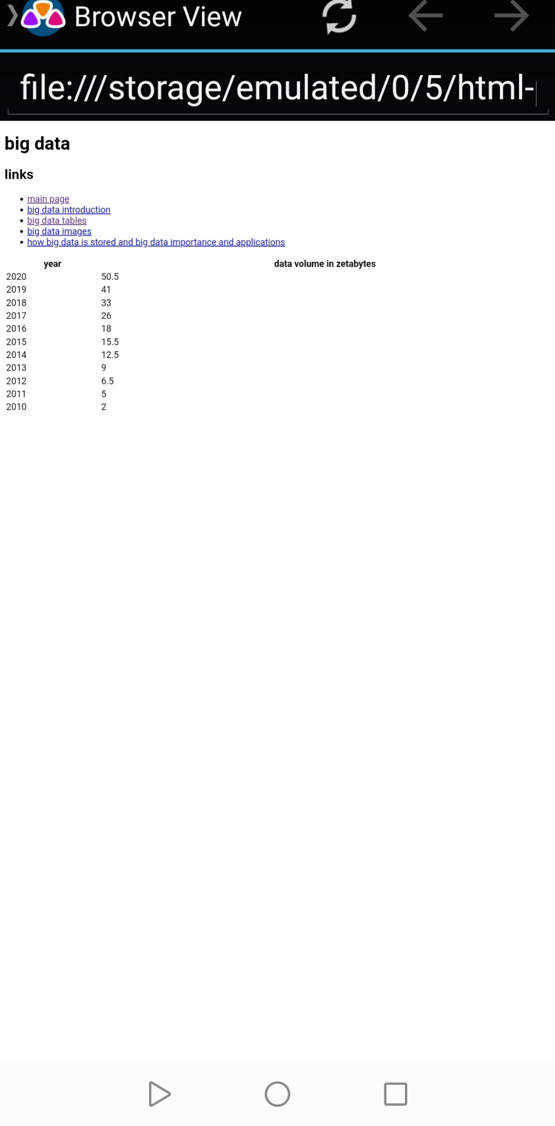

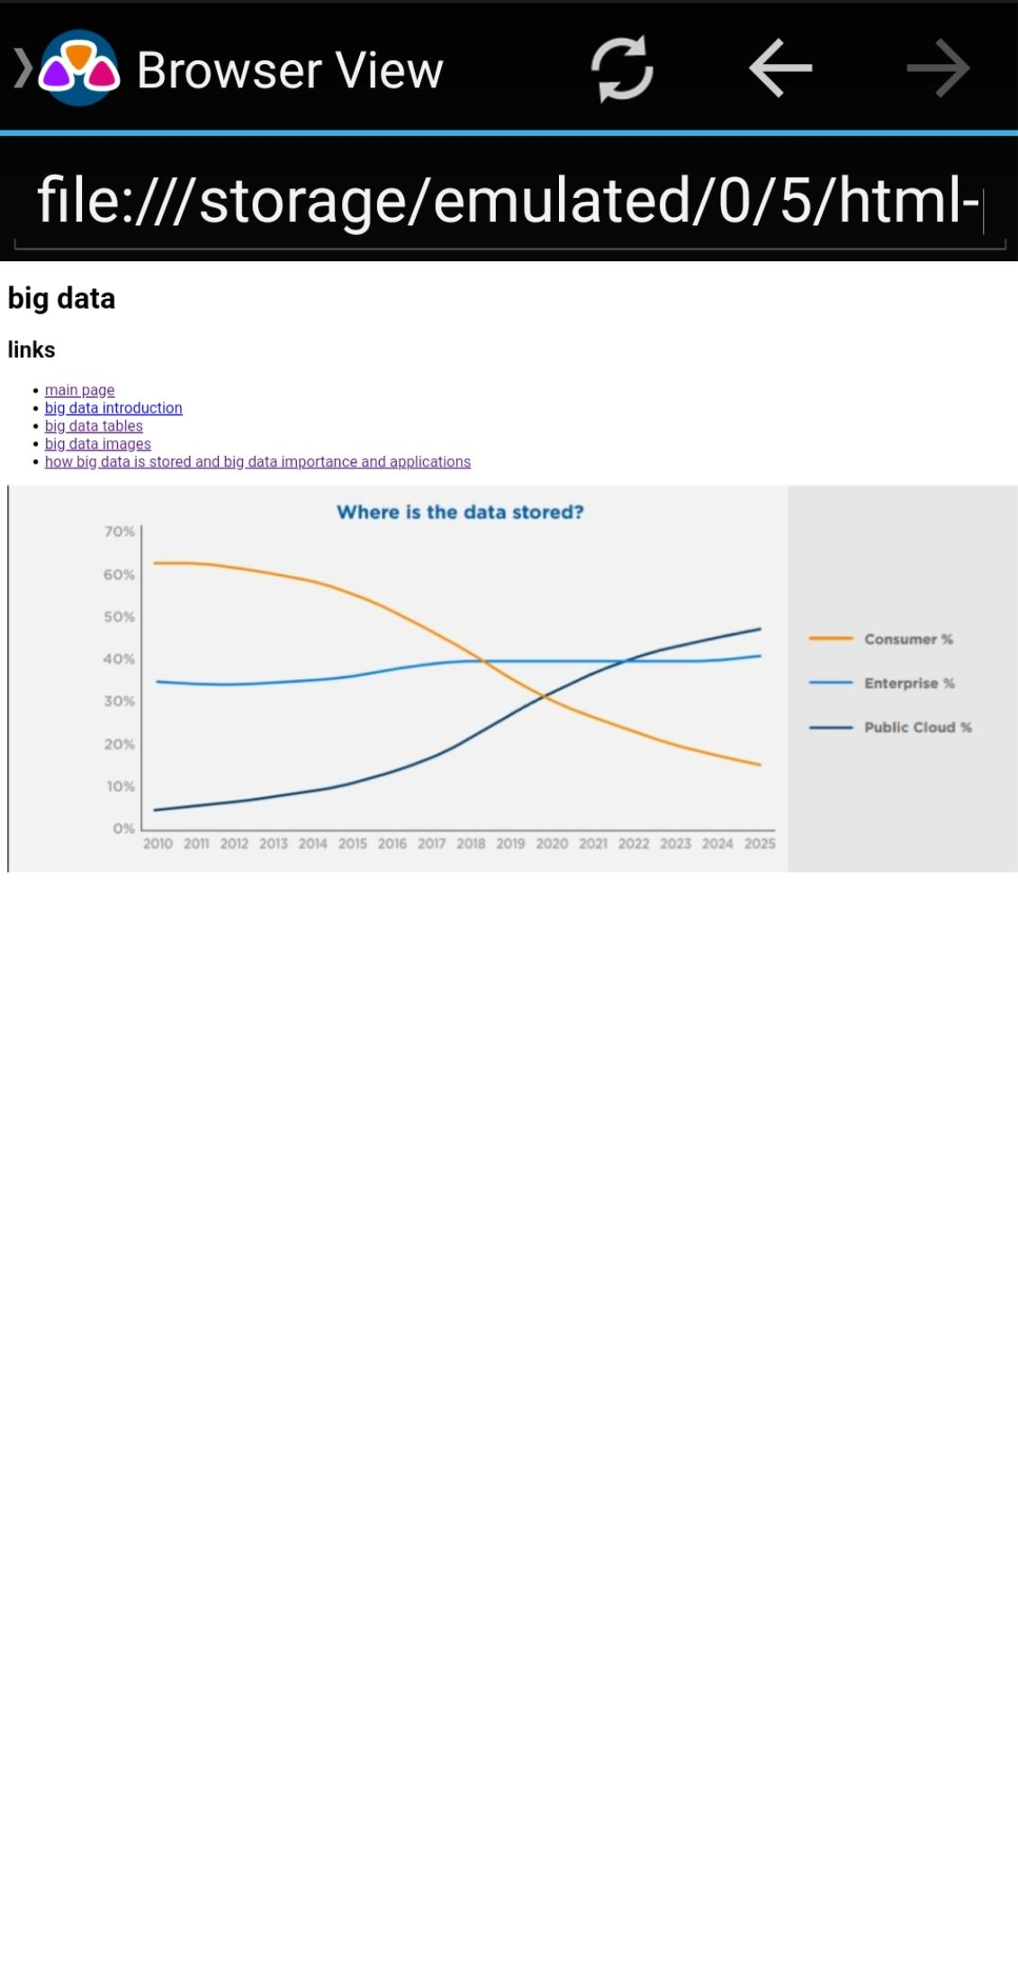

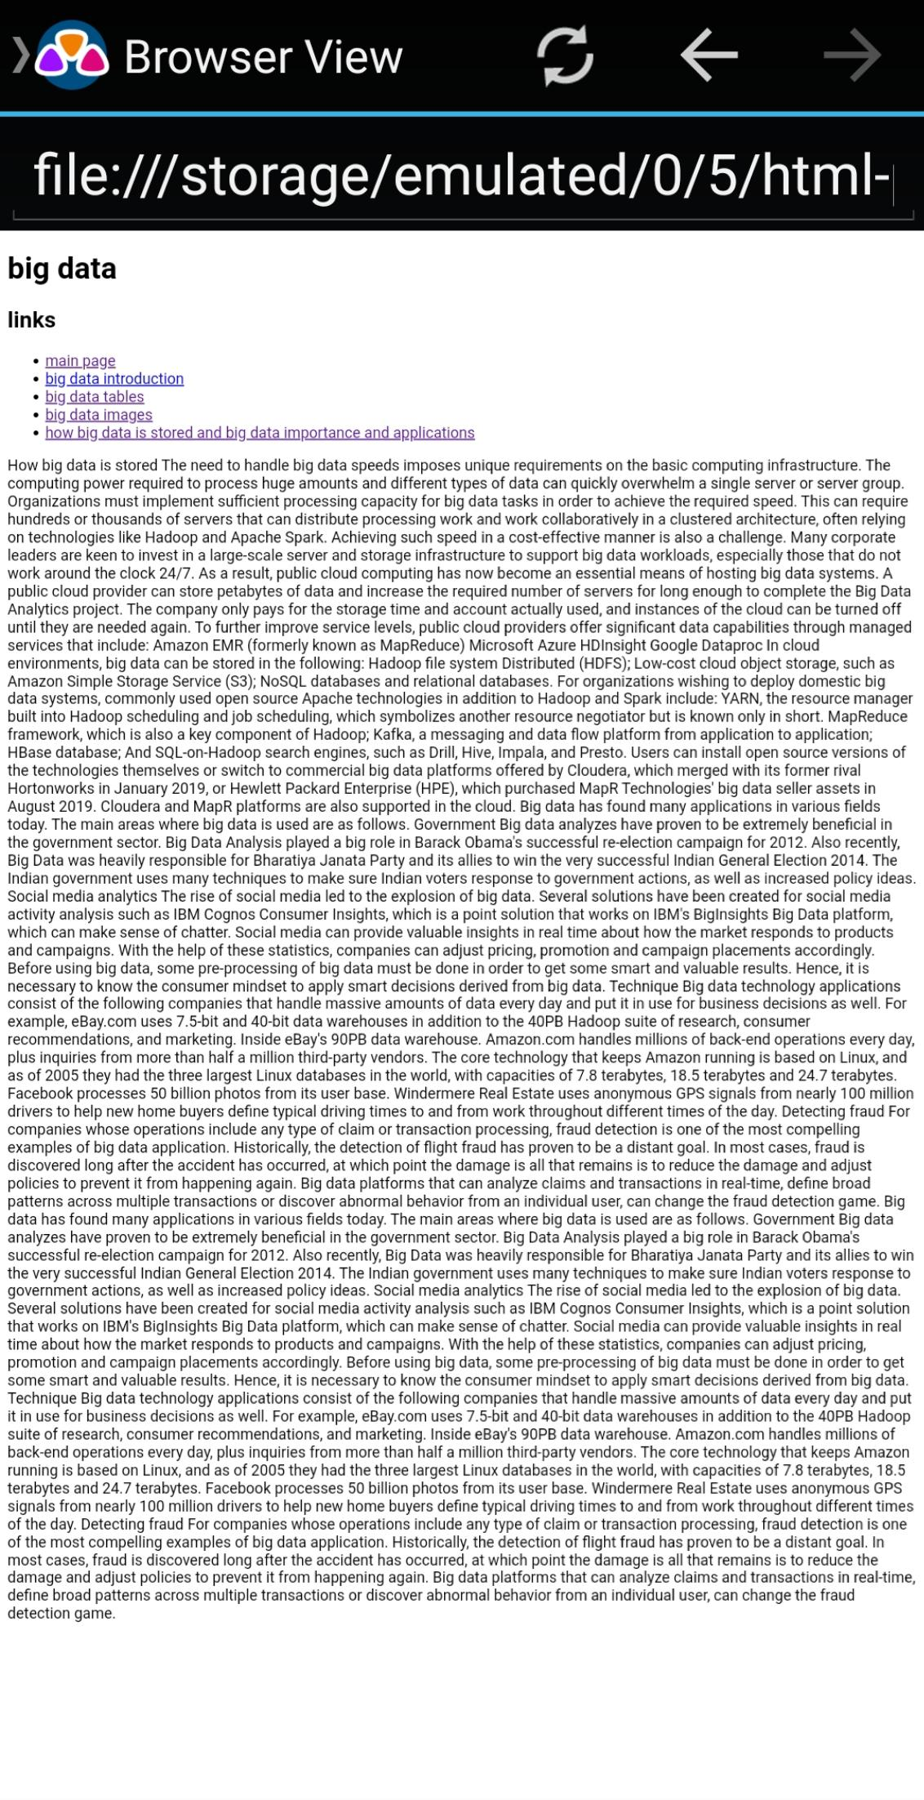

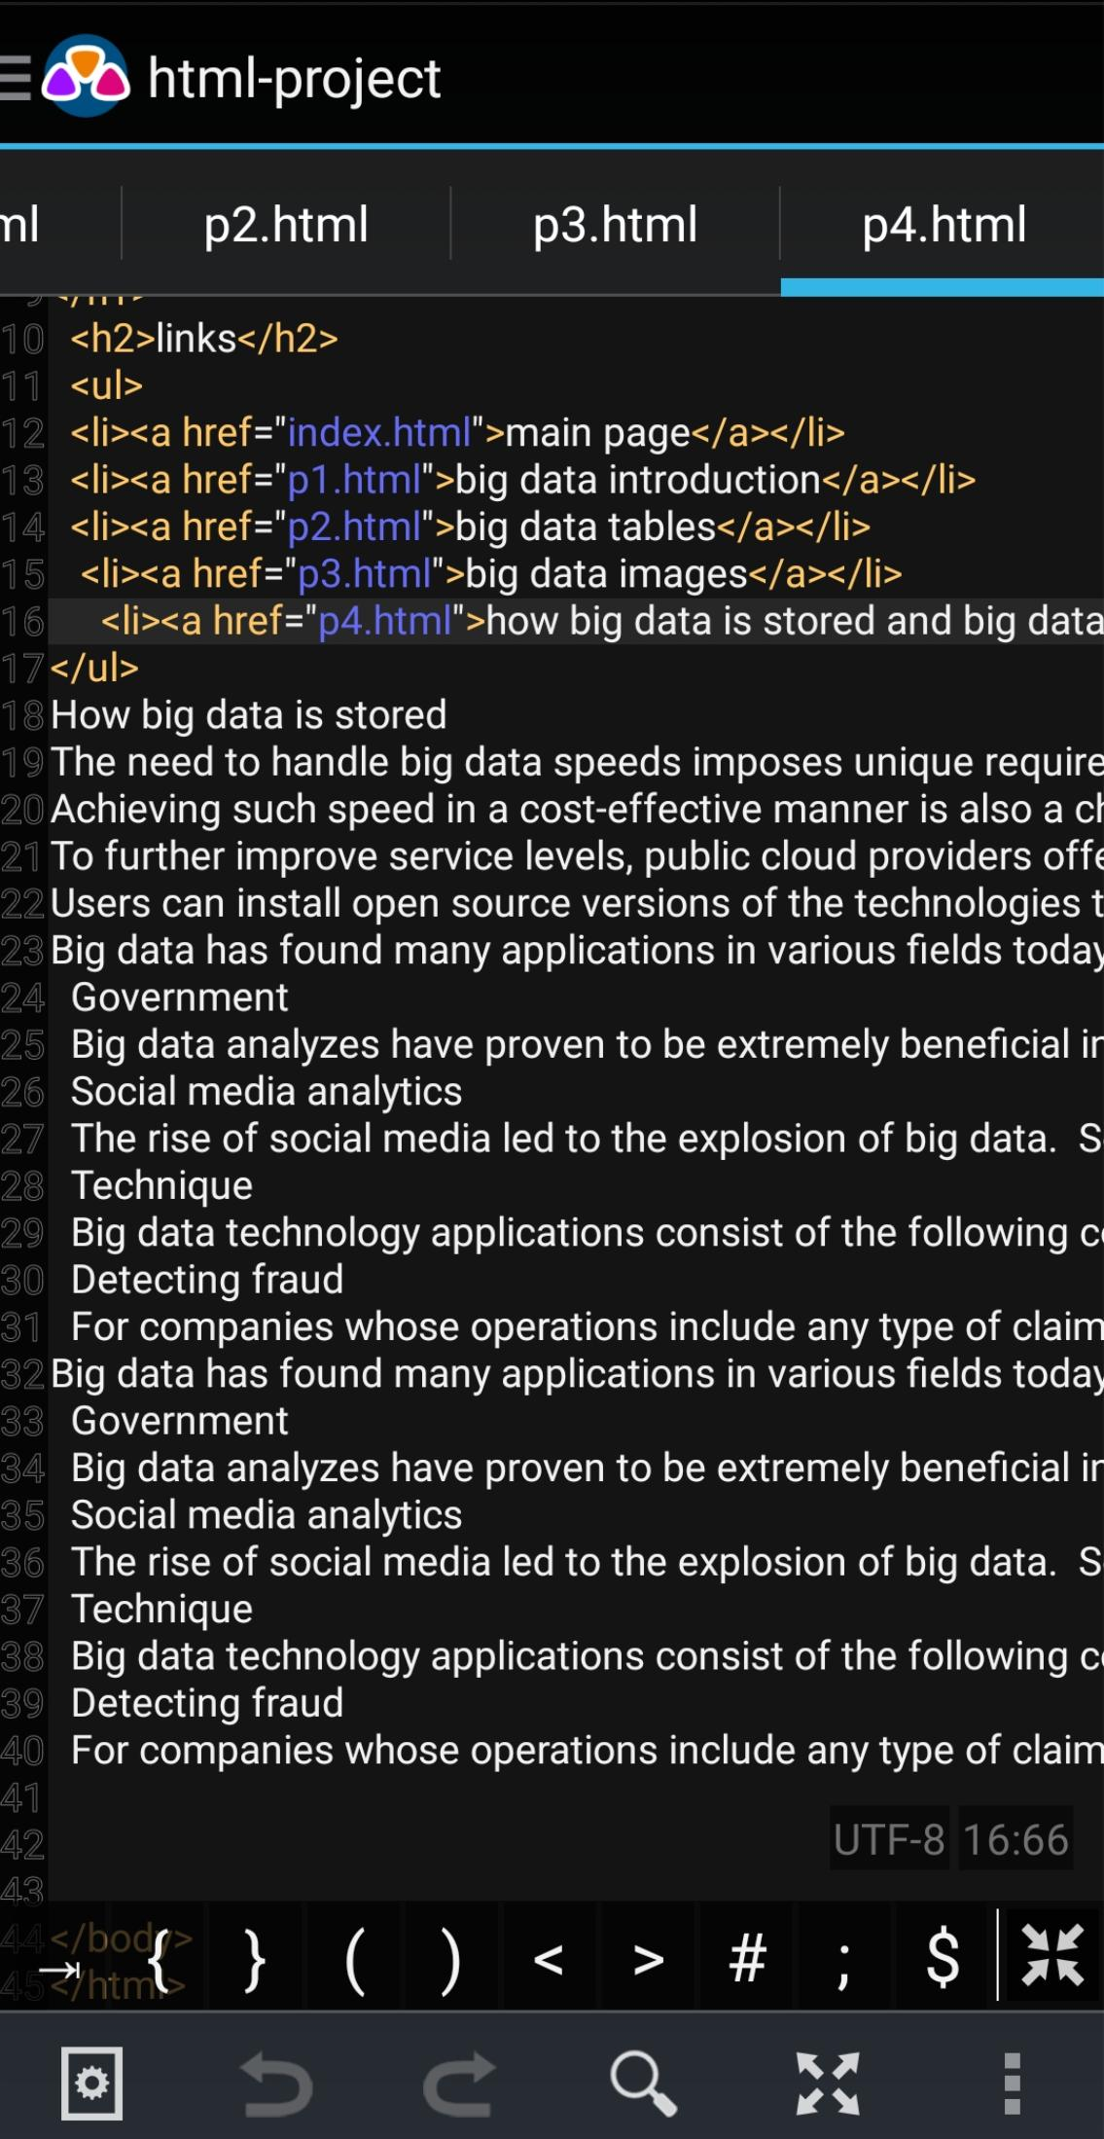**Source code:**

