Report

# *Undersampling* method

## All search terms

Dataset doesn’t filtered by search term of tweets

### Scenario1 (1500)

* size=1500 (500 neg, 500 neu, 500 pos)
* Model: **2 layer BiLSTM**, optimizer:Adam, loss:MAE, epochs:60

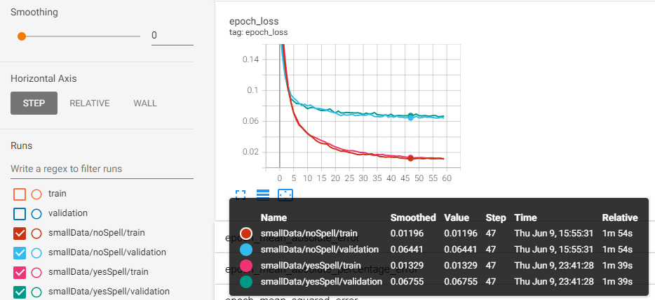

### Scenario2 (3000)

* size=3000 (1000 neg, 1000 neu, 1000 pos)
* Model: **2 layer BiLSTM**, optimizer:Adam, loss:MAE, epochs:60

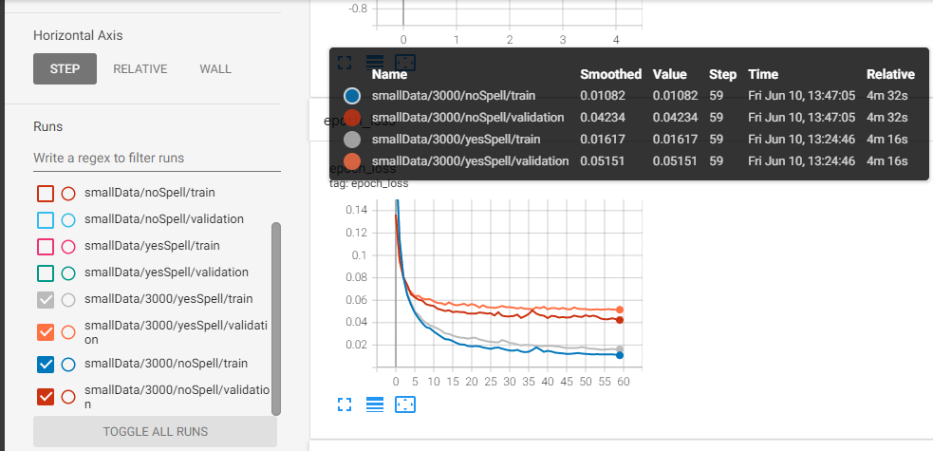

### Compare validations

Compare validation loss of two scenario in yesSpell and noSpell modes

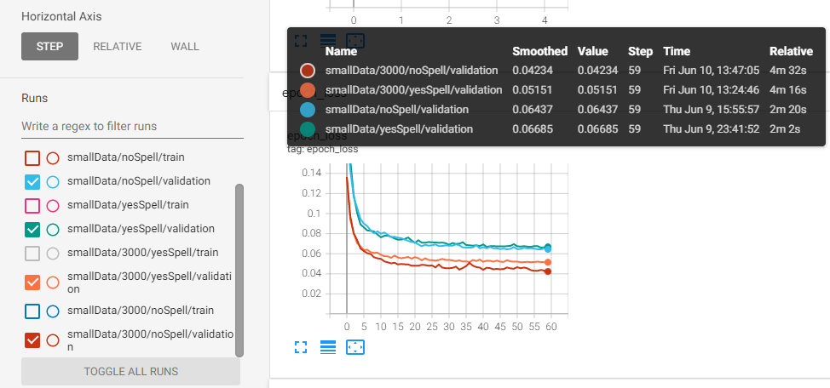

### Compare best with full data

* Full dataset means 820K samples. But it’s better because data is imbalanced.

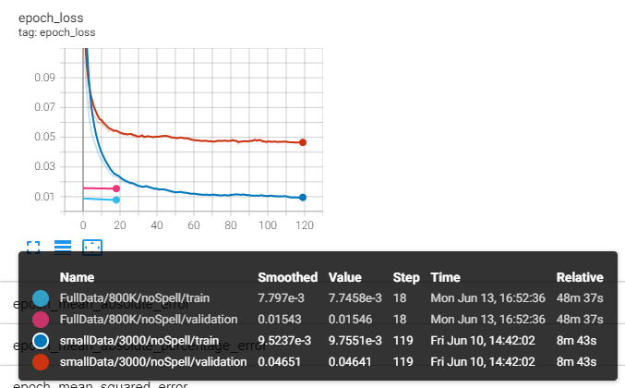

## Just *bitcoin* search term

### Compare multiple layers of bi-lstm

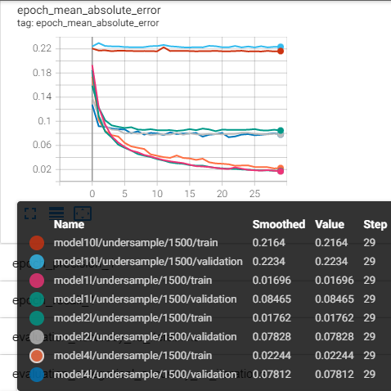

### 3L_regression_1500data

* size=1500 (500 neg, 500 neu, 500 pos)
* Model: **4 layer BiLSTM**, optimizer:Adam, loss:MAE, epochs:60

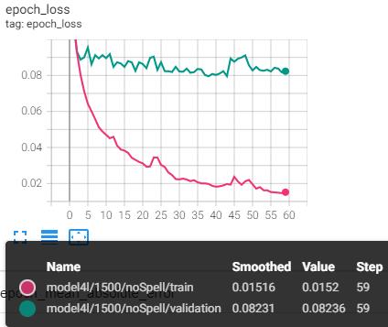

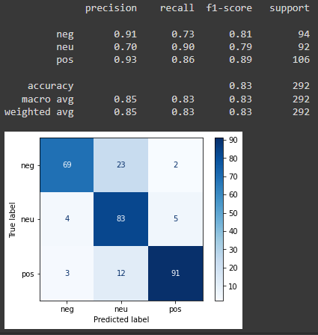

* size=1500 (500 neg, 500 neu, 500 pos)
* Model: **10 layer BiLSTM**, optimizer:Adam, loss:MAE, epochs:120

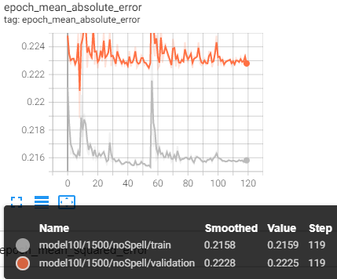

### 3L_oneHot_1500data

* size=1500 (500 neg, 500 neu, 500 pos)
* Model: **4 layer BiLSTM**, optimizer:Adam, loss:categorical_crossentropy, epochs:40

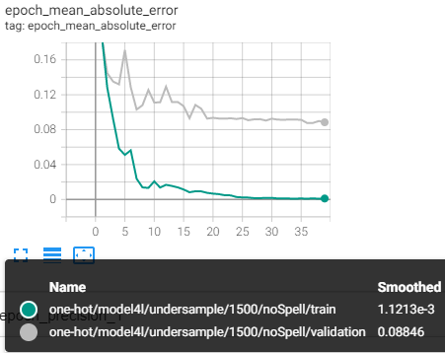

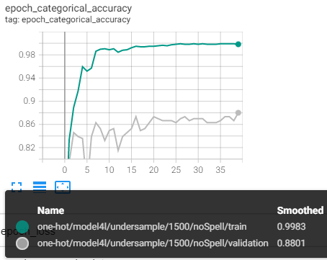

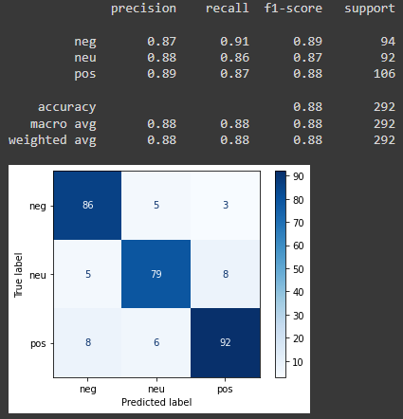

### BERT_oneHot_1500data

* size=1500 (500 neg, 500 neu, 500 pos)
* Model: **bert_en_uncased_L-12_H-768_A-12+batchNorm+dropout+3dense**, optimizer:Adam, loss:categorical_crossentropy, epochs:30

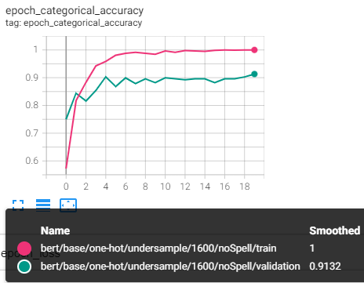

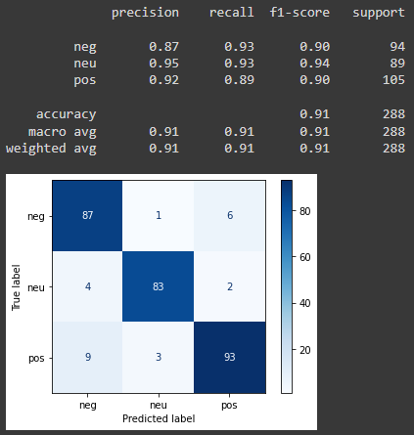

* size=1500 (500 neg, 500 neu, 500 pos)
* Model: **bert_en_uncased_L-12_H-768_A-12+batchNorm+dropout+128dense+3dense**, optimizer:Adam, loss:categorical_crossentropy, epochs:20

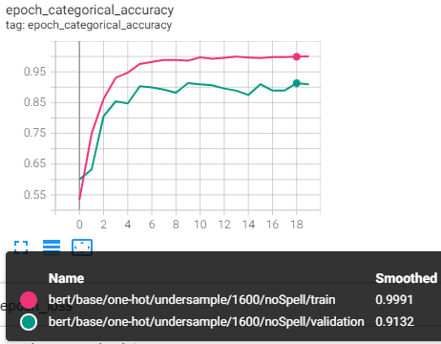

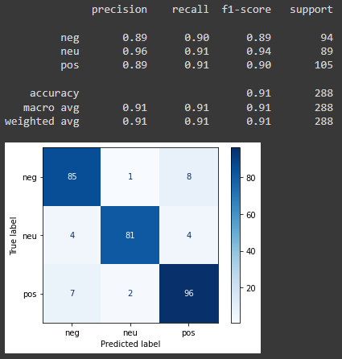

### FinBert_oneHot_1500data

* size=1500 (500 neg, 500 neu, 500 pos)
* Model: **ProsusAI/finbert : transformers bert+dropout+128dense+3dense**, optimizer:Adam, loss:categorical_crossentropy, epochs:20

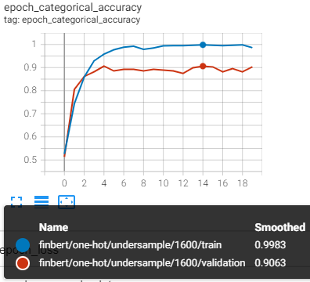

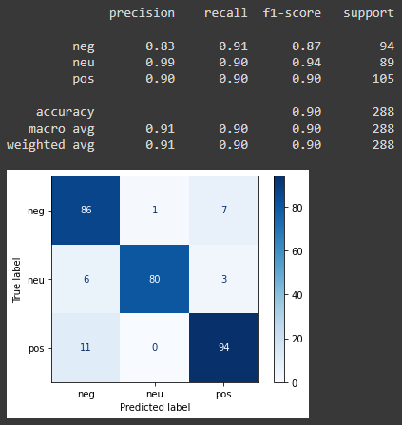

### 4lstm_Regression(-1,1)_1500data

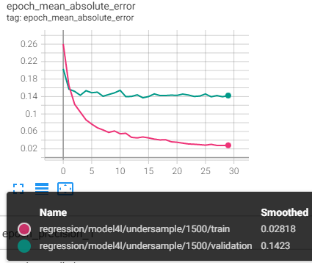

Bert+batch+1dense

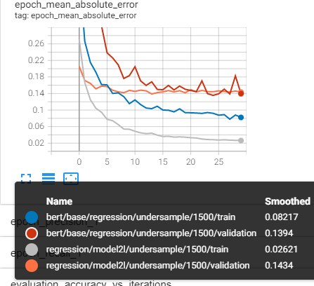

### Bert_regression(-1,1)(Bert+1dense)

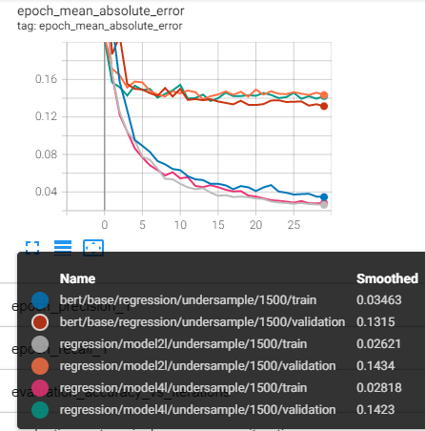

# *Change label value* method

### 3L_regression_11K data

* size=11K (3500 neg, 4000neu, 4000pos)
* Model: **4 layer BiLSTM**, optimizer:Adam, loss:MAE, epochs:40

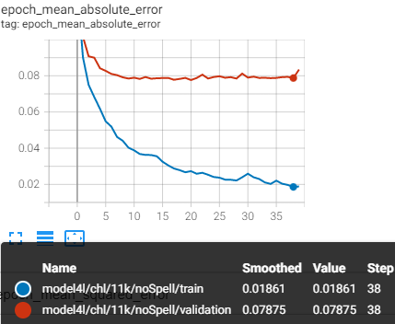

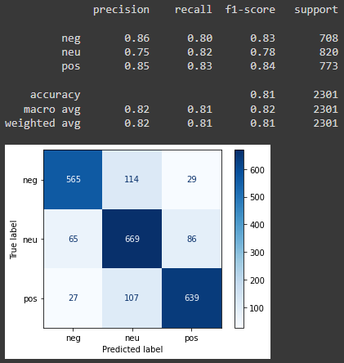

* size=11K (3500 neg, 4000neu, 4000pos)
* Model: **10 layer BiLSTM**, optimizer:Adam, loss:MAE, epochs:40

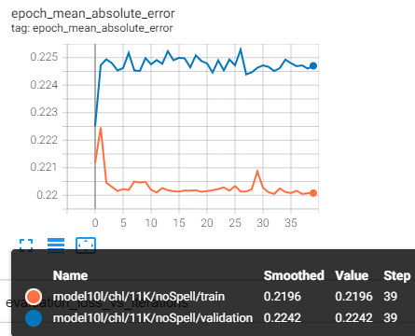

### 3L_oneHot_11K data

* size=11K (3500 neg, 4000neu, 4000pos)
* Model: **4 layer BiLSTM**, optimizer:Adam, loss:categorical_crossentropy, epochs:40

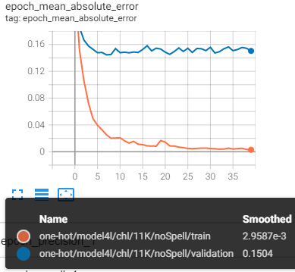

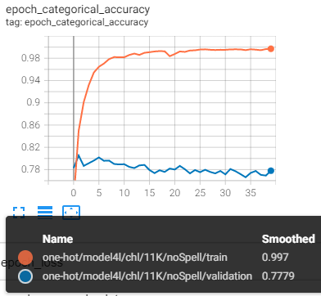

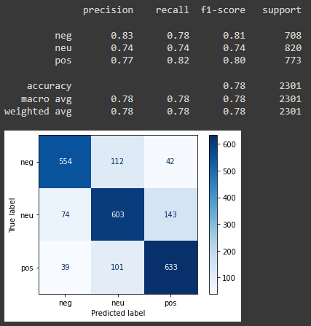

### BERT_oneHot_11K data

* size=11K (3500 neg, 4000neu, 4000pos)
* Model: **bert_en_uncased_L-12_H-768_A-12+batchNorm+dropout+128dense+3dense**, optimizer:Adam, loss:categorical_crossentropy, epochs:20

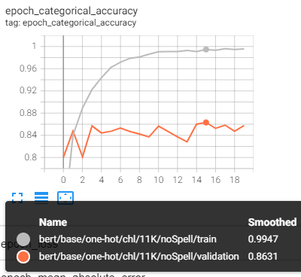

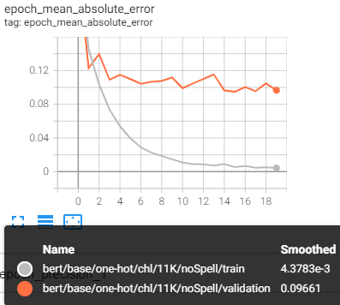

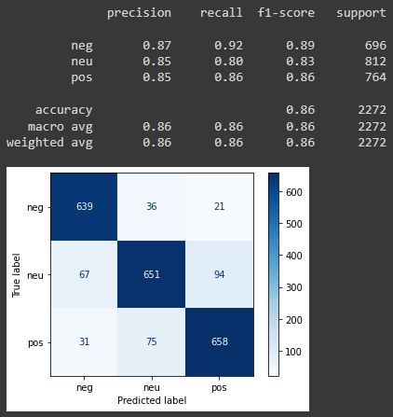

### FinBert_oneHot_11K data

* size=11K (3500 neg, 4000neu, 4000pos)
* Model: **ProsusAI/finbert : transformers bert+dropout+128dense+3dense**, optimizer:Adam, loss:categorical_crossentropy, epochs:20

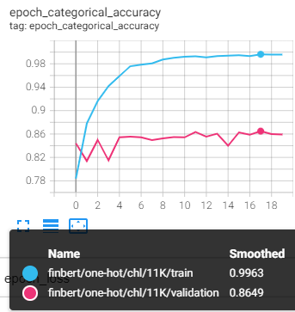

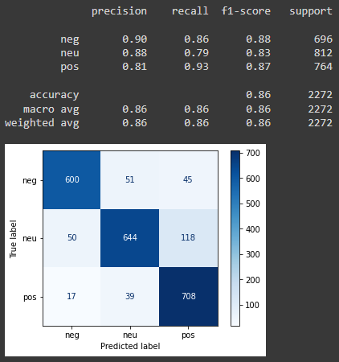

### bert_regression(-1,1)

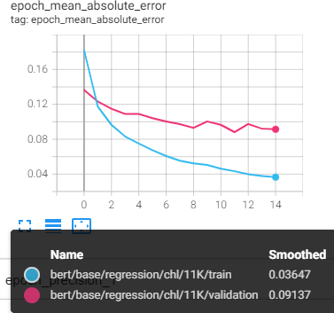

### 4lstm_regression(-1,1)

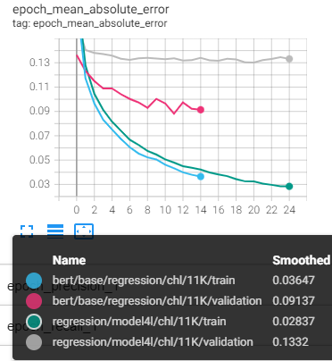

# *removal of neutral data*

## Main dataset (1600)

### 3L_regression

* size=1600 (500 neg, 1000pos)
* Model: **4 layer BiLSTM**, optimizer:Adam, loss:MAE, epochs:70

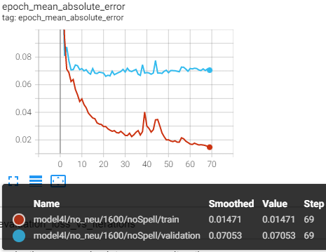

### 3L_oneHot

* size=1600 (500 neg, 1000pos)
* Model: **4 layer BiLSTM**, optimizer:Adam, loss:categorical_crossentropy, epochs:40

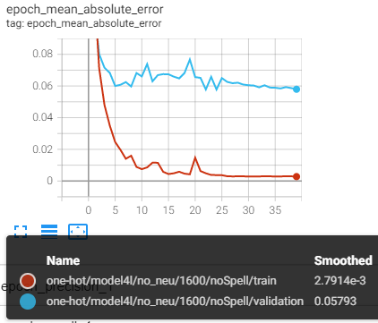

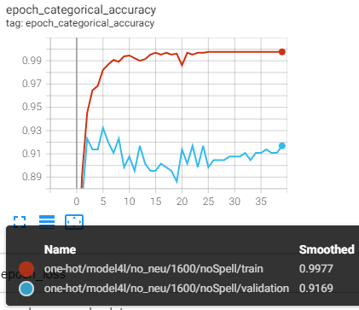

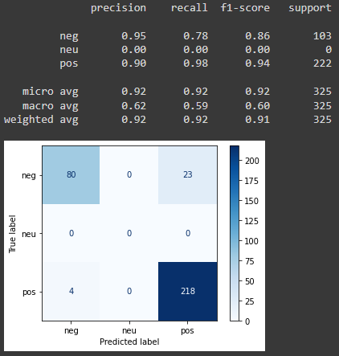

### BERT_oneHot

* size=1600 (500 neg, 1000pos)
* Model: **bert_en_uncased_L-12_H-768_A-12+batchNorm+dropout+128dense+3dense**, optimizer:Adam, loss:categorical_crossentropy, epochs:30

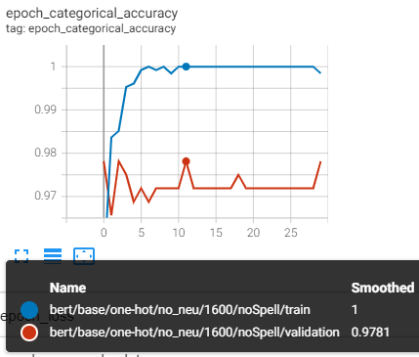

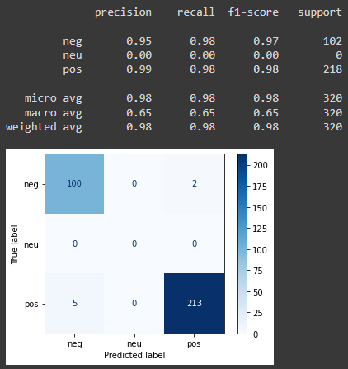

### FinBert_oneHot

* size=11K (3500 neg, 4000neu, 4000pos)
* Model: **ProsusAI/finbert : transformers bert+dropout+128dense+3dense**, optimizer:Adam, loss:categorical_crossentropy, epochs:20

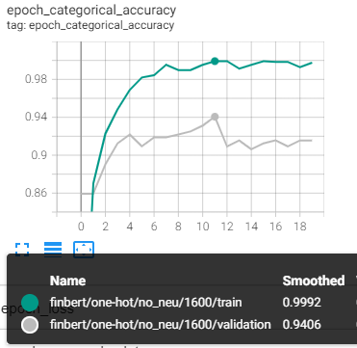

## Change label dataset (7500)

### 3L_regression

* size=7500 (3500 neg, 4000 pos)
* Model: **4 layer BiLSTM**, optimizer:Adam, loss:MAE, epochs:70

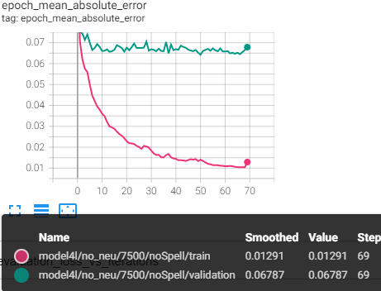

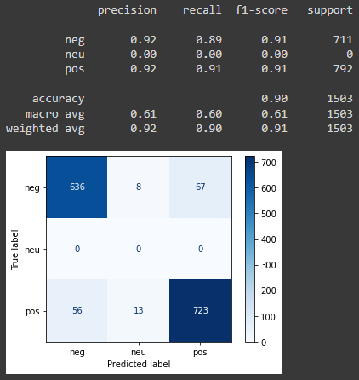

### 3L_oneHot

* size=7500 (3500 neg, 4000 pos)
* Model: **4 layer BiLSTM**, optimizer:Adam, loss:categorical_crossentropy, epochs:40

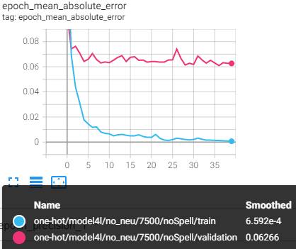

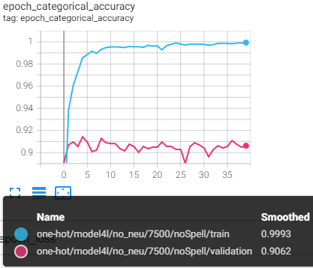

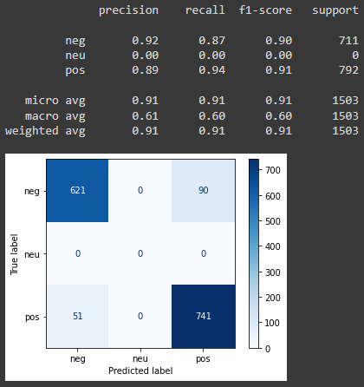

### BERT_oneHot

* size=7500 (3500 neg, 4000 pos)
* Model: **bert_en_uncased_L-12_H-768_A-12+batchNorm+dropout+128dense+3dense**, optimizer:Adam, loss:categorical_crossentropy, epochs:20

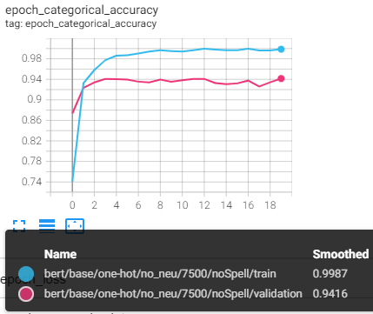

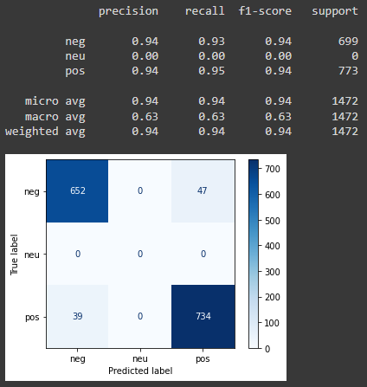

### FinBert_oneHot

* size=11K (3500 neg, 4000neu, 4000pos)
* Model: **ProsusAI/finbert : transformers bert+dropout+128dense+3dense**, optimizer:Adam, loss:categorical_crossentropy, epochs:20

