**Name : Mustafa Moslhy Mohamed Abo Wally**

**B.N: 940**

**Date : 5/6/2020**

**Topic:** **Programming Languages**

**Github link :** <https://github.com/MostafaMeslhy1/ece001>

**Github page:** <https://mostafameslhy1.github.io/ece001/>

**Application brief :**

A programming language: is a formal language comprising a set of instructions that produce various kinds of output. Programming languages are used in computer programming to implement algorithms.

Most programming languages consist of computer instructions. There are programmable machines which use a set of specific instructions rather than general programming languages. Early ones preceded the invention of the digital computer, the first of which was probably the automatic flute player described in the 9th century by the Musa brothers in Bagdad during the Islamic Golden Age. Since the early 1800s, programs have been used to control the actions of machines such as Jacquard looms, music boxes and piano players. Programs for these machines (such as piano scrolls) have not generated different behaviors in response to different inputs or conditions.

Thousands of different programming languages have been created and more are being created each year. Many programming languages are written in an imperative form ( i.e. as a series of operations to be performed) while other languages use the declarative form (i.e. the desired outcome is defined, not how to achieve it).

The description of the programming language is usually divided into two components of syntax (form) and semantics (meaning). Some languages are defined by a specification document (for example, the C programming language is specified by the ISO standard) while other languages (for example, Perl) have a dominant implementation that is treated as a reference. Some languages are common, both the basic language defined by the standard and the extensions taken from the dominant implementation.

**صورة تحتوي على لقطة شاشة, جالس, منضدة, شاشة عرض

تم إنشاء الوصف تلقائياً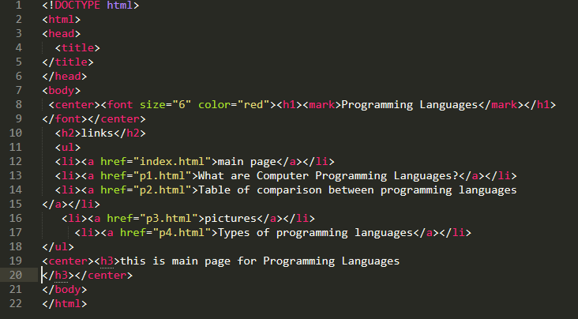Screeshots :**

**صورة تحتوي على لقطة شاشة

تم إنشاء الوصف تلقائياً**

**صورة تحتوي على لقطة شاشة

تم إنشاء الوصف تلقائياً**

**صورة تحتوي على لقطة شاشة

تم إنشاء الوصف تلقائياً**

**صورة تحتوي على لقطة شاشة

تم إنشاء الوصف تلقائياً**

**صورة تحتوي على جالس, شاشة عرض, أسود, كمبيوتر

تم إنشاء الوصف تلقائياً**

**Site screenshotصورة تحتوي على لقطة شاشة

تم إنشاء الوصف تلقائياً**

**صورة تحتوي على لقطة شاشة, شاشة عرض, منضدة, كمبيوتر

تم إنشاء الوصف تلقائياً**

**صورة تحتوي على لقطة شاشة

تم إنشاء الوصف تلقائياً**

**صورة تحتوي على لقطة شاشة

تم إنشاء الوصف تلقائياً**

