Cairo University Faculty of Computers and Artificial Intelligence



**Software Design and Architecture**

**Daily scrum meeting template**

**2021/2022**

**Project Team**

|  |  |  |  |
| --- | --- | --- | --- |
| **ID** | **Name** | **Email** | **Mobile** |
| 20190547 | Mostafa Nassr Eldeen ElSayed | mostafanassr200083@gmail.com | 01112165365 |
| 20190236 | Sandra Nabil Sedky Iskander | sandraiskanderr@gmail.com | 01205309604 |
| 20190700 | Youssef Tariq Sayed Adam | yousef.adam2001@gmail.com | 01149790205 |

Contents

Done requirements 2

What will be done today 4

Current obstacles 4

Current Trello workspace 4

# 

# Day 1:

# Done requirements

Mostafa: Implementation of the driver sending an offer and 1 sequence diagram

Sandra: Implementation of admin verification for the user and 1 sequence diagram

Yousef: Implementation of login for both user and driver

# What will be done today

Mostafa: updating the class diagram for the new modifications

Sandra: analyzing the new requirements for implementation

Yousef: finding classes with similar behavior to be unified and cleaning the code

# Current obstacles

Mostafa: Had some trouble relating the classes in the class diagram

Sandra: Had some trouble deciding on the design patterns

Yousef: Had problems with maintaining the sequence of the program

# Current Trello workspace

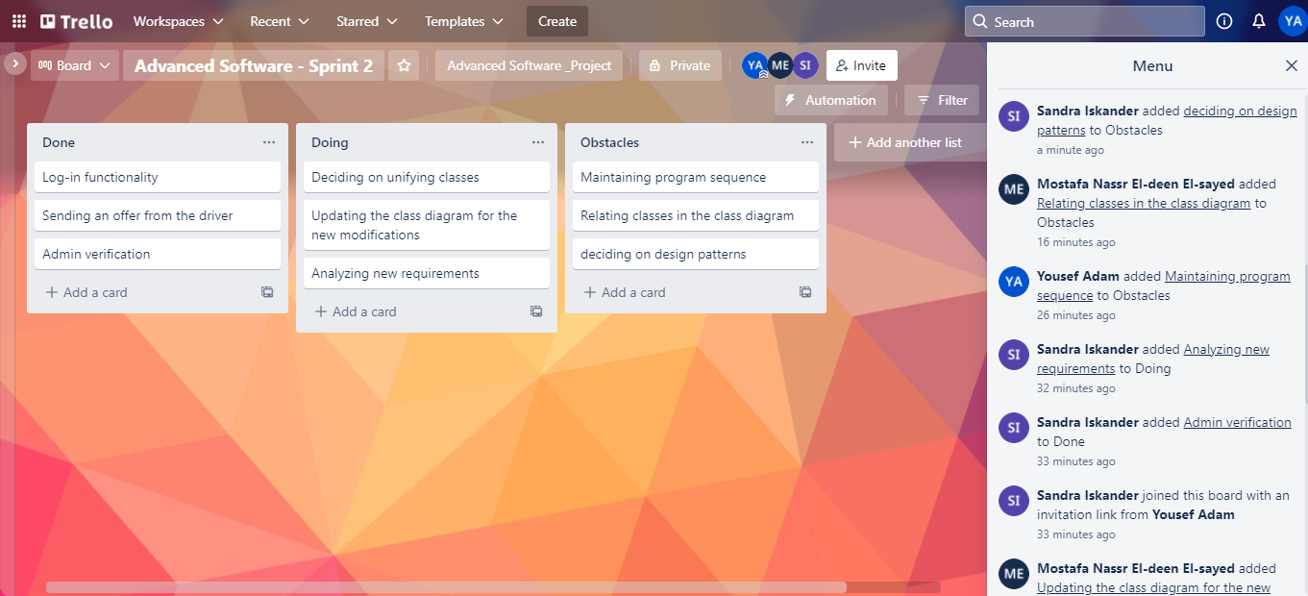

# Day 2:

# Done requirements

Mostafa: updated the class diagram for the new modifications

Sandra: analyzed the new requirements for implementation

Yousef: unified classes with similar behavior and cleaned the code

# What will be done today

Mostafa: moving all the Arraylists (persistence) to the database class

Sandra: encapsulating admin related functions and moving out the database related implementations

Yousef: unifying the IAccess and IAuthorize interfaces into one IAuthurize interface with register and login classes

# Current obstacles

Mostafa: Had some trouble applying changes to the classes after fixing the database classes

Sandra: Had logical errors when improving the admin functions

Yousef: Had some trouble applying the IAuthorize changes to the classes interacting with it

# Current Trello workspace

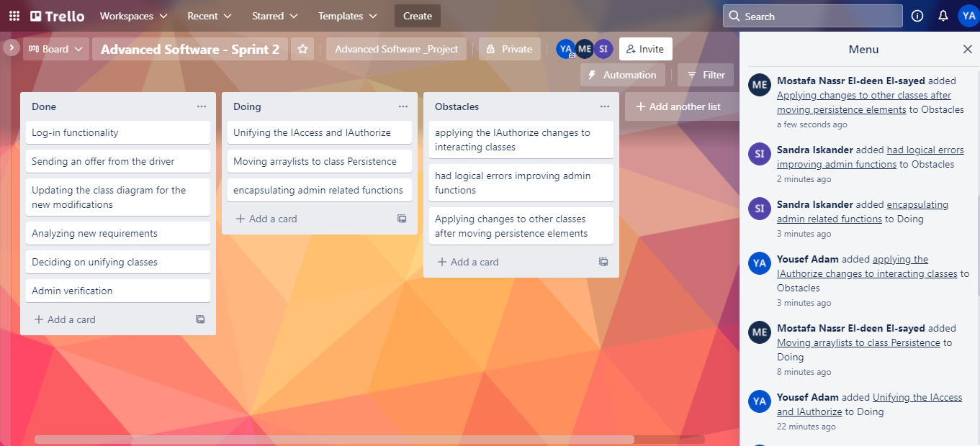

# Day 3:

# Done requirements

Mostafa: moved all the Arraylists (persistence) to the database class

Sandra: unified the IAccess and IAuthorize interfaces into one IAuthurize interface with register and login classes

Yousef: encapsulated admin related function and moved out the database related implementations

# What will be done today

Mostafa: moving all the Arraylists (persistence) related processes/methods to the database class and apply the strategy pattern on the database

Sandra: adjusting the sequences to fit the new IAuthorize interface

Yousef: moving all the related admin Arraylists out to the database class(persistence)

# Current obstacles

Mostafa: Had some logical issues with the new methods in the database class

Sandra: Had some trouble applying the scenarios with the new unified Interface

Yousef: Had logical errors when improving the admin functions

**Current Trello workspace**

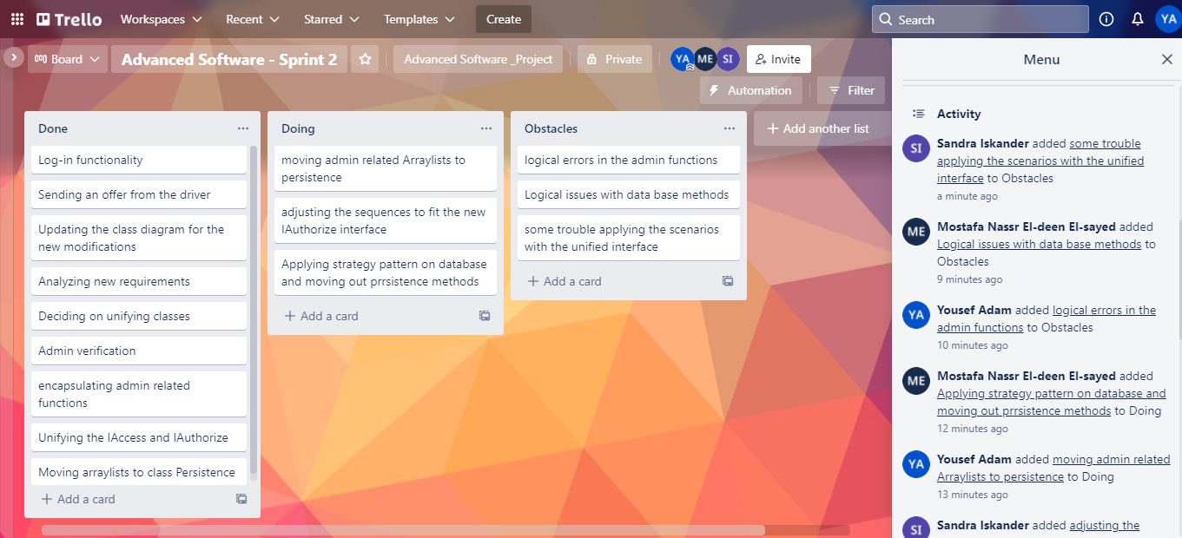

# Day 4:

# Done requirements

Mostafa: moved all the Arraylists (persistence) related processes/methods to the database class and apply the strategy pattern on the database

Sandra: adjusted the sequences to fit the new IAuthorize interface

Yousef: moved all the related admin Arraylists are out to the database class(persistence)

# What will be done today

Mostafa: allowing the admin to add 10% discounts to certain areas

Sandra: implementing the first refactor (notifying only the available riders in the source area)

Yousef: implementing the second refactor (specifying the number of passengers in a ride)

# Current obstacles

Mostafa: Had some troubles regarding updating the locations with the new discount attribute

Sandra: Had some issues with the notification sequence

Yousef: Had issues updating the ride scenarios

**Current Trello workspace**

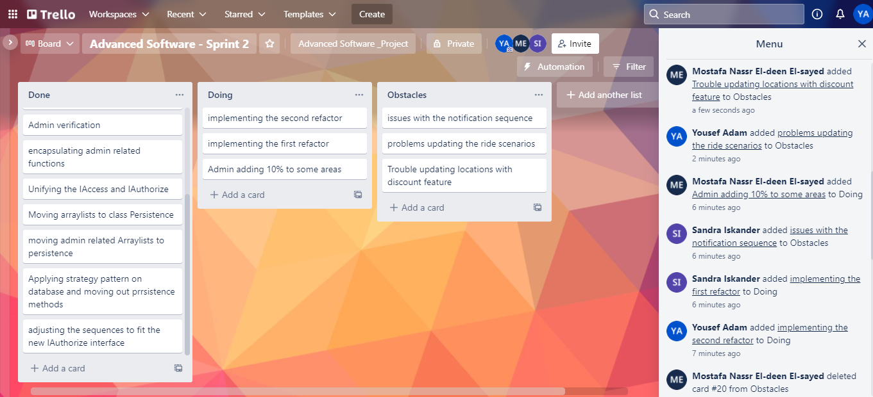

# Day 5:

# Done requirements

Mostafa: allowed the admin to add 10% discounts to certain areas

Sandra: implemented the first refactor (notifying only the available riders in the source area)

Yousef: implemented the second refactor (specifying the number of passengers in a ride)

# What will be done today

Mostafa: implementing the login/register features as web services

Sandra: implementing the ride features as web services

Yousef: implementing the admin features as web services

# Current obstacles

Mostafa: had Problems knowing the correct notations to use with the functions

Sandra: Had some issues maintaining the observer pattern while implementing the web services

Yousef: Had issues with some springboot-related syntaxes

**Current Trello workspace**

