Cairo University Faculty of Computers and Artificial Intelligence



**Software Design and Architecture**

**Software design specification document**

**2021**

**Project Team**

|  |  |  |  |
| --- | --- | --- | --- |
| **ID** | **Name** | **Email** | **Mobile** |
| 20190547 | Mostafa Nassr El-deen El-sayed | mostafanassr200083@gmail.com | 01112165365 |
| 20190236 | Sandra Nabil Sedky Iskander | sandraiskanderr@gmail.com | 01205309604 |
| 20190700 | Yousef Tarek Sayed Adam | yousef.adam2001@gmail.com | 01149790205 |

**TA Name: Hassan Mourad**

Contents

Class diagram design 2

Sequence diagram design 2

Github repository link 9

# Class diagram design

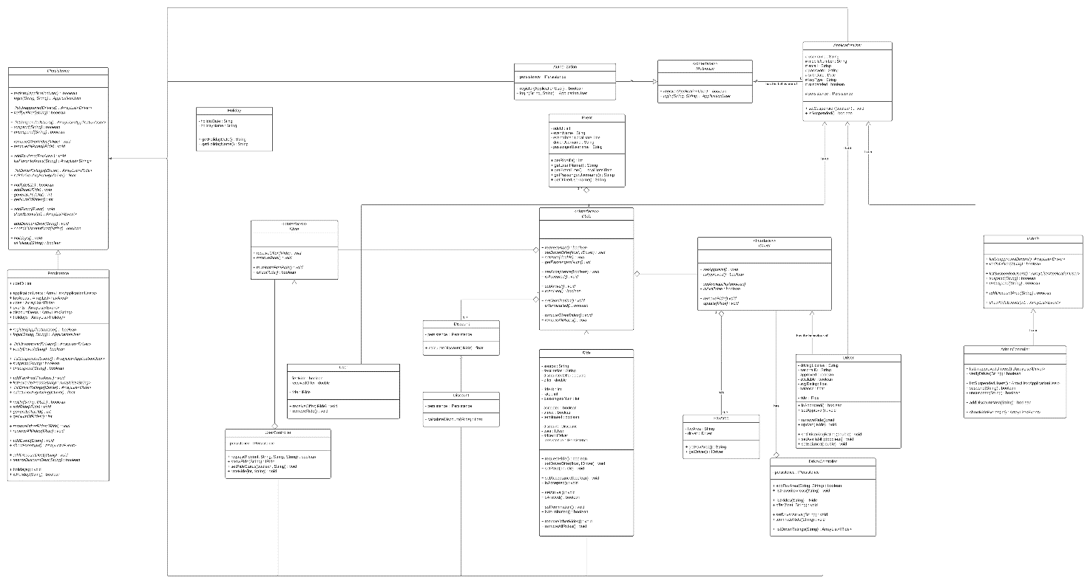

# 

# Sequence diagram design

1. **Calculating discounts:**

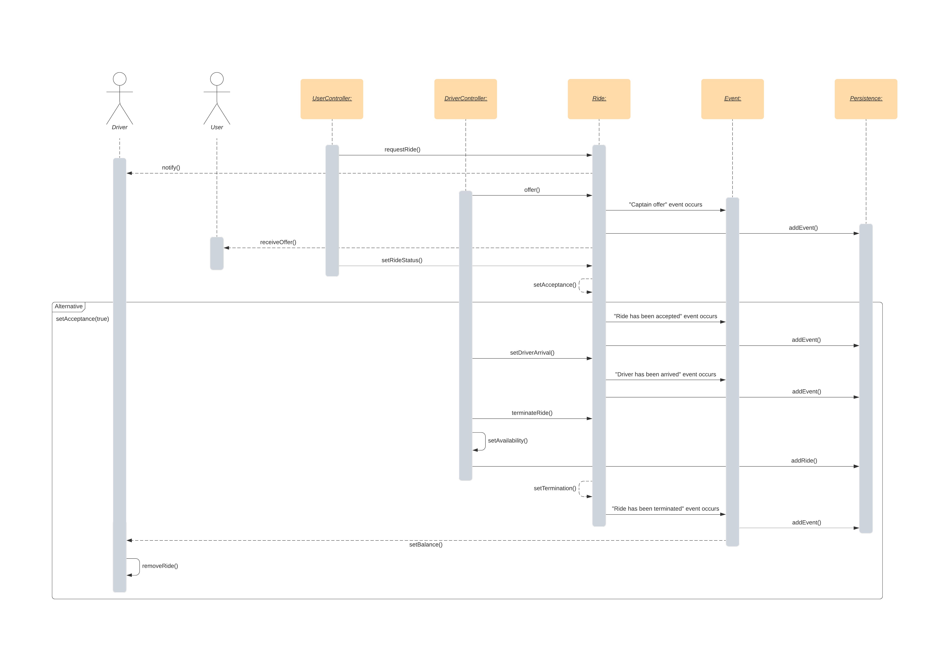

1. **Adding events:**

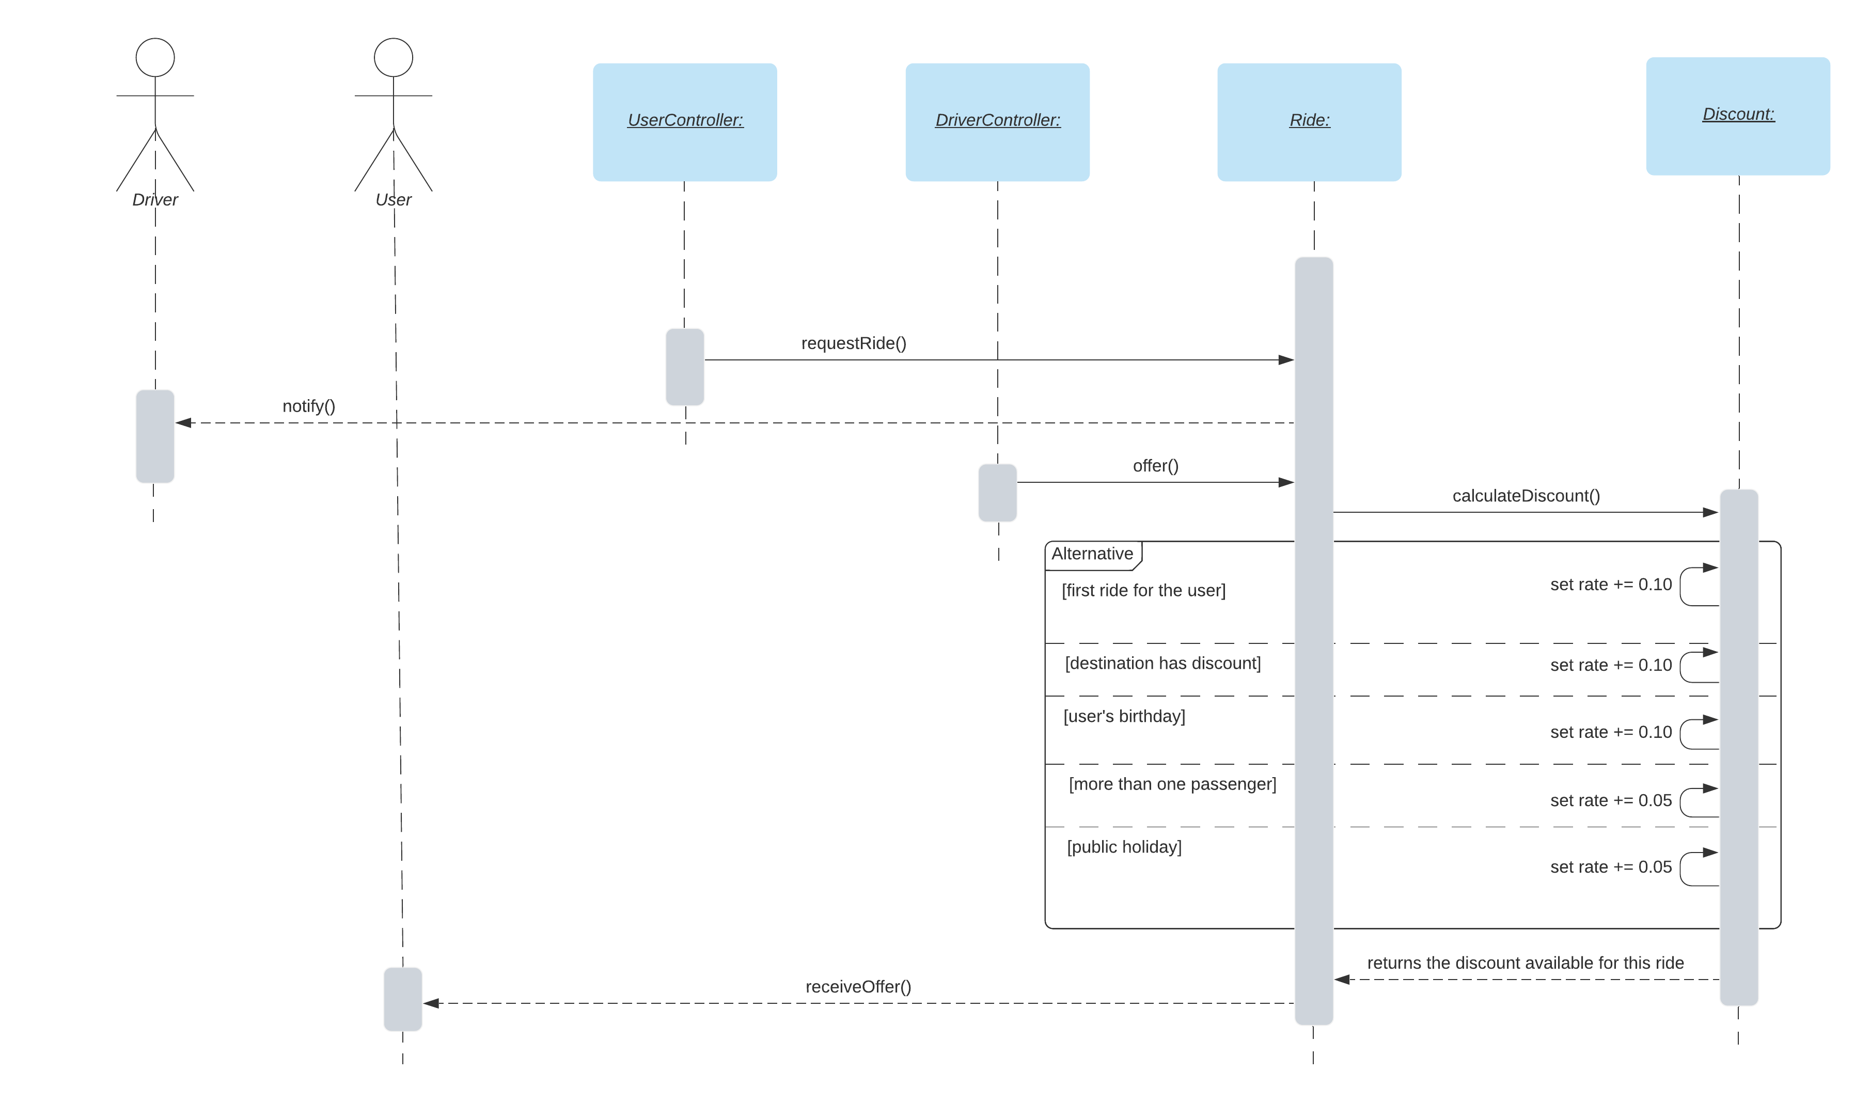

1. **Admin adding discounts on destination areas:**

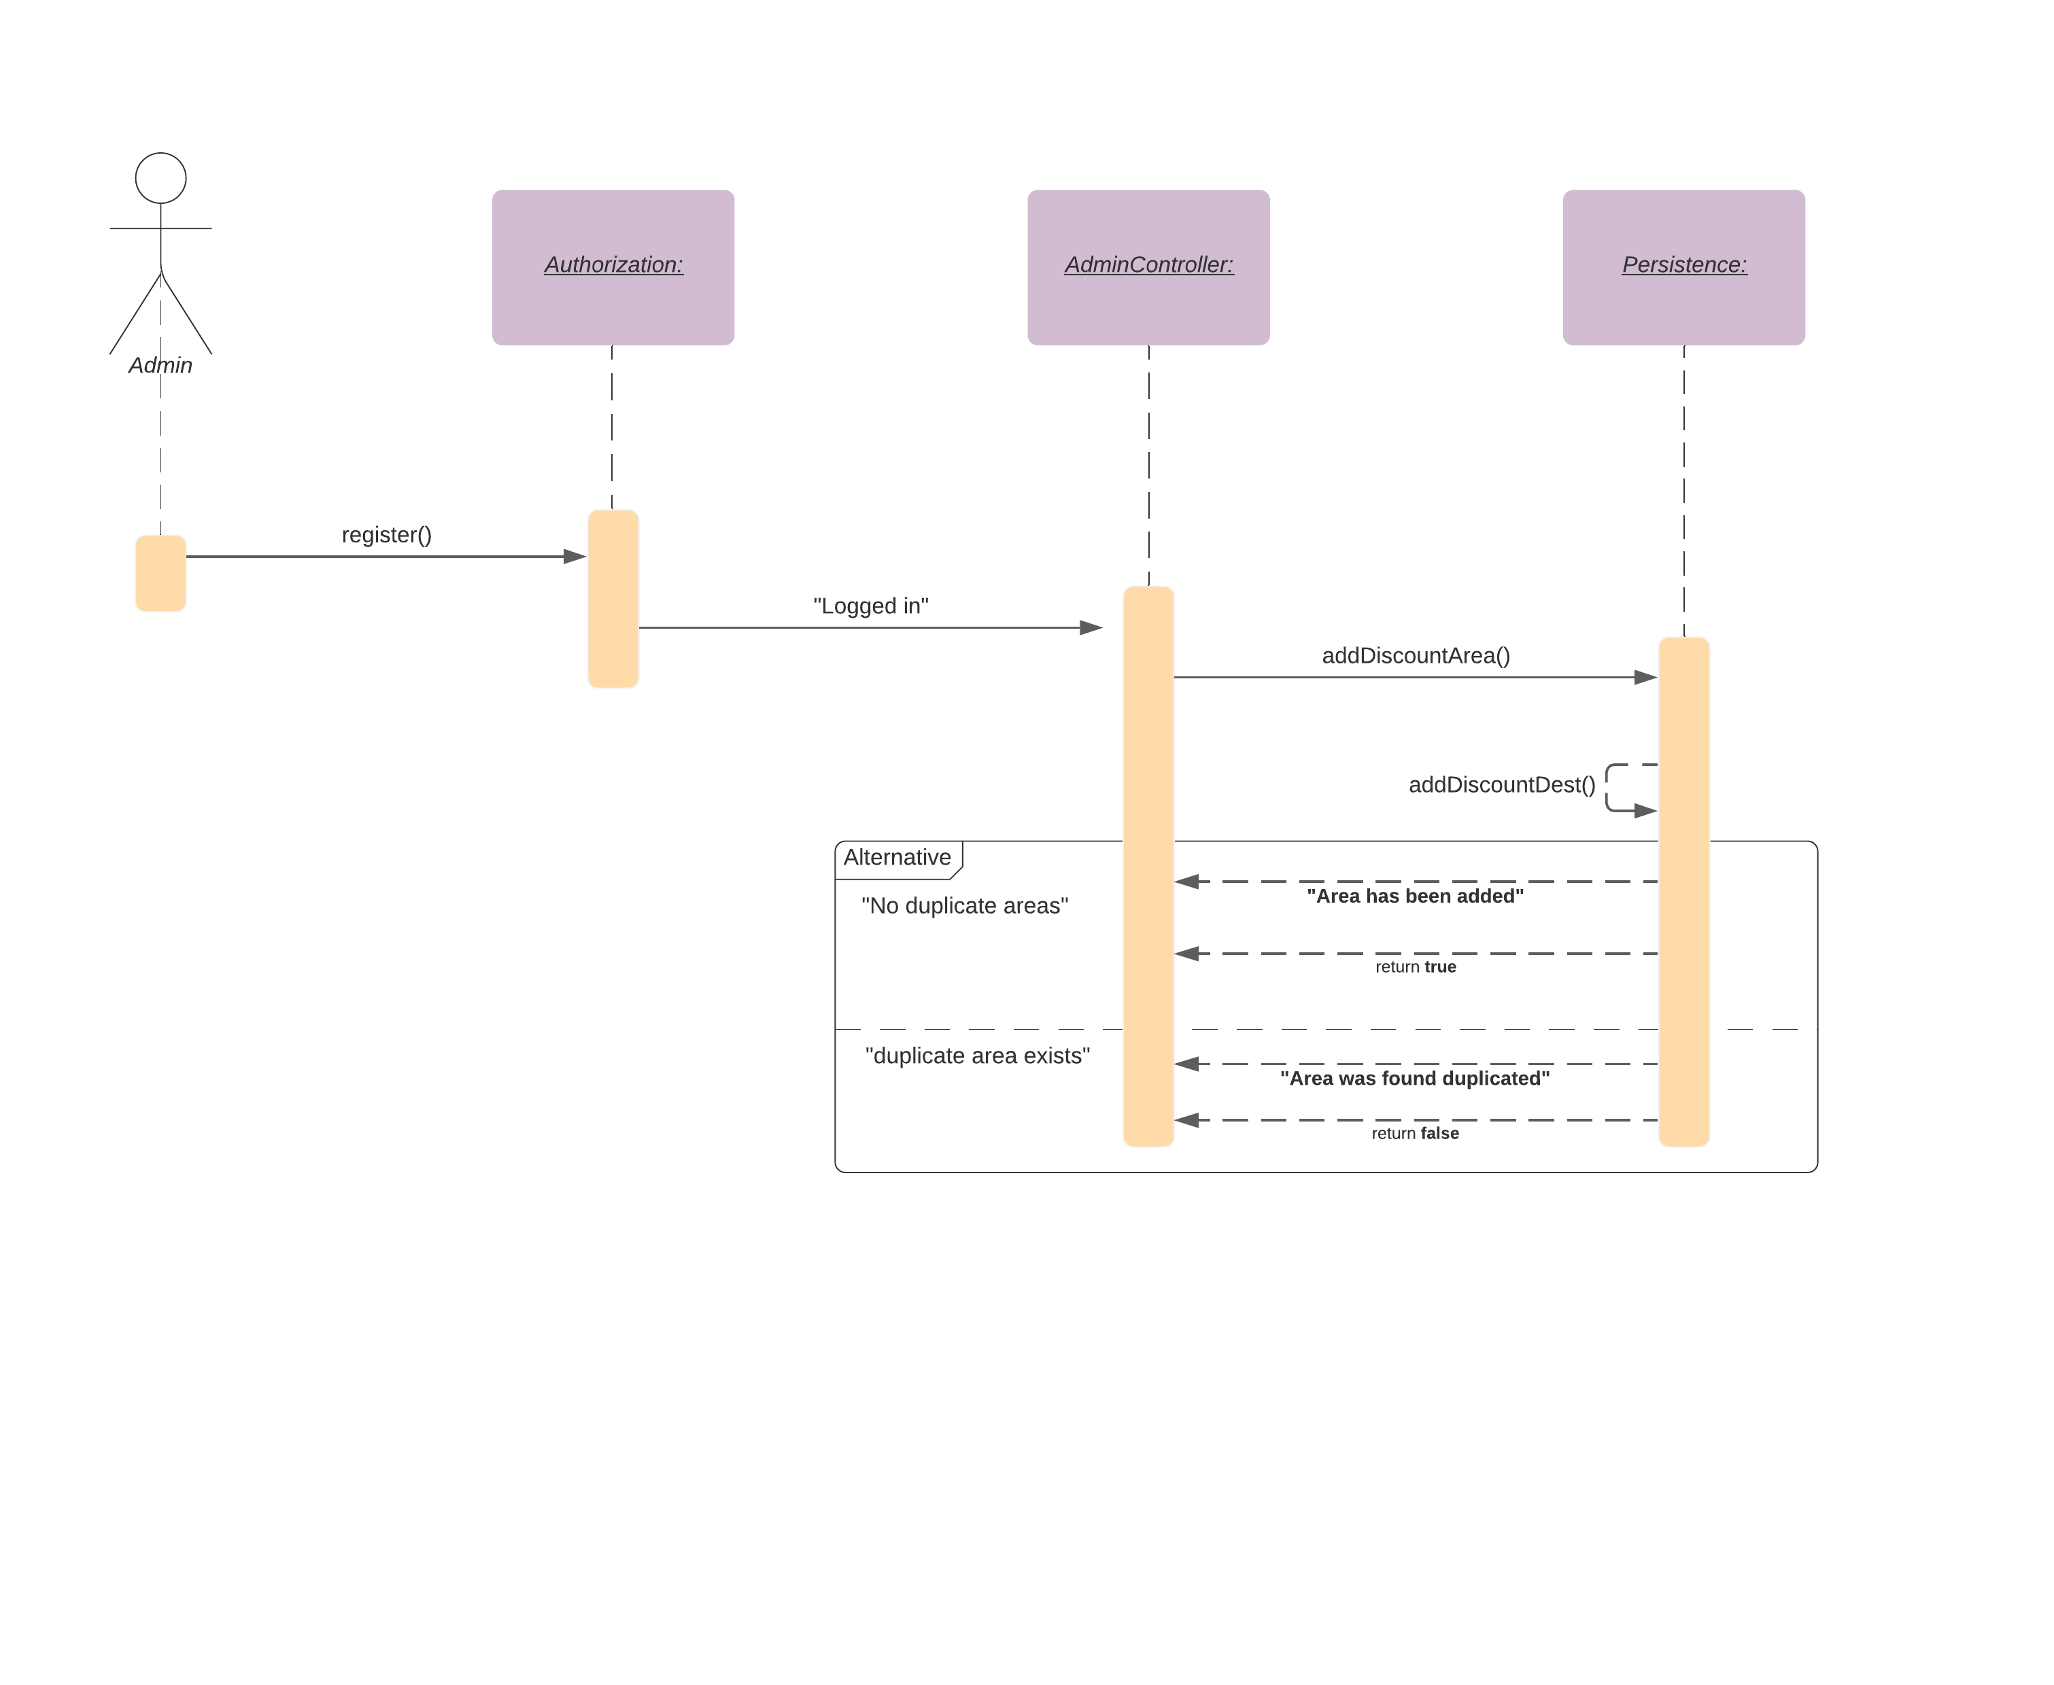

# Component diagram design

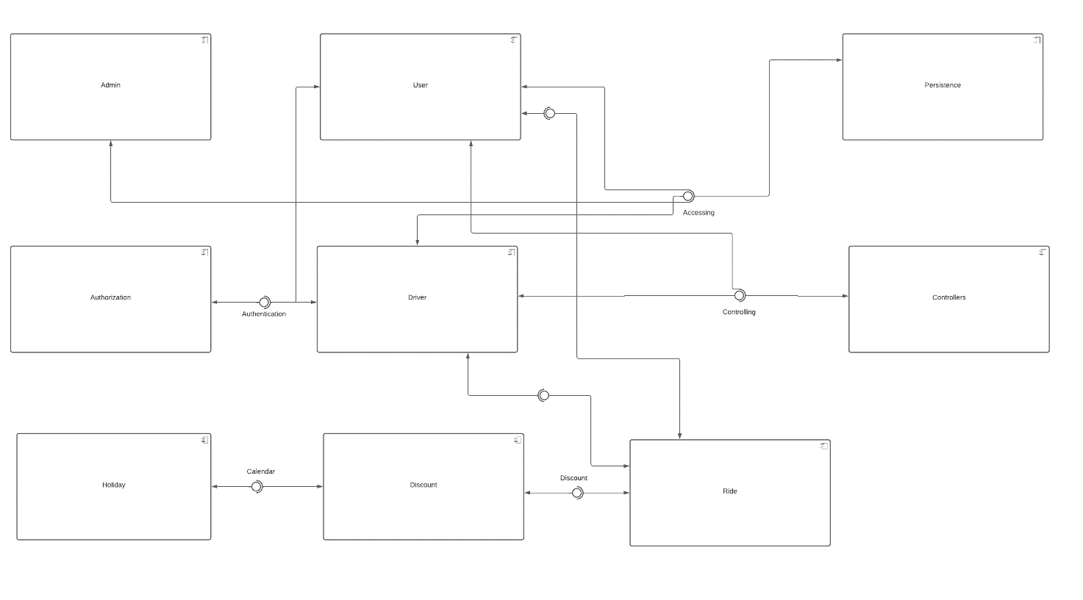

# Decomposition diagram design

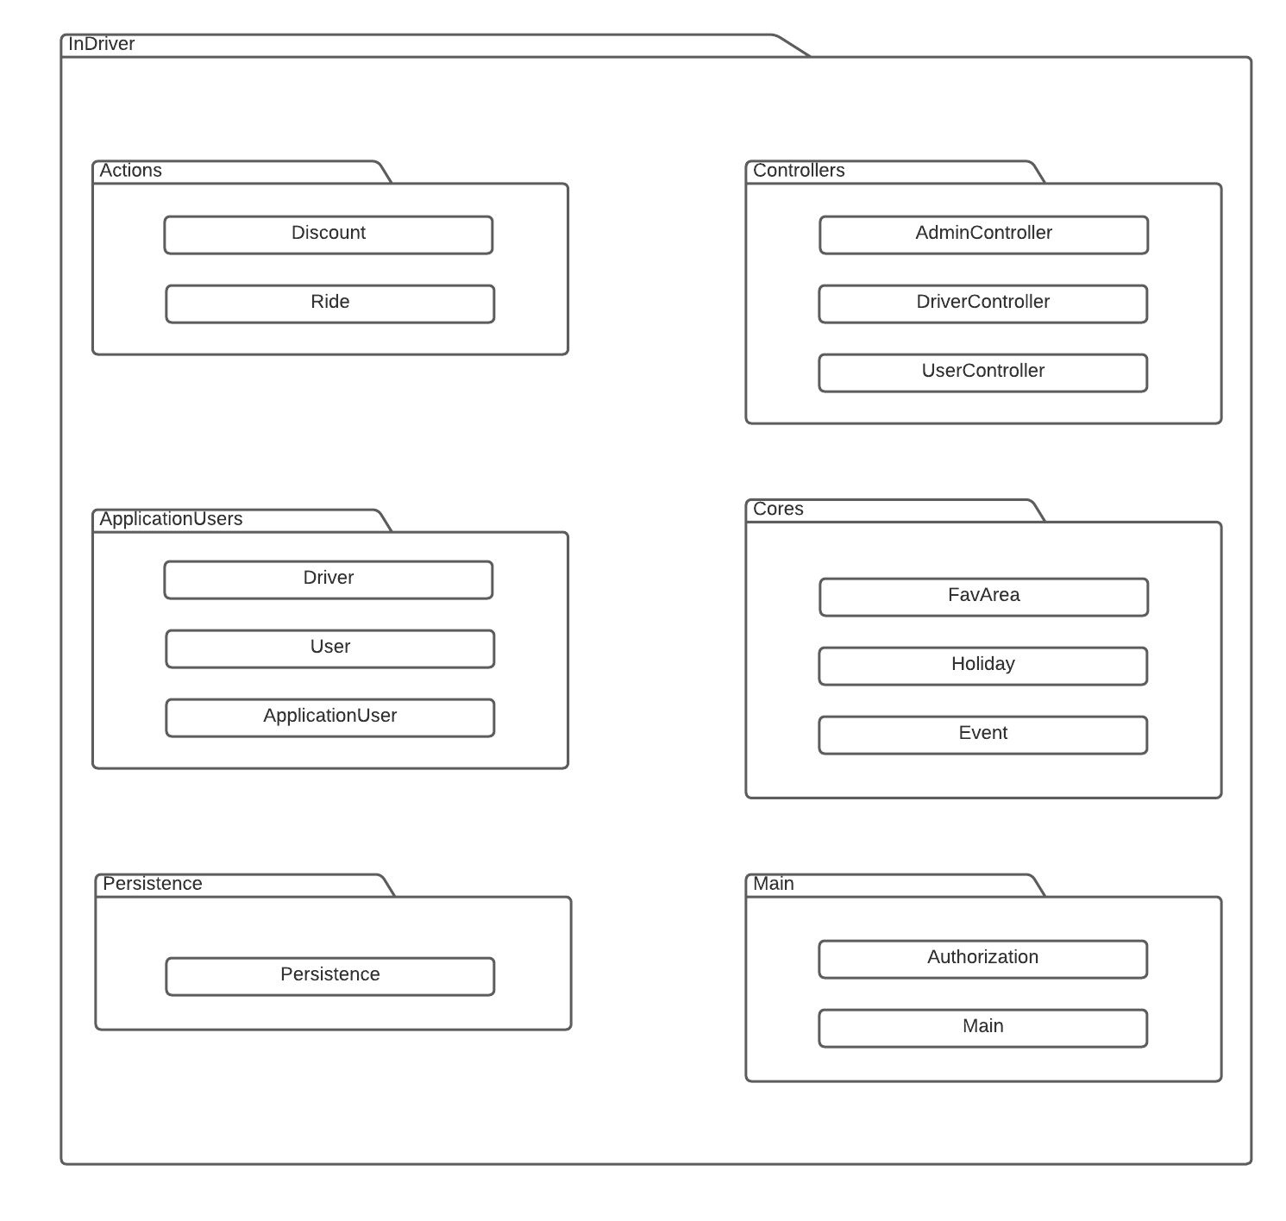

# Github repository link

<https://github.com/mostafanassr20190547/Advanced-Software-Project-Sprint-2>