Using sed utility
1- Display the lines that contain the word “lp” in /etc/passwd file.
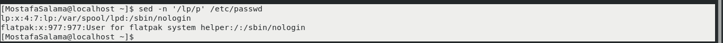
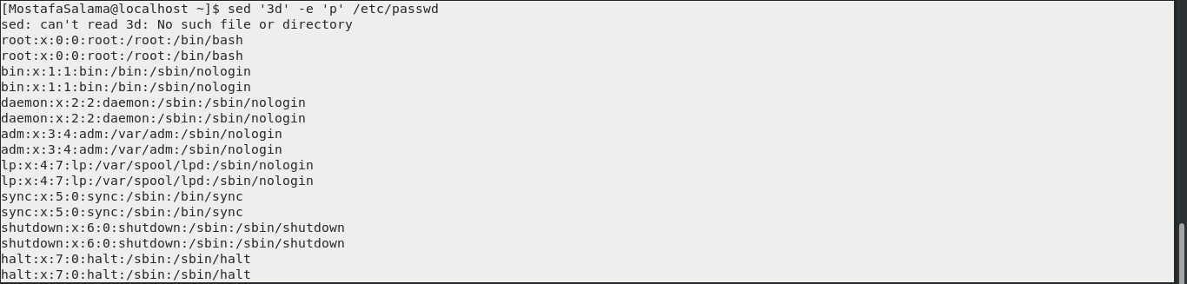
2- Display /etc/passwd file except the third line.

3- Display /etc/passwd file except the last line.
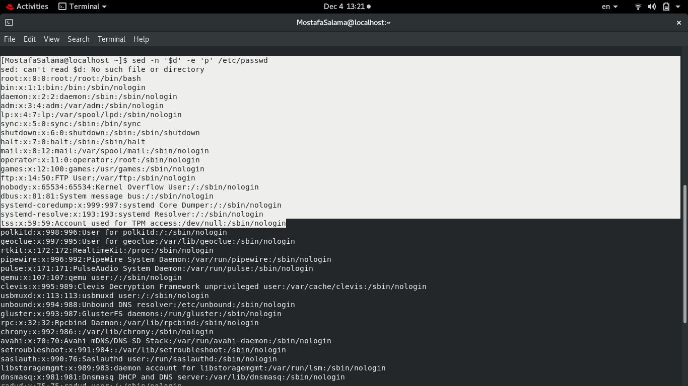

4- Display /etc/passwd file except the lines that contain the word “lp”.
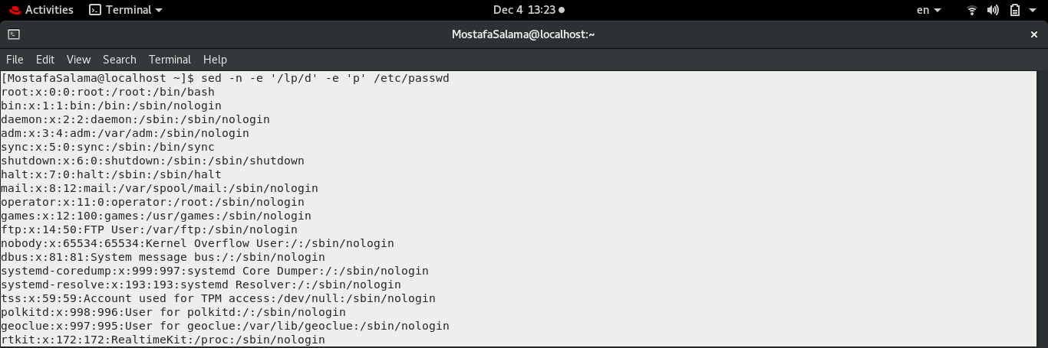
5- Substitute all the words that contain “lp” with “mylp” in /etc/passwd file.
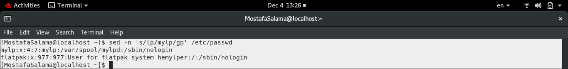

Using awk utility
1- Print full name (comment) of all users in the system.

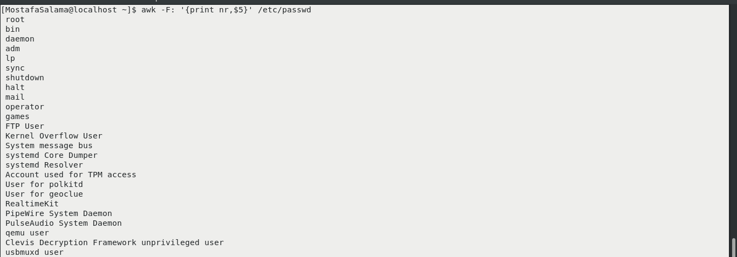

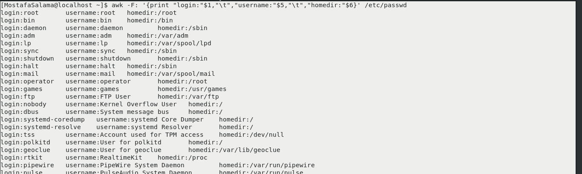
2-Print login, full name (comment) and home directory of all users.( Print each line preceded by a line number)

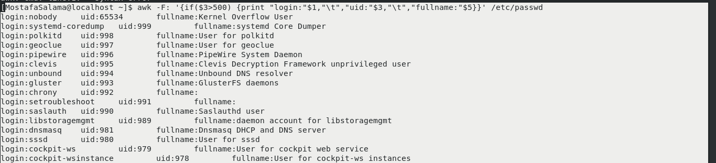
3- Print login, uid and full name (comment) of those uid is greater than 500

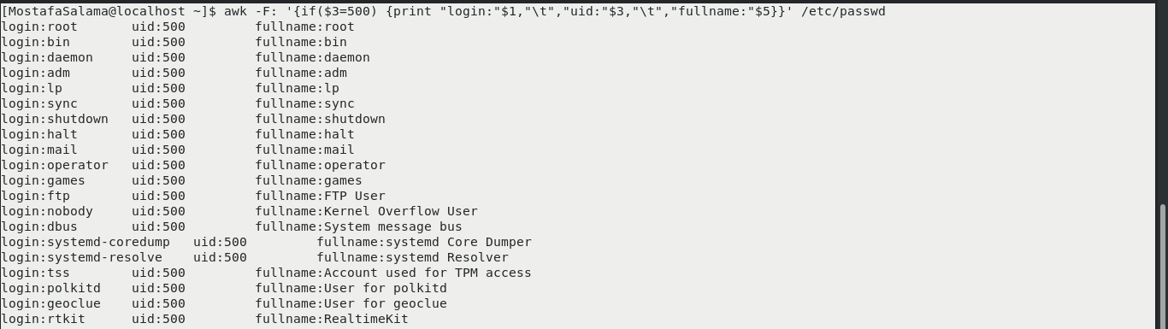
4- Print login, uid and full name (comment) of those uid is exactly 500

5- Print line from 5 to 15 from /etc/passwd
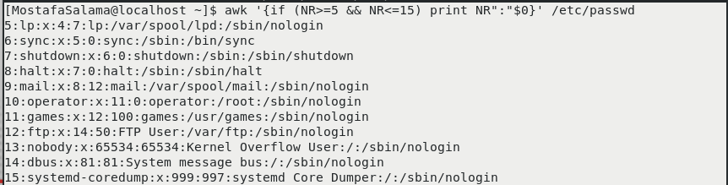

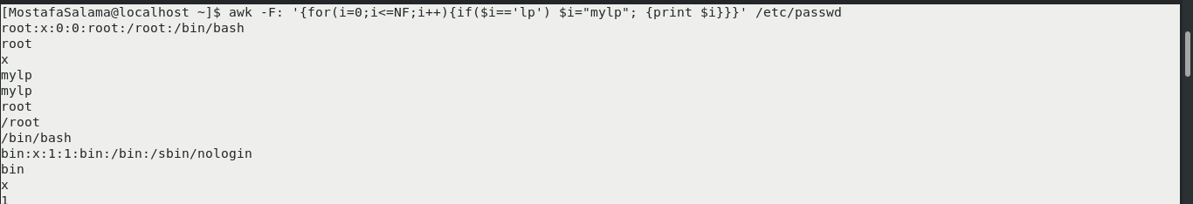
6- Change lp to mylp

7- Print all information about greatest uid.
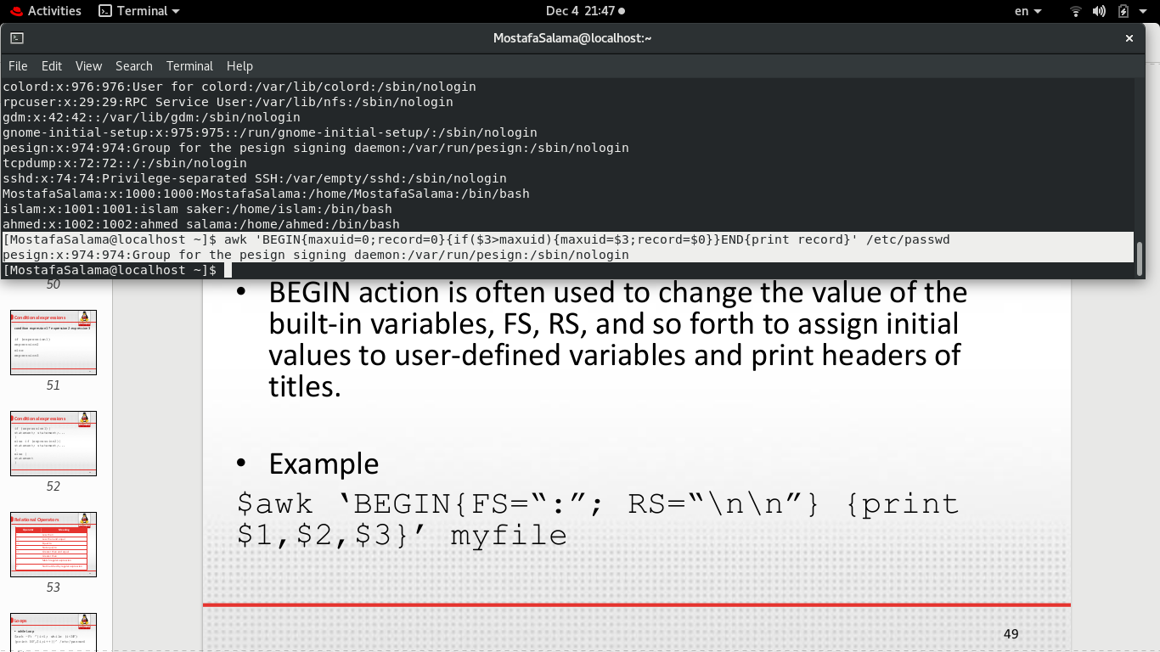
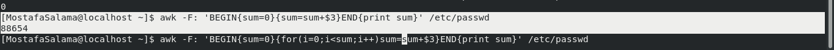
8- Get the sum of all accounts id’s.

