1. Use fdisk -l to locate information about the partition sizes.
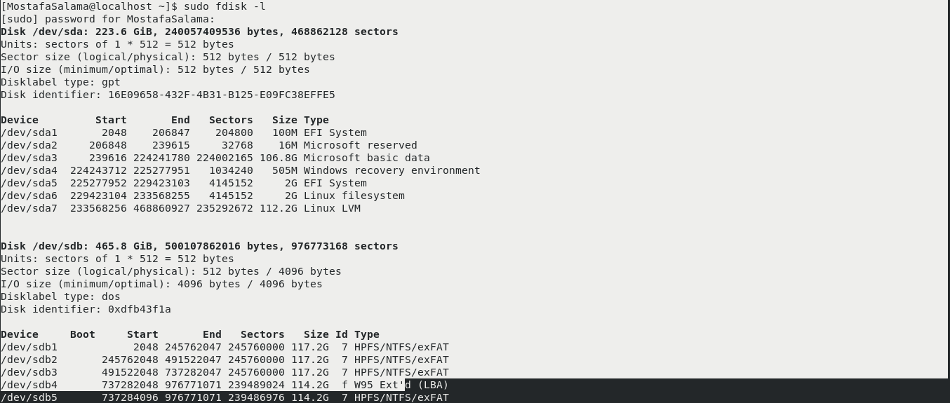
2. Use fdisk to add a new logical partition that is 1GB in size.
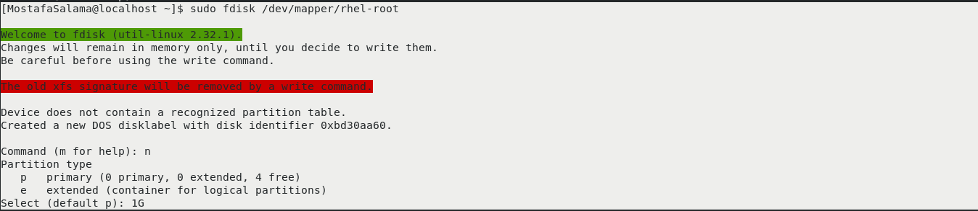
3. Did the kernel feel the changes?
Ans:- no
Display the content of /proc/partitions file? What did you notice? How to overcome that?
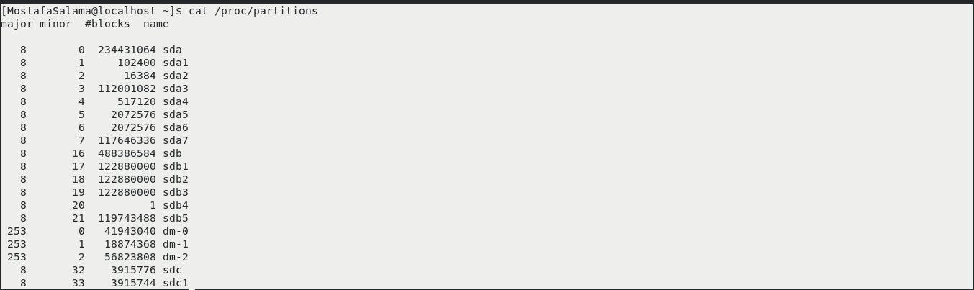
4. Make a new ext2 file system on the new logical partition you just created.

Ans:- Mkfs.ext4 /dev/ nvme0n1p3

Bonus: Try creating the ext2 filesystem with 2k blocks and one inode per
every 4k (two blocks) of filesystem.

5. Create a directory, name it /data.

Ans:- sudo mkdir /data

6. Add a label to the new filesystem, name it data.

Ans:- sudo e2label dev/sdc “flasha”

7. Add a new entry to /etc/fstab for the new filesystem using the label you just create.

8. Mount the new filesystem.

Ans:- mount /dev/sdc /data

9. Display your swap size.
10. Create a swap file of size 512MB.
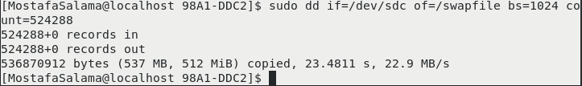
11. Add the swap file to the virtual memory of the system.
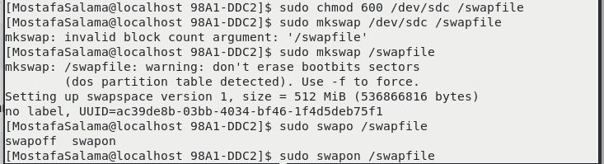
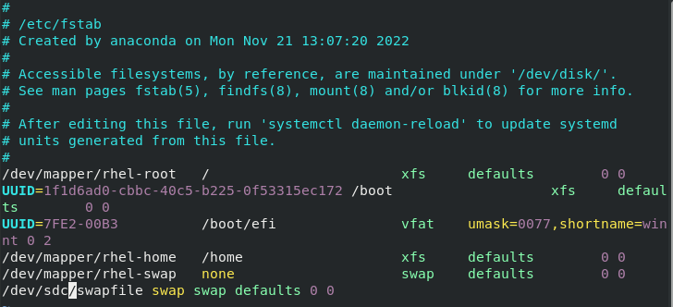

12. Display the swap size
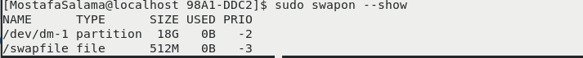
13. Implement disk quotas for users on the /home directory by taking the following actions
  - Edit /etc/fstab and add the usrquota option to the /home filesystem
  - Remount the filesystem with the command mount -o remount /home
  - Use the quotacheck command to create the quota-tracking file
quotacheck /home
  - Use the quotaon command to enable quota tracking by the kernel quotaon /home

