q1.
systemctl list-units --type=service --state=active
q2.
systemctl set-default multi-user.target
sudo reboot
systemctl set-default graphical.target
sudo reboot
q3.
echo "iam slama" | mailx -s "hi" root
root --> mailx
q4.
"photo"
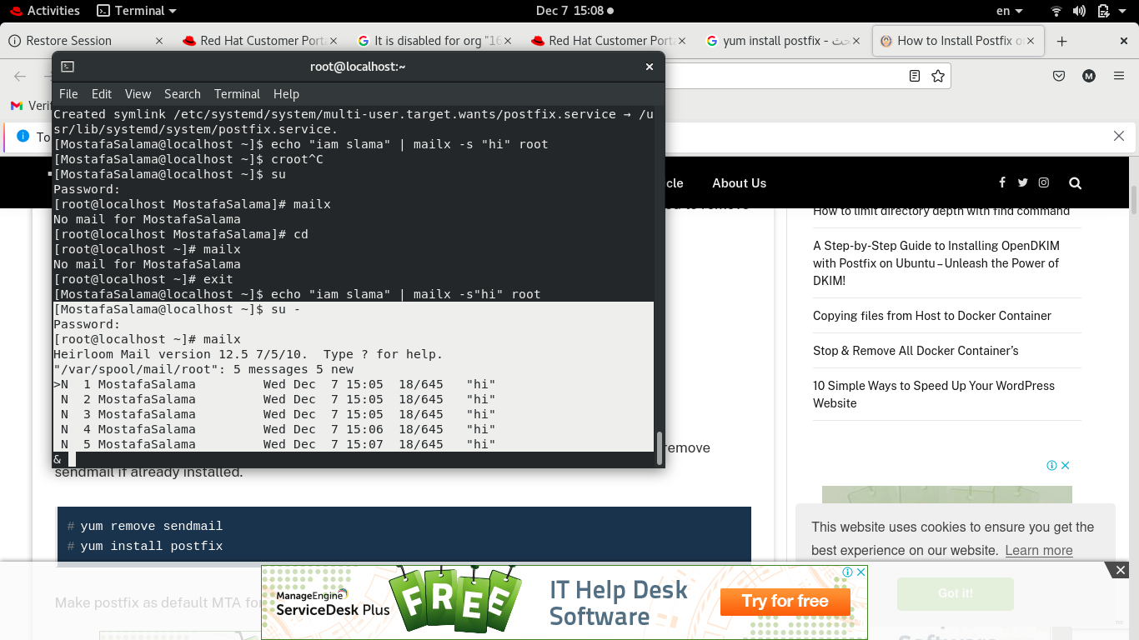

q5.
systemctl stop postfix.service
q6.
echo "iam slama" | mailx -s "hi" root
q7.
no mail sent "photp"
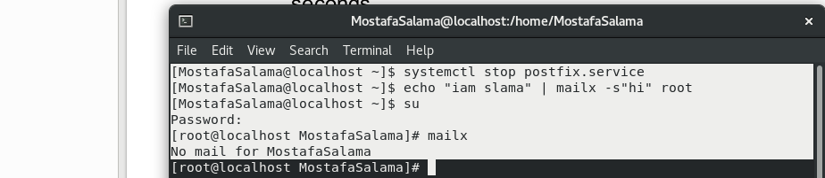

q8.
systemctl start postfix.service

q9.
"photo"

q10.
vi /etc/default/grub "photo"

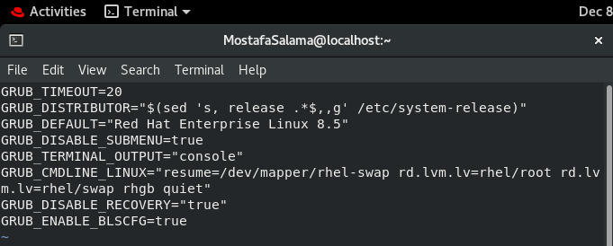

q11.
"photo"

q12.
"photo" from localhost:631

lp options -p mostafa

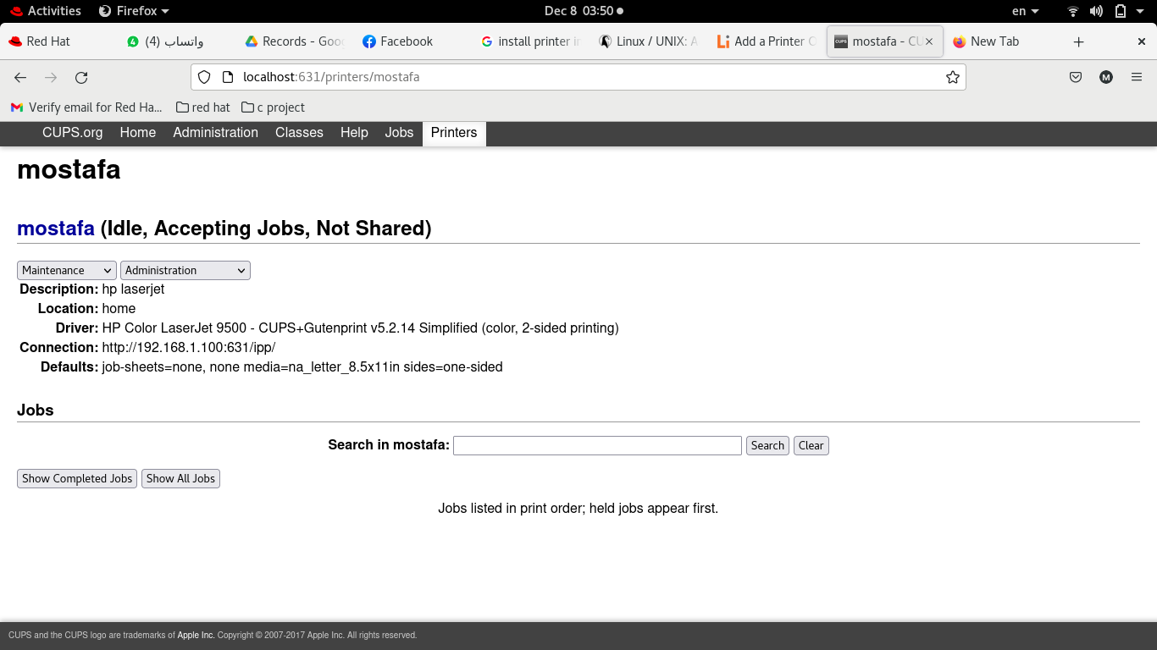

q13
lp /etc/hosts
lpq
q14.
cupsdisable tty12
q15.
cat /etc/hosts /etc/xinetd.conf /etc/hosts.allow | lp
lp mycd.sh ; lp myls.sh ; lp func.sh
q16.
lpq -a "photo"

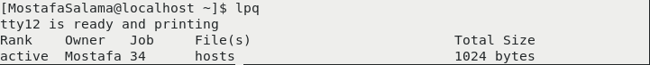
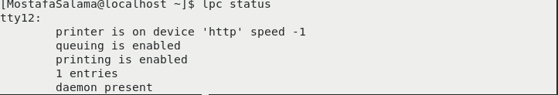

q17.
lprm -P tty12 44
cupsenable tty12

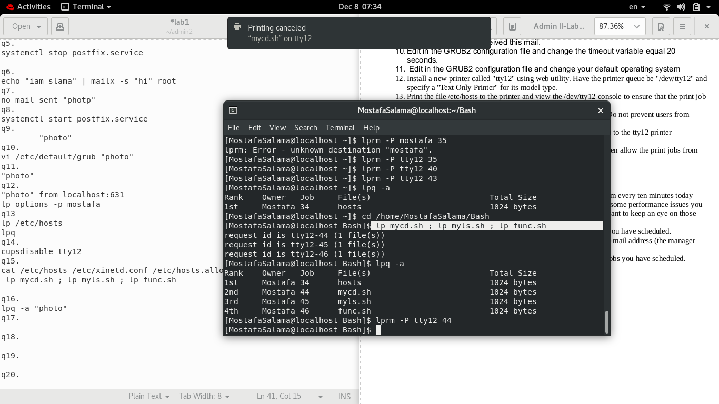
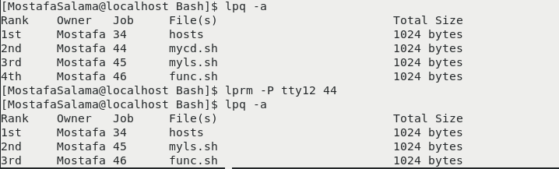

q18.
reject tty12
q19.
"photo"
q20.
lpadmin -x tty12
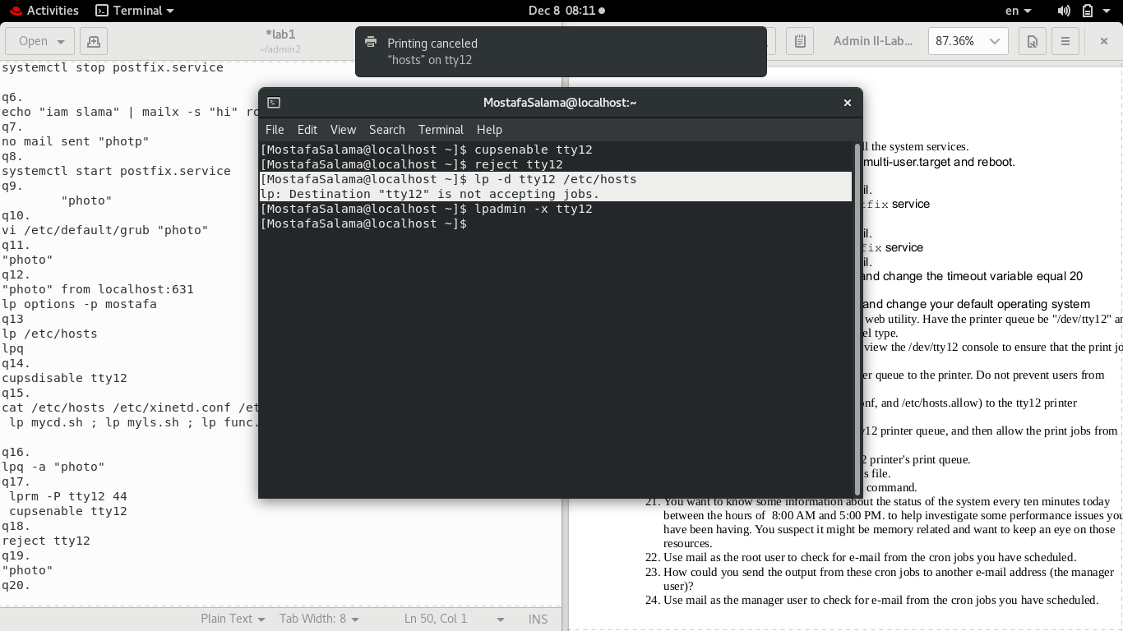
q21,q22.
Crontab -e
*/10 8-17 08 12 4 top
*/10 8-17 08 12 4 systemctl status
*/1 * * * * “top”
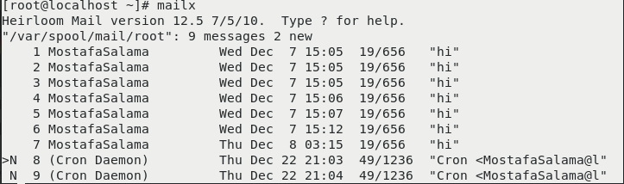
q23,q24.

