1. Compress a file by compress, gzip, zip commands and decompress it again. State the
differences between compress and gzip commands.
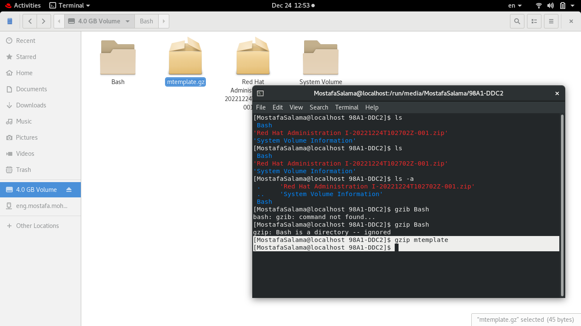

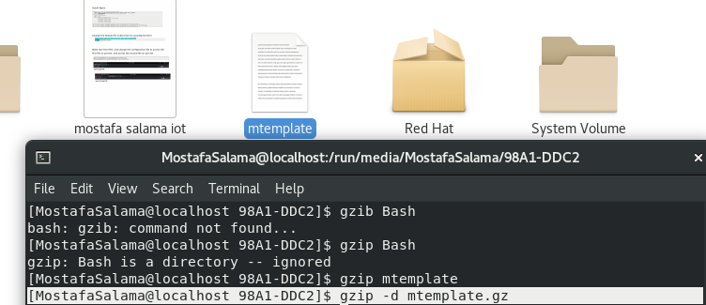
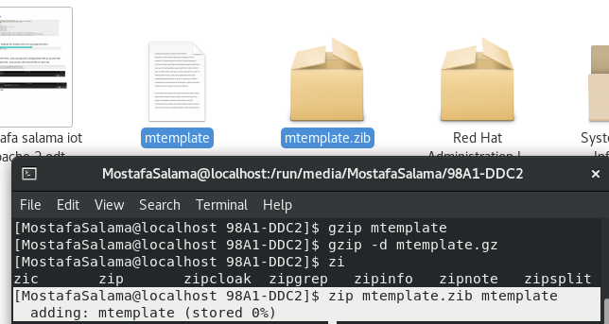
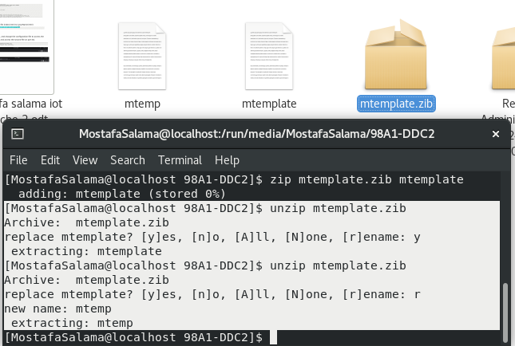

differences between compress and gzip commands.
Ans:-
- ZIP is more popular on Windows operating systems.
- Gzip is the standard file compression for Unix and Linux systems.
- Gzip is faster than ZIP while compressing and decompressing.
- ZIP is an archiving and compression tool, all in one, while Gzip needs the help of Tar command to archive files.
- Gzip can save more disk space than ZIP compression applications.
- Both Gzip and ZIP use the DEFLATE compression algorithm.
2. What is the command used to view the content of a compressed file.

3. Backup /etc directory using tar utility.


4. Starting from your home directory, find all files that were modified in the last two day.
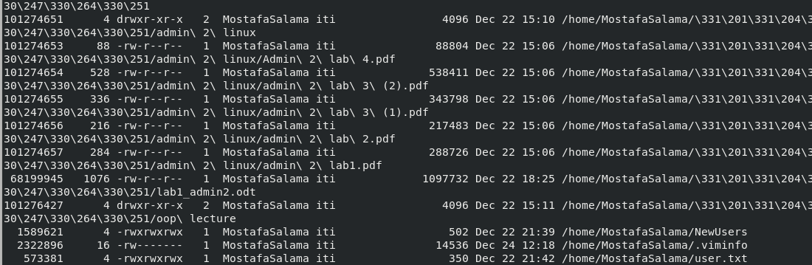
5. Starting from /etc, find files owned by root user.
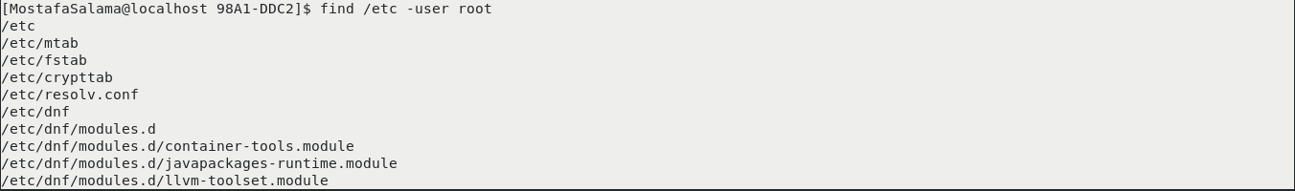

6. Find all directories in your home directory.
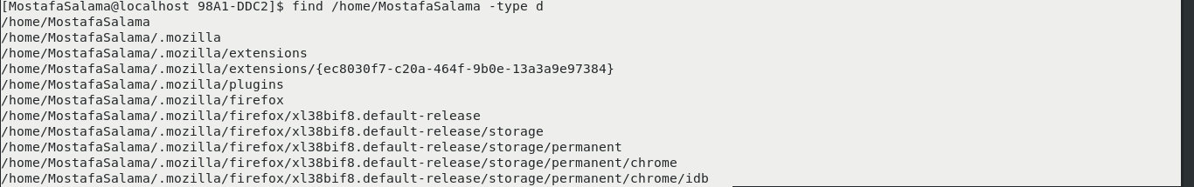
7. Write a command to search for all files on the system that, its name is “.profile”.
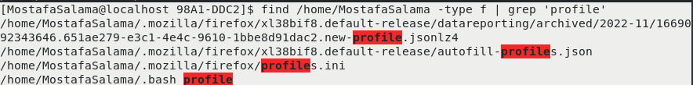
8. Identify the file types of the following: /etc/passwd, /dev/pts/0, /etc, /dev/sda

9. List the inode numbers of /, /etc, /etc/hosts.
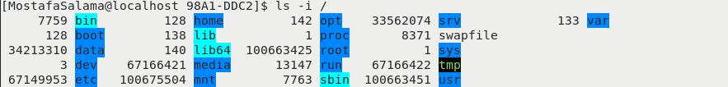
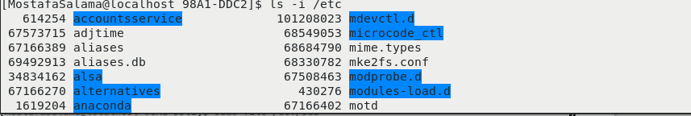
10. Copy /etc/passwd to your home directory, use the commands diff and cmp, and Edit in the
file you copied, and then use these commands again, and check the output.
