Flood Depth and Building Loss Analysis: A Comprehensive Study

REPORT

Course Number: CGN 5432
Submitter: Mostafa Sameer,
P.ID: 6513997
Ph.D. Student, Department of Civil Engineering

Instructor: Dr. Omar Nofal,
Assistant Professor, Department of Civil and Environmental Engineering.

TABLE OF CONTENTS

Introduction. 3
Methodology 3
MATLAB Code for Simulation 4
Figures and Analysis 5
Results and Discussion 6
Conclusion 13

LISTS OF FIGURES
Figure 1 Screenshot of MATLAB Workspace with Building Data and Variables Setup. 4
Figure 2 Screenshot of Excel Script for Simulation of Fragility and Loss Data of Building Archetype 3. 4
Figure 3 Framework of Steps for Flood Fragility Building Loss Analysis. 5
Figure 4 Histogram of Replacement Costs for Component N (Building Component ID 58). 6
Figure 5 Probability of Failure for Various Components at Different Flood Depths. 7
Figure 6 Component Loss with Standard Deviation at Varying Flood Depths. 7
Figure 7 Total Building Loss at Different Flood Depths. 8
Figure 8 Component Loss with Simulated Values and Mean Loss at Various Flood Depths. 8
Figure 9 Cumulative Distribution Function (CDF) of Component Failures Across Flood Depths 9
Figure 10 Exceedance Probability of Damage States (DS) for Different Building Components 9
Figure 11 Exceedance Probability of Damage States with Flood Depth Zones Highlighted 10
Figure 12 Component Loss with Simulated Values and Standard Deviations 10
Figure 13 Total Building Loss vs Flood Depth with Confidence Bounds (Additional View). 11
Figure 14 Total Building Loss in USD vs Flood Depth for Further Analysis. 11
Figure 15 Total Building Loss Percentage vs Flood Depth for Different Models (M1 to M3). 12
Figure 16 Component Loss for Various Building Materials vs Flood Depth. 12
Figure 17 Component Loss Distribution for Building Components under Varying Flood Depth. 13

Abstract
This study examines the vulnerability of building components under several flood conditions to explore the relationship between flood depth and structural damage. The research assesses the failure probabilities and replacement expenses of structural elements at varying flood depths via Monte Carlo simulations. The results demonstrate that building loss increases with flood depth, exhibiting significant variations depending on the material and flood resilience of the structure. This research will inform future mitigation efforts by elucidating the structural and financial vulnerabilities of buildings in flood catastrophes.

Keywords: Flood depth, building loss, Monte Carlo simulations, component failure, replacement costs

Introduction
Flooding poses a substantial threat to structures, resulting in both economic and structural damage. Comprehending the influence of flood depth on the functionality of various building components is essential for evaluating possible dangers and formulating efficient mitigation solutions. This study examines the correlation between flood depth and the resultant damage to building components via a Monte Carlo simulation methodology. The aims are to assess the failure rates of various building components and to determine the replacement costs at different flood depths. The findings will elucidate the vulnerabilities of structures during flood occurrences and facilitate informed decision-making in flood risk management.

Methodology
The analysis uses Monte Carlo simulations to model the impact of flood depth on building components. Data for various building components were obtained from the 'Building_Components_Archetype_3.xlsx' dataset, and the replacement costs and probabilities of failure for each component were simulated at different flood depths. The methodology includes the following steps:
- Data preparation and preprocessing of building components from the spreadsheet.
- Simulation of flood depth scenarios and determination of failure thresholds for each building component.
- Calculation of component loss and replacement costs based on failure probabilities.
- Analysis of the total building loss across varying flood depths using the simulated data.
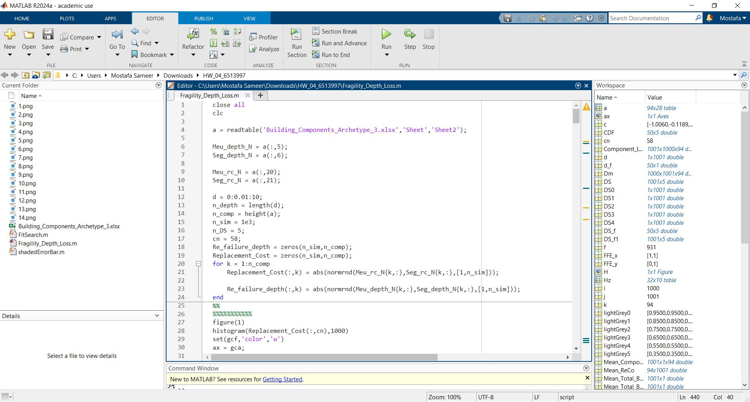
Figure 1 Screenshot of MATLAB Workspace with Building Data and Variables Setup.

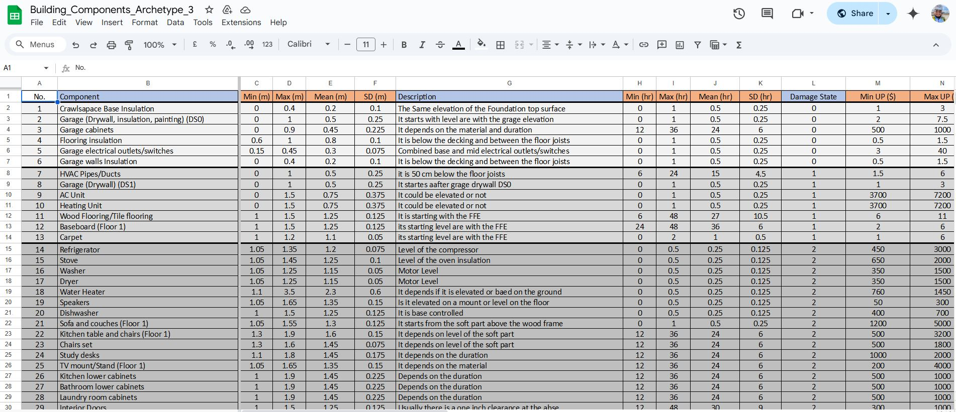
Figure 2 Screenshot of Excel Script for Simulation of Fragility and Loss Data of Building Archetype 3.

MATLAB Code for Simulation
The fragility and replacement cost for many building components at different flood depths were simulated using MATLAB codes here. The replacement expenses and the chance of failure under different flood depths are produced using Monte Carlo models.
Simulating the flood depth and failure criteria, the algorithm generates the related component loss and replacement prices from data from the spreadsheet "Building_Components_Archetype_3.xlsx".
Data processing and the Monte Carlo simulations—which are essential for computing the component loss and investigating flood depth effects—have been done using MATLAB code. The function generates a collection of simulated data for the component failure and replacement cost distributions.
MATLAB codes were created to obtain the required statistics results and automate the simulation procedure. Figure 3 shows the simulation's conceptual structure.

Figures and Analysis
Understanding the financial and structural influence of flood occurrences on structures depends on knowing the unambiguous link between flood depth and building damage, as the simulation findings show. The main conclusions based on MATLAB simulation results are broken out in great depth below.
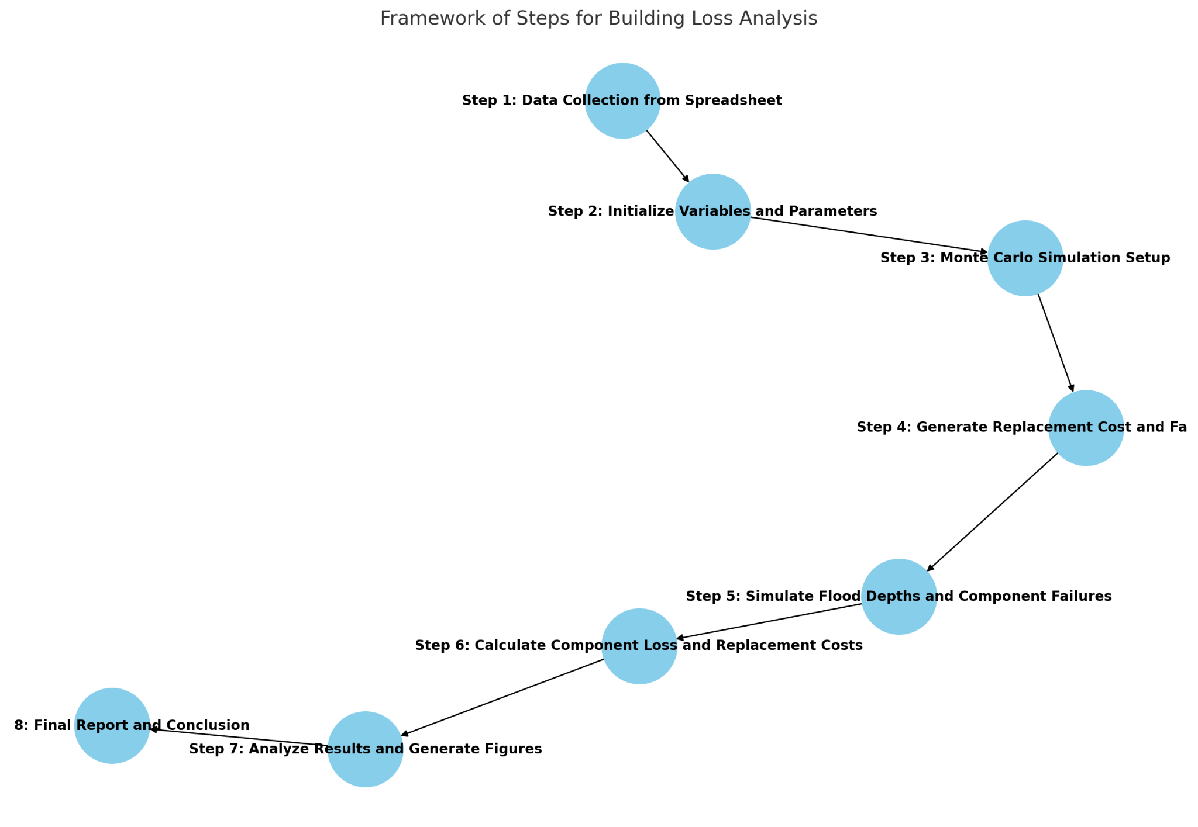
Figure 3 Framework of Steps for Flood Fragility Building Loss Analysis.

Results and Discussion
The modeling findings show a definite link between structure loss and flood depth. Important conclusions are:
Under varying flood depths, this histogram (figure 4) shows the fluctuation of replacement prices for a particular building component (ID 58). Monte Carlo simulations helped create the histogram by modeling replacement costs under many flood depth ranges. The histogram's variability reveals the component's possible replacement cost range, therefore providing information on how financial effects vary with flood degree.
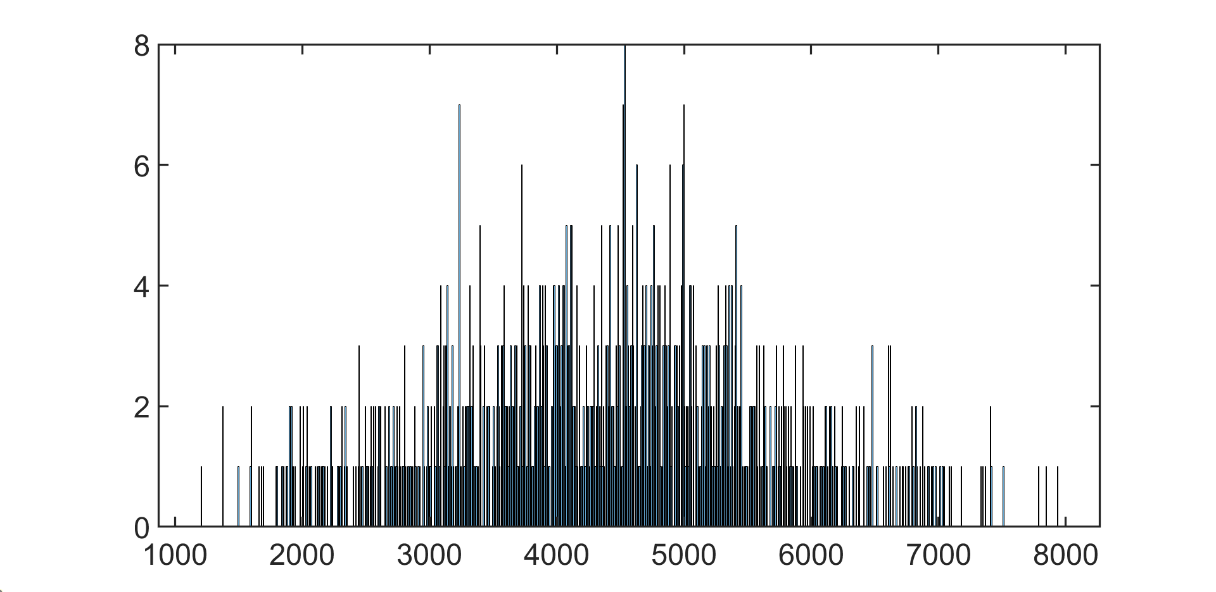
Figure 4 Histogram of Replacement Costs for Component N (Building Component ID 58).

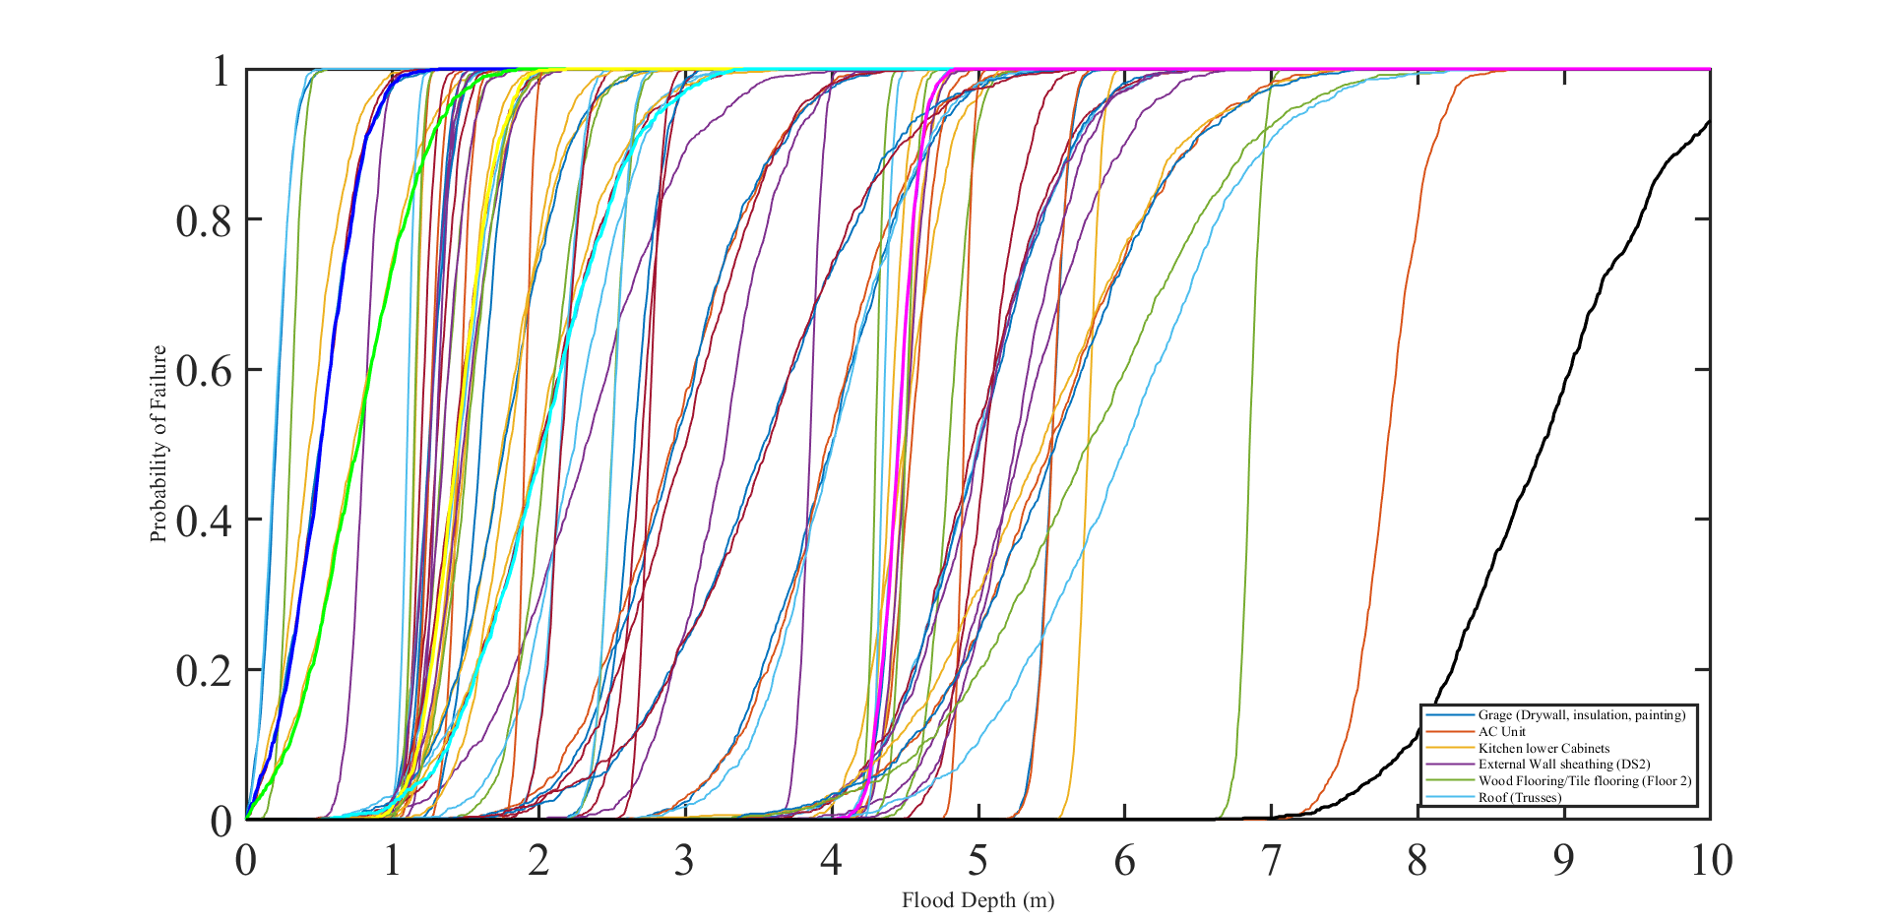
Figure 5 Probability of Failure for Various Components at Different Flood Depths.
Plot component loss at many flood depths in Figure (6) together with the standard deviation of losses. Directly resulting from the Monte Carlo simulations, the standard deviation shows the uncertainty and fluctuation in the loss estimations. This study provides a more complete knowledge of the financial risks connected with flood events by incorporating the standard deviation, therefore helping to comprehend the range of possible losses across various flood levels.
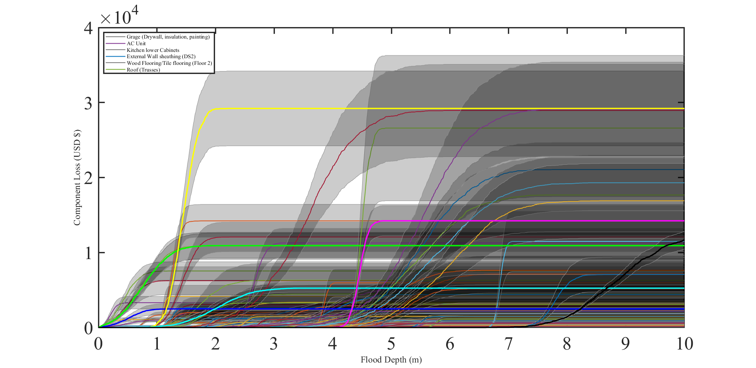
Figure 6 Component Loss with Standard Deviation at Varying Flood Depths.
Figure 7 shows overall building damage over many flood depths. The overall building loss increases greatly as the flood depth rises; most of the notable losses are found in extremely susceptible parts. This study shows how the combined impacts of flooding on several building components cause an overall increase in building loss, which can be used to project the financial influence of flood occurrences on the whole construction.
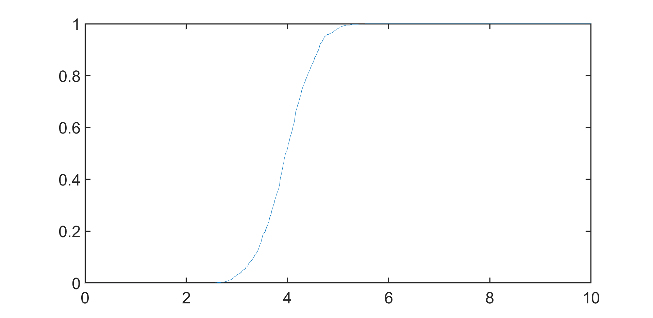
Figure 7 Total Building Loss at Different Flood Depths.
Figure 8 shows the mean loss at different flood depths together with the simulated component loss values, therefore offering a more exact perspective of component loss. Emphasizing the uncertainty in the loss estimates, the shaded error bars show the standard deviation. Including the mean loss estimates clarifies projected component losses and enables decision-makers to evaluate the potential range of damages in flood-prone regions.
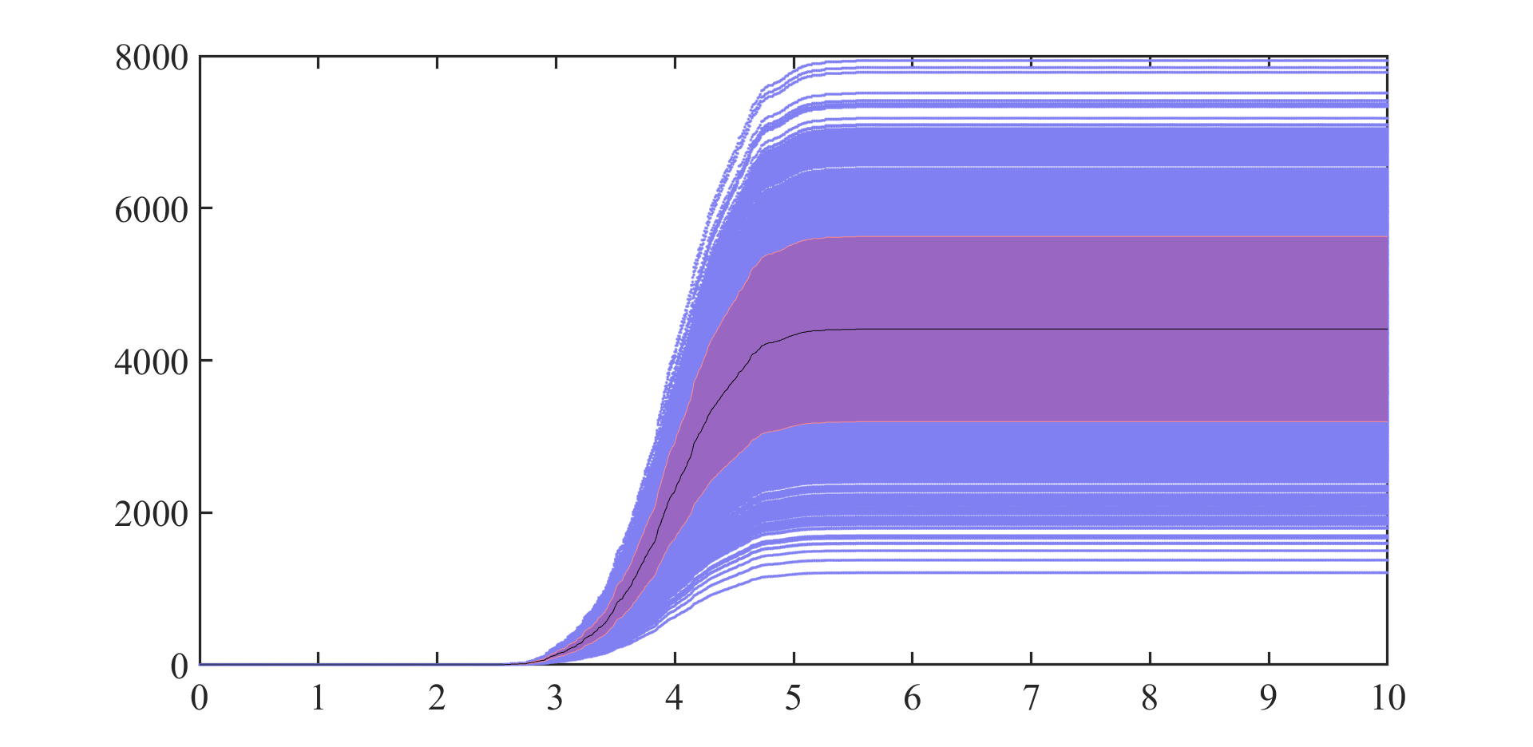
Figure 8 Component Loss with Simulated Values and Mean Loss at Various Flood Depths.

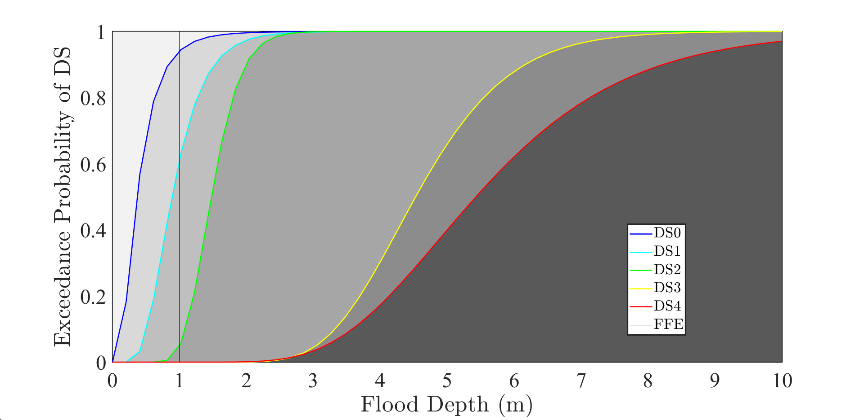
Figure 9 Cumulative Distribution Function (CDF) of Component Failures Across Flood Depths

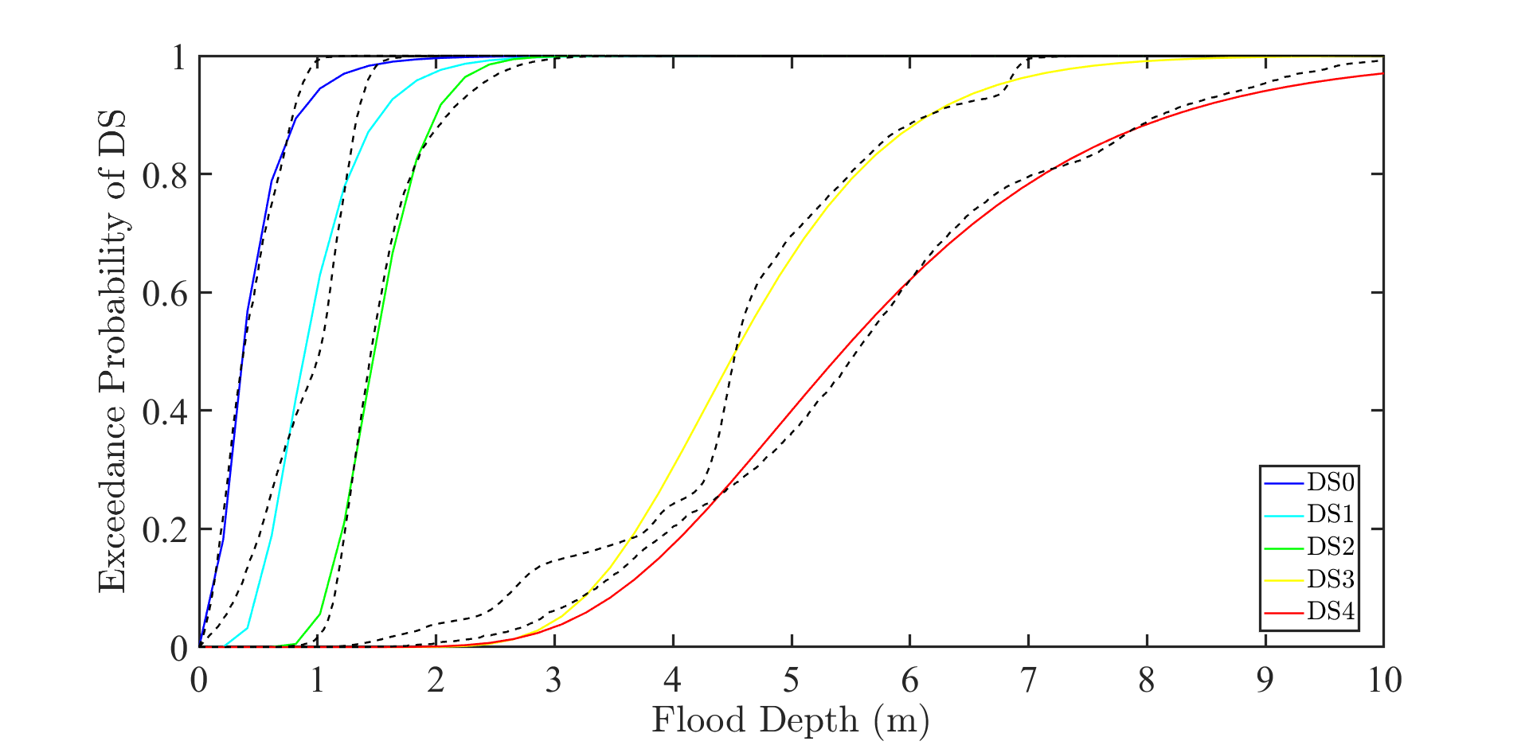
Figure 10 Exceedance Probability of Damage States (DS) for Different Building Components

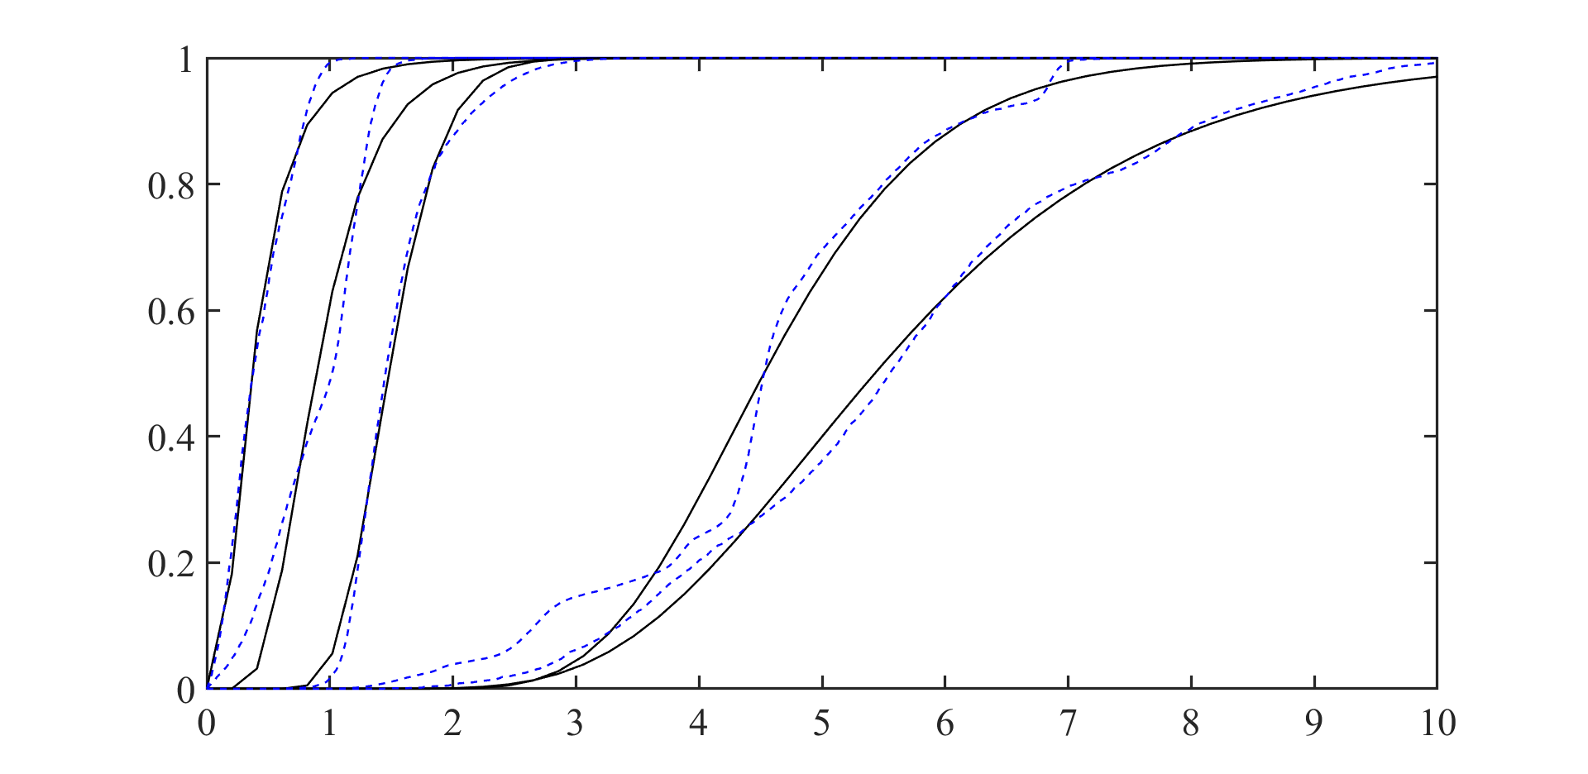
Figure 11 Exceedance Probability of Damage States with Flood Depth Zones Highlighted
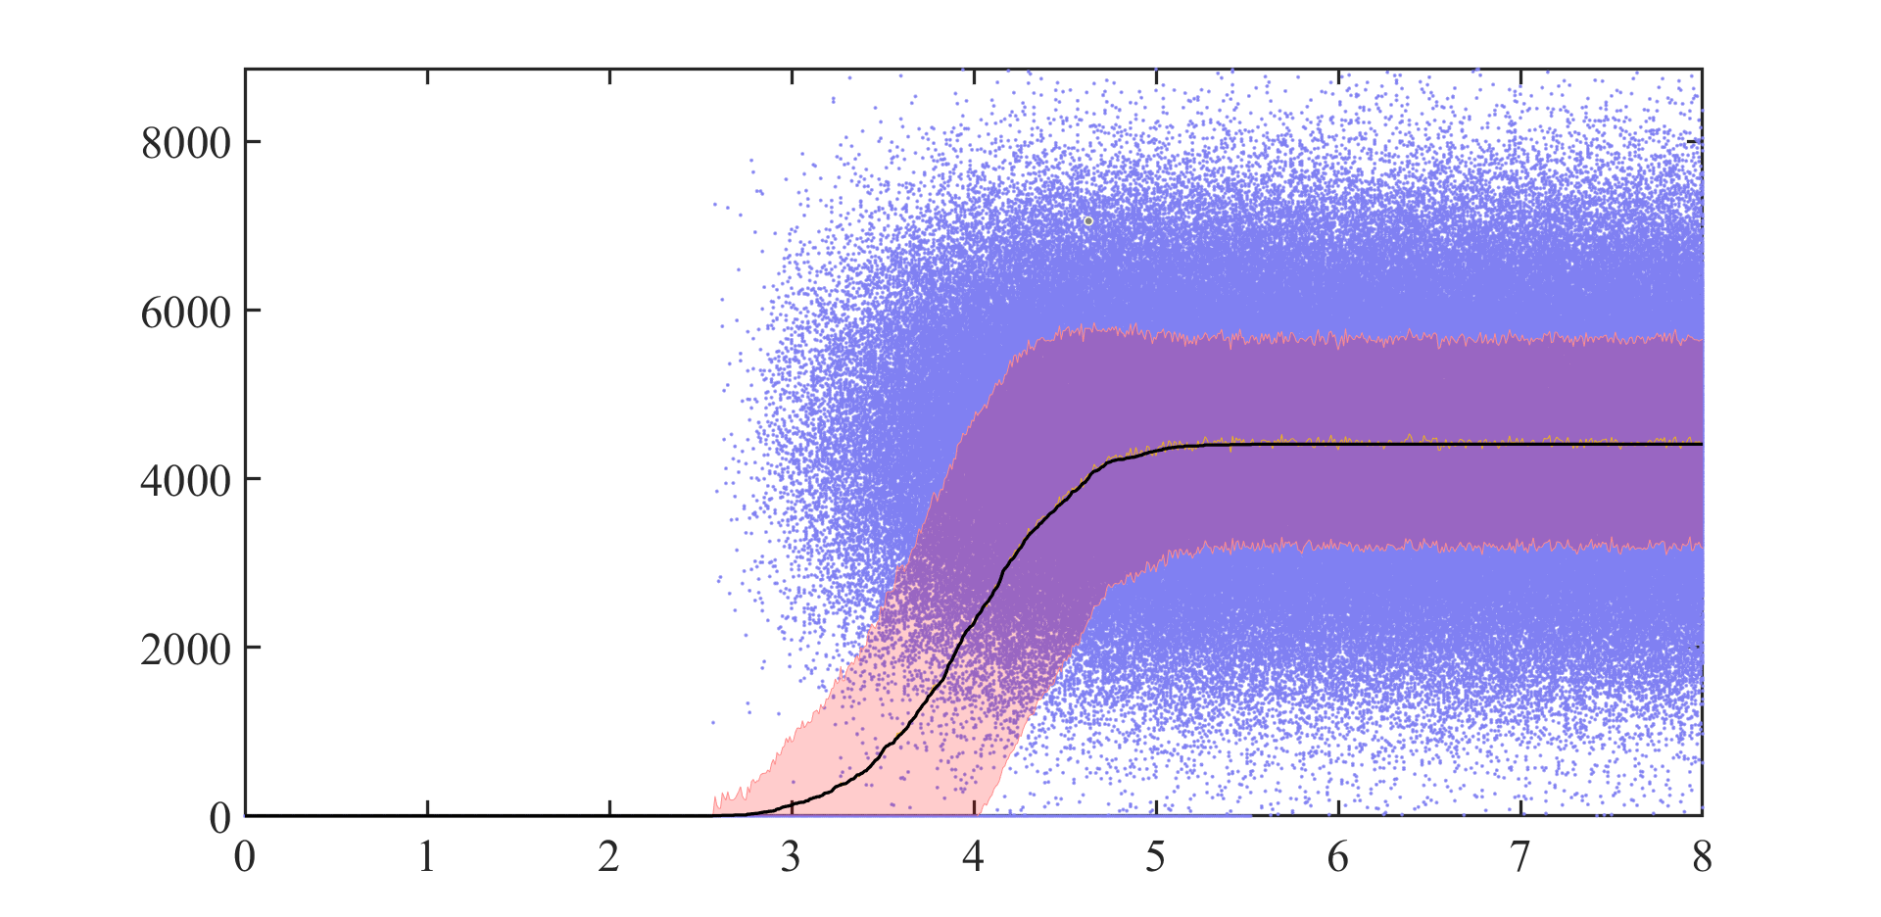
Figure 12 Component Loss with Simulated Values and Standard Deviations
Plotting the overall building loss in Figure 13 against flood depth with confidence limits helps to explain the fluctuation in the simulation outputs. This graph provides confidence intervals reflecting the uncertainty in flood risk projections, therefore helping to see the spectrum of possible building loss results across varying flood levels. Confidence limits improve the validity of the findings and help to guide judgments for the reduction of flood risk.
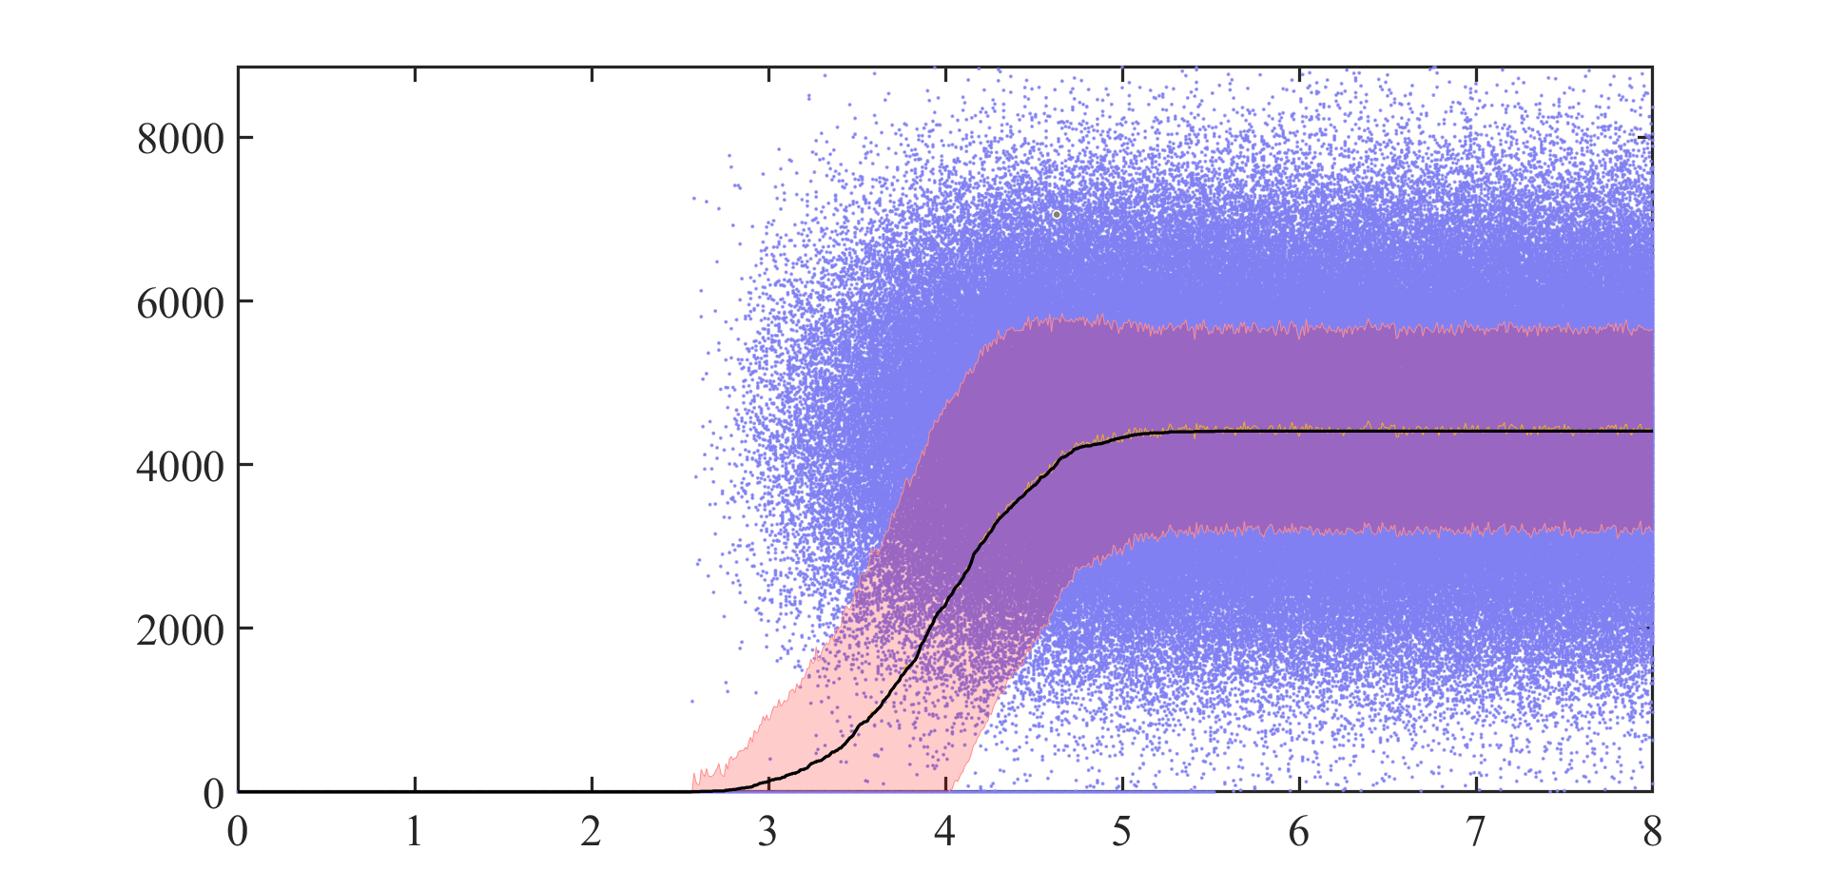
Figure 13 Total Building Loss vs Flood Depth with Confidence Bounds (Additional View).
Showed in Figure 14, the whole building damage analysis emphasizes the financial consequences of different depths of flood episodes. According to the statistics, overall losses might be greatly lowered by mitigating techniques emphasizing improving the resilience of important building components.
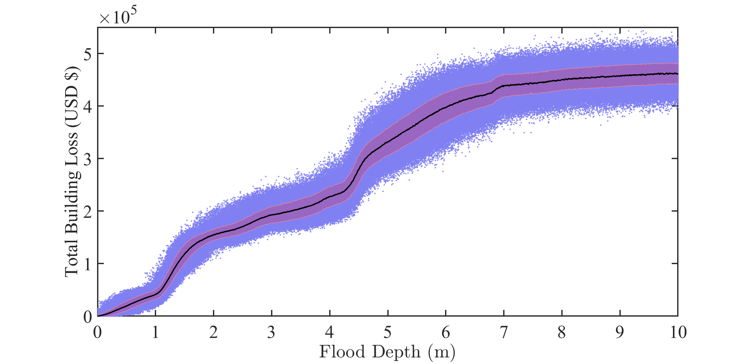
Figure 14 Total Building Loss in USD vs Flood Depth for Further Analysis.
For three separate models—M1, M2, and M3—Figure 15 contrasts the percentage of total building loss at different flood depths. Regarding building materials, structural robustness, and flood scenarios, the several models reflect distinct presumptions. This comparison shows how sensitive building damage estimates are to model assumptions, therefore illustrating how changes in these assumptions can affect the expected financial effect of flood disasters.
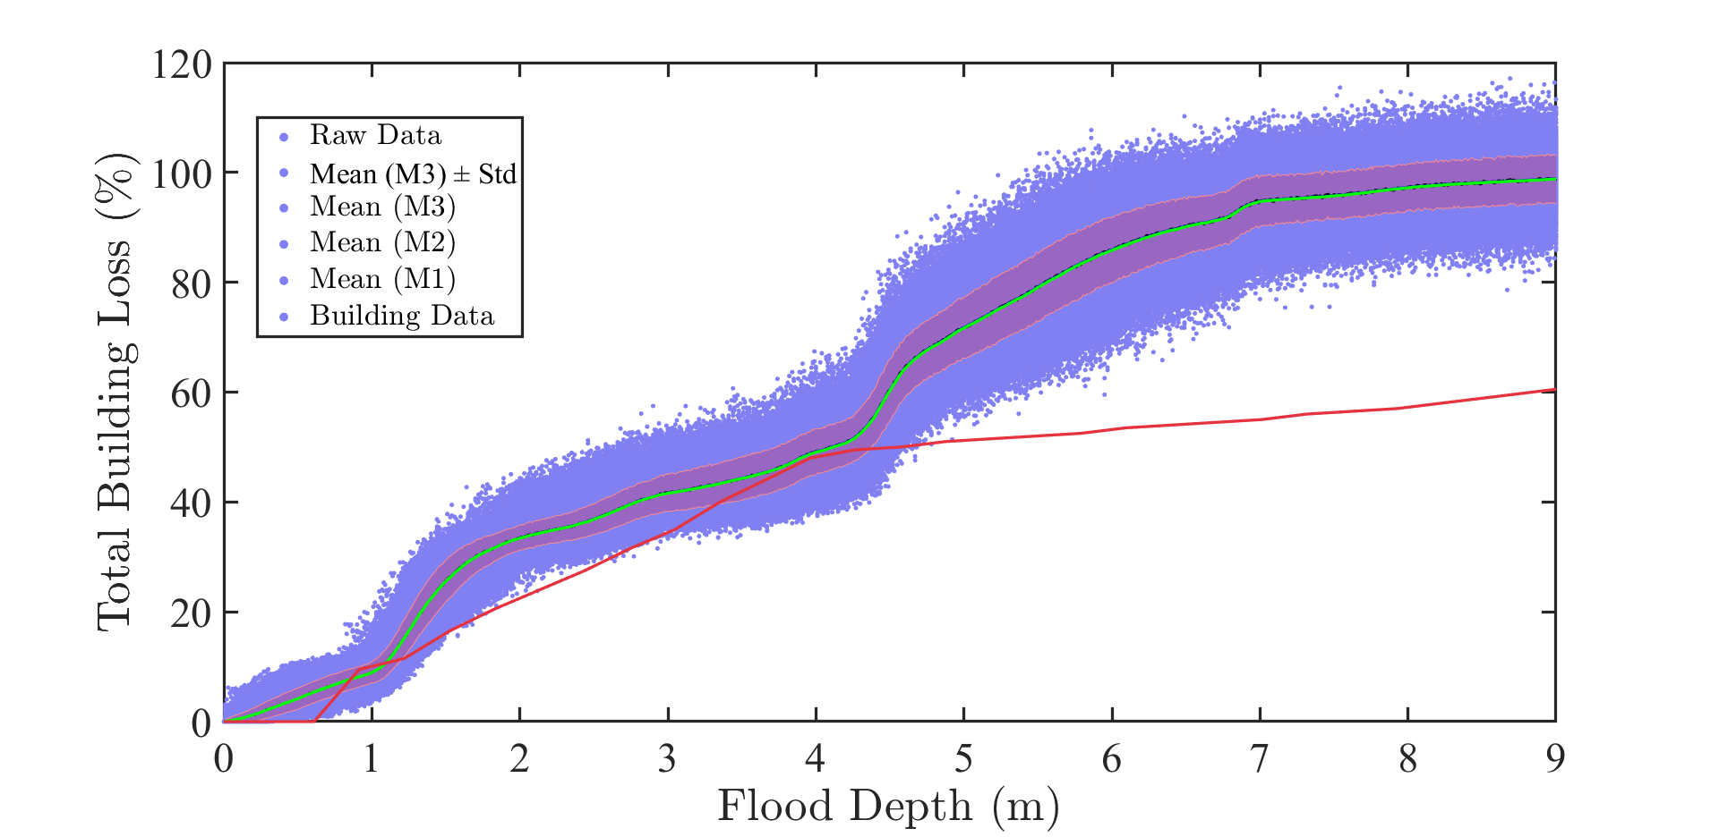
Figure 15 Total Building Loss Percentage vs Flood Depth for Different Models (M1 to M3).
Figure 16: Component Loss Across Different Building Materials Against Flood Depth
This chart contrasts, at varying flood depths, the component loss for many construction materials—e.g., drywall, wood, concrete). The simulation shows how various materials react under flood circumstances; certain materials show more resilience than others. This knowledge may direct the choice of more flood-resistant materials in building and restoration projects, therefore helping to lower the general vulnerability of structures to flood damage.
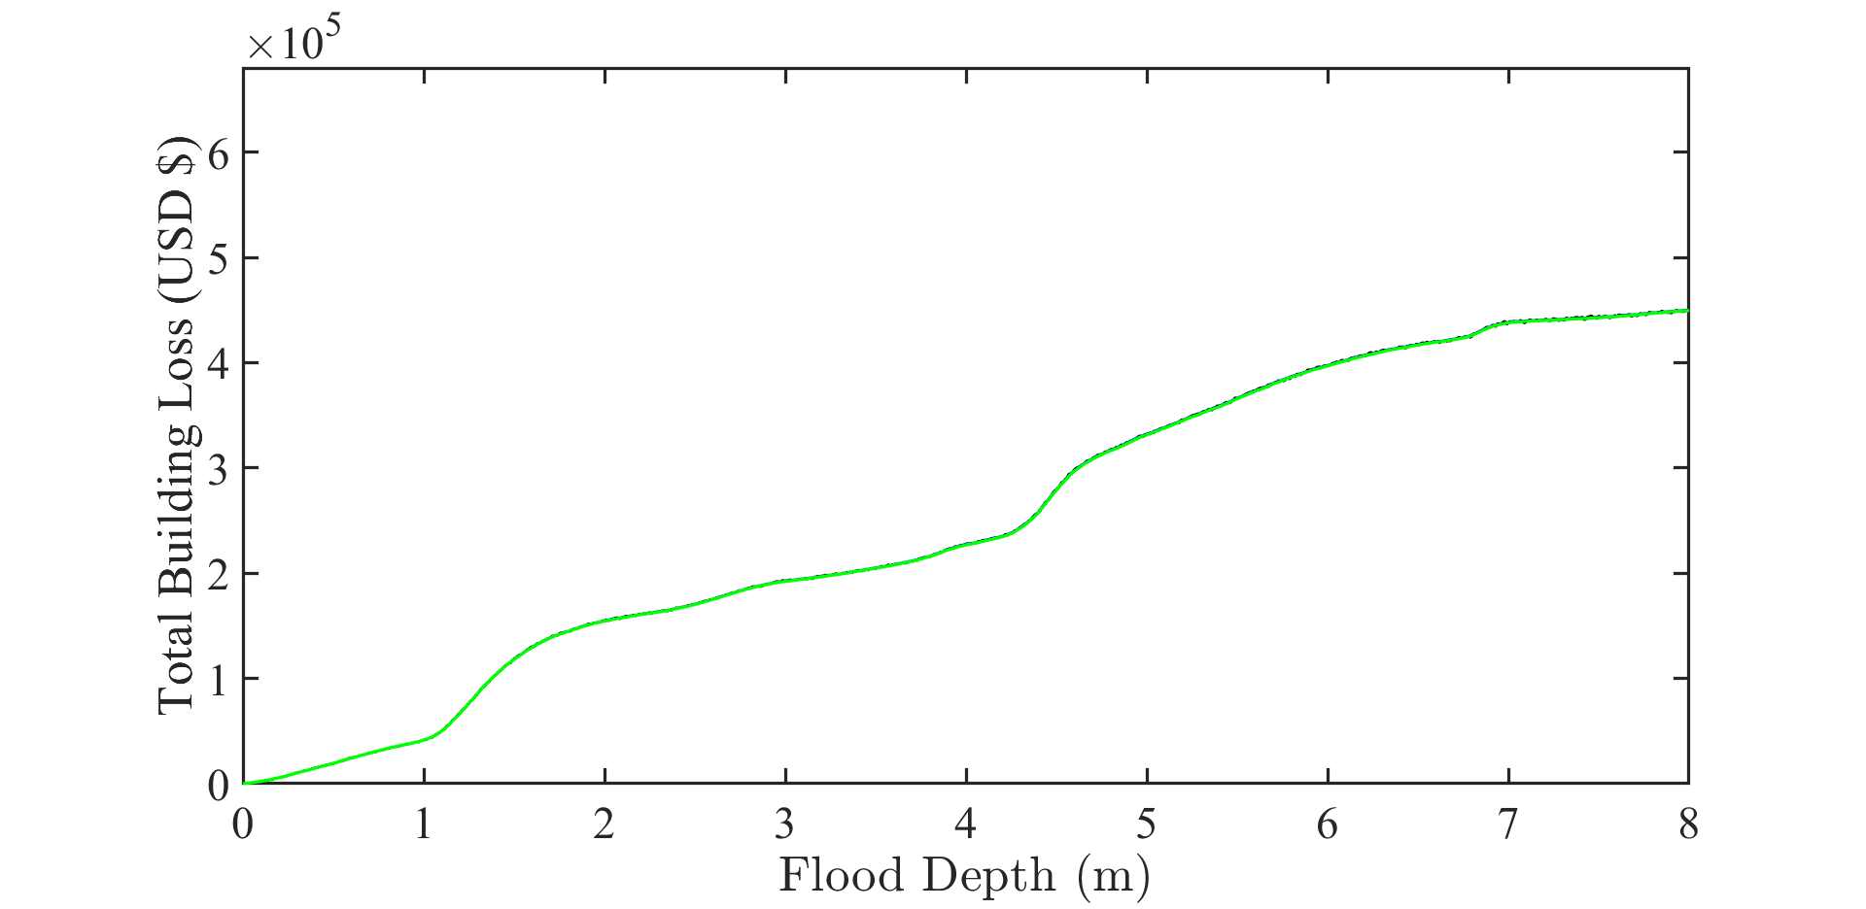
Figure 16 Component Loss for Various Building Materials vs Flood Depth.
Figure 17 shows the component losses for many building components spread over several flood depths. Simulating the failure probability and replacement prices for every component helps one to get a statistical summary of each component's contribution to total building loss. It emphasizes which parts are more likely to break and the possible financial fallout from these breakdowns, therefore guiding areas of mitigating activity.
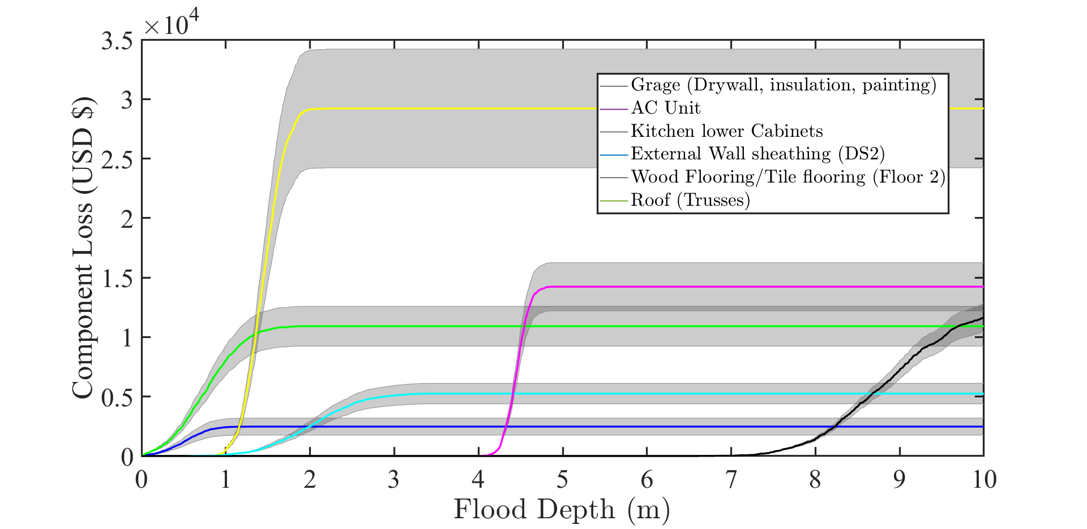
Figure 17 Component Loss Distribution for Building Components under Varying Flood Depth.

Conclusion
Emphasizing the likelihood of failure and related replacement expenses, this paper offers a thorough analysis of how flood depth influences building components. Monte Carlo models have shown success in estimating these hazards and providing an understanding of possible construction weaknesses. Future studies should look at how more modern materials and flood-mitigating techniques could be used to reduce the structural and economic effects of floods.

