**Name: Mostafa Tarek Abdelrahmen Elshat.**

**B.N: 923**

**data:4/6/2021**

**topic: Artificial Intelligence**

**application Microsoft Expression web 4**

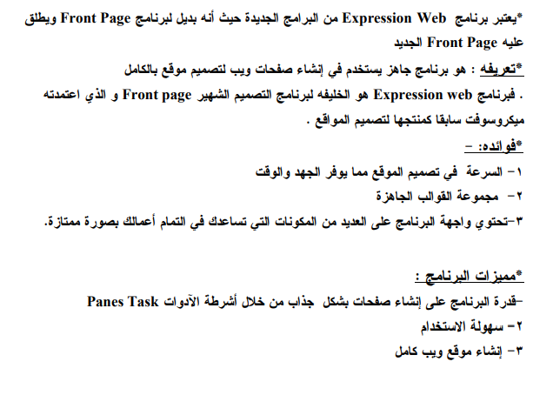

**Screen shot**

