This is a new project called CampusMap. In this project you have to use the Android Google Map and GPS. (Use Android google map API.ref: https://developers.google.com/maps/documentation/android/ )

- When you start your app, It will show a map like following. However user will not be able to zoom out/zoom in. They will only be able to scroll over the map. The zoom level of the map will be fixed such that user will be able to see the campus buildings like following.
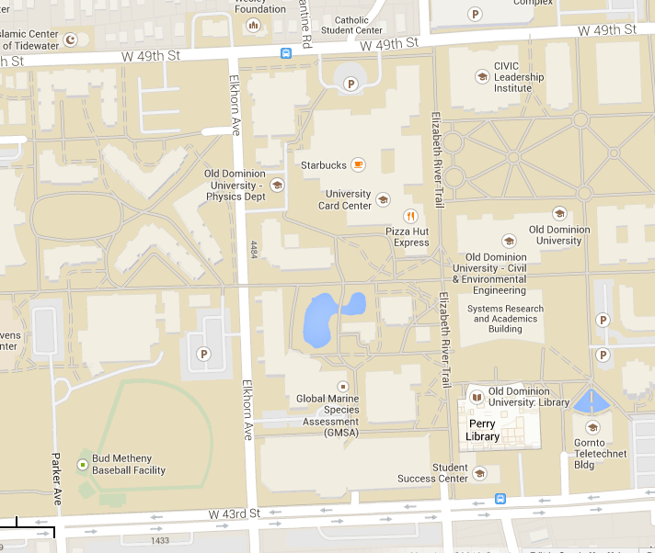
- Next you need to create a location layer at the map that will show you some of the important buildings address. You can do this by following, First, open the google map in your browser. Second, move to the map of our campus like the above picture. Finally, right click on top a campus building and click “what's here?”. Then you will get the lat/long of the building. Collect as much lat/long of the campus building you can(Select most important buildings). Then create a database or file where you will save the buildings name and its lat/long information.
- In the Initial map view activity/view there will be a option menu to see the list of campus buildings.
- In this step, user will select a building from the list of buildings you have saved in your previous step. Then show that building on the map with some anchor point. You will show the list of buildings in a separate Activity/view. After selecting a certain building you will show that building on the map.

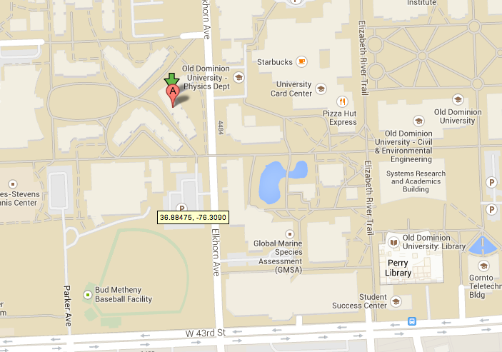
- When you will show the selected building position in the map, also show the position of the user at the map using GPS. Make the anchor point of the user location different from the anchor point of the selected building position. Whenever GPS find your location try to show it at the center(approximately) of your map view.

