# 

**Course Title: Software Project III**

**Course Code: CSE316**

**Submitted to:**

**Mr. Md. Mahbubur Rahman**

**Lecturer,** **Department of CSE, DIU**

**Submitted by:**

**Name: Mostafizur Rahman**

**ID: 221-15-5316**

**Section:61_R**

**Department of CSE,**

**Daffodil International University.**

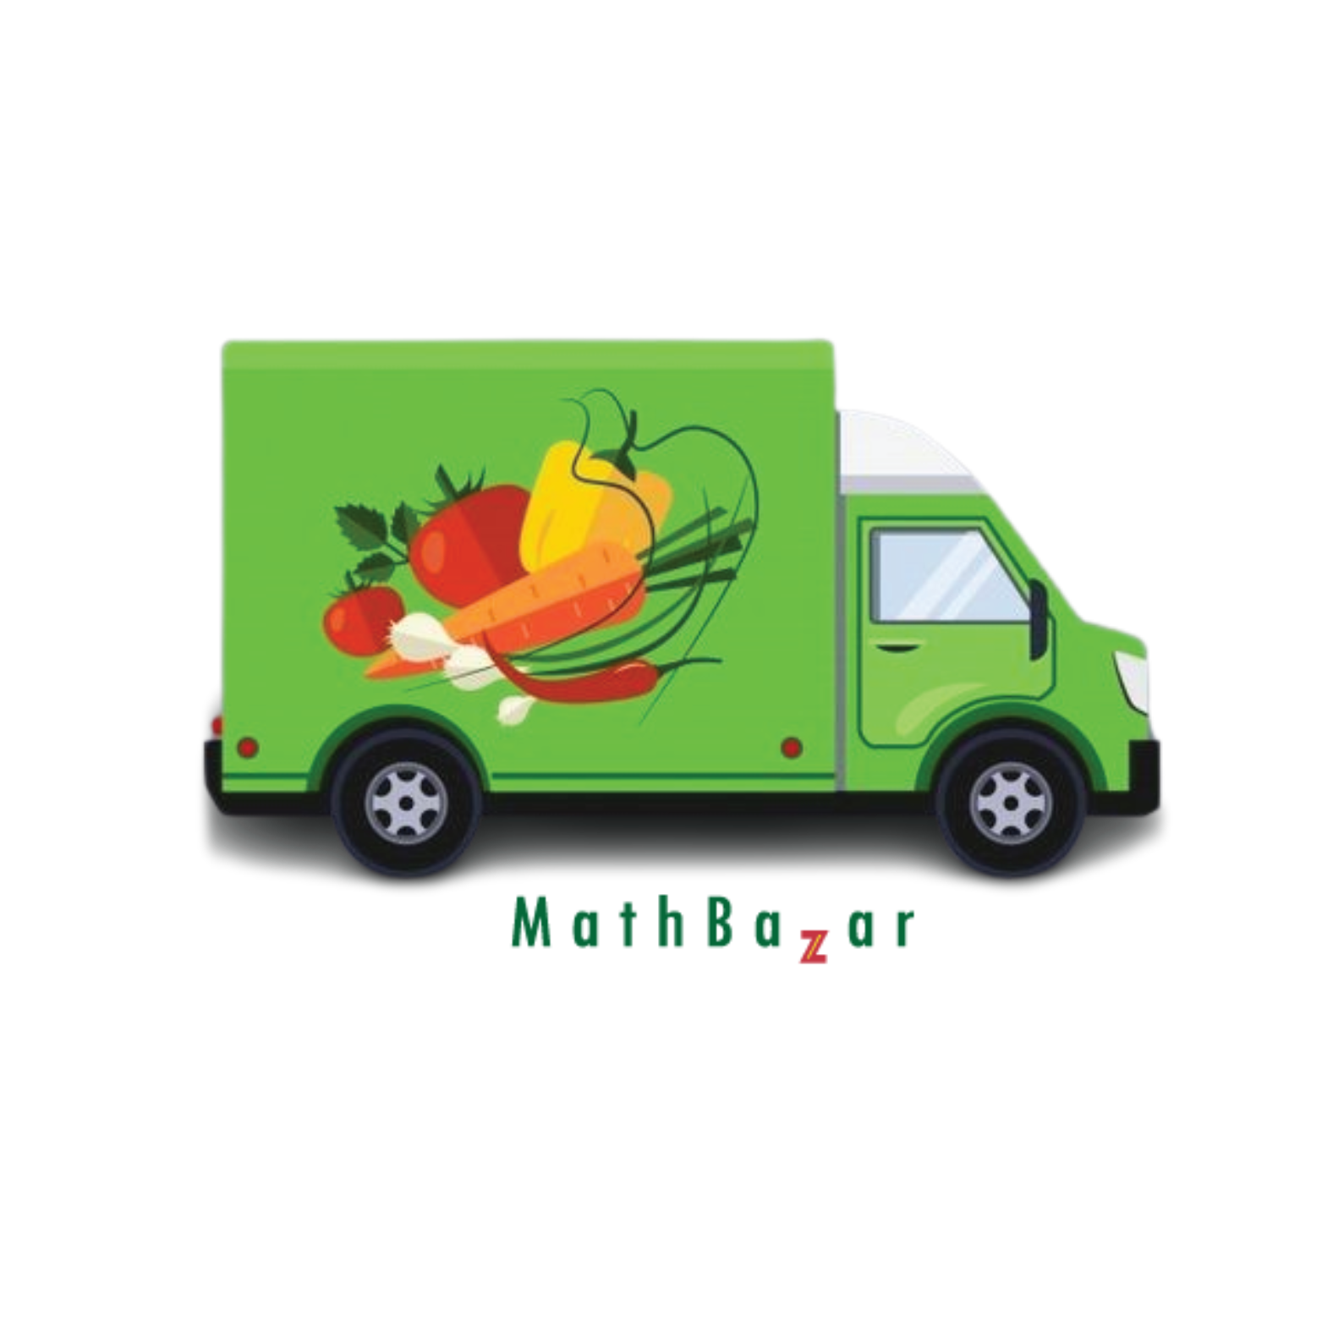

Mostafizur Rahman(221-15-5316)

Section:61_R

# **Overview:**

In the fast-paced and interconnected world of today, the need for swift and reliable delivery services has never been more critical. This is where our courier service steps in–bridging the gap between distances and ensuring that your packages, documents, and parcels reach their destination promptly and securely.

Welcome to **Mathbazar**, where efficiency meets excellence. We understand the significance of timely deliveries in both personal and business realms, and our mission is to provide a seamless and dependable solution for all your courier needs.

With a commitment to customer satisfaction and a passion for logistics, we have established ourselves as a trusted partner in the realm of transportation and delivery. From local deliveries to international shipments, we offer a comprehensive suite of courier services that is not only about moving packages from point A to point B, but also, about getting your satisfaction.

# 

# **Objectives:**

**1.Reliability:** We understand the value of your time and the importance of your shipments. Our commitment to reliability means you can trust us to deliver on time, accurately.

**2.Global Reach:**  With a well-established network and strategic partnerships countrywide, we extend our services beyond borders. Whether it is town or division across, we connect others with us through our communication system.

**3.Technology-Driven Solutions:** Our state-of-the-art tracking systems and communication tools keep you informed every step of the way. Real-time updates provide transparency and reassurance throughout the delivery process.

**4.Customized Services:**  We recognize that each shipment is unique. Our flexible and customizable services cater to your specific requirements, ensuring a tailored solution for every delivery.

**5. Customer Support:** Our dedicated customer support team is ready to assist you around the clock. Have a question or concern? We're just a call or message away.

**6. Security and Safety:**  Your trust is our top priority. We employ stringent security measures to ensure the safety of your shipments. From tamper-evident packaging to secure handling protocols, we go the extra mile to protect what matters most to you.

**7. Environmental Responsibility:** **Mathbazar** is committed to minimizing its environmental footprint. We strive to implement eco-friendly practices in our operations, from fuel-efficient transportation to sustainable packaging options.

**8. Cost-Effective Solutions:** We understand the importance of cost-effectiveness in today's competitive landscape. Our transparent pricing structure and efficient logistics management help you achieve your delivery goals without breaking the bank.

**9. Specialized Services:**  Whether you require specialized handling for fragile items, temperature-sensitive shipments, or high-value goods, we offer specialized services tailored to meet the unique demands of your cargo.

**10. Community Engagement:** At **Mathbazar**, we believe in giving back to the communities we serve. Through various community engagement initiatives, we strive to make a positive impact beyond the realm of logistics.

As your preferred courier service, we stand at the intersection of reliability, innovation, and customer satisfaction. Experience the convenience of seamless deliveries and the peace of mind that comes with entrusting your shipments to **Mathbazar**. We don't just deliver packages; we deliver promises, relationships, and the assurance that your items are in safe hands from pickup to delivery. Choose **Mathbazar** for a courier experience that goes beyond expectations.

# Why are we choosing this project:

The reason we chose this project is because of the failings and the time problems of the courier service system. Some of the courier systems are all product based and they don't get proper advertisement of the organic food. We generally serve the service frequently. That's why the others can't serve like this. Sometimes those courier services take a long time so that the product can be rotten/decomposed often. But in our company we can pay for the product’s decomposition and we ensure that products are delivered before decomposition.

On the other hand, the farmers and the sellers can advertise their products and assure their advertisements through our websites. We can easily send it to the regular customers and the retailers. Customers can choose/chase their organic products and buy those in very simple ways. If we see some online shops like Daraz Amazon Foodpanda, they created big marketplaces of grocery and raw food items through their own delivery system

But none of them provide only organic products and ensure the 100% quality of products with safety measures and return back guarantee.

And also, other companies can't make sure of the decomposition of the products so many of the people can't buy organic products by their own choice.

Bangladesh is not a small country that can send their products from east to west. like mango is a popular fruit in north bengal. The mangoes of north bengal are more tasty than the other sides. Everyone wants to eat mangoes. But in the market the seller takes a big amount or they cannot make the fruit that they want. So that there is no application or website on the basis of our country.

In our project, the main intention is to the satisfaction of the customers in our country. We can make many business ideas for more profit but the main reasons for choosing this project are to serve our people pure organic food. Personally, mango from north bengal area is the main inspiration of the project.if the projects can make a huge users then the north bengal people make a huge profit and make sure they are delivered.

Also some dishonest businessmen give false information about the product, like tasty fruit names replacing others' names. For the lack of knowledge they buy products without knowing.

**Domain:**

The domain I'm targeting is e-commerce. **Mathbazar** is an e-commerce based project. Here we can earn money by selling products by seller to consumers in different ways.

**1. Types of E-commerce:**

- Business-to-Consumer (B2C): This is the most common type where businesses sell products and services directly to consumers. In our Mathbazar we use it for our product.

- Business-to-Business (B2B): Involves transactions between businesses, such as manufacturers selling to wholesalers.in this section we need to use it because the people generally illiterate who get our agent and give them the solution. For the agent system we can use it.

**2. E-commerce Models:**

- Traditional E-commerce: The standard online retail model where customers purchase products directly from an online store.

- Marketplace: Platforms that facilitate transactions between multiple buyers and sellers. Examples include Amazon Marketplace and eBay.

- Auction: Online auctions where buyers bid for products, and the highest bidder wins. eBay is a prominent example.

**3. Key Components:**

- Online Storefront: The digital representation of a physical store where products or services are displayed.

- Shopping Cart: Software that allows customers to add products to a virtual cart as they browse.

- Payment Gateway: Enables secure online transactions by processing payment information.

- Logistics and Fulfillment: The process of packing and shipping products to customers.

- Customer Service: Support provided to customers through various channels like chat, email, or phone.

**4. E-commerce Platforms:**

- Popular e-commerce platforms include Shopify, WooCommerce (for WordPress), Magento, and BigCommerce. These platforms provide tools to set up and manage online stores.

**5. Payment Methods:**

- Various payment methods are supported, including credit/debit cards, digital wallets (e.g., PayPal), and alternative payment options like Buy Now, Pay Later services.

**6. Security Measures:**

- E-commerce businesses must implement secure sockets layer (SSL) encryption to protect customer data during transactions.

- Compliance with data protection regulations, such as GDPR or PCI DSS, is crucial.

**7. Mobile Commerce (m-commerce):**

- With the increasing use of smartphones, many e-commerce transactions occur through mobile devices. Responsive web design and dedicated mobile apps are common.(e.g, bkash, rocket)

**8. Personalization:**

- E-commerce businesses use data and algorithms to personalize the shopping experience, offering tailored product recommendations and content.

**9. Social Commerce:**

- The integration of social media and e-commerce, allowing users to buy products directly through social platforms.

**10. Local Reach:**

- E-commerce facilitates nationwide expansion, allowing businesses to reach customers nationwide.

**11. Regulations and Compliance:**

- E-commerce businesses need to adhere to regulations related to online transactions, consumer protection, and data privacy.

**12. Reviews and Ratings:**

- Customer reviews and ratings play a crucial role in building trust and influencing purchasing decisions.

**13. Emerging Technologies:**

- Artificial Intelligence (AI), Augmented Reality (AR), and Virtual Reality (VR) are increasingly used for product recommendations and enhanced shopping experiences.

**14. Subscription Models:**

- Subscription-based e-commerce models, where customers subscribe to receive products regularly, have gained popularity.

E-commerce is a dynamic and rapidly evolving industry, with continuous advancements in technology shaping the way businesses and consumers interact online. If you have specific questions or need more details on a particular aspect of e-commerce, feel free to ask!

# Reference:

The two best projects are chaldal and food panda which have a great hip in market after the corona pandemic. When people can't go outside because of the pandemic. Those services make life easy for the people. They provide great services to others and create great publicity to the country. The basic type of those project given below,

**1.** [**Foodpanda**](https://www.foodpanda.com.bd)**:**

- **Type:**  Foodpanda is primarily known as an online food delivery platform.

- **Services:**  It connects users with local restaurants and allows them to order food online for delivery or takeout.

- **Business Model:** Foodpanda typically partners with various restaurants, offering their menus on the platform. Users can browse through the available options, place orders, and have food delivered to their doorstep.

-  **Geographical Presence:**  Foodpanda operates in numerous countries globally, providing a convenient solution for those looking to order food online.

**Expected user base:** They targeted almost all the restaurants and then applied their apps to service in home to home.  
 **Traffic Patterns:** Calendars impact traffic patterns on Food panda, with surges occurring during vacation periods. Also time people are generally urgent for their for their works.

**Data Volume:** Almost all kinds of persons are the users. Mainly the all kinds of people in city life use to save the time value and vehicle cost

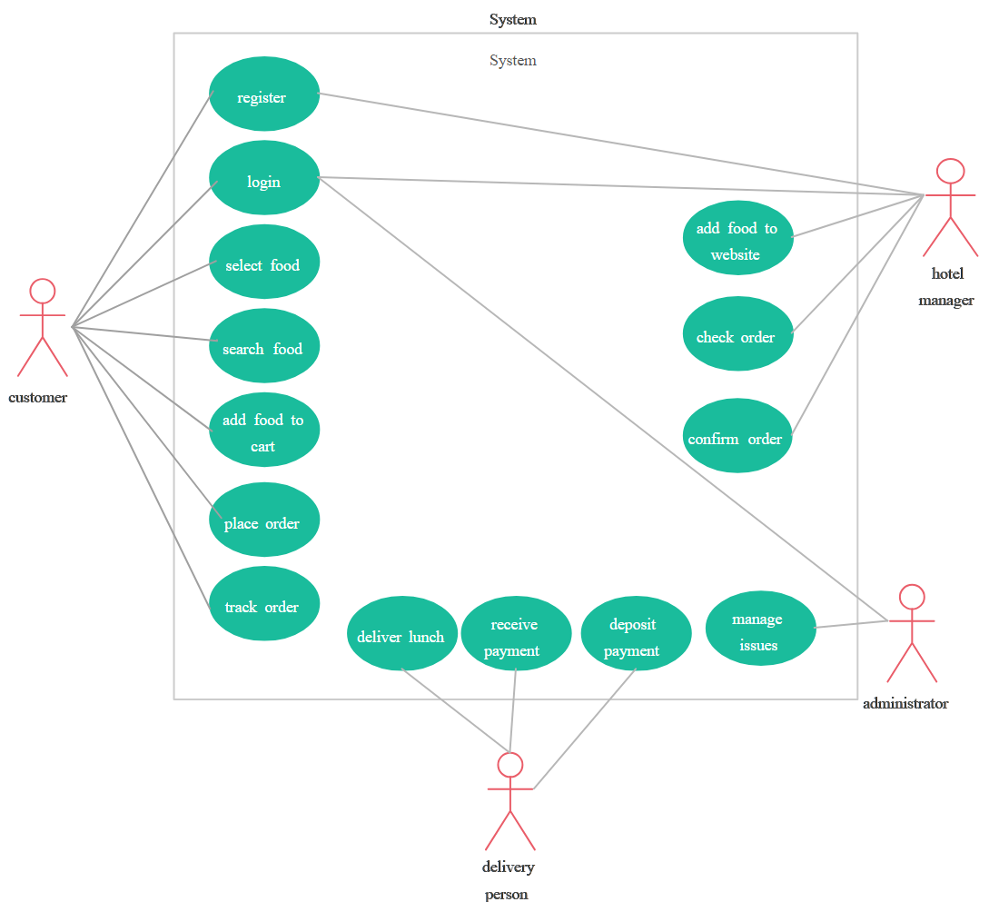

**2.** [**Chaldal**](https://chaldal.com)**:**

- **Type**: Chaldal is an online grocery and household items delivery platform.

- **Services**: Chaldal enables users to order groceries, fresh produce, household essentials, and more through their online platform. They deliver these items directly to the customer's doorstep.

- **Business Model**: Chaldal often sources products directly from suppliers and has its inventory. Users can browse through a wide range of products, add them to their cart, and schedule a delivery time.

- **Geographical Presence**: Chaldal primarily operates in Bangladesh, serving customers in cities like Dhaka. It focuses on providing a convenient way for users to shop for groceries without physically visiting a store.

Both Foodpanda and Chaldal represent the growing trend of online platforms catering to the needs of consumers by offering convenient and efficient ways to access food and groceries. These platforms leverage technology to streamline the ordering process, provide a variety of choices, and improve overall customer convenience.

**Expected user base:** They targeted almost all the glossary shops and then applied their apps to service in home to home.  
 **Traffic Patterns:** Calendars impact traffic patterns on chaldal, with surges occurring during month end and start when the family needs to buy their emergency products. Also time people are generally urgent for their work.

**Data Volume:** Almost all kinds of persons are the users. Mainly the all kinds of people in city life use to save the time value and vehicle cost

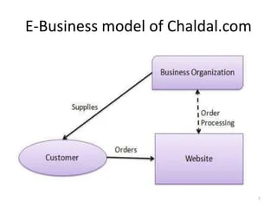

##### 

# Architectural Overview:

Django Web Application with Bootstrap 5 and SQLite3

**1.1 Project Overview**

Provide a brief overview of the project, including its purpose, goals, and target audience.

**1.2 Technologies Used**

List the key technologies employed in the project, such as Django, Bootstrap 5, and SQLite3.

**2. Project Architecture**

**2.1 Backend (Django)**Discuss the backend architecture, highlighting key components such as models, views, and templates.

**2.2 Frontend (Bootstrap 5)**

Describe how Bootstrap 5 is utilized for the project's frontend, including the layout, components, and styling.

**2.3 Database (SQLite3)**

Explain the role of SQLite3 in your project, detailing the database schema and relationships.

**3. Features and Functionality**

**3.1 Core Features**

List and describe the core features implemented in the project. For example, user authentication, data CRUD operations, etc.

**3.2 Additional Features**

Highlight any additional features or functionalities that enhance the user experience or provide added value.

**4. User Interface and Design**

**4.1 Design Principles**

Discuss the design principles followed, including user interface design considerations and user experience enhancements.

**4.2 Responsiveness**

Detail how Bootstrap 5's responsive design features are leveraged to ensure a seamless user experience across various devices.

**5. Challenges and Solutions**

**5.1 Challenges Faced**

Identify any challenges encountered during the development process, whether technical or conceptual.

**5.2 Solutions Implemented**

Describe the solutions implemented to overcome the challenges and ensure the project's success.

**6. Testing**

**6.1 Unit Testing**

Discuss the unit testing approach adopted for backend components, ensuring code reliability and functionality.

**6.2 User Acceptance Testing**

Outline how user acceptance testing was conducted to validate that the application meets the specified requirements.

**7. Future Enhancements**

Discuss potential future enhancements or features that could be added to improve the project.

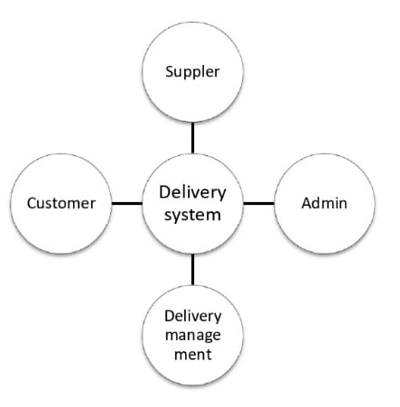

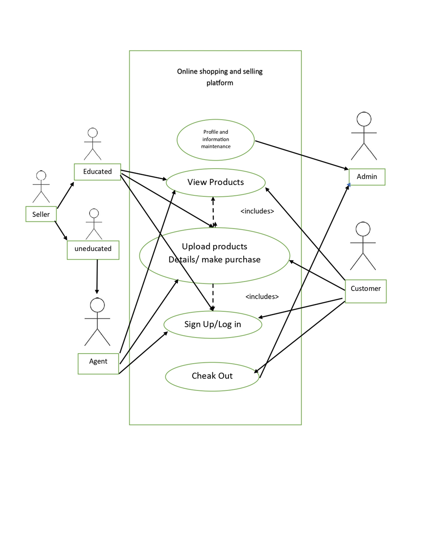

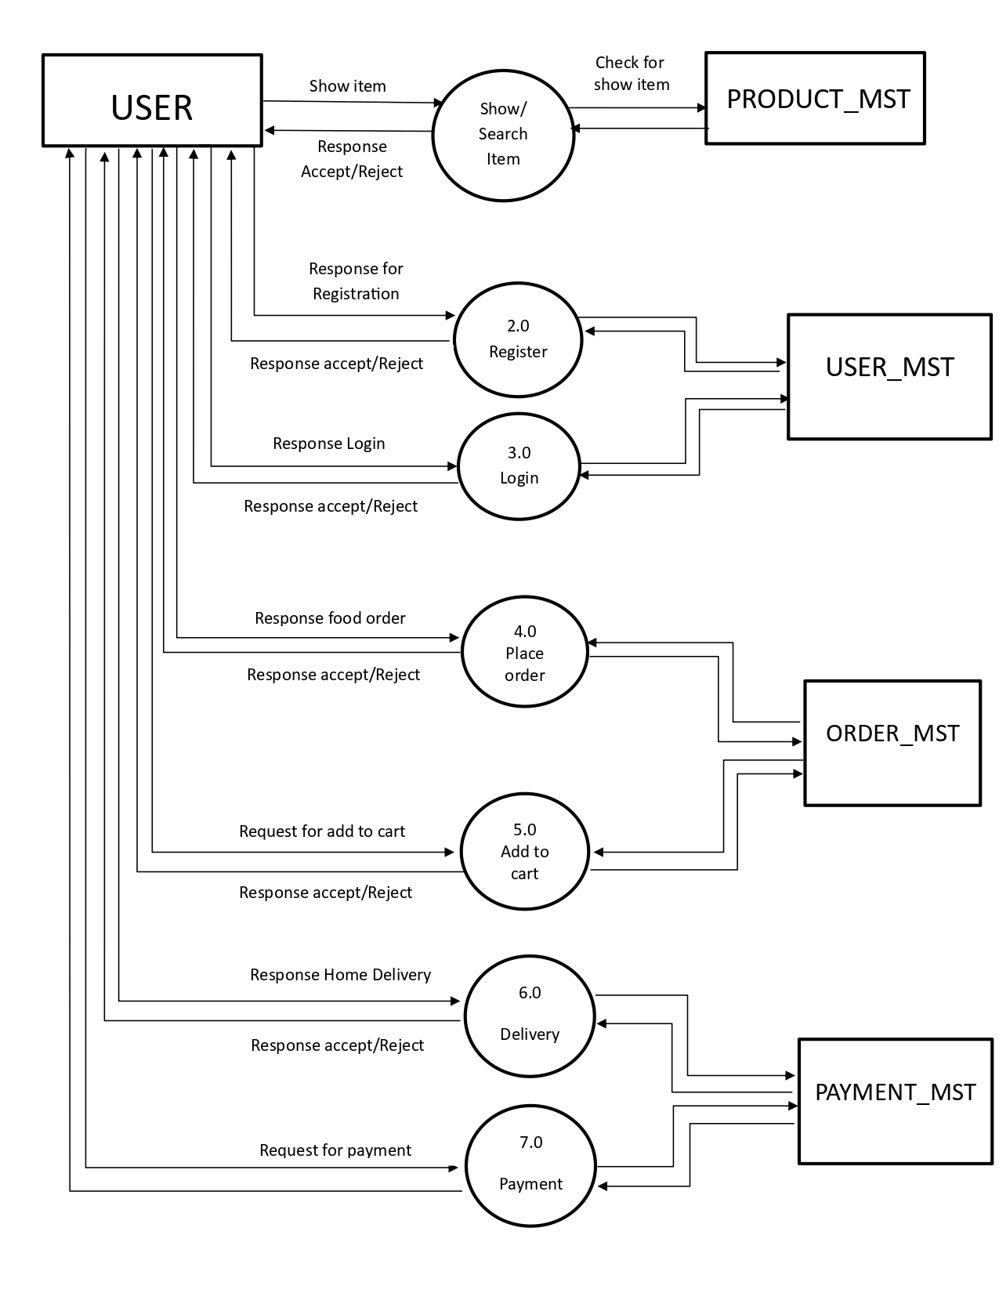

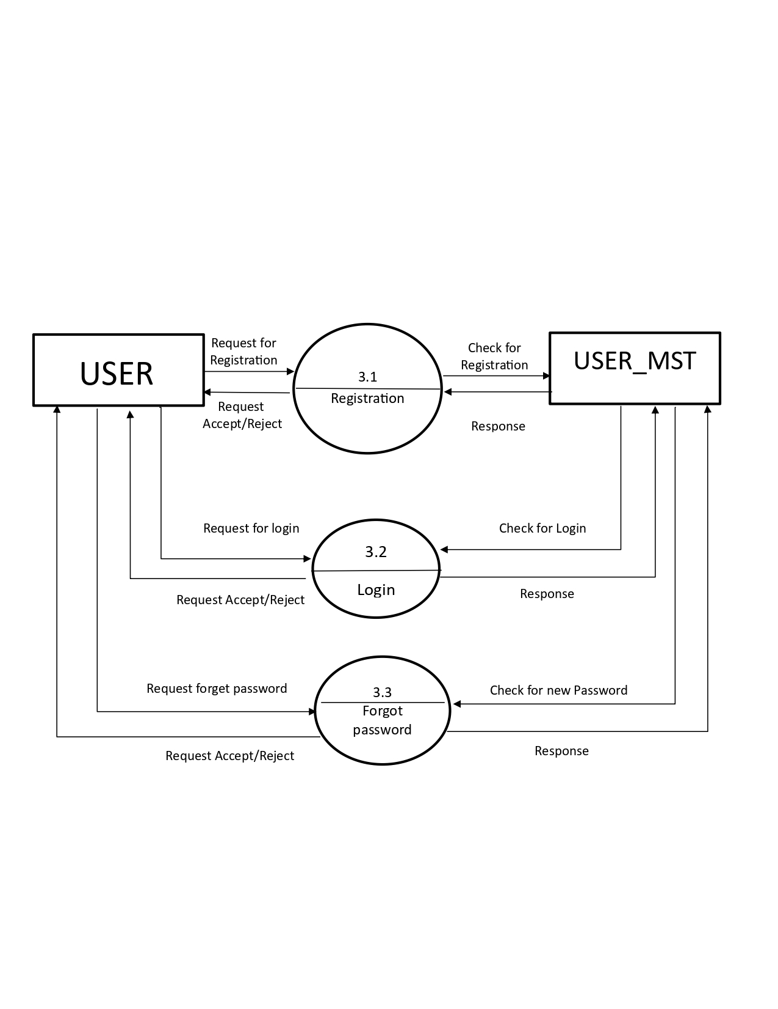

# **Why We Are Better Than Others :**

**Mathbazar** – Revolutionizing B2B Agriculture Commerce

At **Mathbazar**, we've reimagined the e-commerce landscape to specifically cater to the needs of farmers, ensuring a more efficient and mutually beneficial B2B business model. Here's why we stand out:

**Direct Farmer Connectivity:**

Unlike traditional platforms that may overlook the needs of farmers, we prioritize direct connections with agricultural producers. Our platform serves as a bridge between farmers and businesses, eliminating unnecessary intermediaries and ensuring fair pricing for both parties.

**Tailored Agricultural Listings:**

Our platform goes beyond generic product listings. We provide a specialized space for a wide range of agricultural products, allowing farmers to showcase their produce with detailed descriptions. This tailored approach facilitates targeted business transactions and better matches buyers with the specific products they need.

**Transparent and Fair Pricing:**

Transparency is at the core of our platform. We facilitate fair pricing negotiations between farmers and businesses, fostering trust and sustainability. Our commitment to fair trade ensures that farmers receive just compensation for their hard work, creating a more equitable agricultural ecosystem.

**Supply Chain Efficiency:**

We understand the importance of a streamlined supply chain in the agricultural sector. Our platform integrates smart logistics solutions, enabling farmers and businesses to track the movement of products from the farm to the buyer. This not only enhances efficiency but also reduces waste and improves overall supply chain visibility.

**Educational Resources for Farmers:**

Empowering farmers is a key aspect of our mission. We provide educational resources, market insights, and best practices to help farmers optimize their production and navigate the complexities of the market. This commitment to farmer education ensures a sustainable partnership that goes beyond simple transactions.

**Customer-Centric Approach:**

For businesses and customers alike, we prioritize user experience. Our platform is designed for ease of use, with intuitive navigation and comprehensive search features. Businesses can find the products they need quickly, while customers can be confident in the quality and origin of the agricultural products they purchase.

# **Conclusion:**

In summary, **Mathbazar** has established itself as a key player in the competitive food delivery industry. With a strong market presence, technological innovation, and operational efficiency, the company has garnered positive reviews and customer satisfaction. Financial stability, strategic partnerships, and adherence to regulations further contribute to its success.

Challenges include intense competition, the need for enhanced sustainability practices, and navigating a dynamic regulatory landscape. Opportunities lie in diversification, technology enhancement, sustainability initiatives, and customer engagement.

Strategic considerations for the company involve exploring new markets, investing in technology, implementing sustainable practices, and strengthening customer relationships. Overall, **Mathbazar** is well-positioned for continued success, provided it continues to adapt to industry trends and consumer preferences.