**Q 4 - How to store heavy structured data in android?**

A - Shared Preferences

B - Cursor

**C - SQlite database**

D - Not possible

**Q 1 - How to kill an activity in Android?**

A - finish()

B - finishActivity(int requestCode)

**C - A & B**

D - kill()

E - None of the Above

**Q 5 - What is an anonymous class in android?**

A - Interface class

**B - A class that does not have a name but have functionalities in it**

C - Java class

D - Manifest file

**Q 6 - What is log message in android?**

**A - Log message is used to debug a program.**

B - Same as printf()

C - Same as Toast().

D - None of the above.

**Q 7 - What is JSON in android?**

A - Java Script Object Native

B - Java Script Oriented Notation

**C - Java Script Object Notation**

D - None of the Above

**Q 8 - Fragment in Android can be found through**

A - findByID()

B - findFragmentByID()

C - getContext.findFragmentByID()

D - **FragmentManager.findFragmentByID()**

**Q 10 - Can a class be immutable in android?**

A - No, it can't

**B - Yes, Class can be immutable**

C - Can't make the class as final class

D - None of the above

**What is An Activity?**

Activity performs actions on the screen.If you want to do any operations, we can do with activity

**What is An android manifest file?**

Every application must have an AndroidManifest.xml file (with precisely that name) in its root directory. The manifest file presents essential information about your app to the Android system, information the system must have before it can run any of the app's code.

**What do ADT stands for?**

ADT stands for Android development tool,This is useful to develop the applications and test the applications.

**What is android SDK?**

The android software development Kit(SDK) contains the necessary tools to create, compile and package android application.

**What is ADT?**

Google provides the android Development Tools to develop Android application with Eclipse. ADT contains all required functionalities to create, compile , debug and deploy android application**.**

**Android Emulator**

The Android Emulator replicates a typical interface to your desktop machine, so that you donot need a real mobile device.

**Android Application Components type?**

Four main components:

1. Activities =UI and handle the user interaction
2. Services =handle background processing
3. Broadcast Receivers=handle communication between android OS and application
4. Content Providers= handle data and database management

**Additional Components:**

1. Fragments= Fragments is optional you can use views and viewGroups directly in a activity.
2. Views and View Group= contain all ui element
3. Layout
4. Intents
5. Resources
6. Manifest=Configuration file for the application.

**What is layout?**

Layout is ui additional component that defines what is drawn on the screen.it stored as xml file and file location res/layout resource directory.

**Various Layout Types?**

1. Linear Layout= Horizontally or vertically
2. Relative Layout= every element arranges itself relative
3. Table layout =rows and columns and same as html tale layout formate
4. Tab Layout
5. List View
6. Grid view

**Type of menus?**

1. Context Menu= appear menu list and perform a long press on a view
2. Options Menu=Menu key is pressed
3. Sub Menu=items into groups and does not support nested submenus

**What is Dialog?**

A dialog is usually small window tha appears in front of the current activity.

**Types of Dialog?**

1. Alert Dialog =extension fo the dialog class and use title, text message , one ,two or three buttons, selectable items
2. Progress Dialog=extension of the alert dialog class that can display a progress animation
3. Date Picker Dialog
4. Time Picker Dialog

**What is Adapter View class?**

The Adapter view class is a child class of view Group it container view list(List view, spinner , Gallery).

**What is Adapter ?**

An adapter object acts as a bridge between an adapter view object and the underlying data for that view.

**Types of adapter ?**

1. Array adapter
2. Cursor adapter
3. There are a few more

**Activity lifecycle?**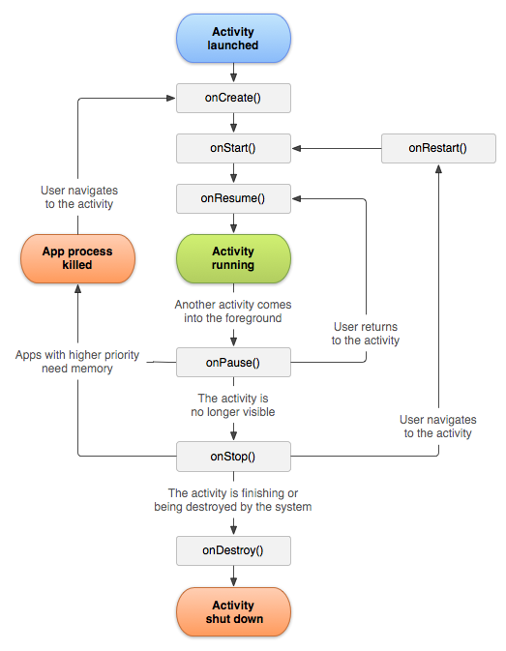

**What is Intents?**

An activity can send intents to the android system which starts another activity. Therefore intents allow to combine loosely coupled components to perform certain tasks.

**What is SQLite?**

Android provides several ways to store user and app data.. SQLite is a very light weight open source database which comes with android OS.

**SQLite supports data types?**

TEXT (java string), INTEGER(long in java), REAL( double in java)

**What is cursor?**

The SQLiteDatabase always presents the results as a **Cursor** in a table format that resembles that of a SQL database