Software Requirements Specification


Synergy Distributed Meeting
Scheduler
TEAM
Meeting ViewPoint
URL: www.utdallas.edu/~jdv052000
Team Members
Bojan Knezevic – bxk062000@utdallas.edu
Haibo Shi – hxs088000@utdallas.edu
Hector Irizarry – hector.irizarry@utdallas.edu
Junia Valente – jdv052000@utdallas.edu
Mark Huber – mah038000@utdallas.edu
Yuhan Tseng – yxt083000@utdallas.edu
Chun Du – cxd081000@utdallas.edu

Revision History
Author | Date | Description | Version
Team | 09/07/2008 | Initial version of the project plan document | 1.0
Haibo Shi | 09/13/2008 | Added functional requirements section | 1.1
Hector Irizarry | 09/18/2008 | Added non-functional requirements section | 1.2
Yuhan Tseng | 09/20/2008 | Added user interface section | 1.3
Junia Valente | 09/22/2008 | Made changes to user role section | 1.4
Team | 09/30/2008 | Document review and corrections | 1.5
Hector Irizarry | 10/14/2008 | Corrections to the 1.3 Definitions and 3.2 requirements. | 1.6
Hector Irizarry | 10/17/2008 | Add requirements several requirements to section 3.2. | 1.7
Hector Irizarry  Mark Huber | 10/18/2008 | Reviewed and corrected sections 1, 2, and 3 | 1.8
Hector Irizarry  Mark Huber | 10/18/2008 | Completed Section 3 | 1.9
Junia Valente  Yuhan Tseng  Chun Du | 10/18/2008 | Refined Non-functional requirements issues Section 4. | 2.0
Hector Irizarry | 10/21/2008 | Refined definitions and added requirement to address multiple languages settings | 2.1
Yuhan Tseng | 10/21/2008 | Added Stakeholder Section1.3, Refined issues (Pros & Cons) Section 4 | 2.2
Chun Du | 10/22/2008 | Refined issues (Pros & Cons) from issue 5 of non-requirement | 2.3
Haibo Shi | 10/22/2008 | Add non-functional requirements and some stakeholders information | 2.4
Mark Huber | 10/22/2008 | Refined and approved incremental additions of V2.5-3.0 | 3.0

Contents
1. Introduction 5
1.1 Purpose 5
1.2 Scope 5
1.3 Stakeholders 5
1.4 Definitions Acronyms And Abbreviations 6
1.5 References 9
1.6 Overview 10
2. Overall Description 11
2.1 Product Perspective 11
2.2 Product Functions 12
2.3 User Characteristics 13
2.4 Constraints 13
2.5 Assumptions And Dependencies 13
3. Specific Requirements 14
3.1 External Interface Requirements 14
3.1.1 User Interfaces 14
3.1.2 Hardware Interaction 14
3.1.3 Software Interaction 14
3.1.4 Communication Protocols 14
3.2 Functional Requirements 15
3.2.1 Administrator 15
3.2.2 Mediator role 18
3.2.3 Initiator role 18
3.2.4 User role (meeting participants) 19
3.3 Performance Requirements 22
3.4 Design Constraints 23
3.4.1 Hardware Limitations 23
3.4.2 Software Limitations 23
3.5 Software System Attributes 23
3.5.1 Reliability 23
3.5.2 Availability 23
3.5.3 Security 23
3.5.4 Extensibility 23
3.5.5 Portability 24
3.6 Other Requirements 24
4. Issues 25
5. Appendix 38
5.1 Mockup Walkthrough 38

Introduction

Purpose
This document defines and describes the functional and non-functional requirements for the SDMS. It will be use as the basis for the design phase and as a reference for development and validation stages.
The intended audience of the SRS is primarily our customer Synergy Soft Inc, and all parties interested on the design and development of the SDMS.

Scope

The overall objective of the Synergy Distributed Meeting Scheduler (SDMS) is to develop a customizable, decentralized system that allows individuals or organizations to easily, efficiently, and precisely schedule meetings in accordance with practical limitations of virtual and real-world meetings. The SDMS will be a web based application designed to support the meeting scheduling needs of an organization. It will not require a client based application; instead it will be accessible and conform to standard HTML Web Application practices. The SDMS will interface with and utilize third party resources to facilitate all of the users’ meeting scheduling needs (e.g. database services, email communication, etc.).

Stakeholders

Stakeholder | Interests
Company | The company prefers comprehensive meeting initiation and negotiation. The meeting scheduling process, and all related processes, should be intuitive, flexible, and full-featured.
Administrator | The administrator prefers a high degree of control over system data and business logic. The administrator desires detailed system accounting access for accurate logging and system monitoring.
Mediator | The mediator prefers a localized and intuitive access to the system to mediate any conflicts which arise in the process of the business logic flow regarding meetings.
User | The user prefers accurate, fast, and intuitive initiation of meetings. The user prefers to easily manage their preference sets, exclusion sets, and monitor meetings correctly. The user prefers conflicts to be solved accurately and negotiations to be kept minimal.
Synergy Inc | SynergySoft Inc. prefers a meeting scheduler system with competing market features, while the time of development cycle and amount budget is acceptable. SynergySoft Inc. also desires strong product support and maintenance after the product is release.
Development team | The development team prefers a well defined system to design and implement.
Testing team | The testing team prefers a clear and complete set of system functional and non-functional requirements to generate test cases. The test team also prefers the user operations to be as simple as possible that the tests can be executed quickly.
IT support team | The IT support team prefers the system, related web server, and database server to be efficient to deploy and maintain.

Definitions Acronyms And Abbreviations

Active participant: A user, who is also an attendee, whose role in the meeting requires them perform an action during the meeting (speaker, demo driver, etc). This user may also be asked provide requirements for equipment.

Administrator: is a privileged user who is responsible for managing user accounts, and managing resources (ex. adding or removing users, rooms, equipment, etc).

Attendee: a user, who receives a meeting invite, and is responsible for either accepting or declining the invite. In the case the invite is accepted, the attendee is required to provide an exclusion and preference set. An attendee can be furthermore classified as important or active participant.

Concurrency: the ability to handle more than one meeting requests at same time.

Confirmation: A notification sent to attendees by the initiator confirming the final meeting arrangements.

COTS: Commercial of-the-shelf. A software product that is ready-made and available for sale.

Customer: Synergy Soft Inc.

Date conflict: occurs when no available date can be found in the stated date range.

Date range: time interval specified by the initiator in which the meeting should take place, this also serves as the boundaries for the exclusion and preference sets.

Date set: a pair of input values, including calendar date and time period.

End customer: person, or organization, that buys the SDMS software.
Equipment: Any type of resource (e.g. projector, microphone, etc) that can be used in a meeting or event. They are further classified as movable or fixed. Movable equipment refers to equipment that can be transported from one location to another without requiring technician (hardware technician, electrician, handyman, etc) intervention. Fixed equipment refers to equipment that is assigned to a location (overhead projector, podium microphone, etc) wherein moving it to another location involves an installation that requires technician intervention.

Exclusion set: a set of dates on which the attendees are not available to attend a meeting.

GUI: Graphical User Interface.

Internationalization (I18N): The process of designing a software application so that it can be adapted to various languages and regions without engineering changes.

Important participant:
A user, who is also an attendee, whose attendance at the meeting is necessary for the meeting to take place. This user may also be asked to provide their meeting location preferences.

Initiator: The user who calls for the meeting. The initiator is responsible for performing the meeting scheduling activities, or to delegate an initiator representative to perform this on their behalf.

Initiator representative: A user who is delegated to act on behalf of the initiator.

Invite: A meeting request sent by an initiator or representative to the potential attendees, which includes meeting topic, date range and requires attendees to respond with their preferences regarding date. For active participants the invite will require the attendee to provide equipment requirements. For important participants the invite will require the attendee to provide location preferences.

Localization (L10N): The process of adapting software for a specific region or language by adding locale-specific components and translating text.

Mediator: A user who has privileges to schedule resources (e.g. locations & equipment). This user also is tasked with determining meeting priority in the event of an irresolvable scheduling conflict.

Meeting scheduling activities: The tasks required in order to schedule a meeting. These usually involve the following tasks: planning the meeting, sending the invites, monitoring the responses, resolving conflicts, and confirming the final arrangements.

Nomadicity: The ability to move from one location to another and start communications from any location.

Preference set: a set of dates on which the attendees would prefer the meeting to take place.

Private meeting: a meeting that concerns only to the user. The attendee’s availability is marked as unavailable in their calendar and no details are given to other users.

Professional meeting: A meeting that concerns the user’s organization. The attendee’s availability is marked as unavailable in their calendar and general information about the meeting is visible to other users.

SDMS: Synergy Distributed Meeting Scheduler

Strong date conflict: This occurs when no date can be found within the date range and outside all exclusion sets.

Strong location conflict: This occurs when there are no available locations which coincide with acceptable dates.
Time interval: a period of time with defined limits. For the purposes of the system, limits are defined in 15 minutes increments (e.g. 8:15 am, 8:30 am, 8:45 am & 9:00am)

UML: Unified Modeling Language

User: A person who interacts directly with the product. A user can have different roles with respect to the system (e.g. administrator, mediator, regular user) and meeting events (e.g. initiator, attendee, active participant, or important participant).

Virtual location: A meeting place which corresponds to a non–physical location where the meeting could take place (e.g. teleconferencing).

Weak date conflict: This occurs when dates can be found within the date range and outside all exclusion sets, but no date can be found which coincides with all preference sets.

Weak location conflict: This occurs when the available locations do not coincide with the preferred locations.

References
[1] L. Chung, “CS 6361 - Advanced Requirements Engineering,” Aug. 08. [Online]. Available: http://www.utdallas.edu/~chung/RE/Project1.pdf. [Accessed: Sept 1st, 08]
[2] D. Bell, “UML basics: An introduction to the Unified Modeling Language,” Sept. 2008. [Online]. Available: http://www.ibm.com/developerworks/rational/library/769.html. [Accessed: Sept. 1, 08]
[3] S. Azam, “Process Specification and Software Requirements Specification,” Oct 17, 06. [Online]. Available: http://www.utdallas.edu/~chung/RE/Presentations06F/T_squared_S_cubed.doc. [Accessed: Sept. 1, 08][5] A. Podelko, “Performance Requirements,” Nov. 27, 06. [Online]. Available: http://www.testingreflections.com/node/view/4432. [Accessed: Oct 22, 08]

[6] IEEE-SA Standards Board , “IEEE Recommended Practice for Software Requirements Specifications,” June 25, 98. [Online]. Available: http://ieeexplore.ieee.org/stamp/stamp.jsp?arnumber=00720574. [Accessed: Sept. 7, 08]

Overview
The rest of the document is composed of the Overall Description and Requirement Specification. The Overall Description section presents a background of the general factors that affect the product and its requirements. The Requirement Specification section defines and describes the system functional and non-functional requirements in enough detail to enable designers and testers to design and test the system so it satisfies the requirements.

Overall Description

Product Perspective
The SDMS is aimed towards organizations with frequent meeting scheduling, organization, and administration needs. The SDMS will facilitate meeting management for both traditional and distributed meeting styles to meet the needs of modern work environments.

The SDMS will be a browser based web service application. The SDMS shall be accessible by any popular web browsers such as Internet Explorer, Firefox, Opera and Safari.

The SDMS shall utilize third-party applications to facilitate its features. A database system will store and organize all existing meeting data. The SDMS will interface with the default mail client and/or specified mail server to facilitate inter-user communication. Rooms and equipment will be managed by a third-party property management system. The SDMS will interface with the property management system to schedule equipment availability.

Product Functions

User Interface
The user interface will be accessible via any standard web browser and shall mimic typical calendar scheduling software appearances to encourage ease of use for users.
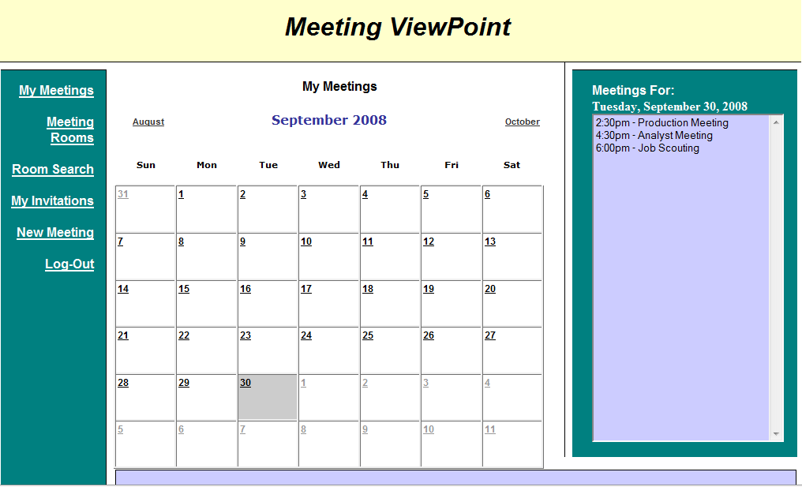
Figure 1. Meeting schedule
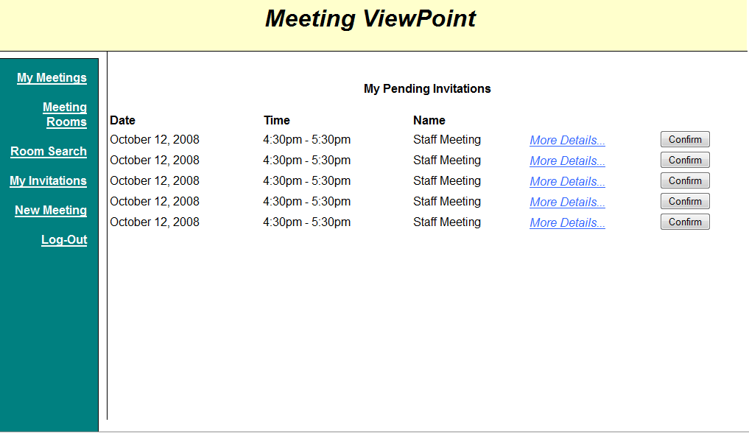
Figure 2. Pending Invitations

User Characteristics
The users shall be familiar with normal meeting scheduling activities in the real world.
The users shall be familiar with web browser operations.

Constraints
SDMS requires that every client machine is able to establish a network connection to the server.
The SDMS user support limitation is constrained by the concurrent user limitations of the web server and database server.

Assumptions And Dependencies
It is assumed that the requirements described in this document have different levels of priority.

Specific Requirements

External Interface Requirements

User Interfaces

All interaction with the SDMS will occur through a web-based interface.

The SDMS will be accessed through a secure user interface requiring the use of a predetermined login name and password.

Any unexpected system operation will be announced to the user with an error web page stating the cause of the error. In the event that a cause can not be readily determined a generic error message will be presented.

The layout of the web interface will conform to a standard screen resolution of 1024x768.

Hardware Interaction

The SDMS will interact only with the provided web server and database server. Any additional system interaction will be handled directly by the operating system and any other supporting software systems.

Software Interaction

The SDMS will interface with Microsoft SQL Server for database interactions

The SDMS will utilize Microsoft IIS 6.0 Web Server to deliver HTML content to clients

The SDMS will access Microsoft Active Directory via the LDAP protocol for user authentication.

The SDMS will provide support for communication with Microsoft Exchange Servers for email notification and calendar synchronization.

The SDMS will provide support for database interaction with a third-party property management system.

The SDMS will provide a standardized API so that third-party programs may access information programatically from the SDMS system.

Communication Protocols

The ASP.Net framework will provide systems for HTTP and HTTPS interactions with the web server.

Functional Requirements

Administrator

The system shall allow the administrator to add users given the following information:

Name

Password

Email Address

Roles

Regular user

Mediator

Administrator

Priority

Office Phone (optional)

Cellular Phone (optional)

Other phone (optional)

Address (optional)

Organization (optional)

Title (optional)

The system shall allow the administrator to modify user information of following fields:

Name

Password

Email Address

Roles

Regular user

Mediator

Administrator

Priority

Office Phone (optional)

Cellular Phone (optional)

Other phone (optional)

Address (optional)

Organization (optional)

Title (optional)

The system shall allow the administrator to remove users.

The system shall allow the administrator to add new equipment given the following information:

Name

Movable or Fixed

Location

ID

Description

The system shall allow the administrator to modify following information about an equipment location:

Name

Movable or Fixed

Location

ID

Description

The system shall allow the administrator to remove equipment.

The system shall allow the administrator to create instances of three types of locations:

Physical

Meeting room

Auditorium

Office

Other

Distributed

Virtual session

SharePoint

Cisco TelePresence

Cisco Unified MeetingPlace

Phone to dial

Custom

The system shall allow the administrator to add new physical locations given the following information:

Name

Location

Type

Capacity

Equipments (optional)

The system shall allow the administrator to modify following information from a physical location:

Name

Location

Type

Capacity

Equipments (optional)

The system shall allow the administrator to configure which of the following distributed location templates are available to the user:

Virtual session

SharePoint

Cisco TelePresence

Cisco Unified MeetingPlace

Teleconference(Phone to dial)

The system shall allow the administrator to install additional distributed location templates.

The system shall allow the administrator to remove physical locations.

The system shall allow administrators to define negotiation rules for the organization.

Mediator role

The system shall give the mediator privileges to schedule location and equipment resources.

The system shall allow the mediator to negotiate a meeting date.

The system shall allow the mediator to solve a date conflict.

The system shall allow the mediator to negotiate a location / equipment.

The system shall allow the mediator to solve a location conflict.

The system shall allow the mediator to send and receive messages from users.

Initiator role

The system shall allow the initiator to send meeting requests given following information:

Duration of the meeting

Range of dates where the meeting could be held

Main subject of the meetings

Expected participants

Expected equipments

Preferred meeting locations

The system shall allow the initiator to view the information of any meetings which they initiated.

The system shall allow the initiator to cancel any meetings which they initiated.

The system shall allow the initiator to modify any of the following information for a meeting which they initiated:

Duration of the meeting

Range of dates where the meeting could be held

Main subject of the meetings

Expected participants

Expected equipments

Preferred meeting locations

The system shall allow the the initiator to perform the following conflict resolution activities for a meeting they have initiated:

Extend date range

Request a participant to change preference set

Request a participant to change exclusion set

Change meeting type

Remove participant

Cancel meeting

Contact conflict mediator

The system shall allow the initiator to send and receive messages from users.

The system shall make suggestion for meeting date and location based on the user response(s) with consideration to the following information:

Preference sets

Exclusion set

Location preference (if any)

Equipment requirement (if any)

Meeting priority (if enforced)

For distributed meetings the system shall allow the initiator to:

View users connected to the session

remove users connected to session

Verify users’ activity status.

The system shall update the suggestion corresponding to meeting date/location after it has been proposed in the case of:

A higher priority meeting needs to be accommodated.

The system shall allow the initiator to consider specific criteria to schedule a meeting

Preference sets

Exclusion set

Location preference (if any)

Equipment preference (if any)

Meeting priority (if enforced)

User role (meeting participants)

The system shall authenticate users at the beginning each session.

The system shall allow the user to view their schedule.

The system shall notify the user of any schedule changes.

The system shall allow users to send and receive messages.

The system shall request a user response to initiator or mediator messages.

The system shall allow the user to modify the date preference set of an already submitted meeting response.

The system shall allow the user to modify the location preference set of an already submitted meeting response.

The system shall allow the user to modify the equipment requirement set of an already submitted meeting response.

The system shall allow the user to modify the date exclusion set of an already submitted meeting response.

The system shall allow the user to change the password.

The system shall allow the user to change following personal contact information:

Email address.

Work phone number

Cell phone number

The system shall allow the user to customize the following interface settings:

Language

Date formats

Time zone

Address formats

The system shall allow the user to view past attended meetings.

The system shall allow the user to search past attended meetings by any of following criteria:

name

time location

initiator name.

The system shall allow the user to view pending meetings.

The system shall allow the user to search pending meetings by any of following criteria:

name

time

location

initiator name.

The system shall show the meetings to the user in ascending time order by default.

The system shall allow users to view equipment information.

The system shall allow users to search for equipment based on the following criteria:

Name

Movable or Fixed

Location

ID

Description

The system shall allow users to search for other users by the following criteria:

Name

Email Address

Roles

Regular user

Mediator

Administrator

Priority

Office Phone (optional)

Cellular Phone (optional)

Other phone (optional)

Address (optional)

Organization (optional)

Title (optional)

The system shall allow users to view other users’ information.

The system shall allow users to search for physical locations based on following criteria:

Name

Location

Capacity

Equipments (optional)

The system shall allow user to specify custom meeting locations.

The system shall allow users to view location information.

The system shall allow users to search for available distributed location templates(if any).

The system shall allow users to view information concerning the available distributed location templates(if any).

The system shall allow the user to specify an ascending or descending sorting order when viewing meetings:

Name

time location

initiator

The system shall notify all involved participants if any the following information about the meeting is modified:

Date of the meeting

Time and duration of the meeting

Location of the meeting

Subject of the meeting

participants of the meeting

Important details of the meeting

The system shall allow users to act on behalf of another user :

Schedule a meeting

Respond to meeting requests

Attend meetings

The system shall allow users to designate a delegate that will perform the following operations :

Schedule a meeting

Respond to meeting requests

Attend meetings

Performance Requirements

The SDMS web application shall add no more than 5 seconds of perceivable overhead time to any necessary web and database transaction time.

In the event the complete SDMS transaction requires longer than 5 seconds, the system shall display an informational messages requesting they continue waiting for a response. [6]

In the event the complete SDMS transaction takes more than twice the expected duration,derived from empirical data (system characterization), for a given type of transaction, the SDMS will inform the user that the transaction has failed.

Design Constraints

Hardware Limitations

The SDMS hardware limitations are defined by the limitations of its support web server and database server.

Software Limitations

The SDMS software limitations are defined by the limitations of its support web server and database server.

Software System Attributes

Reliability

The SDMS should store and retrieve information accurately as provided by the user.

In the event a user’s session times out, any task which requires future dependent information shall be cancelled.

Availability

The SDMS availability is constrained by the availability of the web application server, database server, and other supporting software servers.

Security

The SDMS shall utilize HTTPS communication to ensure data confidentiality.

User authentication and privileges are defined outside the scope of the SDMS by the Microsoft Active Directroy Server.

Personal information security is defined outside the scope of the SDMS by the database server.

Users shall be required to log into the system for all operations except the operations on the login page.

The system shall restrict the user's operation within its user role.

Extensibility

The SDMS will provide an API to allow third-party developers to extend the abilities of the SDMS and include it into their own program.

The system shall support I18N and L10N by configuration files and lanaguage package files.

Portability

The system shall run on Windows Server 2003.

The system shall be compatible with IIS6.0 and above or Apache 2.0 and above.

The system shall conform to HTML standards and therefore support different web browsers including, but not limited to Internet Explorer, Firefox, Opera and Safari.

Other Requirements

Issues

Issue: 1a | Clarification is required for “accurately monitored details”
Criteria: | Ambiguity, incompleteness
Options: | - All participants will get an immediate update notice when any modification is done to a meeting date, location, resources.  - Pros:  Participants will be able to have current meeting editing and an update notice at the same time without having any unfriendly changes.  - Cons:  Participants might ignore the update notice accidentally.  - Participants view will be refreshed immediately when any modification is done.  - Pros:  Participants’ page will be immediately renewed and contain the newest up to date information.  - Cons:  Participants may lose the current information they are editing.  - When a meeting is held, all participates connected virtually (through web conferencing for example) should receive updates in real time via the supported teleconferencing interface.
Resolution: | 1 & 3
Justification: | An update notice without changing user’s current view is a more friendly way. Having the virtually connected meetings respond in time is a key element as well.
Reference: | “A meeting should be accurately monitored, especially when it is held in a virtual place.”

Issue: 1b | Requires clarification of what the word nomadicity means. What is the relationship between nomadicity and accurately monitoring?
Criteria: | Ambiguity, incompleteness
Options: | - Participants shall be able to connect virtually to a meeting or schedule system from anywhere in the world using a web-based system. Virtual meeting sessions shall be closed if no participants are connected, and shall expire if the session stays inactive for a period of time.  - Participants will not be able to moving from one location to another and stay connected to a meeting presentation.
Resolution: | 1
Justification: | Consider the definition of the word nomadicity to be the capacity to move from one location to another and start communicating.
Reference: | “A meeting should be accurately monitored, especially when it is held in a virtual place. Here, nomadicity will then be important to consider;”

Issue: 2 | Further clarification of “dynamically” and “flexibility” is required.
Criteria: | Ambiguity
Options: | Flexibility  - Each participant should be allowed to select time preference sets and exclusion sets.  - Each participant should be allowed to indicate what location is better for him/her and what resources might be needed.  - Interface for planning a meeting should be simple to navigate.  Dynamically  - Participants should be allowed to modify date preference set of an already submitted meeting response as many times as needed before a date is set.  - Only the initiator should be allowed to modify previous defined resources, and location of the meeting. Once a participant selects a date range, only the initiator shall be able to modify it.
Resolution: | 1,2,3, 4
Justification: | User’s preferences are considered and options are given to enhance the flexibility.
Reference: | “Preplanning of a meeting should be done as dynamically and with as much flexibility as possible”
.

Issue: 3 | Further clarification of “minimal interaction” is required.
Criteria: | Unverifiable, Ambiguous
Options: | - Maximal numbers of messages for each participant shall be defined to keep the minimal interaction. ( up to 5 messages for each meeting should be allowed for each participant for example)  - Templates or patterns of email should be standardized including only what kind of conflict and possible resolution.  - Pros:  Templates can assist users clearly clarify the problem.  - Cons:  Users’ responds and descriptions are limited.  - Participants should be able to freely describe conflict without following provided template.  - Pros:  Users are allowed to describe their problems in a more detail manner.  - Cons:  Users may spend time arguing instead of solving problems.
Resolution: | 1,2
Justification: | It is important to structure the meeting negotiation system and to limit the process so that it may be submitted for a higher form of mediation in an orderly manner.
Reference: | “The amount of interaction among participants (e.g., number and length of messages, amount of negotiation required) should be kept minimal”

Issues: 4 | Can productivity gains be clearly measured?
Criteria: | Unverifiable
Options: | - Compare our system’s performance with currently available systems  - Conduct simulations with/without the system to analyze time performance under different criteria. For example, manually communicate with all participants via phones and then use the system to communicate with all participants internet and compare amount of the time it took to negotiate a meeting.  - Pros:  Time factor with/without the system is analyzed which shows the system’s profit clearly.  - Cons:  There’s no comparison between our system’s and currently available systems’ performance.
Resolution: | Option 1
Justification: | While it requires the company to study how long usually takes to plan a distributed meeting, and the study will have to take in to account the amount of participants, physical location of each participant, connection availability and computer literacy of users, It will provide the most effective metric for gauging system contributions.  A clarification on how much the planning time needs to be reduced (a quantitative qualifier) is required.
Reference: | “The intended system should considerably reduce the amount of overhead usually incurred in  - organizing meetings where potential attendees are distributed over many different places and  - communicate with each other, for example, via Internet;”

Issues: 5 | Additional information is required to define “typically managed”
Criteria: | Incompleteness
Options: | - Requires a study of the business rules of a significant sample of the potential customers.  - Define what typically managed means by looking into different existing systems. The new system shall reflect to basic features that other scheduling meeting systems have.  - Pros: Can guarantee the system at least has some features like current scheduling meeting system  - Cons: May involve into some drawbacks of current system as well.  - Some new features may be needed to really manage meetings. E.g. create a mediator role.  - Pros: can reduce the conflict and control the scheduling better.  - Cons: Involves into more human labor
Resolution: | Option 1, 2, 3
Justification: | All options are necessary to accurately define “typically managed”.
Reference: | “The system should reflect as closely as possible the way meetings are typically managed (see the domain theory above);”

Issues: 7 | Additional information is needed regarding “as much decentralized requests as possible”.
Criteria: | Incompleteness
Options | - Could mean that the systems can be accessed through different devices such as computer, cell phone, PDA, etc.  - Pros: Multi-platform increases the mobility and applicability of the system.  - Cons: Greatly increase the difficulties to develop the system. It may also lead to other problems such as security.  - Multiple participants can request a meeting concurrently.  - Pros: Increase the efficiency for user to request meetings.  - Cons: Increase the conflicts of resources.  - The meeting can be scheduled from different locations.  - Pros: Increase the applicability and efficiency for manage the meeting.  - Cons: may lead to security problems.
Resolution | Option 2 & 3
Justification: | A decentralized system should be used at different locations by multiple users at same time.
Reference: | “The system should accommodate as much decentralized requests as possible; any authorized user should be able to request a meeting independently of her whereabouts”

Issues: 8 | What details should be included in “physical constraint”?
Criteria: | Incomplete
Options | - A person may not participate in two meetings at the same time virtually  - A person may not be physically at two different places at the same time.  - A meeting room may not be allocated to more than one meeting at the same time  - Equipment may not be used in two different places at the same time.  - Number of attendant can’t exceed the room capacity.
Resolution | Options 1, 2, 3, 4, 5
Justification: | Options 2 to 5 are restrictions according to real-world experience. But for the option 1, it can be considered if customer wants, because one can attend a meeting virtually at same time.
Reference: | “Physical constraints should not be broken - e.g., a person may not be at two different places at the same time; a meeting room may not be allocated to more than one meeting at the same time; etc.”

Issues: 9 | Quantitative information is required for “appropriate level of performance”
Criteria: | Ambiguity
Options | - System shall give out a higher bound for the elapsed time between the submission of a meeting request and the determination of the corresponding date/location, and for the elapsed time between the determination of a meeting date/location and the communication of this information to all participants concerned.  - Pros: more efficient and convenient.  - Cons: not as quite flexible.  - Initiator shall set up the higher bound for these two kinds of time in option 1 instead of system, but system shall still give out a recommended time to initiator.  - Pros: more flexible. Initiator can manage the meeting better.  - Cons: involve more human labor.  - Set up lower bound for the time.  - Pros: more time to prepare a meeting  - Cons: low efficiency.
Resolution | Option 1
Justification: | Performance constraints should be limited system definitions, human interaction should play no part in determining performance.
Reference: | The system should provide an appropriate level of performance:  - the elapsed time between the submission of a meeting request and the determination of the corresponding date/location should be minimal; or  - the elapsed time between the determination of a meeting date/location and the communication of this information to all participants concerned should be minimal; or  - a lower bound should be fixed between the time at which the meeting date is determined and the time at which the meeting is actually taking place;

Issue: 10 | This issue has been deprecated in V 2.9 of the SRS document.
Criteria:
Options:
Resolution:
Justification:
Reference:

Issue: 11 | This issue has been deprecated in V 2.9 of the SRS document.
Criteria:
Options:
Resolutions:
Justification:
Reference:

Issue: 12 | Clarification and an accurate metric for “flexible” are required.
Criteria: | Incomplete, Ambiguity
Options: | - System shall monitor the changes of the information of the users and update them automatically in a certain time interval.  - Pros: lower system resources occupation  - Cons: may lead to conflicts during scheduling meetings.  - System shall monitor the changes and update them immediately  - Pros: keep consistency of the system on real time.  - Cons: higher system resources occupation
Resolution: | Option 1
Justification: | Option1 is necessary to keep consistency of the system.
Reference: | “The system should be flexible enough to accommodate evolving data - e.g., the sets of concerned participants may be varying, the address at which a participant can be reached may be varying, etc.;”

Issue: 13 | A clear definition of how extensibility is to be implemented is required.
Criteria: | Incomplete, Ambiguity
Options: | - Predefined rules to support later modifications  - Follow formal conventions and detailed documentation for future reuse in other contexts
Resolution: | Option 1& 2
Justification: | Follow particular rules and document can help the system be easier for modification and reuse.
Reference: | “The system should be easily extensible to accommodate the following typical variations:  - handling of explicit priorities among dates in preference sets;  - handling of explicit dependencies between meeting date and meeting location;  - participation through delegation - a participant may ask another person to represent her/him at the meeting;  - variations in date formats, address formats, interface language, etc.; and  - Partial reuse in other contexts - e.g., to help establish course schedule.”

Issue: 14 | What will be the environment for the SMDS?
Criteria: | Ambiguity, Incompleteness
Options: | - The user can freely create accounts. (e.g. Google Calendars)  - Pros:  Users are allowed to create account freely which is the key element when applying under open environment.  - Cons:  Users’ ranks are limited at the same level. The priority issue between users shall not be considered.  - Users exist within an organization and an administrator will create the accounts.(e.g. Lotus Notes)  - Pros:  Attribute of different rank level can be assigned to user through administrator. Rank level can be used to identify user’s importance.  - Cons:  Requires significant administrator intervention
Resolution: | Option2.
Justification | In order to satisfy the priority functional requirement. If users are allowed to create their own accounts they can abuse of the priority feature. Most of our potential customers need the system to schedule meeting in a professional environment therefore the most profitable target customer are organizations.
Reference: | “to take some external constraints into account after a date and location have been proposed - e.g., due to the need to accommodate a more important meeting. here, the original meeting date or location may then need to be changed; sometimes the meeting may even be cancelled”

Issue: 15 | It is impossible to schedule a meeting that satisfies both early and convenient.
Criteria: | Conflicting
Options: | Convenient date/location: Defined as belong to the greatest number of preference set and preferred locations.  Early date: Defined as the first date that the meeting could be held within the date range all participants can attend.  - Choose the most convenient  - Pros:  Most participants should be able to participate the meeting.  - Cons:  The scheduled meetings related to critical issues might be seriously delayed due to having the most convenient date at the end of a date range.  - Choose the earliest date  - Pros:  Issues can be solved quickly by having the meeting as soon as possible.  - Cons:  The meeting might end up with a low attendance rate.  - Give the user the option to choose the want he prefers.  - Pros:  User should be able to balance between early and convenient date depends on his/her need.  - Cons:  If user is unaware of meeting’s importance, he/she might inappropriately set the meeting to an inefficient choice.
Resolution: | Option 3
Justification: | Provide more flexibility. The user can choose according to his immediate need.
Reference: | “The meeting date and location should be as convenient as possible, and available as early as possible, to all (potential) participants;”

Issue:16 | To what extent should support be provided for distributed meetings?
Criteria: | Incomplete, ambiguity
Options: | 1) System should provide predefined templates to describe virtual location for typical virtual meeting using COTS products.  2) It is up to the user to provide the required information.  3) It is up to the administrator to provide support.
Resolution: | 1
Justification: | Adds values to the system.
Reference: | “Monitor meetings, especially when they are held in a distributed manner;”

Issue:17 | If two meetings have the same priority, how do you decide which one receives preference?
Criteria: | Ambiguity, Incompleteness
Options: | - Quit negotiation after a user-define number of attempts  - Pros:  A warning will be issued early to notify all Participants for unsolved conflict.  - Cons:  Conflict is still unsolved.  - Create a mediator role that will decide which meeting gets the slot.  - Pros:  Conflicts can be quickly solved by mediator based on his/her experience.  - Cons:  Mediator should be familiar with processing meeting issues and resources.
Resolution: | Option 2.
Justification: | Option 1 in many cases does not result in a viable solution. Option 2 will always result in a viable solution even though human intervention is required.
Reference: | “to take some external constraints into account after a date and location have been proposed - e.g., due to the need to accommodate a more important meeting.”

Issue:18 | This issue has been deprecated in V 2.9 of the SRS document.
Options
Justification
Resolution:
Reference:

Issue:19 | This issue has been deprecated in V 2.9 of the SRS document.
Options:
Justification
Resolution:
Reference:

Appendix

Mockup Walkthrough

(Next Page)

