Multi-class Classification of Different Stages of Alzheimer’s Disease With Brain MRI Data Through Deep Learning and Transfer Learning

Monjur Hasan
Department of Electrical and Computer Engineering
North South University
Bashundhara, Dhaka-1229
monjur.hasan@northsouth.edu
Muhtasin Mashrur Adit
Department of Electrical and Computer Engineering
North South University
Bashundhara, Dhaka-1229
muhtasin.adit@northsouth.edu
Mostak Ahamed
Department of Electrical and Computer Engineering
North South University
Bashundhara, Dhaka-1229
ahamed.mostak@northsouth.edu
Mohammad Monirujjaman Khan
Department of Electrical and Computer Engineering
North South University
Bashundhara, Dhaka-1229
monirujjaman.khan@northsouth.edu

Abstract— The major base of dementia, bounden for around 60%-80% among entire instances of the condition. Above 55 million individuals in the world are already struggling with dementia, and about 10 million new cases are discovered each year. It has such a negative influence on the brain that patients eventually lose many other cognitive functions as well as their independence in everyday life. There are several available systems, but they are limited to a single location and a higher education level, meaning that these solutions will be prejudiced against people from other regions and with lesser education levels. Furthermore, the accuracy of these procedures in identifying Alzheimer's disease in people with diverse diseases is not the best. The goal is to create an efficient model that is not demographically biased and has a high degree of accuracy that can be used to distinguish between Alzheimer's disease and even several illnesses. Because our method uses data from many locations, it will be significantly less demographically biased. The model will be more accurate in detecting Alzheimer's disease and other disorders. Even with different locations and education levels, our model will outperform other dementia-causing diseases in multi-classification. The model works well on people from diverse areas rather than only those from the datasets that were used to train the algorithm. AD identification is significantly more difficult than it appears in multi-classification. Our model is a positive step forward. Overall, the model outperforms other current models for detecting Alzheimer's disease and a variety of other disorders. In the model, the goal of becoming less demographically biased has been shown to be beneficial. Among them our proposed model got 97.53% Validation Accuracy.
Keywords— Alzheimer, CNN, Inception V3, Transfer learning, MRI, Early Detection, Dementia, Mild Demented, Healthcare, Data preprocessing.

Introduction
As technology advances, we are gaining access to solutions to a variety of challenges. All credit belongs to the dedicated folks who work tirelessly to make human life simpler. A few good books on Alzheimer's Disease exist. In a study, using ML and a fine-tuned SVM model, achieved 92% accuracy [1]. In another study, researchers used a combination of CNN and EL (Ensemble Learning) to distinguish between AD (Alzheimer's Disease) and HC (Cognitively Healthy) or CN (Cognitively Normal), MCIc (Mild Cognitive Impairment patients who would become AD), MCIc and MCInc (MCI stage what should not become positive) and HC. In each of the situations, they obtained around 84%, 79%, and 62% [2]. The MCI and CN (Cognitively Normal) groups were distinguished using 3D sMRI (structural Magnetic Resonance Imaging) of the whole human brain. In the CADDemantia Challenge, they earned 52.3% accuracy [3]. People have obtained outstanding results using CNN architectures that have 93.61% and 95.17% accuracy results for 2D and 3D picture data while undertaking multi-classification for distinct and distinct stages [4]. Among them, our proposed model got a 96.53% validation accuracy.
Alzheimer's disease (AD) is a long-lasting, irreversible neurological condition that causes forgetfulness, cognitive decline, and a loss of numerous other mental abilities over time [5]. The most common cause of dementia, accounting for 60% to 80% of cases, is Alzheimer's disease (AD). A neurodegenerative form of dementia called Alzheimer's disease (AD) begins from the stage of mild cognitive impairment (MCI) and become negative over time. It causes brain cell disruption, memory loss, cognitive decline, and difficulty doing everyday tasks. As a result, Alzheimer's disease is an advanced, complex neurological brain condition. AD is more likely to develop in MCI patients than in healthy controls. Because Alzheimer's disease starts two decades or more before symptoms occur, people only see its effects after years of brain changes. Alzheimer's Disease International says that above 500 lakhs individuals in many countries suffer from dementia. The level of described ratio is expected to rise to 152 million by 2050, implying that one out of every three individuals will get dementia.
The projected yearly expenditure of oscitancy is $1 trillion. It seems like it will be quadruple by the year 2030 [6]. The proportion of people afflicted by Alzheimer's disease changes with age. In 2020, there will be 5.8 million Americans aged 65 and more in the USA. It is anticipated to reach a total of 13.8 million by 2050 [6]. This rate is not only frightening, but it also represents a significant impediment to the global health situation. WHO (World Health Organization) has expressed concern about this issue multiple times in the past few years. This issue is not just affecting the people who suffer from it but also affecting the whole family of those patients.
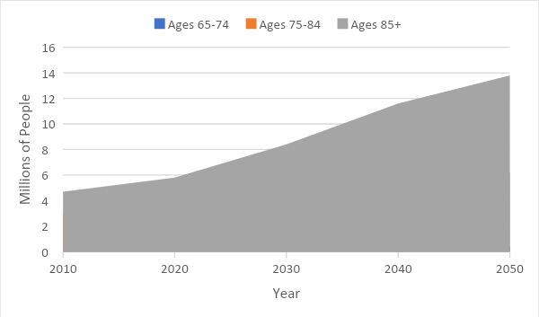
Fig 1: Expected growth rate of AD patients in Millions

Furthermore, because AD and other diseases share so many similar characteristics, it becomes more difficult to identify and distinguish AD disease from other related disorders [7].
Low income is another obstacle to cure AD. People in many nations are unable to obtain effective treatment due to poor finances, resulting in dementia in the future [8]. This issue's growth rate is likewise increasing day by day, and it is anticipated to reach 92 million in poor and middle-income nations by 2050 [9]. It is high time people take this matter seriously as this would only make us suffer in the future. Who is a youth today, will turn into an elderly tomorrow. If we do not take this into account now, it will be too late for our own good health.

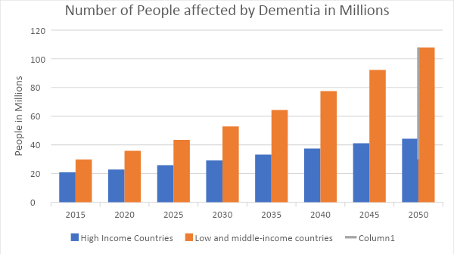
Fig 2: Figure of humans affected with AD

By 2030, dementia is forecast to cost $1 trillion annually and will likely double [10]. The percentage of those afflicted by AD varies depending on age. And 13.8 million people are anticipated to live there by 2050 [11].

Fig 3: Expected growth rate of AD patients in Millions

We used 3d CNN. It performed better than 2d CNN. The CNN layer was trained with an auto-encoder. But it has been adjusted and gave improved performance. Detection of AD is being studied in depth and comes with a number of issues and challenges. They developed an algorithm that analyzes a magnetic field to assess a person's disease condition MRI brain scan using a sparse 3d convolutional neural networks and autoencoder [12]. LeNet-5 and CNN architecture have been used to separate AD from NC brain. The AD was identified using an adaptive 3D convolutional architecture which was deeply supervised [13].
It has been used to find the AD [14]. Using the CAD-Dementia dataset, three layered 3D convolutional architectural autoencoder has been trained without the requirement for a preprocessor for skull stripping. Ten-fold cross-validation was given the priority to performance evaluation [15]. It has been demonstrated that a similar performance is feasible. As the residual network and conventional 3D convolution designs were embed to 3D structural MRI brain data, the findings revealed that the facts of the two networks were considerably different. They did not perform as effectively as expected [16]. A CNN structure's eight layers were examined.
Six convolutional layers assist the feature extraction process, while two fully linked layers help the classification process. The Leaky Rectified Linear Unit (LReLU) and max-pooling both performed admirably, according to the data. Alzheimer's illness was recognized using CNN, a 3D adaptation of Inception. The approach was based on the combination of structural or constructional MRI and DTI modalities on hippocampal areas. In terms of performance, they compared it to the network created using AlexNet [17]. 3D Inception outperformed AlexNet. To study the MRI of the Alzheimer's spectrum, a HadNet architecture was created [18].
For improved training, the MRI image collection is spatially normalized and stripped of the skull using the Statistical Parametric Mapping (SPM) toolset. It is anticipated that as HadNet architecture advances, sensitivity and specificity would rise. For the fourth expression level of apolipoprotein E, the model APOe4 has been proposed. Data from an MRI scan, a genetic test, and a clinical assessment were provided to the APOe4 model. When it was assimilated to other pre trained models like VGGNet and AlexNet. The system had lower memory needs, overfitting, computational complexity [19]. A CNN architecture consisting of a multi-modal MRI processing method was described by a functional MRI data. The framework allows individuals to be categorized as having mild cognitive impairment due to amnestic, AD, or NC (aMCI).
Despite the fact that 2D convolution yielded good level of accuracy, it is believed that using 3D convolution will yield superior results [20]. It was recommended to make only minor adjustments to a pre-trained model, such as ResNet50, Google Net, or AlexNet. The major goal was to determine how each layer influenced the categorization of natural and neuro-images. The PFSECTL mathematical model was proposed and is based on pre-trained CNN and VGG-16 models. Transfer learning hypothesis was supported by the model.
The primary goal of our study was to outperform the available common solutions to this topic. Then our secondary objective is to show the comparisons among different pre-trained models. As such, different datasets give different levels of results. We tend to show the comparisons among different datasets also. There has been a lot of research done in the field of detecting AD using deep learning. There are also works that identify and classify the HC, MCIc, and MCInc classifications. We will utilize Deep Learning to detect Alzheimer's patients and attempt to categorize them into the MCIc and MCInc categories. We will do binary classification and multi-classification and compare the results. Because there are various studies in the field of binary classification with high accuracy, binary classification will not develop as much as multi-classifications in the future, yet multi-classifications now have promising outcomes. However, the datasets utilized in many initiatives are demographically skewed. This means that any model trained with data from a single region will be biased against data from other locations. Another element influencing prejudice is the large disparity in people's educational levels. Our major goal is to create a model that would provide an efficient level of accuracy even across people from diverse regions and with different levels of education.

Methods and Materials

MRI pictures are part of our dataset. Four classes made up the set. The training set is the other, while the first is the validation set. 6400 images (Train+Test) are included in our collection.
The collection included MRI scans of both healthy individuals and those suffering from Alzheimer's disease, as well as four classifications that matched the four stages of the illness. Softmax, the last dense layer, was the activation function employed. We just used the Inception V3 pre-trained model. Incorporate transfer learning models like Resnet50, MobileNetB2, Xception, and VGG19 as well. The accuracy of the model in this study is further evaluated using transfer learning in contrast to the Pretrained Model.

Materials and Tools
Python has been used in this system. It performs better when used for analysis of data. Programming with Python is a very effective method for deep learning jobs due to the vast library access it offers. They were also utilized to store all information so that it could be accessed via GitHub from any GPU. GitHub is great for teamwork since it offers a tool for tracking for collaboration and management of code.

Dataset Description

The collection contains images from MRI's four classes. This class comprises two subclasses that represent the various stages of AD. One is the training set and another is the validation set. Our collection contains a total of 6400 images.
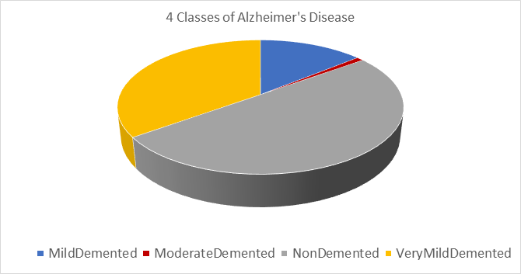
Fig 4: Percentage of Data of Each class

Table I: Count of Data of Each class
Subject | Number of images
Mild Demented | 896
Moderate Demented | 64
Non-Demented | 3200
Very mild Demented | 2240

Block Diagram
In Fig. 5, MRI images are considered as inputs. Before training the model, this system underwent preprocessing, which included importing photos of a specific size, distributing the data and using data augmentation methods [21]. If a user gave a photo as an input model, we might be able to tell in the output section whether they have AD or what stage it is.

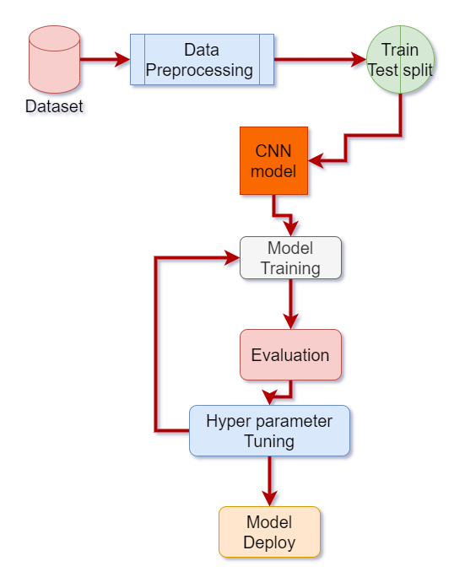
Fig 5: Diagram of the project
This diagram depicts our model architecture as well as the number of steps necessary to deploy our model. We begin by gathering our data collection. After preparing the dataset, view the classes. Following that, we left to execute the train test split. We train both our custom-built model and a transfer learning model after a train-test split [22]. After examining the classification matrix, we retrain our model and find a better model for our dataset. In preprocessing part, if you see in the dataset, you can see that classes are not balanced that’s why we use Oversampling Technique for balancing the classes.

System Architecture
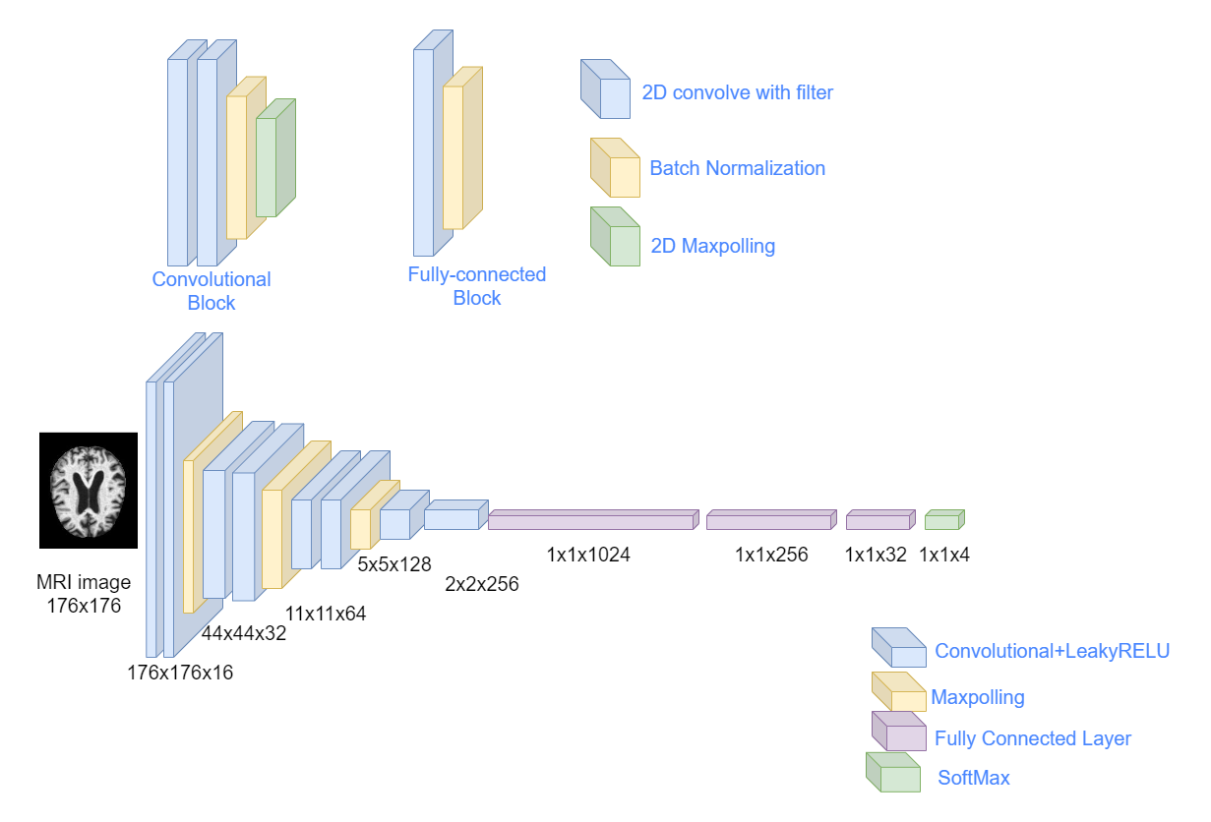
Fig 6: proposed model
The input and output pipeline design has been depicted in this block diagram. As you can see, we begin with an MRI. The input is subsequently sent to the convolutional layer [23]. LeakyRelu is employed as an activation function in this case. Following convolution, we utilize the maximum polling layer. This is the sort of two-layer we use. Then, our input matrix is flattened. Then we connect it to a totally linked layer. In the last layer, we employ Softmax as an activation function, which gives us the probability distribution of our output.

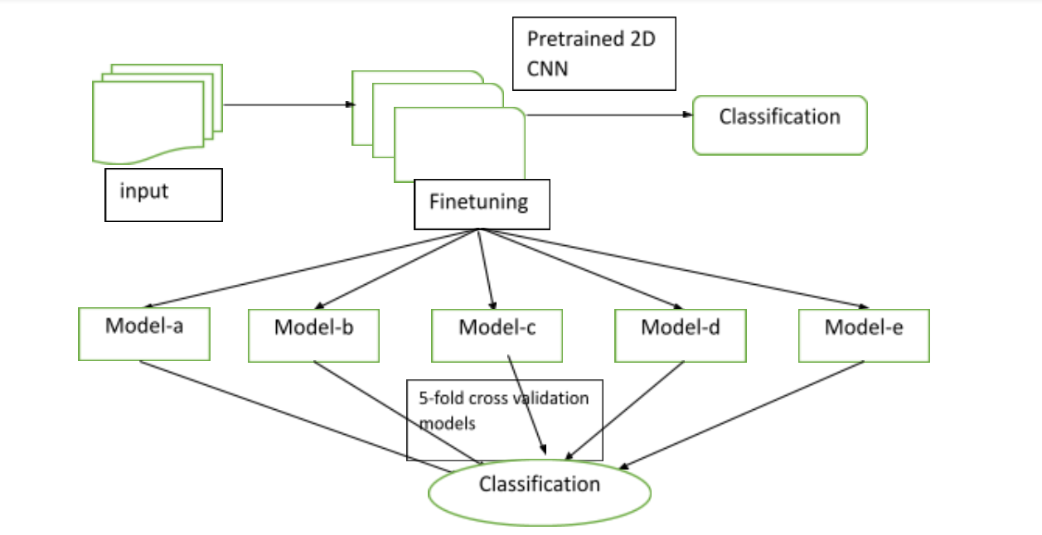
Fig 7: Block diagram of the data processing and finetuning

Pretrained model
As a transfer learning model, Inception V3, Resnet50, VGG19, Xception, and MobileNet are employed [24]. A CNN architecture consisting of 48 layers called Inception-v3 has been used. It is possible to load a network that has already been pretrained using almost a million pictures from the ImageNet collection [25]. A photo of a keyboard, mouse, pencil, or another animal can be classified into one of the approximately 1000 object categories that the pretrained network can recognize. Our model's final layer also includes the attributes of age, gender and area.

Explanation of the functioning of the complete system and all subsystems
We employed Deep Learning to categorize individuals into four different types of AD. Our core system began with a dataset for this. We distributed the dataset in halves for training and testing after minor preprocessing. We obtained an average accuracy using CNN [26], and we attempted to raise the attained accuracy to match our objectives via hyper-parameter tuning. We kept trying till we got a good enough score for these models. During the assessment step, we determined whether or not we needed to do hyper-parameter tuning. Finally, we constructed our model based on the results. Finally, we ran our model through its paces using the test set. Furthermore, we have worked on the display of our collected data and findings.
Our key models in the project were a bespoke CNN architecture and pre-trained Inception-v3 models. In addition, more readily available pre-trained models were employed to demonstrate comparisons. The Inception CNN architecture's reduction and inception stages make it ideal for our work with 2D pictures.

Result and Analysis
Below, we have given our result analysis, recall, confusion matrix, f1 score and precision.

Comparison of loss and validation

Table II: Accuracy and loss of the used models
Model  Name | Loss without  Over  sampling | Loss With over  sampling | Validation accuracy without over sampling | Validation Accuracy with over sampling
customized inception v3 | 0.57 | 0.37 | 0.85 | 0.89
VGG19 | 0.72 | 0.56 | 0.70 | 0.89
Xception | 1.84 | 0.48 | 0.60 | 0.91
MobilenetV2 | 1.54 | 0.53 | 0.71 | 0.91
Resnet50 | 0.93 | 0.57 | 0.62 | 0.87
Proposed Model | 0.52 | 0.17 | 0.8975 | 0.9653

Table 2 illustrates that we use two distinct models. The first model is Customize Inception V3, while the second is a pre-trained VGG19 model. During validation, we obtained a loss of 0.57 in Inception V3 without oversampling. and a loss of 0.722 in the VGG19 model. In the Validation, our validation Accuracy are 0.85 and 0.70 without oversampling, respectively. However, in Inception v3 with oversampling validation accuracy was 0.896, whereas VGG19 received 89%, Xception received 91%, and MobileNetv2 received 91%. Resnet50 accuracy was 87%. And our proposed model received a validation accuracy of 96.53%. and validation loss was 0.17 with oversampling.
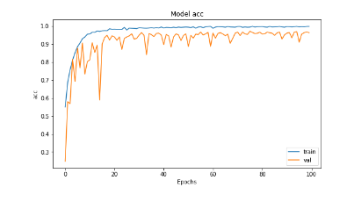
(A)

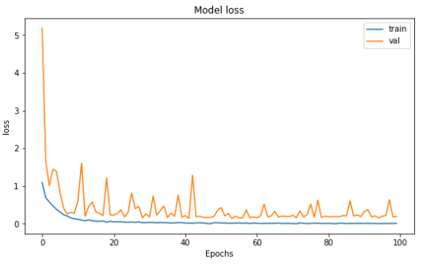
(B)
Fig 8: proposed solutions’ (A) accuracy and model (B) loss

The model loss plot indicates that each of the lines of train and validation loss have steadily reduced. Training loss reached 45% following the first epoch and 5% after 100 epochs. After 100 epochs, the validation loss was reduced to 16%. Figure 8 depicts a visualization of the model loss.

Confusion Matrix
Confusion matrices from our model and the closest solutions model has been shown below.

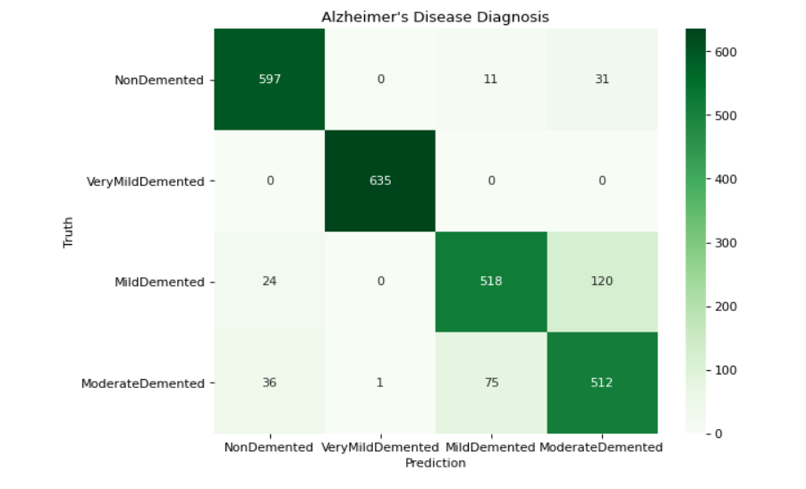
(A)
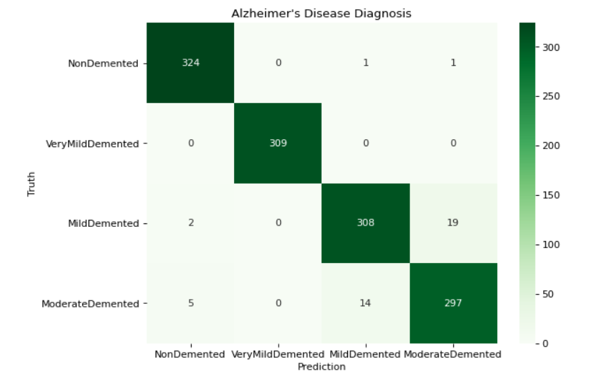
(B)
Fig 9: Confusion Matrices of (a) customized Inception V3 (b) proposed solution

Three terms are critical for examining mistakes. Such predictions, knowledge, and analysis of errors evaluated by prediction-based features can perform with a confusion matrix and depicted by the proportion of true positives, true negatives, false positives, and false negatives [27].
Furthermore, the amount and kind of data are critical for analyzing errors. To construct training and testing, data should be suitably separated. This is essential for analyzing errors since the sets of training and testing can significantly affect the outcomes. Features are needed for error analysis. Regularization and feature engineering were also carried out to eliminate mistakes.

Model Evaluation
The models' accuracy, precision, recall, and F1-score are used to assess their performance. True positive (TP), false positive (FP), true negative (TN), and false negative (FN) were used to assess the efficacy of the proposed model (FN).
The rate at which the impacted photos are correctly recognized among all images is called recall, also known as sensitivity. Recall is the opposite of precision. The F1-score is an accuracy and recall metric that indicates how frequently the anticipated value is correct. In mathematics, it is also known as the harmonic mean of p and r.
The equations are as follows. Matrices can be used to evaluate the performance of a system both before and after the model is built. The mathematical formulae used to determine accuracy are written in Eq. 1 and 2.

accuracy=(TP+TN)/(TP+TN+FP+FN)…………..(1)

accuracy=correctpredictions/totalnumberofexample……… (2)

Because of automation, the amount of time required for any job is gradually decreasing. In this discipline of neuroscience, if any time is saved by automation, it is a good thing that a lot of time will be saved. This technique will save a significant amount of time for professionals. Because of the time saved by experts, this will have an effect on the economy.

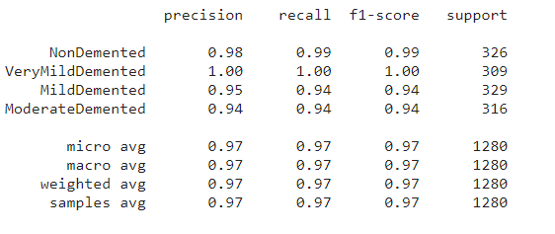
Fig 10: Classification report of our model

Figure 10 depicts our proposed models’ categorization report. A classification report is a performance monitoring indicator. It demonstrates the F1 Score, recall, precision and support of the trained classification models.

Comparison Table
Table III: comparison of different model

Ref | Modality | Sample Size | DL  Archi-  tecture | Class-  ifier | Acc
[28] | MRI | 188 AD, 229 NC and 401 MCI | CNN | Softmax | 79.9%
[29] | MRI | 416 samples | CNN | Softmax | 93%
[30] | MRI,  PET | 1355 AD, 1506 CN | 3D-CNN | Softmax | 90%
[31] | sMRI,  PET | 51 AD, 252 MCI and 228 NC | 3D-CNN | Softmax | 70%
[32] | MRI, DTI | 48 AD, 108 MCI and 58 NC | 3D-CNN | Softmax | 95%
Our  model | MRI | 717 MCI, 52 MCIc, 2560 NC and 1792 AD | CNN | Softmax | 96.53%

We sought to compare the many models that have been utilized thus far in table III. And our model outperformed the validation set by 96.53%. Also, have a look at the other initiatives and their accuracy in detecting Alzheimer's disease.

Conclusion

Our project's major purpose is to contribute to medical knowledge. There is a lot of research being done in the subject of identifying Alzheimer's disease utilizing CNN. We will be able to identify a human with AD because of this effort. As a result, our experts will have an easier time diagnosing the ailment. And this will have an impact on both our economic and social elements. Our major goal is to figure out how to promptly diagnose Alzheimer's disease. As a consequence, our doctors will be able to give prompt treatment, and patients will receive appropriate care. Our methodology will be less discriminatory toward different nationalities and educational levels. Because human brains differ in these two ways, dealing with bias in a model trained with only one dataset from a single location and a high education level is problematic. The use of 2D photos rather of 3D images saves time, money, and processing power [33]. Rather than the equivalent available solutions, this will effectively bring adjustments to our project. As previously stated, our objective is to overcome the challenges posed by the parallels between Alzheimer's disease and other disorders that share many common regions of the human brain. And to deal with the issue of diverse brain architecture caused by ethnicity and education level.

References

[1] | A. H. M. S. J. M. M. M. M. K. S. A. M. K. P. S. M. M. M. B. Antor, "A Comparative Analysis of Machine Learning Algorithms to Predict Alzheimer's Disease," Journal of Healthcare Engeneering, p. 12, 2021.
[2] | Z. A. J. L. H. Y. F. T. a. S. X. P. D, "Early Detection of Alzheimer’s Disease Using Magnetic Resonance Imaging: A Novel Approach Combining Convolutional Neural Networks and Ensemble Learning," Front. Neurosci, vol. 2020, no. 259, p. 14, 2020.
[3] | W. M. C. R. F. P. R. R. A. F. Guilherme, ""Alzheimer's Disease Detection Through Whole-Brain 3D-CNN MRI," Frontiers in Bioengineering and Biotechnology, vol. 8, 2020.
[4] | H. B. M. &. H. A. Helaly, "Deep Learning Approach for Early Detection of Alzheimer’s Disease," Cogn Comput, 2021.
[5] | Z. A. J. L. H. Y. F. T. S. X. P. Dan, "Early Detection of Alzheimer’s Disease Using Magnetic Resonance Imaging: A Novel Approach Combining Convolutional Neural Networks and Ensemble Learning," Frontiers in Neuroscience, vol. 14, 2020.
[6] | D. M. D. C. M. G. &. A. R. F. Castro, "The economic cost of Alzheimer's disease: Family or public health burden?," Dementia & neuropsychologia, vol. 4, no. 4, pp. 262-267, 2010.
[7] | "Alzheimer's disease facts and figures," " Alzheimer's & Dementia, vol. 9, no. 2, pp. 208-245, 2013.
[8] | "Alzheimer's disease facts and figures," Alzheimer's & Dementia, vol. 16, no. 3, pp. 391-460, 2020.
[9] | C. W. &. S. M. Zhu, "Economic considerations in the management of Alzheimer's disease," Clinical interventions in aging, vol. 1, no. 2, pp. 143-154, 2006.
[10] | A. H. M. S. J. M. M. M. M. K. S. A. M. K. P. S. M. M. M. B. Antor, "A Comparative Analysis of Machine Learning Algorithms to Predict Alzheimer’s Disease," Journal of Healthcare Engineering, vol. 2021, p. 12, 2021.
[11] | B. D. P.-M. K. G. K. W. P. K. B. M. A. S. A. S. M. B.-B. B. K. Marek, "Whole Brain and Cranial Size Adjustments in Volumetric Brain Analyses of Sex- and Age-Related Trends," Frontiers in Neuroscience, vol. 14, 2020.
[12] | S. &. E.-D. E.-S. &. M. A.-B. &. S. S. &. E.-D. Soliman, "Predicting Alzheimer's Disease with 3D Convolutional Neural Networks," vol. 1, pp. 125-146, 2020.
[13] | K. P. B. B. E. Altinkaya, "Detection of Alzheimer’s Disease and Dementia States Based on Deep Learning from MRI Images: A Comprehensive Review," Journal of the Institute of Electronics and Computer, vol. 1, pp. 39-53, 2019.
[14] | "Alzheimer's disease facts and figures," Alzheimer's & Dementia, pp. 391-460, 2020.
[15] | S. &. E.-D. E.-S. &. M. A.-B. &. S. S. &. E.-D. Soliman, ""Predicting Alzheimer's Disease with 3D Convolutional Neural Networks," pp. 125-146, 2020.
[16] | "Alzheimer's disease facts and figures," Alzheimer's Dement, vol. 16, pp. 391-460, 2020.
[17] | C. Lynch, "World Alzheimer Report 2019: Attitudes to dementia, a global survey," Alzheimer's & Dementia, vol. 16, pp. 1552-5260, 2019.
[18] | L. T. E. M.-S. F. M. J. J. G. M.-N. Israel, "Ten Years of Research on Automatic Voice and Speech Analysis of People With Alzheimer's Disease and Mild Cognitive Impairment: A Systematic Review Article," Frontiers in Psychology, vol. 12, 2021.
[19] | H. B. M. &. H. A. Helaly, "Deep Learning Approach for Early Detection of Alzheimer’s Disease," Cogn Comput, 2021.
[20] | W. L. Z. Y. T. L. Z. X. L. K. J. T. H. Y, "Regional coherence changes in the early stages of Alzheimer's disease: a combined structural and resting-state functional MRI study," Neuroimage, vol. 32, pp. 488-500, 2007.
[21] | Z. A. J. L. H. Y. F. T. S. X. P. Dan, "Early Detection of Alzheimer’s Disease Using Magnetic Resonance Imaging: A Novel Approach Combining Convolutional Neural Networks and Ensemble Learning," Frontiers in Neuroscience, vol. 14, 2020.
[22] | C. &. I. S. &. V. V. &. A. A. Szegedy, "Inception-v4, Inception-ResNet and the Impact of Residual Connections on Learning," AAAI Conference on Artificial Intelligence, 2016.
[23] | J. L. S. J. W. Bae, ""Identification of Alzheimer's disease using a convolutional neural network model based on T1-weighted magnetic resonance imaging," Sci Rep, vol. 10, 2020.
[24] | P. D. J. L. H. Y. F. T. a. S. X. Z. A, "Early Detection of Alzheimer’s Disease Using Magnetic Resonance Imaging: A Novel Approach Combining Convolutional Neural Networks and Ensemble Learning," Front. Neurosci, vol. 14, p. 259, 2020.
[25] | C. &. B. M. &. F. N. &. T. P. &. A. G. &. H. D. &. B. B. &. B. P. &. W. J. &. W. C. &. D. A. &. F. J. &. G. J. &. H. D. &. K. R. &. S. Jack, "The Alzheimer's Disease neuroimaging initiative (ADNI): MRI methods," Journal of magnetic resonance imaging, vol. 27.
[26] | C. &. C. A. &. B. P. &. G. M. &. Q. A. &. C. I. Salvatore, "Magnetic Resonance Imaging biomarkers for the early diagnosis of Alzheimer’s Disease: a machine learning approach," Frontiers in Neuroscience, vol. 9, 2015.
[27] | B. S. X. C. H. J. Q. M. M. E. D. P. V. M. S. G. B. R. W. G, "Dominantly Inherited Alzheimer Network Trials Unit. A novel cognitive disease progression model for clinical trials in autosomal-dominant Alzheimer's disease," Stat Med, vol. 37, pp. 3047-3055, 2018.
[28] | A. Khvostikova, " 3D Inception-based CNN with sMRI and MD-DTI data fusion for Alzheimer’s Disease," Institut de Neurosciences Cognitives et Int ́egratives d’Aquitaine, 2018.
[29] | Z. Y. Jyoti Islam, "Brain MRI analysis for Alzheimer’s disease diagnosis using an ensemble system of deep convolutional neural networks," Brain Inf, 2018.
[30] | W. Lin, "Convolutional Neural Networks-Based MRI Image," Frontiers in Neuroscience, 2018.
[31] | M. S.Sambath Kumar, "Diagnosis and Prognosis of Alzheimer’s Disease Via 3D CNN," International Journal of Recent Technology and Engineering, 2019.
[32] | J. X. Yechong Huang, " Diagnosis of Alzheimer’s Disease via Multi-Modality 3D Convolutional Neural Network," Front. Neurosci, 2019.
[33] | S. K. S. S. A. S. S. B. M. S. L. D. Y. K. Y. K. Kang, "Deep learning-Based 3D inpainting of brain MR images," Scientific Reports, vol. 11, 2021.

