The keyword def introduces a function definition. The return statement returns with a value from a function. Parameters are the variables listed inside a function's definition, while arguments are the actual values passed to the function when it is called
print() sends information to the screen.
return sends a value back to the caller.
A function packages a specific piece of logic so that we can reuse it, test it, and compose it with other pieces of software.
- src/ it separates application/package code from project-level files such as tests, documentation, configuration, and packaging metadata.
- Tests prove that our code behaves as expected and warn us when a future change breaks that behavior.
- pyproject.toml : it can eventually contain much more: project metadata, dependencies, build configuration, and tool configuration
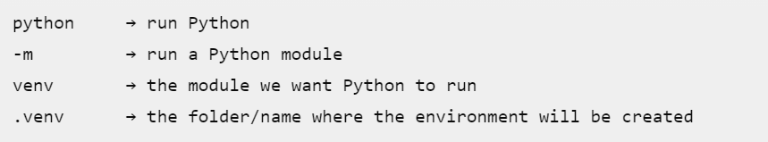
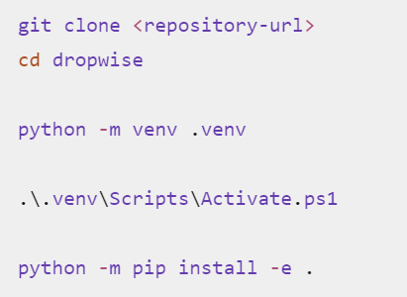
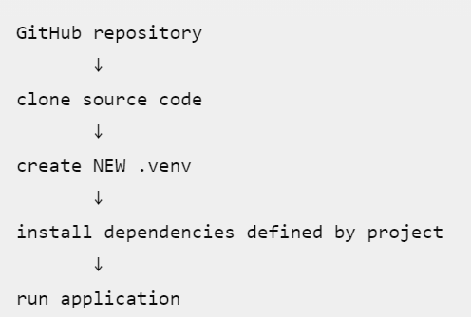

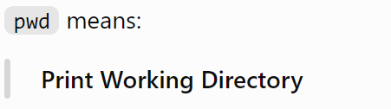

Day 1 Tasks:
