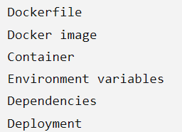
DropWise
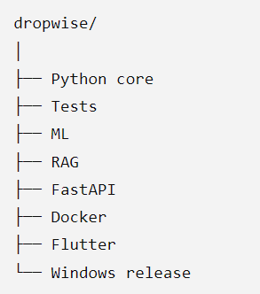
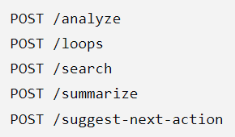
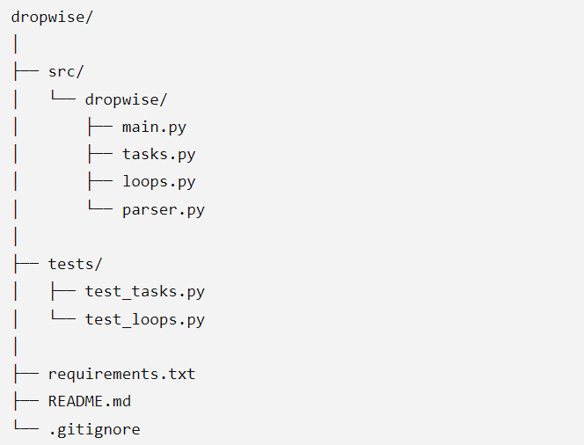

Python  → functions  → imports  → modules  → packages  → tests  → OOP  → Git  → environments  → external libraries | AI  → ML  → embeddings  → LLMs  → RAG  → evaluation | Production  → FastAPI  → Docker  → deployment | Product  → Flet  → Windows UI  → packaging  → Microsoft Store
