Business Insights Assessment
Solution Design Document — Production AWS Data Pipeline
SQL Server → AWS Glue (PySpark) → S3 (medallion) → Streamlit
Author: Mohammad Saim
Date: 2026-07-05 · Status: DRAFT — awaiting SME approval

Contents

1. Overview & Scope
This document defines the target production architecture for the Business Insights pipeline. The pipeline ingests transactional order data from a SQL Server source, processes it with PySpark on AWS, stores it in a layered S3 data lake, and serves aggregated business metrics (CLV, RFM, churn, sales trends, loyalty, location, and pricing analytics) to a Streamlit dashboard.
The design is deliberately all-AWS and PySpark-native: no Snowflake, dbt, or third-party tools, and no new software licenses. Every service choice below is accompanied by an explicit rationale (the "why") so it can be reviewed on its merits. No build work begins until this design receives written SME approval (Section 10).

2. Constraints & Assumptions
- All processing logic in PySpark; all infrastructure on AWS; no external/licensed tools.
- Source is SQL Server hosted on Amazon RDS; order data is effectively append-only (new orders inserted, not edited).
- Workload is a scheduled daily batch of moderate volume (~200K–400K rows/day range), not streaming or interactive.
- The pipeline must include scheduling, encryption, and a failure/reload mechanism.
- Incremental load assumption: an insert timestamp (CREATION_TIME_UTC) reliably identifies new rows. Late edits to historical rows are out of scope for the incremental path and would be handled by a full reprocess-from-raw.

3. Architecture Overview
The end-to-end flow is shown below. Data moves left to right through medallion S3 zones; orchestration and security are cross-cutting concerns wrapped around the data flow.
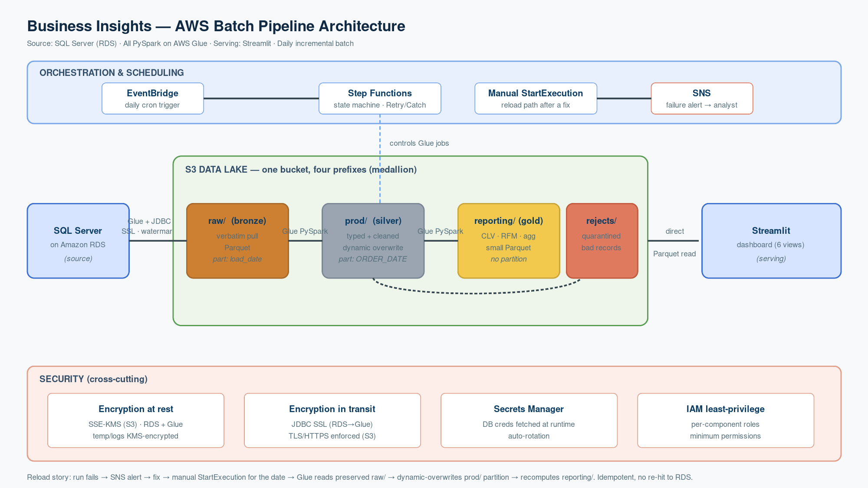
Figure 1 — End-to-end AWS batch pipeline (editable source: Step3_Architecture_Diagram.drawio)
Summary flow:
RDS (SQL Server) → Glue+JDBC ingest → S3 raw/ (bronze) → Glue PySpark → S3 prod/ (silver) → Glue PySpark → S3 reporting/ (gold) → direct Parquet read → Streamlit. Step Functions orchestrates the three Glue stages; EventBridge triggers the daily run; failures alert via SNS and quarantine bad records to rejects/. SSE-KMS, TLS, Secrets Manager and least-privilege IAM apply throughout.

4. Layer 1 — Ingestion (SQL Server → S3)
Choice | Why (rationale for SME)
AWS Glue + JDBC | Glue runs PySpark natively, so ingestion and transformation share one engine and one language — no new license, no second skill set. Reads SQL Server over a JDBC connection and writes to S3.
Incremental load (watermark) | Each run pulls only WHERE CREATION_TIME_UTC > last_watermark, then persists the new max watermark (DynamoDB / SSM / S3). Glue Job Bookmarks are the managed equivalent. Avoids re-reading the full table daily.
DMS rejected | AWS DMS would add a second service and is not PySpark-native; it earns its place for CDC/replication, which this append-only batch does not need.

5. Layer 2 — S3 Storage Zones (medallion)
One S3 bucket with four prefixes. A single bucket keeps lifecycle management simple while still allowing per-prefix IAM scoping — four separate buckets would add overhead without benefit at this scale.
Zone (prefix) | Contents & format | Partitioning
raw/ (bronze) | Verbatim RDS pull, all columns as strings, no typing. Parquet. | load_date (ingestion date)
prod/ (silver) | Typed, cleaned, standardized by PySpark. Parquet. | ORDER_DATE (business date)
reporting/ (gold) | Aggregated metrics: CLV, RFM, etc. Small Parquet. | None (small, read whole)
rejects/ (ops) | Quarantined bad records (corrupt row, orphan options). Parquet. | load_date

Key pattern: raw/ is partitioned by ingestion date (no parsing of source data → it stays a faithful, replayable copy), while prod/ is partitioned by the business ORDER_DATE, because the transform is already touching those columns. reporting/ is intentionally not partitioned — the tables are small pre-aggregates, and partitioning would create the small-file problem while Streamlit reads the whole table anyway.
Operational split: bad data records go to the S3 rejects/ zone; execution logs go to CloudWatch Logs; the failure alert is delivered by SNS (wired in Layer 4). Three separate concerns.

6. Layer 3 — Processing (Glue vs EMR)
Choice | Why (rationale for SME)
AWS Glue (chosen) | Serverless PySpark: spins up, runs, tears down, billed per second. For a bursty daily job (minutes/day), there is nothing idle to pay for and no cluster to patch, version, or tune. Fully managed = clean to operate and to present.
EMR (rejected here) | A provisioned EMR cluster would sit idle 23+ hours a day. EMR wins only when the cluster is highly utilized or long-running — many analysts sharing it interactively, sustained large-scale jobs, or deep Spark customization. At high steady volume the economics flip toward an amortized cluster.
Disclosed trade-offs | Glue has ~1-minute cold-start (irrelevant for daily batch, unsuitable for interactive) and less control over Spark internals. Acceptable for this workload.

One-liner: Glue for scheduled bursty batch; EMR for sustained, shared, or heavily-customized Spark.

7. Layer 4 — Orchestration, Scheduling & Failure/Reload
Choice | Why (rationale for SME)
Step Functions (orchestrator) | Passes JSON state between states, enabling Choice branching and per-state Retry/Catch with exponential backoff, plus native SNS/Lambda integration and a visual DAG. Glue Workflows only chains jobs with weak run-properties and no real conditional/retry logic.
MWAA rejected | Managed Airflow is overkill and carries an always-on cost; justified only for complex DAGs, backfills, or non-AWS-native stacks.
EventBridge (trigger) | Cron rule fires the state machine once daily — the automatic entry point. Preferred over a Glue trigger (not all-Glue), an S3-event trigger (the pipeline starts at RDS, not S3), and box cron (machine-dependent, no retries/monitoring).
Manual StartExecution (reload) | Second entry point into the same state machine, via console or CLI/SDK. This is the reload path: if a run fails overnight and is fixed at 09:00, the operator re-runs on demand without waiting for the next cron.

7.1 Retries & failure handling
- Transient failures (throttling, network): Step Functions Retry with exponential backoff and a capped attempt count.
- Exhausted retries: Catch fires two actions — SNS alert to the analyst (and mark the execution failed), and write the offending records to the rejects/ zone.

7.2 Idempotency & the reload mechanism
RUNNING_LTV is a cumulative sum, so writing a day's data twice would double-count. Idempotency is guaranteed by dynamic partition overwrite (Spark partitionOverwriteMode=dynamic with mode("overwrite")): because prod/ is partitioned by ORDER_DATE, a re-run overwrites only that day's partition and leaves all other days untouched. Running the job once or five times for the same date produces an identical result. The gold reporting/ layer is idempotent for a different reason — it is unpartitioned and fully recomputed off silver each run, i.e. overwrite by nature.
Partitioning therefore does double duty: query performance and safe reprocessing.
Full reload story: run fails → SNS alert → operator fixes the bug → manual StartExecution for the affected date → Glue reads the preserved raw/ zone → dynamic-overwrites the prod/ partition → recomputes reporting/. No duplication, and no need to re-hit RDS.

8. Layer 5 — Security
Choice | Why (rationale for SME)
Encryption at rest — SSE-KMS | S3 encrypted with a customer-managed KMS key rather than SSE-S3: it adds key control (rotate/revoke), key-level access policy, and a CloudTrail audit trail of every decrypt. Defense in depth — S3 access alone is insufficient without KMS decrypt permission. RDS encryption-at-rest covers storage, backups, snapshots; a Glue security configuration encrypts temp shuffle/spill data, logs, and job bookmarks.
Encryption in transit — TLS | JDBC connection RDS→Glue forced to SSL (encrypt=true). S3 access is HTTPS/TLS, enforced by a bucket policy that denies requests where aws:SecureTransport=false.
Secrets — Secrets Manager | Database credentials never live in the Glue script or config. The job fetches them at runtime via its IAM role; Secrets Manager supports automatic rotation.
IAM least-privilege | Each component has its own role with the minimum permissions it needs (e.g. Glue reads raw/, writes prod/, nothing more).

9. Layer 6 — Serving (S3 → Streamlit)
Choice | Why (rationale for SME)
Direct Parquet read (chosen) | The gold tables are small, pre-aggregated, and unpartitioned, so Streamlit reads the Parquet straight into pandas (awswrangler/pyarrow). This is a plain S3 GET — effectively free — and avoids adding a query engine as a moving part.
Athena (deferred) | Flip to Athena only if reporting tables outgrow memory (Athena filters/aggregates server-side and returns just the slice), if ad-hoc SQL push-down over large partitioned data is needed, or if a shared SQL interface is required for other BI tools. Note: cost favors the direct read; the flip driver is scale and SQL push-down, not cost.

10. Appendix A — CLV Data Model
Storage is Design A: one row per (USER_ID, order-day). The "customer value on any given day" experience is served at query time via forward-fill / as-of join, so there is no need to store a row per customer per calendar day.
Columns: USER_ID · SNAPSHOT_DATE · DAILY_SPEND (Decimal) · RUNNING_LTV (Decimal) · CLV_TAG (High/Med/Low).
- Build: groupBy(USER_ID, ORDER_DATE).agg(sum(LINE_REVENUE)) → DAILY_SPEND (collapse line items to one row/day first, or the running sum is wrong); then window partitionBy(USER_ID).orderBy(ORDER_DATE) sum(DAILY_SPEND) → RUNNING_LTV. Verified on one customer: LTV climbs 9.99 → 145.82.
- CLV_TAG recomputed so tags can migrate (Low→Med→High), ranked over the full customer base as-of the date (carry-forward each customer's latest LTV), not just that day's buyers. Refresh cadence can be decoupled (e.g. weekly).
- Money is Decimal, never double (float drift observed: 103.86999999999999). RFM is a separate table on its own cadence.

11. Appendix B — Open Questions for SME
- Discount encoding: the spec says detect discounts via OPTION_PRICE < 0, but the data has zero negatives. Are discounts encoded elsewhere or absent? Blocks the discount-effectiveness metric.
- OPTION_QUANTITY is always 1 (zero variance) — is this expected?
- Confirm drop/handling policy for the 28 orphan options and 1 corrupt line item.

12. SME Approval
This design is submitted for review. Build work (Step 4) begins only after written approval below.
Role | Name & Signature | Date / Decision
SME / Reviewer |  | Approved / Changes requested
Author | Mohammad Saim | 2026-07-05

