Basic Principles of Synthetic Biology

Engineering Biology for Innovation

Magnus Stefansson, MBA, Ph.D.

2025-06-13

## Course Overview

**Today’s Learning Objectives:**

* Define synthetic biology and its core principles
* Understand key engineering approaches in biology
* Explore standardization and modularity concepts
* Examine commercial applications and market potential
* Discuss ethical considerations and future directions

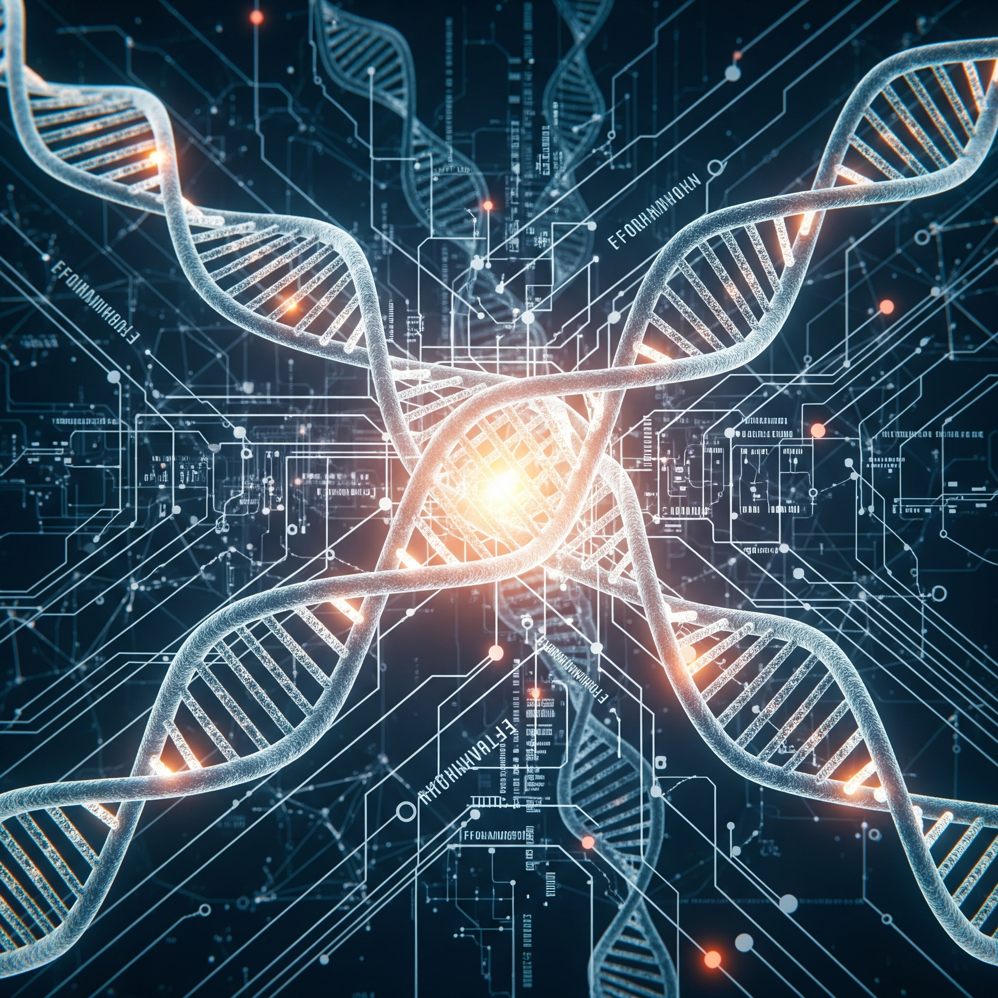

## What is Synthetic Biology?

* Definition: Engineering approach to biology that applies engineering principles to biological systems
* Goal: Design and construct new biological parts, devices, and systems
* Approach: Redesign existing natural biological systems for useful purposes
* Interdisciplinary field: Combines biology, engineering, computer science, and chemistry
* Bottom-up construction: Building biological systems from well-characterized parts

Source: Nature Reviews Molecular Cell Biology (2016)

## Historical Context and Key Milestones

**Key Milestones:**

* 1970s: Recombinant DNA technology foundations
* 2000: First synthetic genome (φX174 bacteriophage)
* 2003: BioBricks and standardized parts concept
* 2010: First synthetic bacterial genome (*Mycoplasma mycoides*)
* 2016: Synthetic yeast chromosome project
* 2020s: CRISPR integration and advanced gene circuits











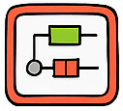

## Core Principle 1: Engineering Design Cycle

**Traditional Engineering Approach:**

* Design: Specify system requirements
* Build: Construct the system
* Test: Measure performance
* Learn: Analyze results and iterate

**Applied to Biology:**

* Design: Define biological function
* Build: Assemble genetic circuits
* Test: Measure biological output
* Learn: Optimize and redesign

Source: Nature Biotechnology (2018)

## Core Principle 2: Standardization

* BioBricks: Standardized biological parts with defined interfaces
* RFC Standards: Request for Comments defining part specifications
* Interchangeable components: Parts that work together predictably
* Characterization: Quantitative description of part behavior
* Registries: Databases of characterized biological parts

Source: iGEM Foundation, Registry of Standard Biological Parts

## Core Principle 3: Modularity

**Hierarchical Organization:**

* Parts: Basic functional units (promoters, genes, terminators)
* Devices: Combinations of parts with specific functions
* Systems: Multiple devices working together
* Chassis: Host organisms containing the systems

AI-generated modular system diagram

## Core Principle 4: Abstraction

* Physical Layer: DNA sequences, proteins, metabolites
* Device Layer: Functional units (sensors, actuators, logic gates)
* System Layer: Complete biological programs
* Application Layer: Real-world functions and purposes
* Benefit: Enables specialists to work at different levels without understanding all details

Source: Molecular Systems Biology (2017)

## Genetic Circuits and Logic Gates

**Boolean Logic in Biology:**

* AND gates: Multiple inputs required
* OR gates: Any input sufficient
* NOT gates: Inverter circuits
* Toggle switches: Bistable systems
* Oscillators: Periodic behavior

**Applications:**

* Biosensors for environmental monitoring
* Therapeutic circuits in medicine
* Metabolic pathway control
* Cell fate determination

Source: Science (2013) - Genetic logic circuits

## Chassis Organisms

* Escherichia coli: Most common, well-characterized, fast growth
* Saccharomyces cerevisiae: Eukaryotic system, post-translational modifications
* Bacillus subtilis: Gram-positive, protein secretion capabilities
* Pichia pastoris: High protein expression levels
* Mammalian cells: Complex protein folding, human-compatible
* Minimal cells: Reduced genomes for predictable behavior

AI-generated comparison of different chassis organisms

## Synthetic Biology Toolbox

**DNA Assembly Methods:**

* BioBrick assembly
* Gibson assembly
* Golden Gate assembly
* SLIC (Sequence and Ligation Independent Cloning)
* CPEC (Circular Polymerase Extension Cloning)

**Characterization Tools:**

* Flow cytometry
* Fluorescence microscopy
* RNA sequencing
* Proteomics
* Metabolomics

Source: Nature Methods (2019)

## CRISPR Integration in Synthetic Biology

* Programmable gene editing: Precise DNA modifications
* CRISPRa/CRISPRi: Activation and interference systems -Base editing: Single nucleotide changes without double-strand breaks
* Prime editing: Precise insertions, deletions, and substitutions
* Multiplexed editing: Simultaneous modification of multiple targets

Source: Nature Reviews Genetics (2020)

## Metabolic Engineering Principles

**Pathway Design Strategies:**

* Heterologous pathway expression: Introducing foreign pathways
* Pathway optimization: Balancing enzyme levels
* Cofactor engineering: Managing cellular resources
* Compartmentalization: Organizing reactions spatially
* Dynamic regulation: Responsive pathway control

AI-generated metabolic pathway diagram

## Protein Design and Engineering

* Directed evolution: Laboratory-based protein evolution
* Rational design: Structure-based protein modification
* De novo design: Creating proteins from scratch
* Protein-protein interactions: Engineering binding specificity
* Allosteric regulation: Designing responsive proteins

Source: Nature Chemical Biology (2018)

## Biosafety and Containment

**Physical Containment:**

* Laboratory biosafety levels
* Specialized equipment and facilities
* Training and protocols
* Waste management procedures

**Biological Containment:**

* Auxotrophic strains (nutrient dependencies)
* Kill switches and terminator genes
* Orthogonal biological systems
* Genetic firewalls

AI-generated biosafety illustration

## Commercial Example 1: Ginkgo Bioworks

**Business Model:**

* “Organism company” - designs custom microbes
* Automated strain engineering platform
* Applications in pharmaceuticals, agriculture, food
* Partnerships with major corporations
* Valuation: $15+ billion (2021)

**Key Technologies:**

* High-throughput DNA assembly
* Automated testing and optimization
* Machine learning for design
* Standardized biological parts

Source: Ginkgo Bioworks company materials

## Commercial Example 2: Synthetic Spider Silk

* Companies: Bolt Threads, Spiber, Modern Meadow
* Product: Recombinant spider silk proteins in microorganisms
* Properties: Stronger than steel, biodegradable, lightweight
* Applications: Textiles, medical devices, protective equipment
* Market potential: $1.3 billion by 2027

Source: Nature Materials (2019)

## Commercial Example 3: Biofuels and Chemicals

**Zymergen (acquired by Ginkgo):**

* Microbial strain optimization
* Machine learning-guided engineering
* Focus on specialty chemicals

**Amyris:**

* Synthetic artemisinin production
* Renewable chemicals from sugar
* Cosmetics and fragrance ingredients

AI-generated biofuel production flowchart

## Commercial Example 4: Synthetic Biology in Medicine

* CAR-T cell therapy: Engineered immune cells for cancer treatment
* Biosynthetic insulin: Recombinant human insulin production
* Synthetic antibiotics: Novel antimicrobial compounds
* Personalized medicine: Tailored therapeutic approaches
* Market size: $39 billion by 2027

Source: Nature Biotechnology (2020)

## Commercial Example 5: Food and Agriculture

**Applications:**

* Impossible Foods: Plant-based meat with synthetic heme
* Perfect Day: Animal-free dairy proteins
* Motif FoodWorks: Designer food ingredients
* Crop enhancement: Improved yield and nutrition

**Benefits:**

* Reduced environmental impact
* Enhanced nutritional content
* Novel flavors and textures
* Sustainable production

AI-generated sustainable food production ::::::::::::::::::::::::::::::::::::::