Towards an Intrinsic Representation of the Corneal Surface

Revised 05/5/95 (previously unpublished)

Anthony M. de Beus, M.D., Ph.D.
Scott E. Brodie, M.D., Ph.D.

(at time of writing)
Department of Biomathematical Sciences¹ and Department of Ophthalmology
Mount Sinai School of Medicine
New York, New York

Keywords: cornea, topography, mathematics, keratoscopy, curvature

Grant Support: Mount Sinai School of Medicine, Research to Prevent Blindness, and the Department of Ophthalmology, Elmhurst Hospital Center.

Presented at ARVO 1994, Sarasota, FL.
Proprietary interests: None
© 1999 by Anthony M de Beus is licensed under CC BY-SA 4.0. To view a copy of this license, visit https://creativecommons.org/licenses/by-sa/4.0/
Purpose. A comparison of conventional corneal topography maps computed from first principles with intrinsic representations of the corneal surface based on classic differential geometry.
Methods. Simple mathematical representations of normal and diseased corneas were developed and used as a basis to compute standard cornea "power maps", and to compute maps of intrinsic descriptions of the corneal configuration using the Mathematica programming language.
Results. Diagnostic criteria such as the presence or absence of symmetric or asymmetric bowtie patterns are shown to be strongly dependent on the location of the center of a corneal topography map. These contour maps typically indicate the curvature at each point in the radial direction, as referenced to the center of the map. For a given corneal configuration, qualitatively and quantitatively dissimilar maps may be generated through different choices for the origin of the map coordinates, quite aside from any dependence of the corneal profile reconstruction algorithm on proper centration. Maps of the local astigmatism, mean curvature, and the lines of principle curvature, by contrast, are dependent only on the shape of the surface of the cornea.
Conclusions. The contours depicted in a radial curvature map can contain artifactual distortions which may greatly exaggerate the irregularity of the underlying surface. Highly contorted contour lines and apparent singularities in a known uniformly smooth surface are features which can result from circumstances of alignment
The shape of the corneal surface and its representation are of great clinical interest in the assessment of pathologic conditions such as keratoconus and the evaluation of surgical techniques such as keratotomy and photorefractive keratoplasty. While the most widespread techniques for obtaining the corneal contour derive directly from the use of the Placido disk, in use for over a century, description of the corneal contour is currently based primarily on a recent ad-hoc scheme, which ignores the standard mathematical techniques and terminology for the description of smooth surfaces. In the present note, we offer a discussion of the color contour "power maps" as generally presented by commercial corneal topography instruments, and suggest as an alternative the use of intrinsic descriptions rooted in classical differential geometry. We emphasize that the focus of our present work relates to the choice of the representation of the corneal topography, not to the algorithm for the reconstruction of the corneal topography from the image data. Thus, we assume as a starting point for our investigation known closed form equations to represent the three-dimensional shape of the cornea, in order to isolate the problem of representation.
The non-standard (from a mathematics point of view) terminology used in corneal topography accurately reflects the ad-hoc nature of the representations but is intrinsically intertwined with the historical methods of reconstructing the corneal surface. Using standard mathematical terminology has the advantage that it is unambiguously defined, although it may require some retraining. Most current contour "power maps" apparently show what is loosely described as the "radial" or "perpendicular" or "sagittal" curvature. "Slope base curvature", and more recently "axial power" have also been used. By contrast, a different quantity has been described as the "local (radial) curvature" or the "instantaneous curvature". None of these terms are standard mathematical usage. We shall define all terms unambiguously while attempting as far as possible to be consistent with prior usage and avoiding "kerato-speak". Despite our emphasis on representation rather than reconstruction, we feel that the following brief review of the historical roots of keratometric maps provides some of the necessary context needed to appreciate the kinds of difficulties in current videokeratoscope (VK) machine representations. In fact, current VK representations of the corneal surface are based on Placido disk reconstruction methods.
The Placido disk was introduced to facilitate qualitative description of variations in corneal contour¹. Instruments for photographic recording of the reflected mire images were introduced in the 1930's². More recently, attempts began to interpret these photographs in quantitative terms -- that is, to attempt to reconstruct the corneal geometry from measurements of the reflected mire images. Mandell, in the 1960's³, developed a small mire keratometer and elliptical targets for use with photokeratoscopy. Rowsey, around 1980⁴, popularized a simple scheme based on the polished spherical steel balls which were well-known as calibration standards for keratometers and radius gauges. He presented simple nomograms relating the radius of the Placido disk ring, the radius of the reflecting steel ball, and the radius of the resultant mire image.
In practice, as the radius of each mire is known, and the radius of each mire image could be readily measured off a keratoscope photograph, it was thus a simple matter to assign the nominal radius of an "equivalent reflecting sphere" to each mire image, separately in each direction from the center. Each direction measured from the center is called a corneal meridian, a somewhat misleading misnomer, as we will explain subsequently. These nominal radii were displayed for convenience on a circular chart, which emphasized the association of each nominal radius with the corresponding mire (or its reciprocal, to be interpreted as a curvature). To further complicate matters, the curvatures are usually converted to dioptric powers by a paraxial formula which does not closely approximate the true dioptric power outside of a narrow region (Roberts, C. ARVO Abstract 1994;35(4):2197). From this chart, it was a simple matter to present the data as a contour map. This scheme was readily automated, and was adopted for the initial reports of the PERK study⁵. For convenience, without implying priority, we will refer to such data as the "Rowsey radial curvature". Indeed, the association of each curvature value with a corresponding mire image is actually rather misleading, as the small patch of corneal surface which forms the reflection giving rise to each mire image is typically closer to the corneal apex than the mire image itself⁶. In addition, for non-axially symmetric corneas, the mire image may be displaced laterally from the patch of corneal surface which formed that image. In fact, it is not possible to
associate one of these curvature values with any specific location on the cornea without additional information. In other words, the radial coordinate of such a map can be rigorously interpreted only as an ordinal value - the radial numbers represent the order of the contours from inner to outer but cannot be relied on as a measure of spatial position.
Subsequent generations of corneal topography instruments have employed more sophisticated algorithms for the corneal reconstruction than the determination of equivalent spheres. Various ray-tracing algorithms have been proposed to determine more local values of corneal curvature, frequently relying on assumptions of locally constant curvature, central sphericity, slight deviations from global sphericity. Algorithms also attempt to model the entire surface in terms of conic sections⁷ or cubic splines⁸. When these assumptions are met, these algorithms more accurately calculate the "local curvature" along each corneal meridian than the Rowsey method, but problems have arisen when they are applied to surfaces with abrupt changes in curvature (Nguyen & Applegate, ARVO Abstract 1993;34(4):1217). The validity of these assumptions, moreover, is doubtful in post-operative corneas. Non-placido disk topographic methods have been developed to avoid some of these difficulties. They are considered to be more sensitive detectors of corneal topography but have been criticized as being less robust than Placido ring devices for irregular corneas⁹. For example, one early device, the Corneal Topography System (CTS) made by PAR Vision Systems Corporation, used a projected rectangular grid rather than a Placido device. The PentaCam device made by Oculus is another, more modern, non-Placido system using Scheimpflug photography. The Heidelberg Anterion system uses 1300 nm OCT to measure the entire anterior segment.
Unfortunately, the manufacturers of commercial topography instruments have generally treated the reconstruction algorithms as proprietary information, precluding independent validation. The method of representing the data has also not been freely disclosed. In many cases, it has been difficult to obtain a clear description of what exactly is plotted on the contour maps. For example, the contour maps are frequently superimposed on tracings of the reflected mire images -- yet, as indicated above, the position of a mire image bears no direct relation to the position of any point on the corneal reconstruction without additional information. The evolution in methods of reconstructing the corneal surface from Placido ring devices has guided the method of displaying the data. As noted above, the initial nomograms for assessing curvature by means of equivalent spheres along each corneal meridian led to the development of polar plots of the data which were interpreted as contour maps. As a logical extension to these early polar plots, corneal curvature contour "power maps" are generally constructed by defining an origin by the intersection of the keratometric axis with the corneal surface. (The keratometric axis is the axis of the VK system, which may or may not be normal to the corneal surface at the origin.) A plane containing the keratometric axis then cuts the corneal surface into two dimensional (plane) curves. The corneal surface is then described on a polar plot by the properties of each the resulting plane curves (the "corneal meridians"). Of course, when the keratometric axis is moved, the position of the plane cutting through the surface changes, as do the shapes of the curves generated by the intersection of the cutting plane and the corneal surface. The ensuing contour map generated by the changed plane curves also changes both quantitatively and qualitatively. In the case of highly astigmatic corneas, such a depiction is liable to misrepresent or omit salient features of the corneal topography. For example, it is thus possible for the identification of symmetric or asymmetric "bow-tie" figures, and thus the early identification of keratoconus, to depend on the arbitrary alignment of the patient's eye with the photokeratoscope. These problems are illustrated in the examples given below. We emphasize that these difficulties arise irrespective of the accuracy of the optical methods and reconstruction algorithms chosen to compute the corneal geometry -- rather, these are difficulties inherent in the scheme commonly used to represent the data.
Theory:
In order to develop a description of corneal geometry intrinsic to the cornea itself, we invoke the classical differential geometry of smooth surfaces^{10,11}. We will include the explicit mathematical definitions of the quantities described to avoid ambiguity, an essential point when introducing concepts new to the field.
At each point of a sufficiently smooth surface, one may define a tangent plane, and a normal line, passing through the point, perpendicular to the surface. A plane containing this normal line may be rotated around the normal line, so as to intersect the original surface in any desired direction. For each possible position of this normal plane, its intersection with the original surface determines a smooth plane curve passing through the original point. When the normal line is the axis of symmetry of a surface of revolution, these plane curves are correctly referred to as meridians. The curves orthogonal to the meridians are known as parallels. Meridians and parallels are the familiar lines of longitude and latitude on the globe. In general, several quantities may be defined relating to the shape of a given plane curve defined in the above manner. It should be noted that videokeratoscopes are aligned along an axis perpendicular (normal) to the cornea at an unknown peripheral point, not along the line of sight, visual axis, or the pupillary axis¹². Since in general the cornea is not a surface of revolution, nor is the VK axis aligned with an axis of symmetry, it is misleading to call the smooth plane curves generated by the intersection of the corneal surface and the normal plane corneal meridians although that is the
common practice in the ophthalmologic literature.

The Definitions - Geometry
Let us present the commonly described properties of these plane curves. Imagine the plane curve described by a cross-section of a corneal surface along a corneal meridian. Figure 1 shows a plane curve with two different inscribed tangent circles.

The circle touching the curve at point D has a radius whose inverse is defined as the curvature of the curve at D; while the circle touching the curve at point F has a radius whose inverse is defined as the curvature of the curve at F. These curvatures are known in the literature as instantaneous curvatures or local curvatures. Since the curve is "flatter" at F, we commonly say that it has less curvature, and therefore it is not surprising that the inscribed circle has a greater radius. Now let us imagine that the line segment AB represents the keratometric axis, here decentered from the axis of symmetry. The line segments CD and EF, which are normal to the curve, represent the "axial distance". CD and EF are aligned with the radii of instantaneous curvature at the points D and F. The inverse of the "axial distance", converted into a power by the paraxial formula is known as the axial power, which as we noted above, has a number of synonyms in the literature. For the purposes of analogy with Rowsey's equivalent spheres, it is plain that the instantaneous curvature represents the sphere which matches the curvature at a point, whereas the axial distance represents the radius of the sphere centered on the keratometric axis which has the same slope at the point. Although documentation on the subject is lacking, it is apparent that most current VK systems primarily display their data as a contour map of the axial power, not surprisingly, since the position of the image of a mire in a Placido device depends on the local slope forming the image.
There are a number of curiosities associated with the definition of axial power. At the apex of the curve in Figure 1, the normal to the curve is parallel to the keratometric axis. Clearly the axial distance at this point is undefined. If we wish the plot of axial power to be continuous at this point for a smooth curve, we may take the axial power to be zero. Furthermore, if we wish the axial power to be a smooth curve at this point, we may take the convention that the sign of axial powers reverses at this point, so that CD represents a negative axial power. Finally, at the point of intersection between AB and the corneal curve, the axial distance is zero, so that as the axial power changes sign at this point it becomes undefined. (There would be a vertical asymptote or "pole" at this point.) We may avoid these anomalies by insisting that the keratometric axis AB must be normal to the curve, as shown by A'B'. It is easy to see that in Figure 1 this definition would lead to a shortened axial distance at D and at F (shown by line segment E'F), both of which would have the same sign.
Now, let us imagine that the plane curve in Figure 1 lies in a three dimensional (corneal) surface and has been generated by a normal plane containing A'B' assuming A'B' is perpendicular to the surface as well as being perpendicular to the plane curve. The instantaneous curvature at any point on the surface then follows from its definition on Figure 1. However, there is a difficulty in the definition of the axial power. If A'B', CD, EF, and E'F are perpendicular to the surface, there is no guarantee that they will be coplanar as shown in Figure 1. In fact, since the VK axis and a line perpendicular to a local tangent generally do not intersect, the axial power is not well defined as the distances CD, EF, or E'F unless all these segments are perpendicular only to the plane curve, and not in general, to the surface. While we may define the axial distance by working in the plane containing the VK axis, or the local normal axis, it should be recognized that the light rays forming the reflection of the target rings certainly do not stay in this plane so that the claim often made, that a slope based map of the cornea is more closely related to the true refractive measure of the cornea than an instantaneous curvature based map, clearly can not be supported.
Both of the definitions above depend on the location of the VK axis, the instantaneous curvatures somewhat less so since only the intersection point between the VK axis and the corneal surface need be specified. Ideally, however, it would be desirable to represent the corneal surface in a manner independent of the VK axis, in the same way as it is desirable for cartographers to make maps whose shapes do not depend on the location of their offices. Classical differential geometers have long since solved this problem. Returning to figure 1. Let us rotate the circle touching at F around the line defined by EF (out of the plane of the figure). As the normal plane defined by EF sweeps around in all possible directions, the curvature of the intersecting curve at the point F will achieve a maximum and a minimum value. These extreme curvature values are known as principal curvatures at the point F and the directions where the principal curvatures are obtained are called the principal directions at that point. It has been pointed out (Klein S. and Mandell R. Axial Power and Instantaneous Power in Corneal Topography. - unpublished MS), that in the special case of a surface of revolution where the keratometric axis is the axis of revolution, the axial power and instantaneous curvatures are simply related, and are, in fact, the principal curvatures. In this sense, the principal curvatures are the natural extension to the notions of instantaneous curvature and axial power for non-axially symmetric surfaces of revolution without reference to an ideally located VK axis aligned with the axis of symmetry.

The Definitions - Analysis

Instantaneous curvature
A surface may be defined as an ordered triplet of functions, {x, y, z[x,y]}; this description is known as a Monge patch. The instantaneous curvature may be obtained directly:

where the angle ϕ is the angle defined by tan[ϕ] = (y-y₀)/(x-x₀), (x₀,y₀) is the origin of the of the plot coordinate system, (x,y) is the point at which κ is evaluated and where z_{x}, z_{y}, z_{xx}, z_{xy}, z_{yy} are the first derivatives of z with respect to x, y, and second derivatives of z with respect to x, x and y and y, respectively. ϕ therefore indicates the direction in which the instantaneous curvature is evaluated with respect to the line y = 0, the x-axis. This formula is provided in a computationally practical form and clearly shows the dependence on the instantaneous curvature on the VK axis location by its dependence on ϕ.
Axial Power
We have explained above how in the case of a non-axially symmetric surface, such as the cornea, the definition of axial power becomes somewhat problematical. Klein, Mandell and Barsky¹³ have recently examined four ways in which axial power may be defined for general surfaces by restricting the normal to the surface and the VK axis to a plane. For the purposes of our discussion we will perform computations with two possible definitions based on Figure 1, either EF or E'F:

The equation shown computes E'F'. EF may be computed by assuming the slopes at the intersection point of A'B' with the corneal surface,z_{x}⁰ and z_{y}⁰, are zero. The line segments EF, AB and A'B' are assumed to lie in the same plane, an unfortunate error made by present VK machines.¹³ See also Appendix A

Principal Curvatures and Directions
Explicit expressions for the principal curvatures for surfaces given in the form of a Monge patch are

This equation is usually presented somewhat more formally and in more general form in classical geometry texts (with reference to such quantities as the first and second fundamental forms); we provide it here explicitly for a Monge patch in a form suitable for computation. Some of the properties of the principal curvatures follow. It may be shown that the principal directions lie perpendicular to each other, and that the curvature for intermediate directions is given by Euler's equation:

where κ is the normal curvature, κ₁ is the greater of the principal curvatures, κ₂ the lesser principal curvature, and θ specifies the orientation of the normal section, measured from the principal direction associated with κ₁. (It is this equation which is at the root of the fact that the principal axes of a cornea with regular astigmatism are perpendicular, and that the power in a given meridian of a cylindrical lens varies as sin²θ.) Note that the curvature defined by Euler's equation is based on the coordinate system defined at any point by the principal curvatures at that point, while the instantaneous curvature or axial power is defined relative to a global coordinate system corresponding to the position of the VK machine. The average of the two principal curvatures,

is known as the mean curvature. This corresponds to the spherical equivalent dioptric power of this patch of the corneal surface. We may similarly define the local astigmatism α,

as the difference between the principal curvatures. Of course, the principal curvatures themselves may be recovered from the mean curvature and the local astigmatism:

The family of principal directions at the points on a surface can be connected to form two families of curves, the "principal lines," (or "lines of curvature") which are tangent to the principal directions at each point. The two families of curves are mutually orthogonal, reflecting the orthogonality of the principal directions at each point, and they thus serve as a natural, intrinsic coordinate system for the surface. The lines of curvature are solutions of a cumbersome non-linear ordinary differential equation. For a Monge patch, this takes the form

where the subscripts indicate partial differentiation with respect to the indicated variable. In the case of a surface of revolution, the lines of curvature are the meridians and parallels of the surface.¹¹
Occasionally, the normal curvature at a point remains constant, independent of the orientation of the normal plane. Such a point is referred to as an "umbilical point." At such points, the principal directions become undefined. For example, each point of a spherical surface is an umbilical point, and there are no intrinsically defined directions on a sphere. Umbilical points are of potential interest in physiological optics, as they represent points free of local astigmatism, where the simple rules for spherical image formation hold. Some, but not all, astigmatic surfaces contain umbilical points; whether they can be found in actual corneas, and whether their presence is of clinical significance, is unknown.
Consider first some basic examples. As mentioned above, a sphere has κ₁ = κ₂ at all points, so that its map of local radial curvature shows only a single contour. There is no dependence on the choice of origin. A cylinder has κ₁ = constant, κ₂ = 0 at each point, so that according to Euler's equation, the local radial curvature is constant along each ray from the origin, regardless of the location of the origin. This constant astigmatism is a limiting case of the "symmetric bow-tie" pattern seen in actual corneas.
An aspheric surface of revolution is formed by taking a non-circular planar curve and rotating it about a normal to the curve at a fixed point. This point, the apex of the surface, is by reason of symmetry an umbilical point. It may be shown that the principal directions coincide with the meridians and parallels of the surface¹¹. The local radial curvature is constant along the parallels, so the contour map of local radial curvature will consist of circles concentric with the apex, so long as the origin coincides with the apex. Even in this very simple case, a plot of local radial curvature drawn from an origin other than the apex will appear distorted, misrepresenting the fundamental symmetry of the surface.
The paraboloid represented as a Monge patch with

provides a simple model of the cornea, replicating both astigmatism and peripheral flattening. Figure 2 shows the strong dependence on the location of the origin of the standard contour "power maps" of the instantaneous curvature (Figure 2, frames 1-6).

In this set of examples, a paraboloid as depicted with the apex displaced half the distance from the center of the cornea to the limbus. In all cases, the astigmatism remains "with the rule" -- that is, the flatter axis lies in the horizontal direction. In the initial frame, the apex lies in the 9 o'clock meridian, and the radial curvature at the apex corresponds to the flatter normal curvature. In subsequent frames the displacement is moved toward the 6 o'clock meridian, resulting in irregular, asymmetric contours. In the fifth frame, the apex is displaced inferiorly, and the radial curvature at the apex corresponds to the steeper normal curvature. Thus, both qualitative and quantitative features of the contour map of local radial curvature are seen to vary with the disparity between the apex of the surface and the display origin. The contours qualitatively resemble those seen clinically.
However, we can gain considerable geometric insight into this cornea by looking at the alternative, intrinsic, representations. Figure 3 shows several different representations of the same paraboloid. Frame 1 and frame 2, once again show the centered and decentered instantaneous curvatures defined by equation (1). Frame 3 shows the mean curvature defined by equation (5).
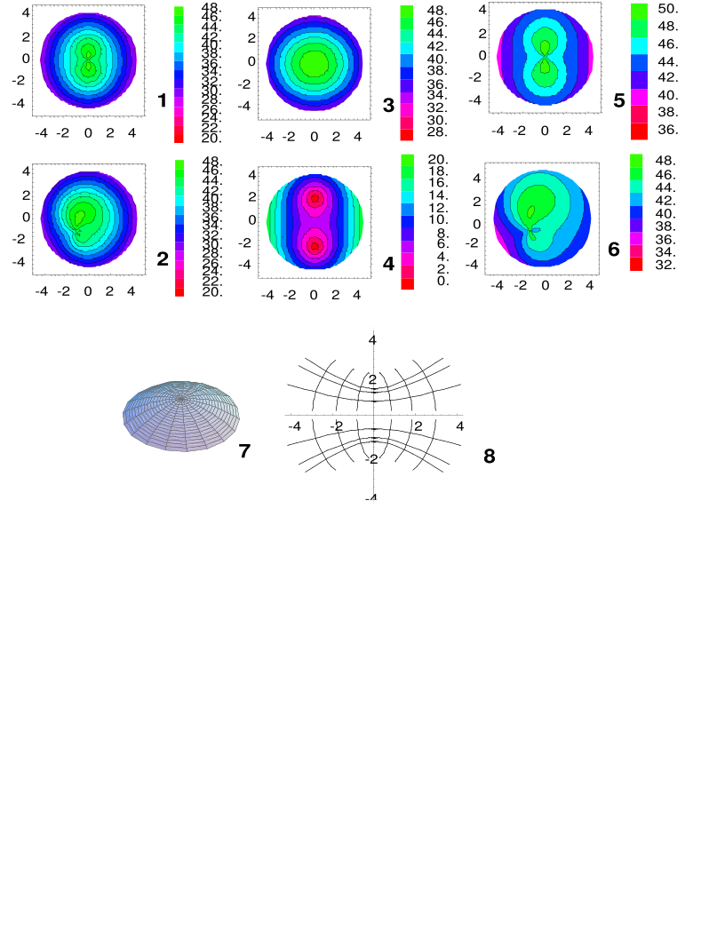
The regularity of the flattening from the center to the periphery is clearly shown, in contrast to the factitious central irregularity suggested by the instantaneous curvature. The plot of the local astigmatism, Figure 3 (frame 4), equation (6), clearly demonstrates the presence of two umbilical points, where the local astigmatism falls to zero. These cannot be found by inspection of the contour map of local radial curvature. (Note that all astigmatic paraboloids have two umbilical points, although one or both of them may not lie within the portion of surface representing the cornea for surfaces sufficiently astigmatic or eccentrically placed. Note also that the "bowtie" pattern seen on the radial curvature plot does not imply the presence of umbilical points; we will later show a surface with a "bowtie" pattern without umbilical points.) Frames 5 and 6 show the axial power defined by equation (2) centered and decentered illustrating that axial power, like instantaneous curvature, also demonstrates an irregularity which changes with position of the axis. A 3-D (equation (9)) wire mesh of the surface is shown in frame 7. The location of the center of symmetry of the surface in Figure 3 and its umbilical points is clearly indicated by the plots of the lines of curvature, seen in projection onto the plane of the corneal limbus (Figure 3, frame 8) (equation (8)). These lines, the mean curvature and the local astigmatism are intrinsic to the surface itself, and would not be altered by any misalignment between the apex and the origin chosen for purposes of computation or illustration.

Another surface frequently invoked as a model refracting surface is that of a small patch of the outer rim of a toric surface¹¹ which is represented as a Monge patch by

where the patch lies along the outermost circumference of the torus.
and shown in Figure 4.
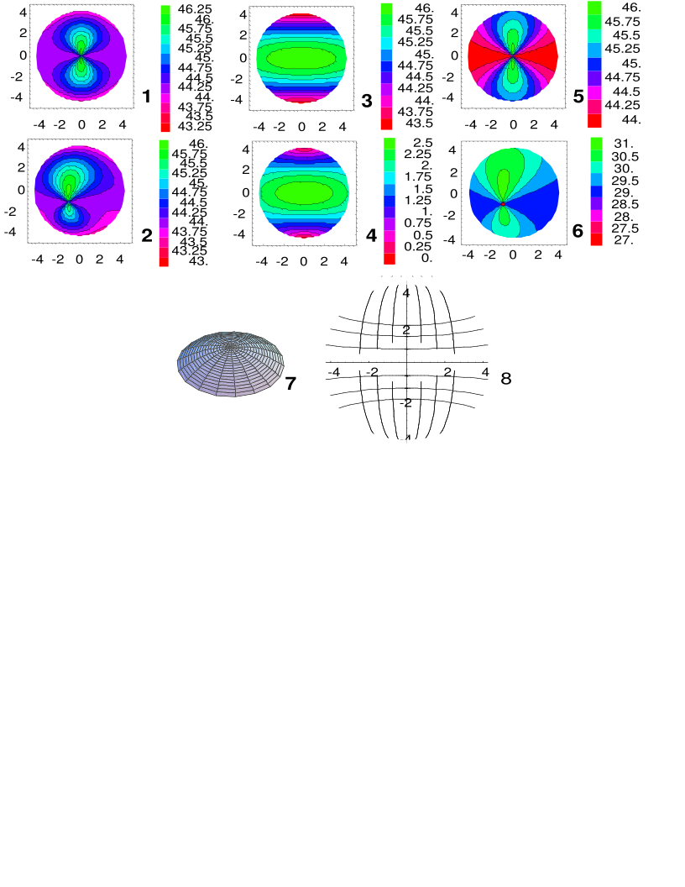
Such a surface approximates the ideal of constant curvatures along both the meridians and parallels, yet the contour map of local radial curvatures strongly emphasizes the diagonals radiating from the apex. The true nature of the invariance is seen in the maps of local astigmatism (figure 4, frame 4) and mean curvature (frame 3), which accurately depict that the torus is a surface of revolution. The slight distortions from strict uniformity are nicely illustrated by the plot of the lines of curvature (figure 4, frame 8), which, of course, are the meridians and parallels of the torus. Frames 1, 2, 5, 6 once again show the centered and decentered instantaneous curvatures, their dependence on position and their central aberrancy. Frame 7 once again shows the 3-D wire frame representation. It is difficult for the eye to discriminate between paraboloid and torus based on 3-D view.

A heuristic model for progressive keratoconus may be obtained by considering a family of nested hyperboloids, which successively approach a fixed cone as asymptote.

Such a set of corneal profiles is shown in figure 5. (The curves are displaced forward by different amounts in the figure for clarity.) Typically, the apex of the cone is not coincident with the center of the cornea. As we have seen, this arrangement can lead to highly irregular contours of the local radial curvature, which tend to exaggerate the degree of corneal distortion. As was seen in the case of the displaced paraboloid, even a very gently curved profile looks quite irregular in the map of local radial curvature Figure 5 (frame 2), yet the map of the local astigmatism shows no gross pathology (Figure 5, frame 3). T The markedly conical shape shown in figure 5 is recognizable even in it 3-D representation, as is its clinical inspiration of severe keratoconus.
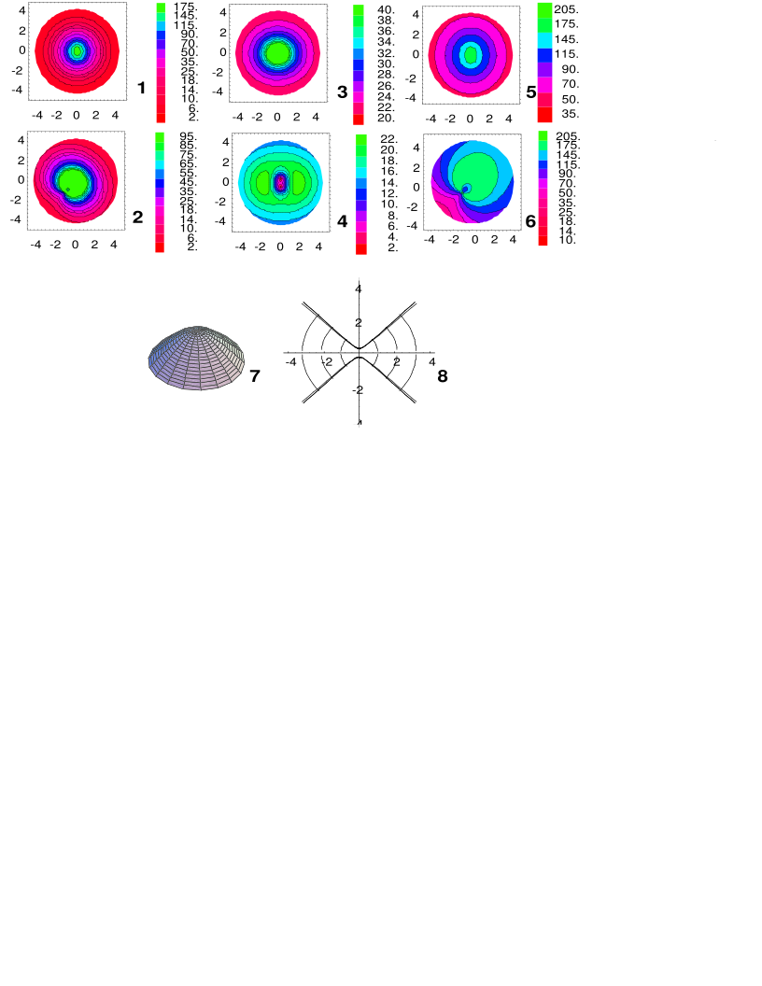
The distinction between symmetric and asymmetric bow-tie patterns in contour maps of the local radial curvature has been used as a clinical marker to distinguish ordinary astigmatism from keratoconus^{14,15}. Yet, as is clear from the above examples (Figure 2), this dichotomy is potentially an artifact of the alignment or misalignment of the videokeratoscope with the geometric apex of the cornea. As the location of the apex of the corneal surface cannot be known in advance, it is clear that this distinction cannot form a reliable basis for clinical decisions. The magnitude of misalignments presented in this work are quite consistent with the eccentricity of the "cone" in early keratoconus¹². While the "line of sight" is a convenient and useful reference point for keratoscopy, misalignments and eccentric locations of the apex of the cornea with respect to the keratometric axis will nevertheless occur due to the fact that the apex of the cornea, the optical axis of the lens, and the macula are not necessarily simultaneously aligned along the line of sight. The line of sight is not intrinsically connected with the surface of the cornea, nor is the "visual axis" or "pupillary axis". The axis used to align current videokeratoscopes is perpendicular to the surface of the cornea while the subject fixates upon a point on the optic axis of the instrument³. This axis depends on many optical properties other than the shape of the cornea and is therefore not an intrinsic reference point for the study of the geometry of the cornea however useful it may or may not be for visual applications.
There are other pitfalls inherent in the use of the standard power maps. Consider the toric surface in figure 4. It would appear from the plot of radial curvature - the power map - that there is a wide variation in the steepness between the superior and inferior fields as opposed to the nasal and temporal fields; however, a comparison of this plot with the plot of mean curvature (the spherical equivalent) shows extremely little variation over the entire surface. The other intrinsic property plots also show great regularity; the lines of curvature for this surface are nearly a rectangular grid. Clearly these intrinsic representations more clearly demonstrate the geometry of this surface than does the power map, and they may well be preferable as a guide to refractive intervention. A real corneal profile illustrating this point is described by Sanders, Gill and Martin (1993)¹⁶ in their figure 3 (p.132), which the authors describe as an unusual against-the-rule astigmatism with wedge shaped areas of greatest steepness. This cornea looks remarkably like our computed prediction of a "power map" of a toric surface shown in our figure 3, frame 1 (rotated by 90 degrees), suggesting the possibility that the cornea described may well have approximated a toric surface. As can readily be appreciated from our figure 4 frames 3 and 4, there are no wedge shaped areas of greater steepness in such a surface -- in fact our toric corneal surface is strictly uniform along horizontal bands.
To avoid difficulties of this nature, we suggest that plots of the mean curvature and the local astigmatism be used in lieu of plots of local radial curvature. The advantages of this presentation include: independence of the contour maps of the alignment between the origin of the contour map and the apex of the cornea (which would enhance the repeatability of measurements even in the absence of variability due to the dependence of the reconstruction algorithm on the alignment of the photokeratoscope), superior display of important features of the geometry of the corneal surface, such as the orientation of the astigmatic axes and the location of umbilical points, and freedom from artifactual contortions of the contour lines, which may greatly exaggerate the apparent degree of optical pathology of a corneal surface. The lines of curvature, displaying the principal directions, are likewise of great utility in appreciating the intrinsic surface geometry, although they may be difficult to compute. To our knowledge, computation from first principles of the expected "power maps" for known closed form geometric surfaces other than the sphere have not been previously published. We present the collection of surfaces presented in this work as the start of a "gallery" of standard corneal shapes against which clinical corneal data can be compared.
There are other representations of the corneal surface which have been considered. The three dimensional topography may be displayed. Additionally, deviations from a sphere or other reference surface may be displayed^{9,17} resulting in a "potato chip" like surface. Although the three dimensional representation is independent of misalignment and eccentricity, the human eye cannot readily distinguish from these plots the important differences between similar eccentric or astigmatic surfaces, nor can it detect optical features such as the umbilical points. Subtraction from a best-fit sphere or spherocylinder is probably an improvement over the radial power map but may still introduce alignment artifacts; furthermore many different surfaces, such as those depicted above, look qualitatively similar with these representations. The cornea represents the only readily accessible differentiable surface in the body. A description of the corneal geometry which includes, rather than ignores, this property stands to facilitate our ability to comprehend the cornea and its optical function.

Acknowledgments
This manuscript is based on unpublished work of the author and Dr S.E. Brodie, who first pointed out the problem of VK instruments. We thank the Department of Biomathematics of Mount Sinai School of Medicine for the use of their hardware and software resources and Dr. S. Klein for a number of helpful suggestions and information regarding axial powers.
References
1) Placido A. Novo instrumento de esploraco da cornea. Periodico oftolmologic. 1880;5:27-30.

2) Duke-Elder S ed. System of Ophthalmology. St. Louis: Mosby; 1970;7:241-242.

3) Mandell RB. The enigma of the corneal contour. The CLAO Journal. 1992;18:267-273.

4) Rowsey JJ, Reynolds AE, Brown R. Corneal Topography. Corneoscope. Arch Ophthalmol. 1981;99:1093.

5) Waring GO III, Lynn MJ, Culbertson W, et al. Three-year results of the Prospective Evaluation of Radial Keratotomy (PERK) study. Ophthalmology. 1987;94:1339-1354.

6) Brodie SE. Corneal Topography and the Hirschberg test. Applied Optics. 1992;31(19):3627-3631.

7) Wang J, Rice DA, Klyce SD. A New Reconstruction Algorithm for Improvement of Corneal Topographical Analysis. Refractive and Corneal Surgery. 1989;6:379-387.

8) Klein, S. A Corneal Topography Algorithm that Produces Continuous Curvature. Optom. and Visual Sci. 1992; 69:829-834.

9) Klyce SD, Wilson SE. Methods of Analysis of Corneal Topography. Refractive & Corneal Surgery. 1989;6:368-371.

10) Lipschutz M. Theory and Problems of Differential Geometry. Schaums' Outline Series McGraw-Hill Book Company; 1969:150-200.

11) Gray T. Modern Differential Geometry of Curves and Surfaces. CRC Press, Boca Raton 1993.

12) Sanders DR, Koch DD. An Atlas of Corneal Topography. SLACK Incorporated, Thorofare New Jersey. 1993.

13) Klein SA, Mandell RB, Barsky BA. Representing corneal shape.

14) Waring III GO, Hannush SB, Bogan SJ, Maloney RK. Classification of Corneal Topography with Videokeratography. In: Schanzin DJ, Robin JB, eds. Corneal Topography. Measuring and Modifying the Cornea. New York: Springer-Verlag; 1992:47-73.

15) Caroline PJ, Norman CW. Corneal Topography in the Diagnosis and Management of Keratoconus. In: Schanzin DJ, Robin JB, eds. Corneal Topography. Measuring and Modifying the Cornea. New York: Springer-Verlag; 1992:75-93.

16) Sanders DR, Gills JP, Martin RG. When keratometric measurements do not accurately reflect corneal topography. J Cataract Refract Surg 1993 Supplement;19:131-135.

17) Klyce SD. Computer-Assisted Corneal Topography. High-Resolution Graphic Presentation and Analysis of Keratoscopy. Invest Ophthalmol Vis Sci. 1984;25:1426-1435.
Figure Legends

Figure 1
Geometry of the cornea in a plane (see text).

Figure 2
Using Equation 5, contour maps of the local radial curvature of a cornea modelled by a paraboloid with shape parameters a = 7.37, b = 7.7, c = 7.7 mm with the apex of the surface centered 50% of the way between the assumed corneal center and the limbus at the following positions: Frame 1 - at 9 o'clock; Frame 2 - at 8 o'clock; Frame 3 - at 7:30; Frame 4 - at 7 o'clock; Frame 5 - at 6 o'clock. Frame 6 shows the surface with the apex at the center. The value shown for the shaded region in each legend represents the average of the curvatures of that region's surrounding contour(s). The local radial curvature at the apex for Frames 1-5 are 44, 45, 46, 47, and 48 D respectively. The axes are in millimeters.

Figures 3-5
Examples of simple analytic surfaces include the quadric surfaces, whose function z[x,y] is a quadratic function of x and y. These surfaces are frequently referred to by analogy with their two-dimensional relatives, the conic sections, as "conicoid surfaces," Bennett (1988), including the ellipsoid, paraboloid, and hyperboloid. We have chosen particular forms for these parameterizations so that the surfaces with the same values for the shape parameters a, b, c, will have the same central power and central astigmatism whenever possible. (a = 7.37, b = 7.7, c = 7.7 mm. The axes are in millimeters.)
Frame 1: Contour maps of the (not-decentered) local radial curvature (Eqn. 1)
Frame 2: Contour maps of the local radial curvature decentered at 7:30 (Eqn. 1)
Frame 3: Mean curvature (centered) (Eqn. 5)
Frame 4: Local astigmatism (Eqn. 6)
Frame 5: Axial Power (Eqn. 2)
Frame 6: Axial Power (decentered) (Eqn. 2)
Frame 7: 3-D representation (Monge patch)
Frame 8: Lines of curvature (Eqn. 8)
of a cornea modeled by a Figure 3: paraboloid,

Figure 4: torus,

where the patch lies along the outermost circumference of the torus.

Figure 5: hyperboloid with s = 4.0, (modelling severe keratoconus),

The hyperboloid requires one additional parameter, s, which specifies the degree to which the surface approaches its conical asymptotes -- as s becomes larger, the surface becomes more pointed, suggesting an analogy with progressive keratoconus.

Appendix A:
Formal definitions

First Fundamental Form:

with

with , and

Second Fundamental Form:

with

then the coefficients of the ODE above are:

a = EM-FL, b = EN – GL, c = FN – GM

and Gaussian and Mean Curvatures are:

and

Principal Curvatures κ₁ κ₂ along the principal directions forming the lines of curvature for a function h(u,v) in Cartesian coordinates.

Note that κ₁ κ₂ > 0 if the Hessian is positive definite:

Monge/Local Astigmatism k1-k2

Mean curvature (k1+k2)/2

Gaussian Curvature K= κ₁κ₂

The principal curvatures are also expressible as

In polar coordinates this gets more cumbersome, though the ubiquitous denominator of first derivatives (the metric) is quite simple, so for r > 0:

The conversion for the second derivatives (Hessian) is

Curiously, if at the origin with

Of course the ratio of h_{t} of to h_{tt} cannot be a function of t at r=0, because that would imply that K is not single valued at the origin. One way to achieve independence from t is if the surface is axisymmetric, then at the origin:
as follows from the axisymmetric versions of the equations below.

Simplified formulae for surfaces of revolution (axisymmetric surfaces with elevation z(r) where r is the radius from the axis of revolution) and all derivatives in ϴ are zero:

z_{ϴ} = 0, z_{rϴ} = 0, and z_{ϴϴ} = 0

“Instantaneous or Tangential” curvature, polar coordinates:

which actually the formula for the first principal curvature for a surface of revolution (axisymmetric) parameterized by z=z(r) The other principal curvature in that case is actually the

“Axial or Sagittal” curvature ”, polar coordinates:

Note also that the tangential curvature is the derivative of the sagittal curvature in this case.

As an example, consider a simple paraboloid, z(r)=r^{2,.} The ratio between κ₁/κ₂ =(1+4r²), showing that for r<<1, the two are similar, but as the radius increases, the axial curvature becomes larger than the tangential curvature. Since the two principal curvatures are orthogonal, that also allows us to realize that the axial curvature is in the radial direction, whereas the tangential curvature is in the circumferential direction.

Mean Power is the arithmetic average (κ₁ + κ₂ )/2.. H is traditionally used.

Gaussian Power is the product k1k2 of the principal curvatures. It’s unfortunate that it isn’t the geometric mean instead of its square...

So in order to get a comparable “power” in diopters, the square root of K is used.

So called Monge Astigmatism κ₁- κ₂ :

Warp/Oblique power, same as axial but with z_{θ} /r instead of z_{r}
This last definition is non-standard and defined here as:

The Cartesian equation for the lines of curvature is given as the solutions of the ODE:

with , which has two solution sets as the solution to where u(t), v(t) describe parametric curves in t using the two roots of the quadratic solution with some rearrangement m(u,v):

or

with

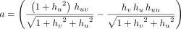

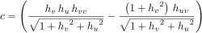

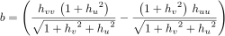

The “lines of curvature” describing the directions of the principal curvatures can be plotted as a vector field in (u,v). The lines of curvature in the axisymmetric case are given by the meridians and circles of longitude.

The “Axial Power” is not defined for off center or non-axisymmetric case, but there are formal alternatives, for example, defining the following, based on the surface vectors and normals:

with normal and at the origin

the values and then we can define the vectors

and which lead to one of three “radii”

with

or

(Klein SA, Mandell RB, Barsky BA. Representing corneal shape. )

Picking Definition 1, with which corresponds to no axial angular misalignment, only (u,v) misalignment, leads to

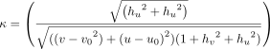

which is very similar to the polar coordinate axisymmetric version given earlier:

Note that with , that the tangent plane of the surface is orthogonal to the VK axis as well as centered. Definition 1 explicitly assumes that rays stay in the meridional plane.

Picking Definition 2, with which also corresponds to no axial angular misalignment, only (u,v) misalignment, but with a different geometric interpretation, leads to

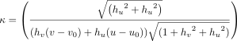

while Definition 3 (still with is quite complicated.

