# The Build Server

The current state of the build can be monitored using the CC.Net tray application:

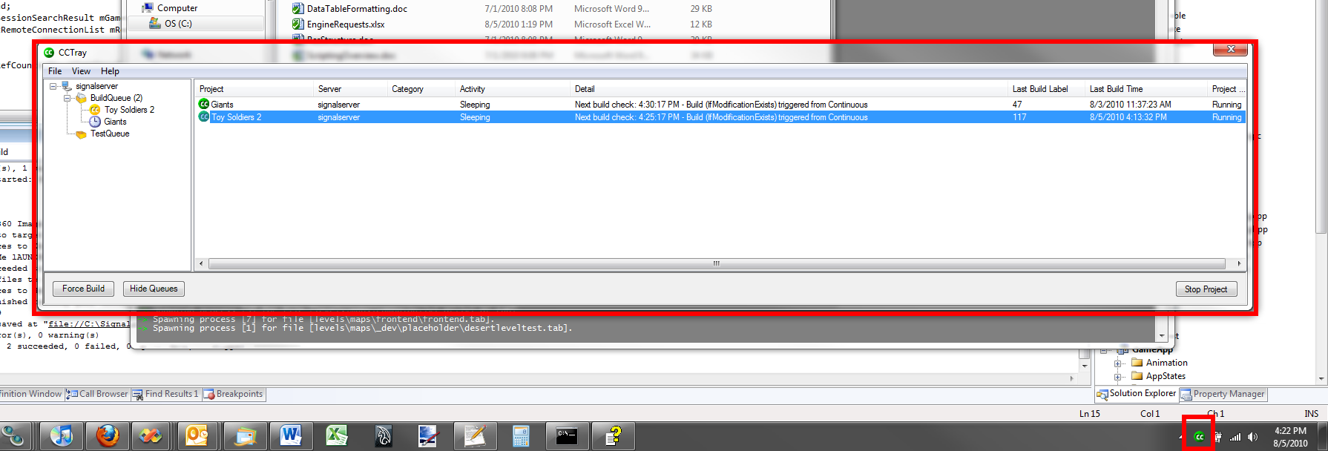

If you are using Windows 7, you will want to ***Customize…*** your lower-right tray icons to ***Show Icon and Notifications*** for Cruise Control.NET.

You can tell the state of the build by the color of the icon:

* Green Icon: The build is good
* Yellow Icon: The build is in the middle of processing
* Red Icon: The build is broken

# Submission Guidelines

* To submit, right-click and select **CommitChanges.cmd** – this will run **BuildRes.cmd** before bringing up the commit dialog in order to help ensure that you fix any local warnings before you commit changes.
* However, this process alone is not enough to guarantee that you won’t break the build.
* Hence, after submitting changes, wait until the build server has processed them to verify your changes don’t break the build. Ask for help on this step if you are unclear of how to do so. It is important that you not leave until you have verified your changes are ok.
* Generally speaking, you should not commit changes if the build is already broken – please wait until the build has been fixed before doing so.
* To get the latest changes from the build server, right-click and select **GetLatest.cmd**. It is not recommended that you get latest when the build is either “yellow” (building) or “red” (broken). The safest time to get latest is when the build is “green” (good).

# Tools that can help you

Sometimes, after moving/renaming files, you will want to verify that the depot is still in a good state. To help with this, you can run one of the various “rebuild” scripts, which will rebuild all of a specific resource type locally. The following commands can be run from the command line (cmd.exe):

* **RebuildSigmls.cmd**
* **RebuildMshmls.cmd**
* **RebuildFxmls.cmd**
* **RebuildAnipks.cmd**
* **RebuildNuts.cmd**
* **RebuildDermls.cmd**

Additionally, if you have the time, you can always perform a full clean of your local assets by running **CleanGame.cmd**, followed by **BuildRes.cmd** (these two are both accessible from the right-click menu).