Overview
Creating Squirrel scripts doesn’t require anything other than a simple text editor (wordpad or notepad). However, creating scripts becomes much easier when you have an “enhanced” text editor, such as is used for editing code. We recommend you use Visual Studio C++ Express for editing squirrel scripts, as you gain useful features such as excellent find and replace, brace and parenthesis matching, syntax coloring, and one-touch commands for compiling scripts directly from within the program. It’s also free!
This document outlines how to install Visual Studio C++ Express, as well as how to set it up for recommended use.

Step 1
Run “vcsetup.exe”, which you can get from the server at: Public\Installers\Misc\VisualStudioExpressC++2008\vcsetup.exe
When prompted to install extras, you can de-select everything (i.e., you don’t need any of the extras if you don’t want them – they’re only useful for C++).
You will probably have to re-boot at the end.

Step 2
By default, Visual Studio doesn’t recognize the extension “.nut”, and hence won’t provide any automatic syntax coloring.
To add the .nut extension as a recognized type, go to Tools|Options:
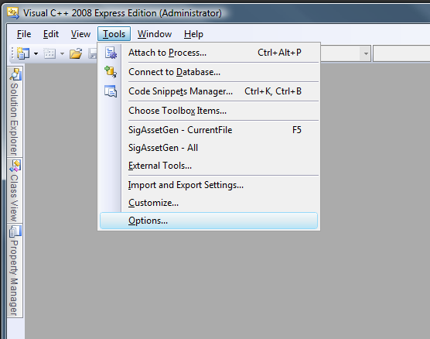
Then, from within the Options Dialog, go to Text Editor | File Extension; type in “.nut” in the provided “Extension” field, and click the Add button:
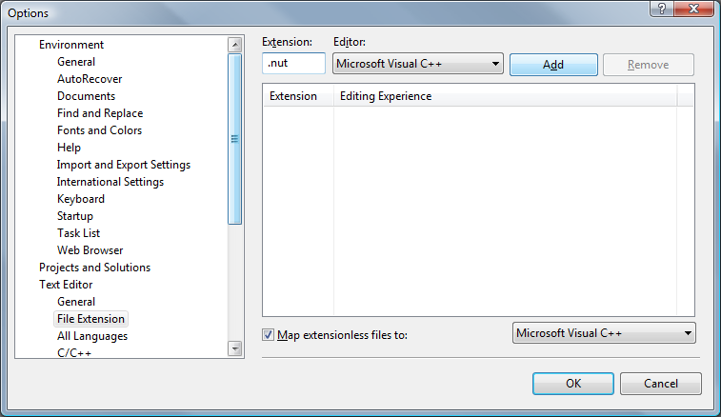
Now verify that the “nut” extension was added to the list:
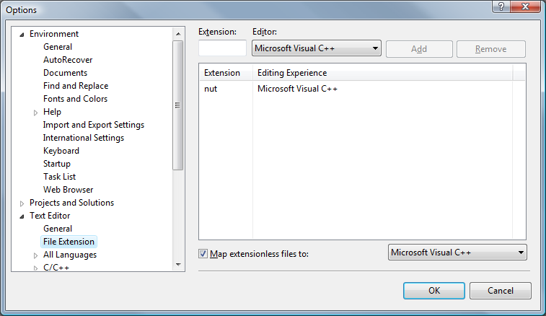
Click OK and you’re done with this step.

Step 3
When using syntax coloring, it’s useful for recognized keywords to become automatically colored. Squirrel and C++ have some keywords in common, however Squirrel has certain keywords that C++ doesn’t use. For these keywords to show up highlighted, we need to add an additional file to the Visual Studio program directory which informs it of the extra keywords to color.
You will want to create a simple text file (use Notepad or Wordpad) called “usertype.dat”, and save this file to the same directory as the Visual Studio C++ Express executable:
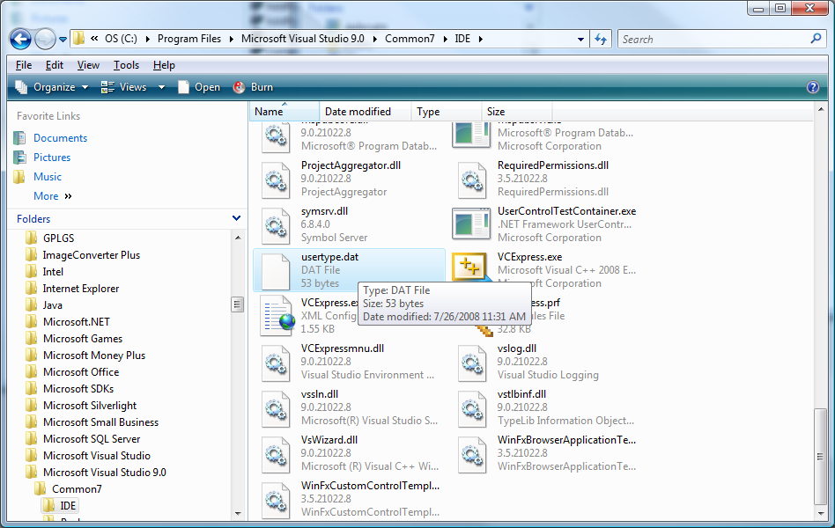
You will then want to add the keywords you would like highlighted to this file (one keyword per line). We suggest the following keywords for highlighting:
function
local
null
sigclass
sigimport
sigexport
You can add additional keywords here if you like.

Step 4
Now you’ll want to hook up commands for compiling scripts using SigAssetGen. We recommend you set up two commands: one to compile the “current” file you’re editing, and one to compile all files in your current project’s Res folder.
Go to Tools | External Tools:
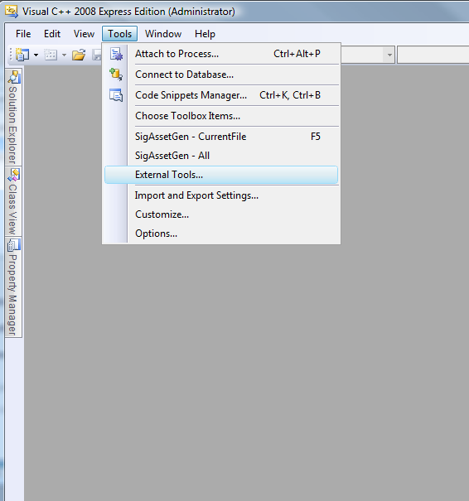
In the dialog box that comes up, delete all existing tools by selecting each and clicking the Delete button. Once the list is empty, you can click the Add button to add the first command:
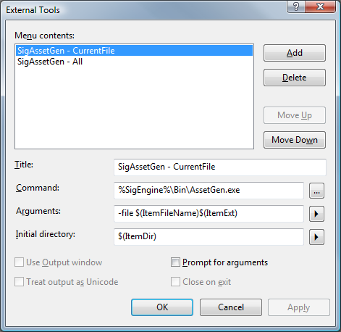
Type in the contents of all the fields so that they match the above screen shot exactly, and then click the “Apply” button.
Now we add the second tool (click the “Add” button).
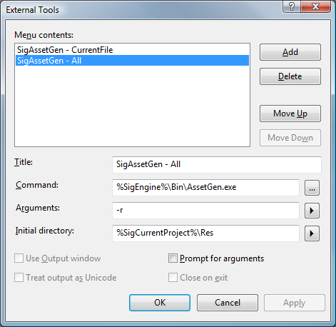
Again, fill out the fields so that they match exactly, and click Apply.
When you’re finished, click the OK button. Now, from the Tools menu, there should be two entries in the pull down menu, one marked SigAssetGen – Current File, the other marked SigAssetGen – All. You can now use these at any time to compile your scripts.
You can also hook these commands up to hot keys (ask a programmer how to do this, or feel free to add Step 5 to this document to show others how ☺).

