CS 157B / SE 157B

Database Management Systems II

Spring Semester 2013

Department of Computer Science

San José State University

Instructor: Ron Mak

**Team: VoidStarStar**

**Project #5 Data virtualization**

**Team members: Nam, Bryan, Greg**

*A screen shot of Composite Studio showing the creation of a view. The image*

*should include the graphical representation of the data sources and the joins.*

-Student_Info

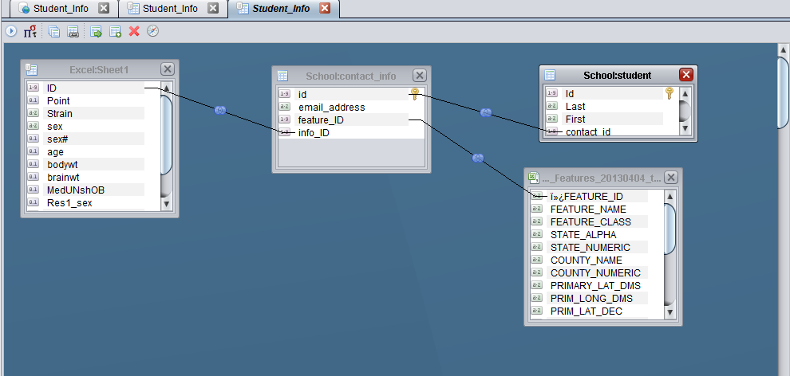

-Teacher_Info

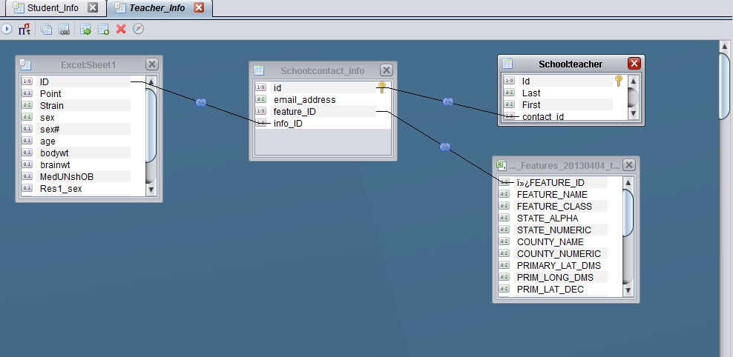

*A text file or screen shot showing the output of your client application.*

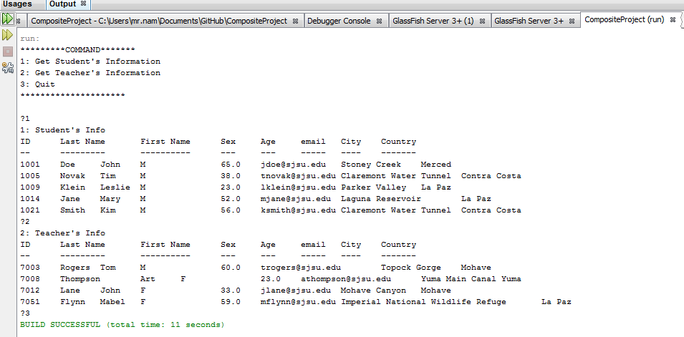

*A short written report that includes:*

* *A brief description of what your client application does and instructions on how to run it.*
  + The application will display information of student and teacher from virtual views of Composite server
  + Run file Test.Java
  + Need import csjdbc.jar from Composite, if running in Netbeans
* *A brief description of your data sources and how you found or created them.* 
  + School.sql: sample database from professor
  + CA_Features_20130404.txt: internet
  + QTL_Sample_data.xls: internet
  + All are stored in @cs08.cs.sjsu.edu

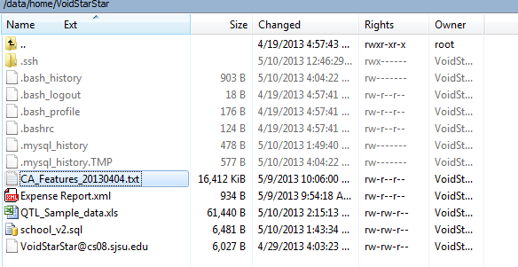

* *A brief description of your virtual views and how you joined your data sources to create them.*
  + 3 data sources have different type of primary key, so we have to change a little bit on them
    - School.sql, we add Feature_ID and Info_ID columns, and choose random values for them from QTL_Sample_data.xls and CA_Features_20130404.txt
    - QTL_Sample_data.xls, the type of ID is double, so we have to change back to INT.
    - QTL_Sample_data.xls, something wrong with column “age” while some values are greater than 100, we reduce them to under 100.
  + We use tables: **sheet1, CA_Features_20130404.txt, contact_info, and student (or teacher)**
    - Because we created Feature_ID and Info_ID columns, we just need to drag and drop their key to correct place.
    - Publish the views to data source
    - Use CompositeJDBC.java to call these data sources and print the result