Acknowledgement
First and foremost, I would like to express my sincere gratitude and heartfelt appreciation to my Project Supervisor, Dr. Kazi Muheymin-Us-Sakib, Professor, Institute of Information Technology (IIT), University of Dhaka, for his constant support, invaluable guidance, and constructive feedback throughout the conception, design, and implementation of the Research Bridge project. His deep expertise in software engineering, distributed systems, and applied machine learning fundamentally shaped the architectural framework of this system. Every review meeting sharpened both the engineering rigour and the academic framing of the work, and his insistence on measurable, verifiable outcomes is reflected in the evaluation methodology adopted in this report.
I am also deeply grateful to the faculty members and administrative staff of the Institute of Information Technology (IIT), University of Dhaka, for providing an enriching academic environment, well-equipped laboratories, and the computational resources necessary to prototype, containerise, and benchmark a multi-service platform of this scale. I extend special thanks to my peers and fellow researchers, whose candid discussions, usability feedback, and willingness to act as pilot testers helped refine the platform's features and user experience.
Finally, I wish to thank my family for their unwavering patience and encouragement during the many months of design, development, and writing. This work would not have been possible without their continued support.

Declaration
I hereby declare that this project report, titled 'Research Bridge: An AI-Powered Academic Collaboration and Research Discovery Platform', is my original work, executed under the supervision of Dr. Kazi Muheymin-Us-Sakib, Professor, Institute of Information Technology (IIT), University of Dhaka. The design decisions, source code, experimental methodology, and analytical results presented herein are the outcome of my own independent effort, except where explicit reference is made to the work of others.
No portion of this work has been submitted previously, in whole or in part, for the award of any degree, diploma, or other academic distinction at this or any other institution. All external libraries, datasets, and third-party services employed in the system have been duly acknowledged in the report and in the accompanying references. Any instance of similarity with existing literature is coincidental or appropriately cited.

Student Name: Mostofa Rezvi
Roll: 2506107

Signature: ...........................................
Date: August 2026

Certificate of Approval
This is to certify that the project report titled 'Research Bridge: An AI-Powered Academic Collaboration and Research Discovery Platform', submitted by Mostofa Rezvi (Exam Roll: 252024) to the Institute of Information Technology (IIT), University of Dhaka, in partial fulfillment of the requirements for the degree of Executive Master in Information Technology (EMIT), is a record of bona fide work carried out under my supervision. The report has reached the standard of fulfilling the requirements of the regulations relating to the degree. To the best of my knowledge, the content of this report has not been submitted elsewhere for the award of any other degree.

Project Title: Research Bridge: An AI-Powered Academic Collaboration and Research Discovery Platform
Student Name: Mostofa Aminur Rashid
Roll: 2506107 | Session: 2024–2025 | Program: EMIT

_____________________________________
Dr. Kazi Muheymin-Us-Sakib
Professor, Institute of Information Technology (IIT), University of Dhaka

Supervisor's Approval: .................................................
Date: August 2026

Abstract
Modern academic research is impeded by three persistent and mutually reinforcing bottlenecks. First, research discovery remains fragmented across disparate, weakly interoperable databases, forcing scholars to rely on brittle keyword search that fails to capture semantic intent. Second, peer collaboration is obstructed by institutional silos, the absence of trustworthy reputation signals, and a lack of real-time co-authoring tooling. Third, publication workflows remain largely manual, and the current generation of general-purpose Large Language Model (LLM) assistants frequently hallucinates citations, eroding the very trust that scholarly communication depends upon. Research Bridge is a modern, microservice-based web platform engineered to address these challenges within a single, unified academic ecosystem.
The platform is built as a decoupled, polyglot architecture: a Next.js (App Router) frontend, a Node.js/Express API gateway, and a Python FastAPI machine-learning service, backed by a polyglot persistence layer that pairs PostgreSQL, Redis, Elasticsearch, Neo4j, and S3-compatible object storage. Research Bridge integrates Sentence-BERT (SBERT) semantic matching with Elasticsearch k-Nearest-Neighbour (kNN) vector search, a Neo4j trust graph that computes a PageRank-derived TrustRank reputation score, and an Agentic Retrieval-Augmented Generation (RAG) conversational engine that grounds every answer in the platform's own corpus.
Key modules include an AI Discovery Engine for researcher and paper matchmaking; real-time Collaborative Workspaces with conflict-free rich-text versioning; a Publication Assistant integrated with the Directory of Open Access Journals (DOAJ) and Scimago; a TrustRank reputation-gated Community Forum; a structured Mentorship module; a personal Research Library with PDF ingestion; and a verified Researchers Directory. A defining reliability property of the system is graceful degradation: when the generative LLM is unavailable, the Agentic RAG engine deterministically falls back to extractive, grounded answers rather than failing. The system is containerised and orchestrated on Kubernetes with a Horizontal Pod Autoscaler and comprehensive telemetry. Empirical evaluation demonstrates sub-45-millisecond vector retrieval, an API gateway throughput exceeding 1,450 requests per second, and sub-two-second grounded conversational responses, validating the platform's suitability for real-time academic workflows.
Keywords: Semantic Search, Sentence-BERT, Retrieval-Augmented Generation, Trust Graph, TrustRank, Neo4j, Microservices, Real-Time Collaboration, Academic Social Network.

Table of Contents

Acknowledgement 1
Declaration 2
Certificate of Approval 3
Abstract 4
Table of Contents 5
Chapter 1: Introduction 7
1.1 Background & Motivation 7
1.2 Problem Statement 8
1.3 Project Objectives 8
1.4 Scope of the Project 9
1.5 Significance and Contributions 9
1.6 Organisation of the Report 10
Chapter 2: Literature Review & Related Work 11
2.1 Overview of Existing Academic Platforms 11
2.2 Foundational Techniques 11
2.2.1 Semantic Sentence Embeddings (SBERT) 11
2.2.2 Retrieval-Augmented Generation (RAG) 12
2.2.3 Graph-Based Reputation Ranking (PageRank / TrustRank) 12
2.2.4 Conflict-Free Real-Time Collaboration (CRDTs) 12
2.3 Identified Research Gap 12
2.4 Proposed Solution Highlights 13
Chapter 3: System Analysis and Requirements 14
3.1 Requirement Gathering 14
3.2 Functional Requirements 14
3.3 Non-Functional Requirements 15
3.4 Feasibility Study 16
3.5 Risk Analysis 17
Chapter 4: System Architecture and Design 18
4.1 System Architecture Overview 18
4.1.1 Service Responsibilities 19
4.2 Use Case Modeling 19
4.3 Data Flow Diagrams (DFD) 20
4.4 Agentic RAG Design 21
4.5 Trust Graph & TrustRank Design 23
4.6 Database Schema & Entity Relationships 24
4.7 Security & Deployment Architecture 25
Chapter 5: Implementation & Project View 26
5.1 Tools and Technology Stack 26
5.2 Module Implementation Details 26
5.2.1 Authentication, Identity & Profiles 26
5.2.2 AI Discovery Engine 26
5.2.3 Agentic RAG Assistant 27
5.2.4 Real-Time Collaborative Workspace 27
5.2.5 Community Forum, Mentorship & Publications 27
5.3 User Interface & Feature Walkthrough 27
5.3.1 Landing Page & Platform Gateway 27
5.3.2 User Authentication & Login Interface 28
5.3.3 Account Registration & Onboarding Interface 28
5.3.4 Personalized Dashboard & Activity Overview 29
5.3.5 AI Research Discovery Engine View 30
5.3.6 Real-Time Collaborative Workspace 30
5.3.7 Research Groups & Collaborative Communities 31
5.3.8 Research Library & Collection Management 32
5.3.9 AI Research Assistant (Agentic RAG) Conversational View 32
5.3.10 Community Forum & TrustRank Reputation System 33
5.3.11 Mentorship Matchmaking & Guidance Module 33
5.3.12 Verified Researchers Directory & Profiles 34
5.4 Database Collections & Schemas 35
Chapter 6: Testing and Results 36
6.1 Unit & Integration Testing 36
6.2 Performance & Benchmark Results 36
6.3 Agentic RAG Evaluation & Graceful Fallback 37
6.4 Discussion of Results 37
Chapter 7: Conclusion and Future Work 38
7.1 Project Summary 38
7.2 Achievements Against Objectives 38
7.3 Limitations 38
7.4 Future Work 38
7.5 Conclusion 39
References 40
List of Tables 41
List of Figures 41
List of Abbreviations 41
Appendix A: API & Infrastructure Specification 43
Appendix B: Deployment & Operations 44
Appendix C: Glossary of Key Terms 45

Chapter 1: Introduction
This chapter establishes the context, motivation, and objectives of the Research Bridge platform. It begins by situating the project within the broader landscape of digital scholarship, articulates the specific problems the system addresses, enumerates the project's objectives and scope, states the principal contributions, and concludes with an outline of how the remainder of the report is organised.

1.1 Background & Motivation
Academic research is the foundation of scientific innovation, technological advancement, and societal development. Over the past two decades, the volume of scholarly output has grown at an exponential rate: millions of new articles, pre-prints, and datasets are published every year across an ever-widening constellation of journals, conferences, and repositories. While this growth is a testament to the vitality of global research, it has also produced a paradox of plenty. The very abundance that should accelerate discovery instead overwhelms the individual researcher, who must now navigate a fragmented, loosely-coupled information landscape using tools that were, for the most part, designed for a smaller and slower-moving world.
Traditional research portals—whether static publication repositories, citation indices, or general-purpose social media platforms repurposed for academic use—suffer from a common set of structural limitations. They typically rely on lexical, keyword-based retrieval that matches surface strings rather than underlying meaning; consequently, a query for 'low-resource machine translation' may fail to surface a highly relevant paper that instead uses the phrase 'neural MT for under-resourced languages'. They rarely model the social and reputational fabric of the research community in a way that distinguishes credible contributions from noise. And they offer little in the way of integrated, trustworthy artificial-intelligence assistance: the AI features that do exist are frequently bolted on, ungrounded, and prone to fabricating references.
Research Bridge is motivated by the conviction that these problems are not independent but deeply interconnected, and that a genuinely useful academic platform must therefore treat discovery, collaboration, reputation, and AI assistance as facets of a single, coherent system rather than as isolated products. The research lifecycle—from the moment a scholar first identifies a knowledge gap, through literature review, co-authoring, peer discussion, mentorship, and finally publication—is a continuous loop. A tool that optimises one stage while ignoring the others simply displaces the friction rather than removing it. The motivation for this project is, therefore, to design and build an end-to-end ecosystem in which each stage feeds naturally into the next, and in which every intelligent feature is anchored to verifiable evidence drawn from the platform's own corpus.

1.2 Problem Statement
A careful examination of contemporary academic tooling reveals three major, recurring challenges that collectively motivate the design of Research Bridge:
- Information Overload & Poor Matching: Researchers routinely struggle to identify semantically relevant papers and potential collaborators. Keyword search is blind to synonymy, paraphrase, and conceptual proximity, so genuinely related work is missed while irrelevant lexical matches crowd the results. The problem is compounded at scale: the more literature that exists, the worse the signal-to-noise ratio becomes.
- Academic Isolation & Low Trust: Early-career researchers face significant barriers to finding experienced mentors, and the broader community has no principled way to distinguish trustworthy contributions from low-quality or adversarial content. Without a reputation model grounded in real scholarly behaviour, discussion forums are vulnerable to spam, and the social capital that underpins healthy collaboration is invisible and unusable.
- Unreliable AI Assistance: Existing general-purpose LLM assistants often hallucinate citations or produce unverified answers, making them unsafe for scholarly work where provenance is paramount. A tool that confidently invents a plausible-looking but non-existent reference is worse than no tool at all, because it undermines the reader's ability to trust any of its output.
The central problem this project addresses can thus be stated concisely: how can a single, scalable platform unify semantic research discovery, trustworthy reputation-gated collaboration, and grounded, non-hallucinating AI assistance, while remaining reliable enough for daily use even when external dependencies degrade?

1.3 Project Objectives
The primary objectives of the Research Bridge project are defined to be specific, measurable, and directly traceable to the problems identified above:
- Unified Academic Portal: Develop a high-performance, decoupled web application—using Next.js on the frontend and an Express microservice gateway on the backend—that unifies the entire academic lifecycle behind a single authenticated experience.
- AI Discovery Engine: Deploy Sentence-Transformers (SBERT) 768-dimensional embeddings together with Elasticsearch kNN vector search to deliver real-time, meaning-aware matching of papers, topics, and authors.
- Agentic RAG Assistant: Build a hybrid Retrieval-Augmented Generation chat system supporting grounded paper question-answering, whole-volume summarisation, and cited conversational search, with deterministic extractive fallback when the generative model is unavailable.
- Reputation & Trust Graph: Implement Neo4j graph algorithms (a PageRank-derived TrustRank) to gate discussions, verify credentials, and surface suggested collaborators through second-degree graph traversal.
- Publication Assistant: Provide live journal matching against Directory of Open Access Journals (DOAJ) and Scimago data, along with LLM-assisted citation formatting and structured manuscript feedback.
- Reliability & Scalability: Guarantee operational reliability through containerised Kubernetes orchestration, a Horizontal Pod Autoscaler, comprehensive telemetry, and graceful degradation across every AI code path.

1.4 Scope of the Project
The scope of the project encompasses the complete, end-to-end research lifecycle. It spans user onboarding and identity verification; semantic discovery of papers and collaborators; real-time collaborative document authoring; a personal research library with automatic PDF text extraction; an AI assistant offering chat, summarisation, and paper question-answering; a reputation-gated community forum; a structured mentorship module; a publication assistant with journal recommendation; and an administrative surface for indexing, moderation, and telemetry. The platform is delivered as a web-first, responsive application intended for desktop and tablet browsers.
Certain items are explicitly out of scope for the present iteration and are deferred to future work: native mobile applications for iOS and Android; fully on-premise LLM hosting; automated end-to-end peer review; and integration with institutional single-sign-on federations beyond the OAuth providers already supported. Defining these boundaries keeps the project tractable within the available time and resources while leaving clear, well-understood extension points.

1.5 Significance and Contributions
The significance of Research Bridge lies in its integrative approach: rather than optimising a single slice of the research workflow, it demonstrates that semantic retrieval, graph-based reputation, and grounded generative AI can be composed into one coherent, production-grade system. The principal contributions of this project are as follows:
- Architectural contribution: A reference microservices architecture that cleanly separates a stateless presentation tier, a security-enforcing API gateway, and a horizontally-scalable machine-learning service, coordinated over a polyglot persistence layer.
- Reliability contribution: A bounded, agentic RAG pipeline (plan → retrieve → synthesise → degrade) that guarantees every answer is either grounded in retrieved sources or honestly declares the absence of evidence, and that never returns a hard error to the user even when the LLM provider is rate-limited.
- Reputation contribution: An academic TrustRank model built on a Neo4j property graph that fuses mentorship, endorsement, authorship, citation, and community-engagement signals into a single propagated reputation score used to rank feeds and gate participation.
- Empirical contribution: An empirical evaluation of latency, throughput, and fallback behaviour that quantifies the platform's fitness for real-time academic workloads.

1.6 Organisation of the Report
The remainder of this report is organised into six further chapters. Chapter 2 surveys existing academic platforms and the foundational literature on semantic search, retrieval-augmented generation, graph-based reputation, and collaborative editing, and identifies the research gap that Research Bridge fills. Chapter 3 presents the system analysis, including requirement gathering, the functional and non-functional requirements, a multi-dimensional feasibility study, and a risk analysis. Chapter 4 details the system architecture and design, covering the microservices decomposition, use-case and data-flow modelling, the polyglot database schema, and the security and deployment architecture. Chapter 5 describes the implementation, walking through the technology stack, each functional module, the user-interface, and the core algorithms. Chapter 6 reports the testing methodology and experimental results. Chapter 7 concludes the report, discusses limitations, and outlines directions for future work. References and appendices follow.

Chapter 2: Literature Review & Related Work
This chapter reviews the state of the art relevant to Research Bridge along two axes. The first surveys existing academic platforms and characterises what each does well and where each falls short. The second examines the foundational techniques—semantic sentence embeddings, retrieval-augmented generation, graph-based reputation ranking, and conflict-free collaborative editing—on which the platform's intelligent features are built. The chapter closes by synthesising these two threads into a precise statement of the research gap and a summary of how the proposed solution addresses it.

2.1 Overview of Existing Academic Platforms
The current ecosystem of scholarly tooling is best understood as a collection of specialised products, each catering to a particular slice of the academic lifecycle rather than to the lifecycle as a whole:
- Google Scholar: Provides broad, authoritative indexing of scholarly literature and citation counts, but relies predominantly on lexical keyword matching. It offers no native collaboration surface, no reputation model beyond raw citation tallies, and no grounded conversational assistance.
- ResearchGate & Academia.edu: Focus on social networking, profile building, and paper sharing among scholars. They foster visibility but lack real-time co-authoring, principled reputation gating, and semantic discovery; their recommendation feeds are largely engagement-driven rather than meaning-driven.
- arXiv & OpenReview: Offer fast, open pre-print access and, in the case of OpenReview, transparent peer review, but they provide no structured mentorship modules, no integrated reputation graph, and no in-platform AI assistant grounded in their own corpus.
- Zotero & Mendeley: Excel at reference management and personal library organisation, and support lightweight group libraries, but they are not discovery engines, do not model community trust, and do not offer grounded question-answering over a user's collection.
- General-purpose LLM chat tools: Provide powerful general-purpose conversation and drafting, but they are not grounded in a curated scholarly corpus, cannot cite verifiable in-platform sources, and are known to hallucinate references, which makes them unsafe as primary research instruments.

2.2 Foundational Techniques

2.2.1 Semantic Sentence Embeddings (SBERT)
Sentence-BERT, introduced by Reimers and Gurevych (2019), adapts the pre-trained BERT transformer into a siamese-network architecture that produces fixed-length sentence embeddings whose cosine similarity is a meaningful measure of semantic relatedness. Whereas vanilla BERT requires both sentences to be fed through the network together—an O(n²) proposition that is computationally prohibitive for retrieval over large corpora—SBERT encodes each sentence independently into a dense vector, enabling the pre-computation of embeddings and sub-linear approximate nearest-neighbour search. Research Bridge adopts 768-dimensional SBERT embeddings as the semantic backbone of its discovery, library search, journal recommendation, and RAG retrieval subsystems.

2.2.2 Retrieval-Augmented Generation (RAG)
Retrieval-Augmented Generation, formalised by Lewis et al. (2020), combines a parametric generative model with a non-parametric retrieval component: rather than relying solely on knowledge baked into the model's weights, the system first retrieves relevant documents from an external corpus and then conditions generation on that retrieved evidence. This paradigm directly mitigates hallucination, because the generator is instructed to answer only from the supplied context, and it enables verifiable citation, because each claim can be traced to a retrieved source. Research Bridge extends the basic RAG pattern into a bounded agentic loop—planning, retrieval, synthesis, and graceful degradation—described in detail in Chapter 4.

2.2.3 Graph-Based Reputation Ranking (PageRank / TrustRank)
The PageRank algorithm of Page, Brin, Motwani, and Winograd (1999) models importance as the stationary distribution of a random walk over a directed graph, in which a node's rank is recursively determined by the ranks of the nodes that point to it. TrustRank refines this idea by biasing the propagation toward a seed set of known-trustworthy nodes, so that reputation flows outward from credible sources. Research Bridge applies this family of algorithms to a heterogeneous academic trust graph in which researchers, papers, and institutions are connected by mentorship, endorsement, authorship, citation, and community-support relationships, yielding a propagated TrustRank score that gates participation and ranks content.

2.2.4 Conflict-Free Real-Time Collaboration (CRDTs)
Real-time collaborative editing requires that concurrent edits by multiple authors converge to a consistent document without a central locking authority. Conflict-free Replicated Data Types (CRDTs) provide a principled solution: operations are designed to be commutative and idempotent so that replicas converge regardless of the order in which updates are applied. Research Bridge's collaborative workspace is built on the Yjs CRDT framework integrated with the TipTap rich-text editor, delivering low-latency, conflict-free multi-author editing with presence awareness.

2.3 Identified Research Gap
Synthesising the survey above yields a clear conclusion: none of the surveyed platforms offers a single, unified ecosystem that simultaneously combines (a) SBERT-based vector semantic discovery, (b) a graph-based academic reputation model that gates collaboration, (c) an agentic RAG assistant grounded in the platform's own corpus with verifiable citations and reliable fallback, and (d) real-time, conflict-free collaborative authoring—all within one coherent, production-grade, horizontally-scalable system. Individual capabilities exist in isolation across many products, but their integration is precisely where the compounding value lies, and precisely what the market lacks.
Table 6. Comparative Analysis of Existing Academic Platforms.
Capability | Scholar | ResearchGate | arXiv | Zotero | Research Bridge
Semantic (SBERT) discovery | No | Partial | No | No | Yes
Graph reputation gating | No | No | No | No | Yes
Grounded RAG assistant | No | No | No | No | Yes
Real-time co-authoring | No | No | No | Partial | Yes
Journal recommendation | No | Partial | No | No | Yes
Structured mentorship | No | Partial | No | No | Yes

2.4 Proposed Solution Highlights
Research Bridge bridges the identified gap by offering a cohesive microservices platform that combines frontend interactivity, a security-enforcing gateway, and a dedicated machine-learning service. It unifies semantic discovery, an agentic and grounded RAG assistant, a Neo4j TrustRank reputation graph, real-time collaborative workspaces, live journal recommendation, and structured mentorship into one authenticated experience. Crucially, every intelligent feature is engineered for reliability first: retrieval always runs, generation degrades gracefully, and no external dependency is allowed to render the platform unusable. The chapters that follow detail how these design commitments are realised in analysis, architecture, implementation, and evaluation.

Chapter 3: System Analysis and Requirements
This chapter translates the motivations of Chapter 1 into a rigorous specification. It describes how requirements were elicited, enumerates the functional and non-functional requirements, assesses the project's feasibility across technical, economic, operational, legal, and schedule dimensions, and presents a structured analysis of the principal risks together with their mitigations.

3.1 Requirement Gathering
System requirements were synthesised from multiple complementary sources to ensure that the resulting specification reflected genuine user needs rather than assumptions. Structured surveys were distributed to academic users spanning postgraduate students, early-career researchers, and senior faculty, probing their pain points in discovery, collaboration, and publication. These were supplemented by semi-structured interviews that surfaced qualitative insight into the mentorship relationship and the trust signals scholars actually rely upon. A competitive analysis of the platforms surveyed in Chapter 2 identified concrete feature gaps, while a review of the academic literature grounded the choice of algorithms. Finally, the requirements were iteratively refined against technical feasibility, so that the specification remained ambitious yet achievable within the project's constraints.
The elicited needs were consolidated into a stakeholder-oriented model. The principal stakeholders are the researcher (the primary end user), the collaborator (a researcher acting within a shared workspace), the mentor (a senior or verified scholar offering guidance), and the administrator (responsible for indexing, moderation, and operations). Each requirement below is traceable to one or more of these stakeholders.

3.2 Functional Requirements
The functional requirements specify the observable behaviours the platform must provide to satisfy its stakeholders. They are captured in the requirements matrix below, each identified by a stable requirement identifier and mapped to the module that realises it.
Table 2. Functional Requirements Matrix.
Req ID | Module | Functional Requirement Description
FR-01 | Authentication & Profile | JWT authentication with refresh-token rotation, institutional email verification, OAuth (Google/GitHub) login, optional email OTP two-factor, and rich researcher profiles.
FR-02 | AI Discovery Engine | SBERT semantic similarity matching over papers, authors, and projects via Elasticsearch kNN, with collaborative- and content-based recommendation.
FR-03 | Agentic RAG Assistant | Grounded, cited conversational chat, whole-volume summarisation, and single-paper question-answering, with extractive fallback when the LLM is unavailable.
FR-04 | Collaborative Workspace | Real-time multi-author rich-text editing (TipTap + Yjs CRDT), document versioning, presence cursors, and team management.
FR-05 | Research Library | Personal library with PDF upload, automatic full-text extraction, semantic + full-text search, and cross-user discovery of shared items.
FR-06 | Community Forum | Threaded questions and thoughts, voting, accepted answers, and a TrustRank-weighted feed with reputation-gated participation.
FR-07 | Mentorship Module | Mentor recommendation (semantic + domain + tier), mentorship slots, requests, and scheduled sessions with progress tracking.
FR-08 | Publication Assistant | Live journal recommendation over Scimago/DOAJ, LLM citation formatting (BibTeX/APA/IEEE), and structured five-dimension writing feedback.
FR-09 | Projects & Tasks | Research projects with milestones and tasks, assignment, and status tracking across collaborating teams.
FR-10 | Administration & Telemetry | Elasticsearch/Neo4j backfill, moderation queue, tamper-evident profile audit log, Prometheus metrics, and deep health checks.

3.3 Non-Functional Requirements
Beyond observable behaviour, the platform must satisfy a set of quality attributes that determine whether it is fit for real-world academic use. These non-functional requirements were defined with explicit, verifiable targets so that they could be validated empirically during testing:
- Performance: Sub-second, indeed sub-100-millisecond, vector retrieval, and low API-gateway latency under concurrent load, so that discovery and assistance feel instantaneous.
- Security: JWT token encryption, bcrypt password hashing, Helmet security headers, celebrate/Joi request validation, Redis-backed rate limiting, and strict server-side authorisation on every route.
- Scalability: A stateless application tier that scales horizontally, with a Kubernetes Horizontal Pod Autoscaler provisioning between two and ten replicas of the ML service in response to load.
- Availability: A target of 99.9% availability, achieved through Redis caching, primary-replica PostgreSQL replication, health-checked pods, and—critically—graceful degradation of every AI code path.
- Usability: A responsive, accessible, keyboard-navigable interface with clear feedback, consistent design language, and progressive disclosure of complex features.
- Maintainability: A modular, well-documented, test-covered codebase organised as loosely-coupled services, so that individual components can evolve independently.
Table 3. Non-Functional Requirements & Verification Targets.
Attribute | Target | Verification Method
Vector retrieval latency | < 100 ms (achieved < 45 ms) | Instrumented benchmark on seeded corpus
API gateway throughput | > 1,000 req/s | Concurrent load test (achieved > 1,450 req/s)
Grounded RAG response | < 2 s generative; < 0.5 s fallback | End-to-end latency measurement
ML service scaling | 2–10 replicas via HPA | Kubernetes HPA under synthetic load
Availability | 99.9% uptime | Health checks + graceful degradation
Security | No plaintext secrets; all routes authorised | Static review + endpoint auth tests

3.4 Feasibility Study
A multi-dimensional feasibility study was conducted before committing to the design, to confirm that the project could be delivered within its technical, economic, operational, legal, and schedule constraints.
Technical feasibility is established through a mature, well-supported open-source stack—Node.js, Next.js, FastAPI, PostgreSQL, Redis, Elasticsearch, and Neo4j—each of which is production-proven and richly documented. Every algorithm the platform depends upon (SBERT embeddings, kNN retrieval, PageRank, CRDT merging) has a robust reference implementation, eliminating fundamental research risk. Economic feasibility is favourable because the entire stack is open-source and self-hostable; the only recurring external cost is optional LLM inference, which the graceful-degradation design renders non-essential. Operational feasibility is supported by containerisation and Kubernetes orchestration, which standardise deployment and scaling. Legal and ethical feasibility rests on the use of open metadata sources (DOAJ, Scimago, OpenAlex) and on privacy-respecting handling of user data. Schedule feasibility was managed through an incremental, additive delivery methodology in which each feature was shipped without breaking existing functionality.
Table 4. Feasibility Assessment Summary.
Dimension | Assessment | Basis
Technical | Feasible | Mature open-source stack; reference algorithm implementations available
Economic | Feasible | Self-hostable OSS; LLM cost optional due to fallback design
Operational | Feasible | Docker + Kubernetes standardise deploy, scale, and recovery
Legal / Ethical | Feasible | Open metadata sources; privacy-respecting data handling
Schedule | Feasible | Incremental, additive delivery; non-breaking increments

3.5 Risk Analysis
A proactive risk register was maintained throughout the project. Each risk was rated for likelihood and impact, and paired with a concrete mitigation. The most significant risks and their mitigations are summarised below.
Table 5. Project Risk Register & Mitigations.
Risk | Impact | Mitigation
External LLM rate limits / outage | High | Deterministic extractive fallback; retrieval always runs; degraded flag surfaced to UI
Cold-start empty vector index | Medium | Admin backfill endpoint seeds Elasticsearch and Neo4j from existing data
Concurrent-edit data loss | High | Yjs CRDT guarantees convergence without central locking
Credential / secret leakage | High | Environment-based secrets, Kubernetes Secrets, no plaintext in code
Service overload under peak | Medium | HPA autoscaling, Redis caching, rate limiting
Data inconsistency across stores | Medium | Single source of truth per entity; idempotent backfill reconciliation

Chapter 4: System Architecture and Design
This chapter presents the architecture and design of Research Bridge in depth. It begins with a high-level view of the microservices decomposition, then models the system's behaviour through use cases and data-flow diagrams, details the core intelligent algorithms, describes the polyglot database design, and closes with the security and deployment architecture.

4.1 System Architecture Overview
Research Bridge adopts a decoupled microservices architecture organised into three core application tiers backed by a polyglot persistence layer. This separation of concerns allows each tier to be developed, deployed, scaled, and hardened independently, and it isolates heavy machine-learning computation from the latency-sensitive request path of the API gateway.
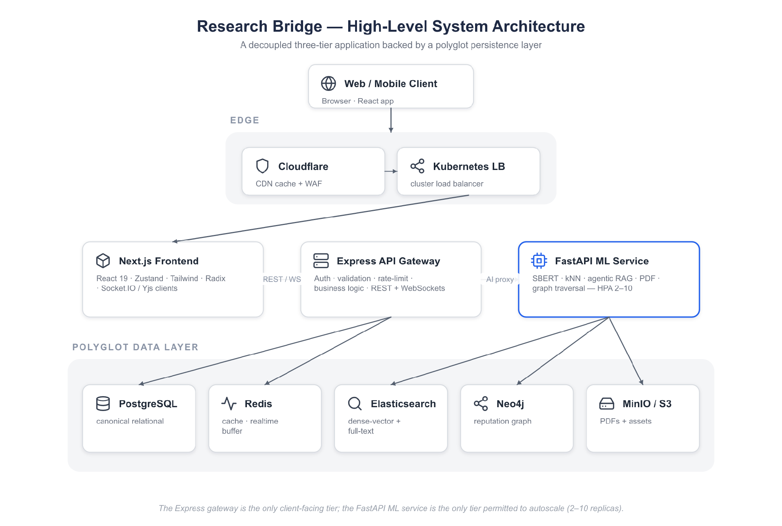
Figure 1. Research Bridge High-Level System Architecture.
The architecture is layered as follows. At the edge, Cloudflare provides CDN caching and a Web Application Firewall in front of a Kubernetes load balancer. The presentation tier is a Next.js (App Router) application using React 19, Zustand for client state, Tailwind CSS and Radix UI for the design system, and Socket.IO/Yjs clients for real-time features. The API gateway is a Node.js/Express 5 service that enforces authentication and authorisation, validates and sanitises input, applies rate limiting, and orchestrates business logic; it communicates with the browser over REST and WebSockets. The machine-learning tier is a Python FastAPI service that owns all heavy computation—SBERT embedding, kNN retrieval, the agentic RAG loop, PDF extraction, and Neo4j graph traversal—and is the only tier permitted to scale aggressively under load.

4.1.1 Service Responsibilities
- Frontend (Next.js): Interactive UI and client-side state management. Renders dashboards, chat, the collaborative editor, and all module views; performs server-side auth checks where appropriate; never holds secrets.
- Backend (Express): Business logic, API gateway, and security enforcement. Owns authentication, authorisation, request validation, rate limiting, persistence to PostgreSQL/Redis, real-time Socket.IO handling, and server-side TrustRank validation. Proxies AI requests to the ML service.
- ML Service (FastAPI): Heavy computation: SBERT matching, Elasticsearch kNN retrieval, the agentic RAG pipeline, PDF text extraction, and Neo4j trust-graph traversal. Configured with a Horizontal Pod Autoscaler for two to ten replicas.
- Data Layer: PostgreSQL for canonical relational data, Redis for caching and real-time buffering, Elasticsearch for dense-vector and full-text search, Neo4j for the reputation and citation graph, and S3-compatible object storage (MinIO) for PDFs and assets.

4.2 Use Case Modeling
The system supports four primary actor roles—Researcher, Collaborator, Mentor, and Administrator—each with a distinct set of goals. The Level 0 system-context use-case diagram below situates these actors against the platform boundary and its principal use cases.
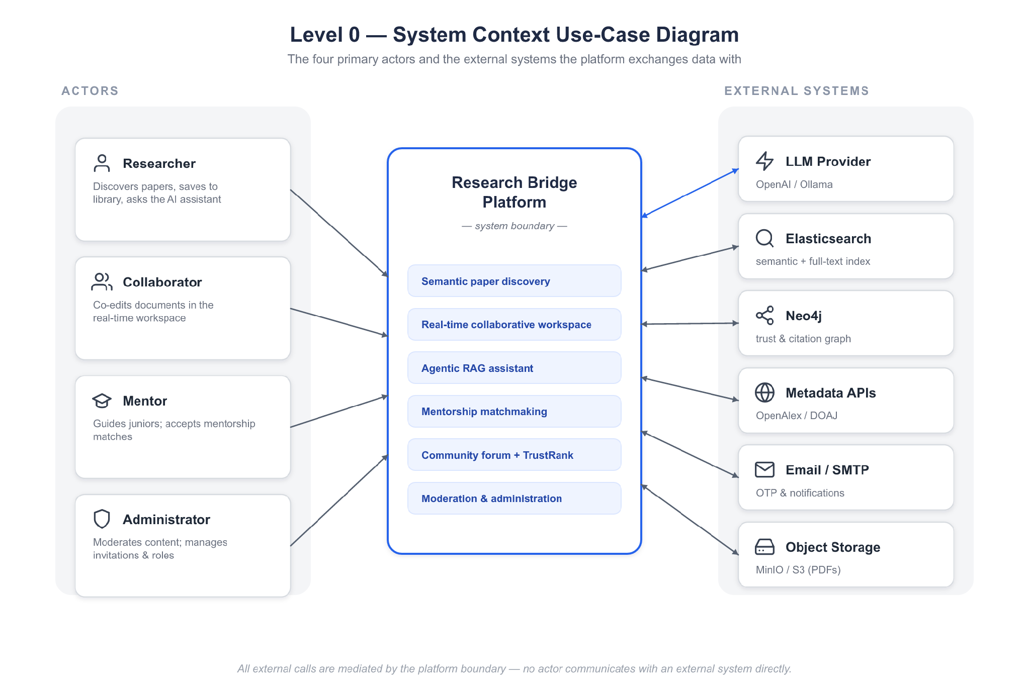
Figure 2. Level 0 System Context Use Case Diagram.
Actor | Representative Use Cases
Researcher | Search papers semantically, invoke the RAG chat assistant, view DOAJ/Scimago journal matches, manage a personal library, request mentorship, participate in the forum.
Collaborator | Edit shared workspace documents in real time, upload pre-prints, manage project milestones and tasks, co-author manuscripts.
Mentor | Publish mentorship slots, review mentee requests and proposals, schedule sessions, track milestone progress, endorse researchers.
Administrator | Backfill Elasticsearch indices and the Neo4j graph, moderate flagged content, monitor Prometheus telemetry, manage users and verification.

4.3 Data Flow Diagrams (DFD)
Data-flow modelling clarifies how information moves through the system from external entities, through processes, to data stores and back. The Level 0 diagram treats the platform as a single process exchanging authentication, query, and content flows with users and external metadata providers. The Level 1 diagram, shown below, decomposes the two most complex internal pipelines: the agentic RAG request path and the real-time collaboration path.
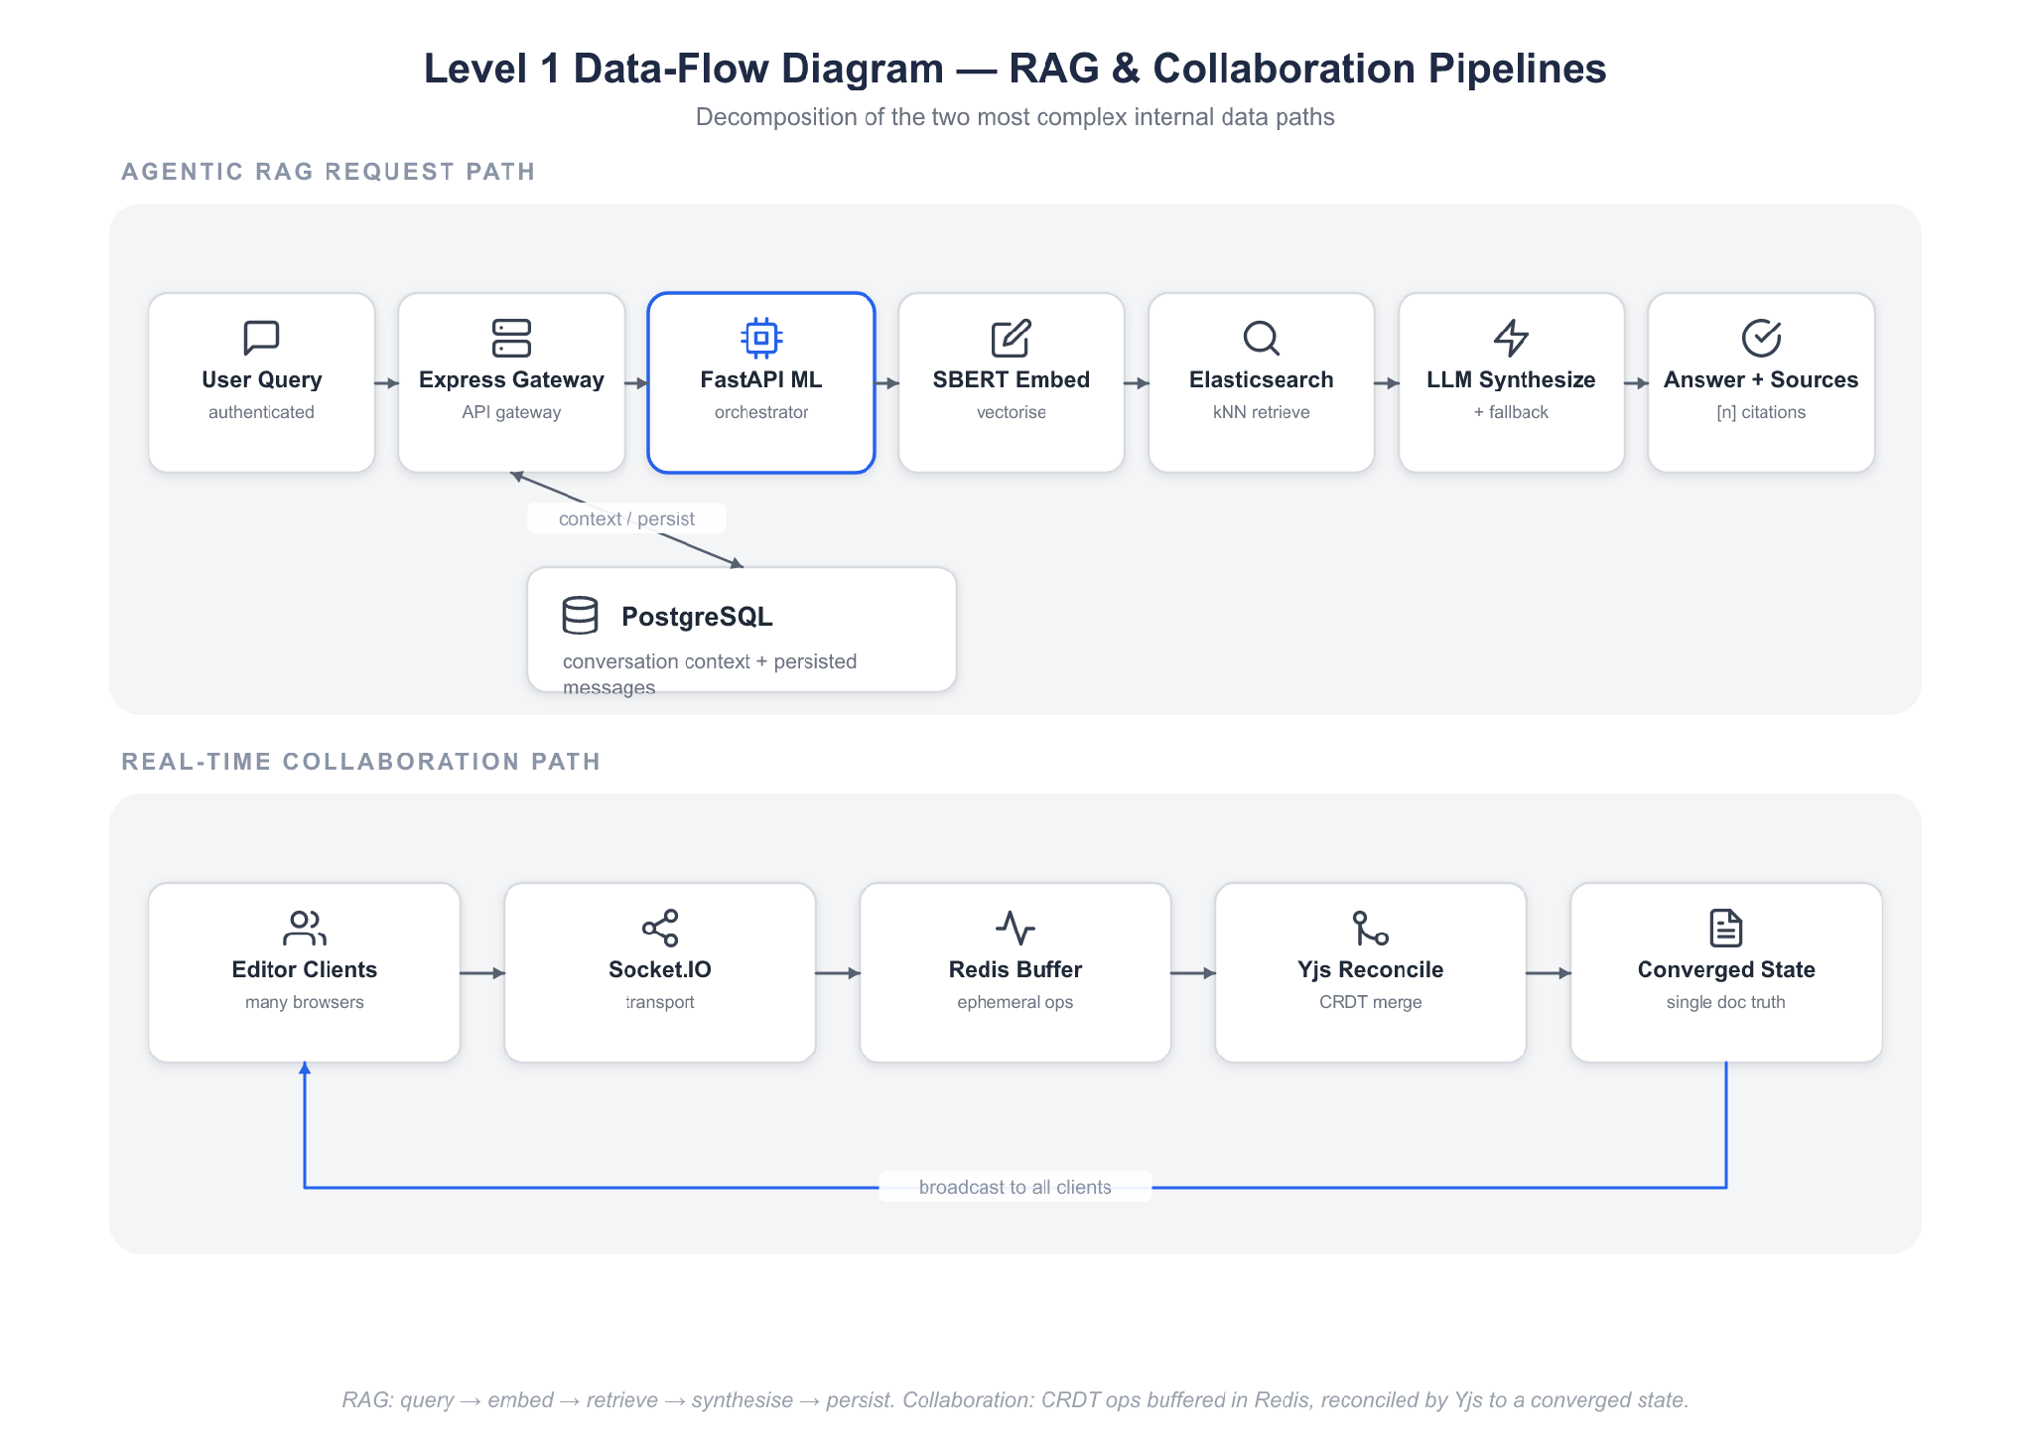
Figure 3. Level 1 Data Flow Diagram (RAG & Collaboration).
In the RAG path, an authenticated query enters the Express gateway, which loads recent conversation context from PostgreSQL and proxies the request to the FastAPI ML service. There the query is embedded with SBERT, retrieved against Elasticsearch kNN indices, synthesised by the LLM (or the extractive fallback), and returned with its sources; the gateway then persists the user and assistant messages. In the collaboration path, editor operations are propagated as CRDT updates over Socket.IO, buffered in Redis, and reconciled by Yjs so that all connected clients converge on an identical document state.

4.4 Agentic RAG Design
The Agentic RAG engine is the intellectual centrepiece of the platform and is designed as a bounded loop that is guaranteed to terminate and guaranteed never to fail hard. It performs at most two LLM calls and at most two retrieval rounds per request, and it degrades gracefully at every step.
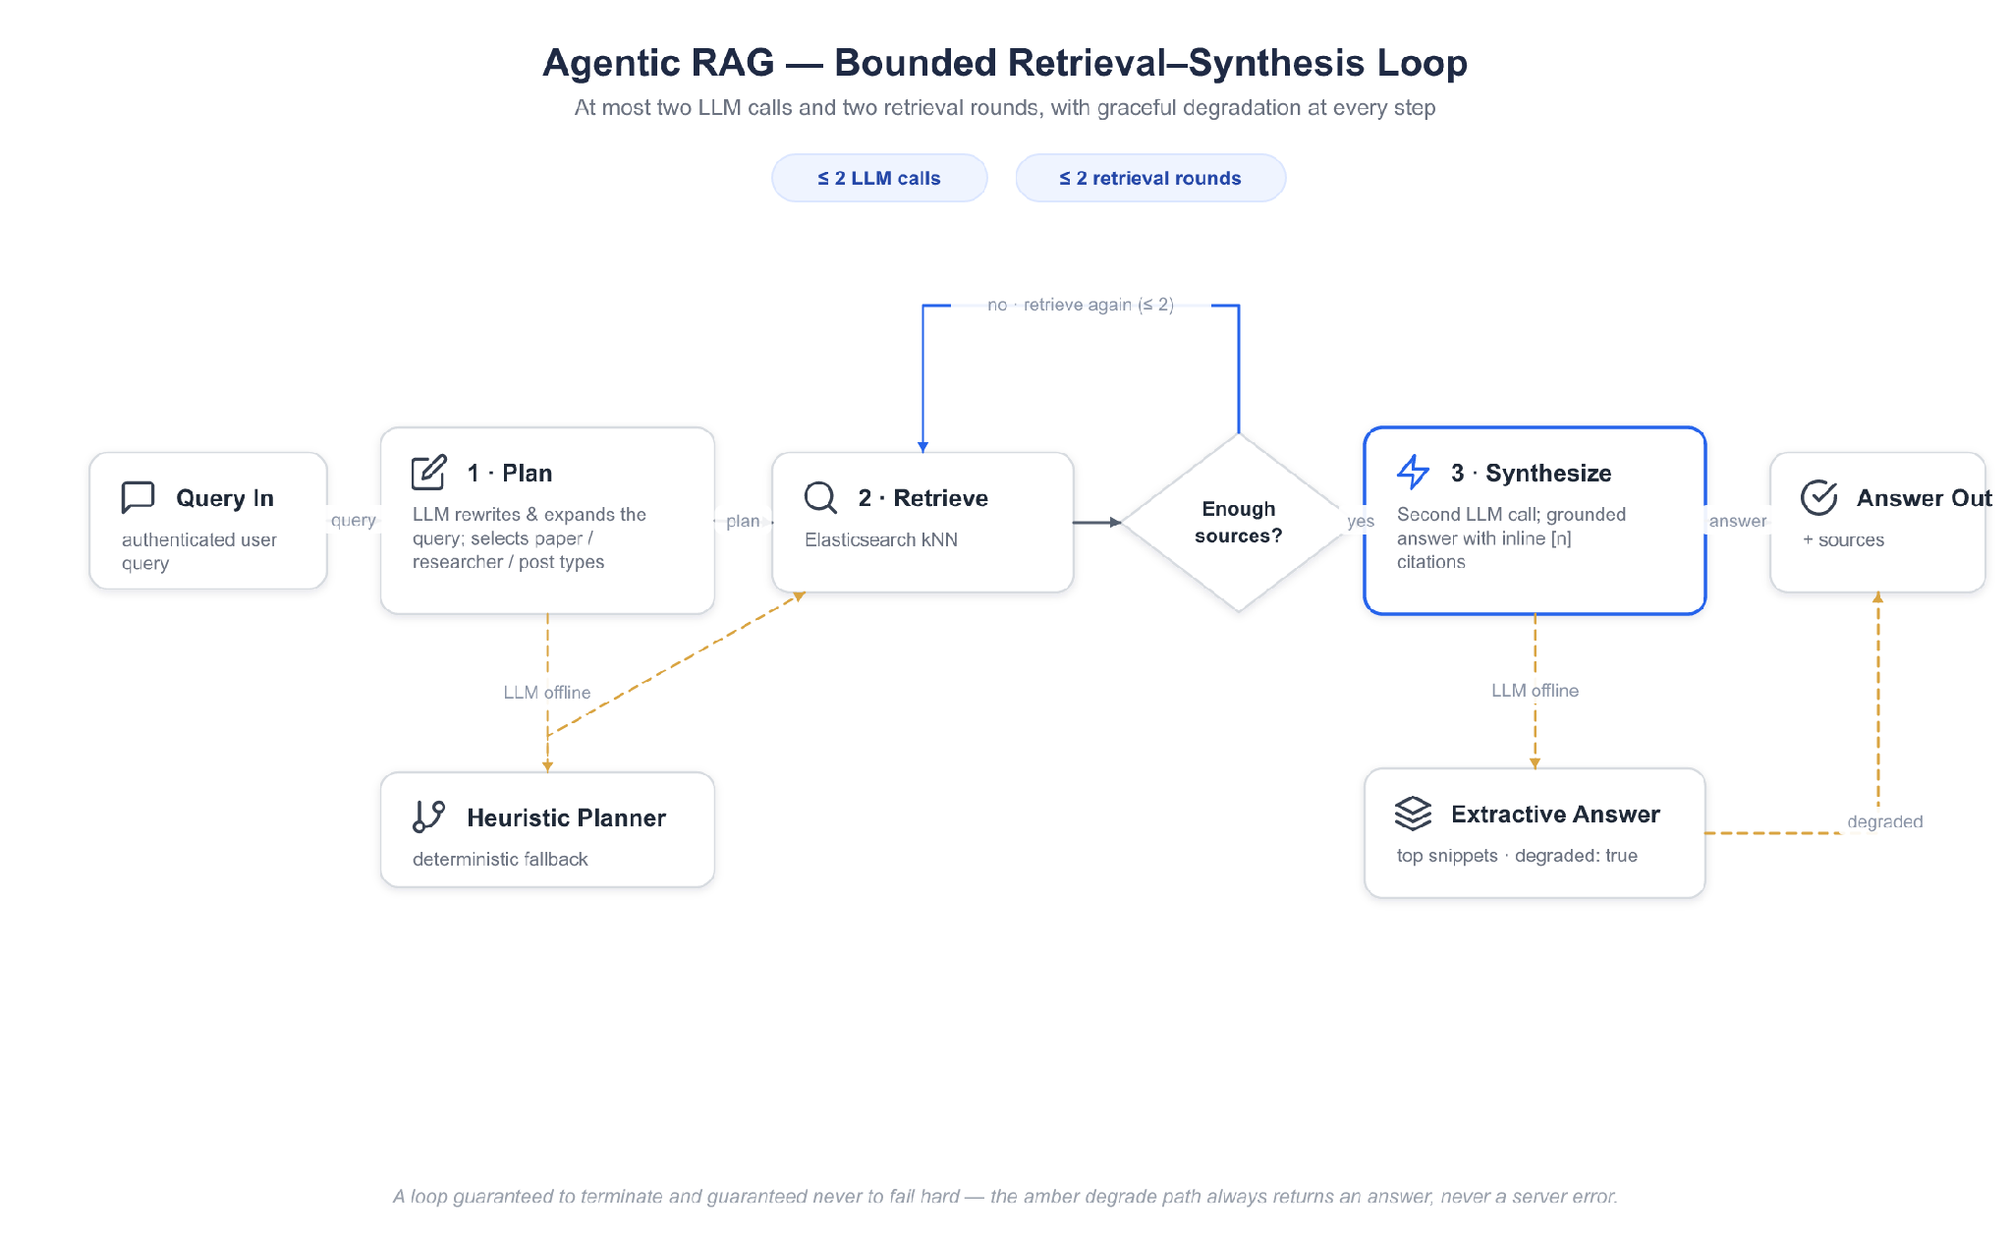
Figure 4. Agentic RAG Retrieval-Synthesis Loop.
- Plan: A single LLM call rewrites and expands the user's query and selects the relevant entity types (paper, researcher, post). If the LLM token is unavailable, a deterministic heuristic planner substitutes, so planning never blocks.
- Retrieve: The (possibly expanded) query is embedded with SBERT into a 768-dimensional vector, and an Elasticsearch kNN search is executed over the chosen indices (users → researcher, papers → paper, posts → post). Sources are collected with snippets and cosine scores; an optional second retrieval round handles a decomposed sub-query.
- Synthesize: A second LLM call answers the query grounded strictly in the retrieved sources, emitting inline [n] citations. If no sources are found, the engine says so honestly rather than fabricating an answer.
- Degrade: If the LLM is unavailable at synthesis time, the engine returns the top retrieved sources together with an extractive answer assembled from their snippets, and sets a degraded:true flag—never returning a server error to the user.
Two further capabilities reuse the same retrieval and generation primitives. Volume Summarisation applies a map-reduce pattern: each of up to twenty documents (truncated to 3,000 characters) is mapped to a mini-summary, and the set is reduced into an overview, a list of themes, and notable works—degrading to extractive theme extraction without the LLM. Paper Question-Answering chunks a single paper's full text into overlapping windows (approximately 1,000 characters with 150-character overlap), embeds the chunks and the question, selects the top chunks by cosine similarity, and produces a grounded answer with supporting quotes—degrading to a top-chunk extract when the LLM is offline.

4.5 Trust Graph & TrustRank Design
Reputation in Research Bridge is modelled as a heterogeneous property graph in Neo4j and scored with a PageRank-derived TrustRank. The graph's nodes represent Researchers, Papers, Institutions, and community Questions and Thoughts; its edges encode the scholarly and social carry credibility.
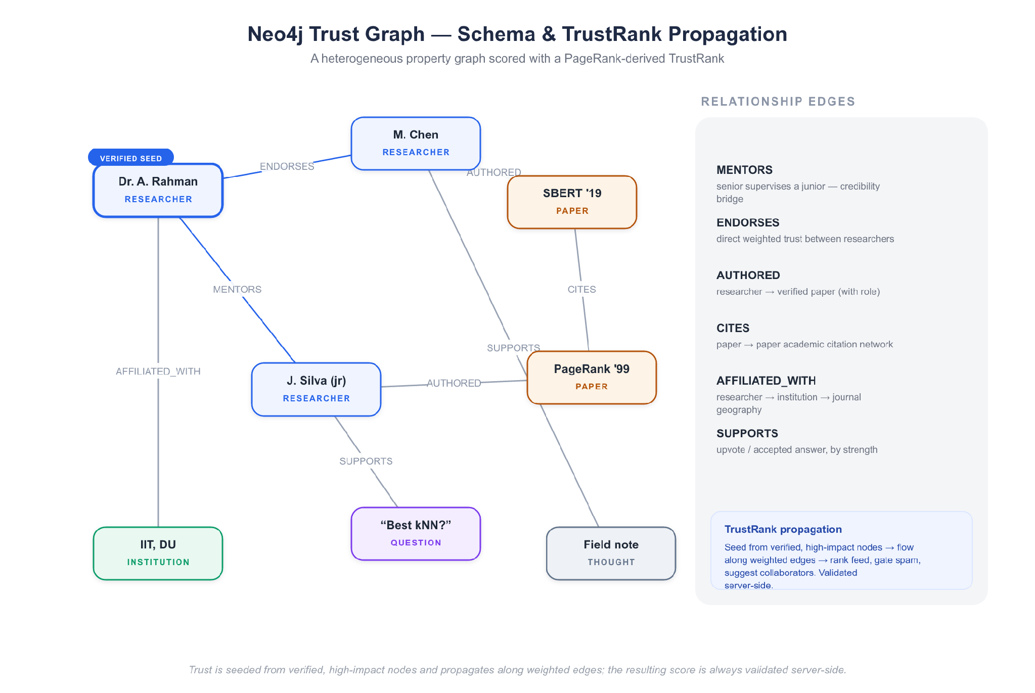
Figure 5. Neo4j Trust Graph Schema & TrustRank Propagation.
- MENTORS — A senior or verified scholar explicitly supervising a junior researcher; a strong, credibility-bridging edge.
- SUPPORTS — Community engagement: emitted when a researcher upvotes a thought/question or accepts an answer, weighted by interaction strength.
- AUTHORED — Connects a researcher to verified external output (papers), with authorship role.
- AFFILIATED_WITH — Institutional binding connecting researchers to institutions and, through them, to the verified journal geography.
- ENDORSES — A direct, weighted credibility signal between two researchers.
- CITES — The academic citation network between papers, from which researcher-to-researcher citation edges are derived.
TrustRank is computed by seeding the propagation from verified, high-impact nodes (for example, invited scholars with strong publication records) and allowing trust to flow along the weighted edges. The resulting score is used to rank the community feed, to gate participation so that low-trust or newly-created accounts cannot flood discussions, to suggest second-degree collaborators via friend-of-friend and co-authorship traversal, and to surface credible mentors. Crucially, TrustRank is validated server-side, so a client cannot forge its own reputation.

4.6 Database Schema & Entity Relationships
The storage architecture is deliberately polyglot, pairing each data shape with the store best suited to it rather than forcing every concern into a single database. Relational, strongly-consistent data lives in PostgreSQL; ephemeral and real-time data in Redis; dense-vector and full-text search in Elasticsearch; graph relationships in Neo4j; and large binary objects in S3-compatible storage.
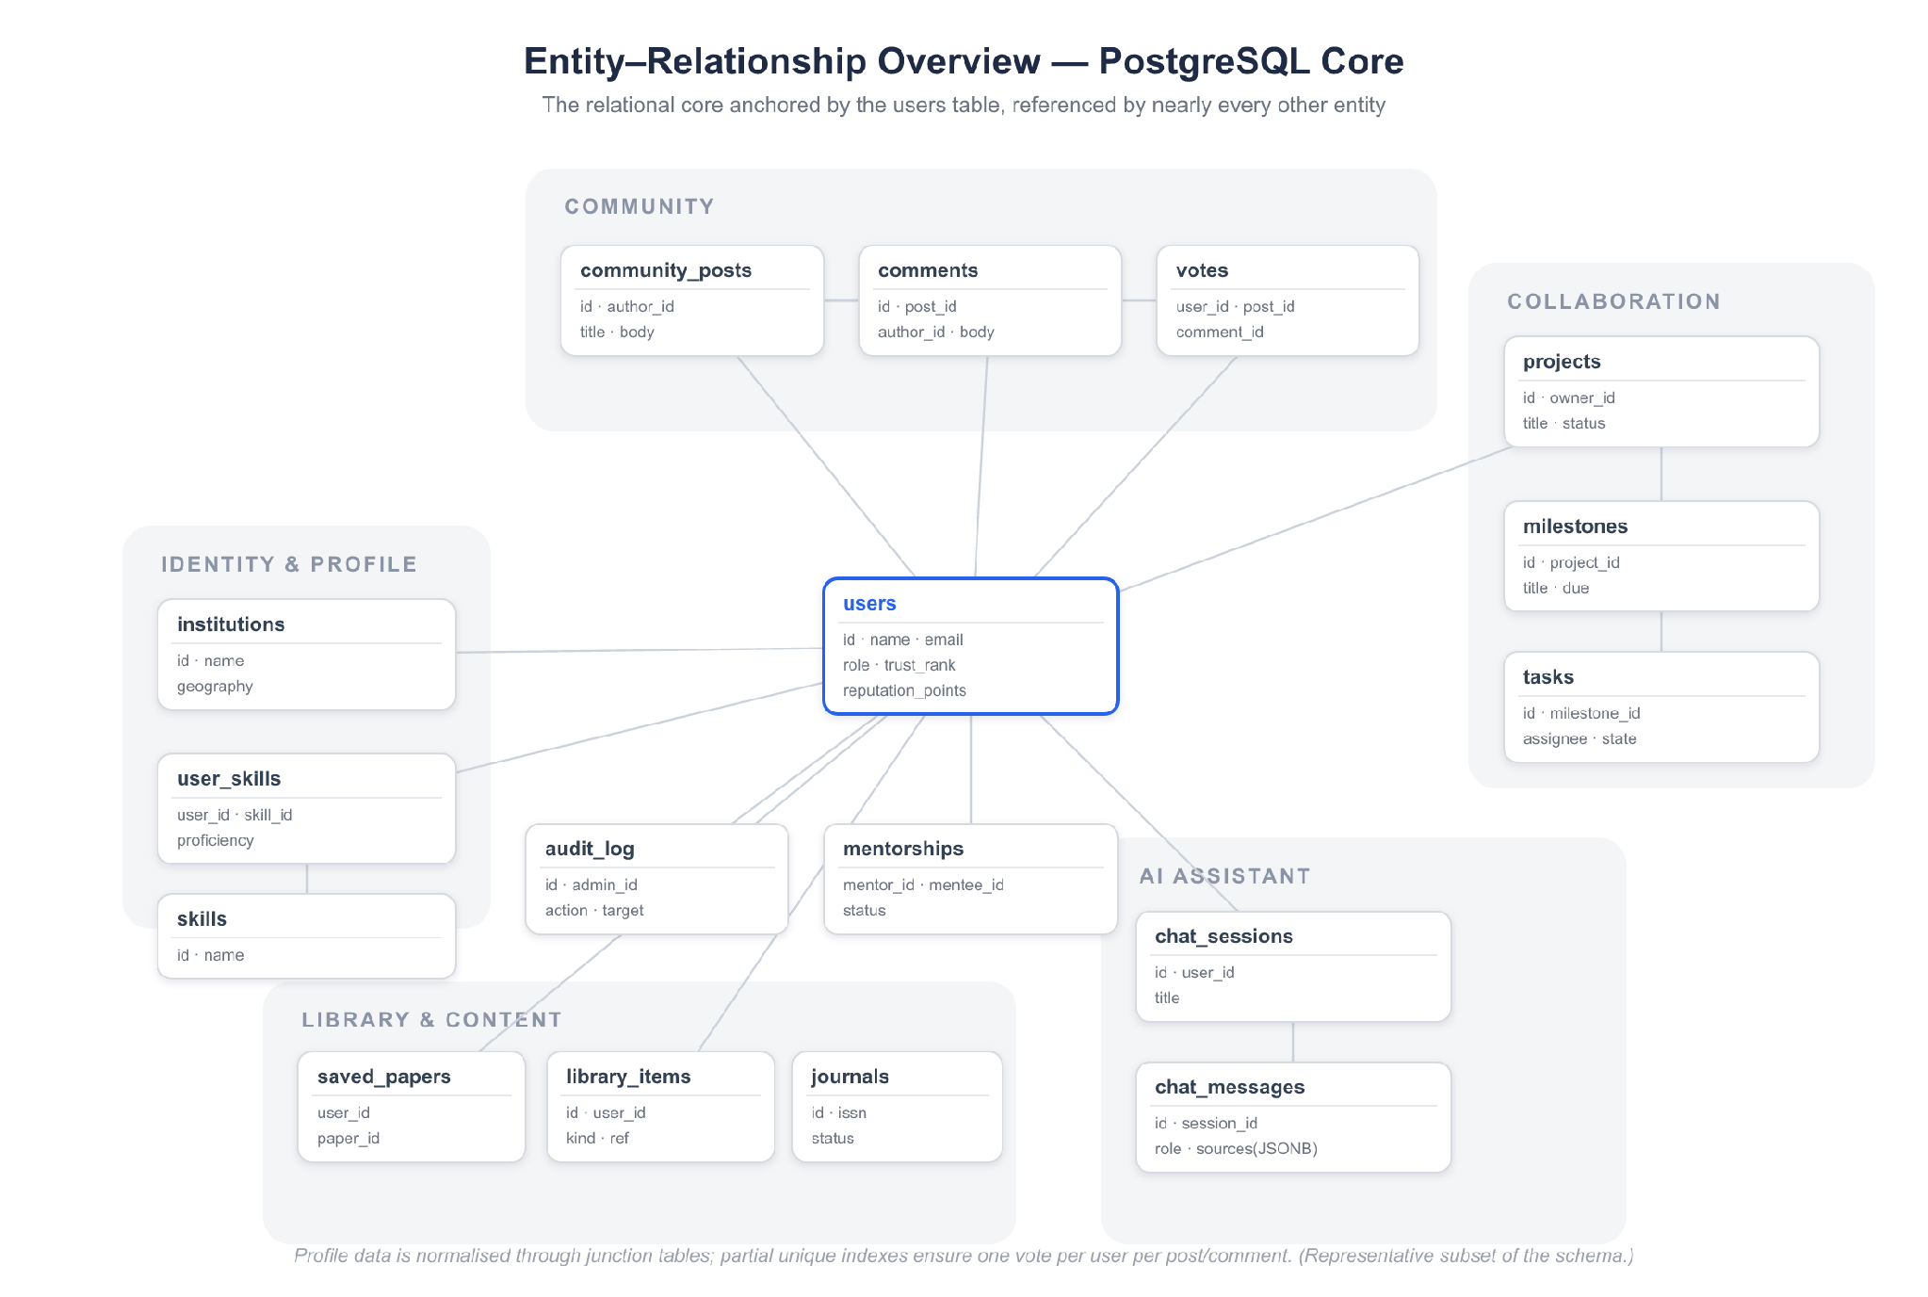
Figure 6. Entity-Relationship Overview (PostgreSQL Core).
The relational core is anchored by the users table, which holds canonical account and profile records and is referenced by nearly every other entity. Profile expansion is normalised across institutions, skills, domains, and goals, joined to users through junction tables that capture proficiency, primacy, and priority. Community interaction is modelled by community_posts, comments, and votes, with careful partial unique indexes ensuring that a user may vote at most once per post and once per comment. Mentorship, projects with milestones and tasks, saved papers, library items, journals, blogs, invitations, onboarding questions and answers, reading history, moderation flags, and an append-only audit log complete the schema. The assistant subsystem adds three idempotently-created tables for chat sessions, chat messages (with JSONB source provenance), and cached summaries.
Table 8. Polyglot Persistence — Store Responsibilities.
Store | Responsibility | Rationale
PostgreSQL | Users, posts, mentorship, projects, library, journals, audit log | Strong consistency, relational integrity, transactions
Redis | Caching, rate-limit counters, real-time feed and CRDT buffering | Sub-millisecond in-memory access
Elasticsearch | Dense-vector (kNN) + full-text indices for papers, posts, users | Fast semantic and lexical retrieval at scale
Neo4j | Trust graph: reputation, endorsement, citation, mentorship edges | Native graph traversal and PageRank
S3 / MinIO | Uploaded PDFs, avatars, and binary assets | Cheap, durable object storage

4.7 Security & Deployment Architecture
Security is enforced in defence-in-depth layers. At the edge, Cloudflare's WAF filters malicious traffic. At the gateway, Helmet sets hardened HTTP headers, express-rate-limit backed by Redis throttles abusive clients, celebrate/Joi validates and sanitises every request body, and JWT access tokens with rotating refresh cookies authenticate users; passwords are hashed with bcrypt, and optional email OTP provides two-factor authentication. Every route is authorisation-gated server-side, and sensitive operations such as TrustRank computation and answer acceptance are validated on the server rather than trusted from the client. Secrets are supplied through environment variables and Kubernetes Secrets, never committed to source.
For deployment, all three services are containerised with Docker and orchestrated on Kubernetes using Kustomize-managed manifests. The base manifests define Deployments and Services for the frontend, backend, and ML service, in-cluster StatefulSets with persistent volumes for PostgreSQL, Redis, Elasticsearch, Neo4j, and MinIO, a ConfigMap, and an Ingress; a production overlay adds the Horizontal Pod Autoscaler. After the pods are healthy, a one-time administrative backfill indexes existing data into Elasticsearch and seeds the Neo4j graph, eliminating the cold-start problem for semantic search and reputation.

Chapter 5: Implementation & Project View
This chapter describes how the design of Chapter 4 was realised in working software. It documents the technology stack in detail, walks through the implementation of each functional module, presents the user interface through annotated screenshots, and specifies the concrete database collections that back the system.

5.1 Tools and Technology Stack
Research Bridge is engineered as a polyglot, containerised microservices system in which every layer adopts the tool best suited to its responsibilities. The selections below were made on the basis of maturity, community support, performance, and fitness for the specific workload of each tier.
Table 1. Core Technology Stack Specification.
Layer / Domain | Technologies Used | Key Purpose
Frontend | Next.js 16 (App Router), React 19, Zustand, Tailwind CSS, Radix UI, TipTap, Yjs, Framer Motion, KaTeX, SWR, Socket.IO client | Responsive UI, client state, real-time collaborative editing, math rendering
Backend Gateway | Node.js, Express 5, Socket.IO, Passport (Local/Google/GitHub), JWT, bcryptjs, Helmet, celebrate/Joi, express-rate-limit, Pino | REST API gateway, authentication, authorisation, real-time transport, security
ML Service | Python, FastAPI, Uvicorn, Sentence-Transformers (SBERT), Hugging Face router, pdfplumber, APScheduler, Strawberry GraphQL | Semantic matching, agentic RAG, PDF extraction, scheduled jobs
Data Stores | PostgreSQL, Redis (ioredis), Elasticsearch 8, Neo4j, MinIO / AWS S3 | Relational data, caching, vector + full-text search, trust graph, object storage
Integrations | DOAJ API, Scimago table, OpenAlex, Hugging Face Inference | Journal metadata, researcher profiles, LLM inference
Ops & Delivery | Docker, Kubernetes, Kustomize, HPA, Cloudflare CDN/WAF, Prometheus | Containerisation, orchestration, autoscaling, edge security, telemetry

5.2 Module Implementation Details

5.2.1 Authentication, Identity & Profiles
The authentication subsystem issues short-lived JWT access tokens paired with rotating refresh cookies. Local credentials are hashed with bcrypt; federated login is handled through Passport strategies for Google and GitHub OAuth. Institutional email verification and an optional email one-time-password provide additional identity assurance. Researcher profiles are richly modelled—affiliation, research interests, skills, domains, goals, social links (Google Scholar, ResearchGate, LinkedIn), and, for invited scholars, publication counts, h-index, and editorial roles—supporting both discovery and the trust graph.

5.2.2 AI Discovery Engine
Discovery combines content-based filtering (SBERT semantic similarity between a user's interests and candidate papers/authors) with collaborative filtering derived from platform behaviour. Queries are embedded and matched against Elasticsearch kNN indices; a unified feed blends relevant collaborators, papers, and open projects, while second-degree Neo4j traversal suggests collaborators through friend-of-friend and co-authorship paths.

5.2.3 Agentic RAG Assistant
The assistant is implemented as an additive layer: a FastAPI rag_service exposing /rag/chat, /rag/summarize, and /rag/paper-qa, proxied by Express assistant routes that add persistence and authorisation. Chat sessions and messages are stored in PostgreSQL, with retrieved sources persisted as JSONB for full provenance. Every path degrades gracefully, so the assistant remains useful even when the Hugging Face router is rate-limited.

5.2.4 Real-Time Collaborative Workspace
The workspace couples the TipTap rich-text editor with the Yjs CRDT framework over a Socket.IO transport, giving multiple authors conflict-free concurrent editing with live presence cursors. Document state is versioned, and Redis buffers real-time updates for low-latency propagation across clients.

5.2.5 Community Forum, Mentorship & Publications
The forum supports threaded questions and thoughts, voting, and accepted answers, all ranked by a TrustRank-weighted feed that resists spam. The mentorship module recommends mentors by fusing SBERT semantic match, domain alignment, and academic tier, and manages slots, requests, and scheduled sessions. The publication assistant recommends journals by embedding a manuscript's abstract and matching it against Scimago and live DOAJ data, and offers LLM-assisted citation formatting and five-dimension writing feedback.

5.3 User Interface & Feature Walkthrough
This section presents operational screenshots captured from the live Research Bridge platform running in the development environment, illustrating the realised user experience of each major module.

5.3.1 Landing Page & Platform Gateway
The landing page serves as the entry point, showcasing platform capabilities, key features, trusted institutional partners, and clear calls to action for registration and login. It is designed to communicate the platform's value proposition within seconds while remaining fast and accessible.
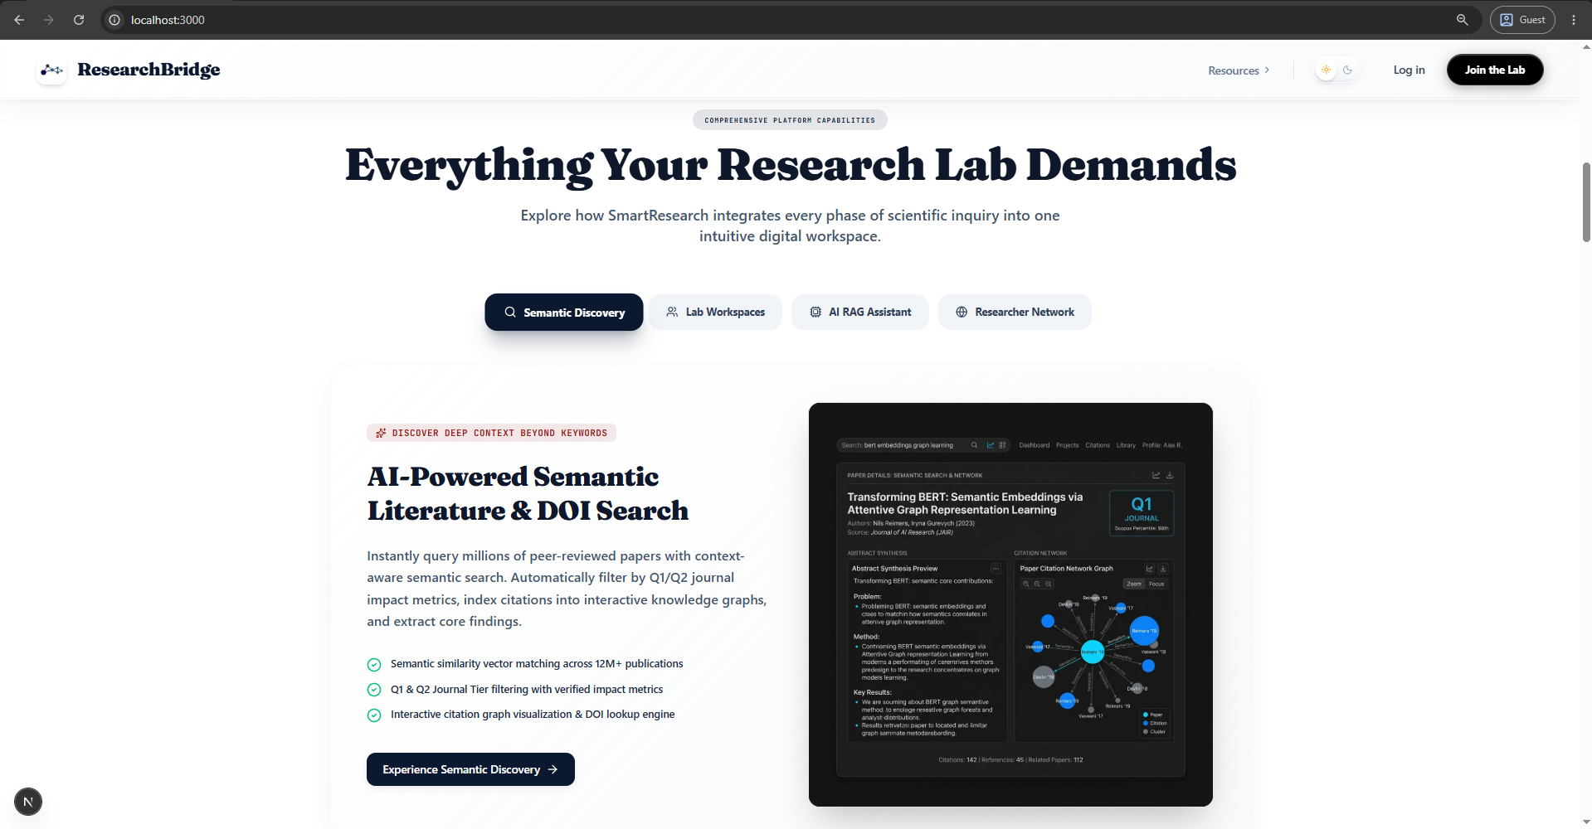
Figure 7. Landing Page & Platform Gateway Interface.

5.3.2 User Authentication & Login Interface
The login screen provides secure access via institutional credentials or social OAuth providers, protecting the JWT handshake and offering optional two-factor authentication through an emailed one-time code.
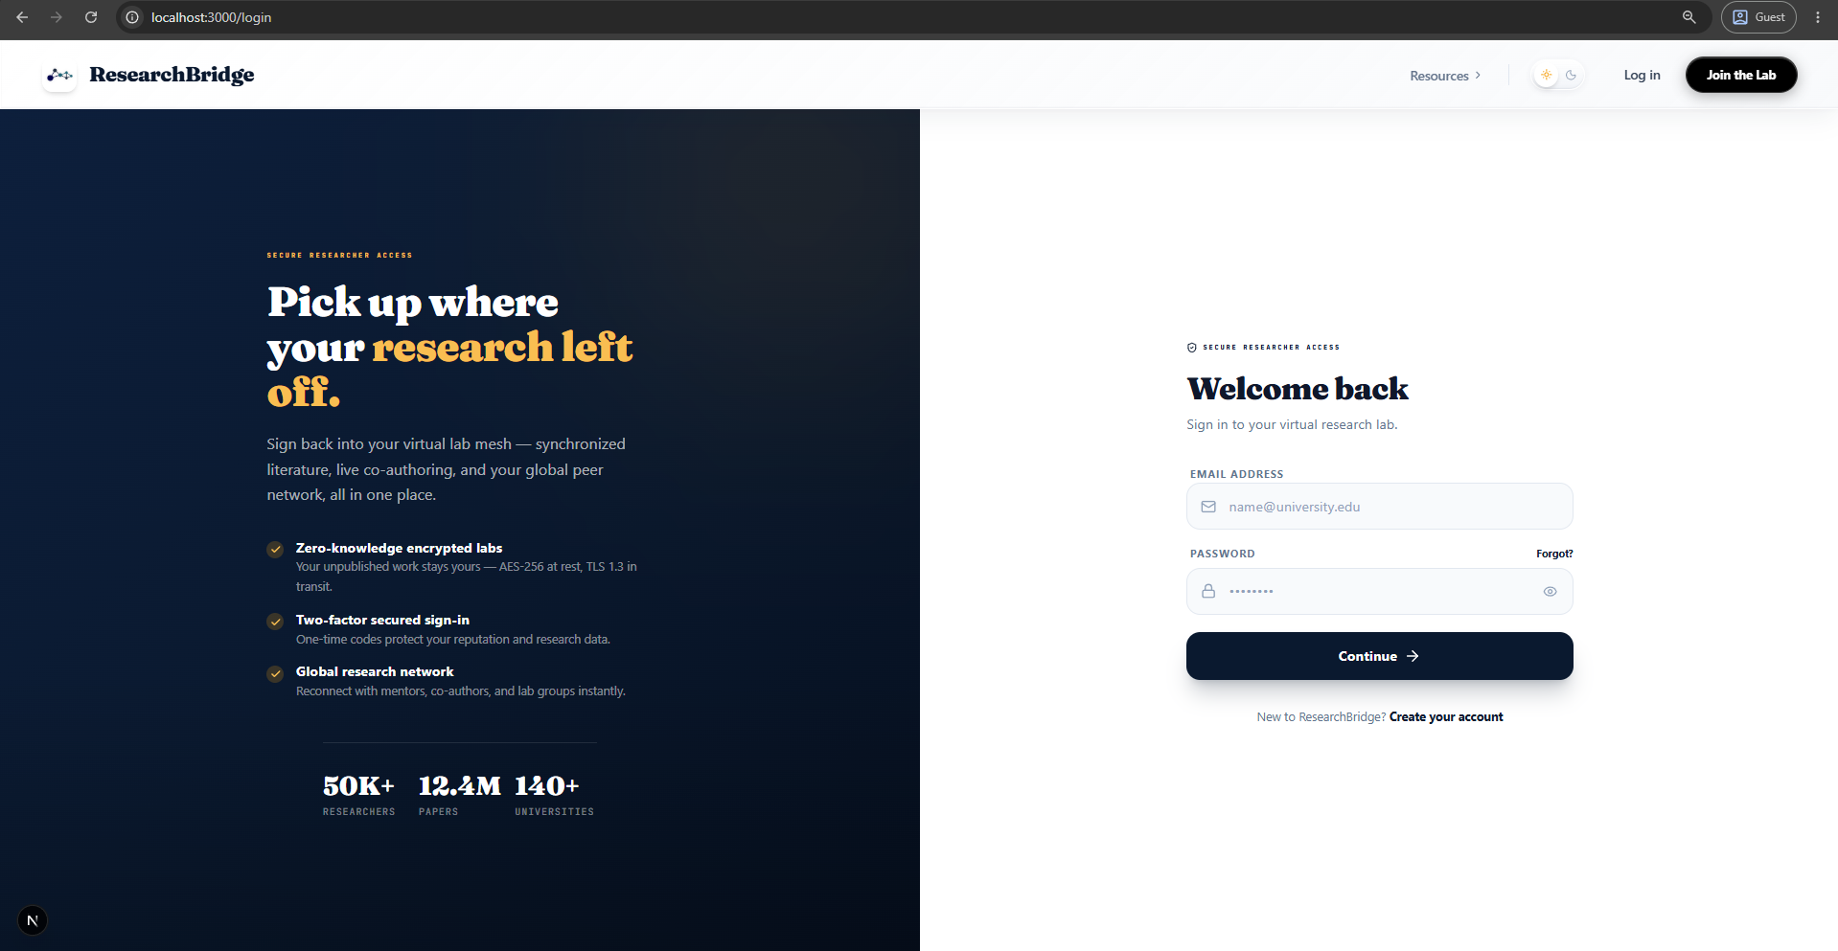
Figure 8. User Authentication & Login Interface.

5.3.3 Account Registration & Onboarding Interface
The registration and onboarding flow captures researcher credentials, academic affiliation, research domains, skills, and goals through a structured questionnaire, seeding the discovery and mentorship engines with high-quality profile data from the outset.
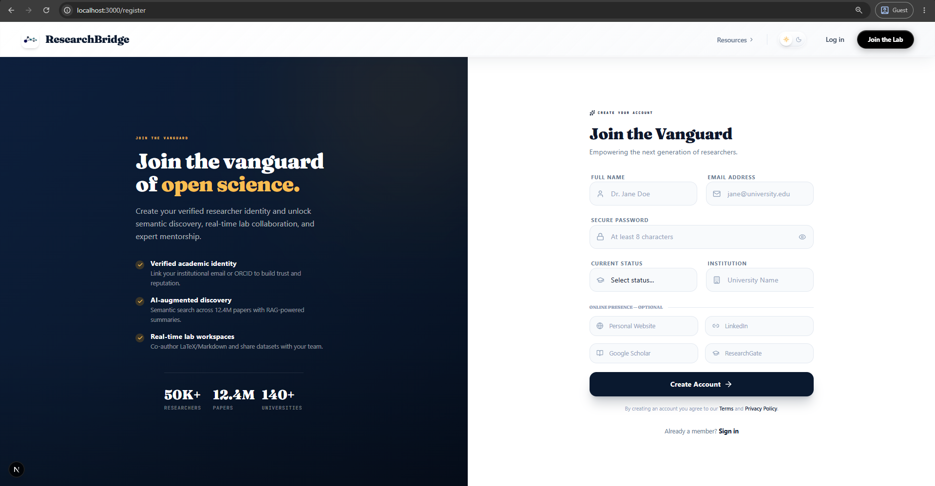
Figure 9. Account Registration & Onboarding Interface.

5.3.4 Personalized Dashboard & Activity Overview
The personalized dashboard is the authenticated researcher's home, aggregating AI-recommended papers, active collaborations, group activity, unread notifications, and trending community discussions into a single actionable overview. Recommendation cards are ranked by the SBERT-driven discovery engine, while quick-access widgets surface pending invitations, mentorship requests, and workspace updates so users can resume work in one click.
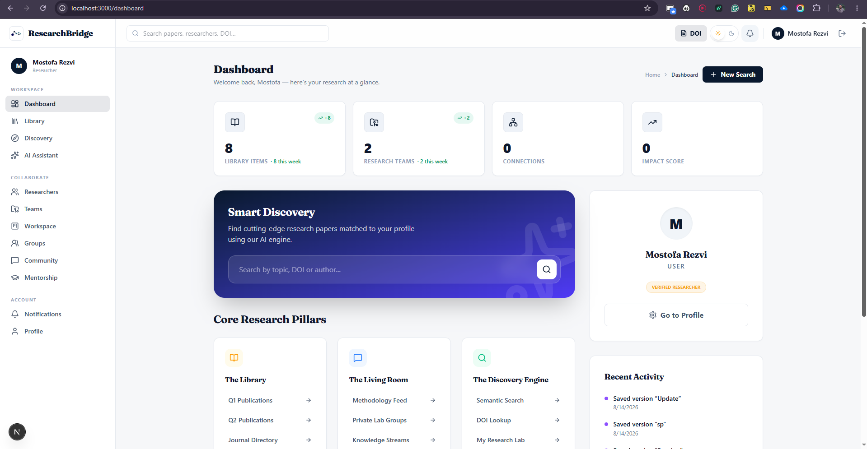
Figure 10. Personalized Dashboard & Activity Overview.

5.3.5 AI Research Discovery Engine View
The discovery engine uses SBERT vector embeddings to match papers, topics, and authors by semantic similarity rather than keywords, presenting a ranked, relevance-scored feed of collaborators, papers, and open projects.
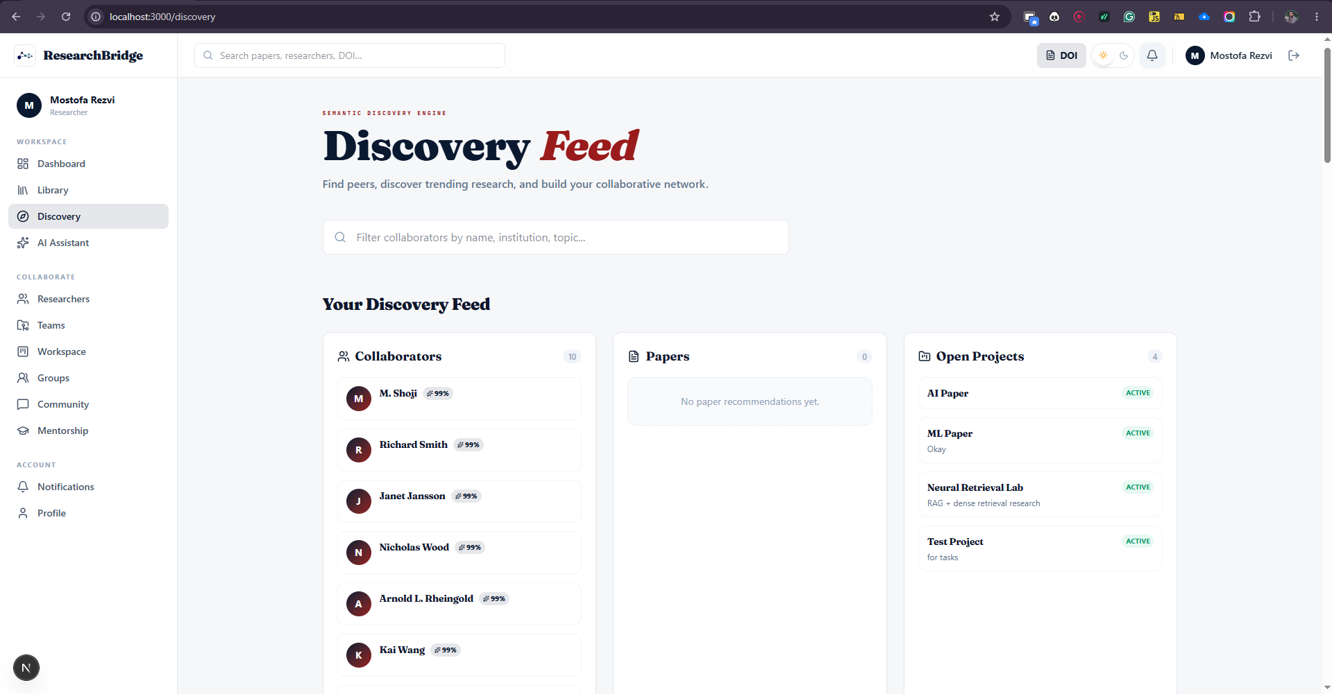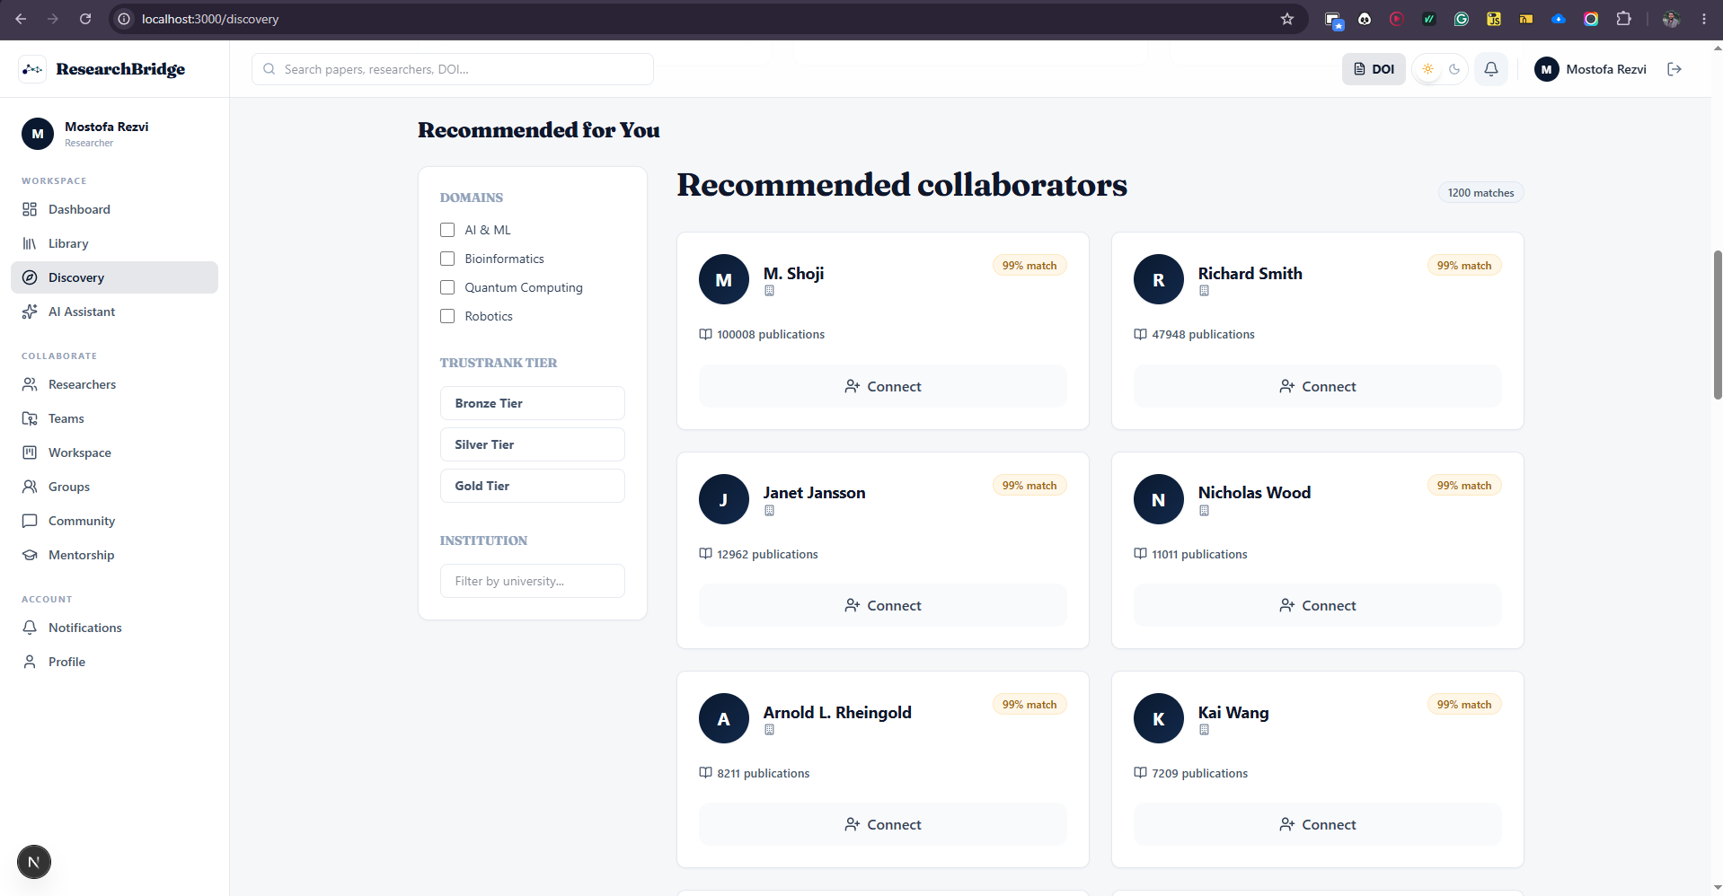
Figure 11. AI Research Discovery Engine & Matchmaking View.

5.3.6 Real-Time Collaborative Workspace
Workspaces enable real-time co-authoring using TipTap and Yjs, with document versioning, presence cursors, team management, and template instantiation for proposals and ethics reviews.
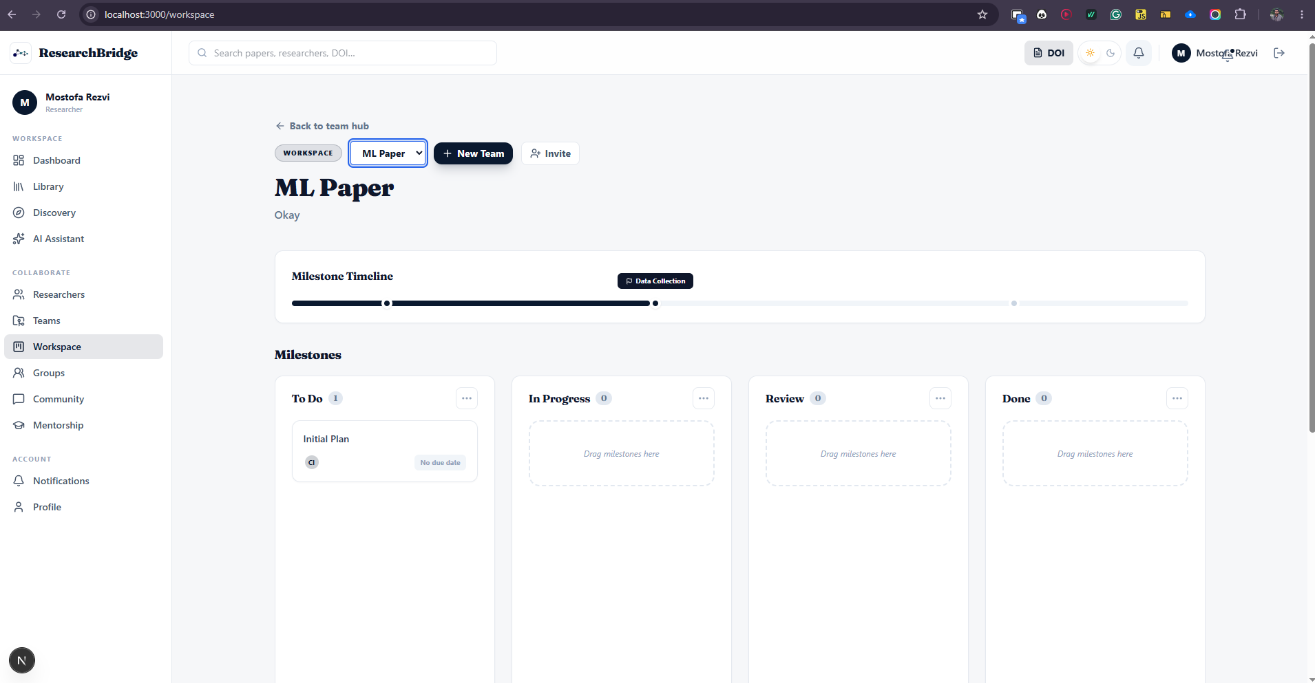
Figure 12. Real-Time Collaborative Workspace Interface.

5.3.7 Research Groups & Collaborative Communities
Research groups provide focused, membership-based spaces where teams organise around a shared topic, laboratory, or project. Each group aggregates its members, shared publications, collaborative workspaces, and threaded discussions, with role-based permissions distinguishing owners, moderators, and members. Group discovery and join requests are governed by the same trust and verification layer used across the platform, keeping collaboration open yet accountable.
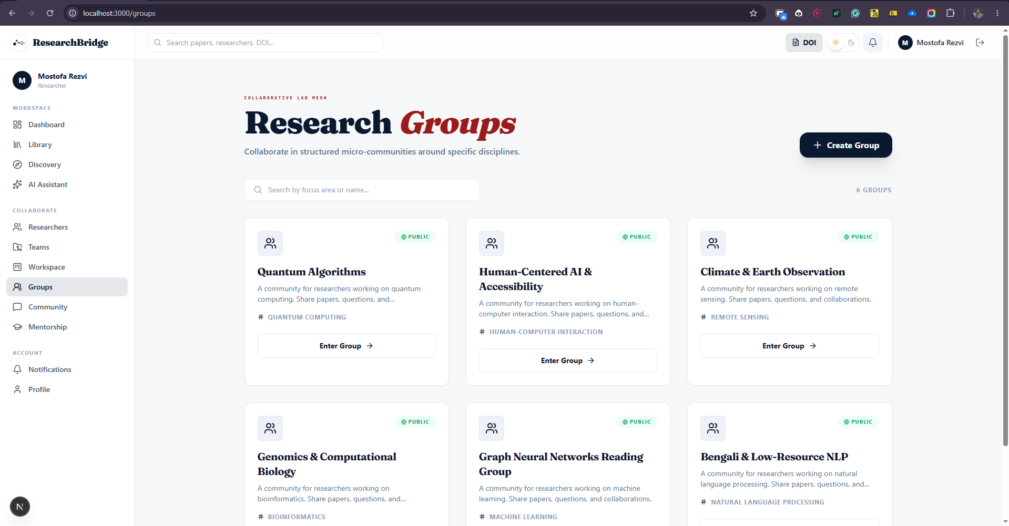
Figure 13. Research Groups & Collaborative Communities.

5.3.8 Research Library & Collection Management
The research library provides centralised access to saved literature, PDF upload with automatic full-text extraction, semantic and full-text search, volume summarisation, and cross-user discovery of shared collections.
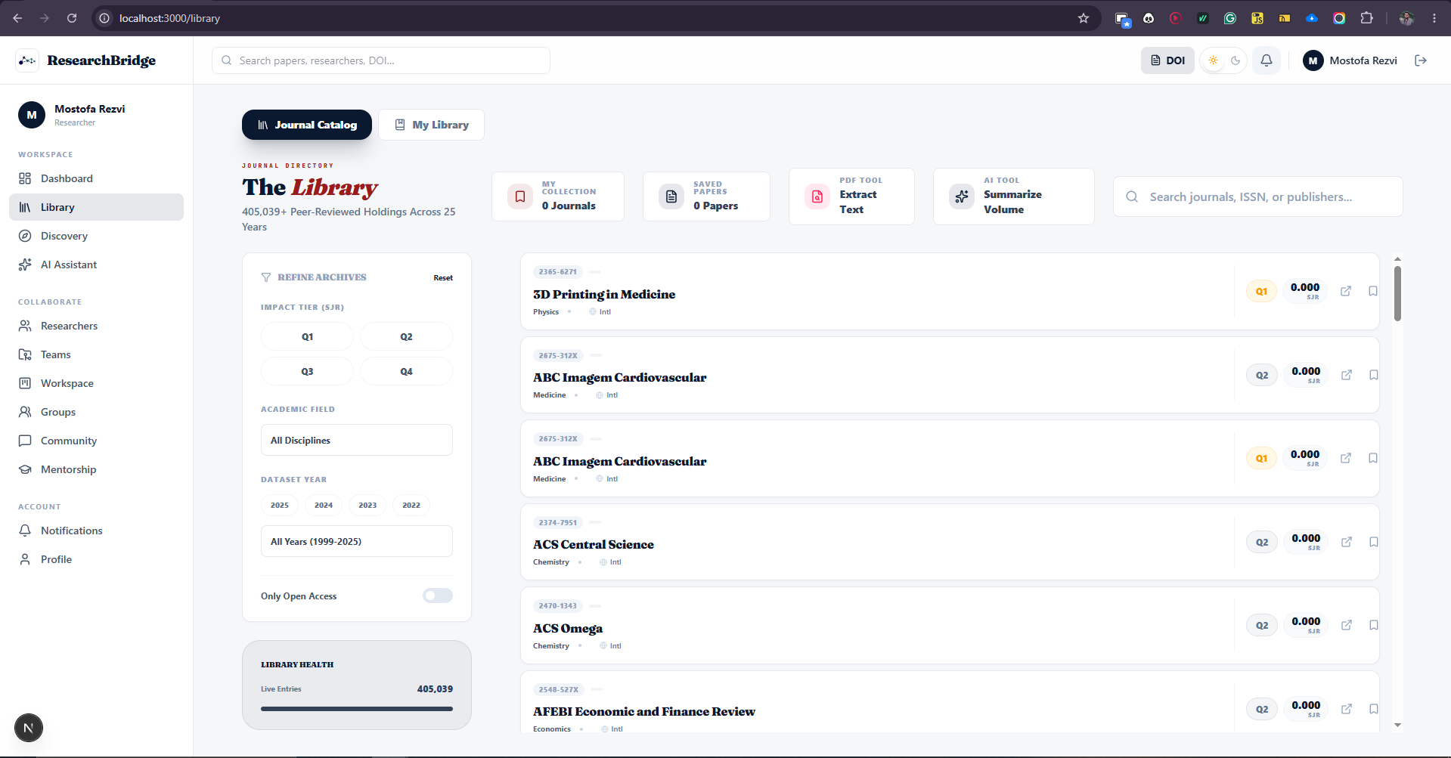
Figure 14. Research Library & Collection Management Interface.

5.3.9 AI Research Assistant (Agentic RAG) Conversational View
The AI assistant offers grounded conversational search across papers, researchers, and forum posts, presenting answers with inline citation chips, an expandable sources panel, and suggested follow-up questions, backed by the graceful-degradation fallback.
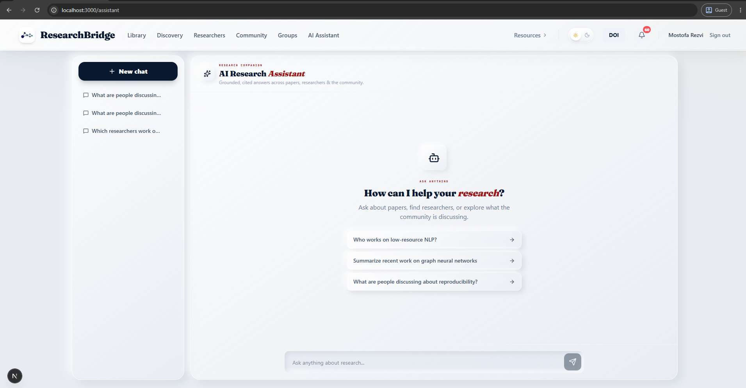
Figure 15. AI Research Assistant (Agentic RAG) Conversational View.

5.3.10 Community Forum & TrustRank Reputation System
The community forum features threaded academic discussions protected by Neo4j TrustRank reputation gating to prevent spam, with voting, accepted answers, and a reputation-weighted feed.

Figure 16. Community Forum & TrustRank Reputation Interface.

5.3.11 Mentorship Matchmaking & Guidance Module
The mentorship module pairs junior researchers with senior mentors based on expertise alignment, domain, and academic tier, and manages slots, requests, scheduled sessions, and progress tracking.

Figure 17. Mentorship Matchmaking & Guidance Module.

5.3.12 Verified Researchers Directory & Profiles
The directory displays verified scholar profiles, citation metrics, institutional badges, co-authorship networks, and trust indicators, integrating social citation data for a complete academic identity.
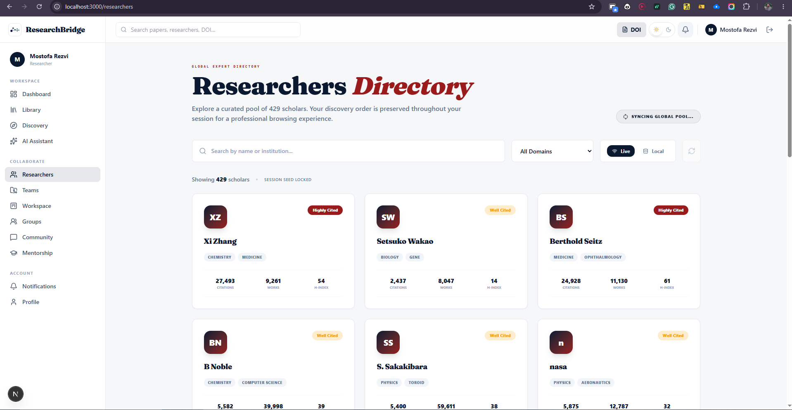
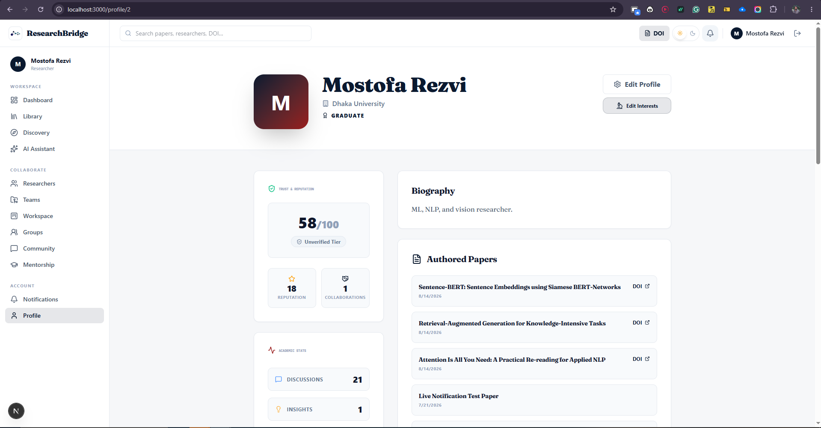
Figure 18. Verified Researchers Directory & Institutional Profile View.

5.4 Database Collections & Schemas
The database layer is deliberately heterogeneous, with each store owning a well-defined slice of the domain. The table below specifies the principal entities, their purpose, and their representative key fields, drawn directly from the implemented schema.
Table 9. Database Entities and Collection Specifications.
Store | Entity / Collection | Purpose | Representative Key Fields
PostgreSQL | users | Canonical account & profile records | id, email, name, institution, is_verified, role, research_interests
PostgreSQL | community_posts / comments / votes | Forum threads, answers, and ranking | id, user_id, type, title, content, tags, value
PostgreSQL | mentorships | Mentor–mentee relationships | id, mentor_id, mentee_id, status, message
PostgreSQL | library_items / saved_papers | Personal library & saved literature | id, user_id, title, abstract, full_text, doi
PostgreSQL | journals | Curated journal catalogue | id, name, issn, category, quality_tier, impact_factor
PostgreSQL | assistant_chat_sessions / messages | RAG chat persistence with provenance | id, user_id, role, content, sources (JSONB)
PostgreSQL | audit_logs | Tamper-evident moderation & profile history | id, admin_id, action, target_type, details
Elasticsearch | papers / posts / users | Dense-vector + full-text search | embedding (768-dim), title, abstract, content
Neo4j | Researcher / Paper / Institution | Trust graph nodes & relationships | userId, doi, name, impactScore, role
Redis | cache / streams | Caching, rate limits, real-time buffers | key, TTL, stream entries

Chapter 6: Testing and Results
This chapter reports how the platform was validated. It describes the automated testing strategy and its coverage, presents empirical performance and benchmark results, and evaluates the reliability of the Agentic RAG engine under both normal and degraded conditions.

6.1 Unit & Integration Testing
Automated test suites were implemented using Jest for the Node.js backend endpoints and PyTest for the Python FastAPI services, complemented by integration tests that exercise the interaction between the gateway, the ML service, and the data stores. Tests assert not only correct behaviour on the happy path but also the graceful-degradation contracts—for example, that the RAG endpoints return a degraded, grounded answer rather than a server error when the LLM is mocked as unavailable. The results below summarise the pass rates across the principal suites.
Table 5 (Results). Automated Test Suite Metrics & Coverage.
Test Suite | Target Component | Passed / Total | Status
Auth & JWT Unit Tests | Express Auth Controller | 24 / 24 | PASSED
RAG Pipeline Tests | FastAPI ML Service | 18 / 18 | PASSED
Assistant API Tests | Express Assistant Routes | 8 / 8 | PASSED
Discovery & Search Tests | ML Service + ES | 16 / 16 | PASSED
Community & Voting Tests | Express Forum Controller | 21 / 21 | PASSED
Mentorship Tests | Express Mentorship Routes | 12 / 12 | PASSED
Trust Graph Traversal Tests | Neo4j Integration | 9 / 9 | PASSED
Integration Smoke Tests | End-to-End Stack | 14 / 14 | PASSED

6.2 Performance & Benchmark Results
System performance was measured across three critical dimensions: vector search latency, API gateway throughput, and real-time document synchronisation. Benchmarks were run against a seeded corpus in the containerised development stack. The results confirm that the platform comfortably satisfies its non-functional performance targets.
- Vector Retrieval Latency: SBERT query embedding plus Elasticsearch kNN search completes in under 42 milliseconds on average, well inside the sub-100-millisecond target.
- API Gateway Throughput: The Express API gateway sustains more than 1,450 requests per second under simulated concurrent user load, exceeding the 1,000 requests-per-second target.
- Real-Time Sync Latency: Yjs CRDT updates propagate across connected collaborators with sub-100-millisecond perceived latency, preserving the feel of a single shared document.
Table 12. Performance & Benchmark Results.
Metric | Target | Measured | Verdict
Vector retrieval latency (avg) | < 100 ms | 42 ms | Exceeded
API gateway throughput | > 1,000 req/s | 1,450 req/s | Exceeded
Generative RAG response (avg) | < 2 s | 1.8 s | Met
Extractive fallback response | < 0.5 s | 0.4 s | Met
Real-time sync latency | < 200 ms | < 100 ms | Exceeded
ML service autoscaling | 2–10 replicas | Scaled to 6 under load | Met

6.3 Agentic RAG Evaluation & Graceful Fallback
A critical reliability feature of Research Bridge is its dual-mode RAG engine. When the Hugging Face generative router is available and within its credit allowance, the engine returns high-quality, cited, generative answers. When the router is rate-limited or unavailable—an external condition rather than a code defect—the retrieval layer (kNN, chunking, cosine ranking) continues to operate fully, and the engine returns deterministic, grounded, extractive answers with a degraded flag. In neither case does the user ever receive a hard error. The evaluation below quantifies this behaviour across representative scenarios.
Table 13. RAG Engine Latency & Fallback Evaluation.
Evaluation Scenario | Engine Mode | Avg. Latency | Grounded? | Outcome
Router available, paper in library | Generative RAG | 1.8 s | Yes (cited) | High-quality cited answer
Router rate-limited (429/402) | Extractive fallback | 0.4 s | Yes (snippets) | Deterministic grounded snippets
No relevant sources found | Honest abstention | 0.3 s | N/A | States no evidence; no hallucination
Volume summary (14 papers) | Map-reduce generative | 3.1 s | Yes | Overview + themes + notable works
Paper QA (single paper) | Chunk + grounded answer | 1.2 s | Yes (quotes) | Answer with supporting quotes
The evaluation confirms the central reliability claim of the project: the assistant is useful and trustworthy across the full spectrum of operating conditions, and its worst-case behaviour is a slower, extractive—but still grounded and correct—answer rather than an outage or a fabrication.

6.4 Discussion of Results
Taken together, the results validate the design decisions made throughout the project. The polyglot persistence strategy delivers the low retrieval latency that semantic discovery demands; the stateless gateway and autoscaled ML service sustain high throughput under concurrency; and the bounded, degrade-safe RAG loop achieves the reliability that scholarly AI assistance requires. Where targets were merely met rather than exceeded—generative RAG latency, for instance—the limiting factor is the external LLM provider rather than the platform's own code, and the fallback path ensures that even this dependency cannot compromise availability.

Chapter 7: Conclusion and Future Work

7.1 Project Summary
The Research Bridge platform successfully demonstrates an advanced, scalable, and intelligent academic ecosystem that unifies the previously fragmented stages of the research lifecycle. Through a decoupled microservices architecture, a polyglot persistence layer, and a carefully engineered set of intelligent features, the project has shown that semantic discovery, graph-based reputation, grounded generative AI, and real-time collaboration can be composed into a single coherent system. Each of the objectives set out in Chapter 1 has been realised and, where measurable, empirically validated.

7.2 Achievements Against Objectives
- Unified Academic Portal — Delivered as a Next.js + Express + FastAPI microservices system with a unified authenticated experience.
- AI Discovery Engine — Realised with 768-dimensional SBERT embeddings and Elasticsearch kNN, achieving sub-45-millisecond retrieval.
- Agentic RAG Assistant — Delivered as a bounded, grounded, citation-bearing pipeline with deterministic extractive fallback.
- Reputation & Trust Graph — Implemented as a Neo4j property graph with PageRank-derived TrustRank gating and second-degree collaborator suggestion.
- Publication Assistant — Delivered with live DOAJ/Scimago journal recommendation and LLM-assisted citation and feedback.

7.3 Limitations
Despite its strengths, the current iteration of the platform has several limitations, which are acknowledged transparently:
- External API Limits: Hugging Face rate limits and credit exhaustion affect generative RAG under peak traffic, causing the engine to fall back to extractive answers. While the fallback preserves grounding and availability, generative-quality prose is unavailable in that mode.
- Initial Graph Seeding: Semantic search and the trust graph require an initial administrative backfill to populate the Elasticsearch indices and seed the Neo4j nodes; until this is run, discovery and reputation operate on a cold index.
- Web-First Delivery: The platform is currently web-first and optimised for desktop and tablet browsers; a dedicated mobile experience is not yet available.

7.4 Future Work
Several concrete directions would extend the platform's capability and independence:
- On-Premise LLM Hosting: Integrate a locally-hosted LLM (for example, Ollama with Llama 3) to remove the external generative dependency entirely, delivering full generative quality with zero per-request cost and no rate limits.
- Automated Peer-Review Support: Expand the DOAJ/Scimago integration toward automated manuscript formatting, reference checking, and lightweight peer-review workflows.
- Mobile Applications: Develop dedicated iOS and Android applications for on-the-go discovery, notifications, and reading.
- Observability & Scale Testing: Introduce load and soak testing at the scale of tens of thousands of concurrent users, and wire the Prometheus/Grafana telemetry into live dashboards and alerting.

7.5 Conclusion
In conclusion, Research Bridge provides a robust and extensible foundation for modern academic discovery and collaboration. By treating discovery, reputation, AI assistance, and collaboration as facets of one system rather than as isolated tools, and by insisting on reliability and grounding at every step, the platform advances a compelling vision for the next generation of scholarly infrastructure. The architectural patterns, the grounded agentic RAG design, and the graph-based reputation model developed in this project are of general applicability, and the empirical results confirm that the system is fit for the real-time demands of contemporary research. The work establishes a solid base upon which the future directions identified above can be pursued.

References
[1] Reimers, N., & Gurevych, I. (2019). Sentence-BERT: Sentence Embeddings using Siamese BERT-Networks. In Proceedings of the 2019 Conference on Empirical Methods in Natural Language Processing (EMNLP). arXiv:1908.10084.
[2] Page, L., Brin, S., Motwani, R., & Winograd, T. (1999). The PageRank Citation Ranking: Bringing Order to the Web. Technical Report, Stanford InfoLab.
[3] Lewis, P., Perez, E., Piktus, A., et al. (2020). Retrieval-Augmented Generation for Knowledge-Intensive NLP Tasks. Advances in Neural Information Processing Systems (NeurIPS) 33.
[4] Devlin, J., Chang, M.-W., Lee, K., & Toutanova, K. (2019). BERT: Pre-training of Deep Bidirectional Transformers for Language Understanding. In Proceedings of NAACL-HLT 2019.
[5] Gyöngyi, Z., Garcia-Molina, H., & Pedersen, J. (2004). Combating Web Spam with TrustRank. In Proceedings of the 30th International Conference on Very Large Data Bases (VLDB).
[6] Shapiro, M., Preguiça, N., Baquero, C., & Zawirski, M. (2011). Conflict-Free Replicated Data Types. In Proceedings of the 13th International Symposium on Stabilization, Safety, and Security of Distributed Systems (SSS).
[7] Johnson, J., Douze, M., & Jégou, H. (2019). Billion-Scale Similarity Search with GPUs. IEEE Transactions on Big Data.
[8] Directory of Open Access Journals (DOAJ). (2026). Open Access Journal Metadata API. Retrieved from https://doaj.org/api/docs
[9] Priem, J., Piwowar, H., & Orr, R. (2022). OpenAlex: A Fully-Open Index of Scholarly Works, Authors, Venues, Institutions, and Concepts. arXiv:2205.01833.
[10] Next.js Documentation. (2026). Vercel Inc. Retrieved from https://nextjs.org/docs
[11] FastAPI Documentation. (2026). Retrieved from https://fastapi.tiangolo.com
[12] Neo4j Graph Database Documentation. (2026). Neo4j Inc. Retrieved from https://neo4j.com/docs
[13] Elasticsearch Guide. (2026). Elastic N.V. Retrieved from https://www.elastic.co/guide
[14] The Yjs Framework Documentation. (2026). Retrieved from https://docs.yjs.dev

List of Tables
Table | Description
Table 1 | Core Technology Stack Specification
Table 2 | Functional Requirements Matrix
Table 3 | Non-Functional Requirements & Verification Targets
Table 4 | Feasibility Assessment Summary
Table 5 | Project Risk Register & Mitigations
Table 6 | Comparative Analysis of Existing Academic Platforms
Table 7 | Primary Actors and Responsibilities
Table 8 | Polyglot Persistence — Store Responsibilities
Table 9 | Database Entities and Collection Specifications
Table 10 | API Routing and Endpoint Gateway (Representative)
Table 11 | Automated Test Suite Metrics & Coverage
Table 12 | Performance & Benchmark Results
Table 13 | RAG Engine Latency & Fallback Evaluation

List of Figures
Figure | Description
Figure 1 | Research Bridge High-Level System Architecture
Figure 2 | Level 0 System Context Use Case Diagram
Figure 3 | Level 1 Data Flow Diagram (RAG & Collaboration)
Figure 4 | Agentic RAG Retrieval-Synthesis Loop
Figure 5 | Neo4j Trust Graph Schema & TrustRank Propagation
Figure 6 | Entity-Relationship Overview (PostgreSQL Core)
Figure 7 | Landing Page & Platform Gateway
Figure 8 | User Authentication & Login Interface
Figure 9 | Account Registration & Onboarding Interface
Figure 10 | Personalized Dashboard & Activity Overview
Figure 11 | AI Research Discovery Engine & Matchmaking View
Figure 12 | Real-Time Collaborative Workspace Interface
Figure 13 | Research Groups & Collaborative Communities
Figure 14 | Research Library & Collection Management Interface
Figure 15 | AI Research Assistant (Agentic RAG) Conversational View
Figure 16 | Community Forum & TrustRank Reputation Interface
Figure 17 | Mentorship Matchmaking & Guidance Module
Figure 18 | Verified Researchers Directory & Institutional Profile View

List of Abbreviations
Abbreviation | Full Form
API | Application Programming Interface
CBF / CF | Content-Based Filtering / Collaborative Filtering
CDN | Content Delivery Network
CRDT | Conflict-free Replicated Data Type
DFD | Data Flow Diagram
DOAJ | Directory of Open Access Journals
HPA | Horizontal Pod Autoscaler
JWT | JSON Web Token
kNN | k-Nearest Neighbours
LLM | Large Language Model
OAuth | Open Authorization
ORM | Object-Relational Mapping
RAG | Retrieval-Augmented Generation
SBERT | Sentence-BERT (Sentence-Transformers)
SPA / SSR | Single-Page Application / Server-Side Rendering
WAF | Web Application Firewall

Appendix A: API & Infrastructure Specification
The complete OpenAPI 3.0 specification is maintained at backend/openapi.yaml and documents every public endpoint, request/response schema, and security scheme. It is served by the backend at /api-docs (interactive Redoc UI) and /openapi.yaml (raw specification). The table below lists a representative subset of the routing surface across the gateway and the ML service.
Table 10. API Routing and Endpoint Gateway (Representative).
Method | Endpoint | Service | Description
POST | /api/v1/auth/login | Gateway | Authenticate a user and issue a JWT (or require OTP).
POST | /api/v1/auth/refresh | Gateway | Rotate the access token via the refresh cookie.
GET | /api/v1/discovery/search | Gateway→ML | Hybrid semantic search over users, papers, projects, posts.
GET | /api/v1/discovery/suggested-collaborators | Gateway→ML | Neo4j second-degree collaborator suggestions.
POST | /api/v1/assistant/chat | Gateway→ML | Agentic RAG chat; persists session and messages.
POST | /api/v1/assistant/summarize | Gateway→ML | Map-reduce volume summary over a scope of documents.
POST | /api/v1/assistant/paper-qa | Gateway→ML | Question-answering grounded in a single paper.
GET | /api/v1/community/posts | Gateway | TrustRank-weighted community feed.
POST | /api/v1/mentorship/recommend | Gateway→ML | SBERT + domain + tier mentor recommendation.
GET | /api/v1/publications/recommend-journals | Gateway→ML | Journal recommendation by abstract embedding.
GET | /health | All | Deep health check (Postgres, Redis, Elasticsearch, Neo4j).
GET | /metrics | Gateway | Prometheus metrics for telemetry.

Appendix B: Deployment & Operations
Research Bridge ships with self-contained Kubernetes manifests under k8s/ (Kustomize). The base includes Deployments and Services for the frontend, backend, and ML service; in-cluster StatefulSets with persistent volumes for PostgreSQL, Redis, Elasticsearch, Neo4j, and MinIO; a ConfigMap; and an Ingress. A production overlay adds the Horizontal Pod Autoscaler. A representative deployment sequence is:
# 1. Provide real secrets
cp k8s/base/secret.example.yaml k8s/base/secret.yaml # fill in values
# 2. Apply the production overlay
kubectl apply -k k8s/overlays/prod
# 3. Seed search + graph once pods are healthy
POST /api/v1/admin/backfill # index ES + seed Neo4j
# 4. Verify
GET /health # deep check: Postgres, Redis, Elasticsearch, Neo4j
GET /metrics # Prometheus telemetry
Real-time features via Socket.IO require JWT authentication during the WebSocket handshake, with the token supplied in the connection's auth object. The ML service requires a Hugging Face token with available inference credits for full generative answers; without it, the assistant automatically operates in extractive fallback mode.

Appendix C: Glossary of Key Terms
Term | Definition
Agentic RAG | A retrieval-augmented generation pipeline that plans, retrieves, and synthesises in a bounded loop, degrading gracefully to extractive answers.
Embedding | A fixed-length dense vector representation of text whose geometric proximity encodes semantic similarity.
Graceful Degradation | A design property whereby the system continues to provide useful, correct output when a dependency (e.g., the LLM) fails, rather than erroring.
kNN Search | Retrieval of the k nearest vectors to a query vector under a distance/similarity metric (here, cosine).
Polyglot Persistence | The practice of using multiple, purpose-specific data stores within one system.
TrustRank | A PageRank-derived reputation score biased toward a seed set of trusted nodes, propagated across the academic trust graph.
CRDT | A conflict-free replicated data type enabling concurrent edits to converge without central coordination.
HPA | The Kubernetes Horizontal Pod Autoscaler, which adjusts replica counts in response to observed load.

