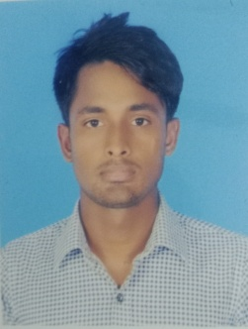
Curriculum Vitae
Name : Mostofa Bhuiyan
Father’s Name : Ohid Bhuiyan
Mother’s Name : Rabia Akter
Permanent Address : Bagjurkandi, Pardiakul, Katiadi, Kishoreganj

Present Address : Park Mor, Cadet College, Rangpur
Mobile No : 01627-728745
Date of Birth : 01-12-2000
Sex : Male
Marital Status : Unmarried
Nationality : Bangladesh Educational Qualification
Degree | Group | Board/University | Pass Year | Result(GPA)
S.S.C | Science | Dhaka | 2016 | 4.44
H.S.C | Science | Dhaka | 2018 | 3.50
B.S.S(Honours | MCJ | Begum Rokeya Universty,Rangpur
Computer Experience :Ms Word,Ms Excel,Ms Powerpoint,Ms office Access
Date: 02-03-23
Signature
(Mostofa Bhuiyan)

