### Reflection

### 1. Describe your pipeline. As part of the description, explain how you modified the draw_lines() function.

My first step is convert rgb to gray image.
2nd step is I used Gaussian blur for edge strength.
3rd step I assigned roi area.
4th step I get Line start and end point using Hough Transform.
5th step I get Line angle. If 25<angle<45 draw line. For outlier line
I get imageheight/2<start,end point <height

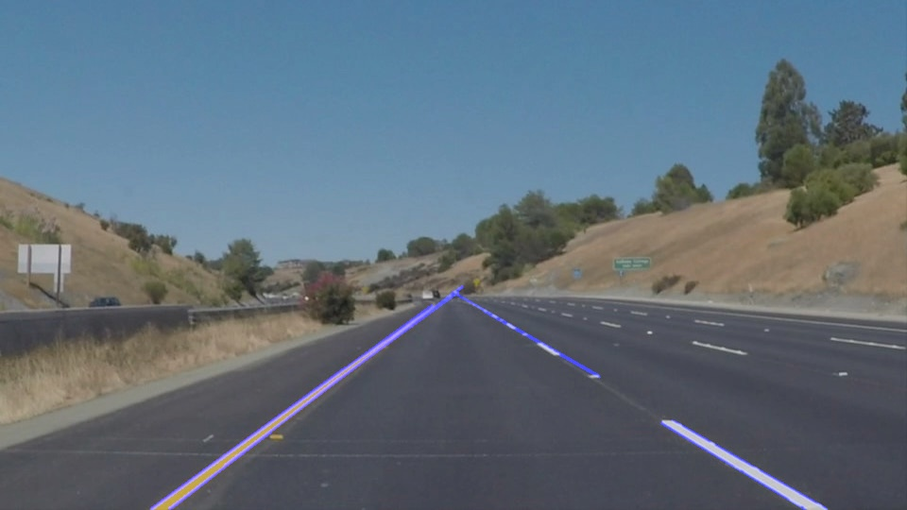
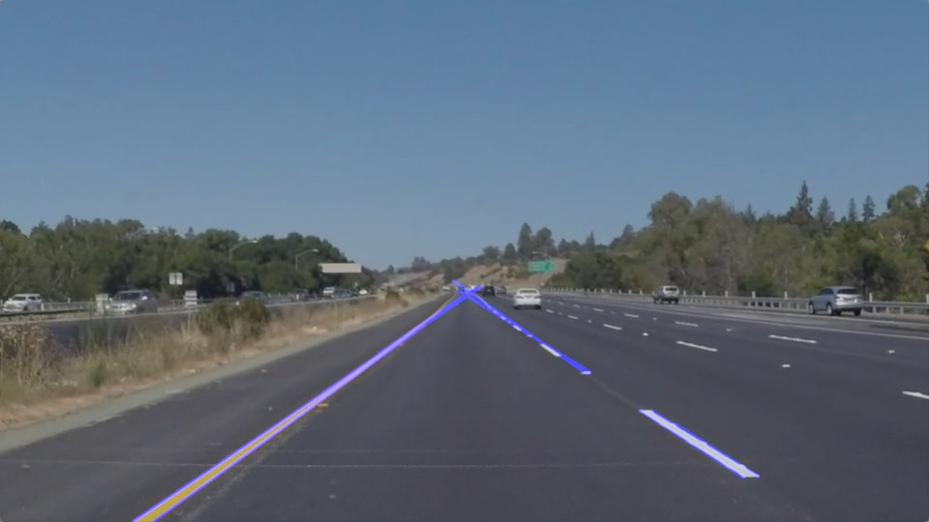

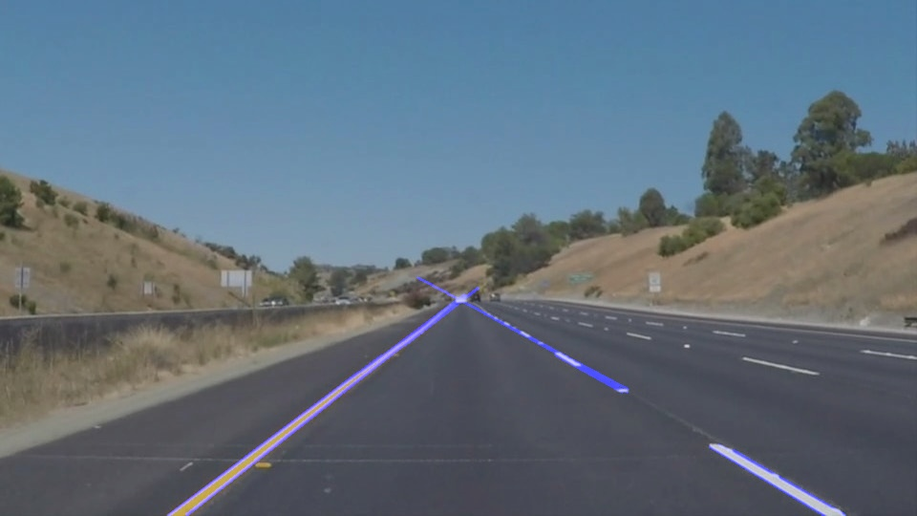
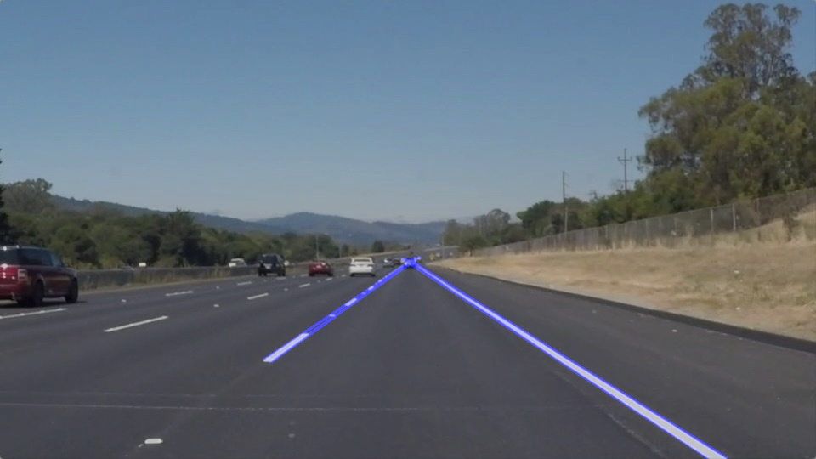

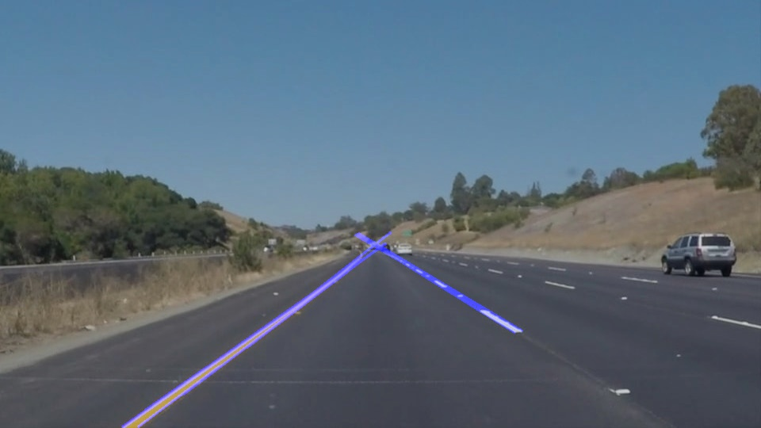

### 2. Identify potential shortcomings with your current pipeline

I did not find hough transform optimal value. And I did not robust line detection.

### 3. Suggest possible improvements to your pipeline.
For improve performance. I want to find Line detection pattern. Always, All road
same color and same shape.

