**1050 Programming Logic**

Lab 5 (15 points total)

Name: __Megan Ostrander_____

*Paste your code and screenshots below.*

1. Compare and contrast the if single-selection statement and the while repetition statement. How are these two statements similar? How are they different? (4 points)

The if single-selection statements are the standard if-then statements that tell you to do one action if it is one situation, or to do another action if it is a different situation. While statements, on the other hand, say to do an action while a situation is true. Both statements have the program performing some type of action based on the situation, but the primary difference between the two statements is the while statement continues to run so long as the situation is true while the if single statement only runs once.

1. Declare two int variables: 1) speedLimit and 2) speed. Assign values speedLimit=35 and speed=42. Write an if statement that displays “SLOW NOW” if speed is greater than speedLimit. (6 points)

class Comparison

{

static void Main()

{

Int speedLimit = 35;

int speed = 42;

if (speed < speedLimit)

{

Console.WriteLine(“Keep Driving”);

}

else

{

Console.WriteLIne(“SLOW NOW”);

}

}

}

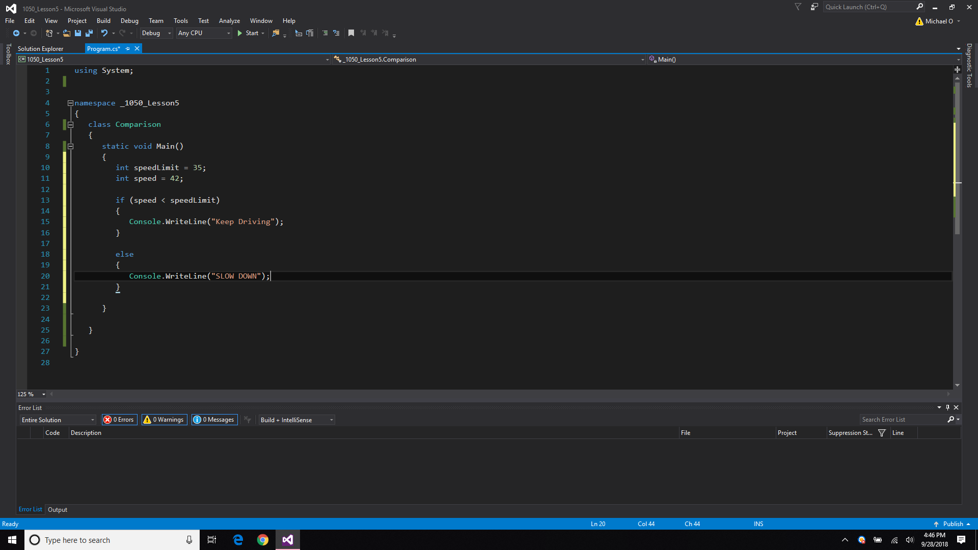

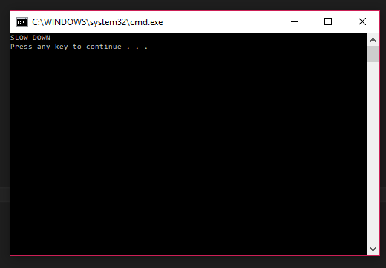

1. if-else statement - Write a program that declares and assigns a value to a Boolean variable called isTrue. Use a condition to output “It is True!” or “It is False!” based on the assigned value. Paste your code and screenshots of your program running with both true and false values (5 points)

Example: bool isTrue = true;

bool isTrue = false;

Note: For some reason I did not understand what you wanted for this question so I did multiple things to better understand how to use bool expressions in if-then statements. I feel I greatly over complicated it then necessary.

static void Main()

{

bool isTrue = true;

int x = 0;

int y = 0;

Console.WriteLine(“Enter a value for x:”);

x = int.Parse(Console.ReadLine());

Console.WriteLine(“Enter a value for y:”);

y = int.Parse(Console.ReadLine());

isTrue = (x == y);

if (isTrue)

{

Console.WriteLine(“It is True!”);

}

Else

{

Console.WriteLine(“It is False!”);

}

}

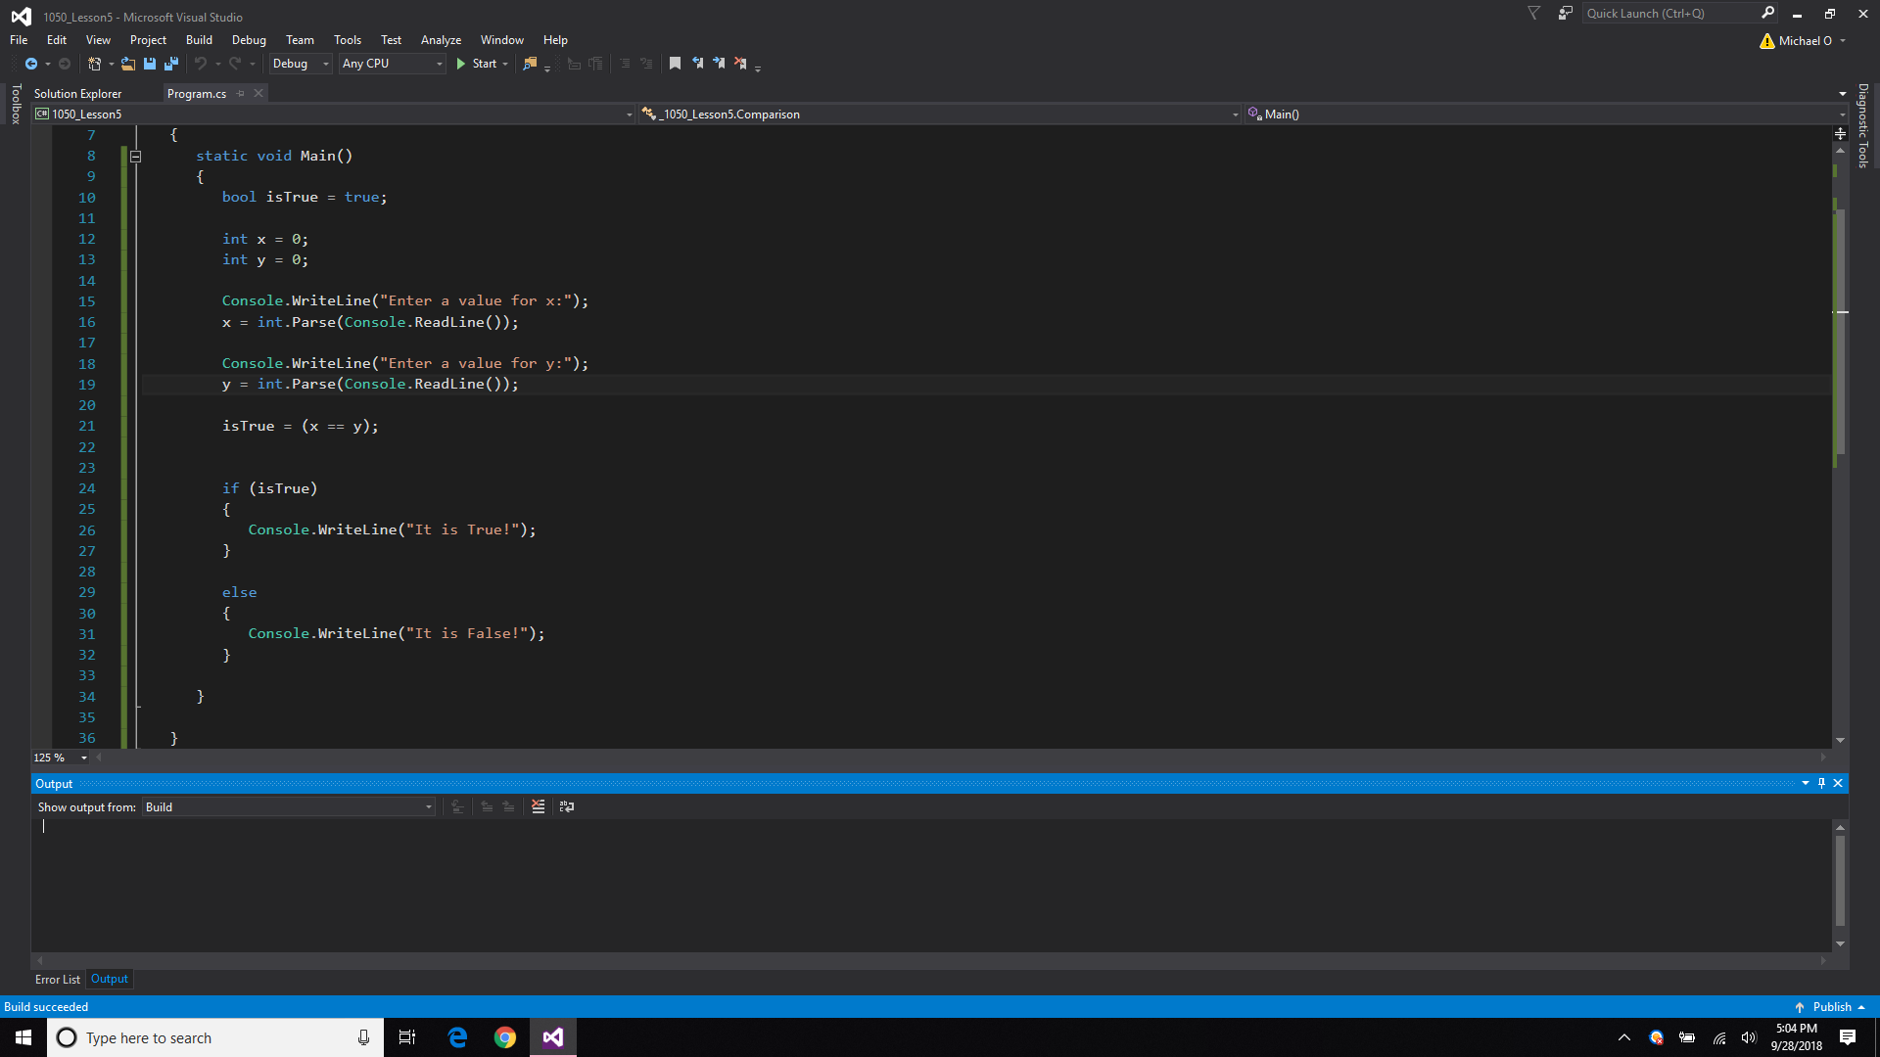

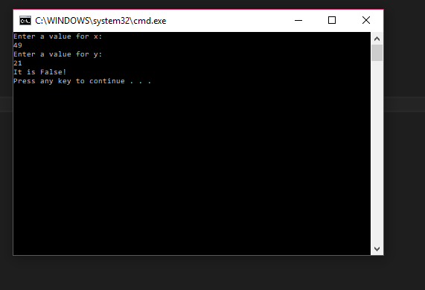

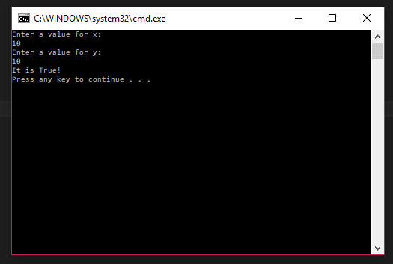

static void Main()

{

Bool isTrue = true;

int creditScore = 0;

Console.WriteLine(“Will you be approved for a bank loan? \nPlease enter your credit score:”);

creditScore = int.Parse(Console.ReadLine());

isTrue = (creditScore > 680);

if (isTrue)

{

Console.WriteLine(“It is True! You will be approved!”);

}

else

{

Console.WriteLine(“It is False! You won’t get that loan, don’t bother.”);

}

