**1050 Programming Logic**

Lab 7

Name: ____Megan Ostrander____

*Paste your code and screenshots below.*

1. Write a for loop that outputs values 2-10. Increment by 1 (3 points).

using System;

namespace ConsoleApplication1

{

   class Program

   {

      static void Main(string[] args)

      {

         int i = 10;

         while(i <= 20)

         {

            Console.WriteLine(i);

            i++;

         }

      }

   }

}

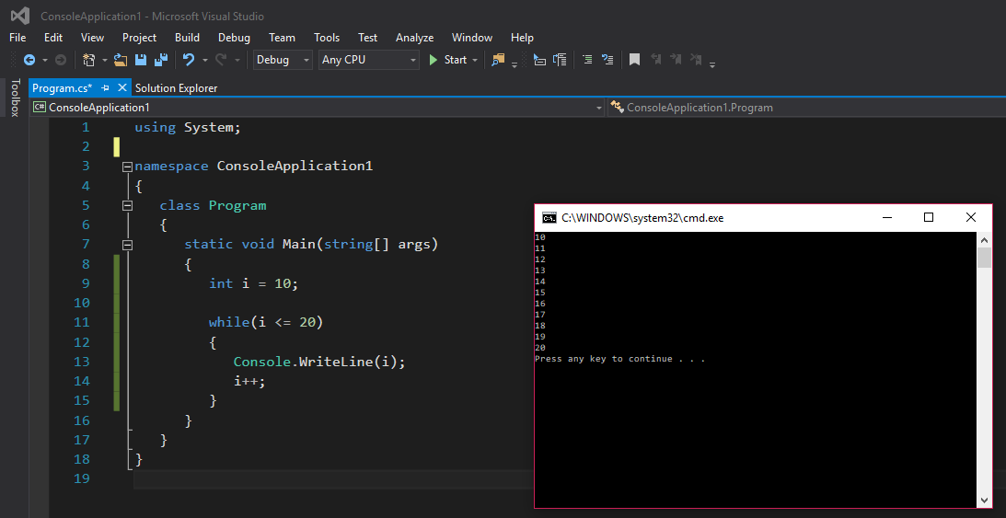

1. Write a for loop that outputs values 20-10. decrement by 1 (3 points).

using System;

namespace ConsoleApplication1

{

   class Program

   {

      static void Main(string[] args)

      {

         int i = 20;

         while(i >= 10)

         {

            Console.WriteLine(i);

            i--;

         }

      }

   }

}

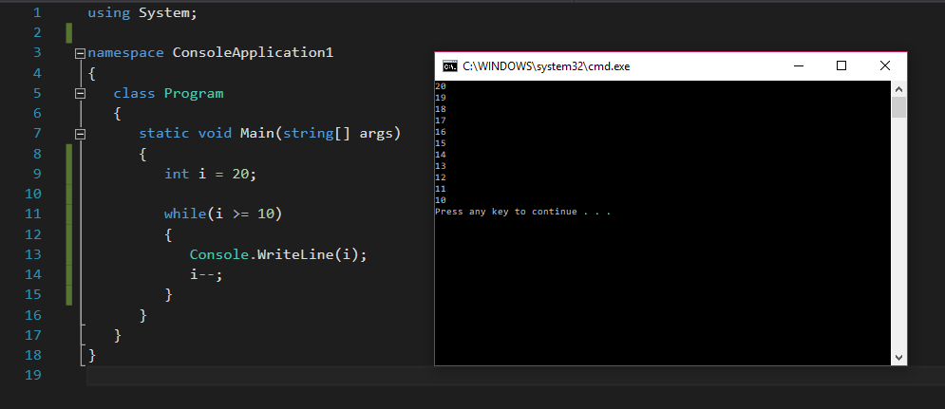

1. Write a do … while loop that outputs values 5-15. increment by 2 (3 points).

using System;

namespace ConsoleApplication1

{

   class Program

   {

      static void Main(string[] args)

      {

         int i = 5;

         do

         {

            Console.WriteLine(i);

            i = i + 2;

         } while (i < 15);

      }

   }

}

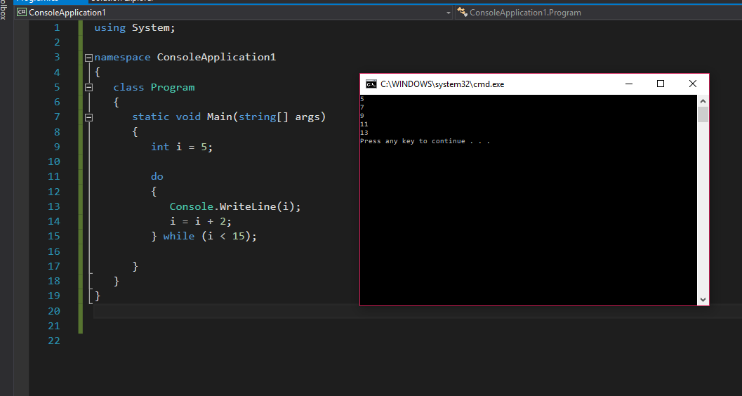

1. (5 points) Use an if…else-if…else statement to output the following based on an int time entered in military time (ie. 23 == 11:00 p.m., 11 == 11:00 a.m.). You will need to use a ReadLine() and then convert the input to an int value. Based on the input, output the following messages:

**Input Output**

0-11 Good Morning  
12-16 Good Afternoon

> 16 Good Evening

using System;

using System.Collections.Generic;

using System.Linq;

using System.Text;

using System.Threading.Tasks;

//Goal: Take information (military time) from user input, convert the info to integer value

//Use integer value in if/else statement to make greeting "Good morning/afternoon/evening"

namespace MilitaryTimeGreeting

{

   class Program

   {

      static void Main(string[] args)

      {

         Console.WriteLine("Please enter the military time:"); //prompt for user input

         int time = int.Parse(Console.ReadLine()); //used to convert text to integer value, put in int variable time

         //Console.WriteLine(time); //used to test functionality, comment out when not used. Worked up to this point!

         if (time < 1200) //if time is between midnight and noon, range extented to noon in case user inputs minutes (i.e. 1145)

         {

            Console.WriteLine("Good Morning!");

         }

         else if ((1200 < time) && (time < 1600)) //note to self: need to do this way to work with multiple conditions CANNOT DO FOLLOWING WAYS:

                                                   //i.e. 1200 < time < 1600   i.e. 1200 < time and time < 1600  i.e. 1200 < time && time < 1600

            {

               Console.WriteLine("Good Afternoon!");

            }

         else  //Do not need if statement if last if/else condition

         {

            Console.WriteLine("Good Evening!");

         }

      }

   }

}

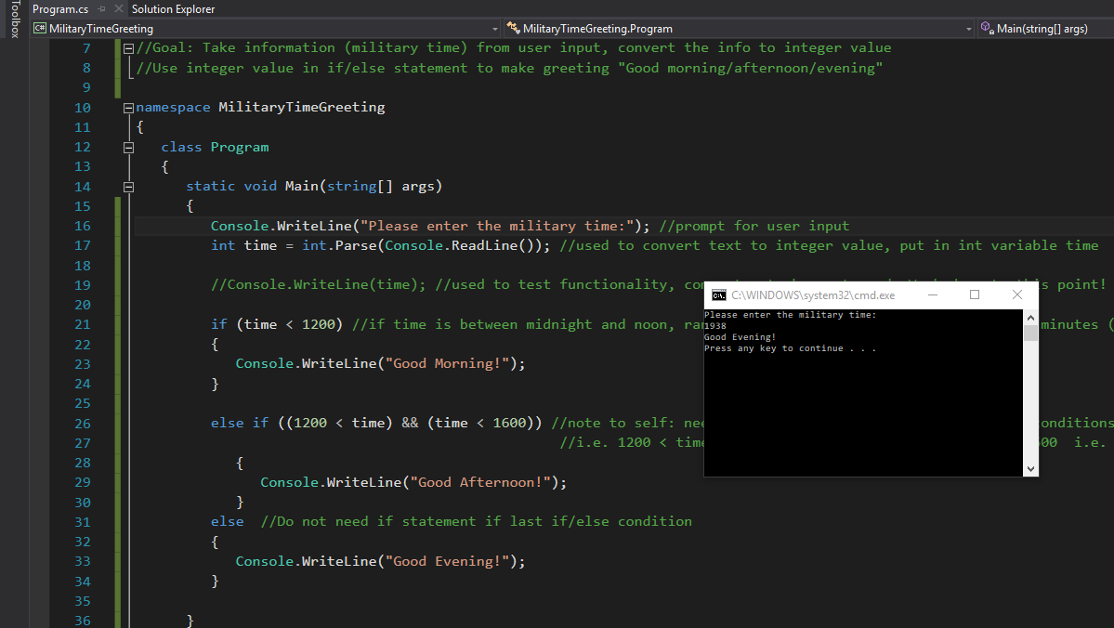

1. (3points) The following code is meant to loop and output 10-20, each number on a separate line. What’s wrong? Fix the problem. Explain what was wrong in a comment.

int i = 10;

while (i <= 21)

{

Console.WriteLine(i);

}

*Example output:*



The code above says “while the variable i is less than or greater to 21, print i”. It should be “while it is less than 21”, otherwise it will also print 21 before ending the loop. I also noticed that the while statement does not increment the variable after printing. Thus, I believe the code is supposed to be the follow:

int i = 10;

while (i < 21)

{

Console.WriteLine(i);

i++;

}

You could also use (i <= 20) instead.

1. (3 points) The following statement is supposed to output every number from 0-100 separated by a line with asterisks on it. What is wrong with the code? Fix it without changing any of the statements.

for (int i = 0; i < 101; i++)

Console.WriteLine(i);

Console.WriteLine("********");

*Example output:*

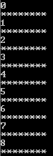

The code above is missing the brackets that enclose the statements. It should be formatted as such:

for (int i = 0; i < 101; i++)

{ Console.WriteLine(i);

Console.WriteLine("********");

}