**1050 Programming Logic**

Lab 6 (20 points total)

Name: ___Megan Ostrander_______

*Paste your code and screenshots below.*

1. **Write a while loop** that outputs values 60 to 20. Decrement by 1 (4 points)

using System;

namespace WhileLoop60to20

{

class Program

{

static void Main()

{

int x = 60;

Console.WriteLine("The value of x is 60.");

while (x > 20)

{

x = x - 1;

Console.WriteLine($"The value of x is now {x}.");

}

}

}

}

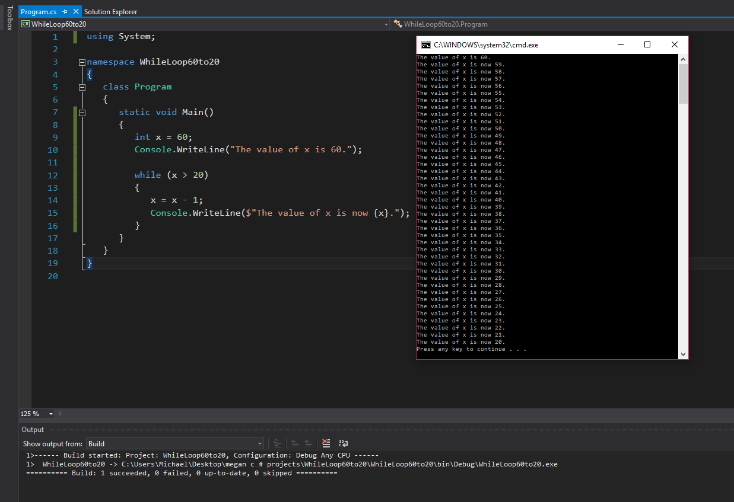

1. **Create a while** that outputs values 10 to 20 Increment by 1 (4 points).

using System;

namespace WhileLoop10to20

{

class Program

{

static void Main()

{

int x = 10;

Console.WriteLine("The value of x is 10.");

while (x < 20)

{

x++;

Console.WriteLine($"The value of x is now {x}.");

}

}

}

}

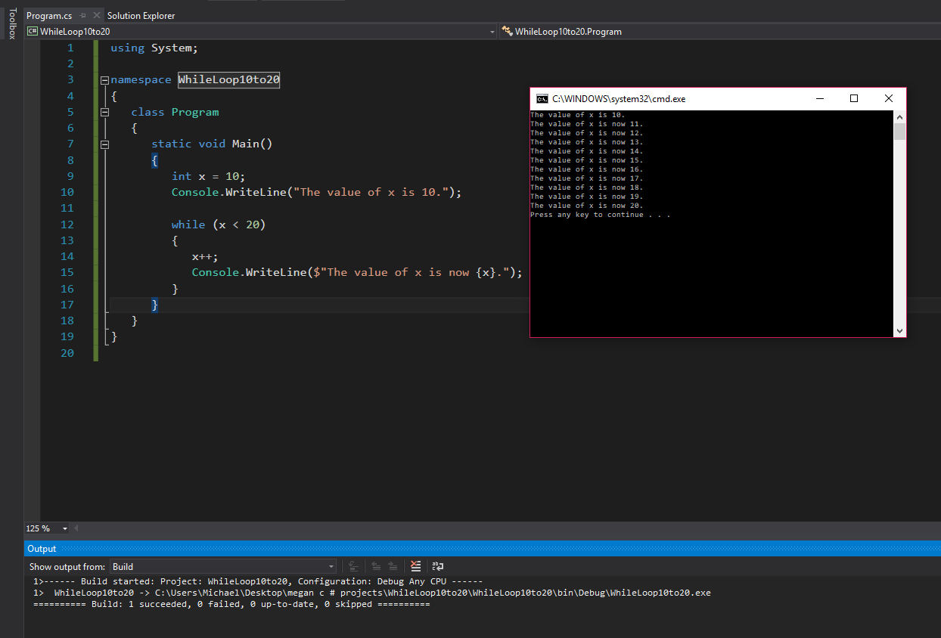

1. Use a while loop and if statement to write a program that prints all the even numbers between 15 and 31 (4 points).

using System;

namespace IfwhileLoopEven15to31

{

class Program

{

static void Main()

{

int x = 15; //declares variable x

Console.WriteLine("All of the even numbers between 15 and 31 are:");

x = x + 1; //adds 1 to make x even

Console.WriteLine($"{x}"); //prints 1st even value to screen

while (x < 31) //while x is less than 31

{

if (x < 30) //if x is less than 30

{

x = x + 2; //adds 2 to x value

Console.WriteLine($"{x}"); //prints value of x

}

}

}

}

}

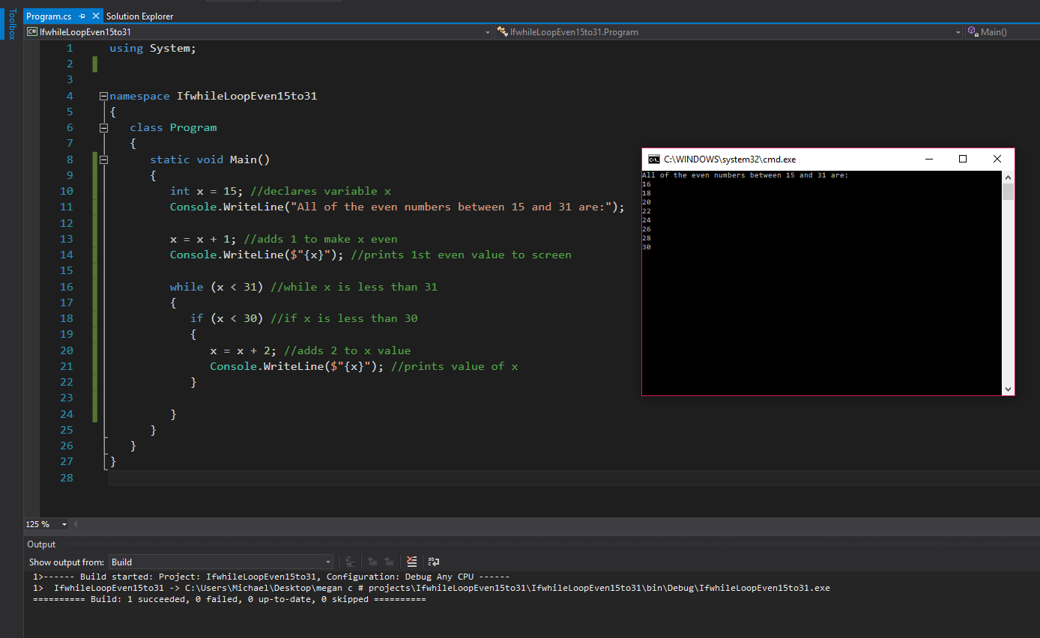

1. if statement - Write a program that converts a Fahrenheit temperature to Celsius. The user should be able to input the temperature in Fahrenheit at the Command prompt and it should output the temperature in Celsius. In addition, you should output “It is cold” if the Fahrenheit value is less than 40 or it should output “It is hot” if the temperature is over 90.

***Code to read a value: double fahrenheit = Convert.ToDouble(Console.ReadLine());***

***Code to convert: double celsius = (fahrenheit - 32) * 5 / 9;***

(8 points)

using System;

namespace TempFahrenheitCelsiusConversionIFstatement

{

class Program

{

static void Main()

{

Console.WriteLine("Enter a value in Fahrenheit:"); //prompts for user input

double Fahrenheit = Convert.ToDouble(Console.ReadLine()); //obtains temp value from user

double Celsius = (Fahrenheit - 32) * 5 / 9; //formula for fahrenheit to celsius conversion

Console.WriteLine($"The equivalent value in celsius is {Celsius}.");

if (Fahrenheit < 40)

{

Console.WriteLine("It is cold!");

}

if (Fahrenheit > 90)

{

Console.WriteLine("It is hot!");

}

}

}

}

