using System;

namespace WhileLoop60to20

{

class Program

{

static void Main()

{

int x = 60;

Console.WriteLine("The value of x is 60.");

while (x > 20)

{

x = x - 1;

Console.WriteLine($"The value of x is now {x}.");

}

}

}

}

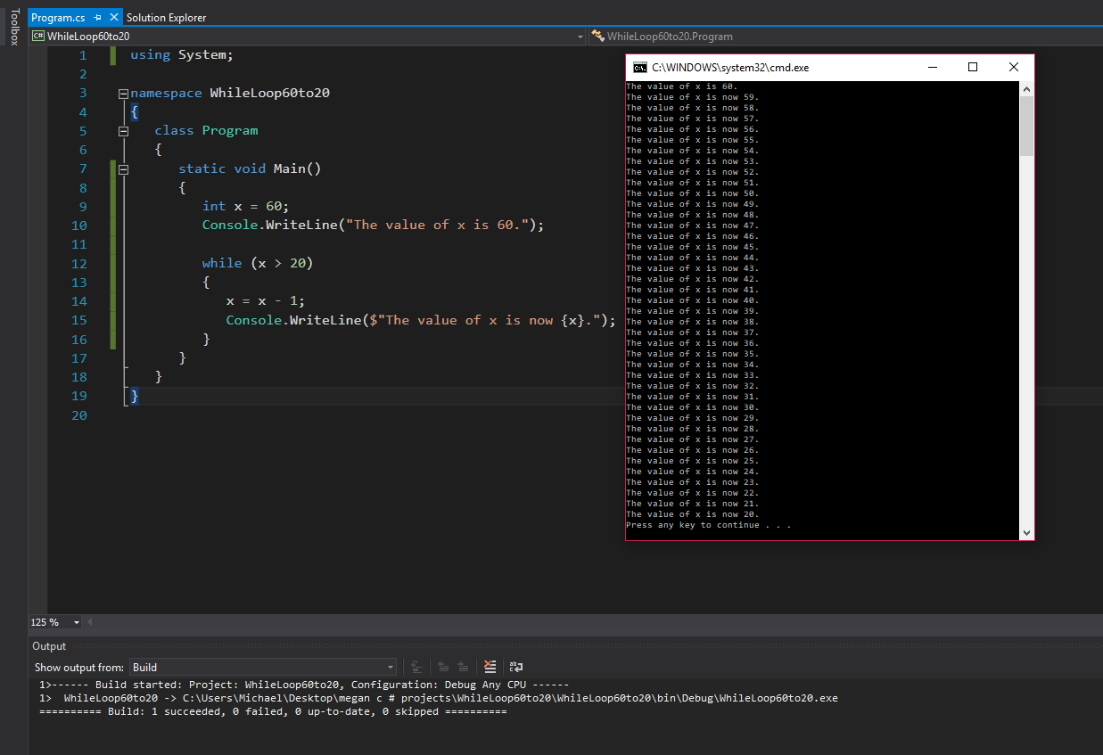

using System;

namespace WhileLoop10to20

{

class Program

{

static void Main()

{

int x = 10;

Console.WriteLine("The value of x is 10.");

while (x < 20)

{

x++;

Console.WriteLine($"The value of x is now {x}.");

}

}

}

}

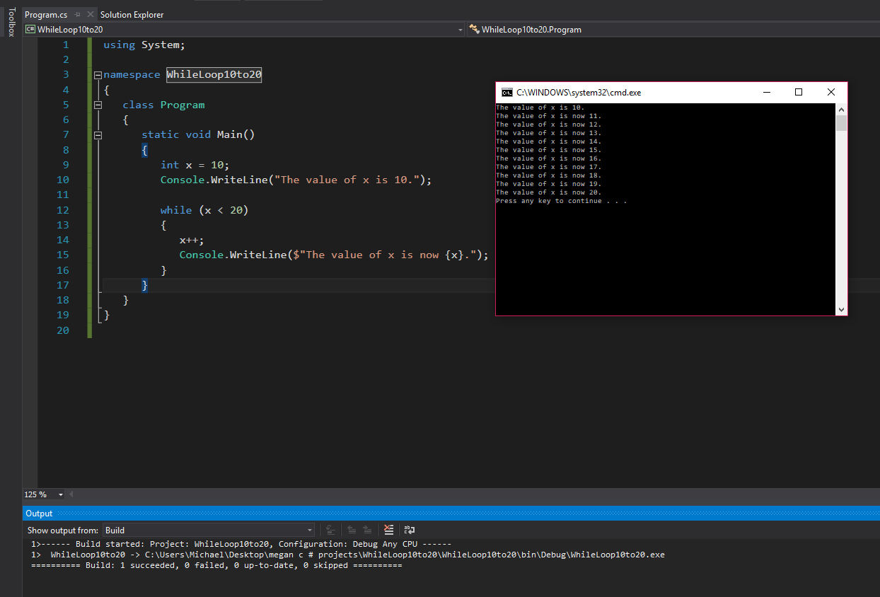

using System;

namespace IfwhileLoopEven15to31

{

class Program

{

static void Main()

{

int x = 15; //declares variable x

Console.WriteLine("All of the even numbers between 15 and 31 are:");

x = x + 1; //adds 1 to make x even

Console.WriteLine($"{x}"); //prints 1st even value to screen

while (x < 31) //while x is less than 31

{

if (x < 30) //if x is less than 30

{

x = x + 2; //adds 2 to x value

Console.WriteLine($"{x}"); //prints value of x

}

}

}

}

}

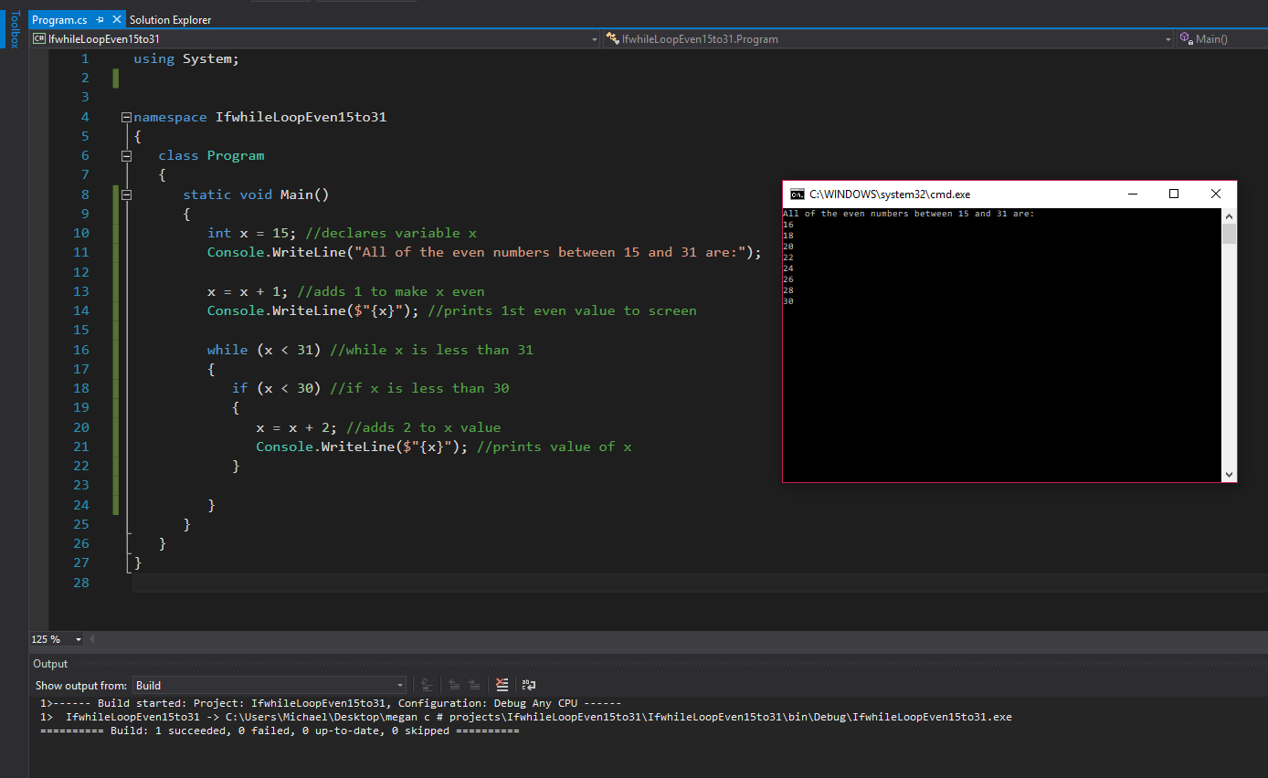

using System;

namespace TempFahrenheitCelsiusConversionIFstatement

{

class Program

{

static void Main()

{

Console.WriteLine("Enter a value in Fahrenheit:"); //prompts for user input

double Fahrenheit = Convert.ToDouble(Console.ReadLine()); //obtains temp value from user

double Celsius = (Fahrenheit - 32) \* 5 / 9; //formula for fahrenheit to celsius conversion

Console.WriteLine($"The equivalent value in celsius is {Celsius}.");

if (Fahrenheit < 40)

{

Console.WriteLine("It is cold!");

}

if (Fahrenheit > 90)

{

Console.WriteLine("It is hot!");

}

}

}

}

